Report

# Laboratory Work 3

Task 1 - Prerequisites

create tablespace tbs_lab datafile 'db_lab_001.dat'

size 5M autoextend ON next 5M MAXSIZE 100M;

create user $DLadutko$ identified by 220025220025 default tablespace tbs_lab;

grant connect to $DLadutko$;

grant resource to $DLadutko$;

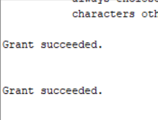

## 2.1. Task 1 – Heap Understanding

Step 1

create table t

( a int,

b varchar2(4000) default rpad('*',4000,'*'),

c varchar2(3000) default rpad('*',3000,'*')

)

/



Step 2

insert into t (a) values ( 1);

insert into t (a) values ( 2);

insert into t (a) values ( 3);

commit;

delete from t where a = 2 ;

commit;

insert into t (a) values ( 4);

commit;

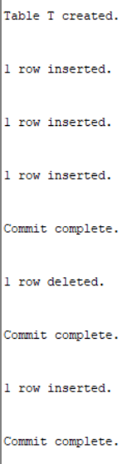

Step 3

select a from t;

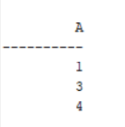

Clean up

drop table T;



## 2.2. Task 2 – Understanding Low level of data abstraction: Heap Table Segments

Step 1

Create table t ( x int primary key, y clob, z blob );



Step 2

PURGE RECYCLEBIN;

select segment_name, segment_type from user_segments;



Step 3

Create table t

( x int primary key,

y clob,

z blob )

SEGMENT CREATION IMMEDIATE

/



Step 4

select segment_name, segment_type from user_segments;

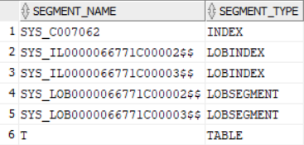

Step 5

SELECT DBMS_METADATA.GET_DDL('TABLE','T') FROM dual

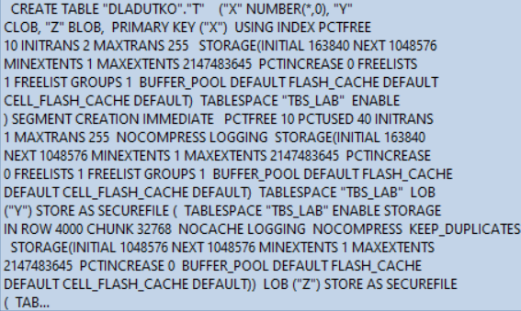

# 3. Index Organized Tables

## Task 3: Compare performance of using IOT tables

Step 1

CREATE TABLE emp AS

SELECT

object_id empno

, object_name ename

, created hiredate

, owner job

FROM

all_objects

/



Create Index:

alter table emp add constraint emp_pk primary key(empno)



begin

dbms_stats.gather_table_stats( user, 'EMP', cascade=>true );

end;



Step 2

CREATE TABLE heap_addresses

(

empno REFERENCES emp(empno) ON DELETE CASCADE

, addr_type VARCHAR2(10)

, street VARCHAR2(20)

, city VARCHAR2(20)

, state VARCHAR2(2)

, zip NUMBER

, PRIMARY KEY (empno,addr_type)

)

/



Step 3

CREATE TABLE iot_addresses

(

empno REFERENCES emp(empno) ON DELETE CASCADE

, addr_type VARCHAR2(10)

, street VARCHAR2(20)

, city VARCHAR2(20)

, state VARCHAR2(2)

, zip NUMBER

, PRIMARY KEY (empno,addr_type)

)

ORGANIZATION INDEX

/



Step 4

INSERT INTO heap_addresses

SELECT empno, 'WORK' , '123 main street' , 'Washington' , 'DC' , 20123 FROM emp;

INSERT INTO iot_addresses

SELECT empno , 'WORK' , '123 main street' , 'Washington' , 'DC' , 20123 FROM emp;

INSERT INTO heap_addresses

SELECT empno, 'HOME' , '123 main street' , 'Washington' , 'DC' , 20123 FROM emp;

INSERT INTO iot_addresses

SELECT empno, 'HOME' , '123 main street' , 'Washington' , 'DC' , 20123 FROM emp;

INSERT INTO heap_addresses

SELECT empno, 'PREV' , '123 main street' , 'Washington' , 'DC' , 20123 FROM emp;

INSERT INTO iot_addresses

SELECT empno, 'PREV' , '123 main street' , 'Washington' , 'DC' , 20123 FROM emp;

INSERT INTO heap_addresses

SELECT empno, 'SCHOOL' , '123 main street' , 'Washington' , 'DC' , 20123 FROM emp;

INSERT INTO iot_addresses

SELECT empno, 'SCHOOL' , '123 main street' , 'Washington' , 'DC' , 20123 FROM emp;

Commit;

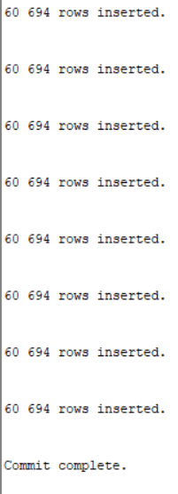

Step 5

exec dbms_stats.gather_table_stats( user, 'HEAP_ADDRESSES' );

exec dbms_stats.gather_table_stats( user, 'IOT_ADDRESSES' );

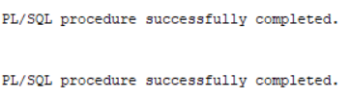

Step 6

Explain 1:

SELECT *

FROM emp ,

heap_addresses

WHERE emp.empno = heap_addresses.empno

AND emp.empno = 42;

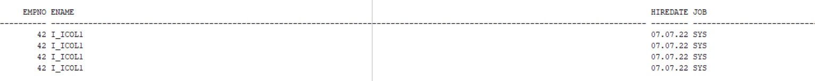…

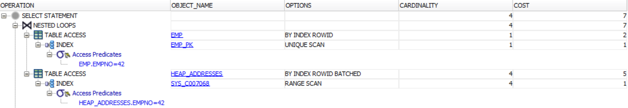

Explain 2:

SELECT *

FROM emp ,

iot_addresses

WHERE emp.empno = iot_addresses.empno

AND emp.empno = 42;



Same SELECTS!

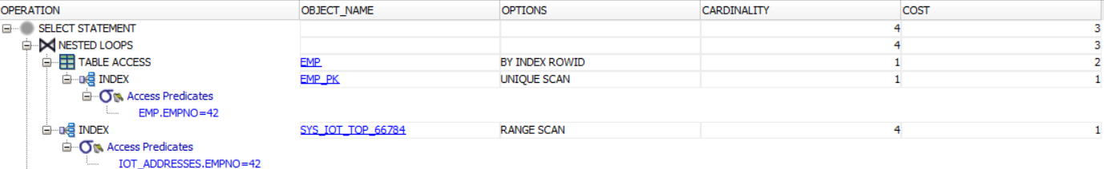

Even though selects are same, the amount of operations using IOT is less. We can see it using Explain Plan Oracle functionality, HOT select costs 7 points, but IOT Select cost 3 points.

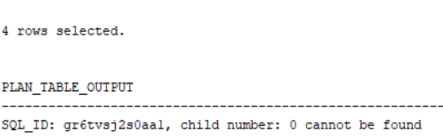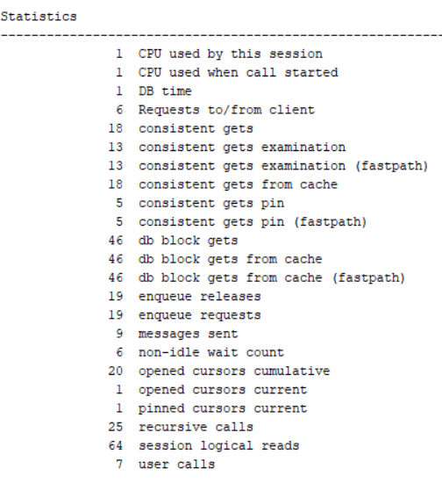

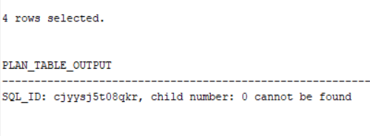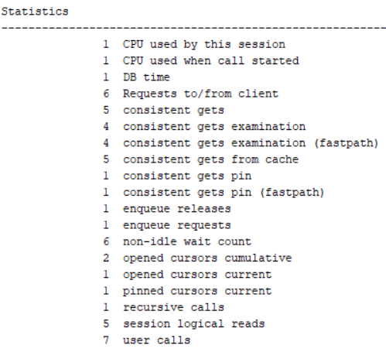

If we compare separate statistic point, we can see that in most of cases the amount of individual compared operations in ION are less then HOT.

Step 7

drop table emp;

drop table heap_addresses;

drop table iot_addresses;

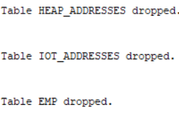

## Task 4: Analyses Cluster Storage by Blocks

Step 1

CREATE cluster emp_dept_cluster( deptno NUMBER( 2 ) )

SIZE 1024

STORAGE( INITIAL 100K NEXT 50K );



Step 2

CREATE INDEX idxcl_emp_dept on cluster emp_dept_cluster;



Step 3

CREATE TABLE dept

(

deptno NUMBER( 2 ) PRIMARY KEY

, dname VARCHAR2( 14 )

, loc VARCHAR2( 13 )

)

cluster emp_dept_cluster ( deptno ) ;

CREATE TABLE emp

(

empno NUMBER PRIMARY KEY

, ename VARCHAR2( 10 )

, job VARCHAR2( 9 )

, mgr NUMBER

, hiredate DATE

, sal NUMBER

, comm NUMBER

, deptno NUMBER( 2 ) REFERENCES dept( deptno )

)

cluster emp_dept_cluster ( deptno ) ;

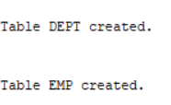

Step 4

INSERT INTO DEPT VALUES (20,'RESEARCH','DALLAS');

INSERT INTO DEPT VALUES (30,'SALES','CHICAGO');

INSERT INTO DEPT VALUES(40,'OPERATIONS','BOSTON');

INSERT INTO EMP VALUES

(7369,'SMITH','CLERK',7902,to_date('17-12-1980','dd-mm-yyyy'),800,NULL,20);

INSERT INTO EMP VALUES

(7499,'ALLEN','SALESMAN',7698,to_date('20-2-1981','dd-mm-yyyy'),1600,300,30);

INSERT INTO EMP VALUES

(7521,'WARD','SALESMAN',7698,to_date('22-2-1981','dd-mm-yyyy'),1250,500,30);

INSERT INTO EMP VALUES

(7566,'JONES','MANAGER',7839,to_date('2-4-1981','dd-mm-yyyy'),2975,NULL,20);

INSERT INTO EMP VALUES

(7654,'MARTIN','SALESMAN',7698,to_date('28-9-1981','dd-mm-yyyy'),1250,1400,30);

INSERT INTO EMP VALUES

(7698,'BLAKE','MANAGER',7839,to_date('1-5-1981','dd-mm-yyyy'),2850,NULL,30);

INSERT INTO EMP VALUES

(7844,'TURNER','SALESMAN',7698,to_date('8-9-1981','dd-mm-yyyy'),1500,0,30);

INSERT INTO EMP VALUES

(7900,'JAMES','CLERK',7698,to_date('3-12-1981','dd-mm-yyyy'),950,NULL,30);

INSERT INTO EMP VALUES

(7902,'FORD','ANALYST',7566,to_date('3-12-1981','dd-mm-yyyy'),3000,NULL,20);

commit;

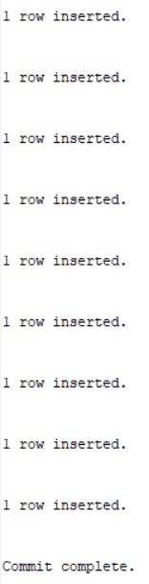

Step 5

SELECT *

FROM

(

SELECT dept_blk, emp_blk, CASE WHEN dept_blk <> emp_blk THEN '*' END flag, deptno

FROM

(

SELECT dbms_rowid.rowid_block_number( dept.rowid ) dept_blk, dbms_rowid.rowid_block_number( emp.rowid ) emp_blk, dept.deptno

FROM emp , dept

WHERE emp.deptno = dept.deptno

)

)

ORDER BY deptno

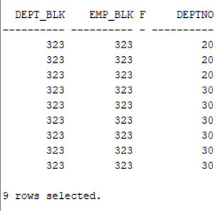

Step 6

drop table dept;

drop table emp;

drop cluster emp_dept_cluster;

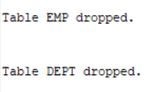



Step 7

Scheme is empty.

# Task 5: Analyses Cluster Storage by Blocks

CREATE CLUSTER emp_dept_clusterr (

deptno NUMBER( 2 ) )

HASHKEYS 10000

HASH IS deptno

SIZE 256;

