Report

# Laboratory Work 4

## Task 1: Full Scans and the High-water Mark and Block reading

Step 1

CREATE TABLE t2 AS

SELECT TRUNC( rownum / 100 ) id, rpad( rownum,100 ) t_pad

FROM dual

CONNECT BY rownum < 100000;



Step 2

CREATE INDEX t2_idx1 ON t2 ( id );



Step 3

select blocks from user_segments where segment_name = 'T2';



select count(distinct (dbms_rowid.rowid_block_number(rowid))) block_ct from t2 ;



SET autotrace ON;



SELECT COUNT( * )

FROM t2 ;

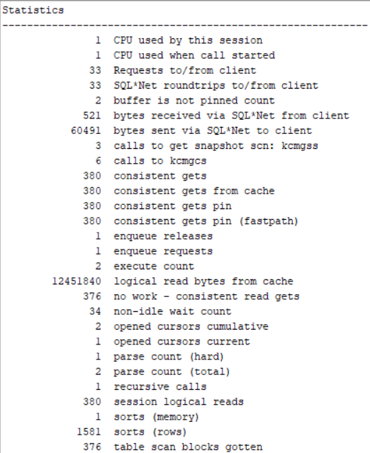

Step 4

DELETE FROM t2;

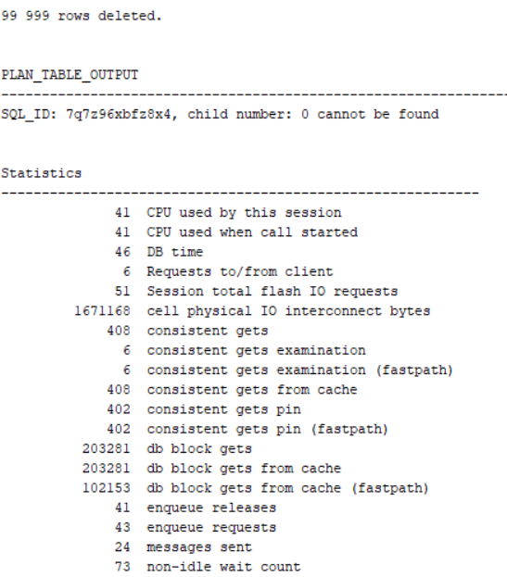

Step 5

--1

select blocks from user_segments where segment_name = 'T2';

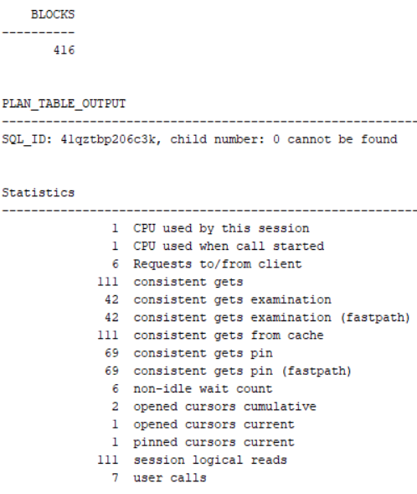

--2

select count(distinct (dbms_rowid.rowid_block_number(rowid))) block_ct from t2 ;

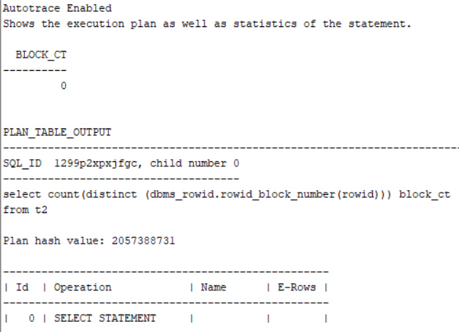 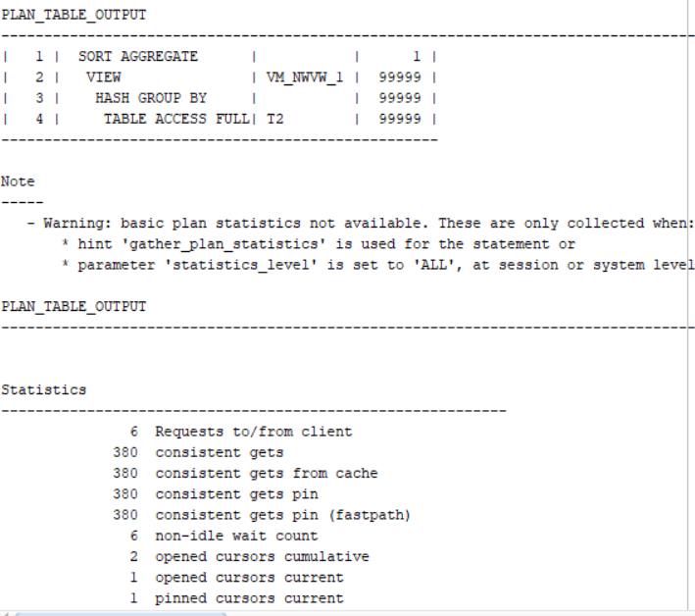

--3

SELECT COUNT( * )

FROM t2 ;

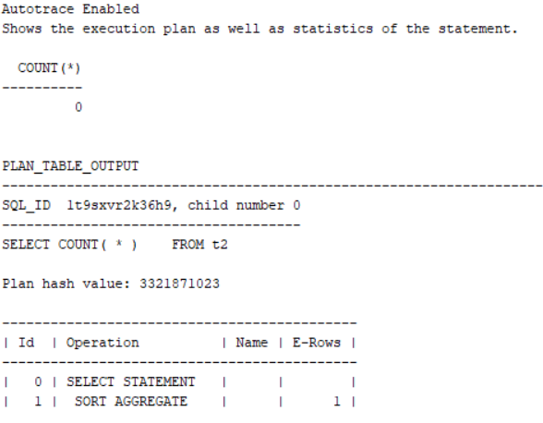 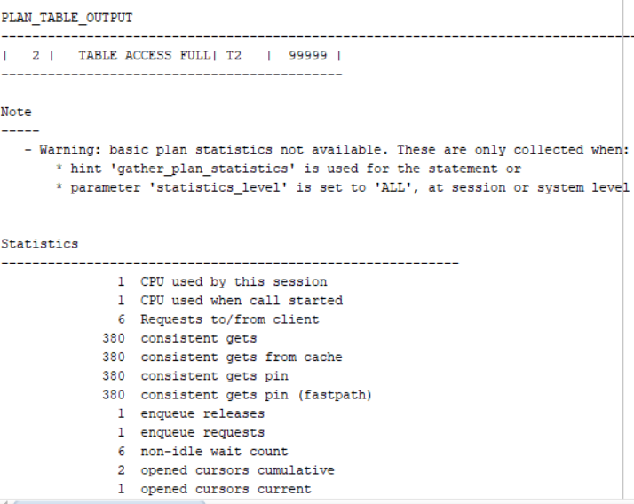

Step 6

INSERT INTO t2

( ID, T_PAD )

VALUES

( 1,'1' );

COMMIT;

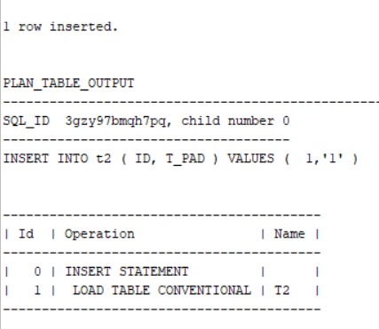 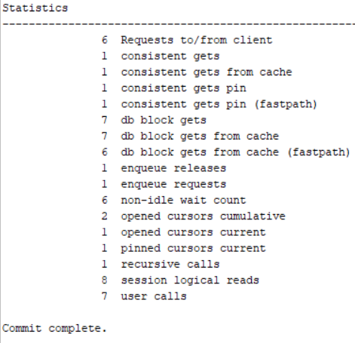

Step 7

Step 8

Step 9