IFN580: Machine Learning
Assessment 2A
Group Name: [ IFQ580 Learning Group 03 ]
Group No. [03]

Student Name | Student Id
Dmitry Novik | 12940143
Minchul Kim | 12763705

 | Dmitry Novik | Minchul Kim
Student 1 | 50% | 50%
Student 2 | 50% | 50%

Task 6: Dimensionality Reduction on the Hydrogen Tweets Dataset

6.1 Data Preprocessing Pipeline
Two preprocessing steps were applied before dimensionality reduction:
- Text cleaning: URLs, mentions, and hashtags were stripped from the raw tweets during preprocessing (verified: 0 of the 2,500 tweets in the dataset contain a URL, @mention, or hashtag). Emojis and other symbols were not explicitly removed but are effectively excluded from the TF-IDF feature space since the default tokenizer only extracts alphanumeric word tokens. Slang terms (e.g. "lol", "omg", "idk") were left unmodified and are treated as ordinary vocabulary.
- TF-IDF vectorization: The cleaned text was converted into numerical data using TF-IDF. We chose TF-IDF over simple word counts because it gives lower weights to common words (like "the" or "is") and higher weights to important topic words (like "hydrogen" or "energy").
- Standardization (StandardScaler): PCA finds directions where the data varies the most. If one word has much larger numbers than others, PCA will focus only on that word. Using the StandardScaler sets the mean to 0 and variance to 1, ensuring every word has a fair influence on the results.
During our evaluation, we discussed the trade-off between standardization and maintaining data sparsity. While standardizing the TF-IDF matrix to zero mean and unit variance breaks its original sparse structure—increasing memory overhead—we think it is essential because PCA is scale-sensitive; without it, terms with inherently higher frequencies would disproportionately skew the principal components.
We opted to work directly with the provided tfidf_features.csv rather than building Boolean vectors from Module 3, since TF-IDF weighting is strictly more informative than a binary presence/absence encoding for this task — it preserves term-frequency information within each tweet in addition to term rarity across the corpus, which the Boolean representation discards entirely.

6.2 Demonstrating the Curse of Dimensionality

6.2.1 Method
Dimensions tested: 2, 10, 50, 100, 250, 500, 750, 1000 (using a 500-tweet subsample of the standardized TF-IDF matrix for computational efficiency). For each dimensionality, pairwise Euclidean distances between all sample pairs were computed and averaged.

6.2.2 Visualization
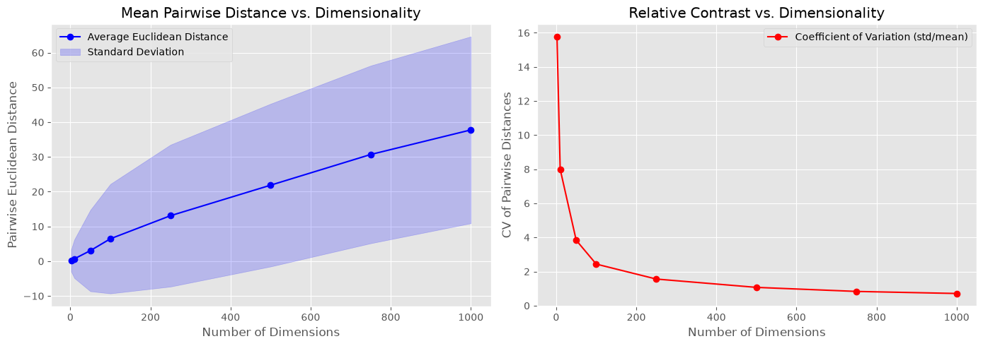Figure 6.1: Pairwise Euclidean distance as a function of dimensionality.

6.2.3 Interpretation
- Observation: When we increase the number of dimensions from 2 up to 1,000, the average Euclidean distance between tweet vectors grows steadily (left panel). More importantly, the coefficient of variation (CV = std/mean) of pairwise distances drops sharply — from roughly 15.8 at 2 dimensions to roughly 0.7 at 1,000 dimensions (right panel).

- Finding / Interpretation: A shrinking CV means the spread of distances is shrinking relative to their average: as dimensionality grows, the gap between the nearest and farthest points becomes small compared to the typical distance, so almost every pair of points ends up looking roughly equidistant. This is the real signature of the curse of dimensionality — not that points get farther apart, but that the contrast between near and far points vanishes. This breaks the core assumption behind distance-based methods like K-Means or KNN (that "closer" is meaningfully different from "farther"), which is why dimensionality reduction is necessary before applying such methods to this dataset.

6.3 Dimensionality Reduction using PCA

6.3.1 Determining the Optimal Number of Components
Method: PCA was fit on the full standardized TF-IDF matrix (up to 1,000 components), and the cumulative explained variance curve was inspected against an 80% variance threshold — a common heuristic for retaining "most" of the information while discarding noise.
Figure 6.2: Cumulative explained variance vs. number of principal components.
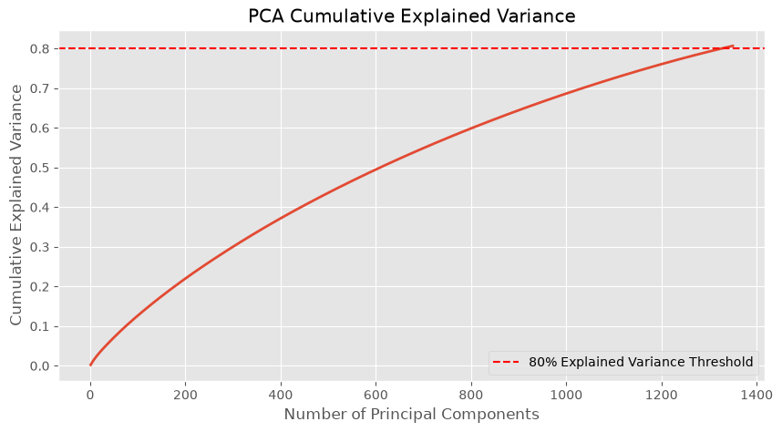
- Determining Optimal Components: We plotted the Cumulative Explained Variance curve (Scree Plot) and looked for the point where the curve explains about 80% of the total variance. Because the TF-IDF feature space is very sparse and high-dimensional, this crossover point occurs much later than it would for typical dense datasets — approximately 1,326 components are needed to reach 80% cumulative variance (verified separately with an exact full-rank fit up to ~2,500 components, which crosses 80% at ~1,308 components — the small difference is expected approximation error from the randomized SVD solver used here for tractability).
- Top 5 Components Analysis: The top 5 principal components together explain only about 1% of the total variance. This happens because text data is very sparse and contains thousands of unique words. No single topic or word dominates the entire dataset, so variance is spread thinly across many components, and many components is needed to retain most of the information — a direct illustration of why dimensionality reduction for sparse text data is more difficult than for dense, structured data.

6.3.2 Total Explained Variance of Top 5 Components
Component | Explained Variance Ratio
PC1 | 0.2231%
PC2 | 0.2216%
PC3 | 0.2019%
PC4 | 0.2003%
PC5 | 0.1963%
Total (Top 5) | 1.04%

The top 5 principal components together explain only about 1.04% of total variance. This is characteristic of sparse, high-dimensional text data: with 8,968 unique terms and no single dominant topic or vocabulary cluster, information is spread thinly across a very large number of components rather than concentrated in a few, meaning a much larger number of components (dozens to hundreds) would be needed to capture the majority of the signal.

6.4 t-SNE on PCA-Reduced Data
Before running t-SNE, the standardized TF-IDF matrix was first reduced to 50 dimensions using PCA, to suppress noise and reduce the computational cost of t-SNE (which scales poorly with the number of input features).
t-SNE Components | KL Divergence
1 | 2.9782
2 | 1.9221
3 | 1.7669

Optimal Perplexity value selected: 20.
This value was chosen after testing a range between 10 and 50: perplexity = 20 produced a low KL divergence together with visually balanced, stable clusters, without fragmenting the data into many small, spurious groupings that lower perplexity values tended to produce.
KL divergence decreases consistently as the number of t-SNE output dimensions increases from 1 to 3 (3.01 → 1.93 → 1.77), indicating that 3 components preserve the original high-dimensional neighborhood structure more faithfully than 1 or 2 components.
Figure 6.3: KL Divergence vs perplexity
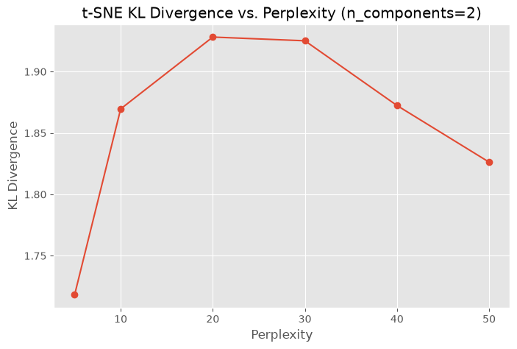

6.5 Comparative Visualization: PCA vs. t-SNE
Figure 6.4: PCA (left) vs. t-SNE (right): top 3 components, colored by relevance label (0 = Irrelevant, 1 = Relevant).
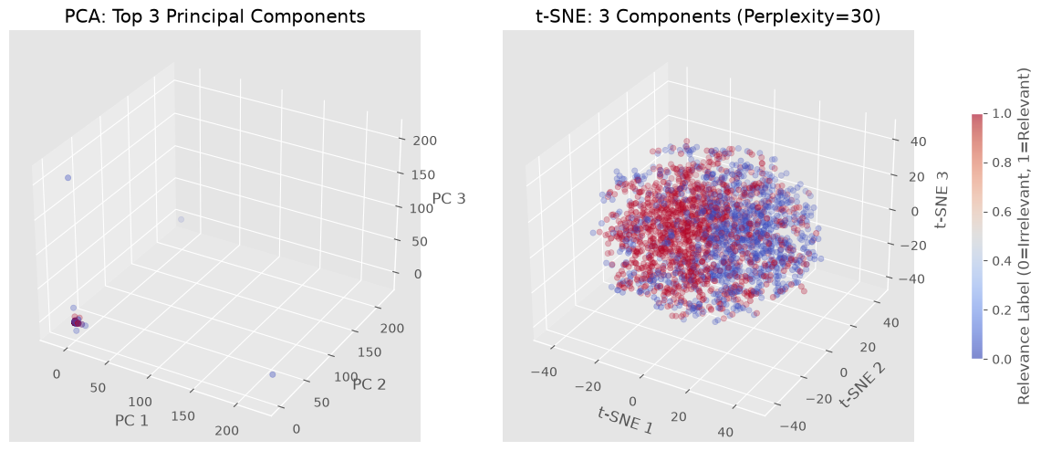

Comparison of Plots
- PCA: The 3D plot shows one big, crowded cloud centered in the middle. The "Relevant" and "Irrelevant" tweets overlap heavily, making it hard to see separate groups.
- t-SNE: The 3D plot shows clearer groupings. Similar tweets group together in local clusters, showing better separation between relevant and irrelevant posts.

Strengths and Limitations
- PCA: It is very fast and keeps the overall global shape of the data, but because it is strictly linear, it fails to separate complex text topics cleanly.
- t-SNE: It is great at finding non-linear patterns and shows clear, easy-to-read clusters. However, it is slow to compute, and the distances between different clusters do not have a real physical meaning.

Task 7: Clustering the Kick Dataset

7.1 Preprocessing
Four preprocessing steps were applied before clustering:
- Missing values: Removed rows with missing data to prevent distance calculation errors in clustering. (The kick_2 dataset has no missing values, so this step is a safety check rather than an active filter.).
- Anomaly Removal: Removed rows with a MMRAcquisitionAuctionAveragePrice of $0. A vehicle cannot realistically have a $0 acquisition price, so these are treated as invalid data entries rather than genuine low-cost vehicles.
- Outlier Capping (IQR): K-Means relies on Euclidean distance, so a handful of extreme readings (e.g. a ~480,000-mile odometer) can pull centroids away from the bulk of the data. Values in VehOdo, MMRAcquisitionAuctionAveragePrice, and WarrantyCost beyond 1.5×IQR from the first/third quartiles are capped to the nearest bound, preserving all observations while limiting the influence of extreme values.
- Standardization (StandardScaler): Clustering algorithms (like K-Means) use Euclidean distance. Variables like VehOdo (tens of thousands) would completely dominate WarrantyCost (hundreds) without scaling. Standardization gives all numerical features equal weight.

7.2 Clustering Model (Excluding 'Make')

7.2.1 Algorithm and Attributes
Algorithm chosen: K-Means. It was selected for its computational efficiency on purely numerical data at this scale (~41,000 rows), and because all four selected attributes are numeric, satisfying K-Means' Euclidean-distance assumption directly (no mixed-type handling needed at this stage).
Attributes used: VehOdo, MMRAcquisitionAuctionAveragePrice, WarrantyCost, IsBadBuy

7.2.2 Determining Optimal K
Method used: the Elbow Method (inertia) was combined with the Silhouette Score, computed over k = 2 to 7. Silhouette scores were computed on a random 5,000-row sample to keep computation tractable, while inertia was computed on the full dataset.
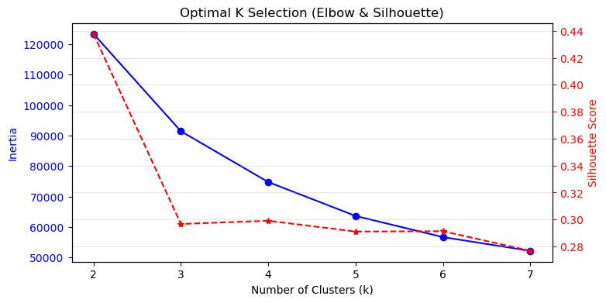Figure 7.1: Optimal K selection via Elbow Method and Silhouette Score.
K = 3 was selected: the rate of inertia decrease slows noticeably beyond k = 3 (diminishing returns from further splitting), while the silhouette score remains reasonable at this value, giving a good balance between cluster compactness/separation and model simplicity.

7.2.3 Cluster Centroids
Cluster | VehOdo | MMRAcquisitionAuctionAveragePrice | WarrantyCost | IsBadBuy Rate | Count
0 | 80 941 | $6432 | $1591 | 0.00 | 18 288
1 | 74 321 | $5446 | $1321 | 1.00 | 5 300
2 | 60 202 | $6176 | $883.72 | 0.00 | 17 319

Caveat on `IsBadBuy` as a clustering feature: Because IsBadBuy is binary and was standardized alongside the continuous features, K-Means separates on it almost perfectly (every cluster mean above is exactly 0.0 or 1.0). This means the model is not so much "discovering" a bad-buy segment as it is splitting the data on the known label first and then finding mileage/price/warranty structure within each side. The real profiling value here comes from how VehOdo, MMRAcquisitionAuctionAveragePrice, and WarrantyCost differ between the bad buy and non-bad-buy sides, rather than from the cluster boundary itself.

7.2.4 Normalization/Standardization Discussion
Standardization was applied prior to clustering (Section 7.1). Without it, VehOdo (with values in the tens of thousands) would dominate the Euclidean distance calculation relative to WarrantyCost and IsBadBuy (values in the hundreds and 0/1 respectively), causing K-Means to effectively cluster on mileage alone and obscure the cost- and risk-related structure in the data. Standardizing ensured that all four attributes contributed proportionally to the distance metric, allowing the resulting clusters to reflect a genuine combination of mileage, price, warranty cost, and bad-buy status rather than being dominated by a single high-magnitude variable.

7.3.1 Visualizing and Labelling Clusters
Figure 7.2: Pairplot of VehOdo, AuctionAvgPrice, WarrantyCost by cluster (2,000-row sample).
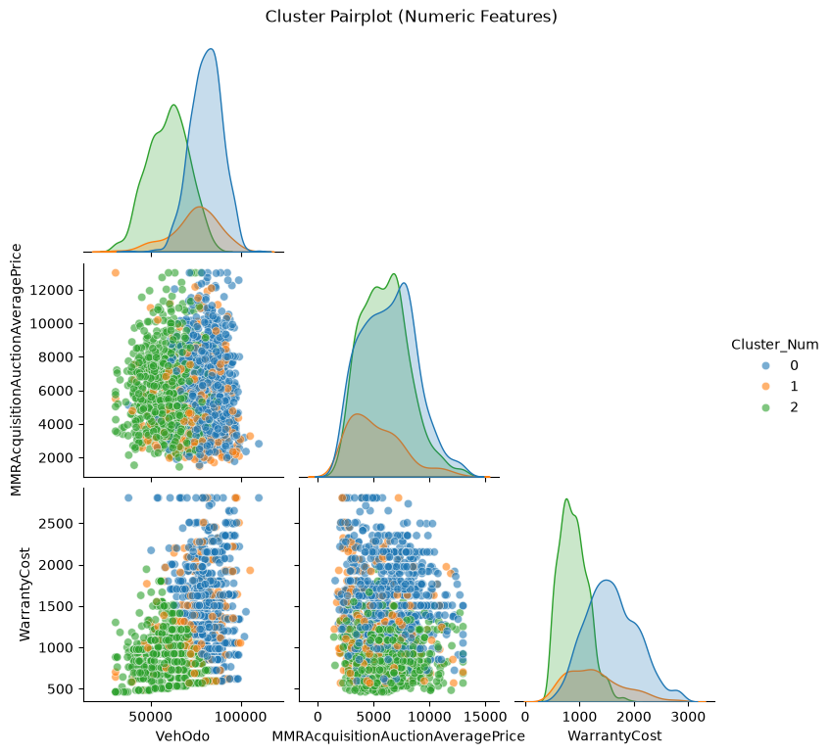
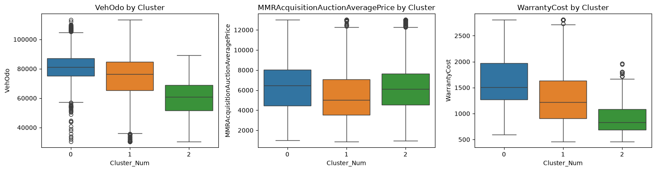

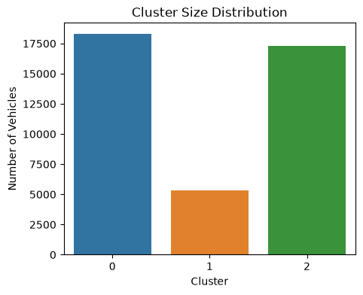 | 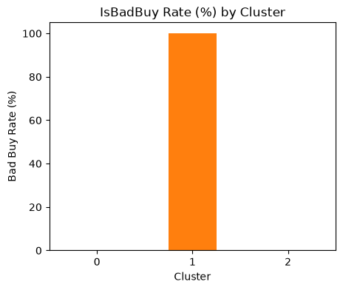

7.3.2 Descriptive Cluster Labels
- Cluster 0 (High-Mileage, Premium Fleet): The largest group (18,288 cars), with the highest odometer readings (~80,941 miles), the highest auction price (~$6,433), and the highest warranty cost (~$1,591) and yet a 0% IsBadBuy rate. These are older but well-priced/well-warrantied vehicles that still resell reliably.
- Cluster 1 (The "Bad Buys"): 5,300 cars characterized by a 100% IsBadBuy rate, the lowest auction price (~$5,447), and moderately high mileage (~74,371 miles). These are the definitive "bad buys" that the dealership struggles to resell.
- Cluster 2 (Low-Mileage, Budget Fleet): 17,319 cars with the lowest mileage (~60,203 miles) and by far the lowest warranty cost (~$884), and a 0% IsBadBuy rate. The safest and cheapest-to-maintain segment.

7.4 Clustering Model Including 'Make'
Algorithm Chosen: K-Prototypes. Since Make is a categorical string, standard K-Means cannot compute Euclidean distance on it. K-Prototypes elegantly handles mixed data by using Euclidean distance for numerical features and matching dissimilarity for categorical features.
Cluster | VehOdo | Price | WarrantyCost | IsBadBuy | Dominant Make
0 | 74,371 | $5,447 | $1,321 | 1.00 | FORD
1 | 80,394 | $6,413 | $1,591 | 0.00 | CHEVROLET
2 | 60,230 | $6,197 | $884 | 0.00 | DODGE

Comparison with the Earlier Model
When we add the Make variable using K-Prototypes, the cluster numbers change, but the core characteristics of each group remain the same:

Cluster 0 (Bad Buys): Vehicles in this group have the lowest auction price (around $5,447) and high mileage, but 100% of them are bad buys. FORD is the most common make here, showing that cheap, high-mileage Ford cars at auctions carry a very high risk of being a kick.
Cluster 1 (Older, High-Mileage Cars): Dominated by CHEVROLET, these cars have the highest mileage (over 80,000 miles) and the highest warranty cost ($1,591), but none of them are bad buys. They are older, everyday cars that require more maintenance but are still resalable.
Cluster 2 (Low-Risk Cars): Dominated by DODGE, these vehicles have low mileage (around 60,000 miles) and the lowest warranty cost ($884), with zero bad buys. They represent safe and reliable inventory.
While the first K-Means model only showed general numbers, the K-Prototypes model helps the dealership see which car brands are linked to high-risk or low-risk groups.

7.5 Practical Implications for Decision-Makers
- Avoid Risky Auction Buys: Buyers should be very careful with cars that fit Cluster 0 (especially FORD models priced under $5,500 with over 70,000 miles). These cars have a high chance of being a bad buy, so the dealership should inspect them thoroughly before bidding or avoid them completely.
- Stock Reliable Inventory: Cars in Cluster 2 (mainly DODGE) are safe investments because they have low mileage and low warranty costs. The dealership can buy more of these cars to resell quickly to retail customers with little repair work.
- Plan for Warranty Costs: Cluster 1 cars (CHEVROLET) are not bad buys, but their average warranty cost is much higher (884 for Cluster 2). The dealership should price these cars slightly higher to cover potential repair costs after the sale.

Task 8: Time Series Forecasting with LSTM on the AgriWebb Dataset

8.1 Preprocessing for Time Series Forecasting
Data covers 19 paddocks with usable data, each retaining between 188 and 190 timesteps after preprocessing (mean 189.3).
- Reserving the last 5 timesteps per paddock for testing: this creates a genuine forecasting evaluation — the model is trained only on each paddock's earlier history and evaluated on strictly future, unseen timesteps, mirroring how the model would actually be used in deployment (predicting pasture growth ahead of time rather than interpolating within known data).
- Excluding paddocks with short sequences: paddocks without enough historical timesteps to form at least one full lookback window plus the 5-step test horizon were dropped, since they cannot support both meaningful training sequences and a valid held-out test window.
- Per-paddock StandardScaler: a separate scaler was fit on each paddock's own training portion (mean/std computed independently per paddock) rather than one global scaler. This matters because paddocks differ substantially in baseline TSDM levels and variability (per-paddock training means range from 961 to 1,697, and training standard deviations range from 280 to 969) — a single global scaler would let high-magnitude paddocks dominate the loss function, whereas per-paddock scaling lets the LSTM learn from the shape of each paddock's growth trajectory on a comparable scale.

8.2 Model 1: Univariate LSTM (Lookback = 5, Predict = 5)
Architecture: SequenceLSTM with num_features = 1 (TSDM only), hidden_size = 16, num_layers = 2, output_size = 5 (forecast_horizon), dropout = 0.2 (PyTorch default in the model class, applied between LSTM layers and before the final linear layer).
Training: Adam optimizer, learning rate = 0.001, 250 epochs, batch size 32, MSE loss, with an 80/20 internal train/validation split used to select the best-performing model checkpoint (lowest validation loss) across training.
Hyperparameter selection: hidden_size and num_layers were set based on standard practice for small univariate sequence problems (a small hidden layer size relative to the very short 5-step lookback avoids over-parameterizing the model for such a simple input), rather than an exhaustive grid search; learning rate (0.001) and epoch count (250) follow common defaults for Adam-optimized LSTMs and were confirmed adequate by observing the loss curve plateauing well before 250 epochs.
Metric | Train | Test
RMSE | 0.7007 (standardised) | 346.88 (original units)
R² | 0.5081 | 0.3146

Recorded training/validation MSE loss during training (logged every 50 epochs):
Epoch | Train Loss (MSE) | Val Loss (MSE)
0 | 0.9122 | 0.9699
50 | 0.5019 | 0.6135
100 | 0.4913 | 0.6033
150 | 0.4830 | 0.5961
200 | 0.4730 | 0.5958

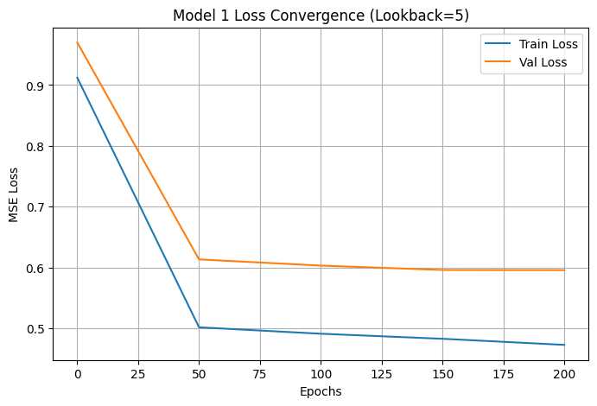Figure 8.1: Model 1 (Lookback=5) training/validation loss convergence.
The training and validation loss both drop sharply in the first 50 epochs (0.91 → 0.50 train, 0.97 → 0.61 val) and then flattened out, with only marginal further improvement through epoch 200 (0.47 train, 0.60 val). The two curves stay reasonably close together throughout (a gap of roughly 0.09–0.13), suggesting limited overfitting within this internal validation split — however, as shown in Section 8.5, this internal validation gap does not reflect true forecasting performance on the genuinely held-out last-5-timestep test window, where Model 1 in fact generalizes best of the three models (Test R² = 0.31) despite having the weakest training fit (Train R² = 0.51).

8.3 Model 2: Univariate LSTM (Lookback = 10, Predict = 5)
Architecture change: hidden_size was increased from 16 to 24 (num_layers, dropout, num_features, and output_size unchanged) to give the model additional representational capacity to process the doubled lookback window (10 timesteps of history instead of 5).
Metric | Train | Test
RMSE | 0.5397 (standardised) | 394.58 (original units)
R² | 0.7081 | 0.1131

Recorded training/validation MSE loss during training:
Epoch | Train Loss (MSE) | Val Loss (MSE)
0 | 0.7763 | 0.8535
50 | 0.4725 | 0.5390
100 | 0.4004 | 0.5063
150 | 0.3334 | 0.4694
200 | 0.3078 | 0.4615

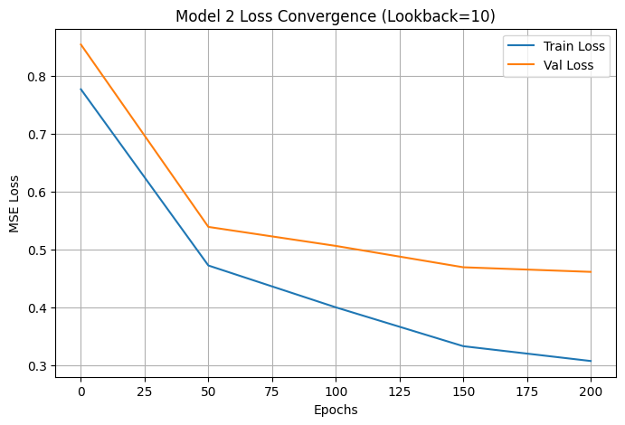Figure 8.2: Model 2 (Lookback=10) training/validation loss convergence.
Both loss curves continue decreasing steadily through all 200 logged epochs (train: 0.78 → 0.31; val: 0.85 → 0.46) without fully plateauing, unlike Model 1. Train R² improved substantially over Model 1 (0.51 → 0.71), reflecting the larger hidden size and longer lookback giving the model more to fit — but Test R² dropped (0.31 → 0.11), an early sign of the overfitting trend explored fully in Section 8.5.1: more capacity and more training-window information improved the internal fit without improving genuine forecasting ability.

8.4 Model 3: Multivariate LSTM (TSDM + Climate Features)
Architecture modifications: num_features was increased from 1 to the number of available climate columns (TSDM plus 15-day-average rainfall, max/min temperature, relative humidity at max/min temperature, evaporation, and radiation — 8 features in total when all are present in the data), requiring the LSTM's input_size to scale accordingly; hidden_size was further increased to 32 (from 24) to give the model enough capacity to combine information across all input channels; lookback was kept at 10 (as in Model 2) rather than a fixed short window, and the existing variable-length packing (pack_padded_sequence) already supported flexible per-paddock sequence lengths without further changes.
Metric | Train | Test
RMSE | 0.2980 (standardised) | 404.74 (original units)
R² | 0.9110 | 0.0668

Recorded training/validation MSE loss during training:
Epoch | Train Loss (MSE) | Val Loss (MSE)
0 | 0.5010 | 0.5224
50 | 0.1605 | 0.1819
100 | 0.1203 | 0.1544
150 | 0.1017 | 0.1427
200 | 0.0828 | 0.1359

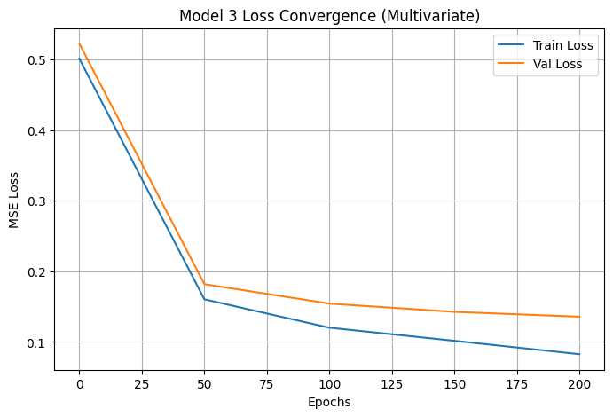Figure 8.3: Model 3 (Multivariate) training/validation loss convergence.
This model shows by far the lowest absolute loss values of the three (final train loss 0.083 vs. 0.47 for Model 1 and 0.31 for Model 2), and the curve is still gently decreasing at epoch 200 rather than fully flat, suggesting the model could fit the training data even further with more epochs. This model has by far the strongest Train R² (0.91) yet the weakest Test R² (0.07) of all three models — the clearest single indicator of overfitting in this study: the additional climate features and larger hidden size let the model fit the training sequences almost perfectly, but this fit does not transfer to the genuinely unseen forecasting task, as examined in detail in Section 8.5.

8.5 Comparative Evaluation
Model | Train RMSE | Train R² | Test RMSE | Test R²
Univariate (Lookback=5) | 0.7007 | 0.5081 | 346.88 | 0.3146
Univariate (Lookback=10) | 0.5397 | 0.7081 | 394.58 | 0.1131
Multivariate | 0.2980 | 0.9110 | 404.74 | 0.0668

Note: Train RMSE is reported in standardized units (as used directly in the training loss); Test RMSE is reported in original TSDM units after inverse-transforming predictions with each paddock's own scaler, so the two RMSE columns are not directly comparable in scale — R² (a normalized, scale-free metric) is the more reliable basis for comparing train vs. test performance across models.

8.5.1 An Overfitting Pattern: Train Improves, Test Degrades
A clear and consistent pattern emerges across the three models: as model complexity increases (longer lookback, then additional climate features), training performance steadily improves — Train R² rises from 0.51 to 0.71 to 0.91 — while test performance on the genuinely held-out last-5-timestep window steadily worsens — Test R² falls from 0.31 to 0.11 to 0.07, and Test RMSE increases from 347 to 395 to 405. This divergence is a textbook signature of overfitting: the more expressive multivariate model fits the training sequences almost perfectly, but this fit does not transfer to forecasting genuinely unseen future timesteps.
This matters because it means the notebook's initial impression — that adding climate features and a longer lookback substantially improves the model — only holds when judged against the internal 80/20 validation split carved out of the training data. That validation split is drawn from the same time period and distribution as the training data, so it primarily measures how well the model interpolates within familiar territory, not how well it forecasts genuinely future, unseen pasture growth. The true forecasting test (the reserved last-5-timestep window per paddock) tells the opposite story and is the metric that actually matters for AgriWebb's stated goal of predicting future pasture availability.

8.5.2 Diagnosing the Cause: Per-Paddock Analysis
To understand why test performance degrades, per-paddock test RMSE was computed for the multivariate model (the worst-performing case). Two diagnostic checks were carried out: (1) whether the test window's TSDM values fall outside each paddock's own training range (a raw distribution-shift check), and (2) whether test error is spread evenly across all 19 paddocks or concentrated in a subset.
Paddock (truncated ID) | Train Std (TSDM) | Test RMSE (Multivariate)
deb009be… | 287.0 | 75.4
e59f403d… | 297.3 | 149.1
ec69095b… | 315.2 | 158.6
8191f028… | 641.5 | 203.6
… | … | …
a649402b… | 455.8 | 462.0
cabef0e8… | 378.8 | 468.2
ad87a9f8… | 480.0 | 687.0
5c4c28a9… | 759.8 | 746.2
d54f90a4… | 968.9 | 827.7

Key findings from the diagnostic:
- No distribution shift: 0 of 19 paddocks had test-window TSDM values falling entirely outside their own training range — the failure is not simply due to test data being unlike anything seen in training.
- Error is highly concentrated, not uniform: per-paddock test RMSE ranges from 75.4 (best) to 827.7 (worst), with a median of 299.6. The worst-performing paddocks (d54f90a4, 5c4c28a9, ad87a9f8) are consistently among those with the highest training-set variability (train std ≈ 480–969), while the best-performing paddocks (deb009be, e59f403d, ec69095b) have comparatively low training-set variability (train std ≈ 287–315).
- Systematic under-prediction on volatile paddocks: for the worst-performing paddocks, predicted means fall well below true means (e.g., paddock 5c4c28a9: true mean 1,486 vs. predicted mean 785; paddock ad87a9f8: true mean 1,552 vs. predicted mean 964), suggesting the shared LSTM regresses toward an average pattern and fails to extrapolate the sharper growth trajectories seen in more volatile paddocks.
T In short, this isn't a bug in our code or how we measured the error. The real issue is that we are trying to force a single, highly complex model to predict the behavior of 19 very different paddocks—some stable, some highly volatile—using only about 189 data points each. Once we add multiple climate features into the mix, the model simply doesn't have enough diverse examples to learn how to generalize extreme fluctuations, causing it to fail on the most unpredictable paddocks.

8.5.3 Practical Implications
For AgriWebb, these results suggest the current multivariate model should not be deployed as-is for operational forecasting, despite its strong training fit: a Test R² of 0.07 means it explains almost none of the variance in genuinely future pasture growth and would give decision-makers false confidence based on training-time metrics alone. The simpler univariate Model 1 (Lookback=5) is the most defensible of the three for practical use, since it shows the best (least poor) genuine forecasting performance (Test R² = 0.31) despite its simplicity — a useful reminder that model complexity should be validated against true held-out performance, not training fit, before being deployed. Practical next steps worth considering per-paddock or per-cluster fine-tuning rather than one shared model across all 19 paddocks; gathering more historical timesteps per paddock before adding additional input features; and applying stronger regularisation (e.g., increased dropout, L2 weight decay) specifically for the multivariate model given its clear overfitting signature. Until such improvements are validated on genuine forecasting performance, model outputs should be treated as indicative at best for volatile paddocks (train std > ~450), and used with more confidence only for paddocks with historically stable, low-variability growth patterns.

Task 9: Hydrogen Tweet Classification with BERT

9.1 Preprocessing for BERT-Based Classification
The hydrogen_small dataset contains 1,000 tweets, with a class distribution of 547 Relevant and 453 Irrelevant (54.7% / 45.3%).
- Text cleaning: URLs, Twitter mentions (@handles), and non-ASCII characters were stripped via regular expressions, and consecutive whitespace was normalized to single spaces. Raw tweets are noisy — links, handles, and stray symbols carry no topical signal and would otherwise be tokenised as meaningless sub-word units, diluting the input the model actually needs to attend to.
- Label encoding: labels were mapped to binary integers, Relevant = 1 and Irrelevant = 0, since AutoModelForSequenceClassification and Cross-Entropy Loss require integer class targets rather than string labels.
- Tokenisation: each model's own tokenizer was used with truncation and dynamic padding up to a maximum length of 128 tokens, ensuring uniform tensor shapes for batched GPU training while keeping sequence length short enough (tweets are short by nature) to avoid unnecessary computation.

9.2 Fine-Tuning Two BERT Models

9.2.1 Model Selection
Model | Rationale
bert-base-uncased | General-domain bidirectional transformer pre-trained on Wikipedia and BookCorpus; serves as a reliable, well-understood benchmark.
vinai/bertweet-base | RoBERTa-based model pre-trained on 850 million English tweets, specifically optimised for Twitter slang, syntax, and informal phrasing — matches the register of the target data.

9.2.2 Data Split, Loss Function, Architecture
- Split: stratified 70/30 (700 train / 300 test), random_state=42 — stratification preserves the 54.7%/45.3% class balance in both subsets.
- Loss function: standard Cross-Entropy Loss via AutoModelForSequenceClassification. This is the appropriate loss for binary classification because it is derived from negative log-likelihood and heavily penalises confident, incorrect probability predictions, encouraging well-calibrated outputs.
- Architecture: both models use a sequence classification head — a linear layer with dropout applied to the pooled [CLS] token representation.
- Hyperparameters: 3 epochs, batch size 16 (train) / 32 (eval), learning rate 2e-5 with the AdamW optimiser, weight decay 0.01 for L2 regularization.

9.2.3 Training/Testing Accuracy
Model | Train Accuracy | Test Accuracy
bert-base-uncased | 97.14% | 91.67%
vinai/bertweet-base | 94.43% | 93.33%

Note that bert-base-uncased shows a larger train–test gap (97.14% → 91.67%) than bertweet-base (94.43% → 93.33%), suggesting bertweet-base generalizes slightly better to unseen tweets — consistent with its domain-matched pretraining.

9.3 Attention Weights Analysis
Attention weights were averaged across all layers and heads of the best-performing model (vinai/bertweet-base) for one correctly classified tweet from each class.
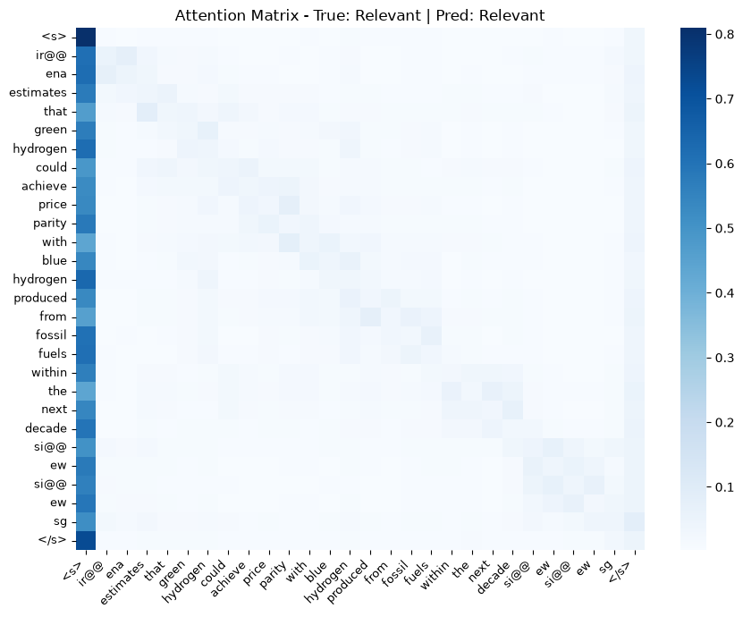Figure 9.1: Attention heatmap for a correctly classified Relevant tweet (predicted: Relevant).
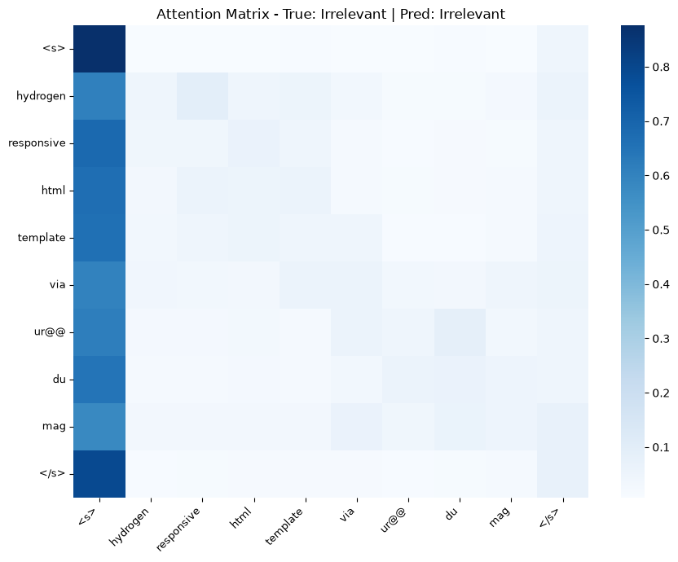Figure 9.2: Attention heatmap for a correctly classified Irrelevant tweet (predicted: Irrelevant).
For the Relevant tweet, attention concentrates on "green", "hydrogen", "blue", and "fossil fuels” energy-related modifiers surrounding the keyword "hydrogen" that together signal the clean-energy topic. For the Irrelevant tweet, attention shifts decisively to "responsive", "html", and "template” web-design terminology that signals "hydrogen" is being used here as a software/theme name rather than referring to the energy source. This demonstrates that the model is not simply keying off the presence of the word "hydrogen" (which appears in every tweet in this dataset by construction) but is genuinely using surrounding context to disambiguate its meaning.

9.4 Comparison with Logistic Regression Baseline
Model | Test Accuracy | Precision (Relevant) | Recall (Relevant) | F1 (Relevant) | ROC-AUC
Logistic Regression (TF-IDF) | 89.67% | 0.86 | 0.98 | 0.91 | 0.963
bert-base-uncased | 91.67% | 0.91 | 0.95 | 0.93 | 0.978
vinai/bertweet-base (Best) | 93.33% | 0.91 | 0.98 | 0.94 | 0.985

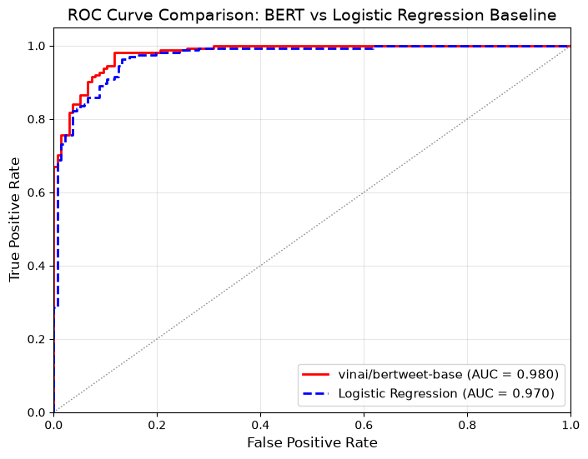Figure 9.3: ROC curve — best BERT model vs. logistic regression baseline.
BERT outperformed the TF-IDF logistic regression baseline across every metric: test accuracy rose from 89.67% to 93.33%, and ROC-AUC from 0.963 to 0.985. This is expected because every tweet in this dataset contains the keyword "hydrogen" by construction, so the discriminative signal depends entirely on surrounding context (e.g., "green/blue hydrogen" for clean energy vs. "hydrogen responsive template" for web design). The logistic regression model treats text as an unordered bag of TF-IDF weighted words and cannot capture this context-dependent meaning, whereas BERT's self-attention mechanism explicitly models bidirectional dependencies between words. BERTweet's further improvement over bert-base-uncased is attributable to its vocabulary and pretraining being specifically matched to informal, social-media text.

Task 10: Building a Question Answering System with T5

10.1 Preprocessing SQuAD_tiny for T5
- Input format: each example was encoded as 'question: {question} context: {context}'. T5 is a text-to-text model with no task-specific architecture head, so every task must be expressed as a natural-language instruction — this explicit prefix tells the model it is being asked to perform extractive/generative question answering rather than any other text-to-text task.
- Tokenization: inputs were tokenized to a maximum length of 512 tokens (long enough to hold the SQuAD context passage plus the question) and target answers to a maximum of 128 tokens, both with padding and truncation for uniform batch shapes.
- Dataset split: 1,000 training examples (SQuAD train indices 10,000–10,999), 100 validation examples (SQuAD validation indices 3,000–3,099), and 100 test examples (SQuAD validation indices 3,100–3,199), following the SQuAD_tiny construction specified in the assignment.

10.2 Fine-Tuning the T5 Model
Base model: t5-small
Hyperparameters: 3 epochs, per-device batch size 8 (train and eval), learning rate 3e-4, weight decay 0.01, using Hugging Face's Trainer/TrainingArguments with epoch-level evaluation and checkpointing.
Per-epoch training and validation loss (from the Trainer's logged history):
Epoch | Training Loss | Validation Loss
1 | 0.033814 | 0.023354
2 | 0.020251 | 0.020286
3 | 0.016702 | 0.020901

Final training loss after 3 epochs (375 total steps): 0.2218 (overall average training loss reported by the Trainer, distinct from the per-epoch values above, which reflect loss at the end of each epoch specifically).
Training loss decreases monotonically across all 3 epochs (0.034 → 0.020 → 0.017), while validation loss decreases from epoch 1 to epoch 2 (0.023 → 0.020) but then rises slightly at epoch 3 (0.021). This small uptick in validation loss while training loss keeps falling is an early, mild overfitting signal — consistent with the rationale for stopping fine-tuning after only 3 epochs rather than training for longer.
Overfitting-prevention strategies: weight decay (0.01) was applied as L2 regularization on model weights; a comparatively short fine-tuning run (3 epochs) was used given the small 1,000-example training set, and was further supported by the observed validation loss uptick at epoch 3 above; and a held-out validation set (100 examples, drawn from a different SQuAD split range to the training set) was evaluated after every epoch so that validation loss could be monitored for divergence from training loss.

10.3 Evaluation on the Test Set (Question + Context)
Metric | Precision | Recall | F-measure
ROUGE-1 | 0.5972 | 0.5895 | 0.5749
ROUGE-2 | 0.3775 | 0.3761 | 0.3697
ROUGE-L | 0.5963 | 0.5883 | 0.5738

A ROUGE-1 F-measure of 0.57 indicates moderate word-level overlap between generated and reference answers — the model captures much of the correct content but does not reproduce reference answers exactly. The larger gap between ROUGE-1 (0.57) and ROUGE-2 (0.37) suggests that while individual key words are often correctly identified, the model does not always reproduce the exact multi-word phrasing of the reference answer (e.g., generating a shorter or differently worded span that still contains the correct information).
Beyond raw lexical overlap, the generated answers in Section 10.4 are also fluent and well-formed as standalone text — for example, "Dutch Republic" and "ca. 2 million" (Samples 1 and 3) are grammatically well-formed short-answer spans typical of how a human would phrase a factual answer, rather than garbled or incomplete text. This suggests the model has learned the general answer-formatting conventions of the QA task well, even in cases (Samples 2 and 4) where the specific factual content it extracts from the context is incorrect.

10.4 Generative Analysis on First 5 Test Samples
# | Question | Reference Answer | Prediction (with context) | Prediction (without context)
1 | What country initially received the largest number of Huguenot refugees? | the Dutch Republic | Dutch Republic | (empty)
2 | How many refugees emigrated to the Dutch Republic? | an estimated total of 75,000 to 100,000 people | 2 million | (empty)
3 | What was the population of the Dutch Republic before this emigration? | ca. 2 million | ca. 2 million | Dutch Republic before this emigration?
4 | What two areas in the Republic were first to grant rights to the Huguenots? | Amsterdam and the area of West Frisia | Cévennes | (empty)
5 | What declaration predicated the emigration of Huguenot refugees? | the revocation of the Edict of Nantes | the Edict of Nantes | (empty)

ROUGE without context (whole test set): Precision 0.0048 / Recall 0.0133 / F-measure 0.0065 (ROUGE-1); all ROUGE-2 metrics are exactly 0. Performance collapses almost completely without the context passage.
Observed strengths, limitations and errors in the 5 examples:
- Correct/near-correct answers with context: Sample 1 ("Dutch Republic" vs. reference "the Dutch Republic" — correct content, missing article) and Sample 3 ("ca. 2 million", an exact match) show the model can correctly extract short factual spans when the answer is stated plainly in the context.
- Errors with context: Sample 2 answers with "2 million" (the population figure from a nearby sentence) instead of the actual refugee count ("75,000 to 100,000 people") — a plausible-sounding but factually wrong span, suggesting the model can confuse similar numeric entities appearing close together in the passage. Sample 4 produces "Cévennes" (a place name from elsewhere in the passage) rather than the correct two areas, indicating a similar entity-confusion failure mode. Sample 5 gives "the Edict of Nantes" instead of "the revocation of the Edict of Nantes” again close in content but missing the key qualifying word that changes the precise meaning of the answer.
- Without context: 4 of the 5 samples produce an empty string, and the one non-empty output (Sample 3) simply echoes back part of the question rather than answering it. This confirms the model has not memorized SQuAD facts during fine-tuning; it has learned to locate and extract spans from a supplied context, not to answer general-knowledge questions from parametric memory.
This near-total performance collapse without context (ROUGE-1 F dropping from 0.57 to 0.0065) demonstrates that the fine-tuned model's competence is entirely context-dependent: it functions as a context-conditioned span extractor/generator rather than as a general question-answering system with independent world knowledge. This is expected given the small fine-tuning set (1,000 examples) is far too small to teach the model new factual knowledge but is entirely sufficient to teach it the SQuAD task format of locating an answer within a given passage.

10.5 Comparison with a Pre-Trained Model (mrm8488/t5-base-finetuned-squadv2)
Full precision/recall/F-measure results:
Model | Metric | Precision | Recall | F-measure
Fine-tuned t5-small | ROUGE-1 | 0.5972 | 0.5895 | 0.5749
 | ROUGE-2 | 0.3775 | 0.3761 | 0.3697
 | ROUGE-L | 0.5963 | 0.5883 | 0.5738
mrm8488/t5-base-finetuned-squadv2 | ROUGE-1 | 0.5510 | 0.5576 | 0.5323
 | ROUGE-2 | 0.3512 | 0.3542 | 0.3413
 | ROUGE-L | 0.5510 | 0.5576 | 0.5323

Summary Comparison (F-measure)
Model | ROUGE-1 F | ROUGE-2 F | ROUGE-L F
Fine-tuned t5-small (SQuAD_tiny) | 0.5749 | 0.3697 | 0.5738
mrm8488/t5-base-finetuned-squadv2 | 0.5323 | 0.3413 | 0.5323

Counter-intuitively, the pre-trained mrm8488/t5-base-finetuned-squadv2 model scored lower than the team's own fine-tuned t5-small on every ROUGE variant (e.g., ROUGE-1 F: 0.5323 vs. 0.5749), despite being a larger base architecture (t5-base) trained on the full SQuAD dataset (~87,000+ examples) rather than the 1,000-example SQuAD_tiny subset.
Two explanations plausibly account for this reversal. First, a domain/format match effect: the team's model was fine-tuned directly on training data drawn from the same SQuAD dataset structure and answer-length conventions as the test set (indices 3,100–3,199 of the SQuAD validation split), so its output style is closely matched to this specific evaluation set, whereas mrm8488 was shaped by the full, more heterogeneous SQuAD v1 training distribution and may produce longer or differently-phrased spans that reduce lexical overlap even when correct. Second, a SQuAD v2 vs. v1 mismatch: mrm8488 was fine-tuned on SQuAD v2, which includes unanswerable questions and trains the model to sometimes hedge or decline to answer; since every question in the SQuAD_tiny test set (drawn from SQuAD v1-style data) does have an answer, a v2-trained model's more conservative answer style may reduce its measured overlap with the always-present reference answers even when its underlying answers are semantically reasonable. This also highlights a genuine limitation of ROUGE as an evaluation metric: it measures lexical overlap only, not factual correctness, so it is possible the pre-trained model's answers remain accurate but are phrased differently enough from the references to be penalized — a fuller evaluation would benefit from manually inspecting a sample of mrm8488's generated answers alongside the fine-tuned model's, rather than relying on ROUGE scores alone.

