**Address Book Project**

**Step 01: Overview**

**Application Requirements and Use Cases**

Here are the use cases:

1. Add Address
2. View All Addresses
3. View a Single Address by last name
4. Remove Address
5. View amount of addresses

**Application Structure**

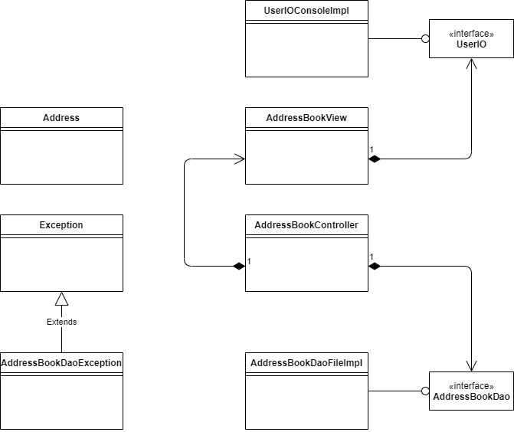

**Construction Approach**

We will build the Address Book application in the following steps:

1. Create the packages and empty classes and interfaces to create the shell of the program.
2. Create the menu system.
3. Implement each use case in order:
4. Create Address
5. Display All Addresses
6. Display a Single Address
7. Remove Address

**Step 02: Application Shell**

**(****,** **,** **)**

* com.sg.addressbook
* App.java
* com.sg.addressbook.controller
* AddressBookController.java
* com.sg.addressbook.dao
* AddressBookDao.java
* AddressBookDaoFileImpl.java
* com.sg.addressbook.dto
* Address.java
* com.sg.addressbook.ui
* AddressBookView.java
* UserIO.java
* UserIOConsoleImpl.java

**Step 03: Menu System**

**Overview**

Navigation through all the menu items will involve working with the following files:

* App
* AddressBookController
* AddressBookView
* UserIO
* UserIOConsoleImpl