<https://digital.nhs.uk/article/197/IT-infrastructure>

There are 14 IT infrastructure systems in the NHS

Such systems include NHSmail, Summary Care Records(SCR), Registration Authorities and smartcards, NHS Pathways, Spine, GP2GP, Network Addressing, Clinical safety, Health and Social Care Network and Solution Assurance.

NHSMAIL ------------------------------------------------------------------------------------------------------------------------

What is NHSmail: - This mail service is a secure email service approved by the Department of Health for sharing patient identifiable and sensitive information. Any organisation commissioned to deliver NHS healthcare or related activities can use NHSmail.

Security for NHSmail: accredited to government OFFCIAL status for sharing patient identifiable and sensitive information, meaning it meets a set of information security controls that offer an appropriate level of protection against loss or inappropriate access.

Main Advantage: - Very Secure

<http://psnc.org.uk/contract-it/pharmacy-it/nhs-mail/>

Distributions networks for NHS N3 network or the open internet.

Flexible – “The service can be viewed through a free web based client or alternatively pharmacies can choose to connect the service to a local email client they have purchased, for example Microsoft Outlook.”

Other advantages applied to pharmacy, this can be used to transfer confidential information including patient MUR (Medicine User Review) information and hospital discharge communications.

Other secure advantages includes users having their own login details to access a shared account. This means multiple employees can be contacted in one instance. Overall advantage for this is speed and efficiency.

<https://www.whatdotheyknow.com/request/52487/response/135236/attach/html/3/What%20are%20the%20benefits%20of%20NHSmail.pdf.html>

Major benefits – Secure email service, only email service that can be used for safely exchanging confidential patient information

Flexible – Can access computer from home, work, wherever the user is located

* Your email address with NHSmail will not change, even if your organisation

does.

* SMS messages and faxes direct from mail
* Mail and calendar folders can be shared amongst colleges

<http://support.nhs.net/advanceemailuse>

Advantages of system – Set an email’s priority and sensitivity, Download attachments and send emails with attachments, set up an email signature and set and automatically schedule the start and end date of automatic replies

Functionalities – none n3 connection means that can only view attachments online. Cannot download attachments to computer

Functionalities – Set an email’s priority and sensitivity, information is confidential and secure. Systems will become more organised

Functionalities – Set up email signature and set automatic scheduling of email replies – this allows systems to become more efficient. This also allows emails to be created quicker.

<http://support.nhs.net/managingdistributiongroups>

Title: Managing Distribution Groups and Contact Lists

Overall Functionalities – Create Distribution groups, manage distribution groups, and create and manage personal contact lists

Advantage of distribution group – Emails can be sent quickly to multiple contacts in one go

Overall advantage – managing and sending emails

<http://support.nhs.net/deliveryandreadreceipts>

Title: Read and Delivery Receipts and Bcc

Functionality – confirmation that email has been sent

Functionality – Securely hide the details of email recipients

<http://support.nhs.net/sharingcalendars>

Title: Sharing Calendars and Calendar Permissions

Overall Functionality – Provide others with access to your calendar and set up permission levels, open other calendars to which you have been given access

Calendar functionality – Availability – Show times when available,

Limited details – Allows others to see the name of the meeting or appointment

Full details – Name of appointment, list of attendees as well as any other details entered in the calendar

Allow someone as editor

Delage access – allows to view private appointments

Different views – allocated for calendar, easy to view a particular set of data

<https://portal.nhs.net/Help/navigatingaroundOWA>

Title: Navigating around Outlook Web App (OWA)

Overall functionalities

* Objectives – Can set objectives, then tick them if and when complete
* Mail – Send mail to receipts
* Calendar – Options of having a group or individual calendar, send each other dates
* People(Contacts) – Contacts can be associated as a group or individual
* Tasks – Active, overdue and completed tasks. View details of tasks and monitor progress
* Options and Personal Setting - Account – view account details
* Options and Personal Setting – Organise Email – Choose how emails will be handled
* Options and Personal Setting – Groups – View distribution groups user belongs too
* Options and Personal Setting – Site Mailboxes – Where can access all content from shared projects in one location
* Options and Personal Setting – Settings – Edit general mail, calendar and regional time settings
* Options and Personal Setting – Phone – See the devices associated to account
* Options and Personal Setting – block or Allow – View junk folder settings
* Options and Personal Setting – Apps – Where can manage outlook apps
* OWA Help – Help for the web application

Major benefits – User friendly as different functionalities are allocated to different pages. Allows users to navigate easily amongst the web based application.

<http://support.nhs.net/delegatedandsharedmailbox>

Title: Delegated and Shared Mailbox

Core functionality – Manage a delegated mailbox AND Manage a shared (or generic) Mailbox

Manage a delegated mailbox – share the user mailbox with other users

Manage a shared (or generic ) – Other users can share their mailbox with the user

Main Benefit, senders don’t need to know all contacts listed.

One disadvantage – privacy and security of data can be affected

<https://portal.nhs.net/Help/sendandrecievingIM>

Title: Sending and Receiving instant messages

Application – Skype for business

Allows quick communication, important for asking important questions or important information

<http://support.nhs.net/owainstantmessenger>

Title: Outlook Web App Instant Messenger

Core functionality – Sign in and Sign out of instant messenger, conduct instant messaging conversations and Understand the presence management feature of instant messenger.

Major benefit - Allows quick communication, important for asking important questions or important information

<https://portal.nhs.net/Help/contactmanagement>

Title: Contact Management , Skype for business

Overall functionality: Search for contacts, create and manage contact groups, view your contacts in a way that is preferable to you

<http://support.nhs.net/skypeforbusinessintro>

Title: Introduction to Skype for Business

Collaboration tool

Benefit – communicate more easily and in real time

<https://portal.nhs.net/Help/calendarappointmentsandmeetings>

Title: Calendars, Appointments and Meetings

Functions – Create appointments and meetings, update meetings and understand the options for providing notifications to meeting attendees, use the scheduling assistant to view other user’s availability and manage calendar invitations

<https://portal.nhs.net/Help/presencemanagement>

Title: Presence Management

Functions – set own presence and view the presence of others

<http://support.nhs.net/managingcontacts>

Title: Managing Contacts

Functions – Find and add contacts from the directory

* Create new contacts
* Manage new contacts

<http://support.nhs.net/viewingandfindingemail>

Title: Viewing and Finding Email

https://digital.nhs.uk/summary-care-records/patients

SUMMARY CARE RECORD(SCR) --------------------------------------------------------------------------------------------

Overall Summary – SCR(Summary Care Record) is an electronic record of important patient information, created from GP medical records. It can be seen and used by authorised staff in other areas of the health and care systems involved in the patient’s direct care.

Minimum – SCR holds current medication, allergies and details of any previous bad reactions to medicines, the name, address, date of birth and NHS number of the patient

Benefits of Using SCR in community pharmacy – Check allergies to prevent prescribing errors, check current medications prescribed for emergency supply purposes, check eligibility for services such as a free flu jab

Having instant access to patients information speeds up care, reduces the need for phone calls to GP practices, and reduces referrals to other services, particularly out-of-hours

<https://www.rpharms.com/resources/quick-reference-guides/summary-care-records-england>

Summary – Summary Care Record(SCR) is a ‘read only’ electronic patient summary containing key clinical information.

The SCR as a minimum contains – medicines – Acute, repeat and discontinued repeat items (discontinued items will be dependent upon the GP system which created it)

Allergies

Adverse reactions

Overall benefits of SCR – Benefits to practice

Patients safety - Benefits to practice

Patient safety:

Reducing prescribing errors

Reducing patient harm and therefore reducing hospital admissions

Ensuring medication that is clinically appropriate is given to the patient

Better understanding of patient health.

Efficiency:

Reducing the number and duration of phone calls to the prescriber

Reducing assessment time

Being able to access required clinical information instantly

Reduces the number of faxes for communicating information.

Effectiveness:

Reducing patients need to visit another care setting

Supply provided sooner

Enhancing customer loyalty

Improving advice given about medication

Increasing confidence in the profession

Improving patient convenience

Supporting seven day services.

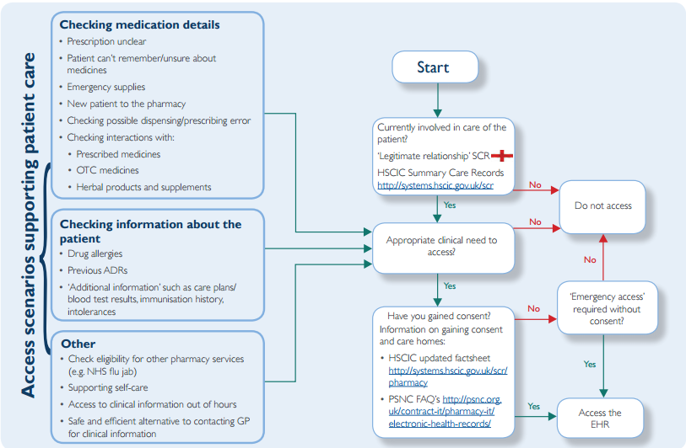

<http://www.northleedsmedicalpractice.nhs.uk/info.aspx?p=5>

Brief description of summary care record – New central NHS computer system called the summary care record. This is an electronic record which contains information about the medicines you take, allergies you suffer from and any bad reactions to medicines you have had

Why a summary care record is needed – Storing information in one place makes it easier for healthcare staff to treat you in an emergency, or when your GP practice is closed.

REGISTRATION AUTHORITIES AND SMARTCARDS ---------------------------------------------------------------------

<https://digital.nhs.uk/Registration-Authorities-and-Smartcards>

Title: Registration Authorities and Smartcards

Brief description – Smartcards and access control are secure measures by which clinical and personal information is accessed by only those that have a valid reason to do so

Registration Authorities – a brief description of Registration Authorities – Registration Authority is a function, usually within a NHS organisation, that carries out the identity checks of prospective smartcard users and assigns an appropriate access profile to the health professional’s role as approved by the employing organisation.

Overview of how smartcards work – NHS smartcards are similar to chip and PIN bank cards and enable healthcare professionals to access clinical and personal information appropriate to their role.

<http://www.this.nhs.uk/our-services/registration-authority-smartcards/>

Title: Registration Authority(Smartcards)

Functionality – Healthcare professionals are required to be registered on the spine and issued with a smartcard.