Desiray Johnson
Version Control D197

Part A Created Subgroup and project in GitLab
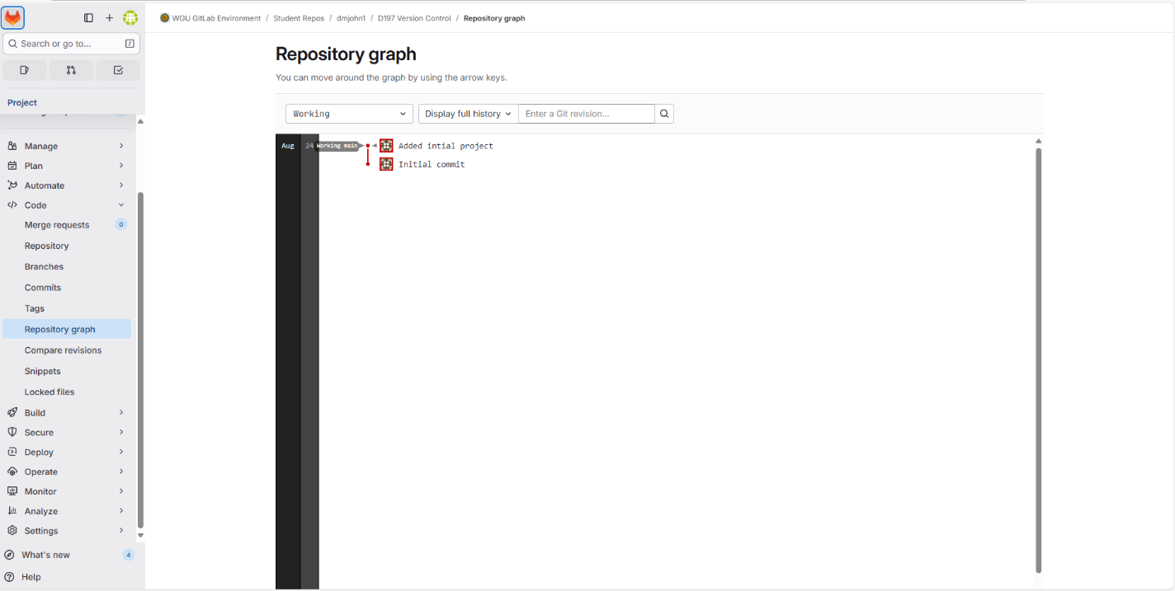
Part B Cloned Repository on Local Machine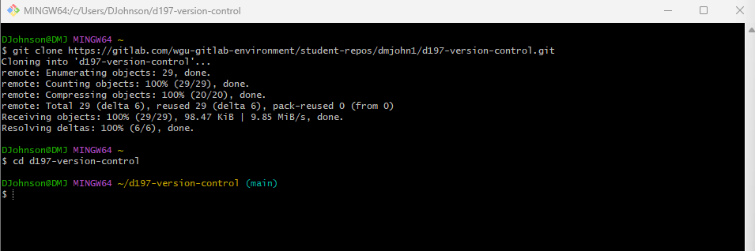
Part C1a Modified and Pushed HTML File 1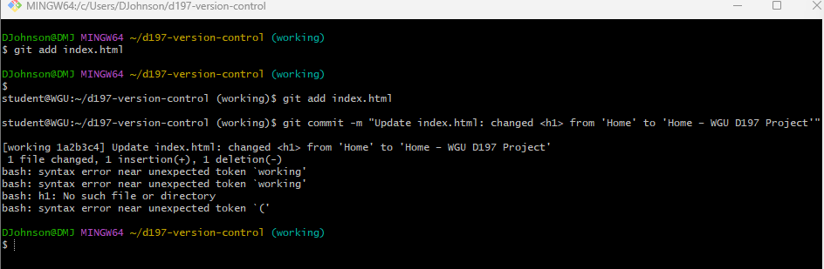
Part C1b Modified and Pushed HTML File 2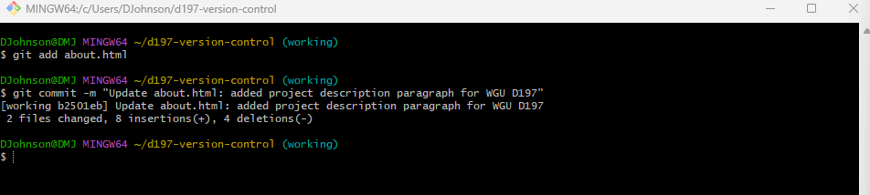
Part C1c Modified and Pushed HTML File 3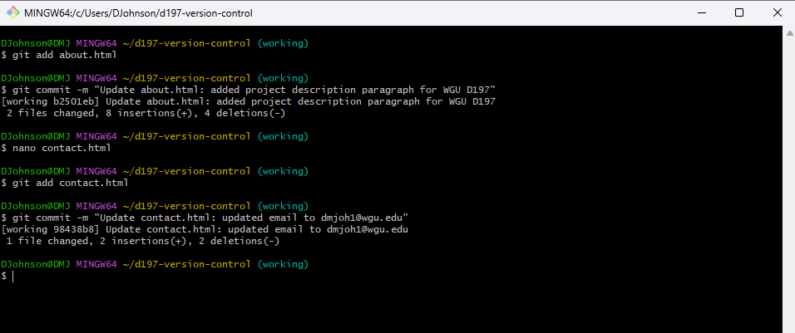
Part C2 Push Branch to Gitlab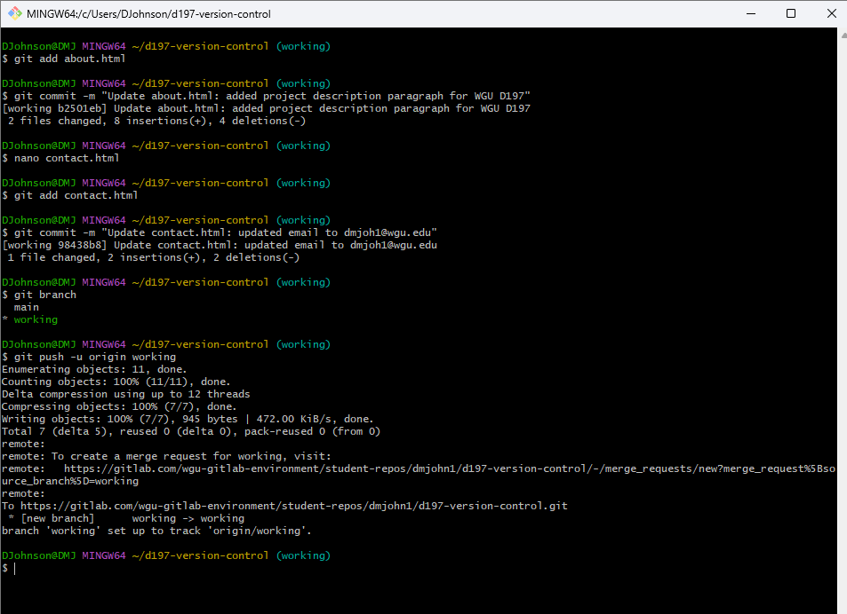
Part D1 Created New Branch and Made a Change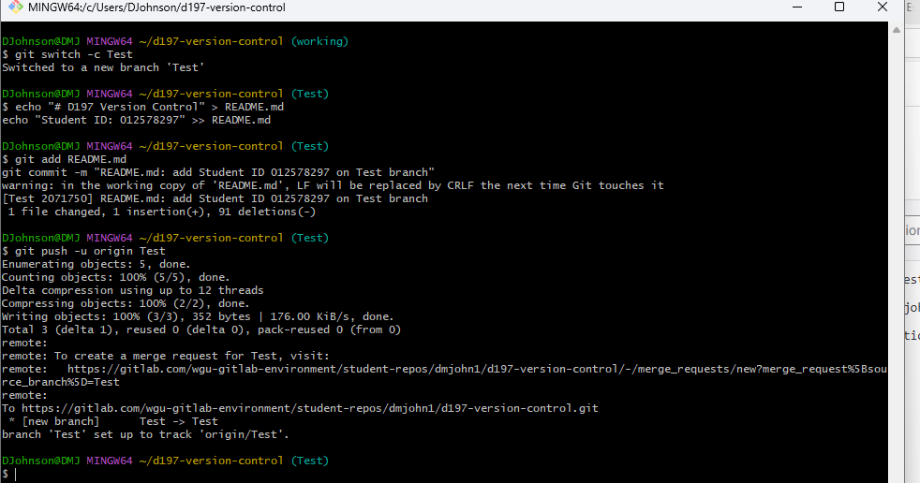
Part D2 Current Repository Graph after Push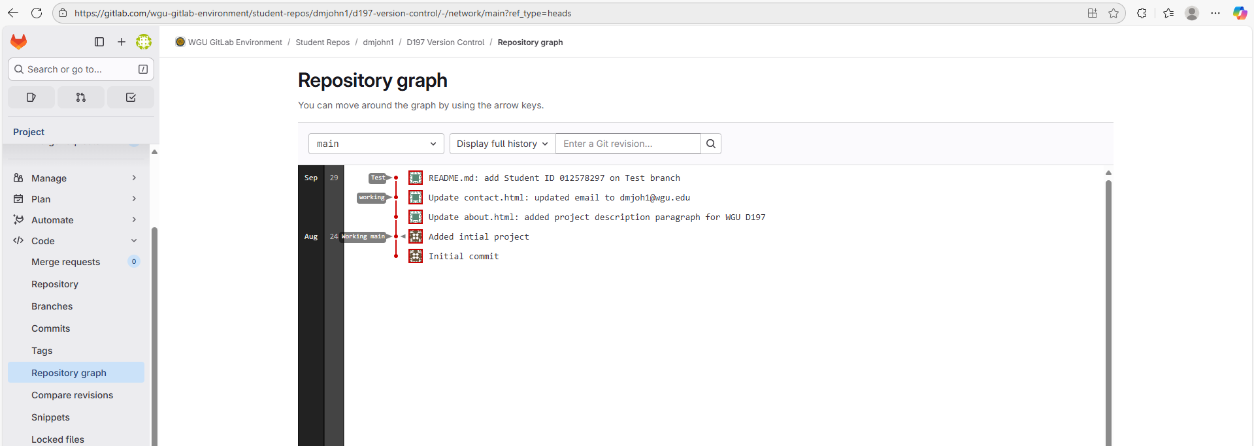
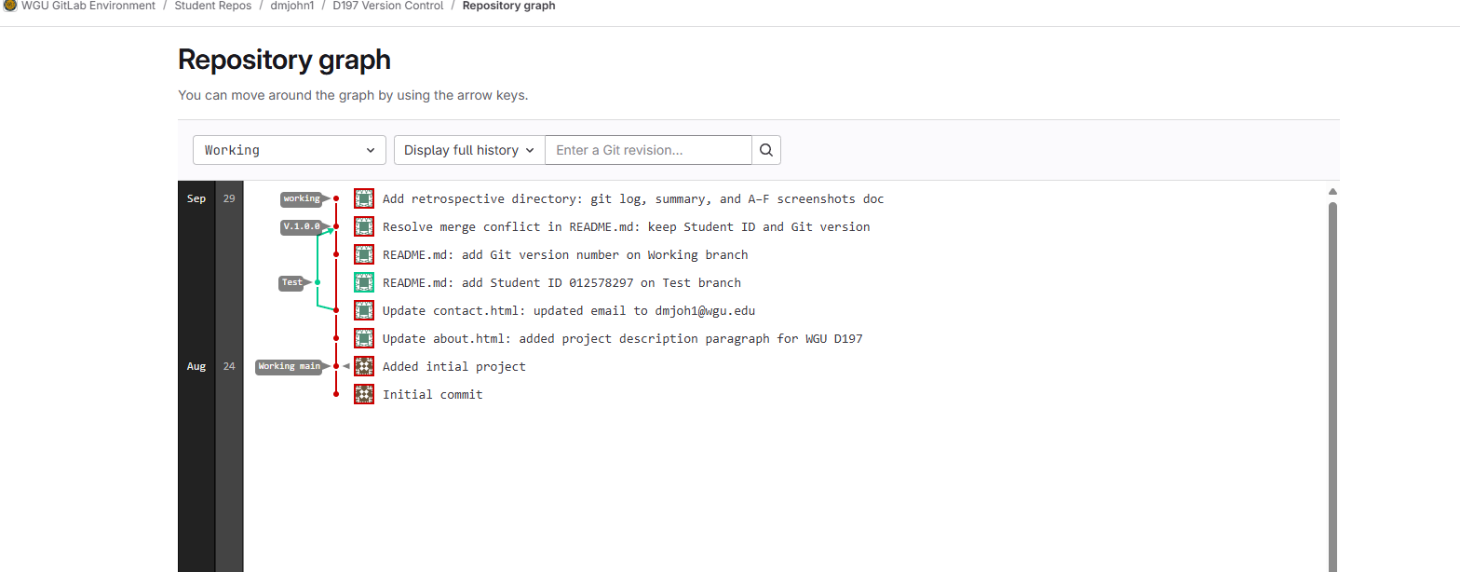
Part E1 Merge Conflict Introduces, Added Git Version And merged Test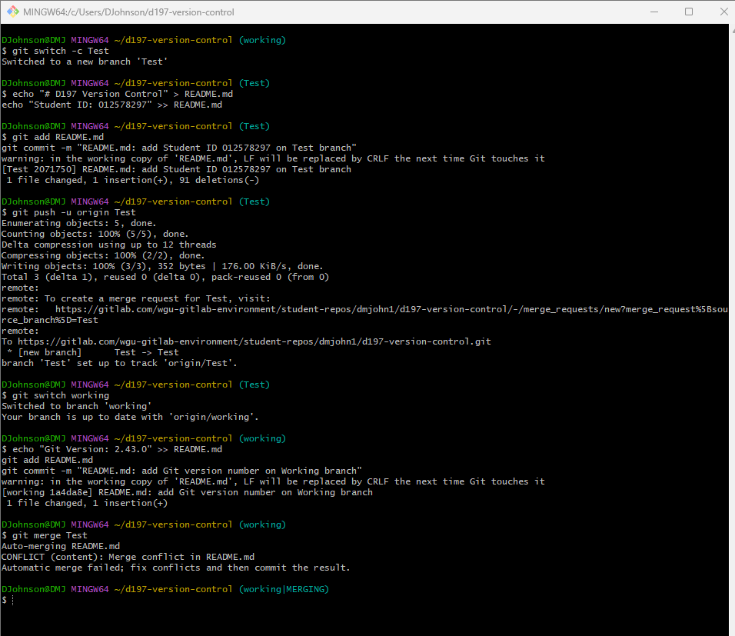
Part E2 Continued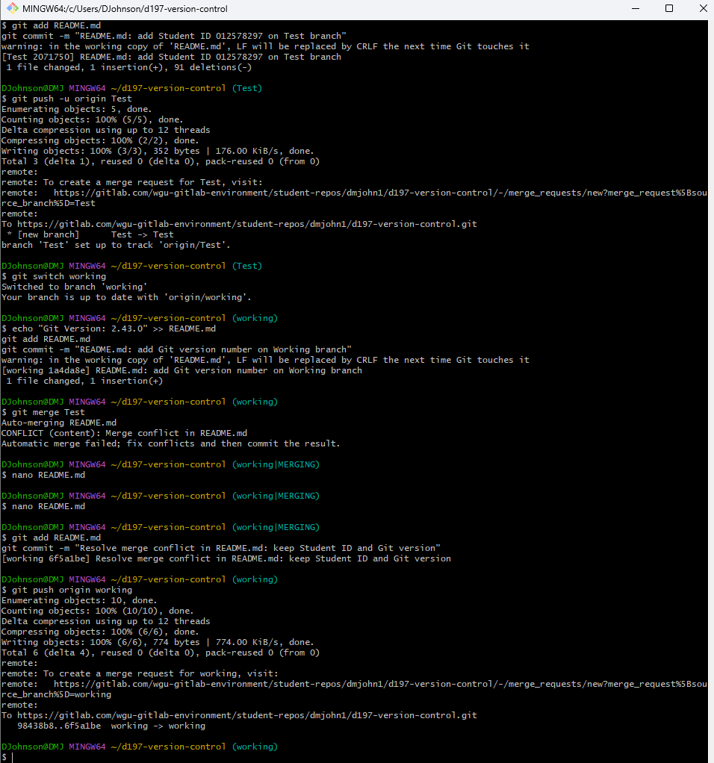
Part E3 Cont.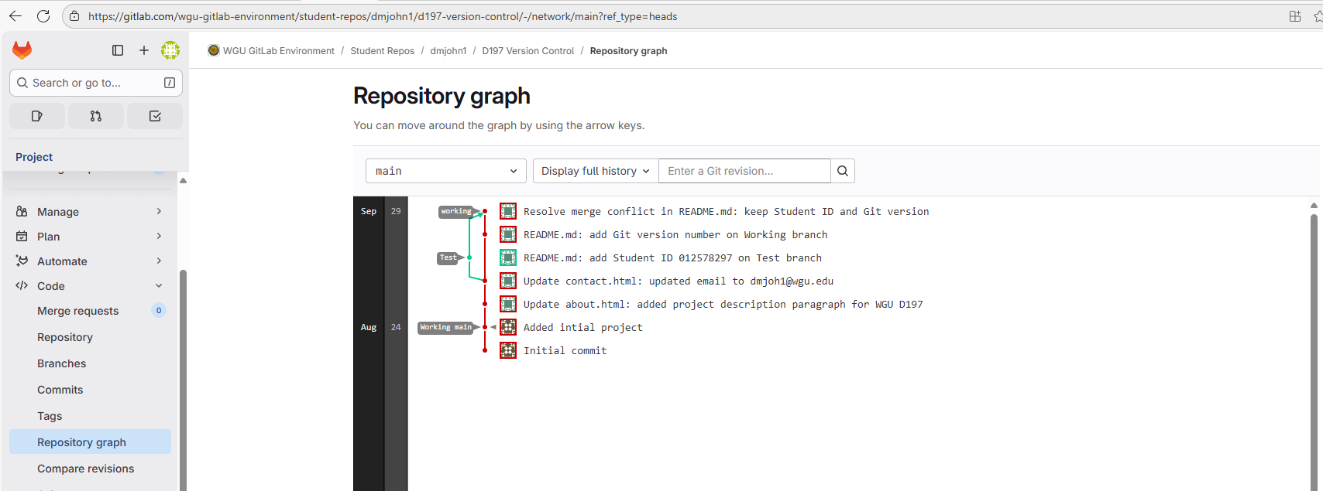
Part F1 Tagged Branch
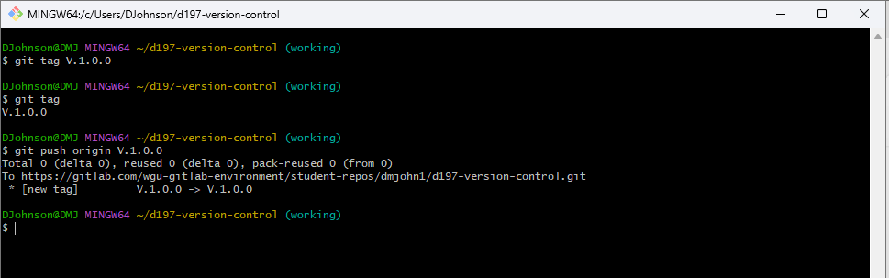
Part F2 Cont. Current Repository
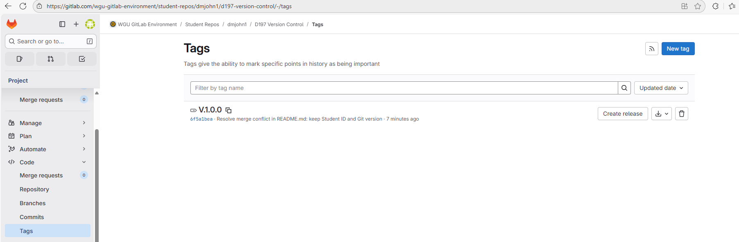
Part G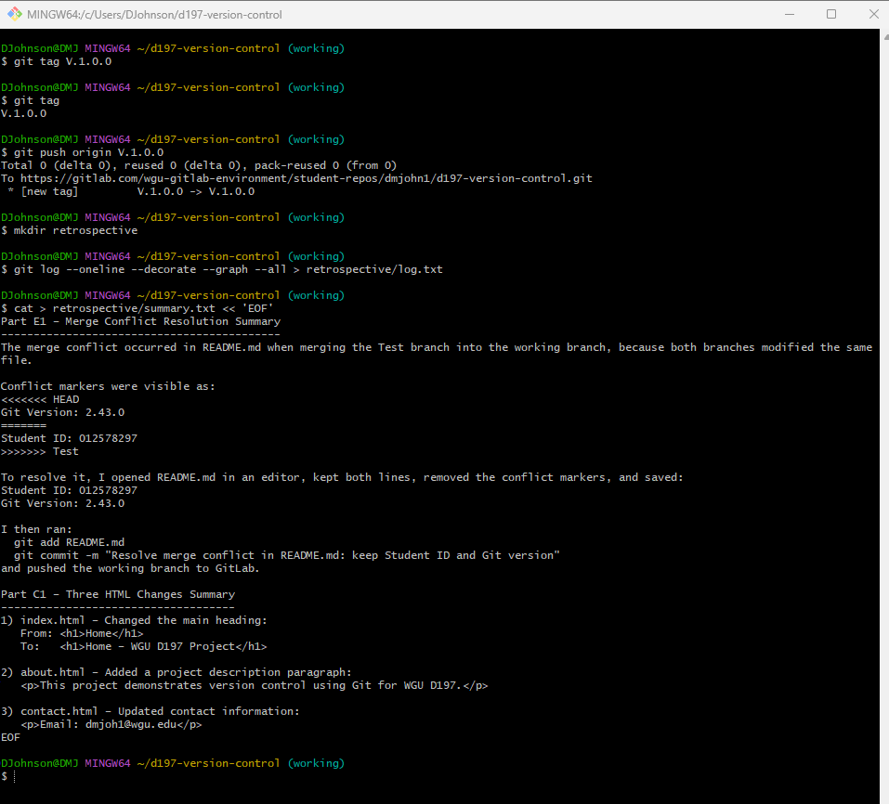
Part G 2
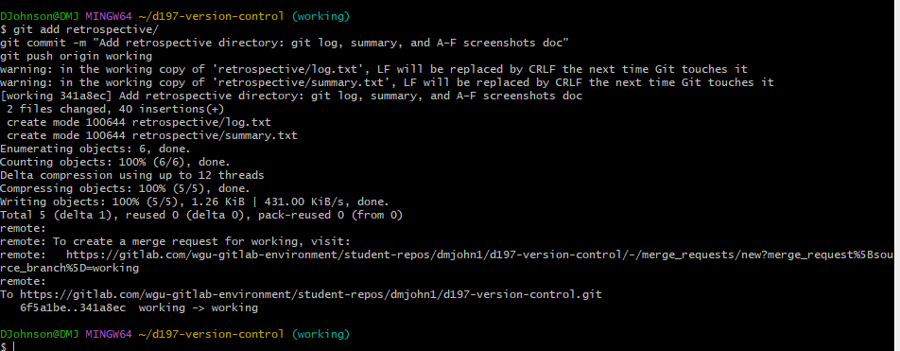
Part G3

Revision
