The Temple of Esna

**An Evolving Translation**

*Esna IV*

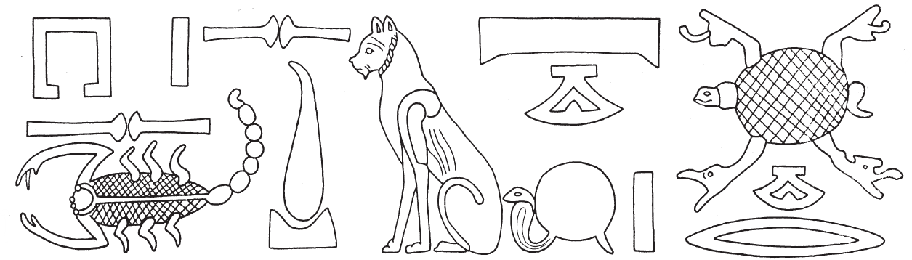

David Klotz