User manual:
This program determines the grade level needed to read a text excerpt. To run the program, install Java Runtime Environment to your computer and make sure it runs properly. The lastest version of Java Runtime Environment can be found at: http://www.oracle.com/technetwork/articles/javase/. Next, save "run.bat", "TextReadability.class" and the text file (.txt file) in the same folder. Double click "run.bat", a console window will appear asking for the file name:
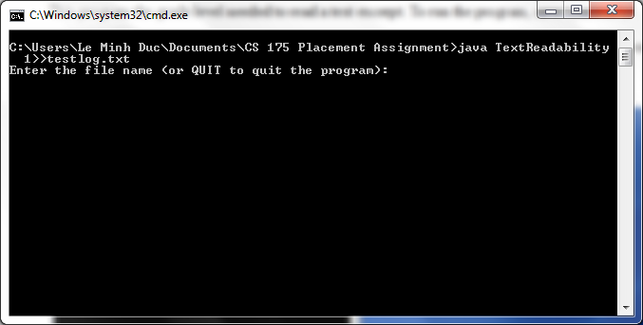

Enter the name of the file, remember to include the .txt expansion. Hit Enter, and the program will return the difficulty of the text. When you are done, enter "QUIT" to quit the program.

System manual:
The program reads in a text and determine its difficulty. It uses the Flesch Reading Ease Score and the Flesch-Kincaid Grade Level Formula to determine the grade level:
FRES = 206.835 - 84.6 * (Number of Syllables) / (Number of Words) - 1.015 * (Number of Words) / (Number of Sentences)
FKRA = 11.8* (Number of Syllables) / (Number of Words) + 0.39 * (Number of Words) / (Number of Sentences) - 15.59
The convention for counting syllables and converting the index to grade level can be found at the website: https://www.cs.drexel.edu/~introcs/Fa14/placement/CS171/index.html)
For number of sentences, the program looks at the last characters of words and determine if a sentence end there.
For number of syllables, the program read through a word and count groups of adjacent vowels.
Notes:
- The program only accepts .txt file.
- Because the FKRA only has grade levels of at least fifth grade, the text with FKRA > 100 (too easy to read) will be put in the Fifth Grade level.
- The number of sentences and syllables are only estimation. Thus, for texts with lots of lists (many ":" characters), the program can count sentences incorrectly.
- The lowest SMOG grade level is 3.

