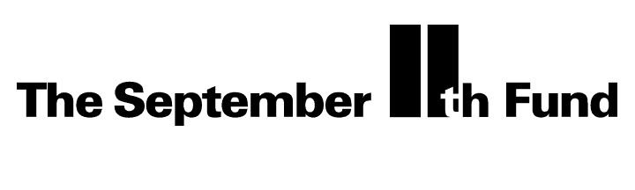
December 14, 2001

Dear Member of the Board:

On Wednesday, December 12th we announced the Cash Assistance Program that you decided upon at the last board meeting. The announcement was widely reported and very well received. We wanted to share some of the highlights with you.

The conference was attended by more than 40 media organizations, and our Chairman Frank Thomas represented the Fund on the network morning shows, CNN and the Nightly News with Tom Brokaw. The New York Times and the New York Daily News carried “day of” stories, and media coverage has continued over the days following.

Sincere thanks go out to actor George Clooney and New York Attorney General Eliot Spitzer who joined us for the press conference. Mr. Clooney, who was actively involved in the “Tribute to Heroes” Telethon, was unequivocal in his support. As you are aware, the new cash assistance program is being funded by the $101 million telethon proceeds, and his presence was no doubt very meaningful to the millions of Americans who donated to that effort.

Attorney General Spitzer also made very complimentary statements about the Fund and the new program, helping cement support for our work among other key constituencies. In addition, our sponsors at the New York Community Trust and United Way of New York City attended, including national United Way President Brian Gallagher.

Please find attached several key print articles on the announcement, synopses of some of the television coverage, as well as transcripts of Frank’s television interviews.

As we go forward we will continue to keep you informed, and I look forward to speaking with you soon.

Sincerely,
Joshua Gotbaum
Executive Director and Chief Executive Officer

