ISSUE: COMPENSATION FOR VICTIMS OF HATE CRIMES
Several groups have suggested that The September 11th Fund support cash assistance for the victims of hate crimes occurring after September 11th. Since then, there have been eight murders and at least 600 bias-motivated violent incidents as part of an overt backlash to the events of September 11th. This number of 600 violent incidents is significantly higher than the 60 incidents reported in the same time frame in previous years.

Most of these occurred in the immediate aftermath of the attacks: Data from a California statewide Hate Crimes hotline showed the number of calls to report hate crimes decreasing by half from October to November, and then dropping precipitously. Additionally, data for six major California jurisdictions showed that the number of hate crimes prosecuted in these jurisdictions declined substantially with each successive month after September.
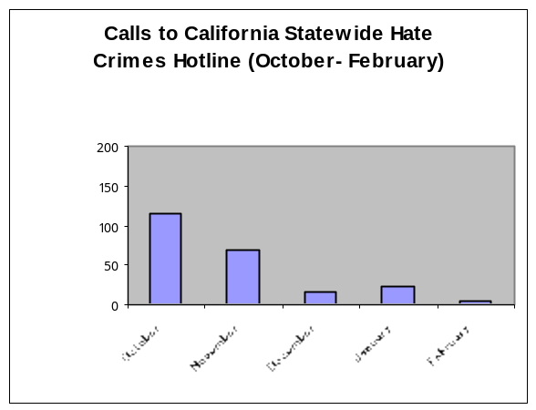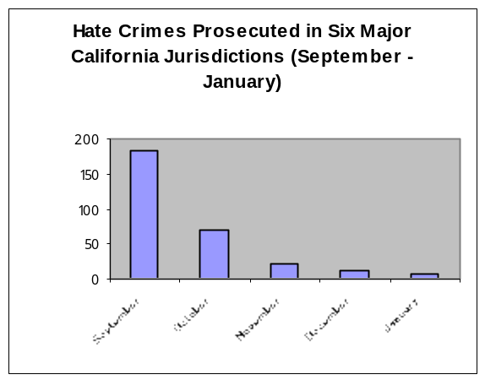

Early on, The September 11th Fund made four grants totaling $150,000 to community groups to support anti-bias programs (listed in appendix). However, the Fund has not considered whether to provide compensation to victims of hate crimes directly. There are no immediately available organizations to provide this support, so we are asking the Board’s direction whether this is of sufficient priority to justify developing a new program.

Background

The Fund made grants in the early days to provide emergency assistance to immigrants and others directly affected by the backlash and to promote outreach to non-English speaking communities in order to distribute information about victim assistance to these communities and to prevent anti-bias attacks from occurring.
Eight murders that occurred in the days following the attacks are apparently related and have been investigated as hate crimes. Groups that monitor bias incidents report some 600 other incidents of violence including assault, intimidation, robbery and other crimes where the victims were targeted due to their perceived affiliation with the ethnic group of the September 11th terrorists. Although there is no universal standard or consensus on any particular crime, this clearly is a dramatic increase.

Fortunately, the wave of violence subsided within a few weeks and the number of incidents declined markedly soon after the upsurge that occurred in the immediate aftermath. Nonetheless, the issue remains whether some of those affected can be identified and should be compensated.

Arguments in Favor
• This is consistent with the mandate of The September 11th Fund.
• Although the Office for Victims of Crime, Department of Justice, gives grants to states to provide victim assistance and victim compensation in the event of a hate crime, these awards, generally between $10,000 and $70,000, cover only direct reimbursement of crime-related expenses such as medical costs, funeral and burial costs, mental health counseling and lost wages. The award for lost wages is capped at $30,000 for all victims.
• Donors surveyed within the first two months of the September 11th attacks indicated that “people who were victims of hate crimes because of their ethnic origin” should be considered “victims” of the attacks. Of those surveyed in November, slightly more than half (58%) responded that these individuals should be considered victims of the attacks, an increase from the 44% figure reported in the October survey.
• Although the incidence of violent hate crimes seems to have peaked, advocacy groups report that many Muslims, Arabs, South Asians and others continue to feel extremely vulnerable.

Arguments Against
• There is not agreement as to which murders can be definitively classified as hate crimes. One murder has been generally recognized as a hate crime (the killing of Balbir Singh Sodhi, a Sikh American gas station owner, on Sept. 15th in Mesa, AZ); investigations into others are still ongoing. Two prominent monitoring organizations, the American Arab Anti-Discrimination Committee and the Council on American Islamic Relations both report eleven and ten deaths, respectively, as hate crimes, but list only four homicide victims in common. (Representatives of these organizations also acknowledge that at least two of the homicide victims listed as hate crime victims by their organizations are most likely murders that occurred for other reasons, but since investigations are still ongoing, these crimes remain on the lists of monitoring organizations.)
• A $100,000 memorial fund for the one confirmed hate crime victim has already been established, with a $48,000 grant from the United Way of Mesa, Arizona.
• There may be a public dispute whether a particular crime was, in fact, a September 11th-related hate crime. Some relatives of other Arab or South Asians murdered within the last six months believe the murders of their relatives to be part of the backlash. However, the police believe that there is no evidence the above killings were, as the victims’ families firmly believe and the media have widely reported, part of a post-September 11th backlash against people from the Middle East.
• We are not aware of any existing organization with the infrastructure to make these determinations and disbursements reliably. A new program would have to be developed for doing so.

Appendix: Related September 11th Fund Grants

Arab-American Family Support Center | To provide emergency assistance to individuals, schools, police and other agencies in dealing with the effects of the attacks on Arab Americans. | $60,000 | 10/15/01
Asian American Legal Defense and Education Fund | For legal assistance and other preventive measures against hate violence in the wake of the World Trade Center attack. | $30,000 | 10/10/01
Liberty Center for Immigrants | To provide emergency assistance to Guyanese immigrants to deal with fear, bias incidents, and concerns of the undocumented. | $10,000 | 9/28/01
New York Immigration Coalition | To help immigrants harmed by the attack gain access to emergency relief assistance and information to document and inform authorities of bias incidents against members of immigrant groups. | $50,000 | 9/28/01

