SUMMARY OF THE SEPTEMBER 11TH FUND
TRAUMA TRAINING INITIATIVE

Because so many different types of mental health practioners were expected to respond to the needs of 9/11 victims throughout the New York area, the Fund decided that it could be most effective in reaching large numbers of impacted people by launching a large-scale training initiative, to provide those offering comfort and care with the latest knowledge on how to recognize and treat symptoms of trauma.

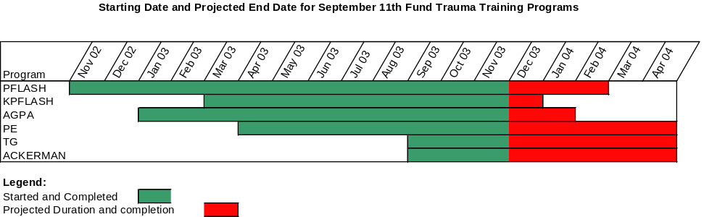
The figure above shows the start date, and projected end date and duration for each of the six training programs established under the September 11th Fund trauma training initiative. A synopsis of the course objectives for each program is included as Attachment #1. The primary mission is to enhance the trauma assessment and intervention skills of mental health professionals who work with victims of the September 11th terrorist attacks. A secondary mission is to enhance the capacity of the metropolitan New York mental health professional community to provide a quick and effective mental health response in the event of future disasters.

This training initiative is scheduled to end on April 30, 2004. The table below shows both the projected (through April 04) and actual (through Nov 03) course offerings and professional enrollment. Attachment #2 provides a more detailed view of course-specific enrollment and completion data.

The program is budgeted to administer 134 courses (several of which are two-day courses) through April 04, of which 100 have been offered and completed to date. The targeted professional enrollment through April 04 is 6879. To date, 5186 professionals have registered for the programs, and 3957 have actually completed the courses. As of now, there are 703 people pre-registered for the remaining 34 courses.

Pre-registration is required for all courses. Standard operating procedure is to try to overbook each session by 10-20%. In addition, several days in advance of each session, all pre-registrants are contacted by phone or email to remind them of the course time and location. The overall completion rate is 76% across all courses, ranging from an 85% rate for the PFLASHes, to 62% for the AGPA series (see attachment #2).

We will continue to closely monitor expenditures and, consistent with demand, offer additional courses if we are able to save on location and related fees (e.g. American sign language interpretation services). At present, we are just below projected budget expenditures, and may be able to offer several additional courses beyond contracted totals.

Course marketing and pre-registration is an ongoing process. Training announcements are blast-faxed using professional staff lists, and sent to an assortment of treatment program contacts. Written training annoucements are also distributed regularly at a variety of September 11th-related meetings throughout the city (e.g. Trauma Resource Network, Project Liberty Borough Provider meetings, etc.). There are regular mailings to, and announcement listings in a variety of professional publications. Finally, we maintain an up-to-date web-based training calendar. Recently, we offered PFLASH and PFLASH for Children courses in upstate counties in order to extend the reach of the program to other affected areas in New York. Working with local Mental Health Association and county mental health groups, we were able to attract registrants from Sullivan, Rockland, Orange, Ulster, Dutchess and Weschester counties.

The training courses are also regularly used as an opportunity to inform practitioners about the September 11th Fund Mental Health Benefit. Staff from the MHA Mental Health Benefit Coordination Office present an overview of the September 11th Fund Mental Health & Substance Abuse Benefit Program to acquaint mental health professionals with how they can connect disaster victims to the benefit enrollment process via LifeNet or via the enrollment website. Participants are also apprised of the opportunity to be credentialed for possible inclusion in the special private practitioner referral panel established by LifeNet that is dedicated to matching beneficiaries in need of mental health treatment with appropriate, skilled, private practitioner referrals.

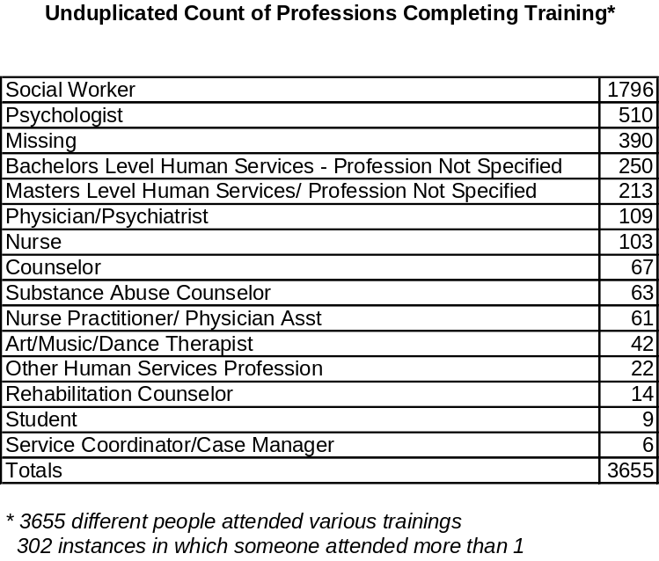
The table to the left summarizes the distribution of professionals who have completed any of the six training programs. We have reached 3655 different professionals, and in 302 instances, a staff member has attended 2 or more courses. We regard this as strong evidence that the reach of the program has been broad. The licensed professions in this table are eligible for any of the programs. For the most part, the unlicensed professions (e.g. service coordinators) represent attendees at the more introductory level PFLASH and PFLASH for children courses.

We are reaching a broad cross-section of practitioners in terms of level of experience. 27% report they have less than 5 yrs experience, 19% have 5-9 yrs , 25% have 10-19 yrs, and 29% have more than 20 yrs of experience. They report an average of 39% of their current caseload as affected by 9/11.

As part of the course registration process we ascertain whether the professional will agree to have their name included in a listing of trained mental health professionals available to assist with crisis counseling and support in the event of future disasters. We have advised the NYC Office of Mental Hygiene of the availability of this resource, and they are evaluating how best to include this resource list within their own evolving crisis response plans.

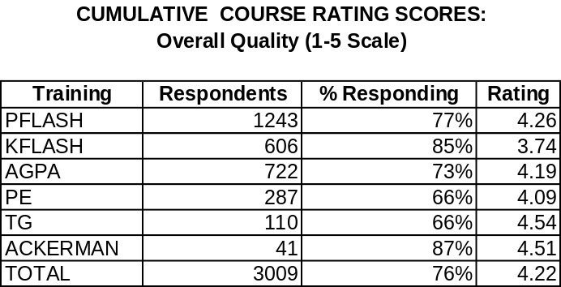
Each course is evaluated on a number of measures such as clarity, content, preparation, relevance and the like. Narrative comments are also invited. Course evaluation data are routinely summarized and/or transferred in total to the faculty/course authors for the various programs. Instructor assignments have, in fact, been adjusted based on these evaluations, and several instructors were dropped based on evaluation scores. The table above summarizes the overall course rating scores, based on evaluations from 76% of those completing the courses. Ratings are on a 1-5 point scale (with 5 being the highest positive rating) and therefore these data suggest that, overall, these six programs are judged to be of very good quality by the professionals who have participated.

In addition to the large scale training program administered by the Mental Health Association, The September 11th Fund has also funded a separate effort, overseen by the New York Council of Churches, to provide training to members of the Clergy, so that those who provide pastoral counseling are able to identify and properly respond to cases of 9/11-related post traumatic stress. The “P-Flash” curriculum has been adapted for this distinct audience and 20 members of the clergy from all faith communities have been trained to teach ‘C-Flash”, with a goal of reaching at least 1,000 religious leaders in the New York area by the spring of 2004.

ATTACHMENT #1: SYNOPSIS OF THE TRAINING PROGRAMS

- PFLASH (Practical Front Line Assistance For Support and Healing). One day.
Objectives:
- Screening and assessment of individuals exposed to disasters and other traumatic events
- Differentiation of normal from pathological response; predictors of resilience and psychopathology
- The diagnosis and sysmptoms of PTSD
- Decision tree for direct intervention and triage
- Discussion of front line intervention methods

- PFLASH for Children. One Day
Objectives:
  - Differentiate normative and clinically signficant responses to trauma
  - Guidelines for case evaluation and triage
  - Intervention tool kit for use with children
  - Development of skills for use now and in the future
.
- AGPA Modules (American Group Psychotherapy Association). One day each
Modules:
  - Module 1: Group Interventions for Treatment of Trauma in Adults
  - Module 2: Group Interventions for Treatment of Trauma in Adolescents
  - Module 3: Group Interventions for Treatment of Trauma in Children
  - Module 4: An Overview of Evidence Based Group Approaches to Trauma with Adults
  - Module 5: An Overview of Evidence Based Group Approaches to Trauma with Children and Adolescents
  - Module 6: The Later Stage: The Role of Group Interventions in Coping with the Aftermath of Traumatic Events
  - Module 7: Counter transference: Effects on the Group Therapist Working with Trauma
  - Module 8: Unique Aspects of Group Work with Trauma
  - Module 9: Identification and Management of Masked Trauma Reactions in Groups
  - Module 10: Group Interventions for Bereavement Following Traumatic Events

- Prolonged Exposure Therapy. Two days. Licensed staff only
Objectives:
  - Learn evidence-based therapeutic techniques (including psycho-education, relaxation and exposure) reduce stress and anxiety, specific phobic reactions and post-trauma symptoms such as nightmares, irritability, and high physiological arousal.

- Traumatic Grief. Two days. Licensed staff only
Objectives:
  - Review of current perspectives distinguishing pathological and normal grief
  - Intensive training in new techniques for addressing impairment related to pathological grief
  - In-depth case review and role play training.

- Ackerman Trauma-Based Family Therapy Training. Two days. Licensed staff only
Objectives:
  - Introduction to relational trauma
  - The power of context to define perception, emotion and action
  - Concepts of family resilience
  - Core concepts of family systems
  - Guide to famnily assessment
  - Assessing impact of trauma in families
- Fundamentals of trauma-centered family therapy

ATTACHMENT #2

