Messrs. : {{Messrs}}
Attn. : {{Attn}}
Tel : {{Tel}}
E Mail : {{EMail}}
Date :
Ref. # : {{RefNo}}

Subject : OFFER FOR ATLAS COPCO DEWATERING PUMP
Dear Sir,
Referring to your inquiry for ATLAS COPCO Dewatering Pump, Kindly find below our proposal for our model
Atlas Copco model {{ModelShort}}
Model : {{ModelFull}}
Pumping fluid: {{PumpingFluid}}
Water Pump  Solid Handling | {{SolidHandling}}
Max. Flow | {{MaxFlow}}
Max. head | {{MaxHead}}
Discharge size | {{DischargeSize}}
Vacuum Pump  Vacuum pump type | {{VacuumPumpType}}
Nominal air capacity | {{NominalAirCapacity}}
Max vacuum | {{MaxVacuum}}
Engine - Liquid Cooled
Type | {{EngineType}}
Output Rated Speed | {{OutputRatedSpeed}}
Engine Speed | {{EngineSpeed}}
Weight | {{Weight}}
Dimensions | {{Dimensions}}
- Made In {{MadeIn}}
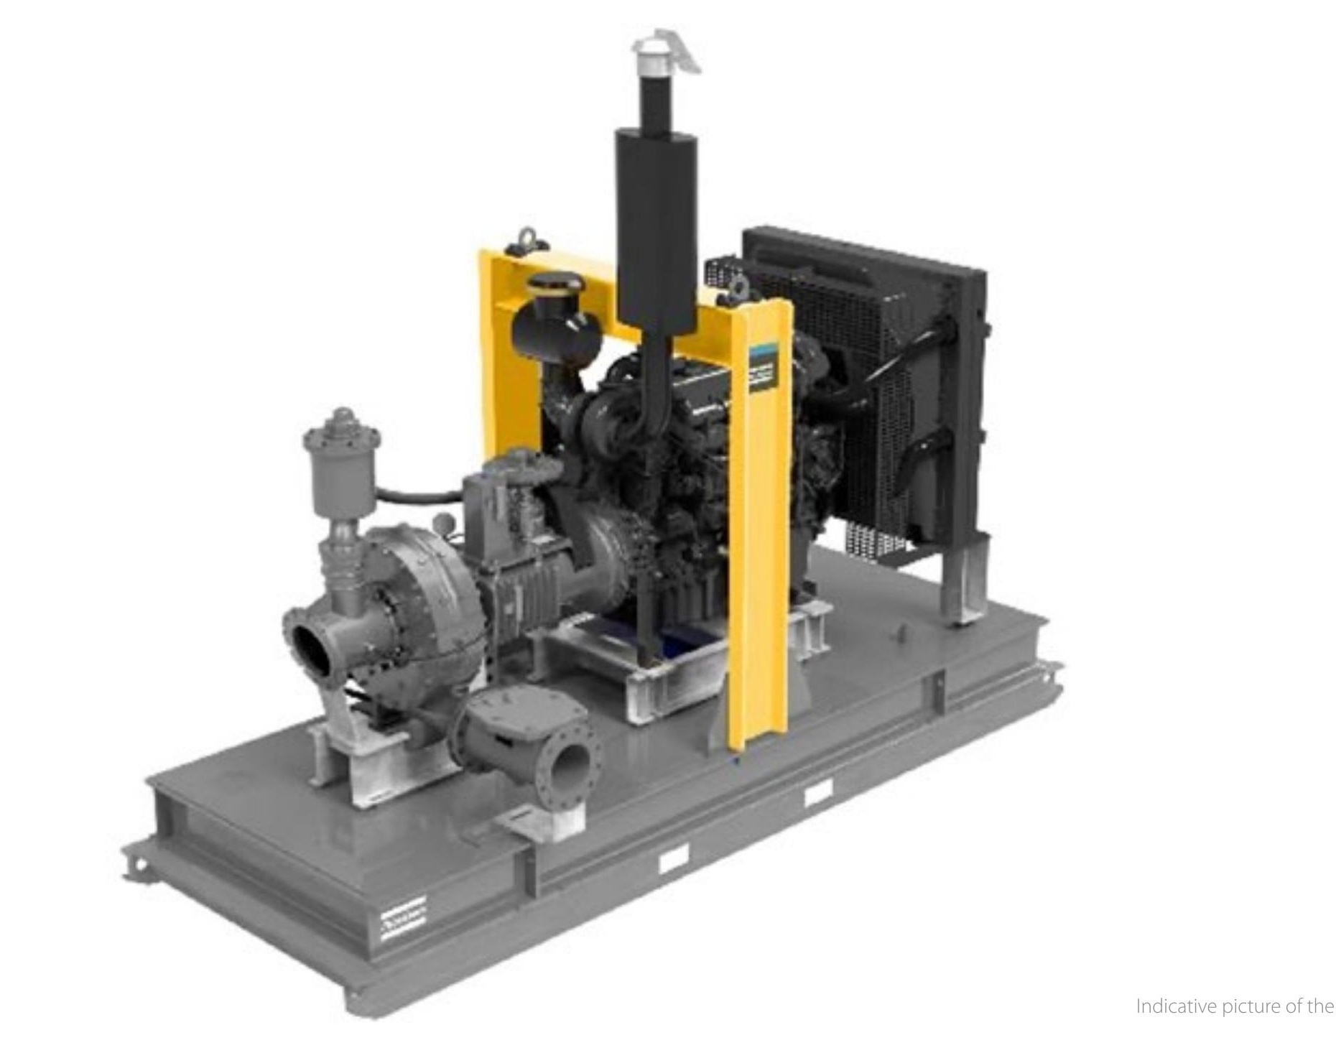

Commercial Terms:

Price
# | Model | Unit Price (SAR) | Quantity | Total Price (SAR)
1 | {{ModelFull}} | {{UnitPrice}} | {{Qty}} | {{TotalPrice}}

- Prices NOT include VAT.

DELIVERY : {{DeliveryWeeks}}

PAYMENT :

WARRANTY : One year/2000 hours which come first from date of delivery, the warranty is valid as long as the pump is operated and maintained as described in the Atlas Copco operating manual from date of delivery against any manufacturing defect and subject to using the genuine Atlas Copco parts including oil, lubricant, coolant and filters.

VALIDITY : Offer is valid for 30 days.
AFTER SALES SERVICE
We have fully equipped Workshops in our Branches in Khobar, Riyadh, Jeddah, Qassim and Abha.
Our Service Managers and Supervisors are all overseas trained and the majority of our Service Engineers have undergone training at our Product Companies. Service vehicles are utilized to carry out any necessary repairs or servicing at our customer sites.

A comprehensive range of spare parts for all our machines marketed in the Kingdom, are held in our main branches. Should a particular part not be available, we utilize air freight or courier deliveries from our Manufacturing Companies.
Thanks and best regards.

