***-Galactosidase Kinetics***

Laboratory Exercise 3

Advanced Biochemistry

St. Francis Xavier University

© David M. Morgan, Ph.D.

**Pre-lab:**

(5 points)

Look up and draw the stereochemically correct structure of ortho-nitrophenyl-β-galactoside.

**Background**

-galactosidase is an essential protein that carries out the hydrolysis of -glycosidic bonds between galactose and another sugar or group. - and -galactosides are distinguished by the stereochemistry of the attachment between the *anomeric* carbon (*i.e.*, the #1 carbon) and the remainder of the molecule. Arbitrary - and -galactosides are indicated in Figure 1, below. The chemistry carried out by -galactosidase is depicted in Figure 2:

**Figure 1:** Arbitrary - and -galactosides.

**Figure 2:** The overall reaction carried out by -galactosidase.

Individuals who are lactose intolerant may consume -galactosidase in tablet form to relieve the symptoms of lactose intolerance, a condition that frequently arises in babies after weaning, when milk becomes less prevalent in the diet. Lactose intolerance among adults is particularly prevalent in groups who do not ordinarily consume dairy products in their diet, although some estimates suggest that up to 90 % of adults in all cultures have some form of lactose intolerance.

-galactosidase has also become an important tool in molecular biology and genetics, in which it is used (a) to measure amounts of gene expression and (b) as a “selectable marker” for successful molecular cloning.

**Experimental:**

You will prepare the following solutions in this experiment, and measure the corresponding reaction kinetics.

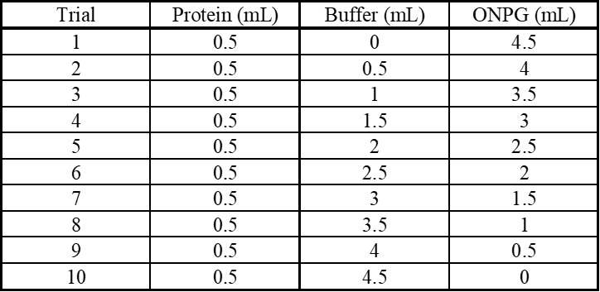

* Work in groups of two.
* Prepare the protein solution:
  + Acquire a lactose tablet, mortar, and pestle.
  + Grind the tablet in a mortar with a pestle until you produce a fine white powder.
  + Scrape the powder into a 50 mL centrifuge tube.
  + Add 10 mL of 0.1 M phosphate buffer, pH = 7, to the centrifuge tube. Gently invert the tube continuously for 5 minutes to extract the protein from the powder.
  + Label the centrifuge tube with your initials and determine its mass.
  + With another group, determine which of your centrifuge tubes is lighter. Using a Pasteur pipet, add phosphate buffer dropwise to the lighter centrifuge tube, until the two centrifuge tubes have the same mass to within 0.1 g.
  + Bring your centrifuge tubes to the centrifuge and spin for 5 minutes at 5000 rpm.
  + Pour the supernatant from the centrifugation into a 50 mL beaker. Attempt not to disturb the powder collected at the bottom of the centrifuge tube while doing so. Discard the contents of the centrifuge tube.
  + Separate the plunger and barrel of a 20 mL syringe. Attach a 0.45 m filter to the syringe. Pour the contents of the beaker into the barrel of the syringe. Put the spout of the filter into a 15 mL centrifuge tube, place the plunger in the barrel of the syringe, and filter the solution into the 15 mL centrifuge tube.
* Take a spectrum of the filtered solution in the range 200 – 700 nm.
  + Dilute the sample if necessary, making certain to record the extent to which you have diluted the sample. Also record the absorbance at 280 nm. You will use this information to determine the concentration of the protein, so you must be quantitative with this step.
* Prepare your protein stock solution.
  + Take 1 mL of the protein solution and dilute it to 25 mL in phosphate buffer in a volumetric flask. Gently invert the volumetric flask 50 times to ensure homogeneity of the solution.
* Carry out enzyme kinetics assays.
  + The reactions are done in the cuvette.
  + Make measurements at 420 nm.
  + Before running each experimental solution, blank the instrument using a solution composed of all of the necessary components *except* the protein.
  + Remove the cuvette from the instrument. Then, add the protein and immediately:
    - Start the timer AND quickly cover the cuvette with a clean, dry, rubber stopper and invert it 5 times.
    - Replace the cuvette in the spectrophotometer.
  + Note absorbance and time every 5-10 sec for the first 2 min then every 30 sec until 5 minutes have elapsed.
  + Repeat for each trial.
* Solution compositions for the various kinetic experiments to be run are outlined in the table below.

***Note: As soon as you add the protein the reaction starts. Do not add the protein until you are prepared to begin the reaction! Add the protein LAST!!***

**Data Processing Instructions:**

For each reaction, determine the INITIAL rate. (If the time profile is not linear, determine the rate ONLY in the linear portion at the beginning.) The extinction coefficient for o-nitrophenol is 2130 M-1 cm-1 at 420 nm. Prepare either a Michealis-Menten or a Lineweaver-Burk treatment of the data.

Determine *kcat* and *KM* for -galactosidase.

Use Microsoft Excel or LibreOffice Calc to perform the necessary calculations and to prepare your plots. Your plot should look professional. It should have a title and properly labeled axes. The graph should include your raw data points and the line (curve) describing the “best fit” to the data.

In addition to your Michaelis-Menten (or Lineweaver-Burk) plot, attach a copy of your spreadsheet.

You will need the extinction coefficient of the protein at 280 nm. The -galactosidase in the tablets is from the organism *Aspergillus oryzae*. Find this protein’s sequence in the Protein database, at the National Center for Biotechnology Information (NCBI), <https://www.ncbi.nlm.nih.gov>. Estimate the protein’s molar extinction coefficient using standard values for absorbances at 280 nm for tryptophan, tyrosine, and phenylalanine. (Hint: plug the sequence into a program like the one found here: <http://www.scripps.edu/~cdputnam/protcalc.html>.)

**Lab Reports:**

Your lab reports should have a title page indicating, at minimum, the name of the experiment which you are writing up, your name, the date the experiment was performed, and the date the report is submitted.

Lab reports should be prepared via a word-processor.

**Pre-lab:**

(5 points)

**Introduction:**

(0 points, up to -2 if missing or inadequate).

Include a short paragraph introducing -galactosidase and its usefulness in treating lactose intolerance. You should include slightly more detail than found in the introduction to this lab experiment. Consult a standard biochemistry text to guide you.

**Results:**

(15 points)

Include a nicely formatted and properly labeled table giving concentrations of ONPG in each trial, and the observed initial rate for each trial.

Include a nicely formatted and properly labeled Michaelis-Menten or Lineweaver-Burk plot.

Attach a nicely formatted, clearly labeled, easy to interpret spreadsheet showing all your data and calculations.

Attach a copy of the protein sequence that you found via the NCBI.

Attach a copy of the output of the program you used to determine the protein’s extinction coefficient (or show your work if you did it yourself).

State your estimates of *kcat* and *K­* for beta-galactosidase from *A. oryzae*.

**Answer the following questions:**

1. (5 points) In a short paragraph, describe the basis of the colour change that takes place as the reaction proceeds. Include a properly balanced chemical equation, which uses structural formulas, for the reaction. You may draw the structures by hand, but you should seriously consider obtaining a copy of ChemSketch, by ACD Labs (which is free), and learning how to use it to produce nice chemistry graphics.

2. (5 points) Describe *either* how -galactosidase may be used to measure the extent of gene activity *or* how it may be used to assess the success of a molecular cloning attempt.

Grading:

Pre-lab: 5 points

Results: 15 points

Questions: 10 points

Total possible: 30 points