# Decision Requirement Diagram

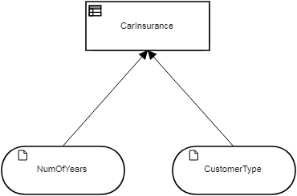

## Elements

 **CarInsurance (Decision)**

**Decision Logic (Decision Table)**

|  |  |
| --- | --- |
| **CarInsurance** | |
| C< | NumOfYears | | CustomerType | CarInsurance | |  |
| CarInsuranceAmount | Required |
|  | |  |  |  |  |
| 1 | >1 | | "Normal" | 98.83 | true |  |
| 2 | >2 | | "VIP" | 150.21 | false |  |
| 3 | >3 | | "VIP" | 205.43 | false |  |
| 4 | >4 | | "Special" | 64.32 | true |  |

 **NumOfYears (Input Data)**

 **CustomerType (Input Data)**

**tCarInsurance_2**

|  |  |
| --- | --- |
| CarInsuranceAmount | Number |
| Required | Boolean |