

DMN Modeler Report

DT on BKM implicit parameters

**Published: 7/30/2018**

**By: Edson Tirelli**

Table of Contents

Page 1 3

Decision Requirement Diagram 3

Elements 3

# Page 1

## Decision Requirement Diagram

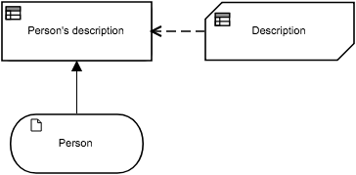

## Elements

 **Person's description (Decision)**

**Output Data Type**

|  |  |
| --- | --- |
| Type | Text |

**Decision Logic (Invocation)**

|  |  |
| --- | --- |
| **Person's description**  *Text* | |
| Description | | |
| Person.Gender  *Text* | | Person.Gender |
| Person.Name  *Text* | | Person.Name |
| Person.Children  *Number* | | Person.Children |

 **Description (Business Knowledge Model)**

**Output Data Type**

|  |  |
| --- | --- |
| Type | Text |

**Decision Logic (Decision Table)**

|  |  |  |
| --- | --- | --- |
| **Description**  *Text* | | |
| U | Person.Gender | | Person.Name | Person.Children | Description | Description |
| *Text*  *"Male", "Female"* | | *Text* | *Number* | *Text* |  |
| 1 | "Male" | | - | - | Person.Name + " is a dad of " + string(Person.Children) + " children." |  |
| 2 | "Female" | | - | - | Person.Name + " is a mother of " + string(Person.Children) + " children." |  |

 **Person (Input Data)**

**Input Data Type**

|  |  |
| --- | --- |
| Type | tPerson |

**tPerson**

|  |  |
| --- | --- |
| Name | Text |
| Gender | Text  *"Male", "Female"* |
| Children | Number |