

DMN Modeler Report

DT on BKM explicit parameters

**Published: 7/30/2018**

**By: Edson Tirelli**

Table of Contents

DT on BKM with explicit parameters 3

Decision Requirement Diagram 3

Elements 3

# DT on BKM with explicit parameters

## Decision Requirement Diagram

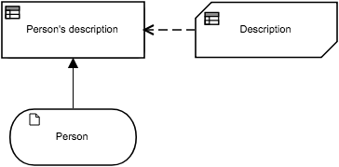

## Elements

 **Person's description (Decision)**

**Decision Logic (Invocation)**

|  |  |
| --- | --- |
| **Person's description** | |
| Description | | |
| Person  *tPerson* | | Person |

 **Description (Business Knowledge Model)**

**Output Data Type**

|  |  |
| --- | --- |
| Type | Text |

**Decision Logic (Function)**

|  |  |
| --- | --- |
| **Description**  *Text* | |
| F | |  |  |  | | --- | --- | --- | | ( | Person  *tPerson* | ) | | |
| |  |  |  |  |  |  |  |  |  |  |  |  |  |  |  |  | | --- | --- | --- | --- | --- | --- | --- | --- | --- | --- | --- | --- | --- | --- | --- | --- | | |  |  |  |  | | --- | --- | --- | --- | | U | Person.Gender | the description | Description | | *Text*  *"Male", "Female"* | *Text* |  | | 1 | "Male" | Person.Name + " is a dad of " + string(Person.Children) + " children." |  | | 2 | "Female" | Person.Name + " is a mother of " + string(Person.Children) + " children." |  | | | the description | | | | |

 **Person (Input Data)**

**Input Data Type**

|  |  |
| --- | --- |
| Type | tPerson |

**tPerson**

|  |  |
| --- | --- |
| Name | Text |
| Gender | Text  *"Male", "Female"* |
| Children | Number |