

DMN Modeler Report

DT list semantics

**Published: 7/31/2018**

**By: Edson Tirelli**

Table of Contents

DT - semantics of lists 3

Decision Requirement Diagram 3

Elements 3

# DT - semantics of lists

## Decision Requirement Diagram

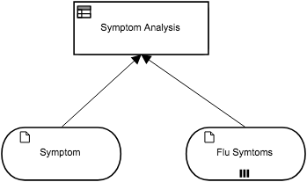

## Elements

 **Symptom Analysis (Decision)**

**Output Data Type**

|  |  |
| --- | --- |
| Type | tListOfStrings |

**Decision Logic (Decision Table)**

|  |  |
| --- | --- |
| **Symptom Analysis**  *tListOfStrings* | |
| C | Symptom | | Symptom Analysis | Description |
| *Text* | | *tListOfStrings* |  |
| 1 | "cough", "sore throat", "stuffy nose" | | Symptom + " is in the list of Cold symptoms" | syntax: list of unary tests |
| 2 | Flu Symtoms | | Symptom + " is in the list of Flu symptoms" | syntax: list variable |

 **Symptom (Input Data)**

**Input Data Type**

|  |  |
| --- | --- |
| Type | Text |

 **Flu Symtoms (Input Data)**

**Input Data Type**

|  |  |
| --- | --- |
| Type | tListOfStrings |

**tListOfStrings**

|  |
| --- |
| Text |