Executive Summary
The Tech-Zone Gadgets project integrates the development of websites, data analytics, and the insights presented as a dashboard to gain insights into the performance of an online gadget shop in terms of sales, customer behavior and product trends. Our e-commerce site’s design was developed on Lovable AI and further simplified by our own edits on the UI. The site also features a Home page that has a carousel, products, product reviews, a login page, a cart page, and individual pages to all the gadget categories such as smartwatches, headphones, keyboards, and mice. We analyzed two datasets with Tableau to know how this online store would perform in an actual business setting:
- Online Retail Sales dataset (orders, revenue, customers, products)
- E-commerce Behavior dataset (views, add-to-cart, checkout events)
Using Tableau, we developed three interactive dashboards covering sales summary, customer journey funnel, loyalty behavior, product performance, and top customers.
E-Commerce Data Analysis with Tableau
Methodology
We downloaded the CSVs from Kaggle and imported it into Tableau Public (free edition) for ETL. Steps Performed
- Importing Data
- Data Cleaning includes blank rows and duplicate rows removal
- Creating New Calculated Fields to support data analysis
- Creating KPIs and then Sheets and Dashboards
- Eash Dashboard is interpreted and documented, then we identified problems and recommend solutions.
- The last was to develop a website to support online sales with lovable ai.
Data Chosen
E-commerce Data
Data source Link: https://www.kaggle.com/datasets/vijayuv/onlineretail
E-Commerce Customer Behavior
Data source Link: https://www.kaggle.com/datasets/uom190346a/e-commerce-customer-behavior-dataset
We have chosen two datasets to conduct our analysis. There is not possible relationship between two datasets and they are independent. So, we will analyze what suits them and then drives results from both datasets.
Data Description
Dataset A: Online Retail Sales
Column Name | Description | Type
InvoiceNo | Unique order/bill number | String
InvoiceDate | Date & time when order was placed | Date/Time
CustomerID | Unique customer identifier | String
Country | Country of customer | String
Product | Item purchased | Text
Quantity | Number of items purchased | Integer
UnitPrice | Price per item | Decimal
TotalPrice | Total = Quantity × UnitPrice | Decimal

Dataset B: E-commerce Behavior
Column Name | Description | Type
EventTime | Time of browsing action | Date/Time
UserID | Unique site visitor ID | String
ProductID | ID of product viewed | String
ProductName | Name of the product | Text
EventType | View, Add-to-cart, Checkout | Text
Category | Product category | Text

Extract, Transform & Load (ETL)
The Raw Data is downloaded from the Kaggle, both of datasets. We have performed transform operation in excel where we have cleaned the dataset by removing duplicates and the blanked data.
We have assigned proper data types to each field., Trimmed Column Names and data removing extra spaces and then load data in Tableau
Online Retail Dataset
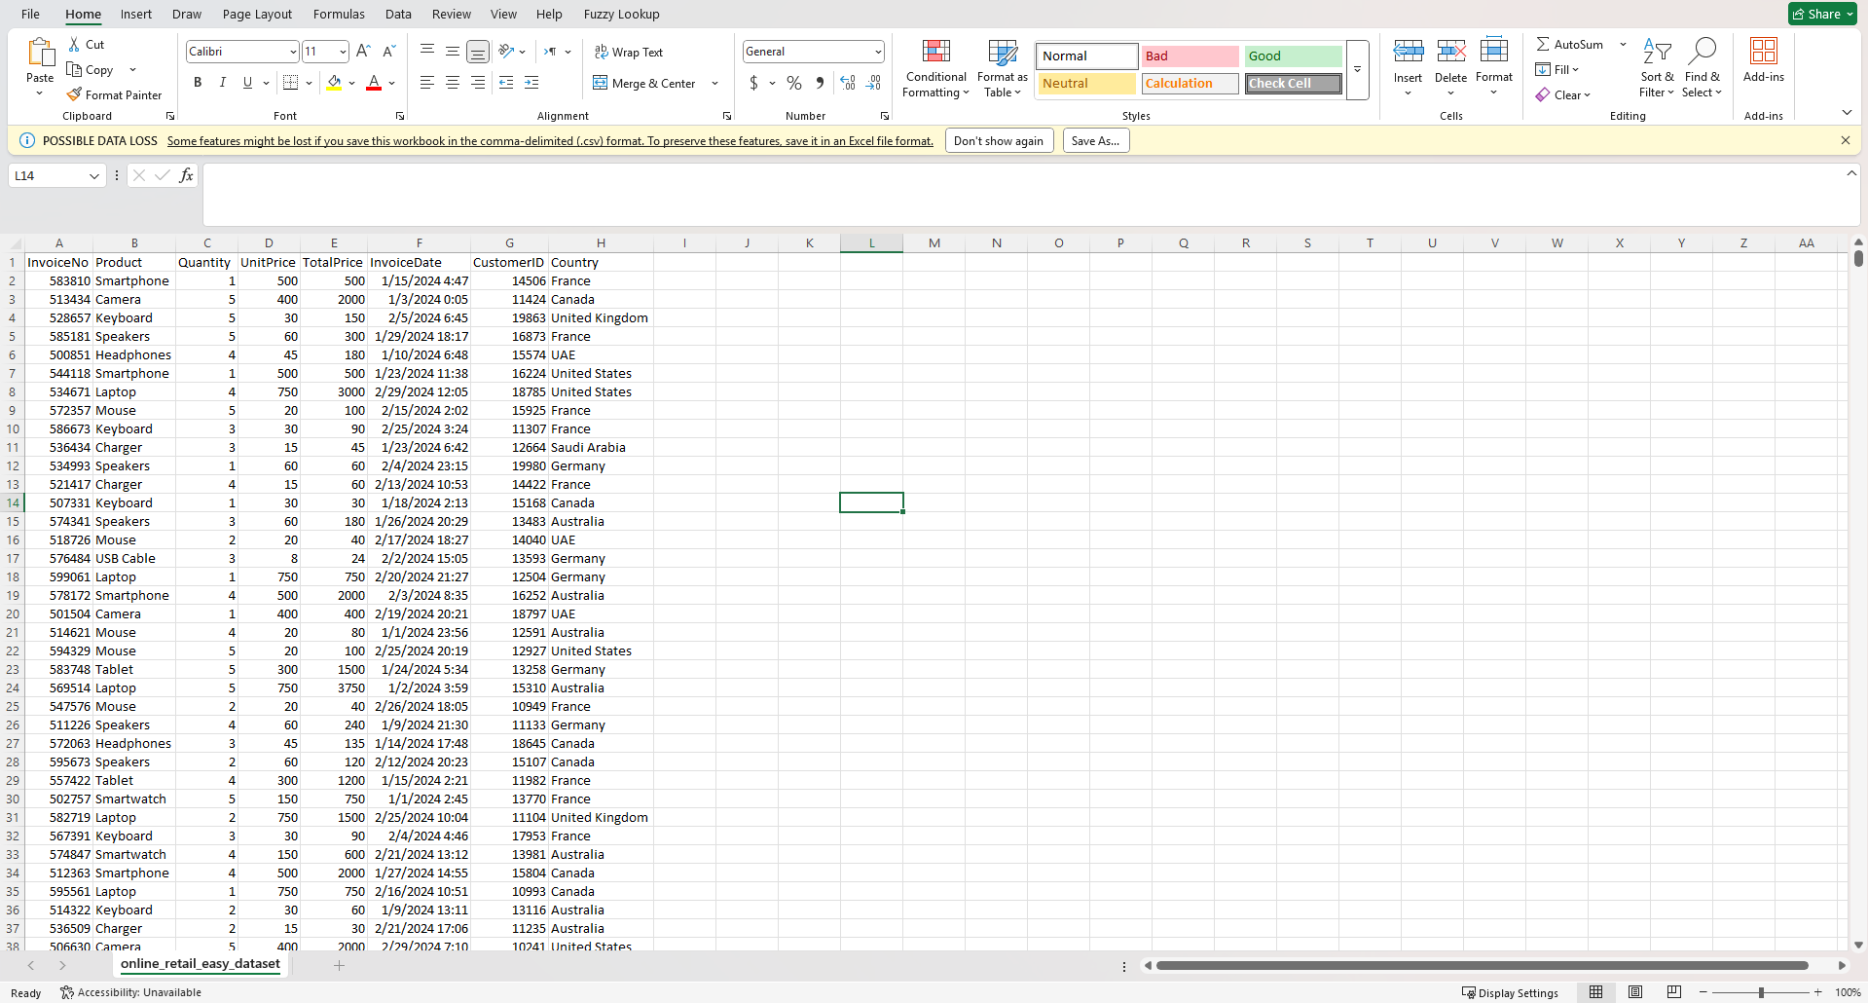
Customer Behavior Dataset
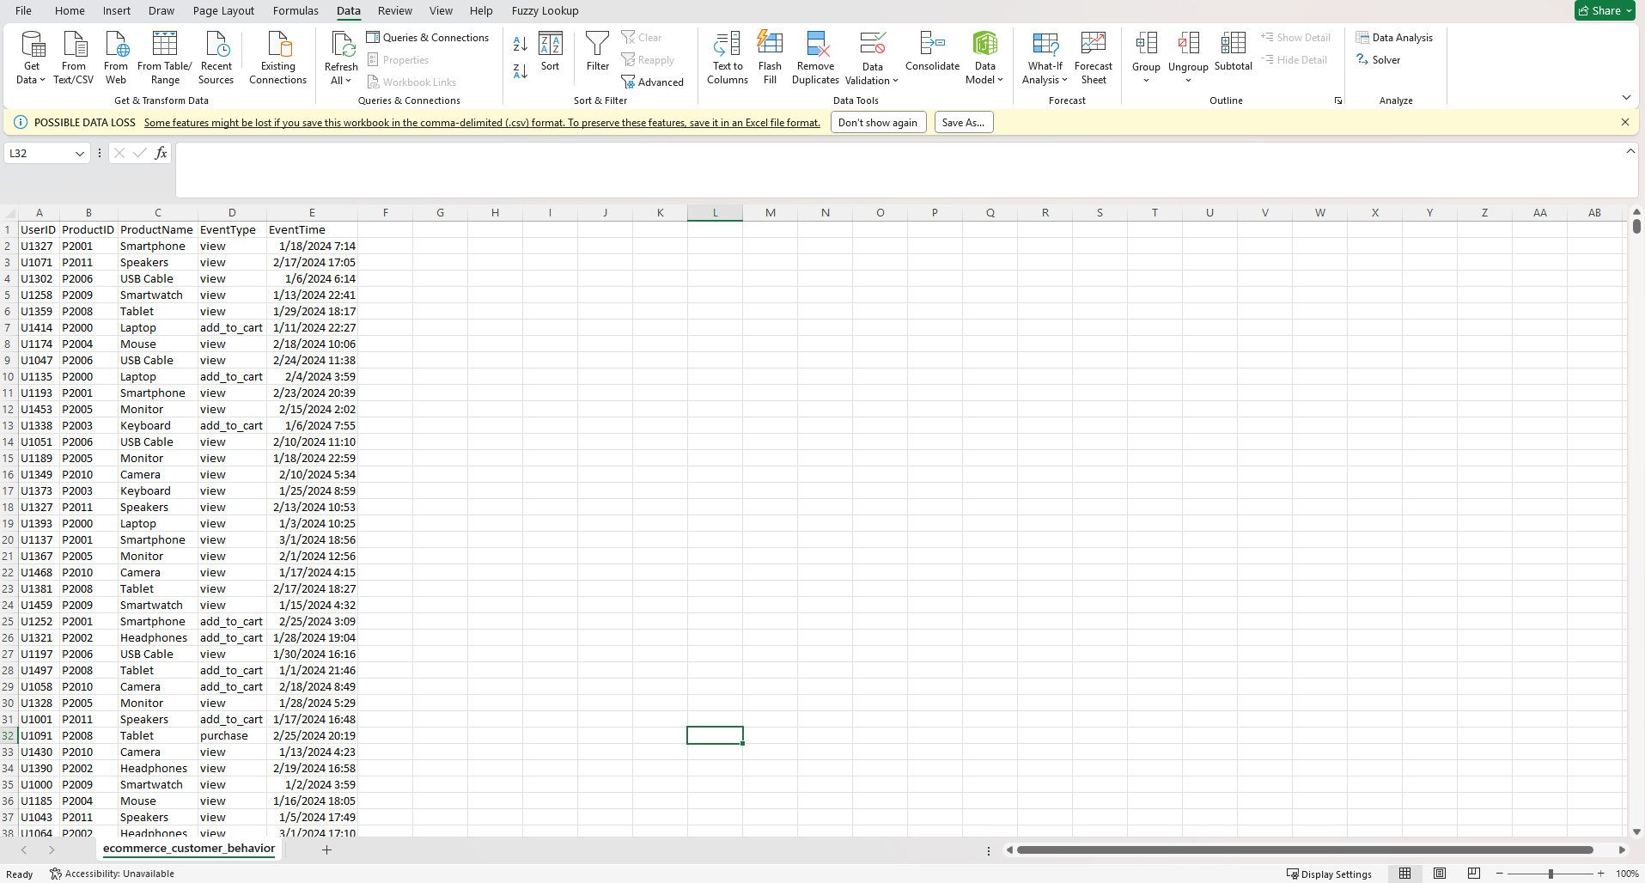
Loading Data in Tableau
We have created a new Tableau file and loaded both of datasets independently
Loading Online Retail Dataset
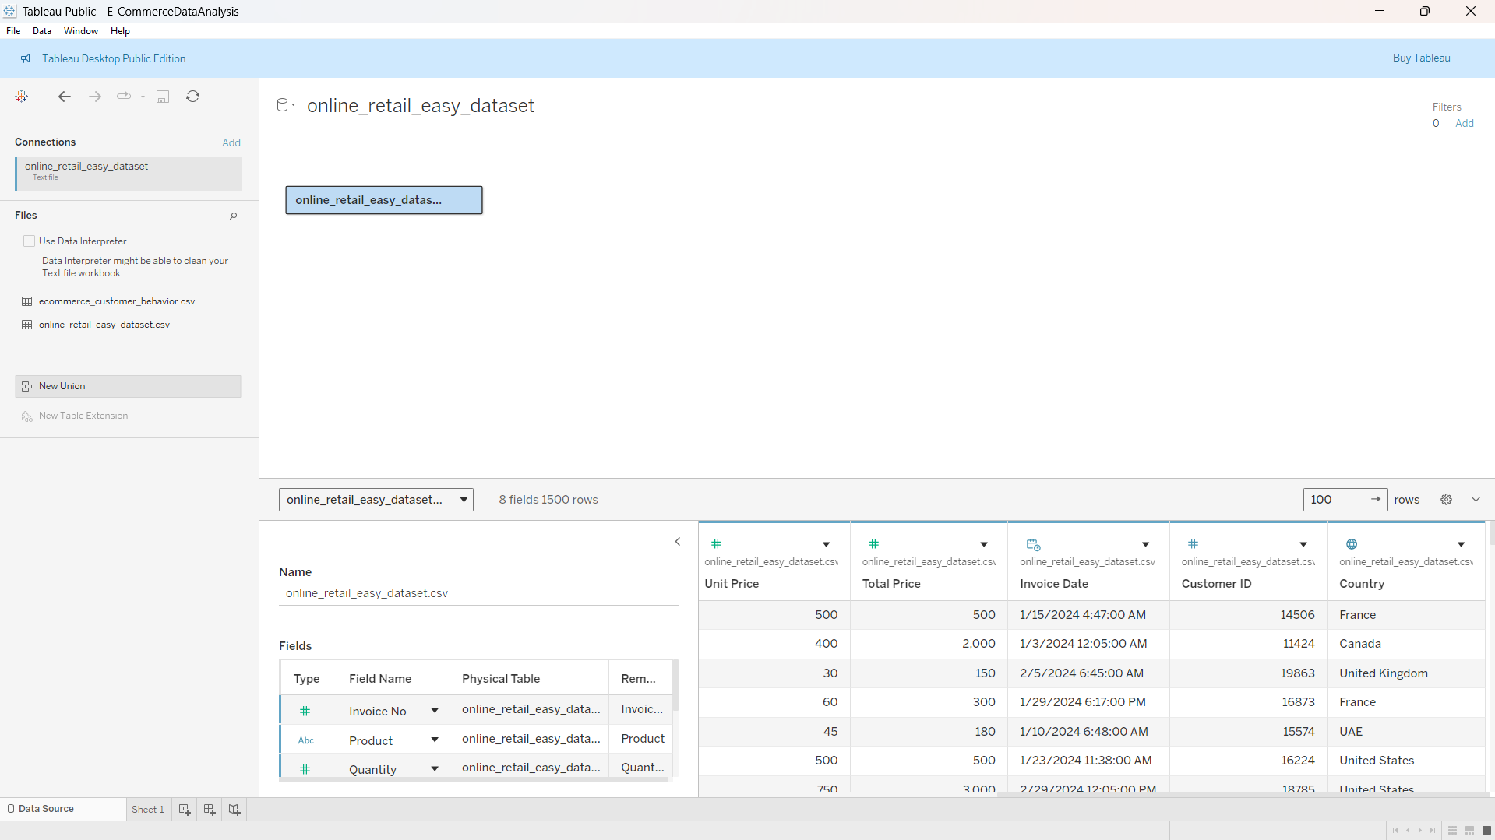
After Loading the Dataset we have created two new fields, one is IsReturn which tell if the order delivered is returned and the return amount which tell us the amount was returned against the order.
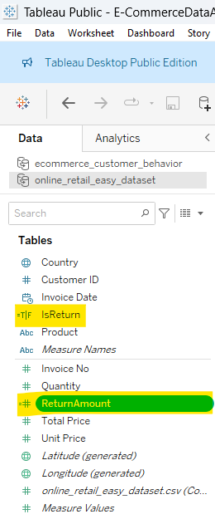
Creating Fields That support KPIs
Average Order value = Sum(TotalPrice)/Count(InvoiceNo)
Loading Customer Behavior Dataset
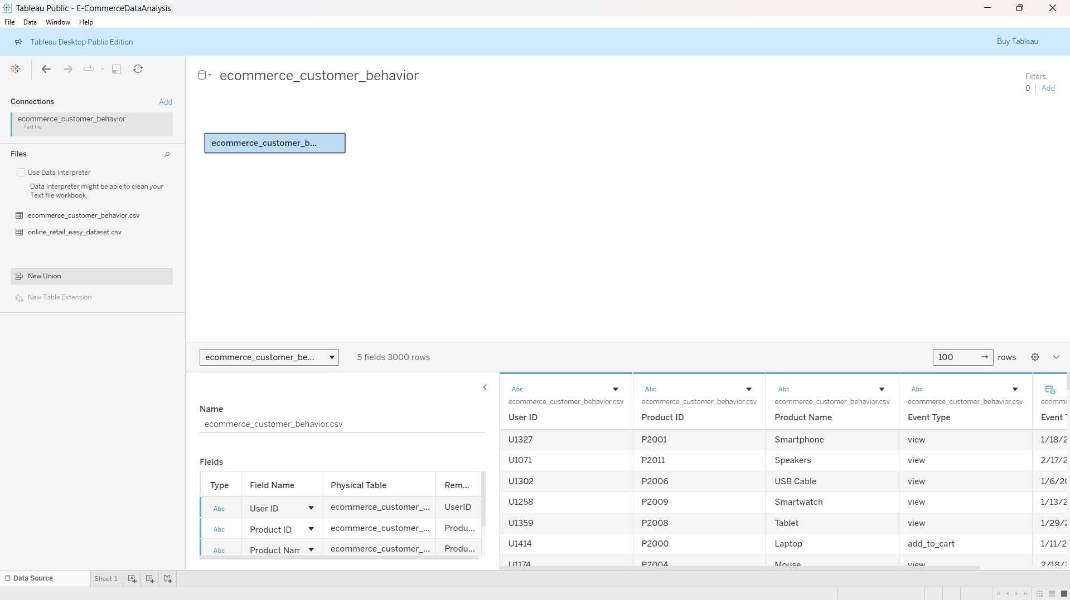
After Loading the Dataset we have created new fields and measures
Stage: Which Tell the Event is View, Add to Cart, Checkout or Purchase
The other Is View, Checkout, Is Purchase is created to support the calculations
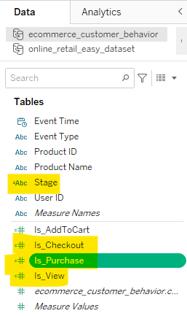

Dashboards
Overview Dashboard
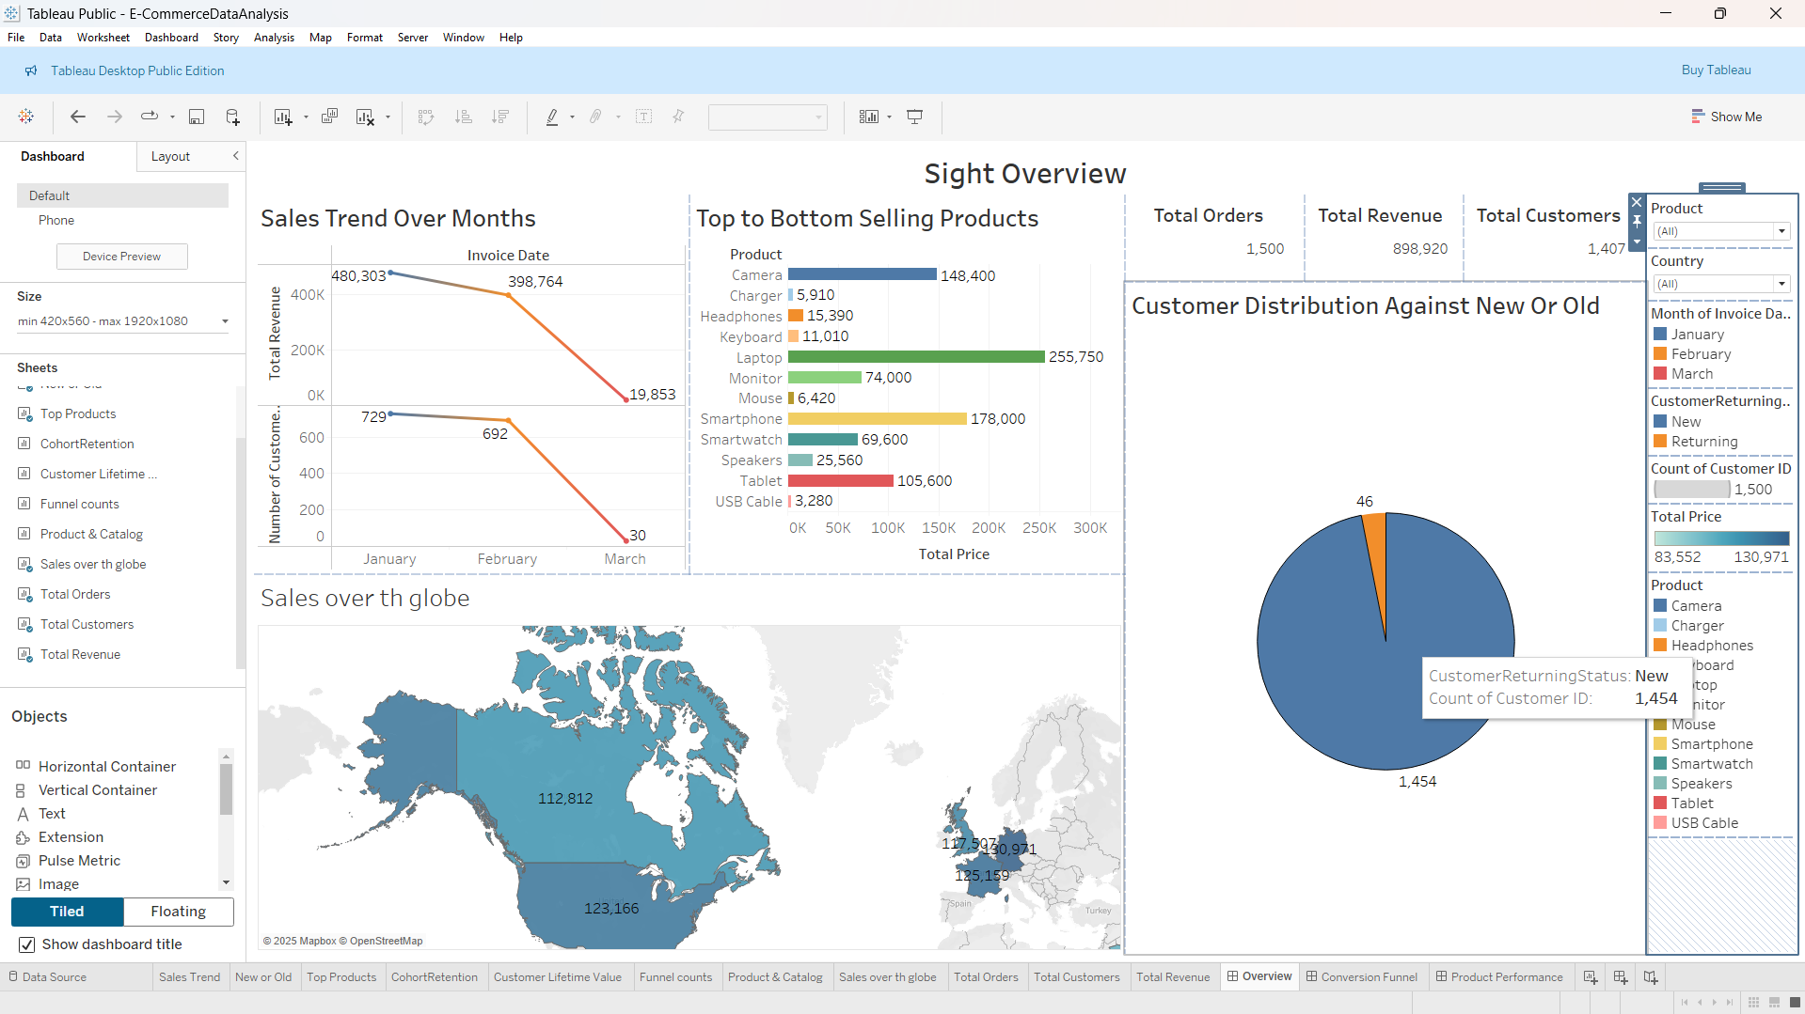
The Overview Dashboard covers three months of sales—January, February, and March—and highlights money made, items sold, customer habits, and where buyers are from.
On the top left, Line Chart Shows Revenue coming in from sales each month.
Things began off well in January. The store earned a sale of approximately up to 480,000 dollars and dispatched approximately 729 bills. February continued very well, and sales fell to about $399,000 and less, and 30 bills received, but March was hard--sales were down to about 20,000 or so, with 20 bills received. The lines curve in, as one would slide down following a nice climb. The store had made a bigger fortune initially but it ran out of steam. The sum of money spent in all the three months amounts to approximately 990,000. They received a total of 1,500 orders and attended to 1,407 buyers.
The multicolored pyramid of bars, Rank products by the most popular to the least. The amount of money that item was able to fetch is indicated in each of the bars, with the small numbers indicating the number sold.
Keyboard (shown in green) is the most selling product. It made the most money at $256,000 from selling 11,110 pieces. Smartwatch (yellow) Close behind at $178,000, with 69,600 sold. USB Cable (red, tiniest bar) Is the worst selling product
The Pie chart shows the big blue slice (about 73% of the pie) is for new customers: 1,061 first-timers. The smaller orange slice (27%) is for returning customers: 394 loyal who shopped again.
The Map shows over sales over the globe and Canada is the most profitable country.
Conversion Funnel Dashboard
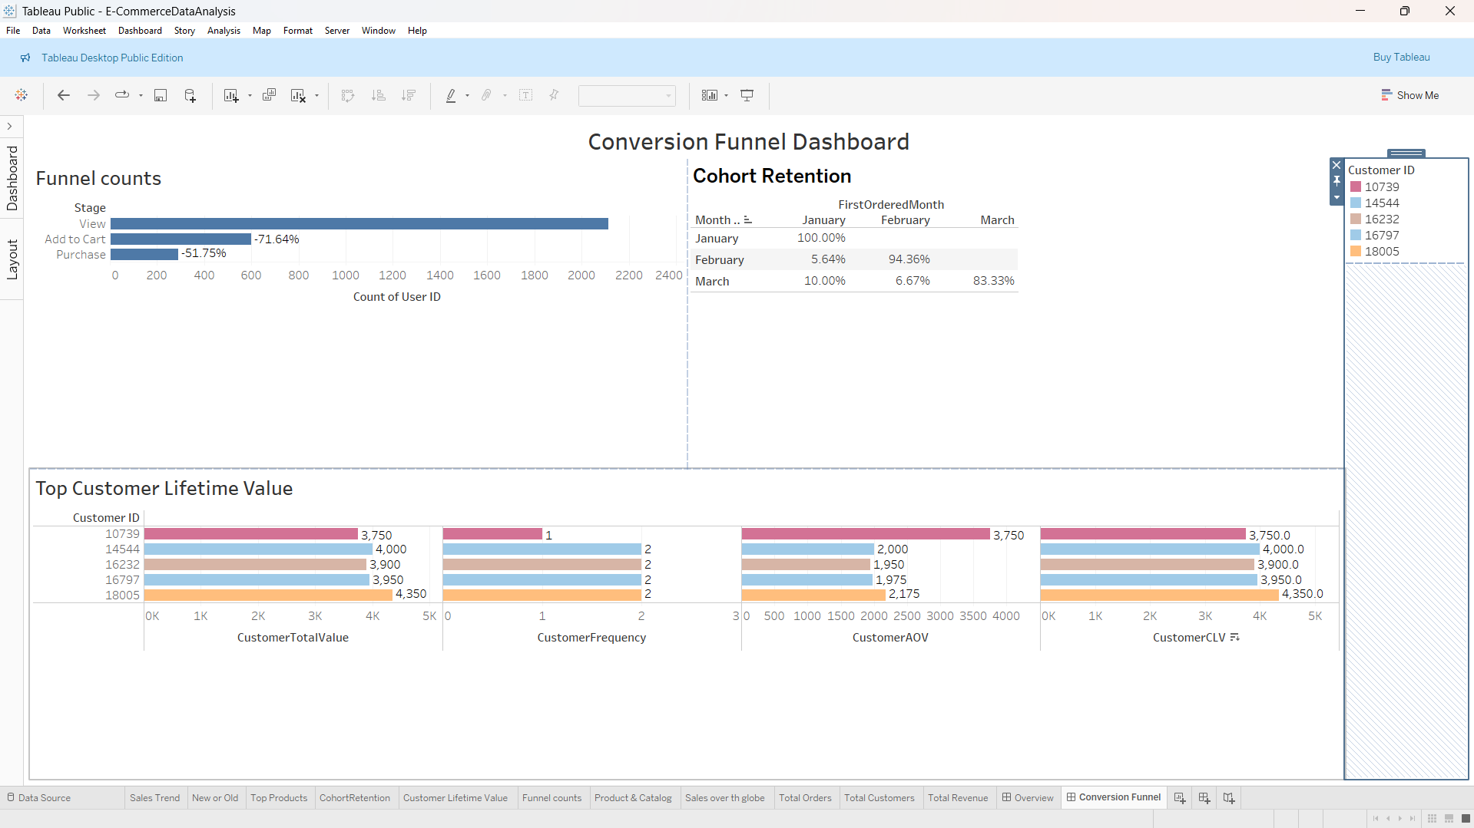
The Dashboard shows the steps from looking at items to buying them, how groups of new shoppers keep coming back each month, and the top customers who spend the most over time.
Based on the funnel counts the frequency of a product shifting to add to cart to buy. It starts with approximately 1,600 individuals visiting the products. More than 50 per cent of them near 914 items and place them in their online shopping cart. Out of which 655 finishes up and pay, approximately 72 percent of the basket fillers. That is a nice figure, but it is leaving off some customers who get excited and bailed at the checkout, perhaps on noticing prices are higher or it is because they get busy.
The following table is on customer loyalty based on the time of joining. It is a tracking of what share is reclaimed the following month/two. Of the large group that began in February, 3622 of them strong almost 60 percent rebuys immediately, followed by about half of those, in the second follow-up month, and peculiarly by 83 percent in the third (a fun sale, perhaps, made them). The smaller group in March group disappears faster: only 10 percent of the group made a first-time return, 7 percent second, and 83 percent following thereof. It is obvious that early joiners are not going to leave earlier, as old friends, and that the new ones would require greater encouragement to visit again. It is a minor fall, all in all, not a huge loss, giving the store an opportunity to establish habitual followers.
The Bottom bar chart Highlights the eight largest spenders by the amount of money they have dropped into the cashier, as well as the number of times they have visited. The highest, customer 3079, spent $3,750 in a single visit most likely took many items in one fell swoop. Two, 3687, also used $3,500 in a single ride. Some others such as 2579 at $3.00 also did big one offs. Nonetheless, others are more consistent: customer 7 spent 3.5 thousand and ID 1 paid 1.850 in four and two visits, respectively. The bars are expanded to indicate dollars (up to approximately 3750) and dots are used to indicate visits (primarily one to four). It amounts to more than 20,000 through these stars, yet the majority of them are flashy first-time buyers, rather than ordinary shoppers.
Product Performance Dashboard
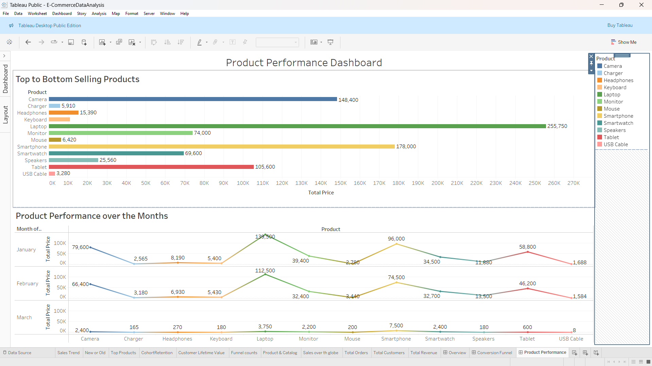
Tech-Zone gadget store report page is a concise product description with the sellers listed by the amount of cash and the ups and downs of each seller within three months. Cameras predominantly lead in the top bars with 5,910 sales at the top, at $148,400; monitors are at the top with 6,420 sales at $74,000, smartphones are at the top with 6,420 sales at $178,000 and tablets are at the top with 6,420 sales at 105,600. The cost of speakers is increased by $69,600 though headphones (15,390 of tons sold) and USB cables (10,500 of 3280) are the cheap extras.
Wiggly lines under trace monthly cash: January had cameras bursting with only 79,600, smartphones with only 58,800, monitors only 39,400. February varied - monitors were higher at $112,500, key boards were higher at $74,500, chargers were lower at $3,180. March was very bang on: the majority of less than $3,000, such as cameras $2,400 and tablets $600, were indicative of slumping sales. Conclusion: Use camera and phone hits to win, but correct the slump in March with advertisements or offers, such as a stand with stars shining in the morning but requiring power to remain relevant.
Problem Findings after analysis
1. Sales Collapse in March
Revenue fell from $480K → $399K → $20K, which is a drastic drop.
Possible reasons:
- Low marketing activity
- Low stock
- Website issues
- Seasonal changes
2. High Funnel Drop-Off
From 1,600 viewers:
- Only 914 add items to cart
- Only 655 complete checkout
This means nearly 60% never purchase.
Possible reasons:
- Price shock
- Shipping cost
- Checkout friction
- Long forms
- Lack of discounts
3. Returning Customers Are Very Low
Only 27% were returning buyers.
Business is mostly running on one-time customers, which is risky.
4. Product Performance Is Uneven
- Some products (Cameras, Smartphones, Keyboards) generate huge sales.
- Cheaper items like USB cables or chargers sell much less.
- Some products show high stock but low revenue contribution.
5. March Product Revenue Crash
Nearly every category dipped in March, meaning:
- Poor promotions
- No campaigns
- Customers not engaged
6. Heavy Dependence on a Few Customers
Top 8 customers contributed $20,000+, but most are one-time big spenders.
Recommendations
1. Fix the March Sales Decline
- Launch seasonal promotions or bundle discounts.
- Improve product visibility on home page.
- Activate email marketing for existing customers.
2. Improve Funnel Conversion
- Add discount coupons during checkout.
- Reduce form fields (one-page checkout).
- Show shipping charges earlier.
- Offer Buy Now quick checkout option.
3. Increase Returning Customer Rate
- Launch loyalty program (points, rewards).
- Send personalized emails based on past purchases.
- Offer returning-customer coupons.
4. Address Low-Performing Products
- Improve product descriptions and images.
- Offer bundles (Cable + Charger + Earphones).
- Reduce price slightly for cheaper accessories.
5. Prevent Over-Dependence on High Spenders
- Build a stronger middle-tier customer base.
- Encourage repeat purchases for small buyers using small discounts.
6. Strengthen Category Winners
- Promote cameras, smartphones, monitors as featured items.
- Add comparison charts or highlight “Best Seller” badges.

Developing website with Lovable AI
We have created the website using Loveable AI named “Tech-Zone Gadgets”. Which is specially for selling online smart gadgets Including headphones, smart-watch, keyboards, mouse and other tech products. For Prompt we have used ChatGPT and it creates a stunning website. We also made some Visual Edits According to our required Need.
The website has a Home page with a Carousal Image and Reviews of Programs and the Main Menu Includes Home, About, Products & Contact Page. It also includes the feature of login and cart. The Website Shows each page of product separately. All Data is sample and generated from Lovable.
Website Link: https://techzone-galaxy-showcase.lovable.app/
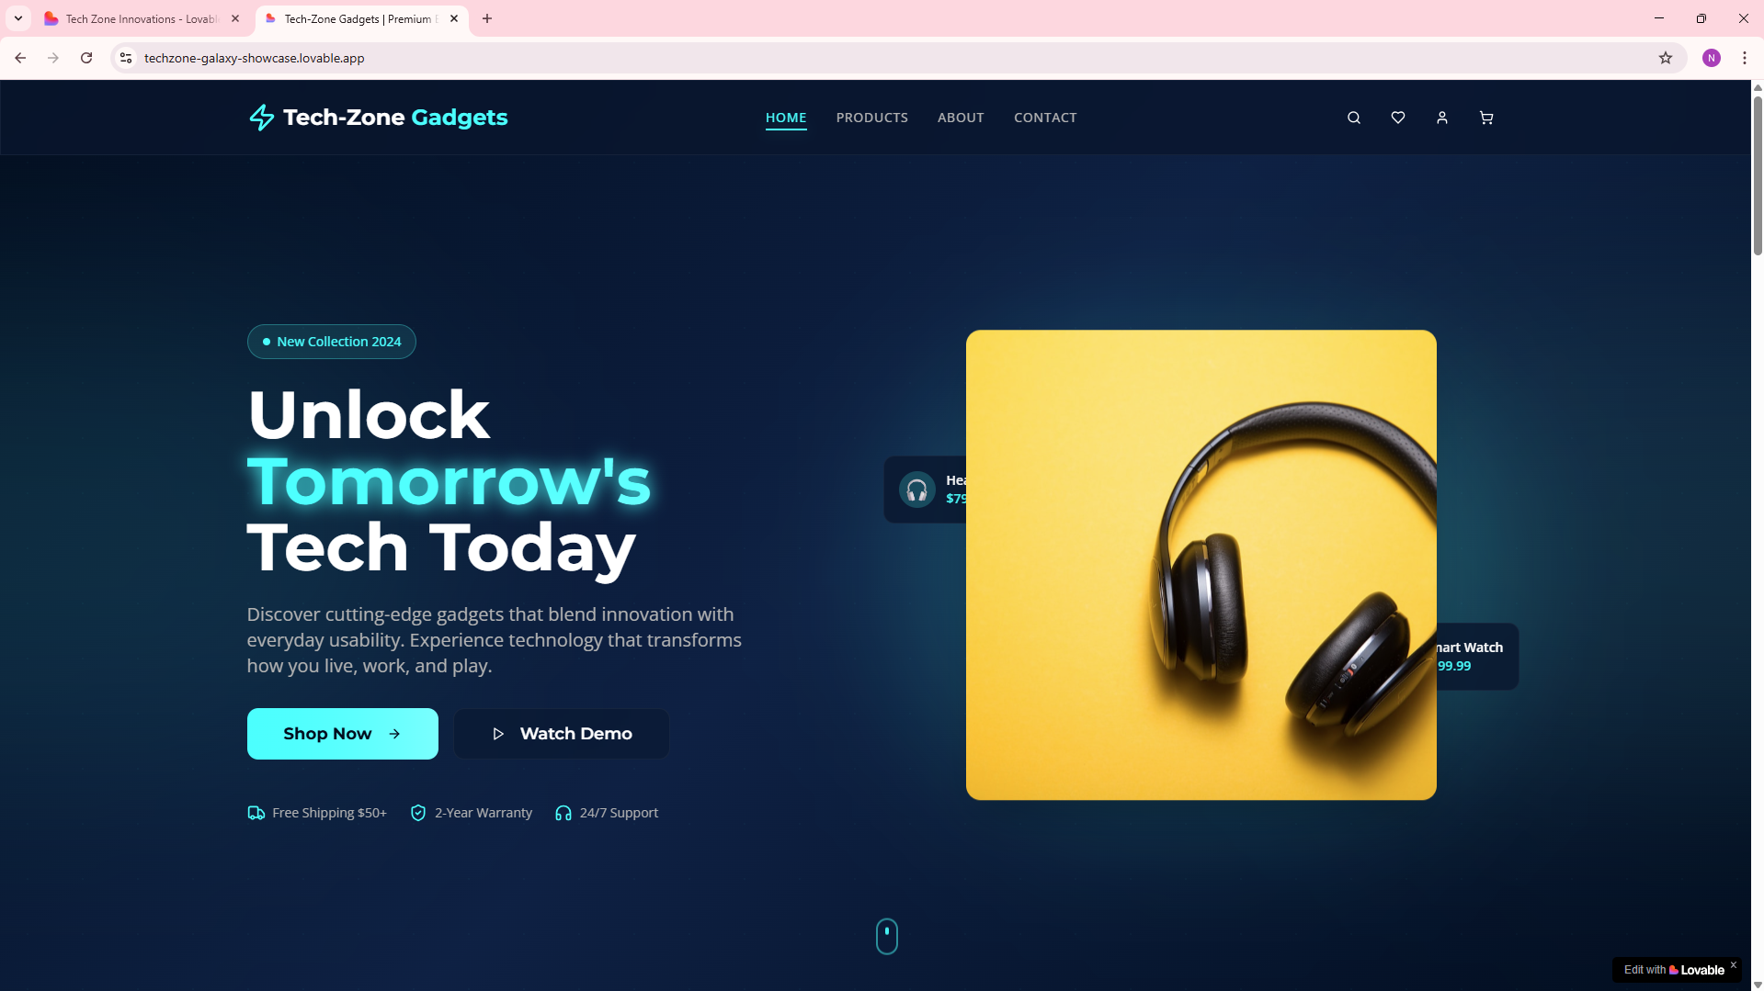
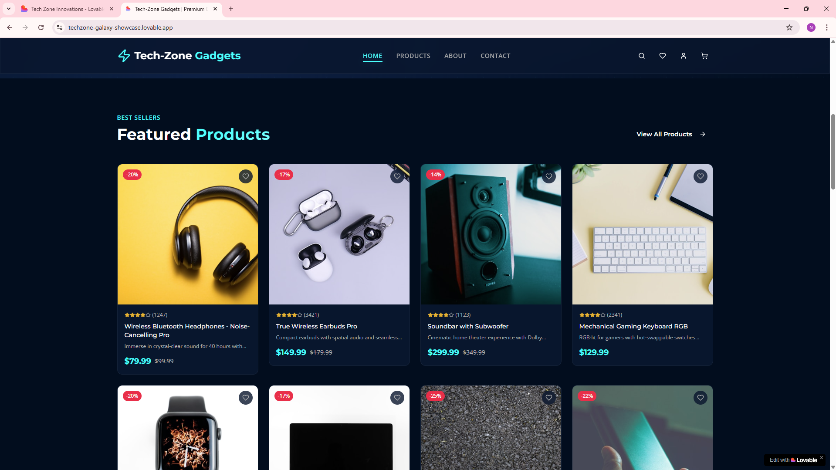
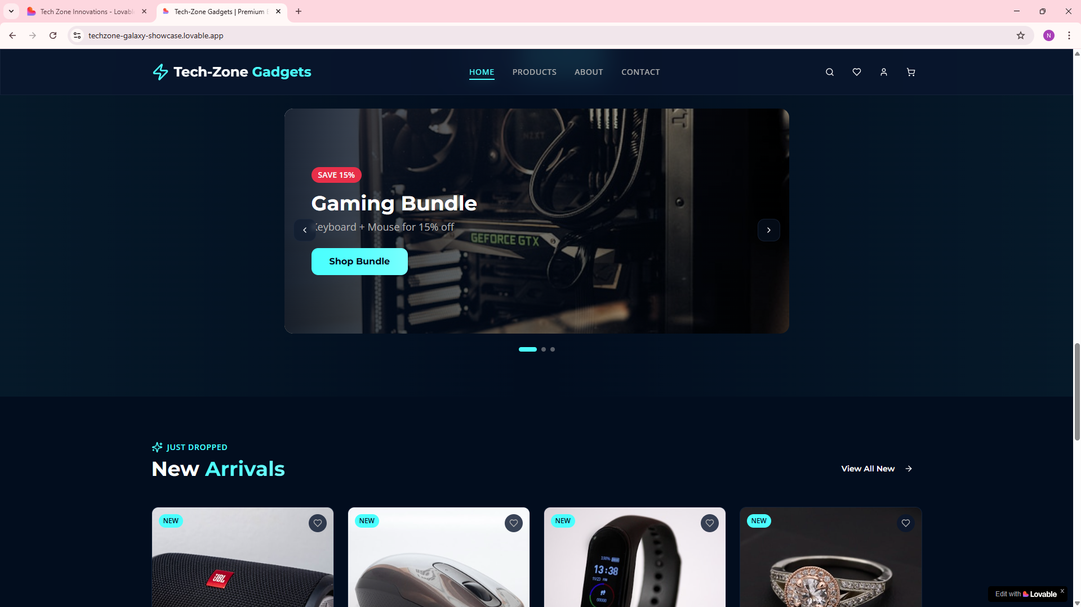
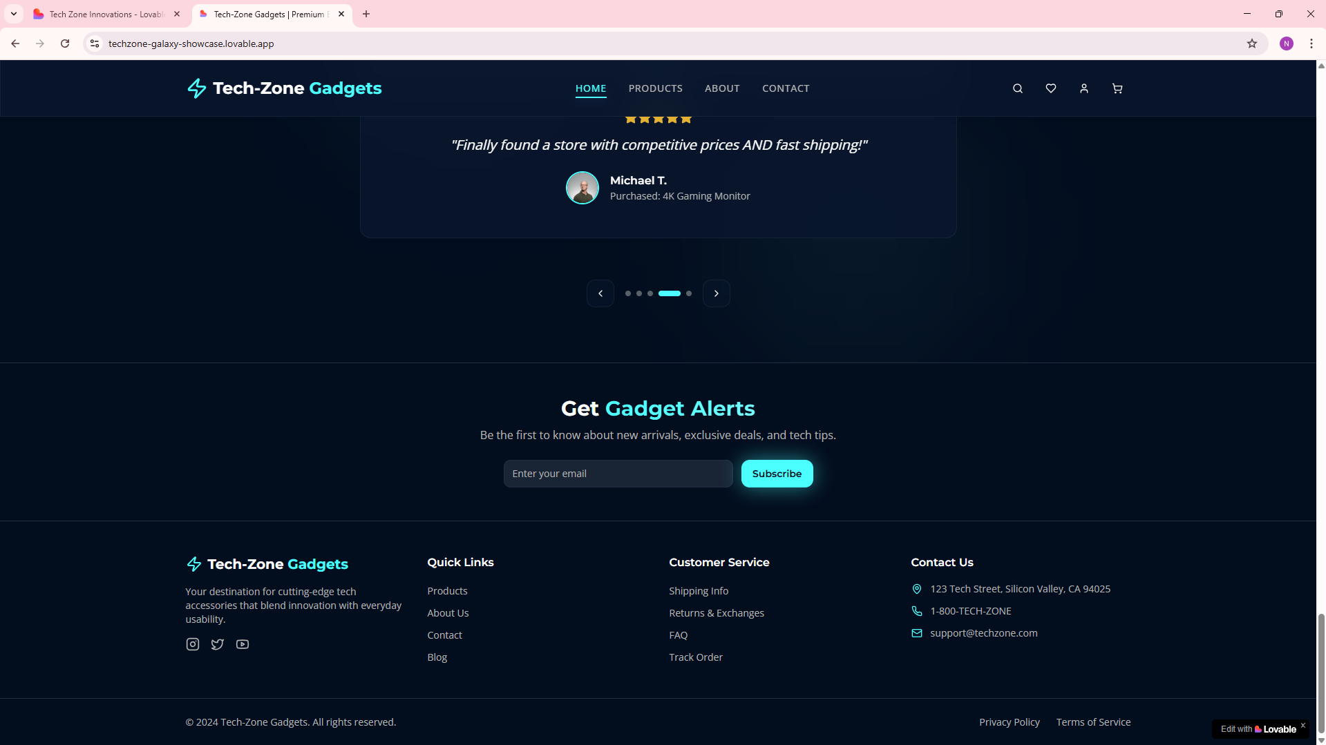
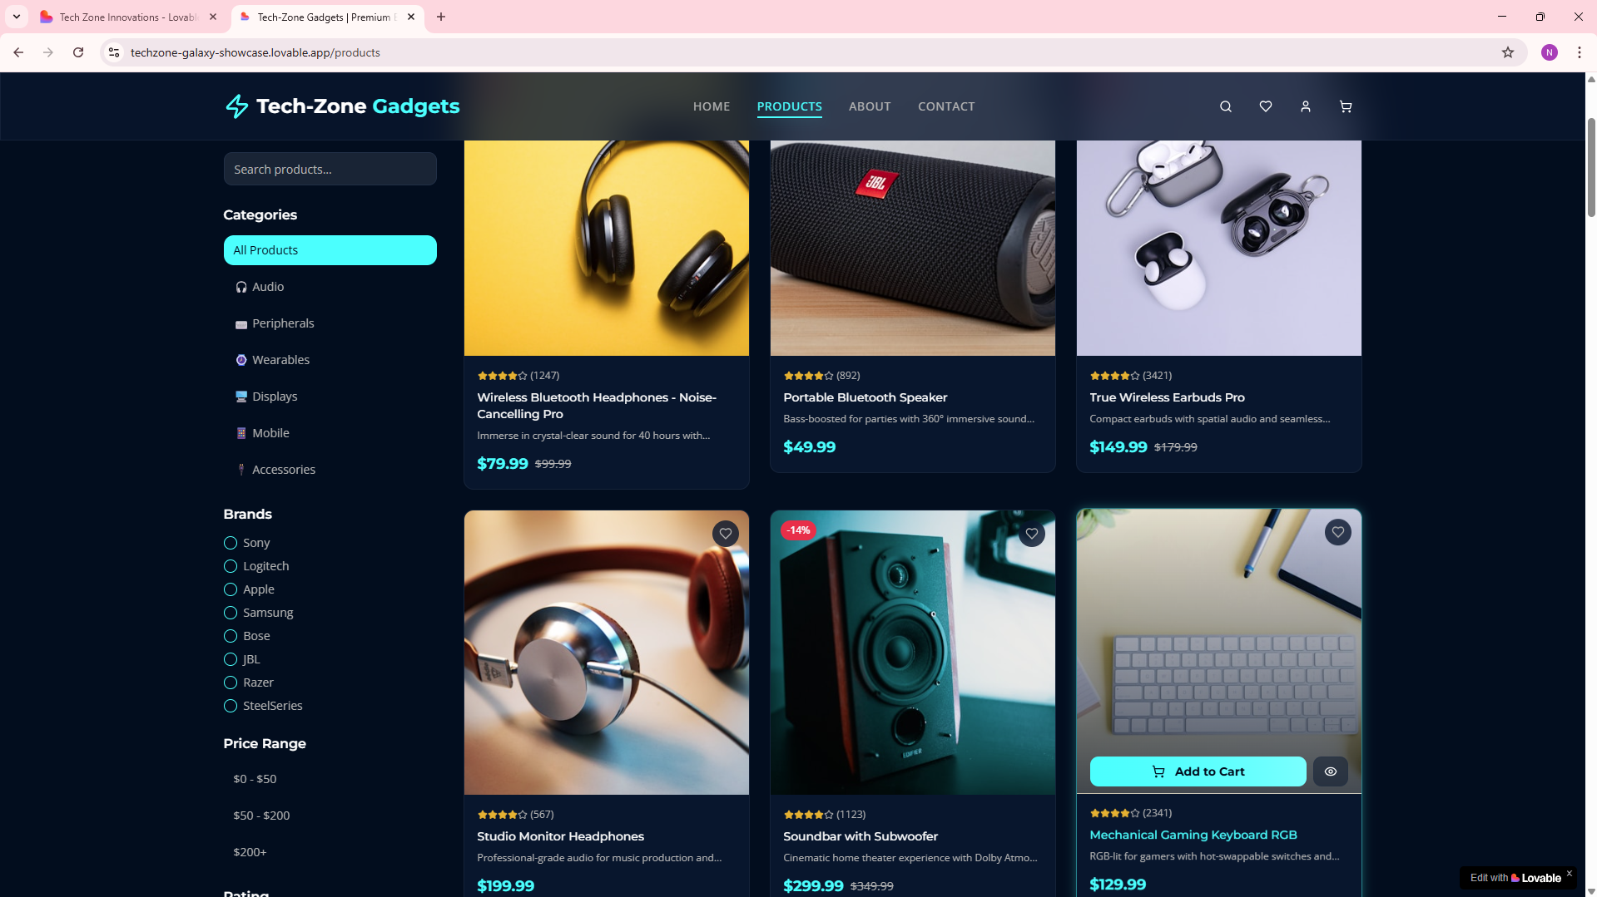
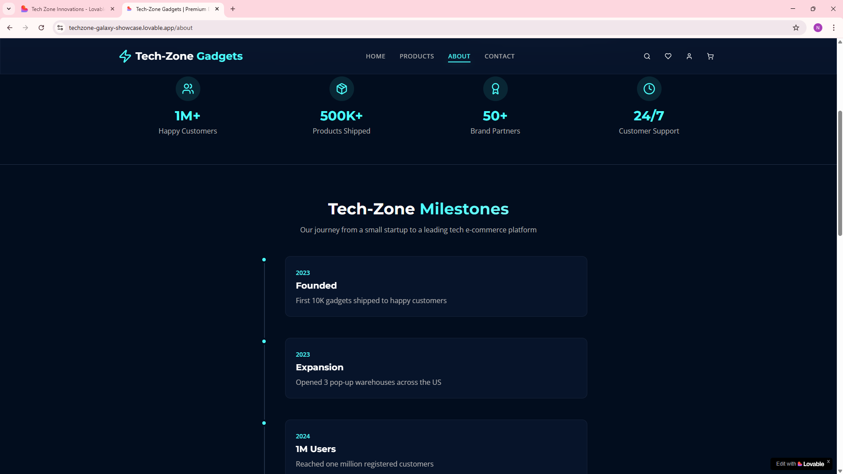
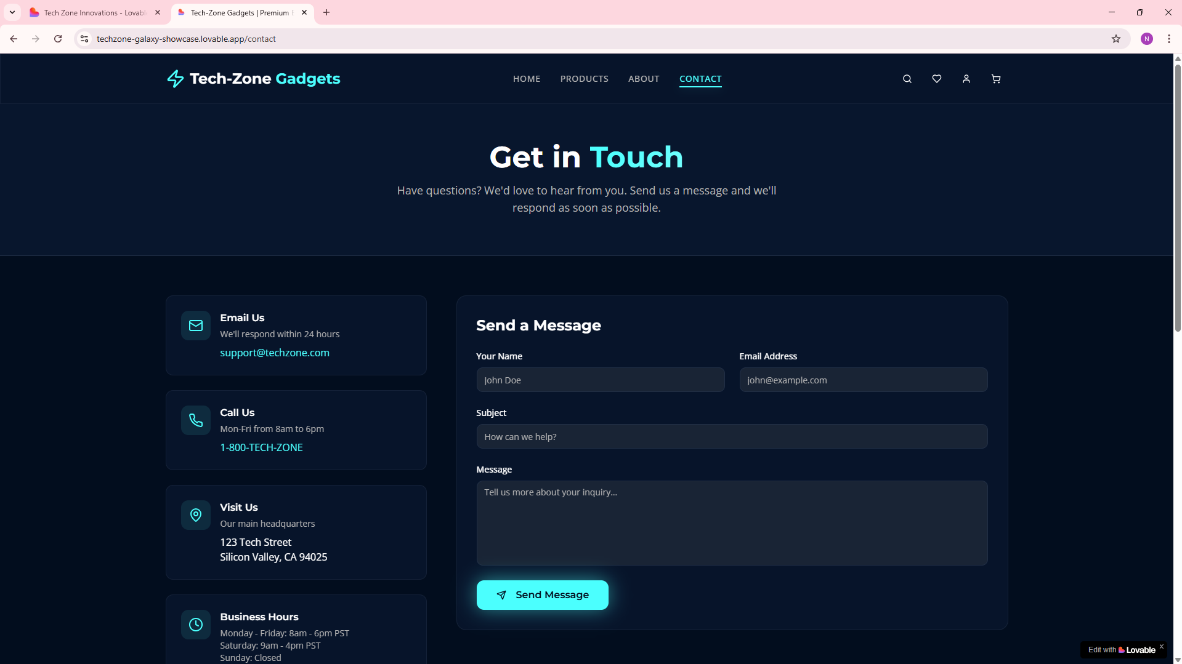

Group Member | Responsibilities | Description of Work
Dana | Data Acquisition & Cleaning Lead | - Load both CSV files into Tableau.  - Verify and correct data types (dates, numbers, strings).  - Handle missing values (CustomerID, EventType, etc.).  - Standardize formats (InvoiceDate → datetime, EventTime → datetime).  - Create calculated fields such as TotalPrice (if missing) and Month/Week fields.
Daman | Retail Sales Dataset Analyst | - Work only on online_retail_easy_dataset.  - Create time-series charts for orders & revenue (daily/weekly/monthly).  - Identify top-selling products & revenue trends.  - Build KPIs like AOV (Average Order Value) and Revenue per Customer.  - Prepare visuals for Dashboard 1 (Sales Overview).
Reem | Customer Behavior & Funnel Analyst | - Work on ecommerce_customer_behavior dataset.  - Build funnel stages: view → add_to_cart → purchase.  - Calculate stage-wise conversion rates.  - Identify drop-off points.  - Create cohort analysis for user retention (based on EventTime).  - Prepare visuals for Dashboard 2 (Conversion Funnel).
Layan | Product Performance & Segmentation Analyst | - Analyze product performance across both datasets.  - Identify high views but low purchases (conversion issues).  - Create geo segmentation (country-wise performance).  - Create customer segments based on buying behavior.  - Build cross-sell or frequently-bought-together charts.  - Prepare visuals for Dashboard 3 (Product Insights).
Zainab | Documentation + Final Tableau Workbook & Presentation | - Combine all dashboards into a single Tableau workbook.  - Format dashboard layout, filters, and interactivity.  - Write ETL explanation, methodology, insights, and conclusions.  - Prepare final PowerPoint/Report for submission.  - Ensure consistency of colors, legends, and formatting.

