Epitopemap: Visualise MHC binding predictions

Table of Contents
- Running predictions
- Viewing predictions
- Genome wide analysis
- Eptiope conservation
- Administration
- Installation
- For Programmers
- References

Background
This is a web interface for running and visualising epitope predictions (currently MHC binding) and allow integrated analysis for entire proteomes. The application is built on the web2py platform.

Running predictions

Submission page
The binding predictions are made by submitting jobs via the submit form. Jobs are queued and run in the background using the web2py scheduler system and are run consecutively. However it is possible to create multiple workers when web2py is started and thus multiple queues. You could do this if you are using a computer with multiple processors and want to make better use of them.
The time taken depends on the number of alleles, number of proteins and the prediction method. Tepitope is fastest and will take less than 15 minutes to do a genome with ~4000 proteins for each allele. NetMHCIIpan will be noticeably slower.

Methods
The Tepitope method is our own Python implementation of TEPITOPEPan and requires no external program to run. netMHCIIpan must be downloaded separately from the website and installed on your system. The process is quite simple. The same applies for the IEDB tools. Both of these tools are free for academic use but we do not distribute them with this app. Here are the available methods with download links for external tools:
- TEPITOPEPan (NO download required).
- NetMHCIIpan
- IEDB tools
- Threading (an untested method)

Selection of alleles
Selection of which alleles to run will be entirely dependent upon the end results required. Users must have a particular goal in mind when making predictions. Simply using all alleles will NOT be helpful and will be very slow since there are so many human alleles.
Some alleles are not available for all methods and will be ignored for those methods. MHCII DP and DQ alleles are for netMHCIIpan only.

How predictions are stored
Storage of results uses a very simple method. Results run via the web app are simply added to the database recording an identifier. All results are then stored according to the label/identifier with one directory per genome and then a folder for each prediction method. Inside this is a file for each protein prediction as follows. Each file is stored in MessagePack format, which is a binary format for efficient storage). Data is stored in this way so that results can be quickly loaded for a specific protein. Example:
../static/results/identifier/genome/method/locus_tag.mpk
e.g:
../static/results/testresults/Mbovis/tepitope/Mb0012.mpk
This example is for tepitope prediction data for the protein Mb0012 in Mbovis. All results are stored in the static/results folder of the web application.

Adding sequences
Before predictions you need to add your proteins/proteome to the application. Annotated protein sequences are added as either fasta, embl or genbank format. Usually these will represent the annotated sequences of a species but any properly formatted file can be used that groups the proteins together. Genbank format files for an organism can be found on the NCBI genomes page or downloaded via ftp.
The program will use the locus tags in the genbank file for each protein. If these are not available the gene names are used. For fasta inputs the identifier following the ">" is used. Genbank or embl format is recommended since fasta files can have non-standard or confusing ids like gi|31563518|ref|NP_852610.1| which is not very user friendly. Fasta files do not contain features present in genbank format such as gene product or location that can be useful for identifying the protein. Improperly formatted files may not work.

Viewing predictions
Every set of predictions for a genome (or maybe just a group of protein sequences) has an identifier associated with it. This is simply a string identifying a set of binding predictions run with the same parameters, e.g. a specific set of alleles. This 'prediction id' simply groups your predictions together in the same folder and can be helpful to separate your predictions from another set if you are working on the same proteins. So if you want a different set of predictions for the same proteins then create a new label/id.

Quick view
This is the usual method for viewing results. It consists of a form on the left side which updates the results on the right panel of the page when the 'update' button is pressed. The id,genome and required protein tag must all be entered correctly.

Binding prediction plots
Predictors will usually make multiple scoring predictions for each allele for an n-mer set of binders. This information can be hard to display in a single plot. The purpose of the plot is to allow the user to quickly visualise where epitopes might be along the sequence and compare all alleles and different methods in one plot. The default representation is a set of tracks with bars representing predicted binders for each allele ordered by position on the sequence as shown below. Plots can be zoomed in and out and panned left right.

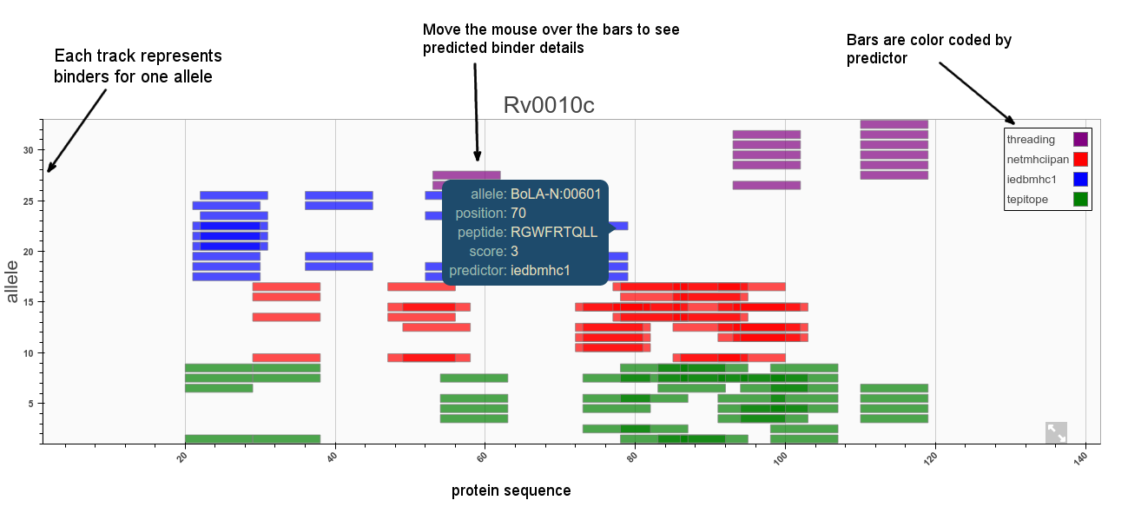
Cut-offs/thresholds
Selection of predicted binders can be done based on the percentile rank or MHC binding affinity (or whatever score is a proxy for binding). It has also been shown that absolute binding affinity threshold correlates better with immunogenicity and MHC allele-specific thresholds should be used to improve correlations. For MHC-II the IEDB currently recommends making selections based on a consensus percentile rank of the top 10%. See this iedb help page for more information.

Using fixed URIs
http://localhost/epitopemap/default/protein/results_bovine/Mbovis/Mb0012
The protein URIs are structured so that they can be entered in the address bar if required. However the easiest way to find and view predictions for a known protein name is via the quickview page which has form for entering the protein details and a few other options.

Genome wide analysis
This page performs an analysis of all proteins to find the top binders found in n alleles. A global percentage cutoff can also be chosen. This allows a quick overview of the proteins with highest percentage of binders and those with epitopes that cluster together. The result is a table that can be sorted according to various metrics such as the number of binders per unit length of each protein or the number and density of epitope clusters.
Explanation of results table columns:
- mean: mean score for binders in that protein
- size: number of binders found in protein
- amax: max score
- length: length of protein
- order: order in genome annotation (for genbank files)
- perc: percentage of binders per protein length
- density: highest density epitope cluster found
Two additional tables showing the top peptides and clusters are also produced.

Epitope conservation analysis
This interface allows you to get an estimate of how well conserved a predicted epitope is across a given set of sequences at a certain identity level.
Orthologs for the sequence are first retrieved using an online blast. This can take up to several minutes but results are saved for later use. Once the alignments are returned the conservation of each epitope can be calculated. This is defined as the percentage of sequences where the epitope is present out of the total aligned. The set of sequences can be chosen based on a desired identity cutoff or taxon specification. For example, the sequences may constitute all orthologs within a bacterial species or just a set of strains.

Results

BLAST options
Our method uses the NCBI online Blast service to retrieve orthologous matches. By default all matches are retrieved with an expect value lower than 10 and the sequences can then be filtered by percentage identity. It may be preferable or necessary to refine blast queries to narrow down the sequence set to a specific taxon or species.
This can be done using the entrez query text box (empty by default). This restricts the search to a subset of entries from the nr protein database fitting the requirement of the Entrez query. For example, to restrict the results to Actinobacteria we would use: txid201174[ORGN]. See this page for more information.
The following field names may be useful:
- ALL, All Fields, All terms from all searchable fields
- UID, UID, Unique number assigned to each sequence
- FILT, Filter, Limits the records
- WORD, Text Word, Free text associated with record
- TITL, Title, Words in definition line
- KYWD, Keyword, Nonstandardized terms provided by submitter
- AUTH, Author, Author(s) of publication
- JOUR, Journal, Journal abbreviation of publication
- VOL, Volume, Volume number of publication
- ORGN, Organism, Scientific and common names of organism, and all higher levels of taxonomy
- ACCN, Accession, Accession number of sequence
- PACC, Primary Accession, Does not include retired secondary accessions
- GENE, Gene Name, Name of gene associated with sequence
- PROT, Protein Name, Name of protein associated with sequence
- ECNO, EC/RN Number, EC number for enzyme or CAS registry number
- PDAT, Publication Date, Date sequence added to GenBank
- MDAT, Modification Date, Date of last update
- SUBS, Substance Name, CAS chemical name or MEDLINE Substance Name
- PROP, Properties, Classification by source qualifiers and molecule type
- SQID, SeqID String, String identifier for sequence
- GPRJ, Genome Project, Genome Project
- SLEN, Sequence Length, Length of sequence
- FKEY, Feature key, Feature annotated on sequence
- ORGL, Organelle, Organelle

Administration

Paths to binaries
The IEDB tools and/or netMHCIIpan distributions are required to be installed locally for the web application to use them. To ensure that these programs can be found you can the path to the install folders here.

Add/remove genomes
See the instructions for adding sequences above.

Add/remove predictions
A row with the identifier is added to the database whenever a set of predictions is submitted with a new id. Therefore this menu is normally only used to delete old predictions. Old results should then be deleted manually from the filesystem.

Starting the server
The server is started by typing the following command from inside the web2py folder:

sudo python web2py.py -i localhost -a 123 -p 80 -K epitopemap -X

Installation
This application has been built and tested on the Ubuntu Linux operating system. web2py and the required Python dependencies are available on both Windows and Mac OSX also but these have not been properly tested yet. We therefore currently recommend running this web app on a linux OS. The following steps:
- Install web2py, which can be downloaded here
- Unzip web2py and place in the folder where you wish to run it
- Download the epitopemap files here
- Unzip epitopemap and place under web2py/applications
- Start the server as outlined above
- Go to http://localhost/epitopemap in your browser

Python dependencies
Setup currently requires you to install the Python libraries yourself. This is a cleaner approach rather than providing them with the application and is simple on linux.
On Ubuntu type the following on the command line to install the Python modules:
sudo apt-get install python-pip
sudo pip install numpy pandas matplotlib biopython

For Programmers

Python mhcpredict library
The Python Predictor class and other modules used to implement the prediction routines are available at this github page. It is possible to implement other prediction methods using these classes and add them to the web application. See instructions on the github page.

References
The following papers provide some background to the field:
- The utility and limitations of current web-available algorithms to predict peptides recognized by CD4 T cells in response to pathogen infection. Chaves et al. J Immunol. May 1, 2012; 188(9): 4235–4248. link
- Predictions versus high-throughput experiments in T-cell epitope discovery: competition or synergy? Expert Review Vaccines, 11(1), 43–54. Lundegaard et al. 2012. link
- Development of an epitope conservancy analysis tool to facilitate the design of epitope-based diagnostics and vaccines. BMC bioinformatics 8, 361 (2007). Bui et al. link
- HLA class I alleles are associated with peptide-binding repertoires of different size, affinity, and immunogenicity. Journal of Immunology 2013, 191(12):5831-5839. Paul et al. link

