1. Create a public/private key pair for myNewRepo
   1. $ ssh-keygen –t ed25519 –C “name@gmail.com”
      1. Answer the “Enter file in which to save the key” prompt with:
         1. /c/myGitDir/myKey
      2. Answer the “Enter passphrase (empty for no passphrase) prompt with:
         1. An empty enter keyboard press (enter nothing)
         2. Repeat for “Enter same passphrase again:”
2. Verify that you have a randomart image such as:

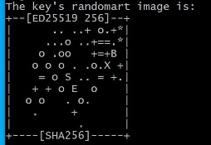

1. Copy the public key to myNewRepo (your remote repo on Github.com)
   1. Goto the directory where myKey.pub is located
   2. $ cat myKey.pub
   3. Using your mouse, copy the public key by selecting the text starting with ssh-ed25519 and ending with your Github email into the Windows clipboard. Select with your mouse, then right-click and choose copy from the fly-out menu. (alternatively: ctrl+shift+C to copy selected text into keyboard)

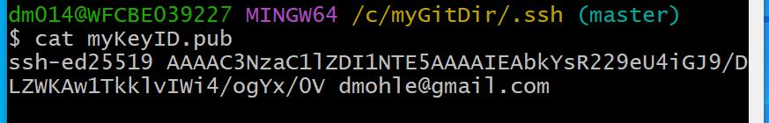

* 1. Goto Github.com and find Settings/Security/Deploy Keys for your repo named myNewRepo
  2. Paste the public key that you copied from your local machine into Github’s Deploy keys / Add new Key textbox.

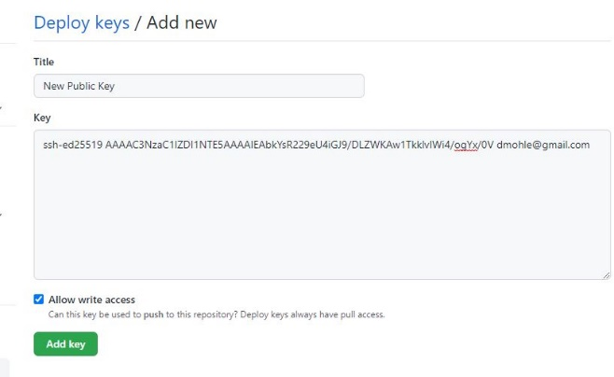

1. Tell Git where your private key is located
   1. Use these bash commands on your local machine
      1. $ eval “$(ssh-agent –s)”
      2. $ ssh-add /c/myGitDir/myKey
2. Validate your new installation with a clone
   1. Change “dmohle” to your Github user name.
      1. You may also copy the SSH clone argument from Github.

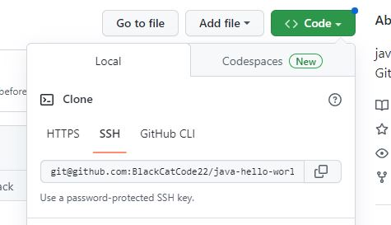

* + 1. $ git clone [git@github.com:dmohle/myNewRepo.git](mailto:git@github.com:dmohle/myNewRepo.git)

1. Validate your new GitHub connectivity with a push
   1. Access your new repository folder and add a file (or two) to the directory (you can do this with the Windows file system explorer or use Git Bash to find it
   2. While in your local Git repo (the directory that looks like /c/myGitDir/myNewRepo) run the Git Bash commands:
      1. $ git add .
      2. $ git status
      3. $ git commit –m ‘a message from you’
      4. $ git push –u origin main