3esi Project

# Scenario

3esi-Enersight is building a new tool to help import entities into our applications. The design calls for a system that can import a comma separated value (CSV) file containing the relevant entity information. A summary of the import should be created, informing the user of any successes and failures during the process. The import should not terminate if a business rule is violated.

# To build and execute the code project

* Please open **Daniah_3esi** main project folder
* To run the project from visual studio 2017, open the project solution **3esi.sln**
* Ensure that **3esi_ConsoleApp** is set as the StartUp project. If not, right click on that project and set it as the start-up project by selecting “Set as StartUp Project”
* CTRL+F5 to run the project or F5 to start a debugging session
* To run the test project, right-click on **3esi.Tests** project and select “Run Unit Tests”

# Screen Shot of Output

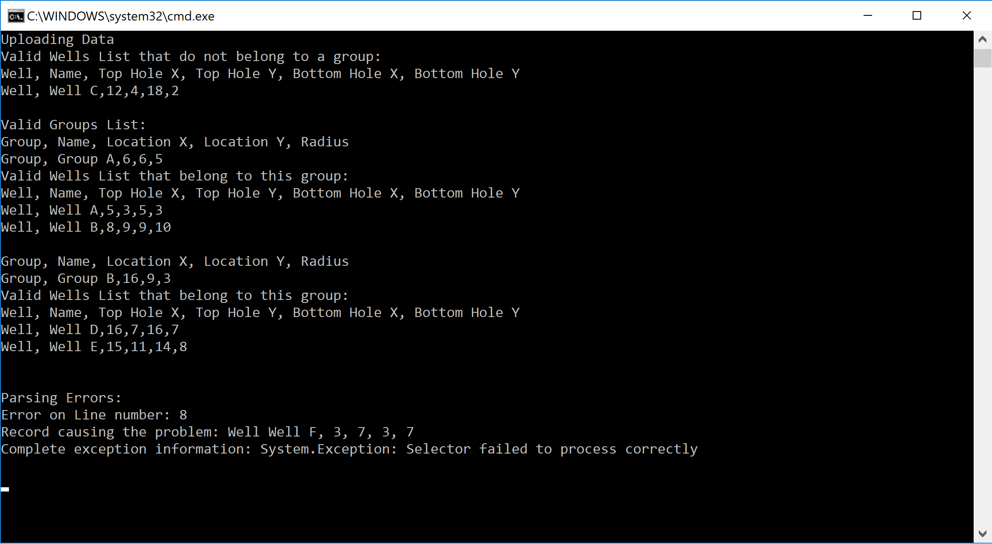

# Solution Structure

* Create a class library named **3esi_BusinessLayer** that parses and applies the business rules.
* Create a console application named **3esi_ConsoleApp** that takes the file name from the user and prints out the results.
* Create a unit testing project to test the functionalities for 3esi_BusinessLayer project named **3esi.Tests**

# Functional Requirements

Write a program that:

Parses inputted csv file:

* + Comma separated
  + Has 2 Types: Well and Group
  + Order of parsing does not matter
  + Names are unique across both wells and groups in the processed file
  + Locations are unique in each type
  + Groups cannot overlap
  + A well is considered a child of a group if the well’s top hole location falls within the area of the group defined by its radius
  + The well type is determined by the distance between the top and bottom hole locations with the following tolerances:
    - Vertical: 0 – 1
    - Slanted: 1 – 5
    - Horizontal: >=5
  + Log errors

# Design Decisions & Assumptions

* Used **FileHelpers** (<https://www.filehelpers.net/download/>) C# Nuget package to parse the files (proven to be fast and reliable)
* Reading only 1 file at each run (for simplicity and demoing the functionality needed)
* csv file is included in Daniah_ConsoleApp/UploadedFiles/3esi.csv
* use the provided csv titles to create the record modeling classes
* Because this is a multi-record csv file, it is not read as an asynchronous file so the performance might be affected for large csv files
* Assumption for the well type that “slanted” includes 1 but vertical does not based on the last condition “horizontal” which includes 5
* Assumption for overlapping group we will keep the first group and all others that overlap with it will be added to error list
* Display output
  + Wells that do not belong to a group
  + Groups and their children wells
  + Parsing Errors
  + Business Rules Errors