EXECUTIVE AI
OPERATING SYSTEM
Coding Agent Build Planner
A detailed implementation specification and storyboard for an executive-first interface layer over Hermes Desktop.
Primary design objective
Make powerful AI orchestration feel clear, governable, and usable by an executive without exposing the full complexity of the Hermes Desktop runtime.
Prepared for engineering and autonomous coding agents

1. Purpose of This Document
This document is written as an implementation planner for a coding agent and the engineer supervising the build. It converts the Executive AI Operating System storyboard into a structured set of product requirements, technical boundaries, data contracts, component responsibilities, state transitions, build phases, test cases, and definition-of-done criteria.
Instruction to the coding agent
Treat this document as the product and implementation contract. Build the shell, routes, types, mock state, and testable interaction model first. Do not couple page components directly to Hermes or Composio. All external systems must be reached through typed adapters so the visual layer can be completed and tested even when live APIs are incomplete.

1.1 Product Definition
The Executive AI Operating System (EAiOS) is a clean executive control surface that rides on top of Hermes Desktop. Hermes remains the underlying runtime and system of record. EAiOS translates agent activity, work queues, connector actions, approvals, schedules, knowledge, artifacts, and configuration into an executive-oriented experience.
- It is not a replacement for Hermes Desktop.
- It is not primarily a chatbot.
- It is not a terminal, developer console, or raw agent debugger.
- It is an executive operating surface for seeing what matters, delegating work, monitoring AI staff, approving consequential actions, and understanding what the AI organization is doing.

1.2 Core User Experience
The executive should be able to open the application and understand the operating situation in seconds: what requires attention today, what can be delegated, which AI agents are working, what is waiting for approval, what automations will run next, and what has recently happened.
Question the user has | Where the answer lives
What do I need to work on today? | Today
What can AI take off my plate? | Today → Delegation recommendations
What is my main AI assistant doing? | My Assistant
Which specialist agents are active or lagging? | Staff + Activity Ledger
What external applications are connected? | Connections
What needs my permission before it is sent or executed? | Approvals
What is on my calendar and what will my AI staff run? | Schedule
What context can Ally use? | Knowledge
What reusable capabilities and operating procedures exist? | Skills & Playbooks
Where are the large outputs created by agents? | Artifacts
How much model capacity and budget are we consuming? | Usage
How do I change models, rules, panels, and environment files? | Settings

1.3 Source-Constrained Requirements
The initial concept explicitly requires a persistent right-side operational rail containing scheduled cron jobs, approval items, and an activity ledger. It also requires the ability to edit approved environment .MD and .TXT files, Composio-backed API connectivity, clear separation between 'Staff' as AI agents rather than human users, and an Artifacts area for agent-created outputs that are too large for the chat surface.
Where this document proposes endpoint names, repository structure, TypeScript interfaces, or implementation patterns, those are design recommendations for the build; they are not claims about the current Hermes API. The coding agent must verify actual Hermes integration points before wiring live data.

2. Non-Negotiable Product Principles
Principle | Implementation meaning
Executive-first | Prioritize clarity, speed, prioritization, and decisions. Hide runtime detail until the user asks to inspect it.
Visible orchestration | The user must always be able to tell whether an agent is idle, queued, working, waiting, blocked, completed, or failed, plus the time of its last meaningful event.
Human-controlled external action | External write, send, publish, post, update, delete, payment, or execution actions must pass through an approval gate unless an explicit policy allows the action.
Adapter-based integration | UI components never call Hermes, Composio, calendar providers, vector stores, or model providers directly. All such access goes through typed service adapters.
Right-rail awareness | Cron jobs, approvals, and agent activity remain accessible across primary pages.
Resizable workspace | Left and right panels can be widened, narrowed, collapsed, and restored. Persist the preference per user/workspace.
Auditability | Every material state change writes an event that can be traced to the work item, agent, tool, target, and result.
Graceful degradation | A slow or unavailable agent must not make the interface look broken. Show elapsed time, last event, and recovery actions.
Crisp visual hierarchy | Dark Allygnment-style canvas, cyan as the primary signal, restrained status colors, summary first and diagnostics second.
No secret leakage | Secrets, OAuth tokens, API keys, raw credentials, and provider secrets are never rendered into the UI or activity ledger.

3. Information Architecture and Global Shell

3.1 Primary Routes
Route | Label | Responsibility | Target
/today | Today | Executive work queue and daily summary | MVP
/assistant | My Assistant | Main AI assistant / orchestrator | MVP
/staff | Staff | AI agent workforce, health, model properties | MVP
/connections | Connections | Composio app connections and scopes | Phase 4
/approvals | Approvals | Human approval gate | MVP
/schedule | Schedule | Calendar + AI scheduled work + cron overlays | MVP-lite
/knowledge | Knowledge | RAG source management | Phase 5
/skills | Skills & Playbooks | Reusable agent capabilities and workflows | Phase 5
/artifacts | Artifacts | Large agent-created deliverables | Phase 3
/usage | Usage | Token/cost/limits by agent and model | Phase 6
/settings | Settings | Models, rules, UI, environment files | MVP-lite

3.2 Layout Contract
- Left pane: workspace identity and primary navigation. Resizable, collapsible to an icon rail, hidden behind a drawer on smaller breakpoints.
- Center workspace: active route. Each screen begins with a concise executive summary before diagnostics or detail.
- Right rail: operational watchtower. Contains Next Cron Jobs, Awaiting Approval, and Activity Ledger in that order.
- Top shell: global search, notifications, profile, and any role/workspace selector the host requires.
- All three horizontal regions must be implemented by a reusable AppShell, not duplicated per route.
- Pane widths should persist per user/workspace. Recommended constraints: left 208–360 px; right 280–440 px; center gets the remainder. These are suggested defaults and may be tuned during visual QA.

3.3 Resizable Panel Behavior
Condition | Required behavior
Drag left handle | Update left width continuously; do not cause content jumps or text selection.
Drag right handle | Update right width continuously; center workspace reflows.
Double-click handle | Reset that panel to default width.
Collapse action | Full panel → icon rail; second collapse may hide where appropriate.
Persist | Save width/collapse state after interaction, scoped to user + workspace.
Small screen | Ignore stored desktop widths and use safe responsive defaults.
Keyboard | Provide a non-drag alternative, e.g., keyboard-accessible resize controls or settings values.

4. Recommended Technical Architecture
The storyboard assumes a React + TypeScript + Tailwind UI. If the existing Hermes Desktop frontend uses a different framework, keep the same boundaries and contracts but adapt the presentation layer to the host. Avoid maintaining a separate application runtime unless required by the Hermes extension/skin model.

4.1 Layering Rule
Required dependency direction
Presentation Layer
routes / pages / components / panels
↓
Application State
query cache + UI store + event reducers
↓
Domain Services
approvals / work / agents / schedule / knowledge / usage
↓
Adapter Interfaces
HermesAdapter | ComposioAdapter | CalendarAdapter | KnowledgeAdapter
↓
Host Systems
Hermes Desktop | Composio | Calendar Provider | Vector / RAG Services

Critical coding rule
No page or reusable component may import a Hermes SDK, Composio SDK, calendar SDK, vector database SDK, or model provider SDK directly. The only allowed imports are the project-level adapter interfaces. This keeps mock-mode and live-mode behavior aligned.

4.2 Proposed Repository Shape
src/
app/
AppShell.tsx
routes.tsx
providers.tsx
components/
navigation/
right-rail/
cards/
tables/
status/
dialogs/
editors/
features/
today/
assistant/
staff/
connections/
approvals/
schedule/
knowledge/
skills/
artifacts/
usage/
settings/
domain/
types/
events/
policies/
selectors/
services/
AgentService.ts
WorkService.ts
ApprovalService.ts
ScheduleService.ts
KnowledgeService.ts
UsageService.ts
adapters/
hermes/
composio/
calendar/
knowledge/
mock/
state/
uiStore.ts
eventStore.ts
mocks/
fixtures/
scenarios/
tests/
unit/
integration/
e2e/

4.3 State Management
Use two conceptually separate state channels: server/runtime state and local UI preference state. Agent status, work items, approvals, cron jobs, activity events, connector state, and usage are runtime state. Pane widths, filters, selected tabs, and display preferences are UI state.
State class | Examples | Recommended handling
Runtime / server | agents, approvals, work items, cron jobs, artifacts | Query cache + event updates; runtime is source of truth
Transient UI | open drawer, selected agent, approval inspector | Component/local store
Persistent UI | pane widths, collapse state, default filters | Local preference store or Hermes user settings
Policy/config | approval defaults, model defaults, limits | Read/write through Settings service; audit changes

4.4 Event-Driven Refresh
The interface should consume live Hermes events if available. If Hermes exposes polling rather than an event stream, implement the event interface anyway and let the Hermes adapter synthesize events from polling differences. The UI should not need to know which transport is used.
Event | Meaning
work.created | A work item enters the operating queue
work.updated | Priority, owner, state, due date, or delegation changes
agent.started | Agent begins a request/work item
agent.progress | Meaningful progress or phase change
agent.waiting | Agent is waiting for approval, tool, or dependency
agent.completed | Agent completes work
agent.failed | Agent fails or stops unexpectedly
approval.requested | External or governed action is ready for review
approval.decided | Approve, reject, or request-changes outcome
connector.called | A connector/tool call is attempted or completed
cron.started | Scheduled automation starts
cron.completed | Scheduled automation completes
cron.failed | Scheduled automation fails
artifact.created | A large output becomes available
config.changed | Model, policy, or system configuration changes

5. Domain Model and Type Contracts
Define the shared domain types before building route-specific components. Mock data, real adapters, tests, and UI selectors must use the same interfaces. The exact fields may change when Hermes is inspected, but the semantic objects should remain stable.

5.1 Core Types
type AgentStatus =
| 'idle' | 'queued' | 'working'
| 'waiting_approval' | 'waiting_dependency'
| 'completed' | 'failed' | 'offline';
interface Agent {
id: string;
name: string;
role: string;
reportsToAgentId?: string; // Staff normally report to Ally
model: ModelRef;
availableModels: ModelRef[];
tools: ToolRef[];
status: AgentStatus;
progress?: number; // 0..100 when meaningful
currentWorkItemId?: string;
lastActivityAt?: string;
health?: 'healthy' | 'degraded' | 'unknown';
}
interface WorkItem {
id: string;
title: string;
summary?: string;
priority: 'critical' | 'high' | 'medium' | 'low';
ownerType: 'executive' | 'agent';
ownerId?: string;
state: 'new' | 'ready' | 'delegated' | 'in_progress'
| 'waiting_approval' | 'blocked' | 'complete' | 'cancelled';
dueAt?: string;
delegationCandidate?: boolean;
sourceRefs?: SourceRef[];
createdAt: string;
updatedAt: string;
}

interface Approval {
id: string;
workItemId: string;
requestedByAgentId: string;
actionType: 'send' | 'write' | 'publish' | 'execute' | 'delete' | 'other';
targetSystem: string;
targetObject?: string;
risk: 'low' | 'medium' | 'high' | 'critical';
status: 'pending' | 'approved' | 'rejected' | 'changes_requested' | 'expired';
submittedAt: string;
evidence: EvidenceRef[];
proposedDiff?: string;
rollbackPlan?: string;
expiresAt?: string;
}
interface CronJob {
id: string;
name: string;
scheduleExpression: string; // storage format verified with Hermes
nextRunAt: string;
ownerAgentId?: string;
connectorId?: string;
actionRef?: string;
approvalPolicy: 'pre_approved' | 'approval_on_result' | 'always_approve';
lastResult?: 'success' | 'failed' | 'skipped';
enabled: boolean;
}
interface ActivityEvent {
id: string;
type: string;
occurredAt: string;
agentId?: string;
workItemId?: string;
action: string;
target?: string;
result?: string;
severity?: 'info' | 'warning' | 'error';
auditRef?: string;
}

interface KnowledgeSource {
id: string;
type: 'file' | 'url' | 'connector' | 'transcript' | 'text';
name: string;
uri?: string;
scope: 'private' | 'workspace' | 'agent';
allowedAgentIds?: string[];
indexingStatus: 'pending' | 'processing' | 'ready' | 'failed' | 'stale';
freshnessAt?: string;
citationEnabled: boolean;
}
interface Artifact {
id: string;
name: string;
mimeType: string;
sizeBytes?: number;
createdAt: string;
createdByAgentId: string;
workItemId?: string;
approvalId?: string;
state: 'draft' | 'ready' | 'approved' | 'shared' | 'archived';
previewAvailable?: boolean;
}
interface UsageRecord {
id: string;
agentId: string;
modelId: string;
workItemId?: string;
inputTokens?: number;
outputTokens?: number;
cost?: number;
occurredAt: string;
}

5.2 Invariants the Code Must Enforce
- Staff means AI agents, not human users. Human team/multi-user capabilities are a separate concept.
- An Approval always points to the governed action and to the work item or orchestration context that produced it.
- The right rail never invents separate copies of state; it renders selectors over the same CronJob, Approval, and ActivityEvent stores used by full pages.
- Agent progress is optional. Do not fabricate a numerical percentage when Hermes only exposes phase/state. Use an indeterminate progress treatment instead.
- A 'working' light must represent a live runtime state or recent event, not a static decorative state.
- Cron jobs sort ascending by nextRunAt. Pending approvals sort ascending by submittedAt (oldest first). Activity sorts descending by occurredAt (newest first).
- A configuration change returns or records an audit event.
- External write/execute actions never bypass the approval policy evaluator.

6. Proposed Adapter Contracts
The following interfaces are intentionally technology-neutral. They allow the coding agent to complete the UI using mocks while the engineer maps them to real Hermes and Composio capabilities. Endpoint names in this section are proposed—not assumed to exist.

6.1 HermesAdapter
interface HermesAdapter {
getTodaySummary(): Promise<TodaySummary>;
listAgents(): Promise<Agent[]>;
getAgent(agentId: string): Promise<Agent>;
updateAgentConfig(agentId: string, patch: AgentConfigPatch): Promise<AuditResult>;
listWorkItems(filter?: WorkFilter): Promise<WorkItem[]>;
delegateWork(workItemId: string, request: DelegationRequest): Promise<AuditResult>;
listApprovals(filter?: ApprovalFilter): Promise<Approval[]>;
decideApproval(approvalId: string, decision: ApprovalDecision): Promise<AuditResult>;
listCronJobs(): Promise<CronJob[]>;
createCronJob(input: CreateCronJob): Promise<AuditResult>;
updateCronJob(id: string, patch: CronJobPatch): Promise<AuditResult>;
listActivity(limit?: number): Promise<ActivityEvent[]>;
subscribeEvents?(handler: (event: RuntimeEvent) => void): Unsubscribe;
listArtifacts(filter?: ArtifactFilter): Promise<Artifact[]>;
getUsage(range: DateRange): Promise<UsageSummary>;
listEditableEnvironmentFiles(): Promise<EnvironmentFileRef[]>;
readEnvironmentFile(id: string): Promise<EnvironmentFile>;
writeEnvironmentFile(id: string, expectedVersion: string, content: string): Promise<AuditResult>;
}

6.2 ComposioAdapter
interface ComposioAdapter {
listConnections(): Promise<Connection[]>;
connectApp(appKey: string): Promise<ConnectionFlow>;
disconnect(connectionId: string): Promise<AuditResult>;
testConnection(connectionId: string): Promise<ConnectionTestResult>;
listActions(connectionId: string): Promise<ConnectorAction[]>;
listScopes(connectionId: string): Promise<ConnectorScope[]>;
}

OAuth flows, credential storage, token refresh, and secret material must remain inside the connector/host integration. The UI receives only safe metadata such as connection health, scope names, last verified time, and available actions.

6.3 KnowledgeAdapter
interface KnowledgeAdapter {
listSources(): Promise<KnowledgeSource[]>;
uploadSource(file: File, metadata: KnowledgeSourceInput): Promise<KnowledgeSource>;
addUrl(url: string, metadata: KnowledgeSourceInput): Promise<KnowledgeSource>;
reindex(sourceId: string): Promise<AuditResult>;
removeSource(sourceId: string): Promise<AuditResult>;
getRetrievalEvidence(answerId: string): Promise<EvidenceRef[]>;
}

7. Shared Right Operational Rail
The right rail is a core product behavior, not a decorative sidebar. It is the executive's persistent operational watchtower and should be available on all major desktop routes.

7.1 Section Order and Sorting
Section | Default sort | Minimum row content | Primary click
Cron Jobs | nextRunAt ascending | name, next run, owner/status | Open schedule/work item
Awaiting Approval | submittedAt ascending | item, agent, age, risk | Open approval inspector
Activity Ledger | occurredAt descending | time, agent, action, result/status | Open event/work context

7.2 Live Update Rules
- New approval.requested event inserts the approval into both the Approvals page data store and the right rail without a full-page refresh.
- approval.decided removes the item from 'Awaiting Approval' immediately and creates a ledger event.
- cron.started may temporarily change a cron row state to 'Running' while preserving its next scheduled run.
- agent.started / progress / completed events appear in Activity Ledger and drive Staff status.
- If the event stream disconnects, show a subtle 'Live updates paused' banner and switch to polling if supported.

8. Feature-by-Feature Build Specification
Each feature below contains the coding-agent objective, required UI regions, state/actions, edge cases, and acceptance criteria.

8.1 Today — Executive Work Queue
Today is the executive's landing page and daily operating queue. It should reduce the first five minutes of the executive's day into a clear set of priorities, approvals, delegation candidates, and scheduled obligations.

Required UI
- Greeting/date and compact daily summary.
- KPI cards: executive-owned priority items, delegatable items, approvals waiting, and next meetings or protected focus block.
- Operating queue with title, owner, urgency, state, due timing, and next action.
- Recommended-to-delegate area generated from explicit rules or Ally recommendations.
- One-click Inspect before any meaningful state-changing action.
- Persistent right operational rail.

Required actions and state transitions
- Delegate: open a chooser for agent or playbook; confirm; create/update work item; add ledger event.
- Start/continue executive item: mark state appropriately and route to detailed work context.
- Open approval: deep link into Approval inspector.
- Dismiss a delegation recommendation without deleting the underlying work item.

Edge cases / failure behavior
- No work today: show a positive empty state, not an empty table.
- Summary data partially unavailable: show available cards and mark unavailable metrics explicitly.
- Duplicate event/update: selectors should de-duplicate by id/event id.

Acceptance criteria
- User can identify top priorities within five seconds.
- Delegation creates a traceable WorkItem assignment and activity event.
- Queue updates live when an agent takes or completes delegated work.
- Today can render entirely from mock adapters before Hermes integration.

8.2 My Assistant — Ally / Main AI Orchestrator
My Assistant is the primary interaction surface with Ally, the main AI assistant. The screen should preserve conversational convenience while making orchestration visible: what Ally understood, what plan it formed, which staff agent it delegated to, and what approvals may be needed.

Required UI
- Conversation panel with clear speaker separation and artifact/evidence links.
- Current orchestration plan: steps, assigned agent, current state, dependencies.
- Context summary: active workspace, knowledge scope, connected apps available to this task.
- Approval forecast: actions likely to require executive approval.
- Optional compact Staff strip showing agents Ally is currently using.

Required actions and state transitions
- Send message/request to Ally.
- Approve or modify an orchestration plan before execution when policy requires.
- Open assigned Staff agent detail from an orchestration step.
- Open evidence/citations or linked artifacts.

Edge cases / failure behavior
- Long-running request: show elapsed time and last meaningful event.
- Ally delegates to unavailable agent: display reassignment or waiting state.
- Context source unavailable: mark it and avoid silently claiming it was used.

Acceptance criteria
- Chat is not the only visible content; orchestration status is visible on the same route.
- Every delegated subtask is traceable to a Staff agent and parent work item.
- User can navigate from a response to evidence and artifacts.

8.3 Staff — AI Agent Workforce
Staff represents AI agents that report to the main assistant, not human users. It is the diagnostic and workforce-management surface for agent health, workload, current task, and configuration.

Required UI
- Agent cards with name, role, status, model, version, last activity, current task, and health.
- Status indicator and progress bar. If a numeric progress value is unavailable, use indeterminate progress.
- Filters: all, active, waiting, failed/offline, idle.
- Add Agent action with template/role setup.
- Right-side Agent Properties drawer: model, model version, tools, permitted connection scopes, runtime options supported by Hermes.
- Lag diagnostics: elapsed runtime, last event, last tool call if safely exposed.

Required actions and state transitions
- Select an agent → open properties drawer.
- Change model/version → validate against allowed model list → save via adapter → create config.changed audit event.
- Add agent → collect role/name/model/tools → create → card appears.
- Remove/disable agent → confirmation; reject removal if agent is actively executing unless the runtime supports safe cancellation.
- Inspect lag → show event history and optional cancel/retry controls only if Hermes exposes them.

Edge cases / failure behavior
- Agent has no current work: show Idle, not 0% progress.
- Agent disappears from runtime: transition to Offline/Unknown after a defined stale interval.
- Model write rejected by Hermes: revert optimistic UI and show the reason.

Acceptance criteria
- Working status is driven by runtime state, not a timer.
- User can identify which agent is currently busy and on what.
- Properties panel never displays provider secrets.
- Config changes are audited and reversible where host supports it.

8.4 Connections — Composio Interface
Connections is the executive-friendly management surface for application connections backed by Composio. It should show what is connected, whether credentials are healthy, what scopes are available, and which automations depend on each connection.

Required UI
- Connection cards or table: application, state, account label, scope summary, health, last verified, dependent cron jobs.
- Connect App flow that invokes the host/Composio OAuth process.
- Scope inspector with clear distinction between read and write/execute capabilities.
- Test Connection action.
- Scheduled queries/jobs associated with the connection.

Required actions and state transitions
- Connect app → begin OAuth → return success/failure → refresh metadata → ledger event.
- Test → execute safe health check → show result and timestamp.
- Disconnect → show dependent automations and warn before disabling connection.
- Open a cron job from the connection detail.

Edge cases / failure behavior
- Expired credentials: show Degraded/Needs Reconnect, not generic failure.
- Connector has write scope: visually flag it and show approval policy.
- Composio temporarily unavailable: preserve cached metadata but mark health unknown.

Acceptance criteria
- No secret tokens appear in DOM or logs.
- User can understand read vs write capability before enabling a connection.
- Connector test and disconnect create audit events.

8.5 Approvals — Human Approval Gate
Approvals is the governance center for actions an agent has completed or prepared but is not allowed to write, send, publish, delete, or execute without explicit approval.

Required UI
- Table/list sorted oldest first by default.
- Filters by risk, agent, target system, action type, and age.
- Inspector showing: work context, agent, target system/object, proposed action, evidence, diff/preview, risk, rollback path, and policy that required approval.
- Approve, Reject, Request Changes actions.
- Decision history.

Required actions and state transitions
- Approve → call policy/adapter action → only then perform or release governed execution → record decision + execution audit refs.
- Reject → block execution → record reason optionally → notify originating agent.
- Request Changes → return work to agent with executive note → preserve original approval object/history.

Edge cases / failure behavior
- Approval expired or target changed since request: disable approve and force refresh/re-evaluation.
- Underlying artifact changed: show stale warning and require new approval.
- Execution fails after approval: approval remains historically approved but show execution failure as separate event.

Acceptance criteria
- No governed external action can execute through the UI without an approval decision or explicit policy exemption.
- Approval inspection exposes enough evidence for an executive to make an informed decision.
- Every decision produces an immutable audit event.

8.6 Schedule — Executive Calendar + AI Work Overlay
Schedule combines the user's calendar with planned AI activity. The key concept is a single time view for executive meetings, agent scheduled work, cron jobs, and optional team calendars.

Required UI
- Day/Week/Month views; Week may be the desktop default.
- Calendar source toggles: My Calendar, AI Agent Schedules, Cron Jobs, optional Team Calendar.
- Distinct visual treatment by event source without overusing colors.
- Event inspector with owner, source, run policy, connector, and next action.
- Create Scheduled AI Work / Cron Job action routed through the appropriate service.

Required actions and state transitions
- Create cron job from schedule → validate schedule → create → appear in calendar and right rail.
- Click AI event → open associated work item/agent/cron detail.
- Enable/disable overlays without deleting events.

Edge cases / failure behavior
- Calendar connection unavailable: continue to show AI/cron data.
- Timezone: normalize storage and explicitly render in user timezone.
- Recurring cron item: avoid rendering hundreds of future instances; render only visible range.

Acceptance criteria
- Cron jobs created here also appear in Connections and right rail from the same data source.
- AI jobs and human meetings are visually distinguishable.
- Timezone tests cover daylight-saving transitions.

8.7 Knowledge — Governed RAG Environment
Knowledge is the context management surface used by Ally and authorized Staff agents. It should make source scope, indexing state, citations, and freshness obvious.

Required UI
- Sources table/cards: source name, type, scope, indexing state, freshness, allowed agents.
- Upload file, add URL, and add approved connector content.
- Source detail with indexing errors and retrieval/citation metadata.
- Reindex and remove actions.
- Clear indication of whether a source may be cited in generated output.

Required actions and state transitions
- Upload → validate type/size → create pending source → index asynchronously → ready/failed event.
- Reindex → status processing → update freshness on success.
- Remove → confirm impact → delete from retrieval index via adapter → audit.

Edge cases / failure behavior
- Indexing failure: preserve source record and error details; allow retry.
- Stale connector data: mark stale instead of silently serving as fresh.
- Permissions changed: retrieval policy must update before next use.

Acceptance criteria
- A generated answer can point back to the source/evidence that was retrieved.
- Scope is enforced by backend/adapters, not only hidden in the UI.
- Uploads never become 'ready' until the indexing service confirms success.

8.8 Skills & Playbooks — Reusable Operating Procedures
Skills represent reusable Hermes capabilities; Playbooks are multi-step workflows that agents can execute. This screen is the executive-friendly library and light management surface for those capabilities.

Required UI
- Tabs or filters for Skills and Playbooks.
- Name, purpose, version, owning agent/team, last run, status.
- Playbook detail: ordered steps, required connections, approval checkpoints, expected artifacts.
- Test Run, Publish, Duplicate, Archive actions as supported.
- Execution history.

Required actions and state transitions
- Test run in safe mode or sandbox where host permits.
- Publish creates a versioned immutable definition; edits create a new draft version.
- Run → create parent work item and execution events.

Edge cases / failure behavior
- Missing connector/skill: block run with an actionable dependency message.
- Published version edited: create a new draft rather than mutate history.

Acceptance criteria
- Every playbook execution is traceable to a version.
- Approval checkpoints are visible before a run starts.
- Execution can emit artifacts and approval requests.

8.9 Artifacts — Agent-Created Outputs
Artifacts stores large agent-created outputs that are too large or inappropriate to render directly in chat, including reports, documents, presentations, spreadsheets, datasets, code, and exported files.

Required UI
- Searchable artifact list with type icon, name, creating agent, work item, created time, approval/share state.
- Preview where safe and supported.
- Open source work item and creating agent.
- Version/history metadata if host supports it.
- Actions: preview, attach, download/export, share, archive subject to policy.

Required actions and state transitions
- Artifact created → insert immediately from artifact.created event.
- Share external → route through approval policy when governed.
- Archive → preserve traceability/history.

Edge cases / failure behavior
- Preview unavailable: still allow metadata and safe download/export if permitted.
- Artifact is replaced or superseded: preserve reference to prior version or record if runtime supports versioning.

Acceptance criteria
- Every artifact maps to a creating agent and provenance context where available.
- External share is governed.
- The chat surface can link to artifacts without duplicating their full contents.

8.10 Usage — Token, Cost, Capacity, and Limits
Usage gives the executive visibility into how much AI capacity is being consumed by agent, model, task type, and time period. Cost projections should be clearly labeled as calculated estimates unless the provider returns authoritative billing data.

Required UI
- Current period totals and remaining budget/limit.
- Usage by agent and model.
- Trend over time.
- Per-agent thresholds/limits if the runtime supports enforcement.
- Projected month-end usage/cost with methodology tooltip.

Required actions and state transitions
- Change threshold → validate → save → audit configuration change.
- Drill into agent usage → filter work items if data is available.

Edge cases / failure behavior
- Provider pricing missing: show tokens without inventing cost.
- Delayed provider usage: label data freshness.

Acceptance criteria
- Authoritative vs estimated numbers are distinguishable.
- No hidden negative or unlimited states; display 'Unlimited' or 'Not provided' explicitly.

8.11 Settings — Safe Hermes Configuration Surface
Settings exposes the subset of Hermes configuration appropriate for an executive/admin without recreating the entire Hermes Desktop complexity.

Required UI
- Model defaults and allowed model list.
- Approval defaults and policy switches supported by the host.
- Pane/layout preferences and reset action.
- Agent/team settings as appropriate.
- Environment Files section for explicitly allowed .MD and .TXT files.
- Environment file editor with file name, version/last modified, content, diff-before-save, validation, and rollback/history if Hermes supports it.

Required actions and state transitions
- Save model/policy setting → validate → write through adapter → ledger event.
- Open environment file → read safe file → edit → show diff → save with expected version.
- Reset layout → clear stored width/collapse preferences.

Edge cases / failure behavior
- Environment file changed by another process: reject stale save using expectedVersion and ask user to reload/merge.
- Attempt to open unsupported file type: block at adapter and UI.
- Secret-bearing configuration: show a masked status or 'configured', never raw value.

Acceptance criteria
- Only allowlisted .MD/.TXT environment files are editable.
- Every file save produces an audit event and uses optimistic concurrency.
- Secrets are never exposed.

9. Approval Policy and Governance Engine
The approval model should be implemented as a policy evaluator, not as page-specific if-statements. Pages and agents ask the policy layer whether an intended action can execute immediately, requires approval, or is denied.
type PolicyResult =
| { decision: 'allow'; policyId: string }
| { decision: 'require_approval'; policyId: string; risk: RiskLevel }
| { decision: 'deny'; policyId: string; reason: string };
evaluateAction({
actorAgentId,
actionType,
connectorId,
targetSystem,
targetObject,
riskSignals,
userPolicy,
workspacePolicy
}): PolicyResult

9.1 Default Governance Posture
Action class | Default posture
Read/search/retrieve | Allow if connector/source permissions permit; log material external calls.
Draft/create internal artifact | Allow; log artifact creation.
External send/write/publish/post | Require approval.
Delete/destructive update | Require approval; high-risk treatment.
Execute operational action | Require approval unless explicit pre-approved automation policy exists.
Credential/scope change | Require admin authorization; never display secret material.
Environment file write | Require explicit user save and audit; consider approval if non-admin users are later supported.

9.2 Audit Event Minimum Fields
- event id
- timestamp
- actor (executive or agent)
- work item / orchestration parent
- action type
- target system/object
- policy result and policy id
- approval id when applicable
- connector/tool reference
- result state
- safe error code/message
- artifact/evidence references where applicable

10. Proposed API / IPC Contract Shape
These routes are a suggested façade for the new UI. If Hermes Desktop exposes IPC, RPC, local SDK calls, or a different URL structure, map the adapter methods to those mechanisms instead of forcing these exact HTTP routes.
Verb | Proposed route | Purpose
GET | /today/summary | Daily executive summary
GET | /agents | Agent workforce state
GET | /agents/:id/status | Single agent live state
PATCH | /agents/:id/config | Model/version/tool config; audited
GET | /work | Operating queue
POST | /work/:id/delegate | Delegate to agent/playbook
GET | /connections | Safe connector metadata
POST | /connections/:id/test | Connection health check
GET | /approvals?sort=oldest | Pending approvals
POST | /approvals/:id/decision | Approve/reject/request changes
GET | /cron-jobs?order=nextRun | Scheduled automations
POST | /cron-jobs | Create scheduled automation
GET | /activity-ledger?limit=50 | Latest auditable activity
POST | /knowledge/upload | Knowledge intake
GET | /artifacts | Agent-created outputs
GET | /usage?range=currentMonth | Usage summary
GET | /settings/environment-files | List allowlisted environment files
PUT | /settings/environment-files/:id | Save with expectedVersion; audited

10.1 Write Response Contract
interface AuditResult<T = unknown> {
ok: boolean;
data?: T;
auditEventId: string;
newVersion?: string;
error?: {
code: string;
safeMessage: string;
retryable: boolean;
};
}

11. Coding Agent Build Plan
The coding agent should execute the work in vertical, testable increments. Do not begin live integration until the visual shell, domain model, mock adapters, and critical interactions pass tests.
Phase | Name | Focus | Exit deliverable
0 | Discovery / Hermes inventory | Confirm host integration points and constraints | Hermes capability matrix, verified auth model, event/config map
1 | Foundation | Shell, routes, design tokens, mock adapters | Resizable left/right panes + route placeholders + mock runtime
2 | Live workforce | Staff, My Assistant orchestration status, right rail activity | Agent cards, status transitions, properties drawer
3 | Governed work loop | Today, Approvals, Artifacts, audit events | Delegate → agent works → approval → artifact/result
4 | Connections + Schedule | Composio metadata, cron jobs, calendar overlay | Create/view cron + connector health + calendar overlay
5 | Knowledge + Skills | RAG intake and playbook surfaces | Sources, indexing states, playbook definitions/runs
6 | Usage + Settings | Usage telemetry, models, policy defaults, environment files | Usage dashboard + safe config/editor
7 | Hardening | Accessibility, performance, error recovery, E2E | Release candidate

11.1 Phase 0 — Discovery Checklist
- Determine exactly how the EAiOS skin is hosted by Hermes Desktop: embedded route, extension, webview, local server, or another mechanism.
- Inventory available Hermes agent list/status APIs or events.
- Confirm whether Hermes emits progress percentages, phase names, last event timestamps, or only final states.
- Identify model configuration write paths and allowed values.
- Identify cron scheduler source of truth, schedule expression format, run history, enable/disable controls.
- Identify approval mechanism if one already exists; do not duplicate it unnecessarily.
- Identify artifact/file APIs and safe preview/download mechanisms.
- Identify editable environment .MD/.TXT files and establish an explicit allowlist.
- Confirm Hermes user/workspace identity and preference storage.
- Confirm authentication boundary between Hermes, the skin, and Composio.
- Confirm Composio account/tenant model and safe metadata available to the UI.
- Confirm calendar provider access and whether it is supplied through Composio or a separate connector.
- Confirm usage telemetry sources and whether cost is authoritative or estimated.
Phase 0 exit gate
Do not wire live calls until the engineer and coding agent can fill out the integration matrix in Section 12. Unknowns may remain, but each must have a mock behavior and a clear owner.

11.2 Phase 1 — Foundation Tasks
- Create route map and AppShell.
- Implement dark theme tokens and typography.
- Implement LeftNav with active route, collapse, and accessibility labels.
- Implement RightRail skeleton with three data selectors.
- Implement resizable split panels and persisted preferences.
- Create typed domain models from Section 5.
- Create MockHermesAdapter, MockComposioAdapter, MockCalendarAdapter, MockKnowledgeAdapter.
- Create deterministic mock scenarios: idle day, busy day, agent lag, approval backlog, connector degraded, indexing failure.
- Create PageHeader, StatusBadge, EmptyState, ErrorBanner, Skeleton, DataTable, Drawer, ConfirmDialog.
- Add route-level error boundaries.
- Add unit tests for panel persistence and right-rail sorting.

11.3 Phase 2 — Workforce Tasks
- Build Staff route and AgentCard.
- Build AgentPropertiesDrawer.
- Implement live status reducer from RuntimeEvent.
- Implement agent stale/offline threshold behavior.
- Build My Assistant orchestration-plan panel.
- Connect Activity Ledger selector to runtime events.
- Add tests for agent state transitions: idle→working→waiting_approval→working→completed; working→failed; working→stale/offline.

11.4 Phase 3 — Governed Work Loop Tasks
- Build Today summary and operating queue.
- Implement delegation flow.
- Build Approvals table and inspector.
- Implement policy evaluator integration point.
- Build Artifacts list and work-item provenance links.
- Ensure right rail updates from approval/work/artifact events.
- Create integration scenario covering the complete executive loop.

11.5 Phase 4 — Connections + Schedule Tasks
- Build Connections route against mock Composio adapter.
- Implement connector scope/health views.
- Build cron job list/detail/create flow.
- Build Schedule calendar and source overlays.
- Create cron from Schedule and verify same object appears in Connections + RightRail.
- Wire to live Composio/calendar adapters after contracts are verified.

11.6 Phase 5 — Knowledge + Skills Tasks
- Build Knowledge source list and intake states.
- Implement upload/add URL with asynchronous indexing state.
- Build evidence/citation drill-down contract.
- Build Skills/Playbooks library and detail view.
- Implement playbook version state and test-run route.

11.7 Phase 6 — Usage + Settings Tasks
- Build usage summary, agent/model breakdown, freshness labels, and estimate labeling.
- Build Settings sections for models, approvals, workspace/UI preferences.
- Implement allowlisted .MD/.TXT environment file viewer/editor.
- Add expectedVersion conflict handling and diff-before-save.
- Audit all configuration writes.

11.8 Phase 7 — Hardening Tasks
- Keyboard-only navigation through left nav, right rail, Staff cards, Approvals, and Settings.
- Contrast verification and visible focus treatment.
- Performance profile with realistic event rates and 100+ work/activity rows.
- Connection loss / event-stream recovery.
- Offline/slow agent UX.
- Safe error messages; no stack traces or secrets.
- E2E tests for top executive workflows.
- Desktop + tablet responsive QA.
- Production telemetry for UI failures and adapter errors without logging sensitive prompts/secrets.

12. Hermes / Host Integration Matrix — Complete Before Live Wiring
Capability | EAiOS needs | Verified host mechanism | Engineering note
Agent list | List staff agents + Ally | Unknown / verify | Must include stable id + role
Agent status | State + last event + current work | Unknown / verify | Need push event or polling mapping
Agent config | Model/version/tools writes | Unknown / verify | Must return allowed values/errors
Work queue | Executive + delegated work | Unknown / verify | Clarify whether Hermes has native work items
Approvals | Governed action gate | Unknown / verify | Reuse native Hermes approval capability if present
Cron scheduler | List/create/update jobs | Unknown / verify | Confirm expression/timezone semantics
Activity events | Runtime/audit stream | Unknown / verify | Need stable event ids
Artifacts | List/open/download | Unknown / verify | Clarify file storage and provenance
Usage | tokens/cost/limits | Unknown / verify | Provider vs Hermes authoritative data
Settings | safe config read/write | Unknown / verify | Separate secrets from safe metadata
Environment files | allowlisted .MD/.TXT | Unknown / verify | Need version/hash for concurrency
Auth/user | user + workspace | Unknown / verify | Needed for preferences and audit actor

13. Required Mock Scenarios
Mocks are not filler. They are acceptance fixtures. Every visual and interaction should be testable before the live Hermes adapter is available.
Scenario | Fixture | Validates
S1 Quiet Morning | 2 executive priorities, no approvals, all agents idle | Empty/positive states
S2 Busy Day | 12 priorities, 7 delegatable, 3 approvals, 4 cron jobs | Primary executive dashboard
S3 Agent in Motion | Researcher working with indeterminate progress + recent events | Live status
S4 Agent Lag | Agent working 8 minutes with no event for 4 minutes | Lag diagnostics
S5 Approval Backlog | 5 approvals varying age/risk/target | Sorting + filters + inspector
S6 Connector Degraded | OAuth expired; cron jobs dependent on connector | Reconnect warning
S7 Cron Running | Scheduled job starts while user is on Today | Right rail + ledger event
S8 Knowledge Index Failure | File upload fails during indexing | Retry/error behavior
S9 Environment Conflict | File changed between read and save | Optimistic concurrency
S10 Event Stream Lost | Live stream disconnects | Paused banner + polling/recovery

14. Test Strategy and Acceptance Suite

14.1 Unit Tests
- Cron selector sorts by nextRunAt ascending and handles missing/invalid next run safely.
- Approval selector sorts pending items oldest first.
- Activity selector sorts newest first and de-duplicates events by id.
- Agent state reducer applies valid event transitions.
- Pane preference reducer clamps widths to supported min/max.
- Policy evaluator routes governed actions to require_approval by default.
- Environment save rejects stale expectedVersion.
- Usage projection never displays NaN/Infinity and labels missing cost.

14.2 Integration Tests
- Delegate work from Today → agent becomes active → Staff card updates → ledger event appears.
- Agent requests approval → item appears in Approvals and right rail → user approves → item leaves pending list → execution event appears.
- Create cron from Schedule → job appears in Schedule, Connections dependency view, and right rail.
- Change agent model in properties drawer → adapter write succeeds → card updates → audit event appears.
- Upload knowledge source → pending → processing → ready/failed event path.
- Edit environment file → diff → save → audit event; stale conflict path prevents overwrite.

14.3 End-to-End Executive Journeys
Journey | Expected path
Morning review | Open Today → scan priorities → delegate one item → open oldest approval → approve → verify right rail reflects changes
Investigate lag | See delayed result → open Staff → locate active agent → inspect last event → open work item → cancel/retry if supported
Schedule automation | Open Schedule → create recurring AI task → select connector/action → configure approval policy → verify next run
Ground a request | Add knowledge source → wait until Ready → ask Ally a question → open evidence/citation
Admin change | Open Settings → edit allowed environment file → review diff → save → verify ledger event

14.4 Accessibility Acceptance
- All interactive controls reachable by keyboard.
- Visible focus ring with strong contrast.
- Status is not communicated by color alone; include text/icon/label.
- Tables have proper header semantics.
- Drawers/dialogs manage focus and close with Escape where appropriate.
- Resizable panels have an accessible alternative to pointer dragging.
- Text meets 4.5:1 contrast where applicable.

15. Non-Functional Requirements
Area | Requirement
Initial route shell | Render immediately with skeletons; do not block entire app on all data sources
Interaction latency | Local UI feedback <100 ms for button/selection; external action shows pending state immediately
Live event update | Render meaningful event within ~1 second of receipt
Large lists | Virtualize or paginate where activity/artifact lists become large
Error recovery | Retryable failures expose Retry; preserve user's current context
Telemetry | Capture adapter/UI errors with correlation ids, excluding secret/prompt content unless explicitly safe
Security | No tokens/secrets in DOM, URL, logs, or client persistence
Compatibility | Desktop-first; usable tablet fallback; mobile may provide summary/read-only behavior initially

16. Definition of Done
- All left-navigation routes exist and use the shared AppShell.
- Left and right panels resize and persist safely.
- Right rail shows cron jobs by next run, pending approvals oldest first, and recent activity newest first.
- Today presents a usable executive summary and delegation flow.
- Staff shows real or mock dynamic statuses, active processing indication, and editable model/version properties through an adapter.
- Approvals prevents governed actions from executing without policy clearance.
- Connections displays safe Composio-backed connection metadata, scopes, health, and test results.
- Schedule overlays executive calendar data, AI scheduled work, and cron jobs from shared entities.
- Knowledge tracks source scope and indexing lifecycle.
- Skills & Playbooks tracks versions and execution history.
- Artifacts preserves provenance and approval/share state.
- Usage distinguishes authoritative data from estimates.
- Settings exposes safe configuration and allowlisted .MD/.TXT file editing without exposing secrets.
- Every material write/action produces an audit event.
- Mock mode and live adapter mode use the same domain interfaces.
- Critical workflows pass unit, integration, accessibility, and E2E checks.

17. Open Decisions the Engineer Must Lock
ID | Decision | Default/constraint
D1 | Should 'Work' exist as a separate nav item? | Recommended default: absorb the executive operating queue into Today unless Hermes has a strong native Work object requiring its own view.
D2 | How is the skin hosted by Hermes Desktop? | Determines route/bootstrap/auth and whether this is embedded, local, or remote.
D3 | Which actions require approval by default? | Use conservative external-write default until workspace policy is defined.
D4 | What counts as an editable environment file? | Create explicit allowlist; never expose arbitrary filesystem browsing.
D5 | What agent runtime data is available? | Do not fabricate progress percentage or health data that Hermes does not expose.
D6 | Calendar source | Confirm whether calendar comes through Composio or a separate calendar integration.
D7 | Cost source | Confirm whether usage cost is authoritative billing or estimated from token rates.

18. Coding Agent Runbook
Use the following runbook when handing this project to an autonomous coding agent. The coding agent should update a progress checklist in the repository after each step and should not silently change requirements.
- Inspect the existing Hermes Desktop repository and identify the UI extension/skin entry point. Do not create a parallel app until you understand the host.
- Create a branch dedicated to the EAiOS interface.
- Create /docs/eaios/ and commit this product spec or a Markdown transcription as the source of truth.
- Create the domain types and adapter interfaces first.
- Create mock adapters and scenario fixtures.
- Implement AppShell, LeftNav, RightRail, route placeholders, theme tokens, and resizable panels.
- Add tests for sorting, persistence, and base state reducers before route complexity grows.
- Implement features in the phase order in Section 11.
- For every live integration, first write or update the adapter contract and a mock parity test.
- Never expose raw credentials. Never bypass the approval evaluator.
- When a Hermes capability is missing, stop and record the missing dependency in an integration-gap document; do not invent a fake production API.
- For every feature PR, include: screenshots, tests, adapter changes, accessibility notes, and any unresolved host dependency.
- Before merging, run the complete E2E executive journeys in Section 14.3.

18.1 Required Agent Deliverables Per Phase
Deliverable | Required content
Code | Feature implementation with typed interfaces and no direct external-system imports in page components
Tests | Unit + integration tests for the feature's state transitions and failure cases
Screenshot | Desktop screenshot matching the storyboard intent
Change log | What was added, changed, and intentionally deferred
Integration note | Which Hermes/Composio methods are live, mocked, or blocked
Acceptance result | Pass/fail against the feature acceptance criteria

19. Master Prompt for the Coding Agent
You are the primary coding agent for the Executive AI Operating System (EAiOS), an executive-first UI layer that runs on top of Hermes Desktop.
Your governing requirements are in this build planner. Hermes Desktop remains the underlying runtime and source of truth. Your job is to translate Hermes capability into a crisp, low-friction executive interface without duplicating or replacing the runtime.
Implement the project in phases. Begin by inspecting the existing Hermes repository and documenting the real integration points. Do not assume proposed HTTP endpoints exist. Create typed adapter interfaces and mock adapters first, then map those adapters to verified Hermes/Composio capabilities.
Core UX:
- Left navigation: Today, My Assistant, Staff, Connections, Approvals, Schedule, Knowledge, Skills & Playbooks, Artifacts, Usage, Settings.
- Center workspace: route-specific executive view.
- Right operational rail on desktop: cron jobs sorted by next run, pending approvals oldest first, activity ledger newest first.
- Left and right panes are resizable, collapsible, and persisted per user/workspace.
- Staff means AI agents that report to the main AI assistant, not human users.
- Agent status must reflect real runtime state or honest indeterminate state; never fabricate progress.
- External write/send/publish/delete/execute actions go through the approval policy layer unless an explicit workspace policy allows them.
- Connections uses Composio through a safe adapter and must never expose credentials.
- Settings includes a controlled editor for allowlisted .MD and .TXT environment files with version checking and audit events.
- Artifacts holds agent-created outputs too large for chat and preserves provenance.
- Every material state change produces an audit event.
Architecture:
- Page components must not import Hermes, Composio, calendar, vector-store, or model-provider SDKs directly.
- Use Presentation → Application State → Domain Service → Adapter → Host System dependency flow.
- Mock mode and live mode use the same domain interfaces.
- If a host capability is unknown or missing, document the gap and stop that live integration rather than inventing a production behavior.
Quality gates:
- Build and test the shared shell first.
- Add unit tests for sorting, state transitions, policy behavior, and pane persistence.
- Add integration tests for delegation, agent status, approvals, cron creation, knowledge indexing, and environment file saves.
- Add end-to-end tests for the executive journeys in this document.
- Meet keyboard, focus, contrast, failure-state, and safe-error requirements.
At the end of each phase, produce:
1. changed files,
2. screenshots,
3. test results,
4. integration status,
5. unresolved dependencies,
6. acceptance-criteria pass/fail.
Do not silently change the product behavior. When a requirement conflicts with the actual Hermes runtime, document the conflict and propose the smallest compatibility change for engineering review.

20. Storyboard Screens — Visual Implementation Targets
The following screens are visual targets for hierarchy, density, navigation, and interaction placement. They are not pixel-perfect contracts. Preserve the executive-first structure and shared shell even if actual Hermes capabilities require small changes.

20.1 Today
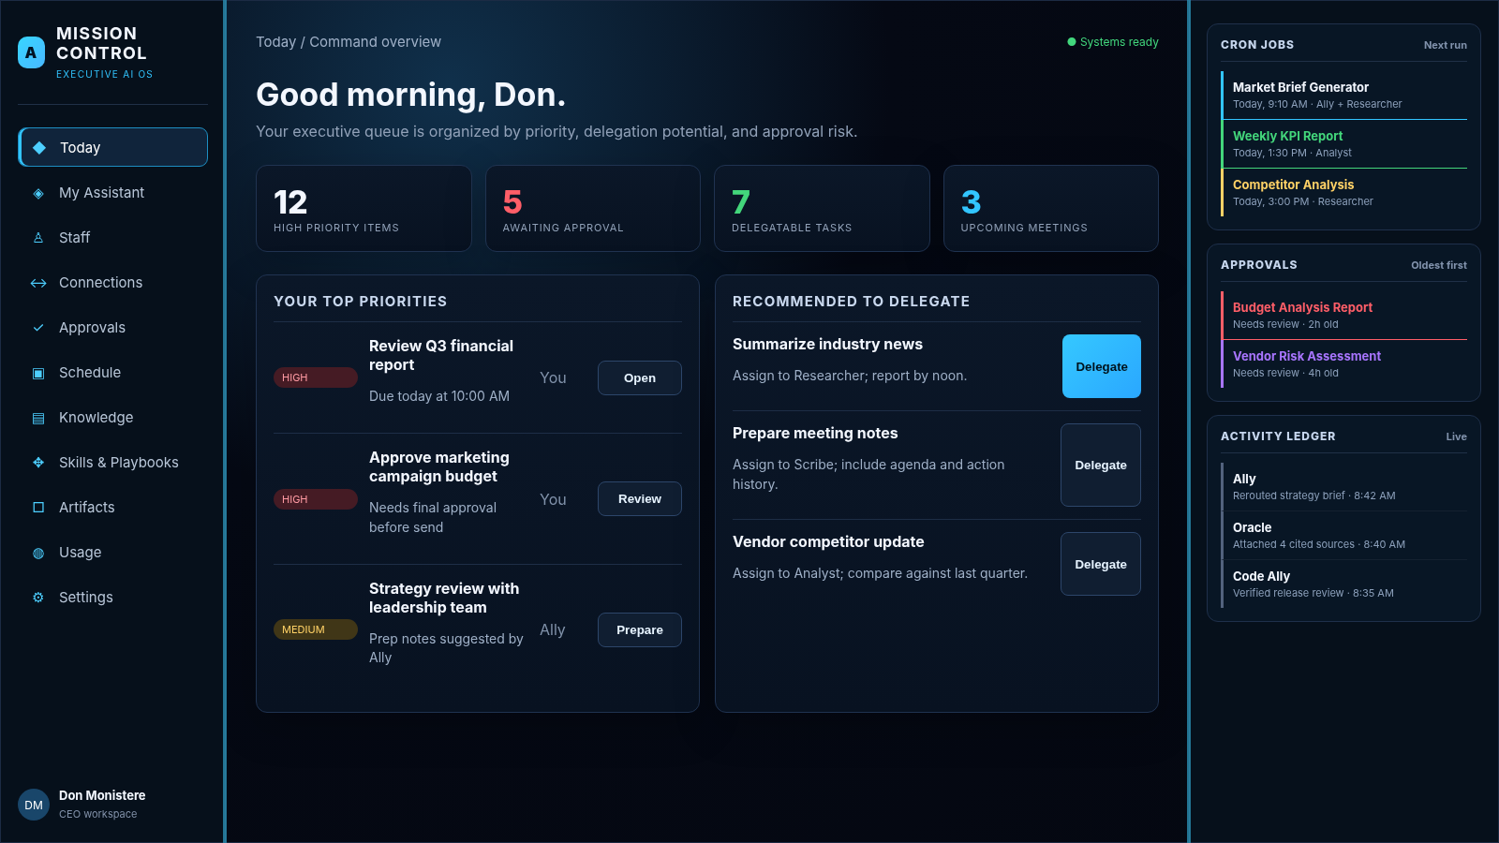
- Use this as the default landing composition: concise summary cards, operating queue, delegation recommendations, and persistent right rail.
- The right rail is not unique to Today; it should be supplied by AppShell.
- Rows should favor scanability over dense metadata.

20.2 My Assistant
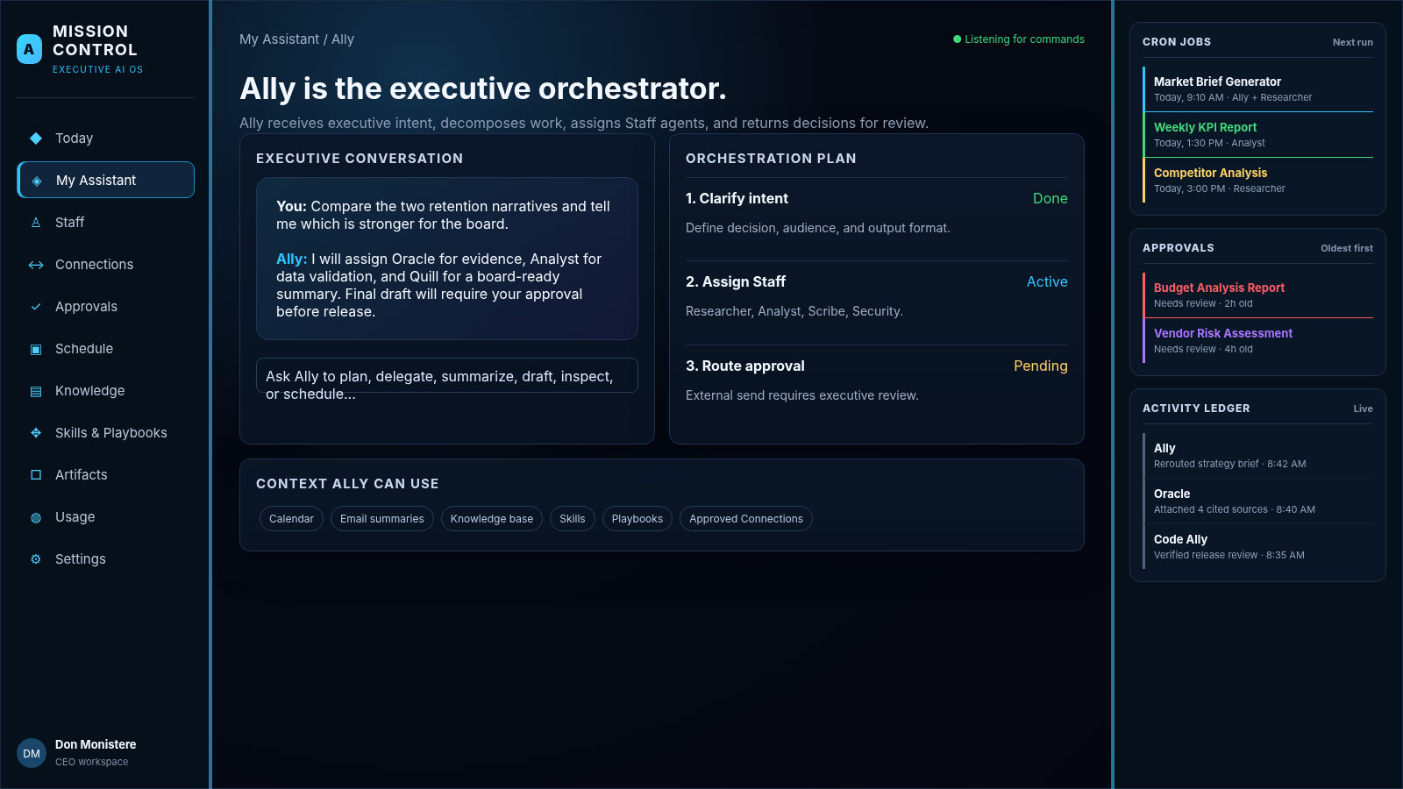
- Keep the conversation as one part of the surface, not the entire product.
- Expose Ally's orchestration plan, assigned staff, context, and approval dependencies.
- Link responses to evidence and artifacts where available.

20.3 Staff
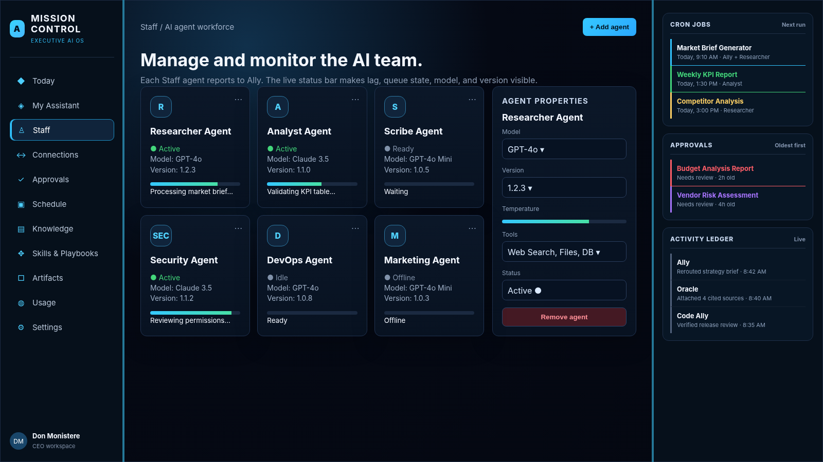
- Agent cards need live status, current work, model/version, and last event.
- Selecting an agent opens a right-side properties drawer; do not navigate away just to inspect configuration.
- Working indicators must be tied to runtime state.

20.4 Connections
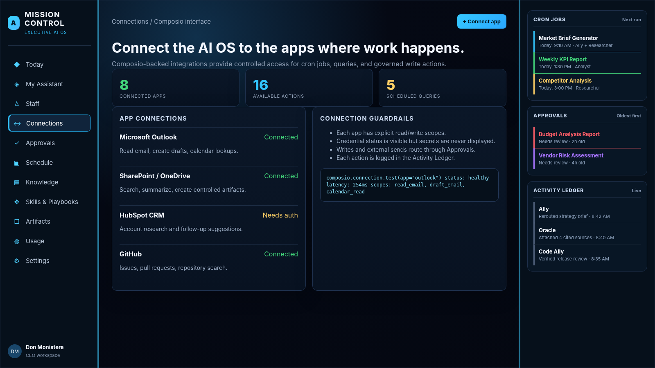
- Use executive-friendly connector cards/table rather than raw OAuth/config screens.
- Show health and scopes; keep secrets out of the UI.
- Make dependent cron jobs visible.

20.5 Approvals
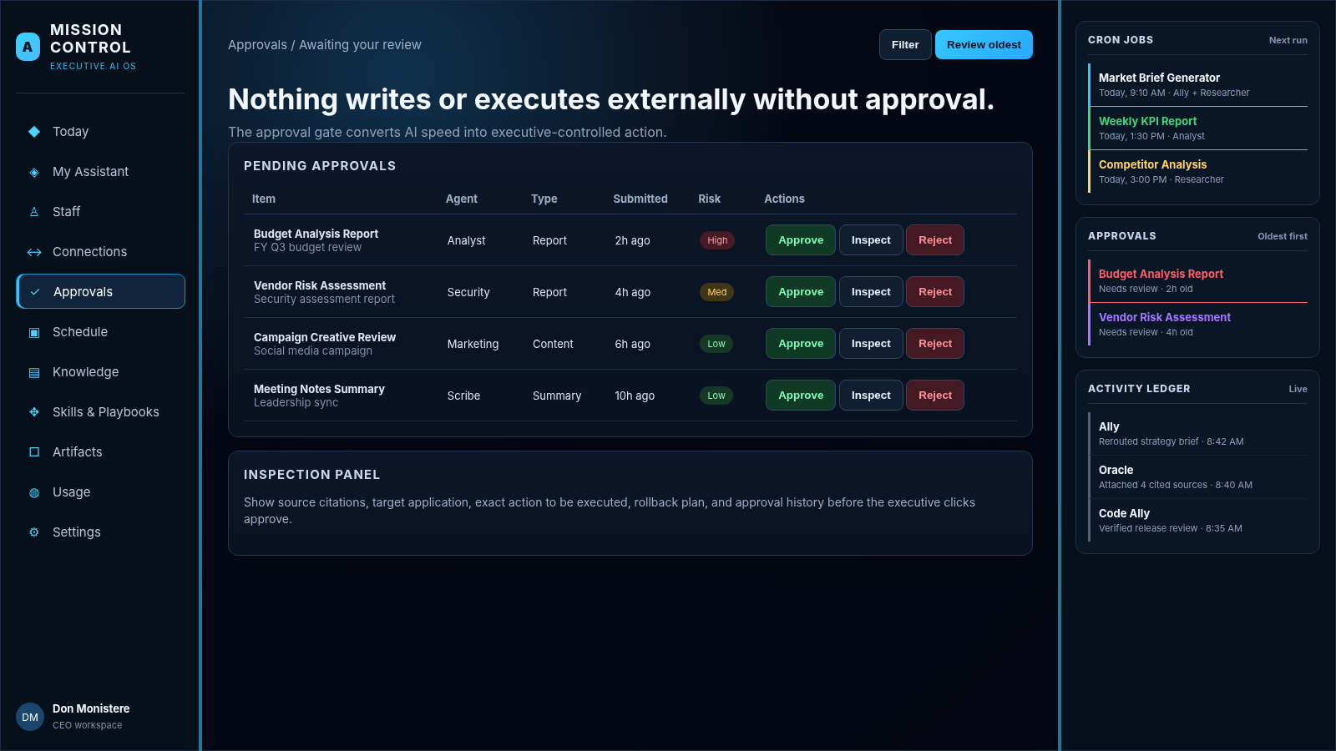
- Default oldest-first and make risk/type/agent filters visible.
- Inspection must expose enough context to make a decision, not just a title and Approve button.
- Approve/reject/request-changes all write auditable outcomes.

20.6 Schedule
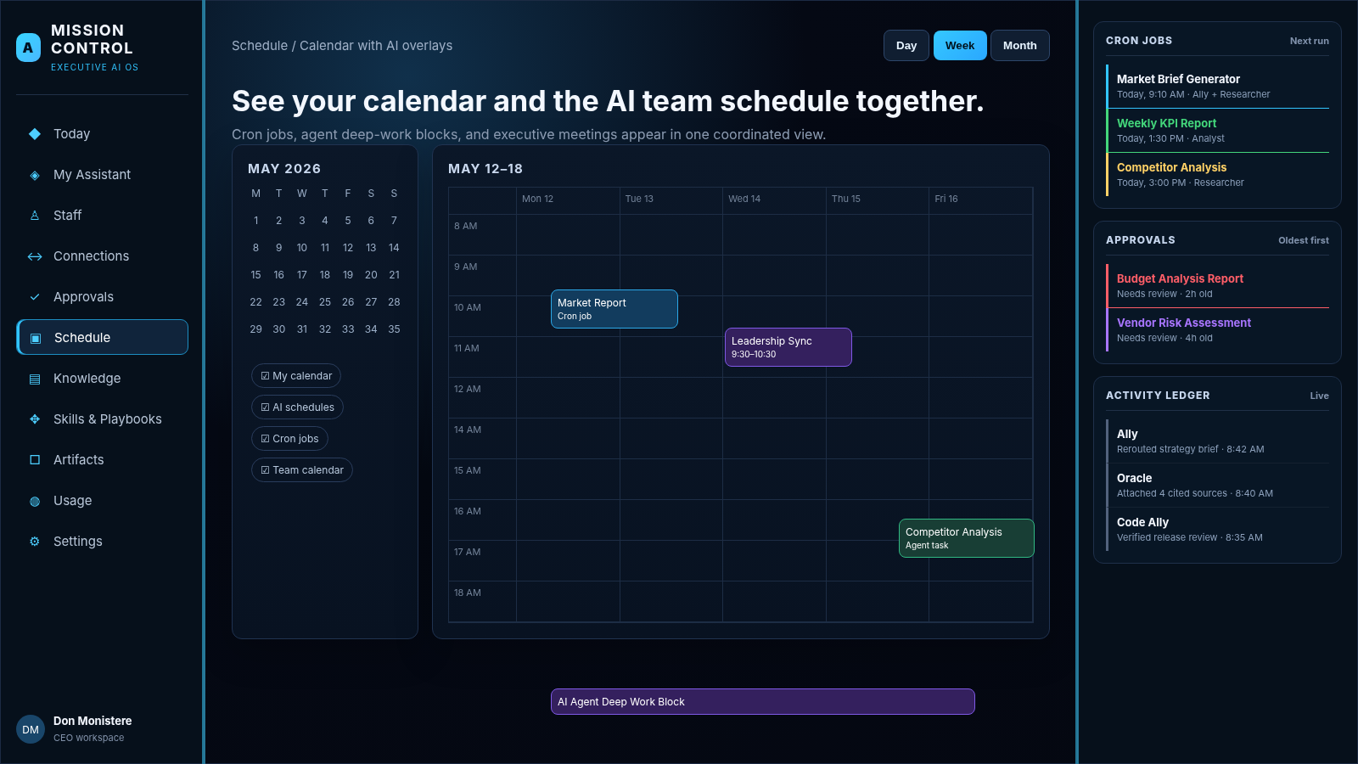
- Overlay human calendar items, AI scheduled work, and cron jobs in a single calendar.
- Use source toggles and clear event provenance.
- Cron jobs shown here are the same entities shown on Connections and the right rail.

20.7 Knowledge
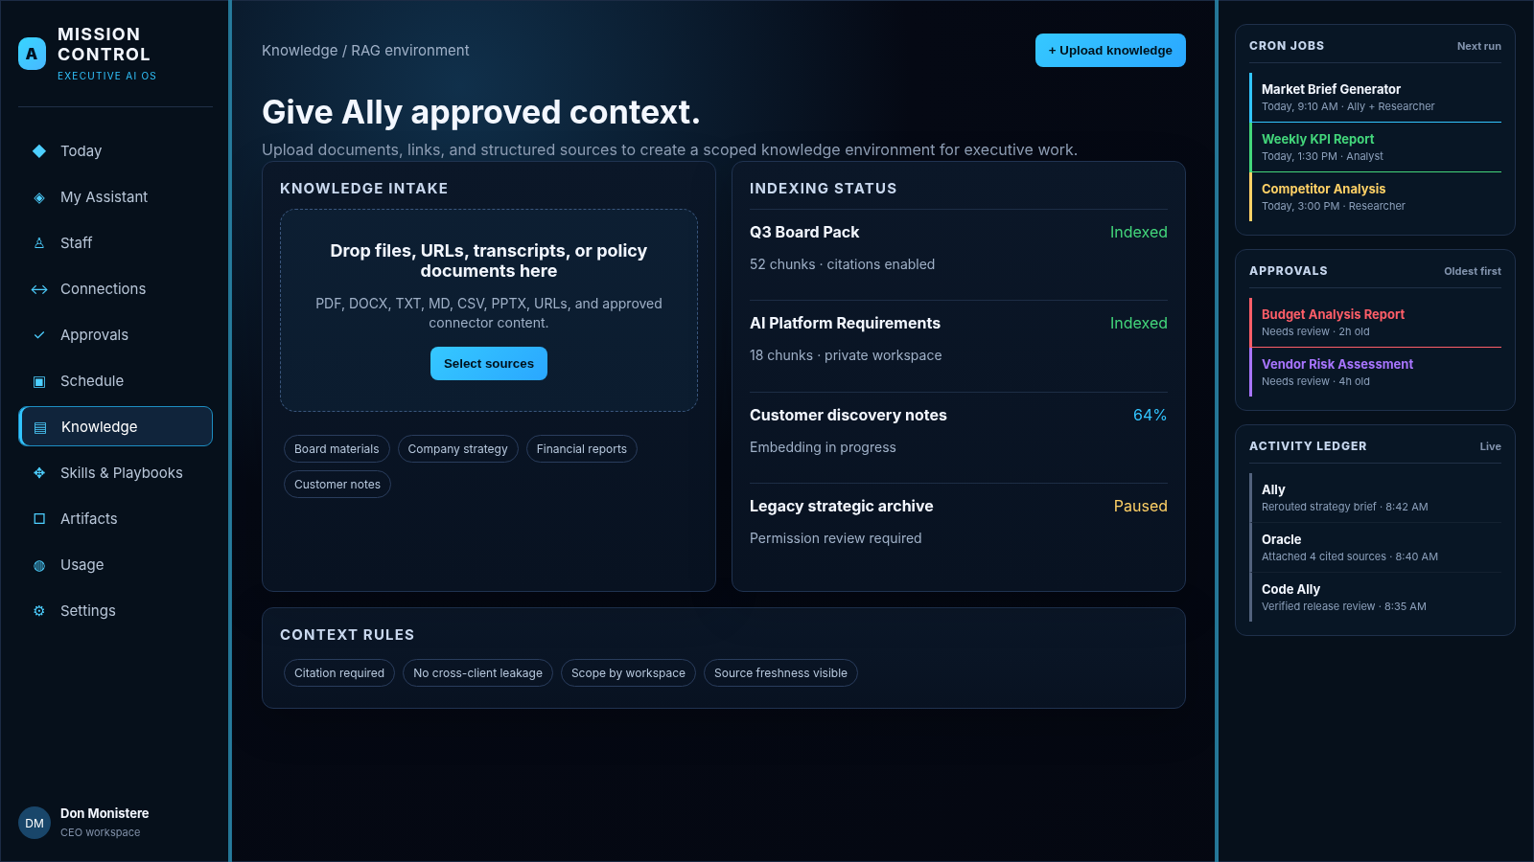
- Center the screen on source governance, indexing state, permissions/scope, freshness, and citations.
- Do not imply a source is available to Ally until indexing is confirmed Ready.

20.8 Skills & Playbooks
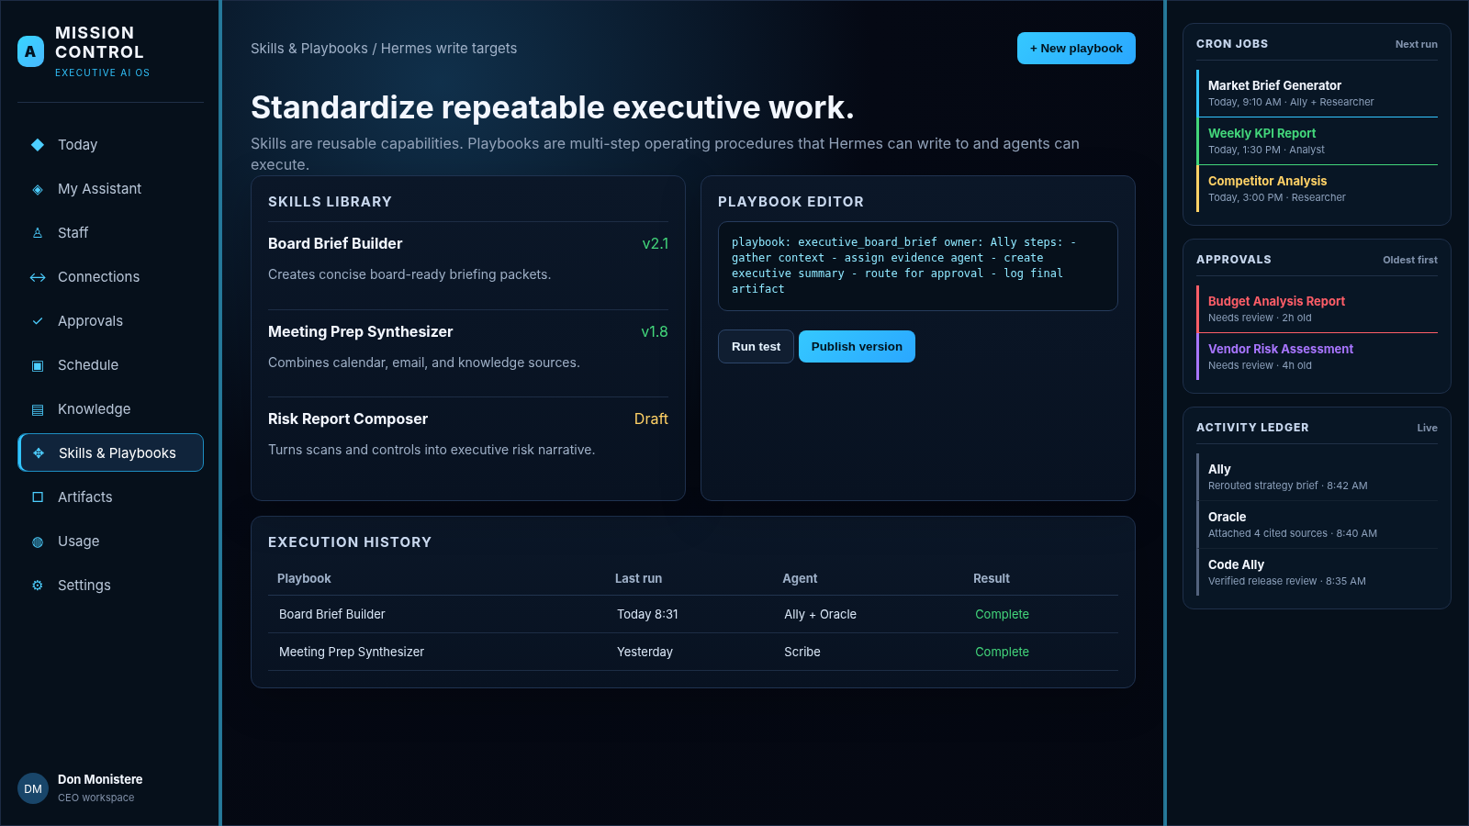
- Treat Skills as reusable capabilities and Playbooks as versioned multi-step workflows.
- Show requirements, approval checkpoints, test run/publish state, and execution history.

20.9 Artifacts
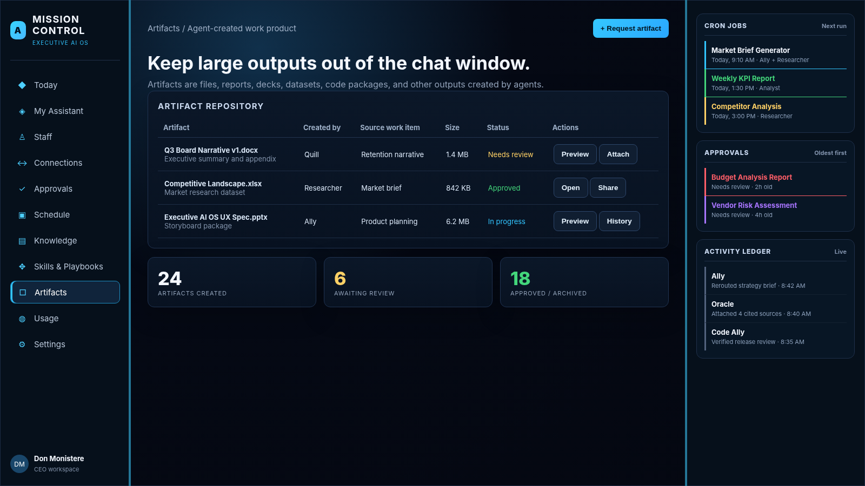
- Use this for documents, decks, reports, data, code, and large outputs too large for chat.
- Every artifact should show provenance: work item, creating agent, date, and share/approval state.

20.10 Usage
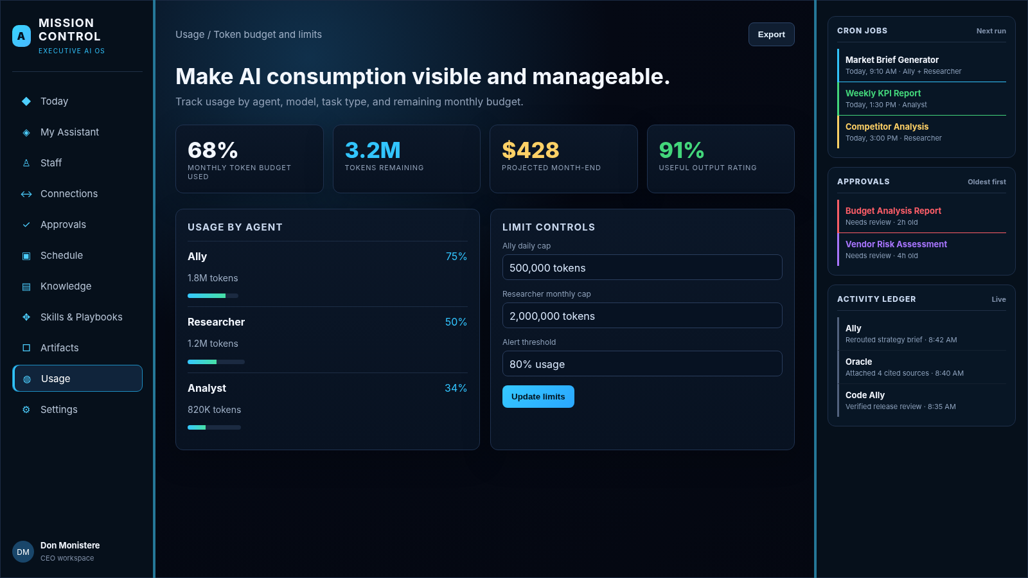
- Summarize capacity/cost first, then provide agent/model detail.
- Clearly label cost estimates versus authoritative billing values.

20.11 Settings
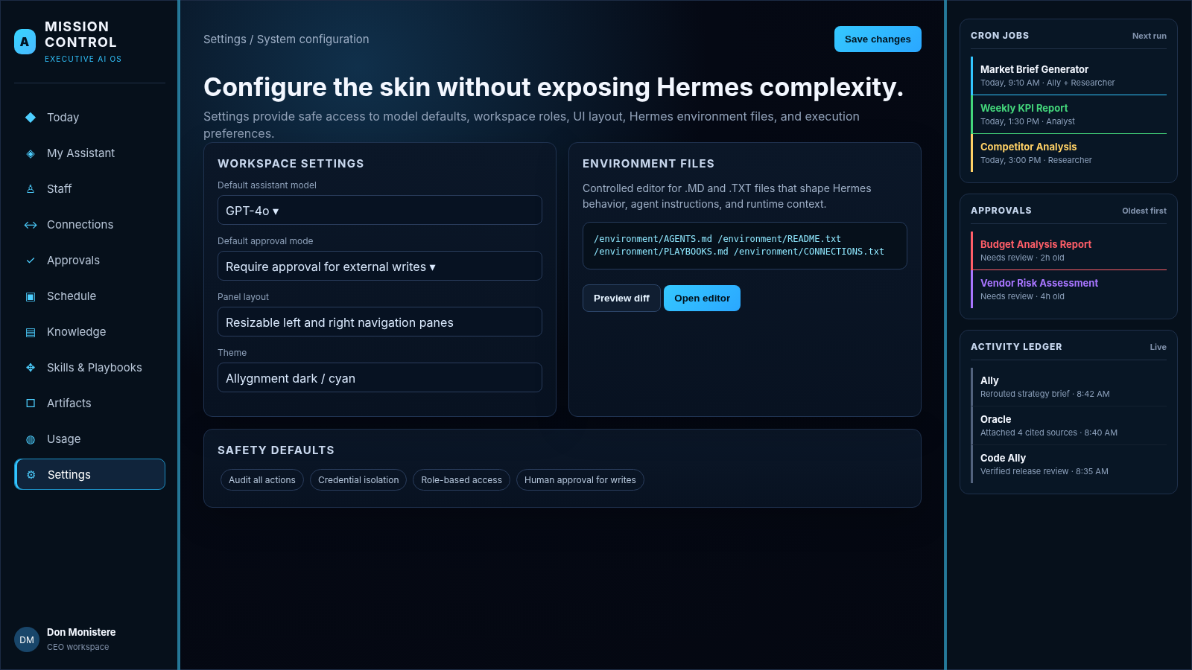
- Expose only the Hermes settings appropriate to this interface.
- Environment-file editing must be allowlisted, version-aware, auditable, and secret-safe.

20.12 Right Rail Detail
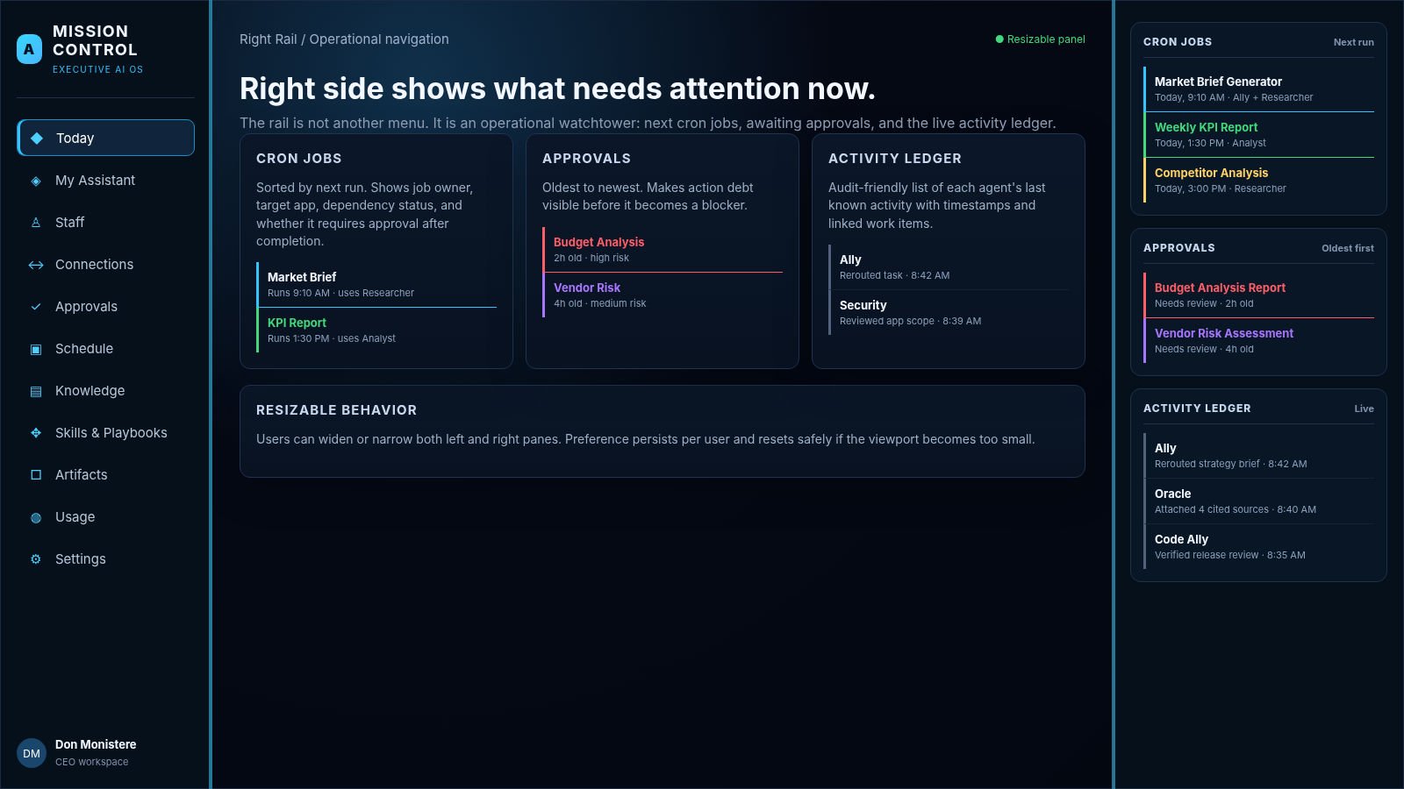
- Use this as the persistent operational watchtower model.
- Cron jobs: soonest next run first. Approvals: oldest first. Activity: newest first.
- Make the rail resizable and collapsible without losing access to urgent approval state.

21. Release Readiness Checklist
☐ Hermes integration matrix is completed and reviewed.
☐ All routes load without uncaught errors.
☐ Mock and live adapters pass the same contract tests.
☐ Resizable panel preferences survive reload and do not break tablet layouts.
☐ Right rail sorting and live updates pass tests.
☐ Agent status is truthful and does not fabricate progress.
☐ Approval policy covers every external write/execute path.
☐ No secrets appear in UI, browser/client logs, URLs, or telemetry.
☐ Cron jobs are consistent across Schedule, Connections, and right rail.
☐ Knowledge source scope and indexing states are enforced.
☐ Environment file editor is allowlisted and version-aware.
☐ Audit events exist for configuration changes and governed actions.
☐ Keyboard navigation and focus management pass review.
☐ Critical executive E2E journeys pass.
☐ Screens visually align with the storyboard: dark Allygnment language, cyan signal, spacious hierarchy, minimal console feel.
Final implementation standard
The build is successful when an executive can understand the state of the AI organization, delegate work, inspect live execution, approve consequential actions, and understand what is scheduled or completed—without needing to understand the mechanics of Hermes Desktop.

