**Wildlife health perceptions and monitoring practices in globally distributed protected areas**

**Abstract**

Protected areas are threatened by anthropogenic pressures, exposing wildlife to physical, chemical and biological hazards. Wildlife health monitoring facilitates the early detection of exposure and disease, and enables response to mitigate risks and adverse outcomes. Despite its importance for biodiversity conservation, wildlife health monitoring remains uncommon or deficient.

The status of wildlife health monitoring practices in protected areas is largely unknown but potential gaps could undermine biodiversity conservation at these key sites. There is a lack of baseline information regarding the local perception of wildlife, human, and livestock health relevance also that could impact health monitoring implementation. To solve these deficiencies, we conducted a survey targeting globally distributed protected area data managers. Eighty-six valid responses were considered for analysis.

Protected area data managers considered wildlife health as relevant to the conservation goals of PAs and >90% of them confirmed that non-healthy wildlife (injured, sick, and dead) are encountered. However, >50% and >20% of protected area data managers claimed that injured/sick and dead animals were not recorded, respectively. When these animals were documented, the recording methods and information collected differed. Although domestic animal presence was common and considered a conservation concern, these animals and their health status were not always recorded. Health data were often stored in a database, but paper forms and spreadsheets were also used.

Responses suggest that valuable syndromic wildlife health surveillance data from protected areas are being lost due to non-collection or inadequate management and their value could be limited by unstandardized recording. Rangers could become a globally distributed “One Health workforce” but these flaws must be addressed first.

**Introduction**

Protected areas (PAs) safeguard intact landscapes, conserving diverse wildlife and flora, and preserve essential ecosystem services while supporting local communities. However, they are increasingly threatened by anthropogenic pressures. Human encroachment and land-use change [(Laurance et al. 2012; Vicente et al. 2021; Meng et al. 2023)](https://paperpile.com/c/XTYkqo/LCYpb+qRlso+6q4Pi) drive resource extraction, pollution, the creation of human-wildlife-livestock interfaces, and ecosystem degradation [(Plowright et al. 2021; Vicente et al. 2021; Reaser et al. 2023)](https://paperpile.com/c/XTYkqo/8dO04+RLXJa+6q4Pi). These processes expose wildlife to physical (e.g., snaring), chemical (e.g., toxins), and biological (e.g., pathogens) hazards with the capacity to impact biodiversity conservation and global health [(De Vos et al. 2016; Wolf et al. 2019; Machalaba et al. 2020; Hacon et al. 2020; Porco et al. 2023; Groenenberg et al. 2023)](https://paperpile.com/c/XTYkqo/Et0aN+3hFA6+XhE3Q+NtszP+Z4dNj+7ZaS3).

Wildlife health (WH) monitoring, which involves tracking diseases, pathogens, and toxic agents in wildlife populations [(World Organisation for Animal Health & International Union Conservation of Nature 2024)](https://paperpile.com/c/XTYkqo/a6cQ) facilitates the early detection of exposure and disease, enables rapid response to mitigate risks and adverse outcomes, and supports the evaluation of health management strategies [(Woods et al. 2019; Machalaba et al. 2021; One Health High-Level Expert Panel (OHHLEP) et al. 2022; Porco et al. 2023; Elnaiem et al. 2023; Vora et al. 2023; Thompson et al. 2024)](https://paperpile.com/c/XTYkqo/AzG8Q+9eOhK+xWX2x+Q8qA+xrpKY+OOz7z+XhE3Q). The One Health (OH) approach recognizes that the health of animals, humans, and their shared environment are deeply interconnected [(Machalaba et al. 2021; OHHLEP et al. 2022; World Organization for Animal Health 2023)](https://paperpile.com/c/XTYkqo/xWX2x+Q8qA+qaIhP). As a result, WH monitoring is essential for biodiversity conservation and for safeguarding human and animal health.

Ebola virus disease is an illustrative example. Outbreaks in wildlife have decimated populations of western gorillas and chimpanzees (Whitfield 2003; Leroy et al. 2004; Bermejo et al. 2006). Index cases of human outbreaks have included hunters who extracted wildlife including within PAs (Judson et al. 2016). Virus spread into urban areas of West Africa through human-to-human transmission in 2014 resulted in over 20,000 excess human deaths [(Dudas et al. 2017; Jacob et al. 2020)](https://paperpile.com/c/XTYkqo/cIMrU+YfF8Q).

Despite its importance, WH monitoring systems remain uncommon or deficient [(Machalaba et al. 2021; OHHLEP et al. 2022; World Organization for Animal Health 2023)](https://paperpile.com/c/XTYkqo/xWX2x+Q8qA+qaIhP). To our knowledge, the status of WH monitoring practices in PAs is largely unknown. Potential gaps could undermine biodiversity conservation and compromise OH, highlighting the need for urgent attention. Additionally, baseline information regarding the perception of wildlife, human, and livestock health relevance for biodiversity conservation by PA personnel is also unknown. Their perceptions could impact WH monitoring practices and their implementation.

To address knowledge gaps associated with current WH monitoring practices in PAs and associated perceptions by personnel, we conducted a survey targeting protected area data managers (PADMs) to assess: i) their perceptions regarding WH and pathogen transmission between wildlife, humans, and livestock, ii) the detection and documentation of injured, sick, or dead wildlife and domestic animals in PAs, and iii) health data management in PAs.

**Methods**

We developed a web-based questionnaire aimed at PADMs users of the “Spatial Monitoring and Reporting Tool” (SMART). SMART is a technology platform to support the administration of PAs [(Cronin et al. 2021)](https://paperpile.com/c/XTYkqo/Tj6Wx) distributed in more than 1,000 conservation sites worldwide, offering the opportunity to engage a large number of PADMs. The survey was distributed to the SMART Community Forum users by the SMART Partnership ([https://smartconservationtools.org](https://smartconservationtools.org/en-us/)) via email in October 2022 and remained open for three months. A reminder was sent three weeks before the closing date.

Because the SMART Community Forum includes many conservation actors, respondents were asked first if their job roles and responsibilities matched our definition of PADM: “a person directly responsible for managing SMART data in one or more PAs or a general manager or administrator of one or more PAs that uses SMART data”. Respondents who did not identify as a PADM were considered outside our target population and excluded. The survey had five sections. Section 1 assessed the perception of PADMs on the importance of WH in achieving conservation goals, the role of human and livestock pathogens in affecting WH, and the role of wildlife pathogens in affecting public and livestock health. Section 2 requested PADMs to rank the overall frequency of encounters with injured, sick, or dead wildlife in PAs and to indicate whether animals in each of these classes, along with healthy wildlife, are recorded as a specific type of individual when found during patrols. Section 3, asked about the presence of domestic animals in the PA(s), the documentation of their health status, and the perceived threats of domestic animals to conservation goals. Likert scales were used to answer questions in Sections 1-3. Section 4 addressed health data storage practices when collected and Section 5 assessed the current state of SMART deployment in PAs.

An introductory web page explained that the survey was voluntary, anonymous, aimed at PADMs, and that clicking the “Start the survey” button constituted consent. A tutorial was provided for the language-translation tool of this survey built on Google Forms (Appendix S1). The survey did not request personal information and was exempt from full ethics review [placeholder].

Responses by PADMs could represent either a single or multiple PAs. For our analysis, we focused on what we defined as “local” responses, which included one or two PAs. “Non-local responses”, which covered more than two PAs, were analyzed separately. We assumed that PADMs that included more than two PAs would conduct occasional site visits making them less likely to have insights of specific PA realities. However, they can help understand perceptions at central offices at decision-making level. Instead, “local” PADMs would work on-site and understand PA realities. The two-PA cutoff was chosen to balance maximizing the sample size of local respondents while accurately classify them as having first-hand knowledge of field activities. We discarded responses that only included marine PAs based on the World Database on Protected Areas (<https://www.protectedplanet.net/en/thematic-areas/wdpa?tab=WDPA>) as marine PA management, species, and patrol logistics are markedly different than terrestrial ones. The descriptive analysis of survey responses was conducted in R v4.3.1. The responses dataset can be found here https://figshare.com/s/36513db82ac5dfa8e71d?file=49682265. Descriptive analysis can be found at [placeholder].

**Results**

We received 128 responses. Forty-two were removed because either the PA name(s) were not provided, only marine PAs were listed, or the respondents did not match the target audience (8, 7, and 27 responses, respectively). The final dataset contained 86 respondents from 23 countries. Seventy-three were local responses with 67 surveys representing a single PA and 6 representing 2 PAs. Local responses came from 19 countries. There were 13 non-local responses that came from 10 countries (results in Appendix). The specific countries are not provided to protect the identity of the respondents, but local responses were from North, Central, and South America (n=45); West, Central, East, and Southern Africa (n=16); Southeast and South Asia (n=11); and Europe (n=1), with most coming from South America. Non-local responses were from West, Central, and East Africa (n=6), Central and South America (n=3), and Southeast and South Asia (n=4).

### **Perceptions regarding wildlife health importance in conservation and potential consequences of pathogen transmission among wildlife, domestic animals, and people**

### Most respondents either strongly agreed or agreed with the affirmations “Wildlife health, including infectious and non-infectious diseases, is important to achieve the conservation goals of the protected areas where I work” and “human or livestock pathogens can affect wildlife populations inhabiting the protected area(s) I work in” (92%; and 81%, respectively). Regarding the affirmation “pathogens carried by wildlife inhabiting the protected area(s) where I work in can affect livestock health”, most respondents strongly agreed or agreed (48%) although neutral respondents were more prominent (29%). Across respondents, 63% strongly agreed or agreed that “pathogens carried by wildlife inhabiting the protected area(s) where I work in can affect human health”. The percentage of neutral responses was 19%. Detailed distributions are shown in Figure 1. Non-local responses followed similar trends with proportionally fewer neutral responses (Appendix S2).

**Overall frequency of encounters with injured, sick, or dead wildlife in protected areas and their documentation when found during patrols**

Most local “overall frequency of encounters” responses concentrated between “Very rarely” and “Occasionally” (Figure 2). Seventy-six percent of local PADMs reporting the encounter of dead animals in the PAs (e.g., "Very rarely" or more frequently) answered that these encounters were documented. Only 48% and 35% of local PADMs reporting encounters with injured or sick animals in the PAs (e.g., "Very rarely" or more frequently) confirmed their documentation, respectively. In general, the documentation of injured, sick, or dead animals tend to be higher as the encounter frequency increased from “Very rarely” to “Very frequently”. For example, the proportion of local responses reporting the documentation of sick animals in the encounter frequency “Very rarely” was less than 20% versus over 50% in the encounter frequency “Very frequently” (Figure 2).All non-local PADMs reported the encounter with injured or sick wildlife and dead wildlife (“Very rarely” up to “Very frequently”). The proportions of non-local PADMs reporting the documentation of these animals were larger compared to local responses (85, 62, and 92% for injured, sick, and dead wildlife respectively; Appendix S3).

All 17 local PADMs who ranked encountering dead wildlife “Very rarely” or more frequently but answered that these animals were not documented, either agreed or strongly agreed with the importance of WH to achieve conservation goals. Similarly, 94% of local PADMs who ranked encountering injured wildlife "Very rarely" or more frequently but answered that these animals were not documented, either agreed or strongly agreed with this statement. For sick wildlife, the percentage was 91%. The corresponding percentages for non-local PADMs were 50, 80, and 0% (for injured, sick, and dead wildlife).

**Documentation method** **for** **dead, sick, or injured wildlife in protected areas**

The documentation method of injured, sick, or dead wildlife varied among the 58 local PADMs that reported the recording of one or more of these groups. Most often, each animal was documented individually (“Individual observation”). The second most common method involved a complete inventory of healthy, injured, sick, or dead animals for each species (“Part of the full count”). Reporting their presence or absence was the third most common method (“Present or absent”; Figure 3). For non-local responses, the predominant method was “each animal is an individual observation” across health categories (Appendix S4).

The items recorded from each observation were not consistent across responses (Figure 3). Photographs and the species were the main items collected across documentation methods and health categories. Anomalies observed in non-healthy wildlife and the condition of carcasses were not always recorded (Figure 3). In non-local responses the trend was relatively similar, however, items were reported to be recorded more consistently (e.g., age, anomalies, and condition in the three health categories; Appendix S4).

**Presence of domestic animals in protected areas, the documentation of their health status, and the perceived threats of domestic animals to conservation goals**

Fifty-two local PADMs (71%) responded that domestic animals were found in the corresponding PAs. Among them, 67% reported that domestic animals were documented if observed during patrols, but only 26% reported recording their health status (Figure 4). Forty-two local respondents reporting domestic animals in the PAs (81%) either agreed or strongly agreed that domestic animals are a conservation concern (Figure 4). Twenty-seven of them (64%) answered that these animals were documented. Fourteen out of twenty-one respondents claiming that domestic animals are not found in the corresponding PAs also either agreed or strongly agreed that they are a conservation concern (67%).

Eight non-local PADMs (62%) responded that domestic animals were found in the PAs. Among them, seven (88%) reported that domestic animals were documented if observed during patrols, of which only two (29%) reported recording their health status (Appendix S5).

**Health data storage practices in protected areas**

Seventy-two, 54, and 65% of local PADMs reporting the documentation of either injured, sick, or dead wildlife stored all these data in a SMART database. Paper forms, reports, and spreadsheets were employed when non-healthy wildlife were documented but their data was not stored in a SMART database.

Thirty-one of the 35 local respondents (89%) recording domestic animals during patrols indicated that this information was stored in a SMART database. The health status of domestic animals, when documented, was also stored in a SMART database.

**Discussion**

We developed a questionnaire aimed at globally distributed PADMs to learn about their perceptions regarding WH; the monitoring of injured, sick, and dead wildlife and domestic animals in PAs; and health data storage practices. Our findings suggest that syndromic WH surveillance data are being lost due to non-collection or inadequate management. Even when WH data are collected and properly managed, the usefulness for surveillance is likely limited by the diversity of methods employed to record them. By the time of the survey, an initiative to foster the harmonized recording of WH data in PAs [(Montecino-Latorre et al. 2024)](https://paperpile.com/c/XTYkqo/5eUw) had been implemented in a couple of sites in a single country, not impacting the results.

PADMs largely considered WH as relevant to the conservation goals of PAs. However, several local PADMs expressed neutral views on the potential impact of wildlife pathogens on human and livestock health. Local PADMs represent field staff and they might have a risk of exposure to zoonotic pathogens [(Adjemian et al. 2012)](https://paperpile.com/c/XTYkqo/N4JE). It is essential to provide rangers with training in biosecurity measures to mitigate these risks.

Most PADMs confirmed that non-healthy wildlife were encountered. However, the percentage of local PADMs who agreed or strongly agreed that WH is relevant for the conservation goals of PAs was higher than the percentage of those reporting the recording of non-healthy wildlife. In other words, the perceived importance of WH did not translate into reporting. This contradiction was also observed in the responses specifically reporting the encounter of non-healthy animals but not their documentation. The discrepancy could be explained by recent global pathogen-driven crises such as SARS-CoV-2 and H5N1 Highly Pathogenic Avian Influenza virus (Nicola et al. 2020; Leguia et al, 2023) or by other morbidity or mortality events of different etiology that might have sensitized our audience by the time the survey was distributed but before health-associated monitoring objectives could be planned and rolled out. These findings could also suggest a lack of knowledge or resources to act on their understanding of the importance of WH for conservation goals.

A larger proportion of non-local respondents reported the documentation of non-healthy wildlife compared to local respondents. This difference could be explained by non-local and local responses coming from different PAs or it could represent differences between the expectations of managers in an administrative role (non-local PADMs) and field realities in PAs (local PADMs). For example, the mandate to record non-healthy animals may exist but it is not pursued in practice because of limitations regarding WH training, the use of a recording tool, comprehension of the methodology to record these data, or willingness to record these data [(Wilfred et al. 2019; Kavhu & Mpakairi 2021)](https://paperpile.com/c/XTYkqo/7NTk+HHQt). If this were the case, PA management agencies should take a more active local role to identify and correct weaknesses in WH data collection.

We noted a general agreement among PADMs regarding the conservation threat that domestic animals (e.g., dogs, cats, cattle) present. Although we did not explicitly ask why domestic animals are a conservation concern, most PADMs also agreed with the statement “human and wildlife pathogens can impact wildlife health” whether these animals were found in the PAs or not (Appendix S6 and S7). Pathogen transmission from domestic animals to wildlife can seriously harm biodiversity conservation efforts including in PAs e.g., [(Porco et al. 2023)](https://paperpile.com/c/XTYkqo/XhE3Q) and they add to the pressures on wildlife from domestic animals in- and out-side of PAs (e.g., predation, competition [(du Toit 2011; Gompper 2013)](https://paperpile.com/c/XTYkqo/t3Teg+t8nJh)). The observed contradiction between perceived conservation risk of domestic animals and documentation of their presence and health status could be explained by the same drivers mentioned above.

Effective management of data and harmonization are foundational pillars for WH monitoring [(World Organisation for Animal Health 2010, 2015, 2018; Sleeman et al. 2012; Ryser-Degiorgis 2013; Stephen 2018; Machalaba et al. 2021; Stephen & Berezowski 2022; Giacinti et al. 2022; Hayman et al. 2023; Heiderich et al. 2023)](https://paperpile.com/c/XTYkqo/UHfyN+c2om4+mp57W+Q8qA+rLdPA+Yn7OQ+hqwh9+EmnO6+hrbMU+r7Zzt+y9Pcw+bmt7Y). However, we identified challenges in WH data harmonization and governance that align with historical pitfalls in WH surveillance [(Carmichael 2012; Cardoso et al. 2021; World Organization for Animal Health 2023; Heiderich et al. 2023; Suwanpakdee et al. 2024)](https://paperpile.com/c/XTYkqo/UHfyN+bmt7Y+qaIhP+asnm+h2Lk+teRy). When healthy and non-healthy wildlife were documented, inconsistencies in data structure and attributes were present. The lack of harmonization across PAs, within and beyond country borders, diminishes the value of collected health data, making transboundary health assessments challenging. Similarly, tracking wildlife health trends over time becomes infeasible. Additionally, records of non-healthy wildlife could be stored in paper forms or Excel sheets rather than a SMART database. Data can be uploaded to a SMART database manually by filling specific fields or through a mobile application (SMART Mobile) designed to capture data as determined in the corresponding SMART database [(Cronin et al. 2021)](https://paperpile.com/c/XTYkqo/Tj6Wx). Consequently, the use of paper forms and spreadsheets reflect that WH data was not considered in the PAs SMART databases and does not reveal problems with the recording tool used (SMART Mobile or other). We did not ask about the use of SMART Mobile but challenges in its adoption have been described [(Wilfred et al. 2019; Kavhu & Mpakairi 2021; Wyatt et al. 2023)](https://paperpile.com/c/XTYkqo/7NTk+HHQt+lObm).

This is the first account of wildlife health perceptions and monitoring practices in PAs. Survey respondents were contacted through the SMART Partnership, and while informative, the targeted audience and participants may not fully represent the broader population of local and non-local PADMs. Ideally, a follow-up longitudinal study and respondents selected through random sampling from a sampling frame, including local and non-local PADMs of the same PAs, could further refine and enhance these initial insights. This approach could also identify geographic differences and associations between distance patrolled per time unit, the landscape type, and the fauna size in the overall encounter rates with health and non-healthy wildlife and domestic animals. Potential differences in reporting as a consequence of experience with the recording tool employed (SMART Mobile or other) should also be assessed.

Leveraging existing PA human resources that can detect morbidity and mortality in animals offers a cost-effective strategy to establish minimal WH monitoring. Rangers can detect non-healthy animals in PAs and they have provided data to assess health risks and trends or trigger responses to disease outbreaks [(Wolf et al. 2019; Vila et al. 2019; Kuisma et al. 2019; Orozco et al. 2020; Montecino-Latorre et al. 2020; Porco et al. 2023)](https://paperpile.com/c/XTYkqo/Z4dNj+zsKBA+he4Tv+ADidr+Q0FkQ+XhE3Q).

Our recommendation is to include WH monitoring within the remit of rangers following a unified methodology and standards. Currently, there are approximately 280,000 rangers worldwide and 1.5 million will be needed by 2030 to protect 30% of the planet [(Appleton et al. 2022)](https://paperpile.com/c/XTYkqo/NMMum). The present and projected number of rangers reveal their unique potential as a worldwide “One Health workforce” that could drastically improve WH and OH surveillance [(Machalaba et al. 2021; Hopkins et al. 2024; Montecino-Latorre et al. 2024; World Organisation for Animal Health & International Union Conservation of Nature 2024)](https://paperpile.com/c/XTYkqo/Q8qA+dRZv+a6cQ+5eUw). However, our findings suggest that several issues must be addressed first.

**Acknowledgements**

Thanks to responders and the SMART Partnership, especially to Mōnica Barcellos. Thanks to Jonathan Palmer, Executive Director of the Wildlife Conservation Society’s Conservation Technology Department.

**Supporting Information**

Additional supporting information may be found in the online version of the article at the publisher’s website.

**References**

[Adjemian J et al. 2012. Zoonotic infections among employees from Great Smoky Mountains and Rocky Mountain National Parks, 2008-2009. *Vector Borne and Zoonotic Diseases* (Larchmont, N.Y.) **12**:922–931. Mary Ann Liebert Inc.](http://paperpile.com/b/XTYkqo/N4JE)

[Appleton MR et al. 2022. Protected area personnel and ranger numbers are insufficient to deliver global expectations. *Nature Sustainability* **5**:1100–1110.](http://paperpile.com/b/XTYkqo/NMMum)

[Cardoso B, García-Bocanegra I, Acevedo P, Cáceres G, Alves PC, Gortázar C. 2021. Stepping up from wildlife disease surveillance to integrated wildlife monitoring in Europe. *Research in Veterinary Science*](http://paperpile.com/b/XTYkqo/teRy)**144**:149-156*.*

[Carmichael C. 2012. Coordinating an effective response to wildlife diseases. *Wildlife Society Bulletin* **36**:204–206.](http://paperpile.com/b/XTYkqo/asnm)

[Cronin DT, Dancer A, Long B, Lynam AJ, Muntifering J, Palmer J, Bergl RA, Wich SA, Piel AK. 2021. Application of SMART software for conservation area management. Pages 201–224 *Conservation Technology*. Oxford University Press Oxford, UK.](http://paperpile.com/b/XTYkqo/Tj6Wx)

[De Vos A, Cumming G, Cumming D, Ament J, Baum J, Clements H, Grewar J, Maciejewski K, Moore C. 2016. Pathogens, disease, and the social-ecological resilience of protected areas. *Ecology and Society* **21**.](http://paperpile.com/b/XTYkqo/7ZaS3)

[Dudas G et al. 2017. Virus genomes reveal factors that spread and sustained the Ebola epidemic. *Nature* **544**:309–315.](http://paperpile.com/b/XTYkqo/YfF8Q)

[du Toit JT. 2011. Coexisting with cattle. *Science* **333**:1710–1711](http://paperpile.com/b/XTYkqo/t8nJh).

[Elnaiem A et al. 2023. Global and regional governance of One Health and implications for global health security. *The Lancet* **401**:688–704.](http://paperpile.com/b/XTYkqo/xrpKY)

[Giacinti JA, Jane Parmley E, Reist M, Bayley D, Pearl DL, Jardine CM. 2022. Canadian wildlife health surveillance—patterns, challenges and opportunities identified by a scoping review. *Facets* **7**:25–44.](http://paperpile.com/b/XTYkqo/y9Pcw)

[Gompper ME. 2013. *Free-Ranging Dogs and Wildlife Conservation*.](http://paperpile.com/b/XTYkqo/t3Teg) Oxford Univ. Press. UK.

[Groenenberg M et al. 2023. Snaring devastates terrestrial ungulates whilst sparing arboreal primates in Cambodia’s Eastern Plains Landscape. *Biological Conservation* **284**:110195.](http://paperpile.com/b/XTYkqo/NtszP)

[Hacon S de S, Oliveira-da-Costa M, Gama C de S, Ferreira R, Basta PC, Schramm A, Yokota D. 2020. Mercury exposure through fish consumption in traditional communities in the Brazilian northern Amazon. *International Journal of Environmental Research and Public Health* **17**](http://paperpile.com/b/XTYkqo/3hFA6): 5269

[Hayman DTS et al. 2023. Developing One Health surveillance systems. *One Healt*h:100617.](http://paperpile.com/b/XTYkqo/EmnO6)

[Heiderich E et al. 2023, July 13. Analysis of a European general wildlife health surveillance program: chances, challenges and recommendations.](http://paperpile.com/b/XTYkqo/bmt7Y) *Plos One* **19**: e0301438.

[Hopkins SR et al. 2024. Protected areas and One Health. *Parks* **30**:6–13.](http://paperpile.com/b/XTYkqo/dRZv)

[Jacob ST et al. 2020. Ebola virus disease. *Nature Reviews Disease Primers* **6**:13](http://paperpile.com/b/XTYkqo/cIMrU).

[Kavhu B, Mpakairi KS. 2021. Spatial Monitoring and Reporting Tool (SMART) in Mid‐Zambezi Valley, Zimbabwe: Implementation challenges and practices. *Conservation Science and Practice* **3**: e492.](http://paperpile.com/b/XTYkqo/HHQt)

[Kuisma E et al. 2019. Long-term wildlife mortality surveillance in northern Congo: a model for the detection of Ebola virus disease epizootics. *Philosophical transactions of the Royal Society of London. Series B, Biological sciences* **374**:20180339.](http://paperpile.com/b/XTYkqo/he4Tv)

[Laurance WF et al. 2012. Averting biodiversity collapse in tropical forest protected areas. *Nature* **489**:290–294.](http://paperpile.com/b/XTYkqo/qRlso)

[Machalaba C, Feferholtz Y, Uhart M, Karesh WB. 2020. Wildlife conservation status and disease trends: ten years of reports to the Worldwide Monitoring System for Wild Animal Diseases. *Revue Scientifique et Technique* **39**:991–1001](http://paperpile.com/b/XTYkqo/Et0aN)

[Machalaba C, Uhart M, Ryser-Degiorgis M-P, Karesh WB. 2021. Gaps in health security related to wildlife and environment affecting pandemic prevention and preparedness, 2007-2020.](http://paperpile.com/b/XTYkqo/Q8qA) *Bulletin of the World Health Organization* **99**.

[Meng Z, Dong J, Ellis EC, Metternicht G, Qin Y, Song X-P, Löfqvist S, Garrett RD, Jia X, Xiao X. 2023. Post-2020 biodiversity framework challenged by cropland expansion in protected areas. *Nature Sustainability* **6**: 758-768.](http://paperpile.com/b/XTYkqo/LCYpb)

[Montecino-Latorre D et al. 2024. Rangers as an essential One Health workforce: Strengthening the preservation of biodiversity and global health in practice. Preprint.](http://paperpile.com/b/XTYkqo/5eUw) SSRN. [http://dx.doi.org/10.2139/ssrn.4997409](https://dx.doi.org/10.2139/ssrn.4997409).

[Montecino-Latorre D, Napolitano C, Briceño C, Uhart MM. 2020. Sarcoptic mange: An emerging threat to Chilean wild mammals? *Perspectives in Ecology and Conservation* ***18****:267–276.*](http://paperpile.com/b/XTYkqo/ADidr)

[One Health High-Level Expert Panel et al. 2022. One Health: A new definition for a sustainable and healthy future. *PLoS Pathogens* **18**:e1010537.](http://paperpile.com/b/XTYkqo/xWX2x)

[Orozco MM et al. 2020. A participatory surveillance of marsh deer (*Blastocerus dichotomus*) morbidity and mortality in Argentina: first results. *BMC Veterinary Research* **16**:321.](http://paperpile.com/b/XTYkqo/Q0FkQ)

[Plowright RK, Reaser JK, Locke H, Woodley SJ, Patz JA, Becker DJ, Oppler G, Hudson PJ, Tabor GM. 2021. Land use-induced spillover: a call to action to safeguard environmental, animal, and human health. *The Lancet* *Planetary Health* **5**:e237–e245.](http://paperpile.com/b/XTYkqo/8dO04)

[Porco A et al. 2023. Case Report: Lumpy skin disease in an endangered wild banteng (*Bos javanicus*) and initiation of a vaccination campaign in domestic livestock in Cambodia. *Frontiers in Veterinary Science* **10**.](http://paperpile.com/b/XTYkqo/XhE3Q)

[Reaser JK, Chitale RA, Tabor GM, Hudson PJ, Plowright RK. 2023. Looking left: ecologically based biosecurity to prevent pandemics. *Health security*](http://paperpile.com/b/XTYkqo/RLXJa)**22**: 74-81.

[Ryser-Degiorgis M-P. 2013. Wildlife health investigations: needs, challenges and recommendations. *BMC Veterinary Research* **9**:1-17.](http://paperpile.com/b/XTYkqo/Yn7OQ)

[Sleeman JM, Brand CJ, Wright SD. 2012. Strategies for wildlife disease surveillance. In: A.A. Aguirre, R.S. Ostfeld, P. Daszak (Eds.), *New Directions in Conservation Medicine: Applied Cases in Ecological Health*. Oxford University Press. New York. 539-551.](http://paperpile.com/b/XTYkqo/c2om4)

[Stephen C. 2018. Evolving urban wildlife health surveillance to intelligence for pest mitigation and monitoring. *Frontiers in Ecology and Evolution* **6**.](http://paperpile.com/b/XTYkqo/mp57W)

[Stephen C, Berezowski J. 2022. Wildlife Health Surveillance and Intelligence. Challenges and Opportunities. Pages 99–111 in Stephen C, editor. *Wildlife Population Health*.](http://paperpile.com/b/XTYkqo/hqwh9)

[Suwanpakdee S et al. 2024. Wildlife health capacity enhancement in Thailand through the World Organisation for Animal Health Twinning Program. *Frontiers in Veterinary Science* **11**:1462280.](http://paperpile.com/b/XTYkqo/h2Lk)

[Thompson L, Cayol C, Awada L, Muset S, Shetty D, Wang J, Tizzani P. 2024. Role of the World Organisation for Animal Health in global wildlife disease surveillance. *Frontiers in Veterinary Science* **11**.](http://paperpile.com/b/XTYkqo/OOz7z)

[Vicente J, Vercauteren KC, Gortázar C. 2021. *Diseases at the Wildlife - Livestock Interface: Research and Perspectives in a Changing World*. Springer Nature.](http://paperpile.com/b/XTYkqo/6q4Pi)

[Vila AR et al. 2019. Putative parapoxvirus-associated foot disease in the endangered huemul deer (*Hippocamelus bisulcus*) in Bernardo O’Higgins National Park, Chile. *PloS One* **14**:e0213667.](http://paperpile.com/b/XTYkqo/zsKBA)

[Vora NM et al. 2023. Interventions to reduce risk for pathogen spillover and early disease spread to prevent outbreaks, epidemics, and pandemics. *Emerging Infectious Diseases* **29**:1–9.](http://paperpile.com/b/XTYkqo/9eOhK)

[Wilfred P, Kayeye H, Magige FJ, Kisingo A, Nahonyo CL. 2019. Challenges facing the introduction of SMART patrols in a game reserve, western Tanzania. *African Journal of Ecology* **57**:523–530.](http://paperpile.com/b/XTYkqo/7NTk)

[Wolf TM, Annie Wang W, Lonsdorf EV, Gillespie TR, Pusey A, Gilby IC, Travis DA, Singer RS. 2019. Optimizing syndromic health surveillance in free ranging great apes: the case of Gombe National Park. *The Journal of Applied Ecology* **56**:509–518.](http://paperpile.com/b/XTYkqo/Z4dNj)

[Woods R, Reiss A, Cox-Witton K, Grillo T, Peters A. 2019. The Importance of wildlife disease monitoring as part of global surveillance for zoonotic diseases: The role of Australia. *Tropical Medicine and Infectious Disease* **4**.](http://paperpile.com/b/XTYkqo/AzG8Q)

[World Organisation for Animal Health. 2010. Training manual on wildlife diseases and surveillance. World Organisation for Animal Health.](http://paperpile.com/b/XTYkqo/r7Zzt)

[World Organisation for Animal Health. 2015. Training manual on surveillance and international reporting of diseases in wild animals.](http://paperpile.com/b/XTYkqo/hrbMU)

[World Organisation for Animal Health. 2018. Training manual on wildlife health information management.](http://paperpile.com/b/XTYkqo/rLdPA)

[World Organisation for Animal Health, International Union Conservation of Nature. 2024. General guidelines for surveillance of diseases, pathogens and toxic agents in free-ranging wildlife: An overview for wildlife authorities and others working with wildlife.](http://paperpile.com/b/XTYkqo/a6cQ) Paris, Gland, 56 pp.

[World Organization for Animal Health. 2023. In-country wildlife disease surveillance survey report.](http://paperpile.com/b/XTYkqo/qaIhP)

[Wyatt A, Singh R, Read C. 2023. Assessing the adaptative management process in SMART sites: Lessons learned. *Parks* **29**.](http://paperpile.com/b/XTYkqo/lObm)

**Supporting Elements**

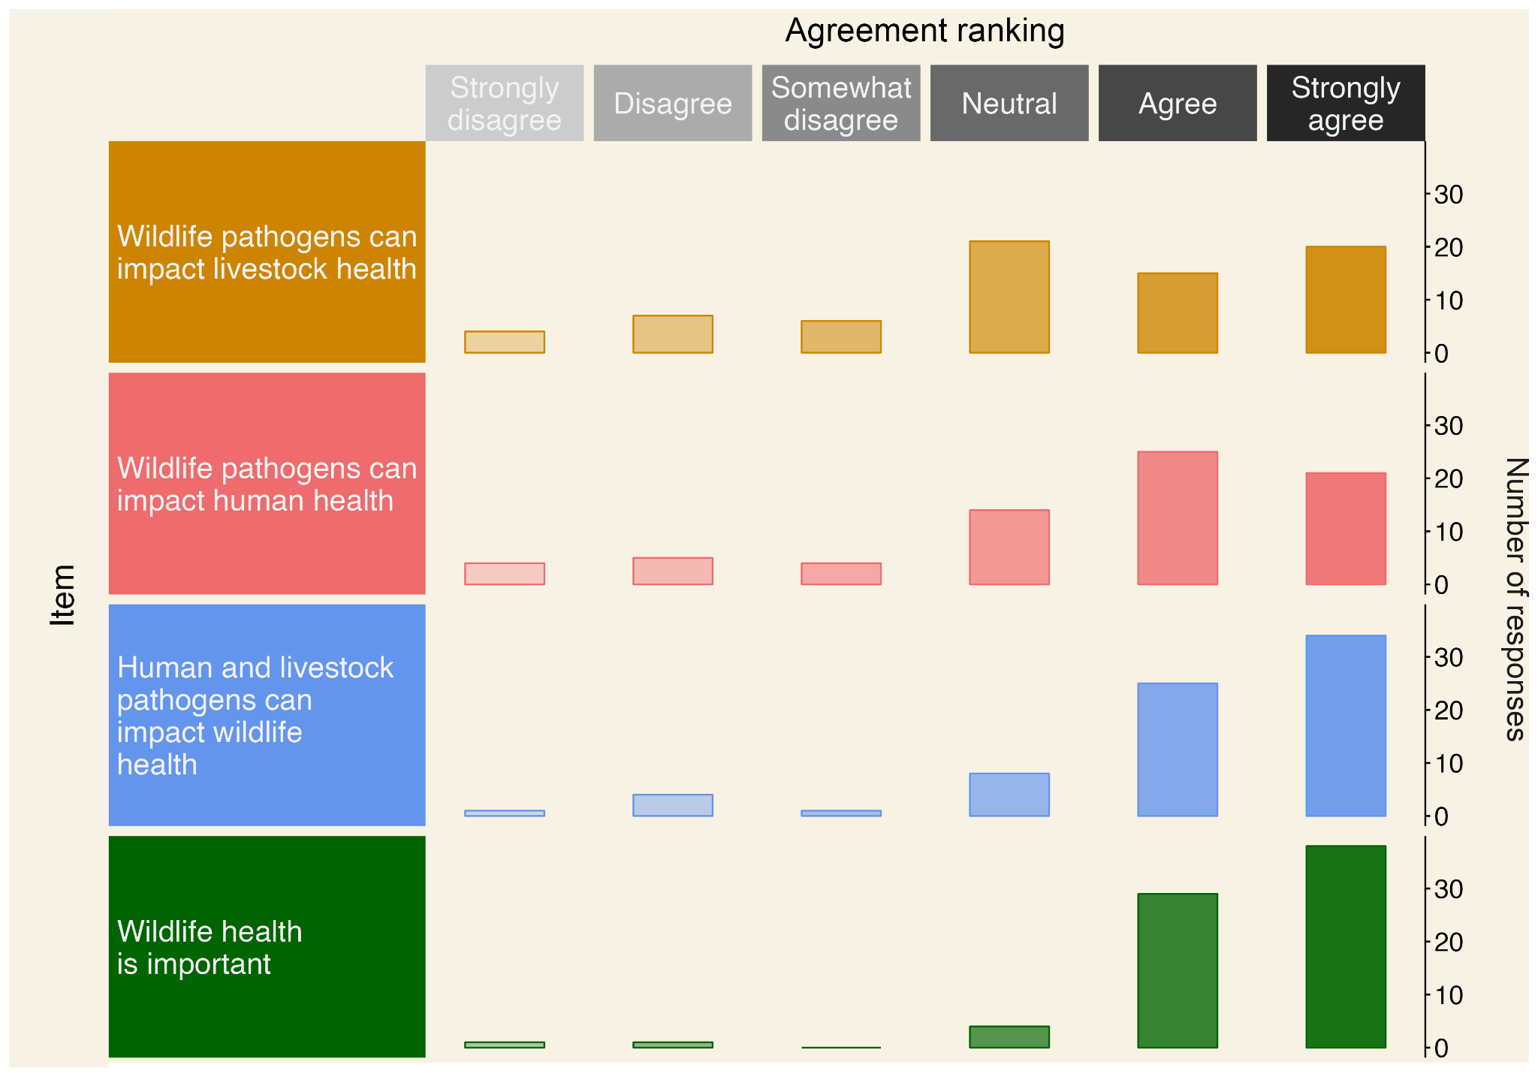

* The overall encountering frequency for sick and injured wildlife was requested in a unique question, therefore, rows one and two show the same total number of responses per encountering frequency.

*Figure 1. Distribution of the level of agreement (grey scale) among local protected area data managers with statements: ‘Pathogens carried by wildlife inhabiting the protected area(s) where I work in can affect livestock health’ (brown), ‘Pathogens carried by wildlife inhabiting the protected area(s) where I work in can affect human health’ (red), ‘Human or livestock pathogens can affect wildlife populations inhabiting the protected area(s) where I work in’ (blue), and ‘Wildlife health is important to achieve the conservation goals of the protected area(s) where I work’ (green).*

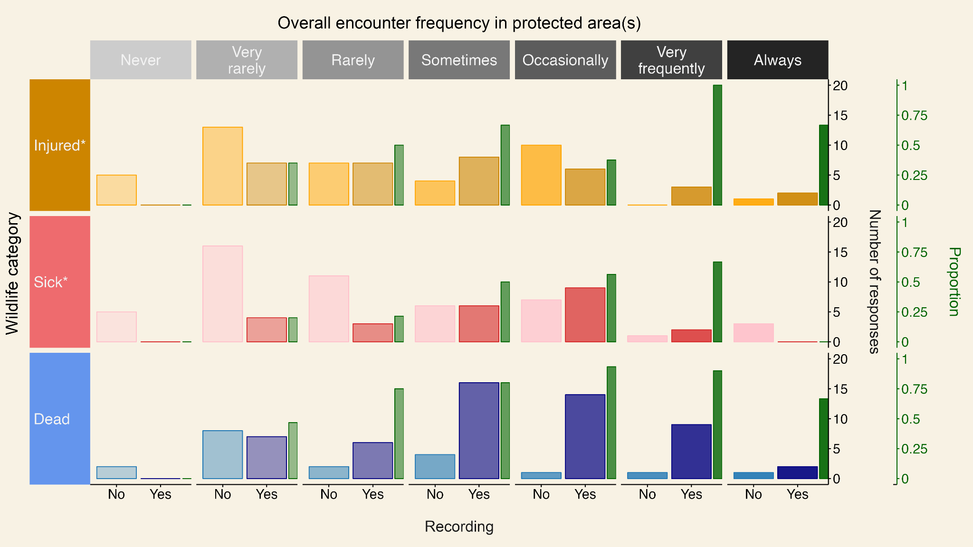

*Figure 2. Number of local protected area data manager responses reporting the recording or not of wildlife across health status and encounter frequency in the protected area(s) where they work. Bright and pale orange, red, and blue bars represent the number of responses reporting recording and not recording of injured, sick, and dead wildlife in each category, respectively. Green bars represent the proportion of responses that reported recording of wildlife in each category.*

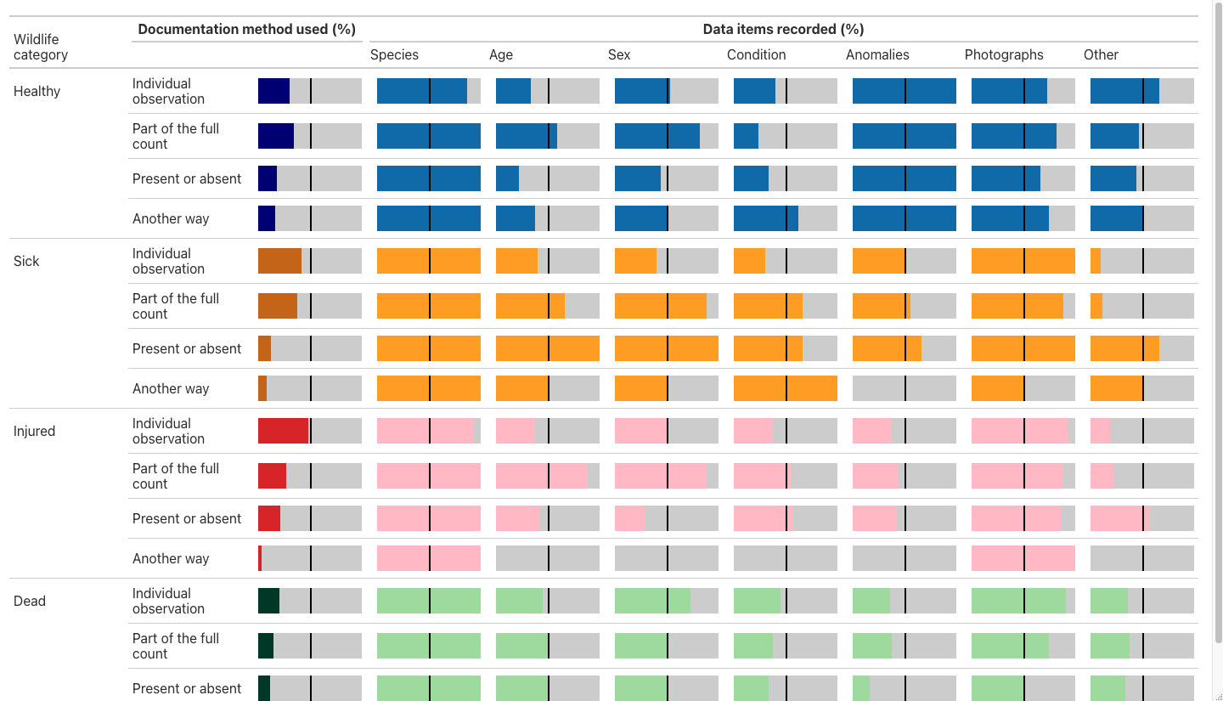

* *The black line shows the 50% reference.*

*Figure 3. Distribution of the method of documentation to register either healthy, sick, injured, or dead wildlife found during ranger patrols reported by local protected area data managers (“Individual observation”, “Part of the full count”, “Present or absent”, “Another way”) and the recording of specific data items for each wildlife health status across documentation methods.*

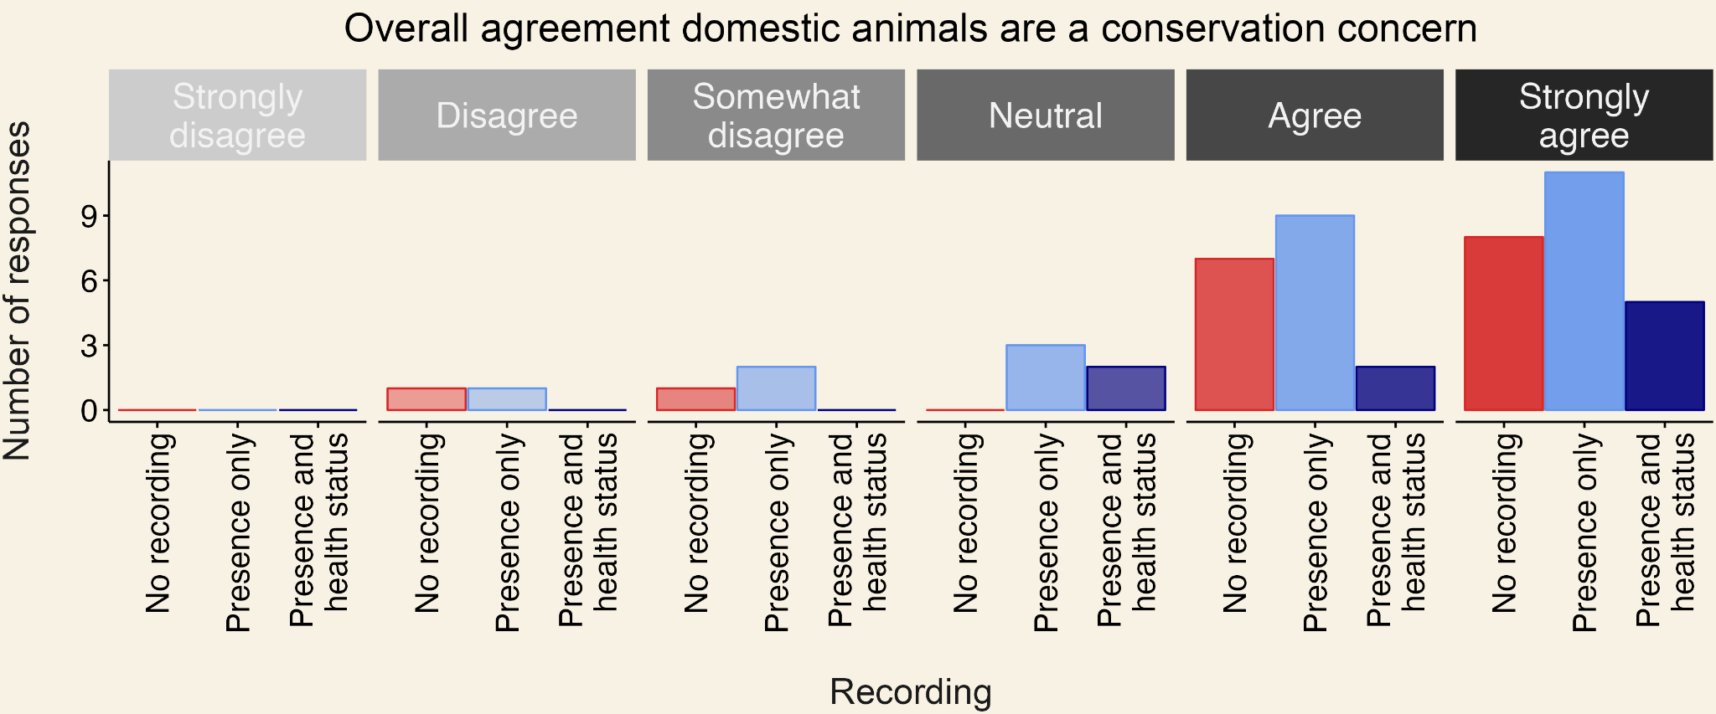

*Figure 4. Number of local protected area data manager responses reporting the recording of domestic animals when found in the protected area and their health status across agreement categories with the statement: ‘Introduced domestic animals are a conservation concern for the conservation goals of the protected areas where I work’. Red, light-blue and blue bars show the number of responses reporting non-recording of domestic animals, the recording of domestic animals but not their health status, and the recording of domestic animals and their health status, respectively. The data shown represents the group of protected area data managers that reported the presence of domestic animals in the protected area(s).*