**Wildlife health perceptions and monitoring practices in globally distributed protected areas**

Diego Montecino-Latorre1*, Mathieu Pruvot1,2, Sarah H Olson1

1 Wildlife Conservation Society, Health Program, Bronx, NY, USA

2 University of Calgary, Faculty of Veterinary Medicine, Calgary, AB, Canada

email Diego Montecino-Latorre: [dmontecino@wcs.org](mailto:dmontecino@wcs.org)

email Mathieu Pruvot: mpruvot@wcs.org

email Sarah H Olson: solson@wcs.org

*Corresponding author: Dr Diego Montecino-Latorre

2300 Southern Boulevard

Bronx, New York 10460

Email: [dmontecino@wcs.org](mailto:dmontecino@wcs.org)

Keywords: conservation, protected areas, rangers, wildlife disease, wildlife health, wildlife health monitoring, wildlife health surveillance

**Abstract**

Diseases are a threat to biodiversity conservation and global health, however, wildlife health (WH) surveillance systems remain uncommon. This deficit is especially relevant in protected areas (PAs) facing anthropogenic pressures. Integration of field conservation actors patrolling PAs can drastically strengthen WH surveillance. Nevertheless, baseline information regarding current WH monitoring mandates and practices at these sites is missing. To address this gap, we surveyed globally distributed protected area data managers (PADMs).

PADMs considered WH as relevant to the conservation goals of PAs and >90% of them confirmed that non-healthy and dead wildlife are encountered. However, >50% and >20% of PADMs claimed that these animals were not recorded, respectively. When these animals were documented, the recording methods and information collected differed. Although domestic animal presence was common and considered a conservation concern, these animals and their health status were not always recorded. Health data were often stored in a database, but paper forms and spreadsheets were also used.

Responses suggest that valuable syndromic WH surveillance data from PAs are being lost due to non-collection or inadequate management and their value could be limited by unstandardized documentation. Rangers could become a globally distributed “One Health workforce” but these flaws must be addressed first.

**Introduction**

Despite the growing recognition that the health of animals, people, and their shared environment are inseparably linked, effective surveillance systems collecting, analyzing, and responding to wildlife health (WH) data remain uncommon or deficient [(Machalaba et al. 2021; One Health High-Level Expert Panel et al. 2022; World Organization for Animal Health [WOAH] 2023)](https://paperpile.com/c/3IYyWY/YZJoC+vZcR2+6ofeg). This deficit is especially relevant in protected areas (PAs), Nature’s last strongholds [(Mittermeier et al. 2011; Machalaba et al. 2021; IUCN & EcoHealth Alliance 2022; WOAH 2023)](https://paperpile.com/c/3IYyWY/vZcR2+6ofeg+cJlIU+H0Pmh). Human encroachment, land-use change, and other activities not only threaten the mission of PAs [(Laurance et al. 2012; Vicente et al. 2021; Meng et al. 2023)](https://paperpile.com/c/3IYyWY/6qE46+l83Le+zEyxH), but they are also associated with extraction, pollution, the creation of human-wildlife-livestock interfaces, and ecosystem degradation that increase pathogen shedding from wild species [(Plowright et al. 2021; Vicente et al. 2021; Reaser et al. 2023)](https://paperpile.com/c/3IYyWY/Pdw12+pR3BG+zEyxH). These processes expose wildlife and people to physical (e.g., snaring), chemical (e.g., poisoning events), and biological sources of disease (e.g., pathogen transmission between species and epidemics) impacting protected area resilience, biodiversity conservation, and global health [(De Vos et al. 2016; Vila et al. 2019; Wolf et al. 2019; Hacon et al. 2020; Machalaba et al. 2020; Becker et al. 2023; Groenenberg et al. 2023; Porco et al. 2023)](https://paperpile.com/c/3IYyWY/WDnmz+rdQnL+jBfhE+hY7cn+gPxeq+VHjKM+MdegJ+NVdu).

The integration of field conservation actors at key interfaces offers a sound and cost-effective strategy to establish baseline WHM [(Kuisma et al. 2019; Vila et al. 2019; Wolf et al. 2019; Orozco et al. 2020; Machalaba et al. 2021; IUCN & EcoHealth Alliance 2022; World Health Organization [WHO] et al. 2023)](https://paperpile.com/c/3IYyWY/cJlIU+gPxeq+fWh6k+vKwDo+vZcR2+M4yXR+VHjKM). Rangers can detect injured, sick, and dead animals in PAs and the few documented initiatives that explicitly report ranger participation in WHM have demonstrated their potential to provide data to assess health risks and trends or trigger responses to disease outbreaks of global and conservation concern [(Kuisma et al. 2019; Vila et al. 2019; Wolf et al. 2019; Montecino-Latorre et al. 2020; Orozco et al. 2020; Porco et al. 2023)](https://paperpile.com/c/3IYyWY/VHjKM+gPxeq+fWh6k+iW5Zy+vKwDo+jBfhE).

Technology can enhance ranger integration into WH surveillance systems. The “Spatial Monitoring and Reporting Tool” (SMART) is a technology platform designed to administer PAs [(Cronin et al. 2021)](https://paperpile.com/c/3IYyWY/0csUi). Its field-ready technology, SMART Mobile, is in the hands of thousands of rangers supporting the digital documentation of user-determined “incidents” of conservation interest (e.g., fire, illegal hunting). The engagement of a large community of SMART-using rangers to document “health incidents” in PAs represents a promising opportunity to create a technology-supported worldwide network of WH sentinels [(Worsley-Tonks et al. 2022)](https://paperpile.com/c/3IYyWY/LeNlX).

However, there is a lack of baseline information regarding the perceived relevance of wildlife, human, and livestock health for biodiversity conservation in PAs, mandates of rangers to document findings of health interest, current WHM practices in PAs worldwide, and technical status of SMART to support WH data collection and management at these sites. To address this gap, we conducted a survey targeting protected area data managers (PADMs) to assess: i) their perceptions regarding WH and pathogen transmission between wildlife, humans, and livestock; ii) the detection of dead, sick, or injured wildlife, and domestic animals in PAs and their documentation; iii) health data management; and iv) the status of SMART deployment in PAs.

**Methods**

We developed a web-based questionnaire aimed at PADMs defined as a person directly responsible for managing SMART data in one or more PAs or a general manager or administrator of one or more PAs that uses SMART data. Respondents were asked if their position matched this definition.

The survey had five sections. Section 1 assessed the perception of PADMs on the importance of WH in achieving conservation goals, the role of human and livestock pathogens in affecting WH, and the role of wildlife pathogens in affecting public and livestock health. Section 2 requested PADMs to rank the overall frequency of encounters with dead, sick, or injured wildlife in PAs and their documentation when found during patrols. Section 3, asked about the presence of domestic animals in the PA(s), the documentation of their health status, and the perceived threats of domestic animals to conservation goals. Likert scales were used to answer questions in Sections 1-3. Section 4 addressed health data storage practices and Section 5 assessed the current state of SMART deployment in PAs.

An introductory web page explained that the survey was voluntary, anonymous, aimed at PADMs, and that clicking the “Start the survey” button constituted consent. A tutorial was provided for the language-translation tool of this survey built on Google Forms (<https://sites.google.com/wcs.org/smarttorecordwildlifehealth/home>).

The survey was distributed globally to the SMART Community Forum users (https://forum.smartconservationtools.org/) by the SMART Partnership ([https://smartconservationtools.org](https://smartconservationtools.org/en-us/)) via email in October 2022 and remained open for three months. A reminder was sent to the SMART Community three weeks before the closing date.

Responses by PADMs could represent single or multiple PAs. For our analysis, we focused on what we considered to be “local” responses which represented one or two PAs, and assumed they provided insights into specific local realities. “Non-local” responses represented more than two PAs, which were assumed to help understand perceptions at the decision-making level and were analyzed separately (see Supporting Information). Respondents who did not identify as a PADM (as defined above) were considered outside our target population and excluded. We also discarded responses that only included marine PAs based on the World Database on Protected Areas (<https://www.protectedplanet.net/en/thematic-areas/wdpa?tab=WDPA>) as marine PA management, species, and patrol logistics are markedly different. The descriptive analysis of survey responses was conducted in R v4.3.1. The questionnaire, survey data, and descriptive analysis can be found at https://github.com/dmontecino/SMART_survey.

**Results**

We received 128 responses. Forty-two were removed because either the PA name(s) were not provided, only marine PAs were listed, or the respondents did not match the target audience (8, 7, and 27 responses, respectively). The final dataset contained 86 respondents from 23 countries. Seventy-three were local responses from 19 countries and 13 were non-local responses from 10 countries (Supporting Information).

### **Perceptions regarding wildlife health importance in conservation and potential consequences of pathogen transmission among wildlife, domestic animals, and people**

### Sixty-seven local respondents (91.8%) either strongly agreed or agreed with the affirmation “Wildlife health, including infectious and non-infectious diseases, is important to achieve the conservation goals of the protected areas where I work”. Most respondents (80.8%) strongly agreed or agreed with the affirmation “human or livestock pathogens can affect wildlife populations inhabiting the protected area(s) I work in”. In comparison, 63% strongly agreed or agreed that “pathogens carried by wildlife inhabiting the protected area(s) where I work in can affect human health” with 19.2% of respondents (47.9%) although the proportion of neutral respondents was more prominent (28.8%). Detailed response distributions are shown in Fig 1. Non-local responses followed similar trends (Supporting Information, section 1.1).

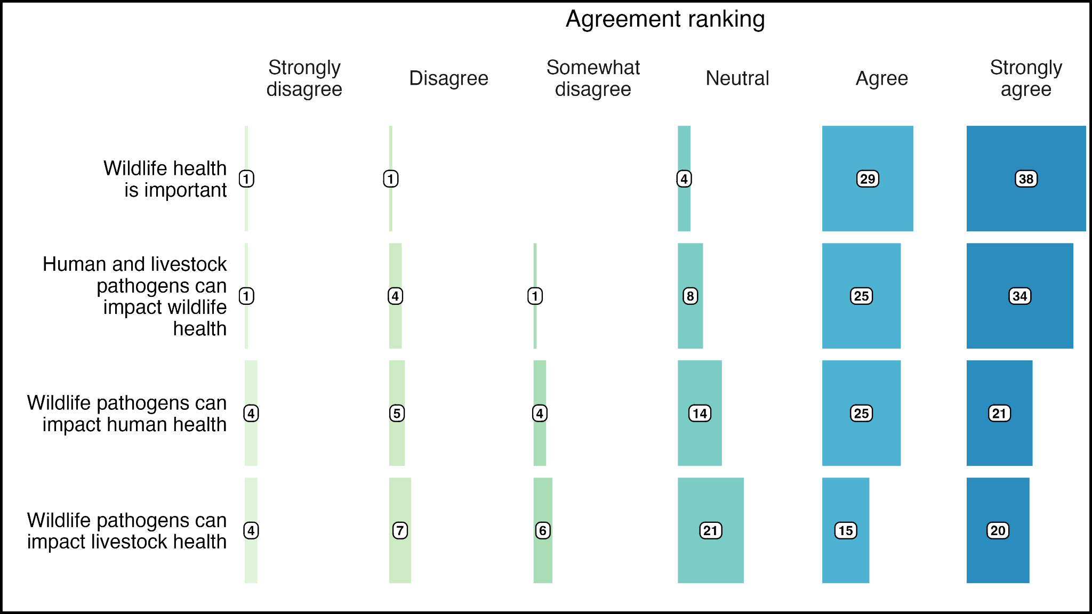

*Fig 1. Distribution of the level of agreement among protected area data managers with statements: ‘Wildlife health is important to achieve the conservation goals of the protected area(s) where I work’ (row 1), ‘human or livestock pathogens can affect wildlife populations inhabiting the protected area(s) where I work in’ (row 2), ‘pathogens carried by wildlife inhabiting the protected area(s) where I work in can affect human health’ (row 3), and ‘pathogens carried by wildlife inhabiting the protected area(s) where I work in can affect livestock health’ (row 4).*

**Overall frequency of encounters with dead, sick, or injured wildlife in protected areas and their documentation when found during patrols**

Seventy-one local respondents (97.3%) ranked encountering dead animals in the PA at least "Very rarely" whilst 76.1% of these respondents answered that these animals are documented if found during patrols. Sixty-eight local respondents (93.2%) ranked encountering sick or injured animals in the PA at least "Very rarely", whilst 35.3% and 48.5% of these respondents answered that sick and injured animals are documented if found during patrols (Fig 2).

~~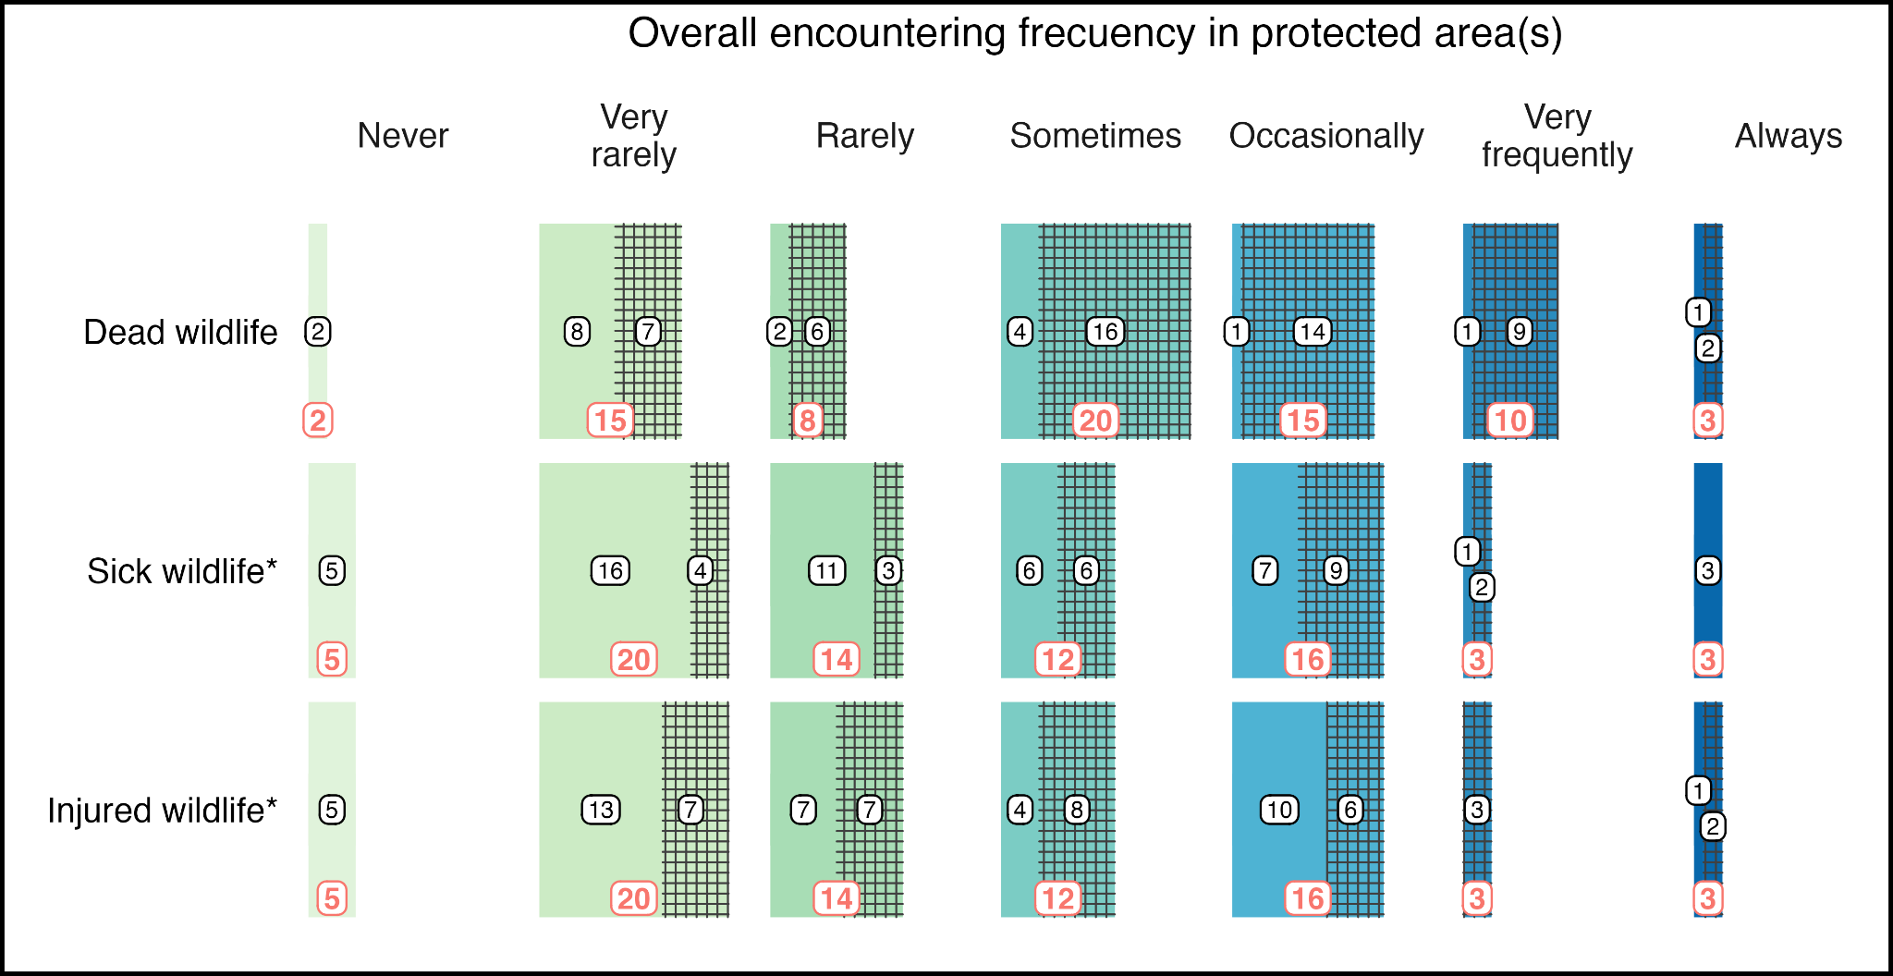~~* The overall encountering frequency for sick and injured wildlife was requested in a unique question, therefore, rows two and three show the same total number of responses per encountering frequency.

*Fig 2. Distribution of protected area data manager responses regarding the encounter of dead and sick or injured wildlife in the protected area(s) where they work. Red numbers indicate the total number of responses per encountering frequency. The dashed area of the polygons represent the responses indicating that dead, sick, and injured wildlife found during ranger patrols are recorded (rows 1 – 3, respectively). Black numbers indicate the total number of responses reporting recording and non-recording of dead, sick, and injured wildlife found during patrols within each frequency category.*

All 17 local PADMs who ranked encountering dead wildlife at least "Very rarely" but answered that these animals were not documented, either agreed or strongly agreed with the importance of WH to achieve conservation goals. Similarly, 90.9% and 94.3% of respondents who ranked encountering sick or injured wildlife at least "Very rarely" but answered that these animals were not documented either agreed or strongly agreed with this statement.

Most non-local respondents ranked the overall encounter with non-healthy wildlife between “Very rarely” and “Occasionally”. A larger proportion of non-local PADMs reported the documentation of these animals when found during patrols compared to local responses (92.3%, 61.5%, and 84.6%, for dead, sick, and injured wildlife respectively, Supporting Information, section 1.2).

For the 58 local PADMs reporting the documentation of either dead, sick, or injured wildlife, the recording method reported varied. Most often, each individual animal was documented according to health status (healthy, sick, injured, dead). The second most common method involved a complete inventory of healthy, sick, injured, or dead animals for each species. The distribution of the recording methods across healthy, sick, injured, or dead wildlife is shown in Fig 3. For non-local responses, the predominant method was “each animal is an individual observation” across health categories (Supporting Information, section 1.2).

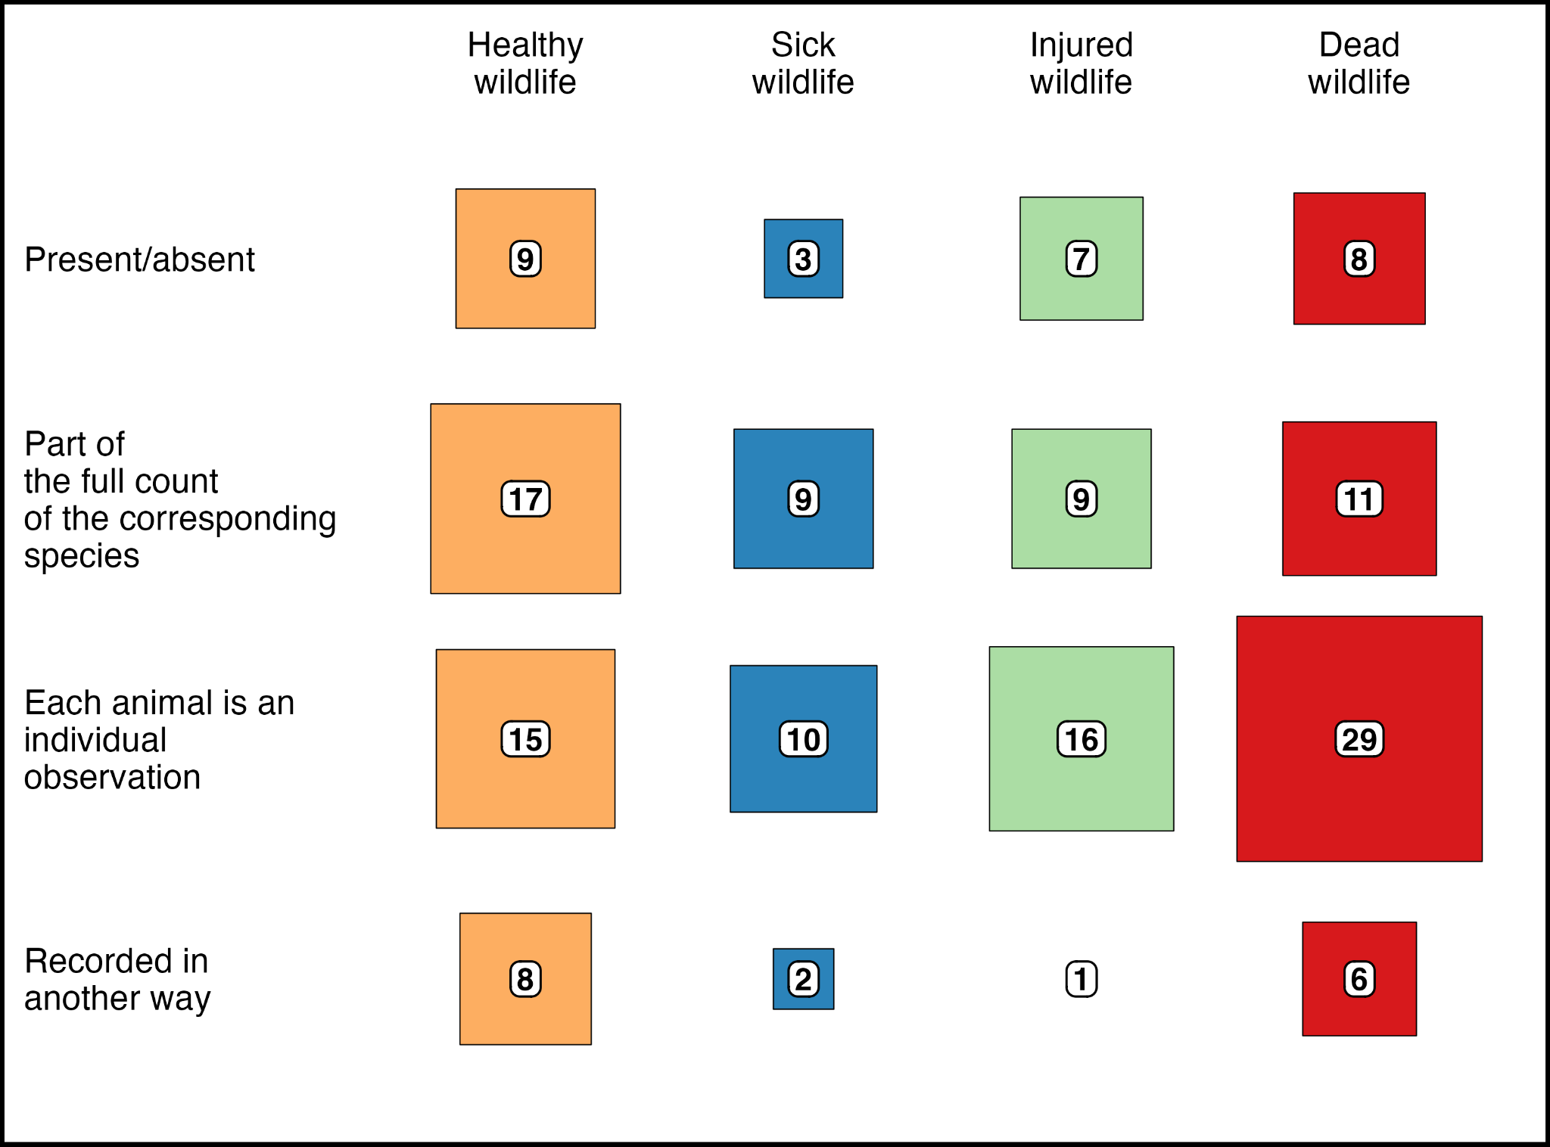

*Fig. 3. Distribution of methods of documentation to register either sick, injured, or dead wildlife found during ranger patrols reported by protected area data managers.*

The data types and attributes used by local respondents to document sick, injured, or dead wildlife are shown in Fig 4. None of them were collected consistently. Across health categories, photographs and species were the main data types and attributes collected. In non-local responses the trend was relatively similar, however, items were reported to be recorded more consistently (e.g., age, anomalies, and condition in the three health categories; Supporting Information, section 1.2).

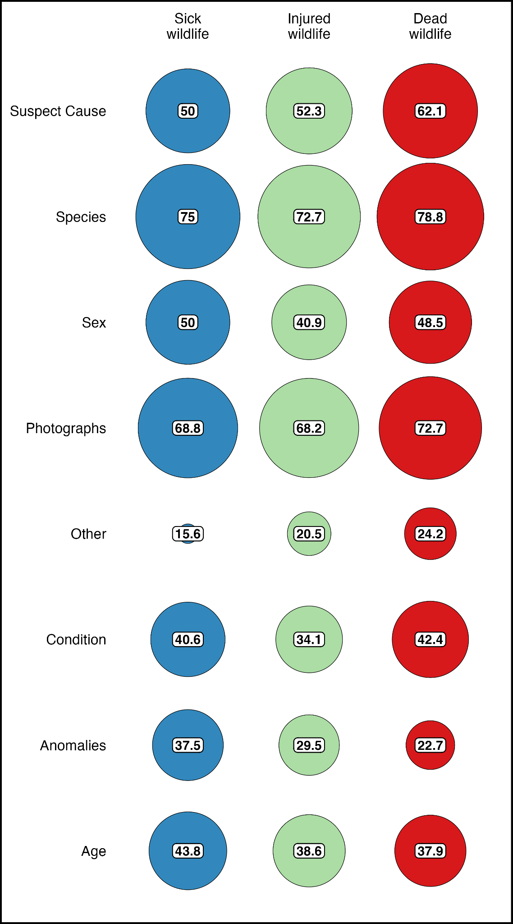

*Fig 4. The percentage of protected area data manager responses indicating the documentation of sick, injured, and dead wildlife found during patrols that record specific data items for each wildlife health status. The size of the circles is proportional to the percentages observed.*

**Presence of domestic animals in protected areas, the documentation of their health status, and the perceived threats of domestic animals to conservation goals**

Fifty-two local PADMs responded that domestic animals were found in the corresponding PAs (71.2%). Among them, 67.3% reported that domestic animals were documented if observed during patrols, of which only 25.7% reported recording their health status. Forty-two (80.8%) local respondents reporting domestic animals in the PAs either agreed or strongly agreed that domestic animals are a conservation concern (Fig 5). Twenty-seven of them (64.3%) answered that these animals were documented.

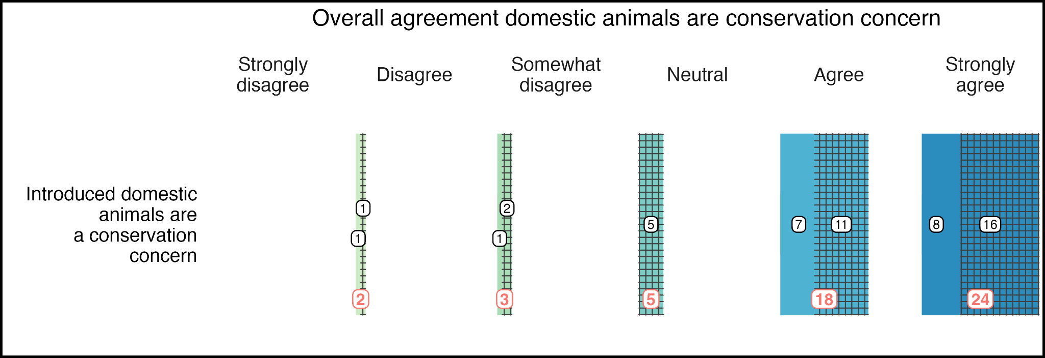*Fig 5. Distribution of the level of agreement among protected area data managers with the statement: ‘Introduced domestic animals (e.g., dogs, cats, cattle, pigs, cats) are a concern for the conservation goals of the protected areas where I work’. Red numbers indicate the total number of responses per agreement. The dashed areas of the polygons represent the responses indicating that domestic animals found during ranger patrols are recorded. Black numbers indicate the total number of responses reporting documentation and non-documentation of domestic animals found during patrols.*

Eight non-local PADMs (61.5%) responded that domestic animals were found in the PAs. Among them, seven (87.5%) reported that domestic animals were documented if observed during patrols, of which only two (28.6%) reported recording their health status (Supporting Information, section 1.3).

**Health data storage practices in protected areas**

For the subset of local PADMs reporting the documentation of either sick, injured, or dead wildlife (24, 33, and 54 responses, respectively), their data was often stored in a SMART database (Fig 6). Paper forms, reports, and spreadsheets were employed when their data was not stored in a SMART database. Most non-local PADMs responded that health data were stored in a SMART database (Supporting Information, section 1.4).

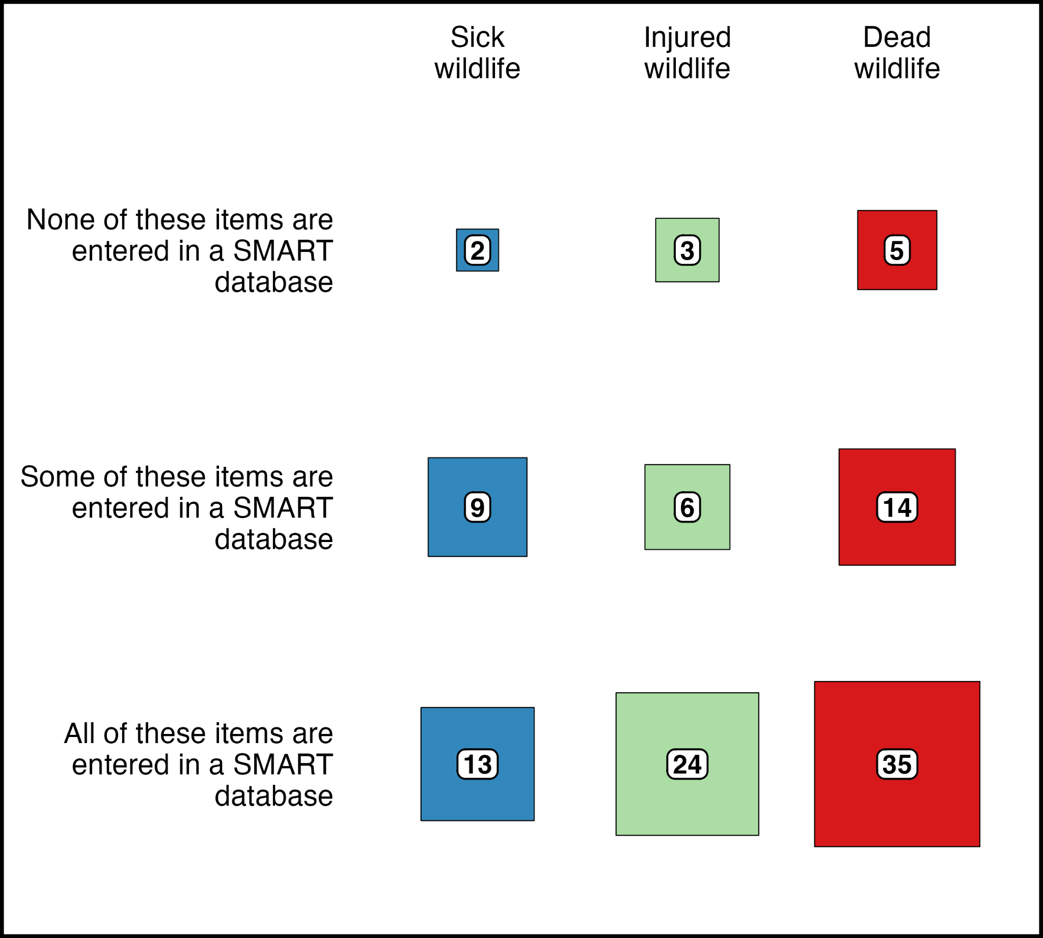

*Fig 6. Distribution of protected area data managers reporting the documentation of either sick, injured, or dead wildlife found during ranger patrols across data storage practices with respect to the use of SMART.*

Thirty-one of the 35 local respondents (88.6%) recording domestic animals during patrols indicated that this information was stored in a SMART database. All PADMs reporting the recording of health status in domestic animals responded that this information was stored in a SMART database.

**Current state of SMART deployment in protected areas**

Forty-two local PADMs reported that SMART was fully rolled out, 23 partially rolled out, and 8 under pilot. The most common version was SMART 6, reported by 41 PADMs. SMART 7 was already available for 19 PADMs at the time of the survey. Older SMART versions were less used. Non-local responses were similar (Supporting Information; section 1.5).

**Discussion**

We developed a web-based questionnaire aimed at globally distributed PADMs to learn about their perceptions regarding WH; the monitoring of dead, sick, and injured wildlife and domestic animals at these sites; health data storage practices; and local status of the SMART information technology system. Responses suggest that valuable syndromic WH and, consequently, One Health surveillance information is being lost due to non-collection or inadequate management. The usefulness of data actually collected is likely limited by unstandardized documentation.

PADMs largely considered WH as relevant to the conservation goals of PAs and most of them confirmed that dead, sick, or injured wildlife were encountered at least “Very rarely”. However, the documentation of these animals was not necessarily conducted and it was less common in responses from local data managers. This contradiction could be explained by recent global pathogen-driven crises such as SARS-CoV-2 and H5N1 Highly Pathogenic Avian Influenza virus that might have sensitized our audience by the time the survey was distributed but before health-associated monitoring objectives could be planned and rolled out. These findings could also suggest a lack of knowledge or resources to act on their understanding of the importance of WH for conservation goals. Although only 13 non-local responses were included in the final dataset, the observed larger proportion of non-local responses reporting the documentation of non-healthy and dead wildlife could suggest differences between managers' expectations and field realities.

We noted a general agreement among PADMs regarding the conservation threat that domestic animals (e.g., dogs, cats, cattle) represent. While most PADMs reported the presence of these animals in PAs, they were not always documented and only a minority responded that their health status was recorded. This contradiction could be explained by similar drivers mentioned above. Pathogen transmission from domestic animals to wildlife can seriously harm biodiversity conservation efforts (e.g., [Vila et al. 2019)](https://paperpile.com/c/3IYyWY/gPxeq) and they add to the direct and indirect pressures on wildlife from domestic animals, such as predation, competition, disturbance, and land-use change [(du Toit 2011; Gompper 2013)](https://paperpile.com/c/3IYyWY/EEQG4+PYamP).

Harmonization and adequate management of data are foundational pillars for WH monitoring [(WOAH 2010, 2015, 2018; Sleeman et al. 2012; Ryser-Degiorgis 2013; Stephen 2018; Lawson et al. 2021; Machalaba et al. 2021; Giacinti et al. 2022; Stephen & Berezowski 2022; Hayman et al. 2023; Heiderich et al. 2023)](https://paperpile.com/c/3IYyWY/GVgfG+veGVY+czvOA+vZcR2+mqxmz+Mi4Ne+N2Ppz+CeEjH+didki+LGKKa+4vvmA+NVvrn). However, when non-healthy and dead wildlife were recorded, a variety of methodologies were used and different information was collected. The use of paper forms and Excel sheets to manage health data was reported by PADMs. These responses are aligned with historical pitfalls in WH surveillance’s data governance (e.g., [Avery-Gomm et al. 2016; Lawson et al. 2021; Heiderich et al. 2023; WOAH 2023)](https://paperpile.com/c/3IYyWY/GVgfG+NVvrn+NPT3L+6ofeg). To date, relevant WH information from PAs is likely being lost due to non-collection and inadequate management. The value of collected data could also be limited by the lack of harmonization.

In a world with active encroachment into natural habitats, ubiquitous stressors for wildlife, and continuous disease emergence at human-wildlife-livestock interfaces, strengthening WH surveillance in key locations and its integration into One Health systems is critical to fostering the conservation of biodiversity and global health security [(Machalaba et al. 2021; Hayman et al. 2023)](https://paperpile.com/c/3IYyWY/CeEjH+vZcR2). The survey responses confirm that rangers can detect obviously non-healthy and dead wildlife on a much larger temporospatial scale than isolated research initiatives. Currently, there are approximately 280,000 rangers worldwide and it is estimated that 1.5 million will be needed by 2030 to adequately protect 30% of the planet [(Appleton et al. 2022)](https://paperpile.com/c/3IYyWY/vaXRI). The present and projected number of rangers and their local contributions to a healthier planet [(Kuisma et al. 2019; Vila et al. 2019; Wolf et al. 2019; Montecino-Latorre et al. 2020; Orozco et al. 2020; Singh et al. 2021; Porco et al. 2023; Stolton et al. 2023)](https://paperpile.com/c/3IYyWY/VHjKM+gPxeq+fWh6k+iW5Zy+vKwDo+jBfhE+Z3eD+IIwRF) reveal their unique potential as a worldwide distributed “One Health workforce” that could drastically strengthen WH and One Health surveillance systems [(Machalaba et al. 2021; Worsley-Tonks et al. 2022)](https://paperpile.com/c/3IYyWY/vZcR2+LeNlX).

However, responses to our survey point to several issues that must be addressed before this potential can be realized. First, the documentation of dead and non-healthy wildlife found during patrols is imperative. A definition of a health event optimized for rangers must be established. The minimal set of variables to be recorded from each health event and their documentation method must be harmonized across jurisdictions. Secondly, a database to guarantee the proper governance of ranger-documented health events must be available. Contemporaneous SMART technology is ready to support the management of harmonized syndromic health data, provided that adequate resources for planning, training, and expert support are available.

Efforts to build this workforce have already started. WildHealthNet, a Wildlife Conservation Society (WCS) initiative, focuses on creating national surveillance networks and codifying their Standard Operating Procedures [(Denstedt et al. 2021; Porco et al. 2023; Pruvot et al. 2023)](https://paperpile.com/c/3IYyWY/18t9S+jBfhE+EkB7K). Currently, WCS is supporting the integration of rangers into WH monitoring using the same standards in Lao, Peru, Cambodia, and Guatemala. Additional efforts are underway through the Wildlife Health Intelligence Network (<https://snappartnership.net/teams/whin/>) whose objectives include building a larger community of practice that supports the scaling of local WH surveillance globally, and the establishment of WH data collection and management standards.

**Acknowledgments and Data**

Thanks to all responders to our survey and the SMART Partnership (<https://smartconservationtools.org>) for distributing the survey across the community of SMART users, especially to Mônica Barcellos. Special thanks to Jonathan Palmer, Executive Director of the Wildlife Conservation Society’s Conservation Technology Department.

The questionnaire, survey data, and descriptive analysis can be found at <https://github.com/dmontecino/SMART_survey>. The survey was exempt from full ethics review (ref #22-53 Wildlife Conservation Society Institutional Review Board).

The authors have no conflicts of interest to declare.

**References**

[Appleton, M.R., Courtiol, A., Emerton, L., Slade, J.L., Tilker, A., Warr, L.C., Malvido, M.Á., Barborak, J.R., de Bruin, L., Chapple, R., Daltry, J.C., Hadley, N.P., Jordan, C.A., Rousset, F., Singh, R., Sterling, E.J., Wessling, E.G. & Long, B. (2022). Protected area personnel and ranger numbers are insufficient to deliver global expectations. *Nature Sustainability*, 5, 1100–1110.](http://paperpile.com/b/3IYyWY/vaXRI)

[Avery-Gomm, S., Valliant, M., Schacter, C.R., Robbins, K.F., Liboiron, M., Daoust, P.-Y., Rios, L.M. & Jones, I.L. (2016). A study of wrecked Dovekies (Alle alle) in the western North Atlantic highlights the importance of using standardized methods to quantify plastic ingestion. *Mar. Pollut. Bull.*, 113, 75–80.](http://paperpile.com/b/3IYyWY/NPT3L)

[Becker, D.J., Eby, P., Madden, W., Peel, A.J. & Plowright, R.K. (2023). Ecological conditions predict the intensity of Hendra virus excretion over space and time from bat reservoir hosts. *Ecol. Lett.*, 26, 23–36.](http://paperpile.com/b/3IYyWY/MdegJ)

[Cronin, D.T., Dancer, A., Long, B., Lynam, A.J., Muntifering, J., Palmer, J., Bergl, R.A., Wich, S.A. & Piel, A.K. (2021). Application of SMART software for conservation area management. In: *Conservation Technology*. Oxford University Press Oxford, UK, pp. 201–224.](http://paperpile.com/b/3IYyWY/0csUi)

[Denstedt, E., Porco, A., Hwang, J., Nga, N.T.T., Ngoc, P.T.B., Chea, S., Khammavong, K., Milavong, P., Sours, S., Osbjer, K., Tum, S., Douangngeun, B., Theppanya, W., Van Long, N., Thanh Phuong, N., Tin Vinh Quang, L., Van Hung, V., Hoa, N.T., Le Anh, D., Fine, A. & Pruvot, M. (2021). Detection of African swine fever virus in free-ranging wild boar in Southeast Asia. *Transbound. Emerg. Dis.*, 68, 2669–2675.](http://paperpile.com/b/3IYyWY/18t9S)

[De Vos, A., Cumming, G., Cumming, D., Ament, J., Baum, J., Clements, H., Grewar, J., Maciejewski, K. & Moore, C. (2016). Pathogens, disease, and the social-ecological resilience of protected areas. *Ecol. Soc.*, 21.](http://paperpile.com/b/3IYyWY/NVdu)

[Giacinti, J.A., Jane Parmley, E., Reist, M., Bayley, D., Pearl, D.L. & Jardine, C.M. (2022). Canadian wildlife health surveillance—patterns, challenges and opportunities identified by a scoping review. *Facets (Ott)*, 7, 25–44.](http://paperpile.com/b/3IYyWY/4vvmA)

[Gompper, M.E. (2013). *Free-Ranging Dogs and Wildlife Conservation*. OUP Oxford.](http://paperpile.com/b/3IYyWY/EEQG4)

[Groenenberg, M., Crouthers, R., Yoganand, K., Banet-Eugene, S., Bun, S., Muth, S., Kim, M., Mang, T., Panha, M., Pheaktra, P., Pin, T., Sopheak, K., Sovanna, P., Vibolratanak, P., Wyatt, A.G. & Gray, T.N.E. (2023). Snaring devastates terrestrial ungulates whilst sparing arboreal primates in Cambodia’s Eastern Plains Landscape. *Biol. Conserv.*, 284, 110195.](http://paperpile.com/b/3IYyWY/hY7cn)

[Hacon, S. de S., Oliveira-da-Costa, M., Gama, C. de S., Ferreira, R., Basta, P.C., Schramm, A. & Yokota, D. (2020). Mercury Exposure through Fish Consumption in Traditional Communities in the Brazilian Northern Amazon. *Int. J. Environ. Res. Public Health*, 17.](http://paperpile.com/b/3IYyWY/rdQnL)

[Hayman, D.T.S., Adisasmito, W.B., Almuhairi, S., Behravesh, C.B., Bilivogui, P., Bukachi, S.A., Casas, N., Becerra, N.C., Charron, D.F., Chaudhary, A., Ciacci Zanella, J.R., Cunningham, A.A., Dar, O., Debnath, N., Dungu, B., Farag, E., Gao, G.F., Khaitsa, M., Machalaba, C., Mackenzie, J.S., Markotter, W., Mettenleiter, T.C., Morand, S., Smolenskiy, V., Zhou, L. & Koopmans, M. (2023). Developing One Health surveillance systems. *One Health*, 100617.](http://paperpile.com/b/3IYyWY/CeEjH)

[Heiderich, E., Keller, S., Pewsner, M., Origgi, F.C., Zürcher-Giovannini, S., Borel, S., Marti, I., Scherrer, P., Pisano, S.R.R., Friker, B., Adrian-Kalchhauser, I. & Ryser-Degiorgis, M.-P. (2023). Analysis of a European general wildlife health surveillance program: chances, challenges and recommendations. *bioRxiv*.](http://paperpile.com/b/3IYyWY/NVvrn)

[IUCN & EcoHealth Alliance. (2022). *Healthy people and wildlife through nature protection: Guidelines for prevention, detection, response, and recovery from disease risks in and around protected and conserved areas*.](http://paperpile.com/b/3IYyWY/cJlIU)

[Kuisma, E., Olson, S.H., Cameron, K.N., Reed, P.E., Karesh, W.B., Ondzie, A.I., Akongo, M.-J., Kaba, S.D., Fischer, R.J., Seifert, S.N., Muñoz-Fontela, C., Becker-Ziaja, B., Escudero-Pérez, B., Goma-Nkoua, C., Munster, V.J. & Mombouli, J.-V. (2019). Long-term wildlife mortality surveillance in northern Congo: a model for the detection of Ebola virus disease epizootics. *Philos. Trans. R. Soc. Lond. B Biol. Sci.*, 374, 20180339.](http://paperpile.com/b/3IYyWY/fWh6k)

[Laurance, W.F., Useche, D.C., Rendeiro, J., Kalka, M., Bradshaw, C.J.A., Sloan, S.P., Laurance, S.G., Campbell, M., Abernethy, K., Alvarez, P., Arroyo-Rodriguez, V., Ashton, P., Benítez-Malvido, J., Blom, A., Bobo, K.S., Cannon, C.H., Cao, M., Carroll, R., Chapman, C., Coates, R., Cords, M., Danielsen, F., De Dijn, B., Dinerstein, E., Donnelly, M.A., Edwards, D., Edwards, F., Farwig, N., Fashing, P., Forget, P.-M., Foster, M., Gale, G., Harris, D., Harrison, R., Hart, J., Karpanty, S., Kress, W.J., Krishnaswamy, J., Logsdon, W., Lovett, J., Magnusson, W., Maisels, F., Marshall, A.R., McClearn, D., Mudappa, D., Nielsen, M.R., Pearson, R., Pitman, N., van der Ploeg, J., Plumptre, A., Poulsen, J., Quesada, M., Rainey, H., Robinson, D., Roetgers, C., Rovero, F., Scatena, F., Schulze, C., Sheil, D., Struhsaker, T., Terborgh, J., Thomas, D., Timm, R., Urbina-Cardona, J.N., Vasudevan, K., Wright, S.J., Arias-G, J.C., Arroyo, L., Ashton, M., Auzel, P., Babaasa, D., Babweteera, F., Baker, P., Banki, O., Bass, M., Bila-Isia, I., Blake, S., Brockelman, W., Brokaw, N., Brühl, C.A., Bunyavejchewin, S., Chao, J.-T., Chave, J., Chellam, R., Clark, C.J., Clavijo, J., Congdon, R., Corlett, R., Dattaraja, H.S., Dave, C., Davies, G., Beisiegel, B. de M., da Silva, R. de N.P., Di Fiore, A., Diesmos, A., Dirzo, R., Doran-Sheehy, D., Eaton, M., Emmons, L., Estrada, A., Ewango, C., Fedigan, L., Feer, F., Fruth, B., Willis, J.G., Goodale, U., Goodman, S., Guix, J.C., Guthiga, P., Haber, W., Hamer, K., Herbinger, I., Hill, J., Huang, Z., Sun, I.F., Ickes, K., Itoh, A., Ivanauskas, N., Jackes, B., Janovec, J., Janzen, D., Jiangming, M., Jin, C., Jones, T., Justiniano, H., Kalko, E., Kasangaki, A., Killeen, T., King, H.-B., Klop, E., Knott, C., Koné, I., Kudavidanage, E., Ribeiro, J.L. da S., Lattke, J., Laval, R., Lawton, R., Leal, M., Leighton, M., Lentino, M., Leonel, C., Lindsell, J., Ling-Ling, L., Linsenmair, K.E., Losos, E., Lugo, A., Lwanga, J., Mack, A.L., Martins, M., McGraw, W.S., McNab, R., Montag, L., Thompson, J.M., Nabe-Nielsen, J., Nakagawa, M., Nepal, S., Norconk, M., Novotny, V., O’Donnell, S., Opiang, M., Ouboter, P., Parker, K., Parthasarathy, N., Pisciotta, K., Prawiradilaga, D., Pringle, C., Rajathurai, S., Reichard, U., Reinartz, G., Renton, K., Reynolds, G., Reynolds, V., Riley, E., Rödel, M.-O., Rothman, J., Round, P., Sakai, S., Sanaiotti, T., Savini, T., Schaab, G., Seidensticker, J., Siaka, A., Silman, M.R., Smith, T.B., de Almeida, S.S., Sodhi, N., Stanford, C., Stewart, K., Stokes, E., Stoner, K.E., Sukumar, R., Surbeck, M., Tobler, M., Tscharntke, T., Turkalo, A., Umapathy, G., van Weerd, M., Rivera, J.V., Venkataraman, M., Venn, L., Verea, C., de Castilho, C.V., Waltert, M., Wang, B., Watts, D., Weber, W., West, P., Whitacre, D., Whitney, K., Wilkie, D., Williams, S., Wright, D.D., Wright, P., Xiankai, L., Yonzon, P. & Zamzani, F. (2012). Averting biodiversity collapse in tropical forest protected areas. *Nature*, 489, 290–294.](http://paperpile.com/b/3IYyWY/l83Le)

[Lawson, B., Neimanis, A., Lavazza, A., López-Olvera, J.R., Tavernier, P., Billinis, C., Duff, J.P., Mladenov, D.T., Rijks, J.M., Savić, S., Wibbelt, G., Ryser-Degiorgis, M.-P. & Kuiken, T. (2021). How to Start Up a National Wildlife Health Surveillance Programme. *Animals (Basel)*, 11.](http://paperpile.com/b/3IYyWY/GVgfG)

[Machalaba, C., Feferholtz, Y., Uhart, M. & Karesh, W.B. (2020). Wildlife conservation status and disease trends: ten years of reports to the Worldwide Monitoring System for Wild Animal Diseases. *Rev. Sci. Tech.*, 39, 991–1001.](http://paperpile.com/b/3IYyWY/WDnmz)

[Machalaba, C., Uhart, M., Ryser-Degiorgis, M.-P. & Karesh, W.B. (2021). Gaps in health security related to wildlife and environment affecting pandemic prevention and preparedness, 2007-2020. *Bull. World Health Organ.*, 99, 342–350B.](http://paperpile.com/b/3IYyWY/vZcR2)

[Meng, Z., Dong, J., Ellis, E.C., Metternicht, G., Qin, Y., Song, X.-P., Löfqvist, S., Garrett, R.D., Jia, X. & Xiao, X. (2023). Post-2020 biodiversity framework challenged by cropland expansion in protected areas. *Nature Sustainability*, 1–11.](http://paperpile.com/b/3IYyWY/6qE46)

[Mittermeier, R.A., Turner, W.R., Larsen, F.W., Brooks, T.M. & Gascon, C. (2011). Global Biodiversity Conservation: The Critical Role of Hotspots. In: *Biodiversity Hotspots: Distribution and Protection of Conservation Priority Areas* (eds. Zachos, F.E. & Habel, J.C.). Springer Berlin Heidelberg, Berlin, Heidelberg, pp. 3–22.](http://paperpile.com/b/3IYyWY/H0Pmh)

[Montecino-Latorre, D., Napolitano, C., Briceño, C. & Uhart, M.M. (2020). Sarcoptic mange: An emerging threat to Chilean wild mammals? *Perspectives in Ecology and Conservation*, 18, 267–276.](http://paperpile.com/b/3IYyWY/iW5Zy)

[One Health High-Level Expert Panel (OHHLEP), Adisasmito, W.B., Almuhairi, S., Behravesh, C.B., Bilivogui, P., Bukachi, S.A., Casas, N., Cediel Becerra, N., Charron, D.F., Chaudhary, A., Ciacci Zanella, J.R., Cunningham, A.A., Dar, O., Debnath, N., Dungu, B., Farag, E., Gao, G.F., Hayman, D.T.S., Khaitsa, M., Koopmans, M.P.G., Machalaba, C., Mackenzie, J.S., Markotter, W., Mettenleiter, T.C., Morand, S., Smolenskiy, V. & Zhou, L. (2022). One Health: A new definition for a sustainable and healthy future. *PLoS Pathog.*, 18, e1010537.](http://paperpile.com/b/3IYyWY/YZJoC)

[Orozco, M.M., Argibay, H.D., Minatel, L., Guillemi, E.C., Berra, Y., Schapira, A., Di Nucci, D., Marcos, A., Lois, F., Falzone, M. & Farber, M.D. (2020). A participatory surveillance of marsh deer (Blastocerus dichotomus) morbidity and mortality in Argentina: first results. *BMC Vet. Res.*, 16, 321.](http://paperpile.com/b/3IYyWY/vKwDo)

[Plowright, R.K., Reaser, J.K., Locke, H., Woodley, S.J., Patz, J.A., Becker, D.J., Oppler, G., Hudson, P.J. & Tabor, G.M. (2021). Land use-induced spillover: a call to action to safeguard environmental, animal, and human health. *Lancet Planet Health*, 5, e237–e245.](http://paperpile.com/b/3IYyWY/Pdw12)

[Porco, A., Chea, S., Sours, S., Nou, V., Groenenberg, M., Agger, C., Tum, S., Chhuon, V., Sorn, S., Hong, C., Davis, B., Davis, S., Ken, S., Olson, S. & Fine, A. (2023). Case Report: Lumpy skin disease in an endangered wild banteng (Bos javanicus) and initiation of a vaccination campaign in domestic livestock in Cambodia. *Frontiers in Veterinary Science*, 10.](http://paperpile.com/b/3IYyWY/jBfhE)

[Pruvot, M., Denstedt, E., Latinne, A., Porco, A., Montecino-Latorre, D., Khammavong, K., Milavong, P., Phouangsouvanh, S., Sisavanh, M., Nga, N.T.T., Ngoc, P.T.B., Thanh, V.D., Chea, S., Sours, S., Phommachanh, P., Theppangna, W., Phiphakhavong, S., Vanna, C., Masphal, K., Sothyra, T., San, S., Chamnan, H., Long, P.T., Diep, N.T., Duoc, V.T., Zimmer, P., Brown, K., Olson, S.H. & Fine, A.E. (2023). WildHealthNet: Supporting the development of sustainable wildlife health surveillance networks in Southeast Asia. *Sci. Total Environ.*, 863, 160748.](http://paperpile.com/b/3IYyWY/EkB7K)

[Reaser, J.K., Chitale, R.A., Tabor, G.M., Hudson, P.J. & Plowright, R.K. (2023). Looking Left: Ecologically Based Biosecurity to Prevent Pandemics. *Health Secur*.](http://paperpile.com/b/3IYyWY/pR3BG)

[Ryser-Degiorgis, M.-P. (2013). Wildlife health investigations: needs, challenges and recommendations. *BMC Vet. Res.*, 9, 223.](http://paperpile.com/b/3IYyWY/Mi4Ne)

[Singh, R., Galliers, C., Moreto, W., Slade, J., Long, B., Aisha, H., Wright, A., Cartwright, F., Deokar, A., Wyatt, A., Deokar, D., Phoonjampa, R., Smallwood, E., Aziz, R., Koutoua Benoit, A., Cao, R., Willmore, S., Jayantha, D. & Gosh, S. (2021). Impact of the COVID-19 pandemic on rangers and the role of rangers as a planetary health service. *Parks & Recreation*, 119–134.](http://paperpile.com/b/3IYyWY/IIwRF)

[Sleeman, J.M., Brand, C.J. & Wright, S.D. (2012). Strategies for Wildlife Disease Surveillance. USGS Staff -- Published Research.](http://paperpile.com/b/3IYyWY/veGVY)

[Stephen, C. (2018). Evolving Urban Wildlife Health Surveillance to Intelligence for Pest Mitigation and Monitoring. *Frontiers in Ecology and Evolution*, 6.](http://paperpile.com/b/3IYyWY/czvOA)

[Stephen, C. & Berezowski, J. (2022). Wildlife Health Surveillance and Intelligence. Challenges and Opportunities. In: *Wildlife Population Health* (ed. Stephen, C.). Springer International Publishing, Cham, pp. 99–111.](http://paperpile.com/b/3IYyWY/N2Ppz)

[Stolton, S., Timmins, H.L., Dudley, N., Biegus, O., Galliers, C., Jackson, W., Kettunen, M., Long, B., Rao, M., Rodriguez, C.M., Romanelli, C., Schneider, T., Seidl, A., Singh, R. & Sykes, M. (2023). Essential planetary health workers: Positioning rangers within global policy. *Conserv. Lett.*](http://paperpile.com/b/3IYyWY/Z3eD)

[du Toit, J.T. (2011). Ecology. Coexisting with cattle. *Science*.](http://paperpile.com/b/3IYyWY/PYamP)

[Vicente, J., Vercauteren, K.C. & Gortázar, C. (2021). *Diseases at the Wildlife - Livestock Interface: Research and Perspectives in a Changing World*. Springer Nature.](http://paperpile.com/b/3IYyWY/zEyxH)

[Vila, A.R., Briceño, C., McAloose, D., Seimon, T.A., Armién, A.G., Mauldin, E.A., Be, N.A., Thissen, J.B., Hinojosa, A., Quezada, M., Paredes, J., Avendaño, I., Silva, A. & Uhart, M.M. (2019). Putative parapoxvirus-associated foot disease in the endangered huemul deer (Hippocamelus bisulcus) in Bernardo O’Higgins National Park, Chile. *PLoS One*, 14, e0213667.](http://paperpile.com/b/3IYyWY/gPxeq)

[Wolf, T.M., Annie Wang, W., Lonsdorf, E.V., Gillespie, T.R., Pusey, A., Gilby, I.C., Travis, D.A. & Singer, R.S. (2019). Optimizing syndromic health surveillance in free ranging great apes: the case of Gombe National Park. *J. Appl. Ecol.*, 56, 509–518.](http://paperpile.com/b/3IYyWY/VHjKM)

[World Health Organization, Food and Agriculture Organization of the United Nations, United Nations Environment Programme & World Organisation for Animal Health. (2023). *A guide to implementing the One Health Joint Plan of Action at national level*.](http://paperpile.com/b/3IYyWY/M4yXR)

[World Organisation for Animal Health. (2010). *Training Manual on Wildlife Diseases and Surveillance*. World Organisation for Animal Health.](http://paperpile.com/b/3IYyWY/LGKKa)

[World Organisation for Animal Health. (2015). *Training Manual on Surveillance and International Reporting of Diseases in Wild Animals*. World Organisation for Animal Health.](http://paperpile.com/b/3IYyWY/didki)

[World Organisation for Animal Health. (2018). *Training Manual on Wildlife Health Information Management - Fifth Cycle*. World Organisation for Animal Health.](http://paperpile.com/b/3IYyWY/mqxmz)

[World Organization for Animal Health. (2023). *In-country Wildlife Disease Surveillance Survey Report*.](http://paperpile.com/b/3IYyWY/6ofeg)

[Worsley-Tonks, K.E.L., Bender, J.B., Deem, S.L., Ferguson, A.W., Fèvre, E.M., Martins, D.J., Muloi, D.M., Murray, S., Mutinda, M., Ogada, D., Omondi, G.P., Prasad, S., Wild, H., Zimmerman, D.M. & Hassell, J.M. (2022). Strengthening global health security by improving disease surveillance in remote rural areas of low-income and middle-income countries. *Lancet Glob Health*, 10, e579–e584.](http://paperpile.com/b/3IYyWY/LeNlX)