David Mooney

dmooney3

CS 7646 Machine Learning for Trading Spring 2016

MC3 P2

# Charts

## Plot 1 – Predicted Y

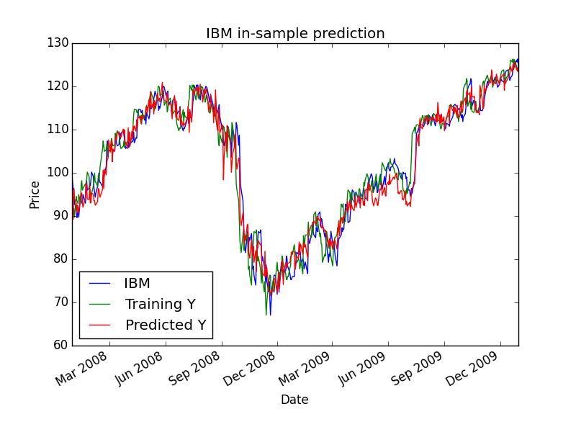

Figure 1

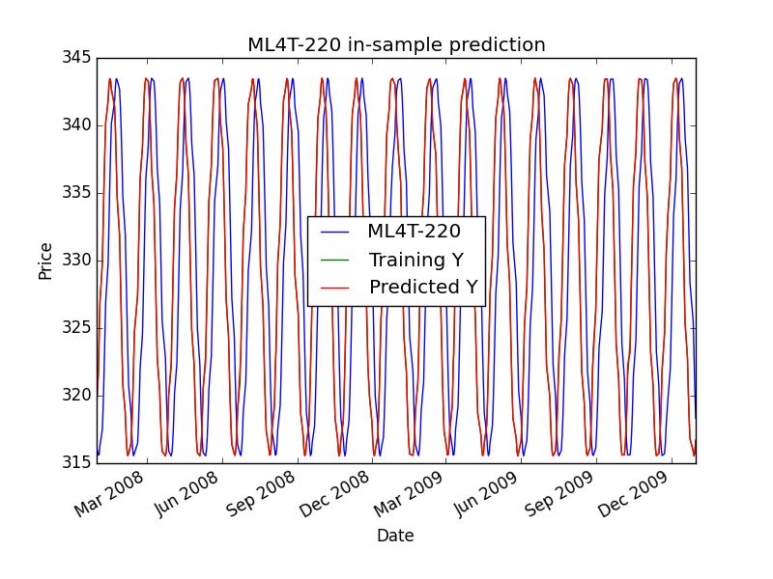

Figure 2

Predicted Y is covering Training Y.

## Sine In Sample Entry/Exit

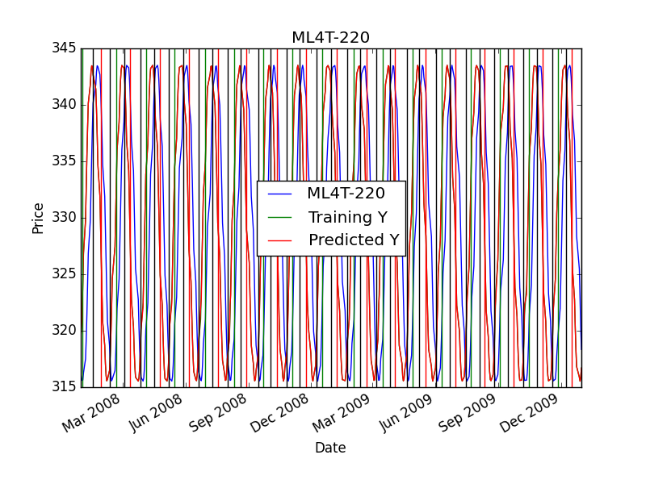

Figure 3

### Zoomed In

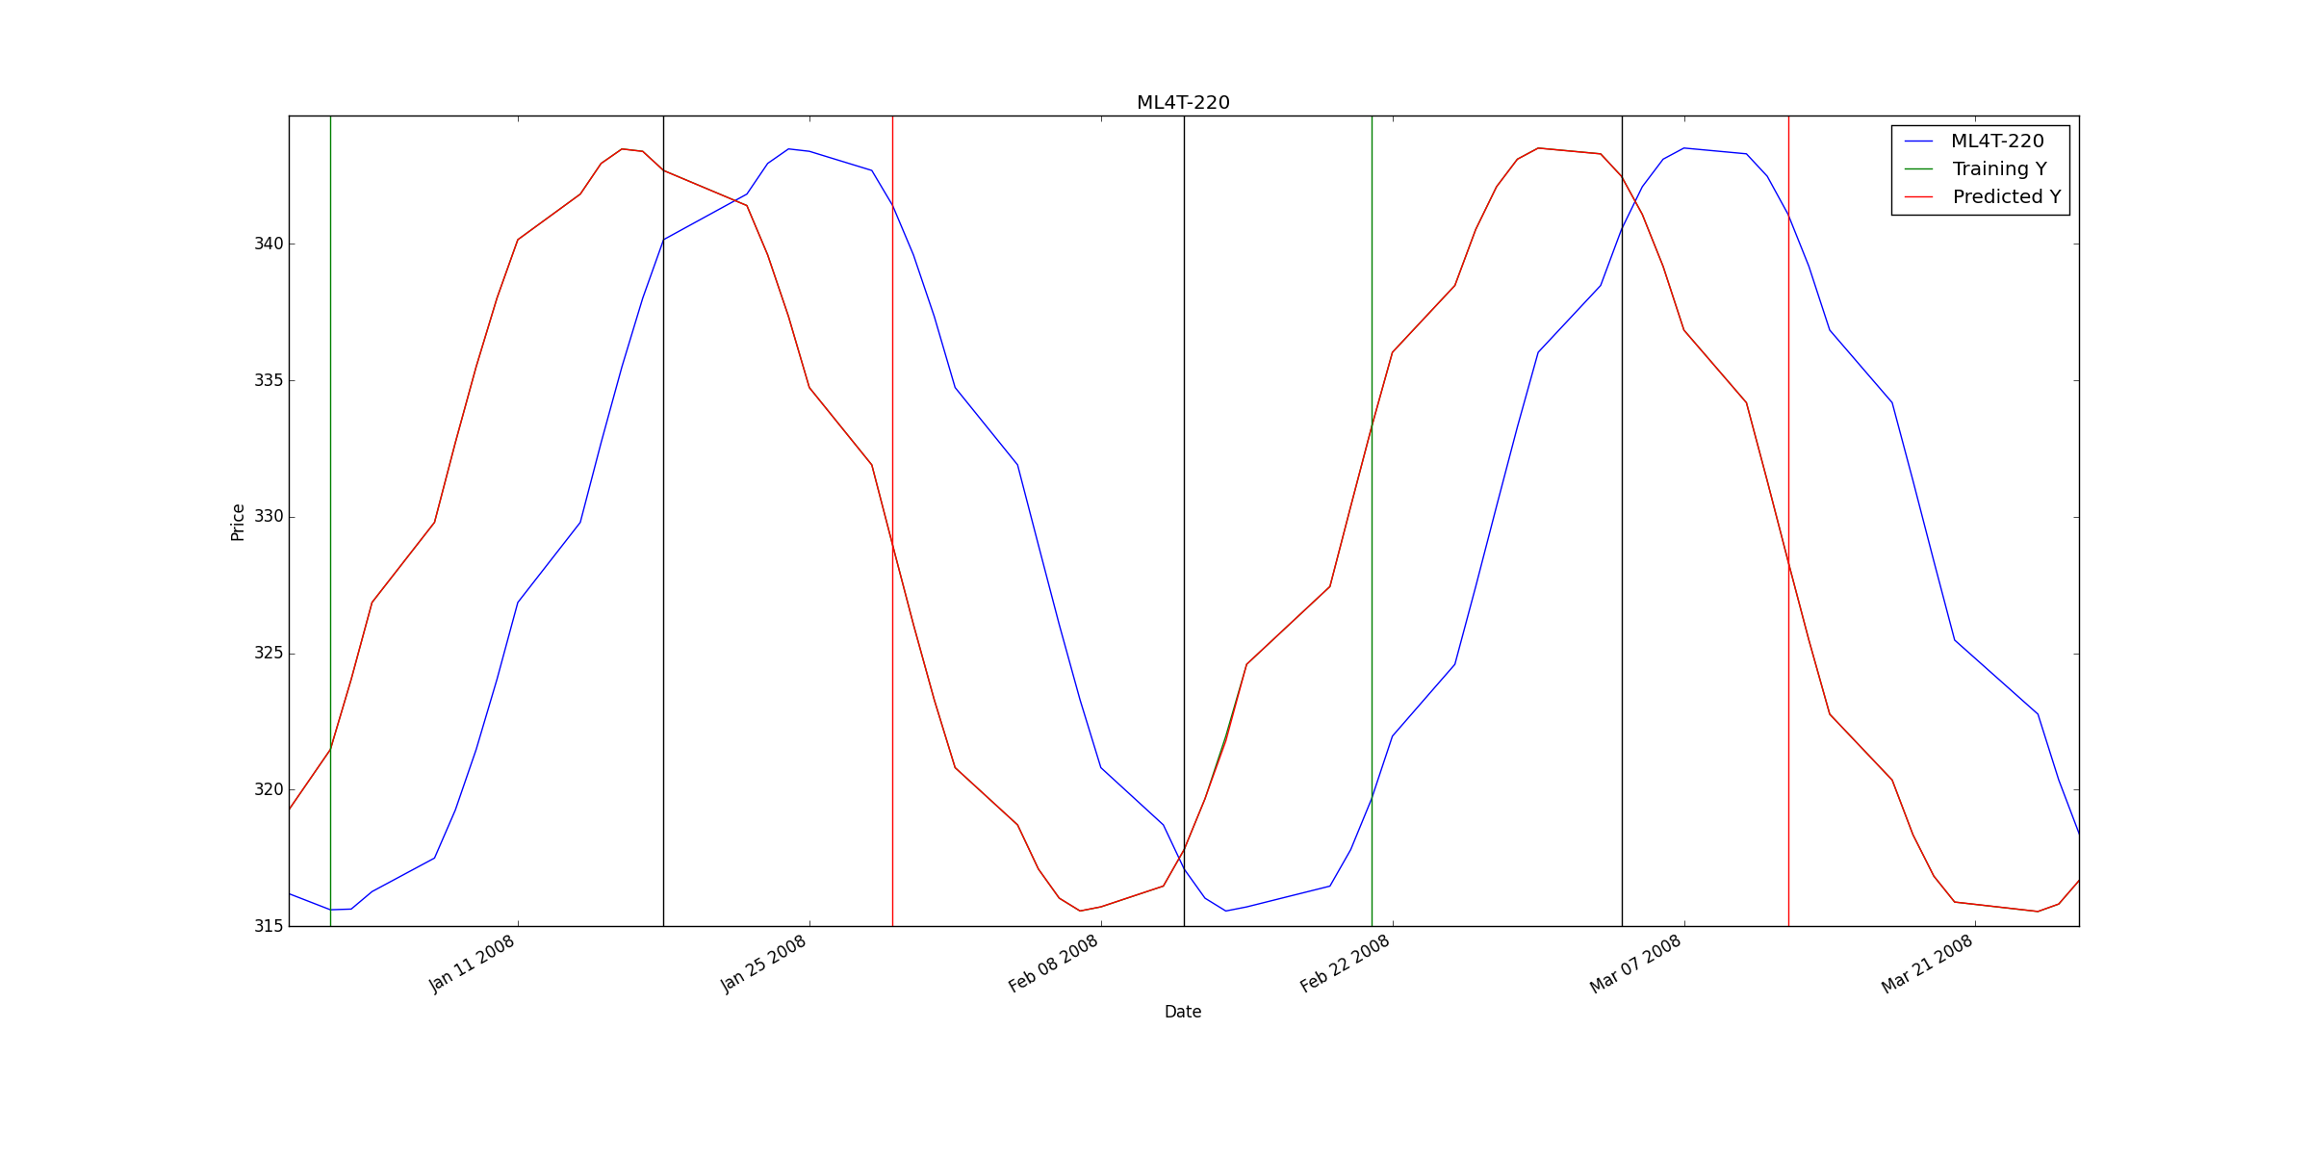

Figure 4

## Sine In Sample Backtest

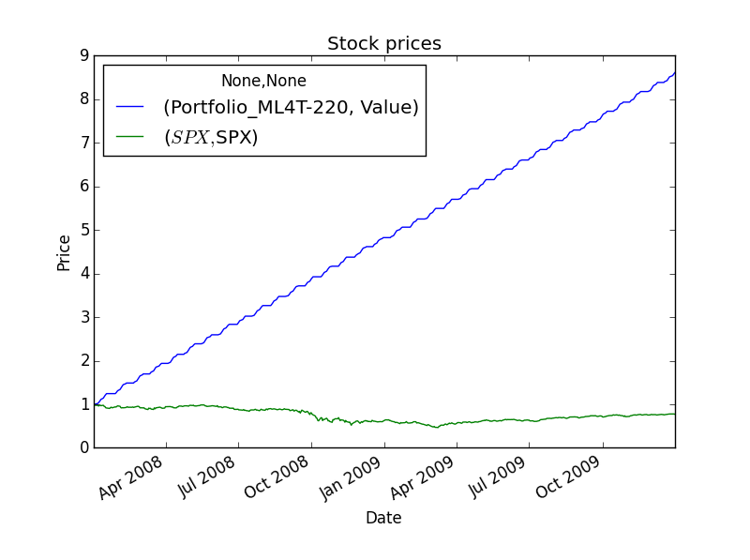

Figure 5

## Sine Out of Sample Entry Exit

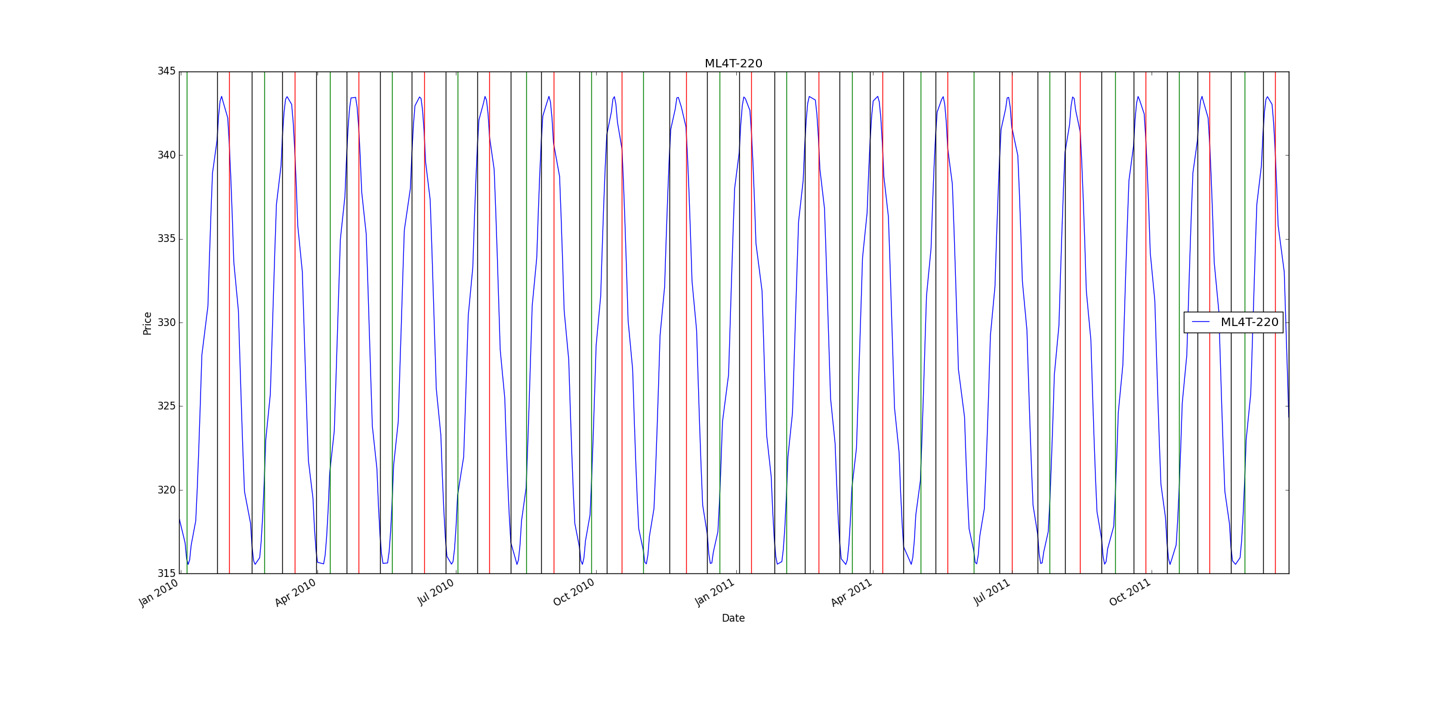

Figure 6

## Sine Out of Sample Backtest

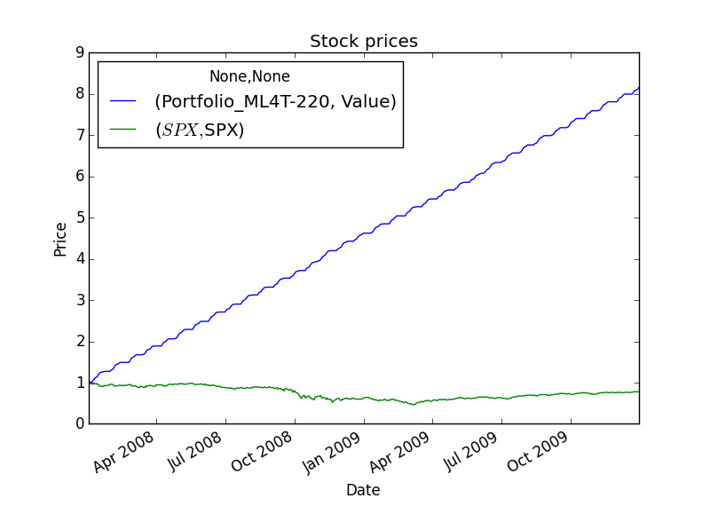

Figure 7

## IBM In Sample Entry/Exit

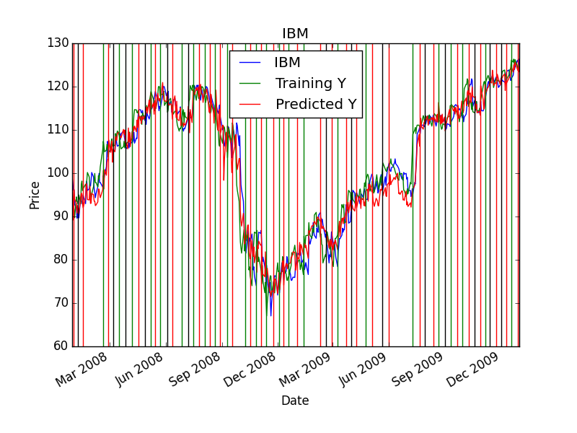

Figure 8

## IBM In Sample Backtest

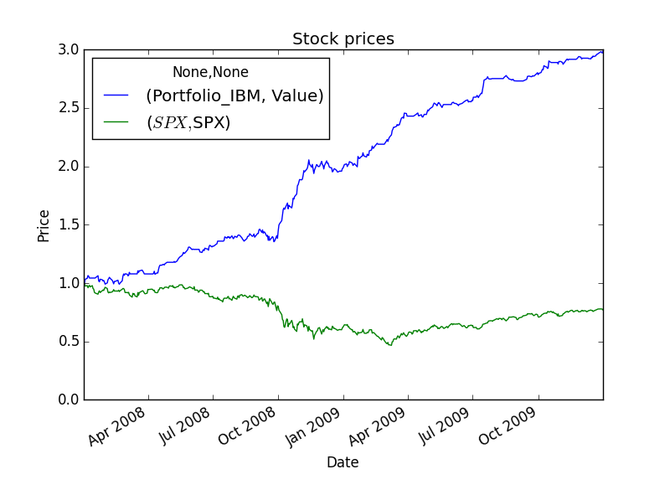

Figure 9

## IBM Out of Sample Entry/Exit

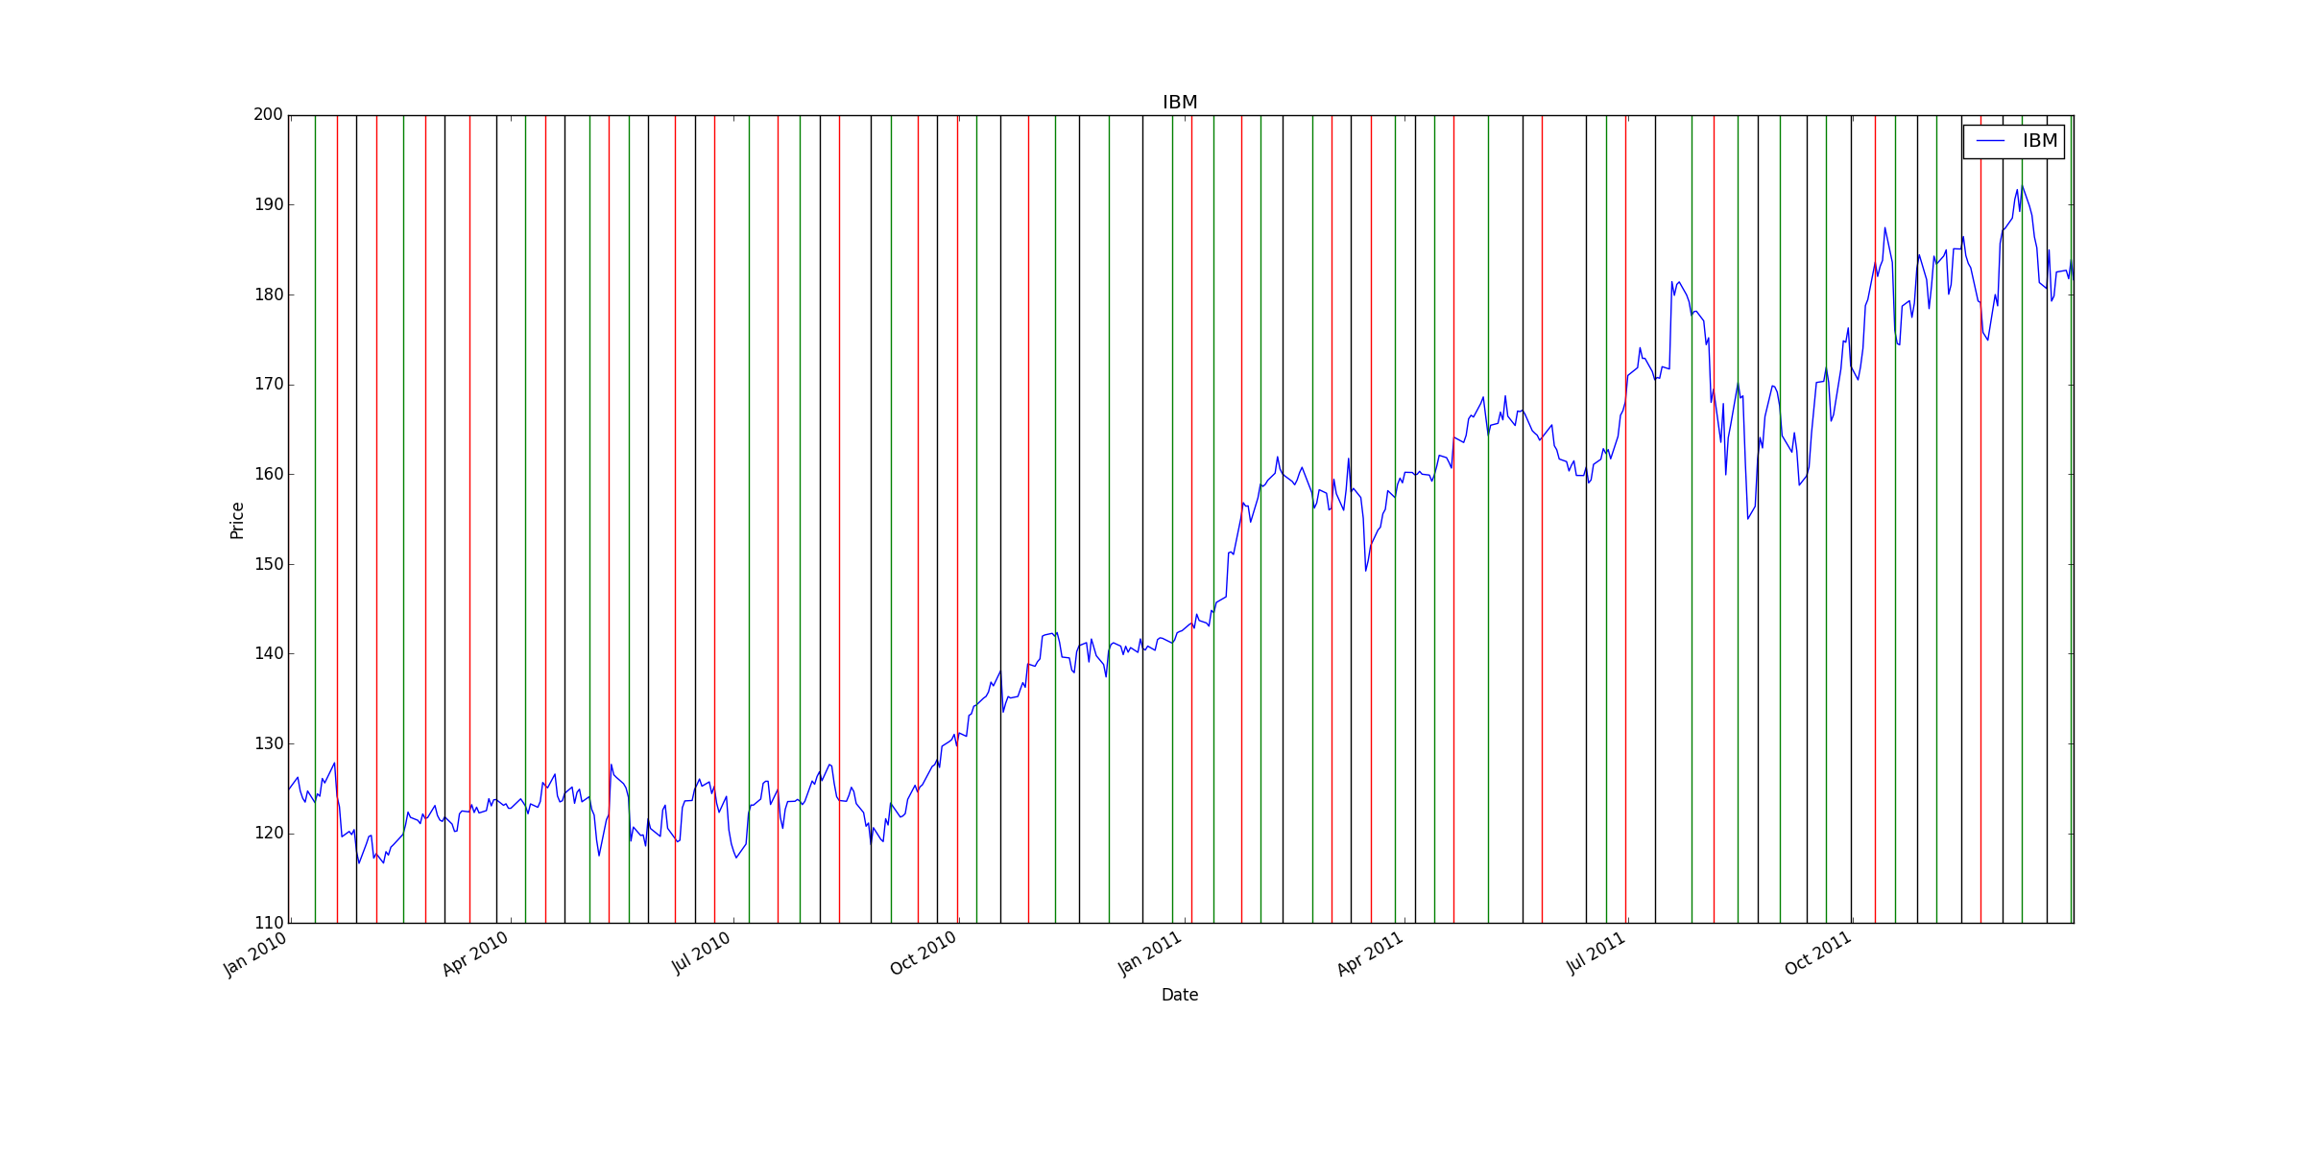

Figure 10

## IBM Out of Sample Backtest

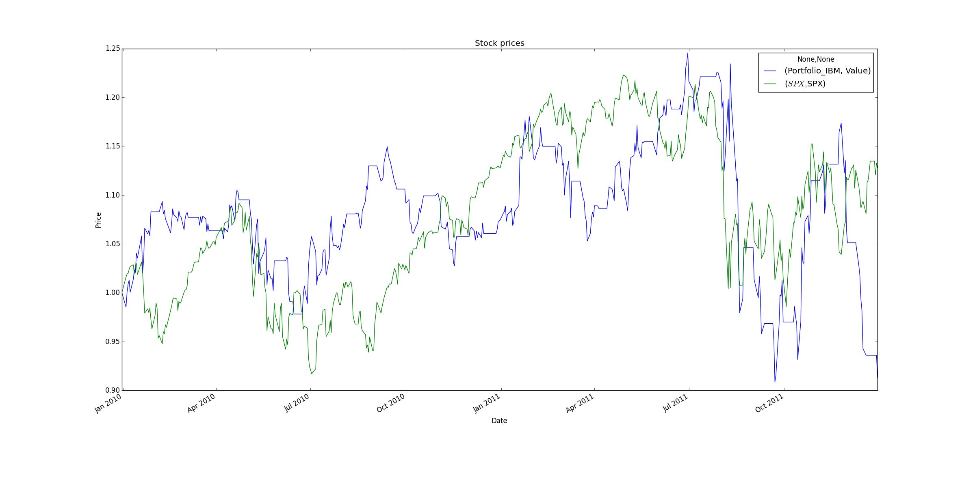

Figure 11

# Indicators

## Normalized Bollinger Bands

Based on a 20 day rolling mean, I normalized the Bollinger Band using this method:

(prices[symbol] – 20_day_sma)/(2 * stdev(symbol))

## Short to Medium Moving Average Ratio

Based on some success I had in the trading strategy assignment, I created a normalized ratio of the 15 day rolling mean divided by the 75 day rolling mean using this method:

(15 day moving average/75 day moving average) - 1.0

## Normalized Price

I normalized the stock price by dividing by the mean and subtracting 1.0.

## Momentum

Current price / 5-day-prior price - 1.0

# Trading Policy

If in cash or short and the predicted Y is > 0.01, go long by buying once or twice depending on the state.

If in cash or long and the predicted Y is < -0.01, go short by selling once or twice depending on the state.

If short and the predicted Y is between 0 and 0.01, buy to go to cash.

If long and the predicted Y is between 0 and 0.01, sell to go to cash.

If holding any position at the end of the time period, go to cash.

Once a position is taken, it is held for five trading days no matter what.

# External Code

I used the util.py file provided in earlier projects, unmodified.

I used Pandas, Matplotlib, and Numpy as sanctioned by earlier projects.

No other external code was used.

# Discussion

The trading policy above with my KNN (k=3) learner worked very well on the in-sample IBM and the sine data. It also did OK in 2010, beating a pretty flat market. 2011 was a disaster, however.

More tweaking of the trading policy would be required to do better in the IBM out of sample test. I don’t believe I fully captured essence of the manual policy I created in the prior assignment in the indicator so more work should be done there. In the prior assignment, I took into account the number of days the short term moving average was below the medium term moving average and I did not create an indicator for that in this project.

There are other potential indicators or variables I could have played around with more time. We really need a ML approach to picking the trading policy itself.

Performance against the SINE data was as expected. The policy goes long as the wave goes up, goes to cash as it changes direction, and goes short on the way back down.