Dan Mopsick

Dr. Juan Arias

Software Development 1

20 January 2017

Assignment 0

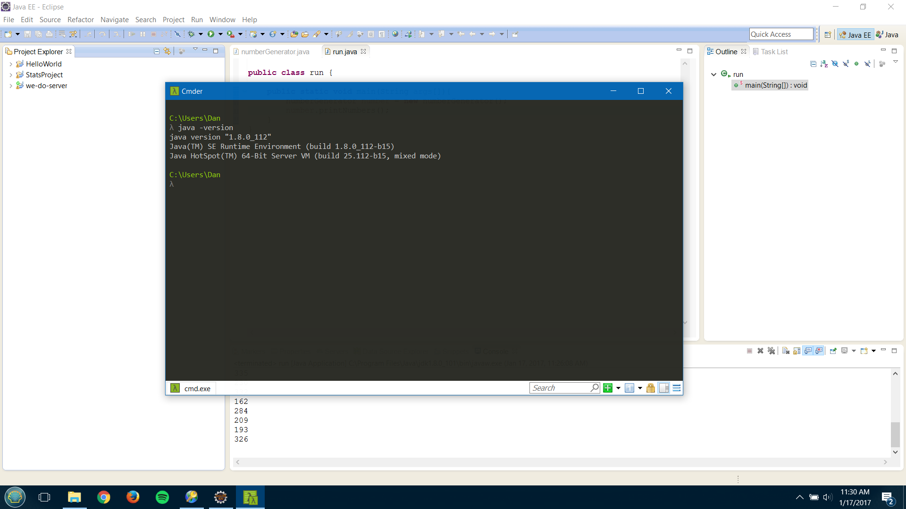

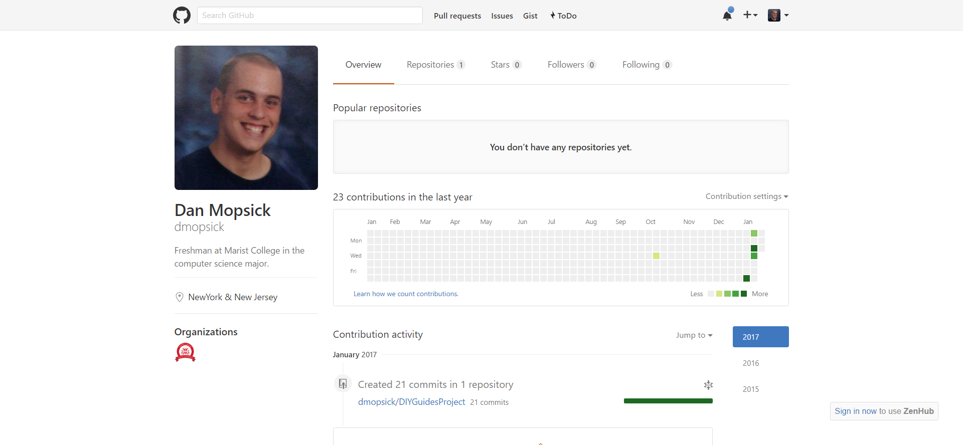

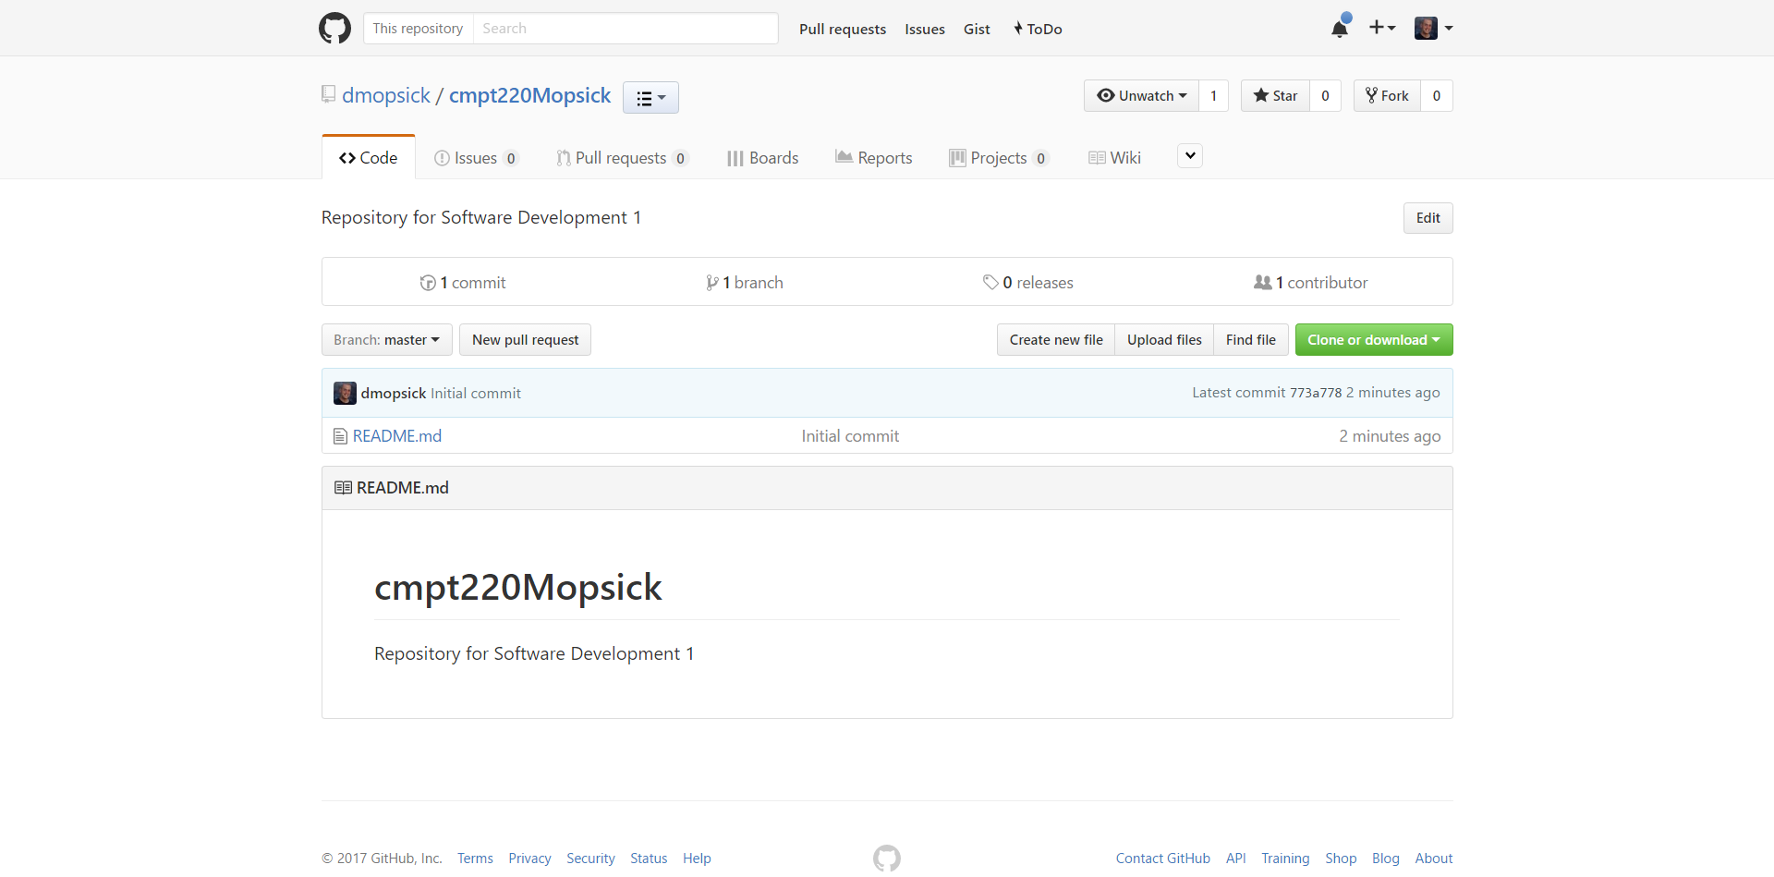

Javac

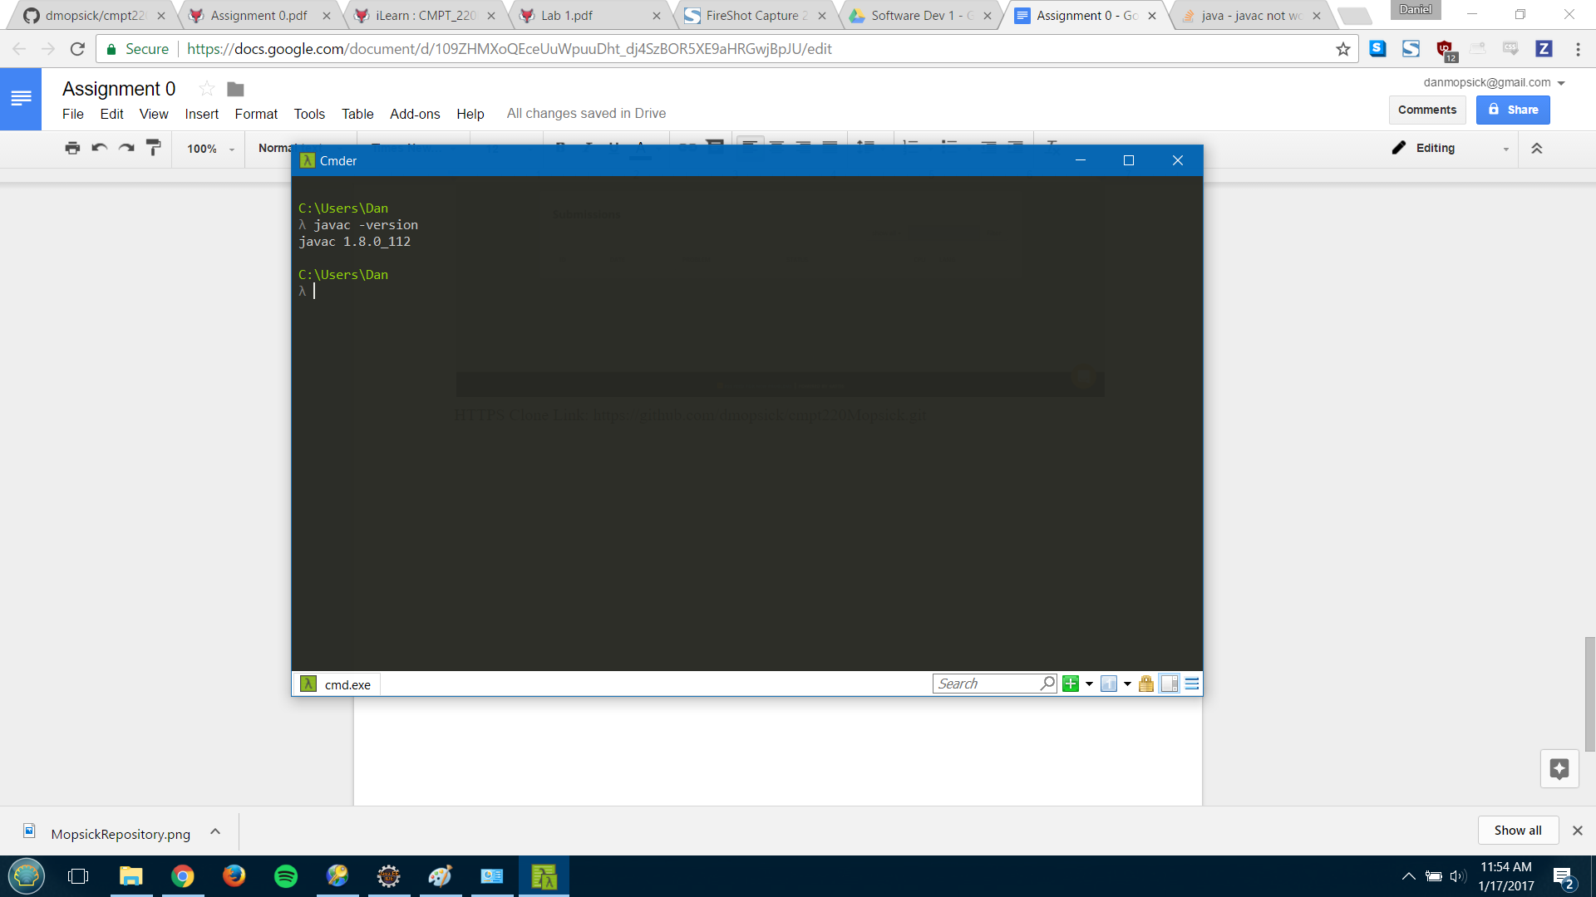

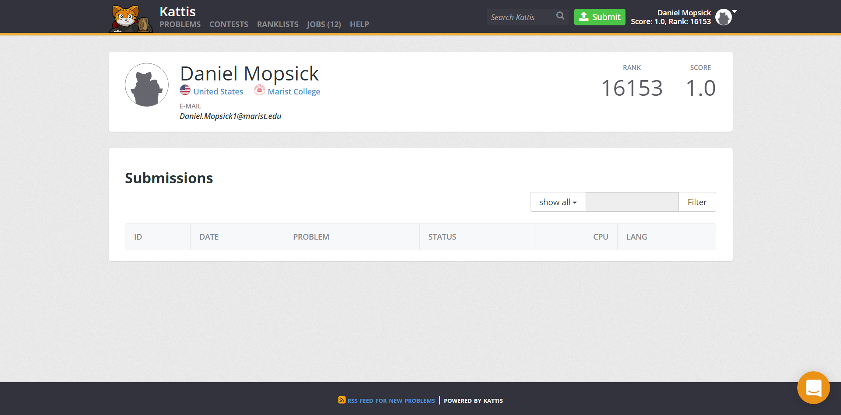

HTTPS Clone Link: https://github.com/dmopsick/cmpt220Mopsick.git