K8s Cluster
The project's root folder is install_k8s. The project to create the cluster was divided into roles to facilitate the execution of roles. The structure of the roles was divided as follows:

Roles

- create-cluster
This as the name says creates the cluster. The main file for this role is: init- cluster.yml

- get-token
This captures the token in an auxiliary way in the playbooks (main-newwrk.yml, main-master.yml) so that they have the keys and certificates to add the new servers to the cluster. The main file for this role is: init-cluster.yml

- ha-proxy
This configures the HA proxy. The main file for this role is: init-cluster.yml

- install-helm
This performs the download of the binaries for the execution of the helm that is used in the creation of the monitoring.

- install-k8s
This performs the installation of the packages: docker, kubectl, kubeadmin, kubelet.

- install-monit-tools
T his installs the prometheus operator stack.

- join-workers
This adds workers to the cluster when deploying the cluster.

- new-master
This adds the new masters to the existing cluster.

- new-workers
This adds the new masters to the existing cluster.

Playbook files and hosts.

In the hosts file we have all groups of computers used by ansible:

In the [kubernetes] group, we must place all hosts that will have the kubernetes role, for future actions that must be performed in all kubernetes.

In the [k8s-master] group there should be all servers that have the role of master.

In the [k8s-workers] group there should be all servers that have the role of worker.

In the [k8s-master-new] group there must be all servers that will become master, after the completion of the main-master.yml playbook the server must be removed from this group.

In the [k8s-master-init] group there is the server that was used for the initial creation of the cluster.

In the [k8s-master-new] group there must be all the servers that will become a worker, after the completion of the main-newwrk.yml playbook the server should be removed from this group.

In the group [ha-proxy] there is the server that is the haproxy

In the [k8s-workers: vars] and [k8s-master-init: vars] groups there are variations used in the creation of the cluster.

Resolution Name
It is very important that all machines have hosts registered in /etc/hosts.

Execution playbooks

main-base.yml: Install base programs to run ansible, it must be run on all servers.
main-createcluster.yml: This cleans up any old configuration and recreates the cluster.
main-Install-k8s.yml: Install docker, kubeadm, kubelet, kubectl.
main-master.yml: Add a new server with the master paple.
main-monititools.yml: Installs prometheus operator monitoring.
main-newwrk.yml: Add a new server with the worker paple.
main-proxy.yml: install the haproxy packages and configure it.

Structure

The structure used was the re-command by kubernetes inc, following the structure of figure 1

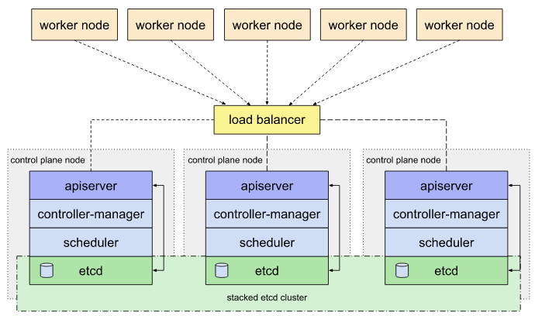Figura 1

In this image we have the drawing of how the cluster is configured. For the environment.

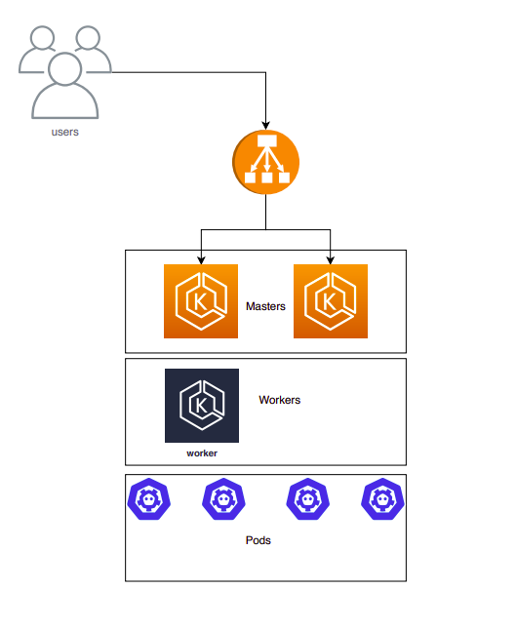Figura 2:
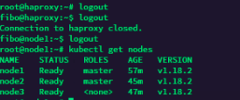

Monitoring
For the monitoring we used the helm with the prometheus-monitor stack. These are some of the grafana dashboards:

