Devin Morin

7/13/2020

3-Magnet Array for 100x50x10 mm Block Magnets w/ Homogeneous Spot

All magnets within the 3-magnet array have dimensions of 100x50x10 mm. They are separated by spacers with a 1.03 cm thickness. The center magnet is displaced downwards by 0.747 cm. For this simulation, the magnet material is set to air, and the case/spacer material is set to aluminum.

The magnet design contains a sensitive spot region of 0.99 cm in length, from 0.46-1.45 cm above the surface. The sensitive spot has an approximate field strength of 804 gauss (3.42MHz).

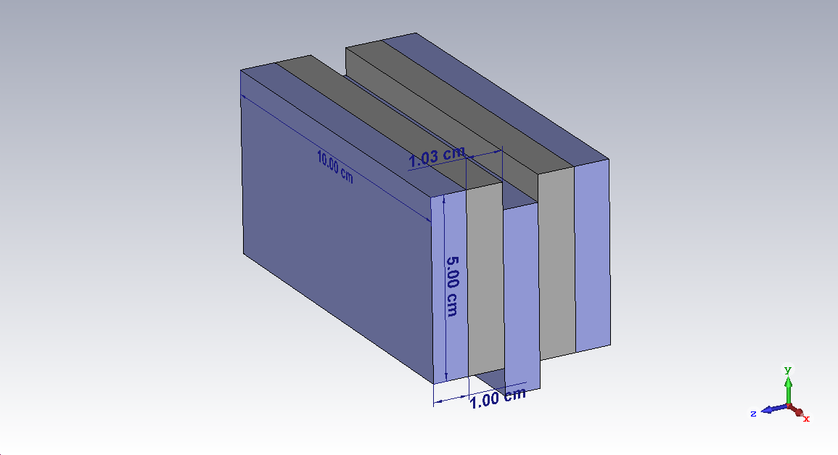

Figure 1: Overview of magnet design.

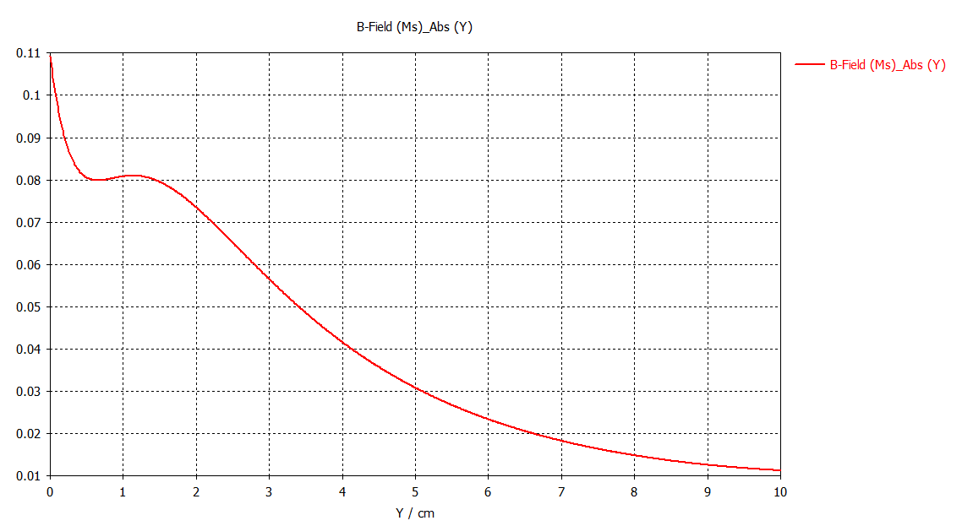

Figure 2: Magnitude of magnetic field along the y-axis. The field is displayed along the line that is perpendicular to the surface at z=0, x=0.

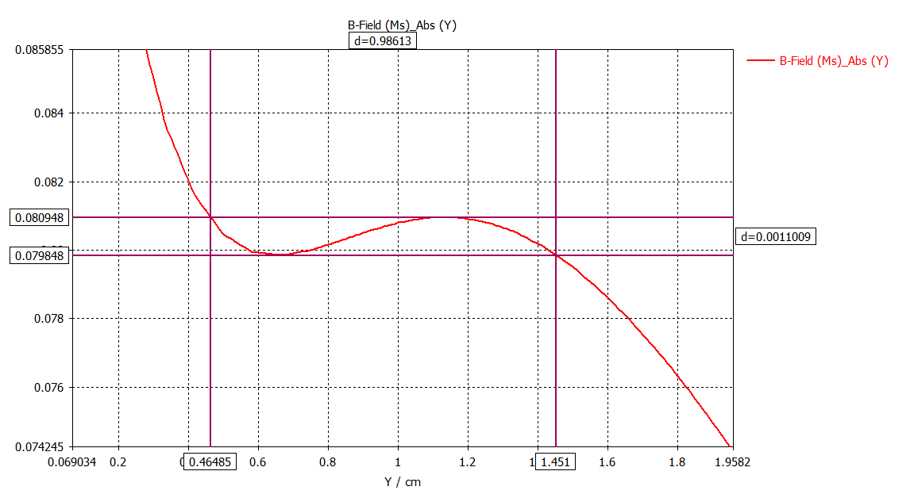

Figure 3: Close up of fig.2. This shows an acceptable region from 0.48-1.45 cm above the surface, where the magnitude of magnetic field varies by less than 15 gauss.

Because of the very inhomogeneous magnetic field above a single magnet block (compared to a magnet block with a thickness larger than 1 cm) it was very difficult to develop a design with a homogeneous region. Many optimization goals were altered such that the variation of magnetic field throughout the sensitive region will be minimized. It was concluded that these parameters are acceptable given that the sensitive region is 1 cm, and the magnetic field will vary by less than 15 gauss.

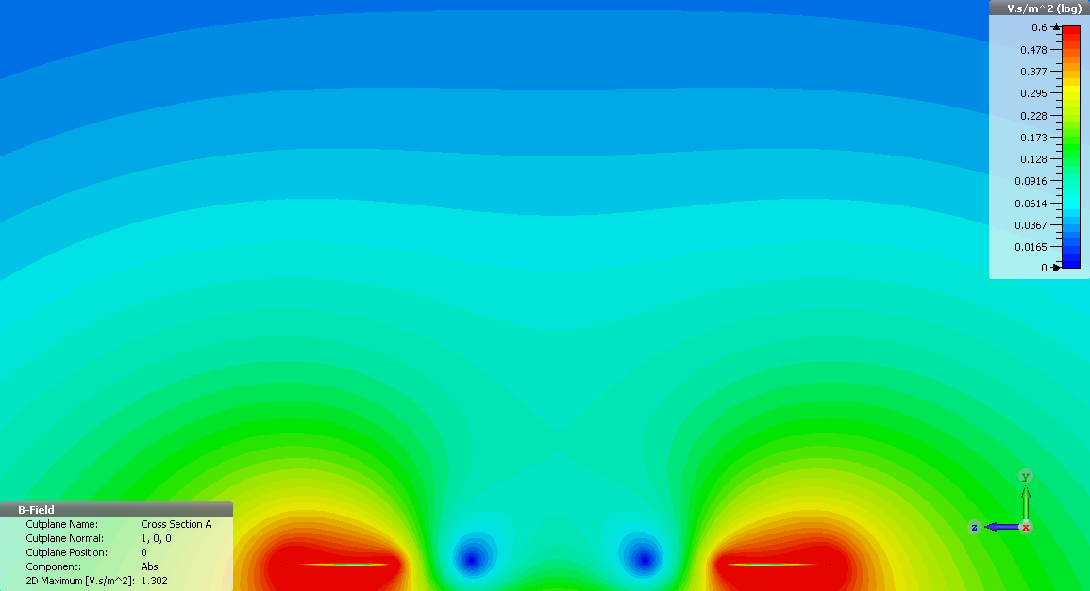

Figure : Contour plot of the magnitude of magnetic field in the YZ plane.

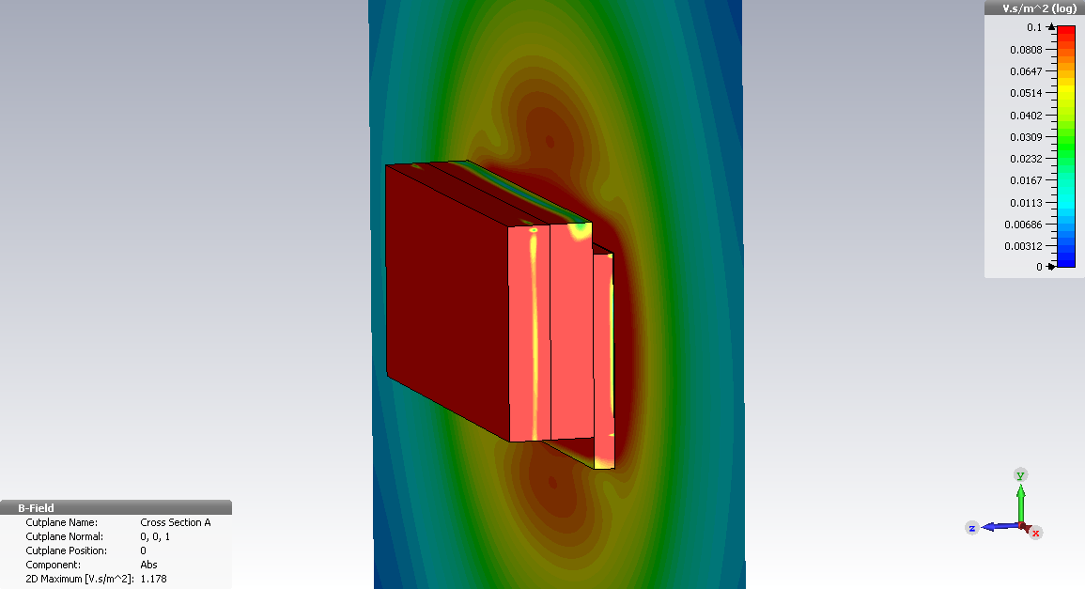

Figure : Contour plot of the magnitude of magnetic field in the YX plane.