**3-Magnet Array – Homogeneous Spot Simulation**

Devin Morin

6/12/2020

V.1.4

**Introduction**

This report describes the steps taken to produce a 3-magnet array with a homogeneous spot. This design is guided by Andrew Marble’s paper, on designing a magnet that has a homogeneous spot [1]. Marble describes a magnet array that consists of two outer magnets with a width of 3 cm, and one inner magnet with a width of 2 cm. All magnets have a height of 5 cm. The center magnet is displaced downwards by 0.48 cm (labeled ‘d’ in figure 1) and spaced from the adjacent magnets equally on both sides by 0.467 cm (labeled ‘b’ in figure 1). The magnets were NdFeB with a remanence of ~1.3T.

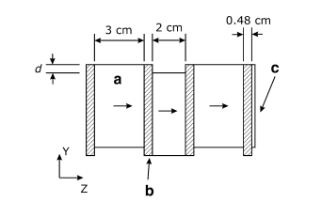

Figure 1: Diagram of three magnet array found in Andrew Marble's paper. [1]

The MagnetArray.m MATLAB program can be used to model magnetic fields of three magnet arrays [2]:

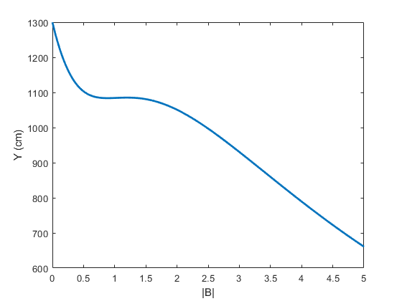

Figure 2: Magnet array magnetic field simulation from the MagnetArray.m MATLAB software. The plot shows the magnitude of magnetic field (T) as a function of Y (cm). The magnetic field is calculated along the line at z=0.

The above figure shows the magnitude of magnetic field as a function of Y. There exists a homogeneous spot between 1.0-1.5 cm above the surface of the magnet. The program describes the magnetic field as being produced by two infinite sheets of current. One sheet of current at the top of the magnet, and one at the bottom. A limitation of this program is that no real magnet will be infinitely long. Because of this, there will be a slight disagreement between what is found in the MATLAB program, and what is measured in real life.

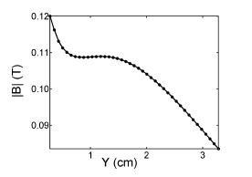

Figure 3: Figure from Marble's paper [1]. This is the experimental field plot, of the magnitude of magnetic field (T) as a function of Y (cm). The magnetic field is plotted along the line at z=0, x=0, at the center of the magnet surface. This experimental measurement (after the field had been corrected with metal spacers) shows almost an exact agreement with the predicted model found in MATLAB.

Exploration in Computer Simulation Technology (CST) [3] Studio has shown that there exists a homogeneous spot in the same location as where Marble had found. However, the field is less homogeneous than what is simulated in the MagnetArray software. This is because CST does not simulate the magnetic field by assuming an infinite sheet of current. This is a proper magnetostatics simulation, where a change in length will affect the magnetic field. In figure 4, we can see the same magnet with a varying length. By changing the length of the magnet (in the infinite or X direction), we change the strength of the magnetic field. We also minimize edge effects from the magnet and come closer to having a homogeneous spot resembling what was found in MATLAB.

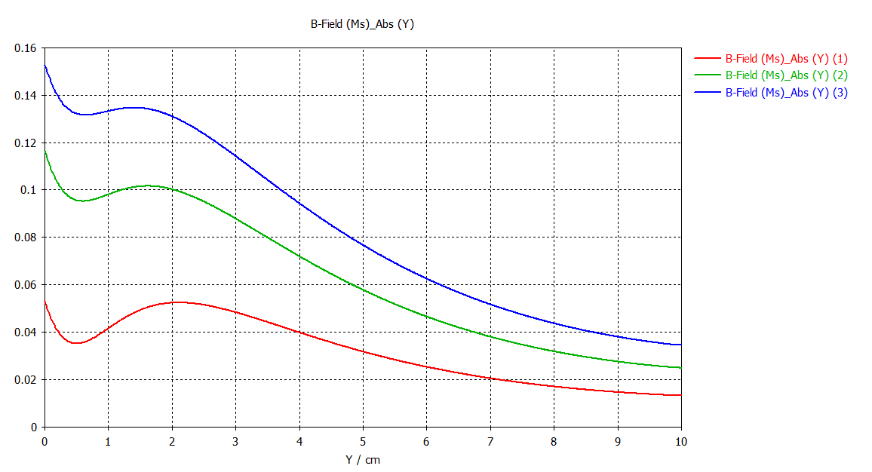

Figure 4: Magnitude of magnetic field (T) as a function of Y (cm) from CST. Red, green, and blue correspond to a magnet length of 5, 10, and 15 cm. The magnetic field is calculated along the line at z=0, x=0, at the center of the magnet surface.

Because there’s close agreement with the MagnetArray software and CST Studio, as CST contains many useful functions (e.g. RF simulation, optimization algorithms, materials simulation, electronic component analysis, force breakdown on componenets), the decision was made to explore unilateral magnet simulations using CST Studio. One of the benefits of CST, is the inbuilt optimizer. The optimizer allows the user to set goals, for example, that the derivative of the magnetic field along some line is 0 over a set range. It also allows the user to set any defined parameter as a scalable parameter with a minimum and maximum value. We can take the three-magnet array simulation a step further with the use of this tool, by setting the spacer thickness and center magnet dip (or ‘d’ in figure 1) as parameters in the optimizer. The optimizer algorithm can then find the optimum values such that we have a large homogeneous spot over a range.

**Design**

To construct the 3-magnet array in CST, 3 components are initially created: Case, Magnets, and Spacers. All components are set to a material of air. A list of parameters is then created to represent all lengths of the magnets. The lengths of the magnets are set based on our current inventory list of block magnets. Two spacers are included with a width to separate the center magnet from the left and right magnets. The case component contains 5 rectangular blocks that are arranged to provide the visuals for a housing around the 3-magnet array.

Once the blocks are set to the appropriate lengths, the permanent magnet feature of CST is used to set the all 3 magnets to a ‘Remanent flux’ of 1.44T, in the Z direction.

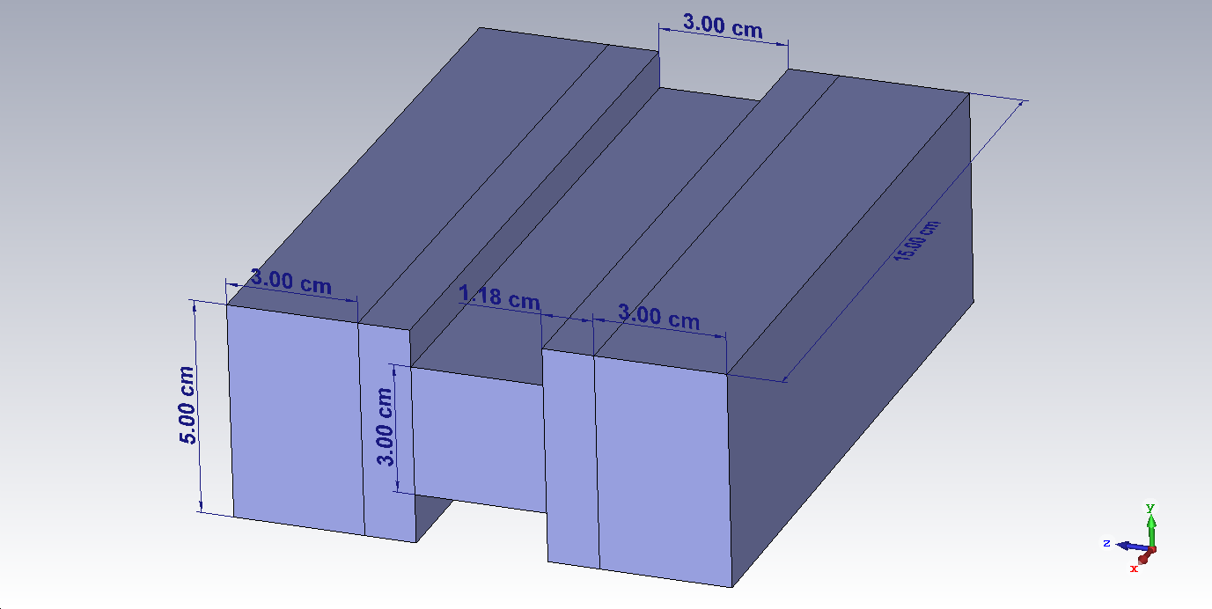

Figure 5: 3-Magnet array diagram.

**Simulation & Optimization**

To use the CST Optimizer function, we begin by creating a 1D field plot. To do this, under ‘Home’, the ‘Setup Solver’ is set to magnetostatics with a mesh type of hexahedral, and an accuracy of 1e-12. Then by clicking ‘Start Simulation’, H-field and B-field results will be produced in the ‘2D/3D Result’ navigation tree. By clicking ‘Abs’ in B-Field, and then ‘2D/3D Plot’ in the top ‘Results Tools’ bar, we can access the 1D Field Plot option in the ‘Tools’ column. A 1D field plot can then be taken of the magnetic field as a function of Y.

To use the CST Optimizer, goals can be set over range within a field plot. Since we’re looking for a homogeneous spot, we can take the derivative of the field plot and then iterate until the derivative is 0 over a range. Once the magnitude of magnetic field, and derivative of field plots are created, we can begin setting optimizer settings. In the ‘Optimizer’ window, Dip_C (center magnet dip length) is set to be a parameter with a min and max length from 0 to 3 cm. The spacer width is also set to a parameter, with a min and max length of 0 to 2 cm. The algorithm is set to ‘Trust Region Framework’, with a ‘% of initial value’ set to 0.01. The optimizer tool contains many other algorithm choices. The Trust Region Framework algorithm appears to be the best choice for this work, as other algorithms have a much longer runtime and produce equivalent results.

After inputting the initial settings, two new goals are created for the algorithm. The first, is for the derivative field plot to be equal to 0 with a weight of 1.0, from 1.5-2.5cm. Then, the magnitude field plot is set to be larger than 0.05T with a weight of 1.0, from 0-0.5 cm. Without setting this goal, the optimization software can create fields that are too weak. Once the goals are set, the optimizer is started and allowed to iterate through parameter lengths until the most optimal values are found. Below is a table describing the result of the optimization.

|  |  |  |  |  |
| --- | --- | --- | --- | --- |
|  | **Length (cm)** | **Width (cm)** | **Height (cm)** | **Y (cm)** |
| **Left** | 15 | 3 | 5 | 0 |
| **Center** | 15 | 3 | 3 | -0.859 |
| **Right** | 15 | 3 | 5 | 0 |
| **Spacer** | 15 | 1.177 | 5 | 0 |

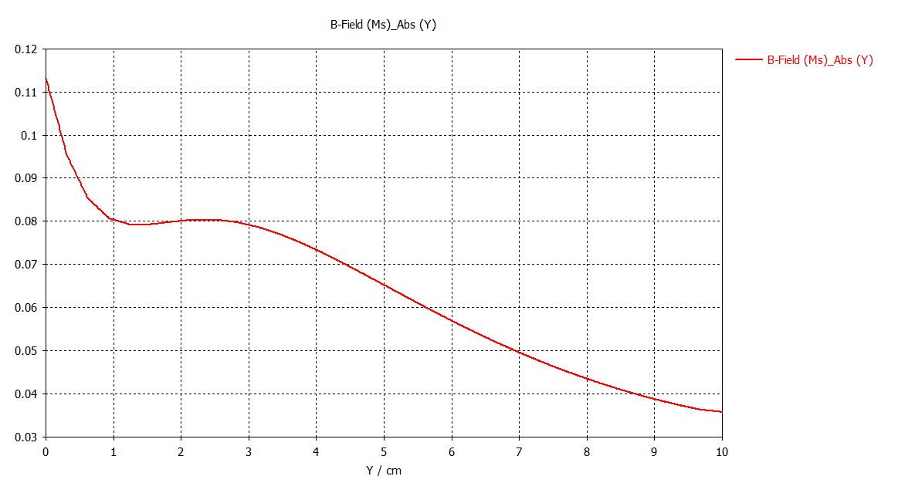

Figure 6: Magnitude of magnetic field (T) as a function of Y/cm produced by CST Studio.

From figure 6, we can see that with this method there exists a homogeneous spot with little variation between 1.5-2.5 cm. These methods can be employed for various combinations of block magnet types.

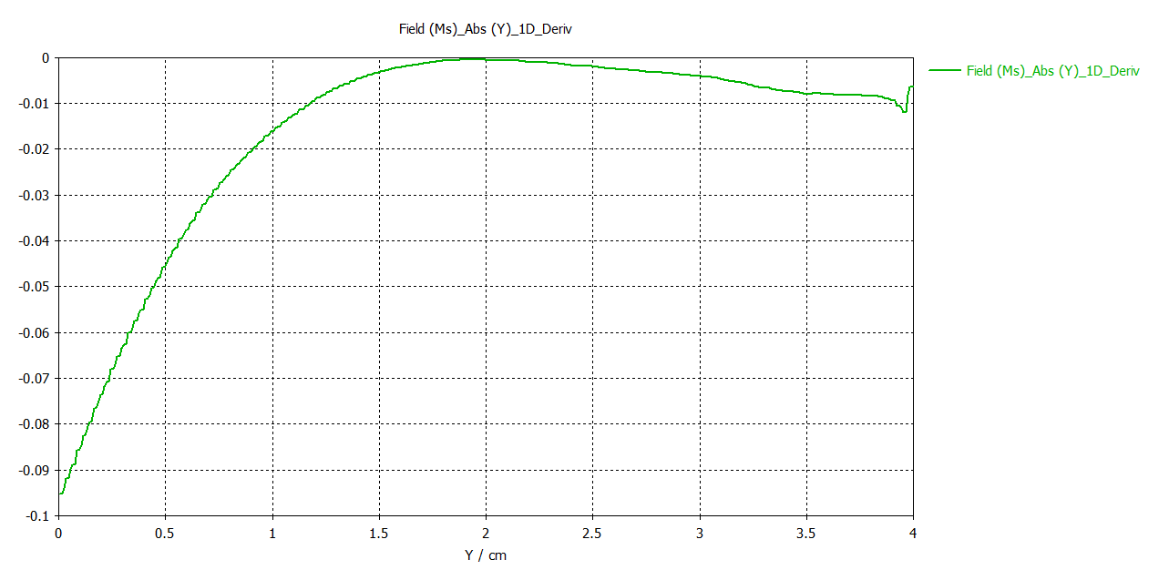

Figure 7: Derivative of the magnitude of magnetic field as a function of Y/cm. This figure is made in a very high-resolution simulation, as low-resolution simulations result in discontinuous jumps in the value of the derivative. This is of course, unavoidable due to the discrete nature of the data.

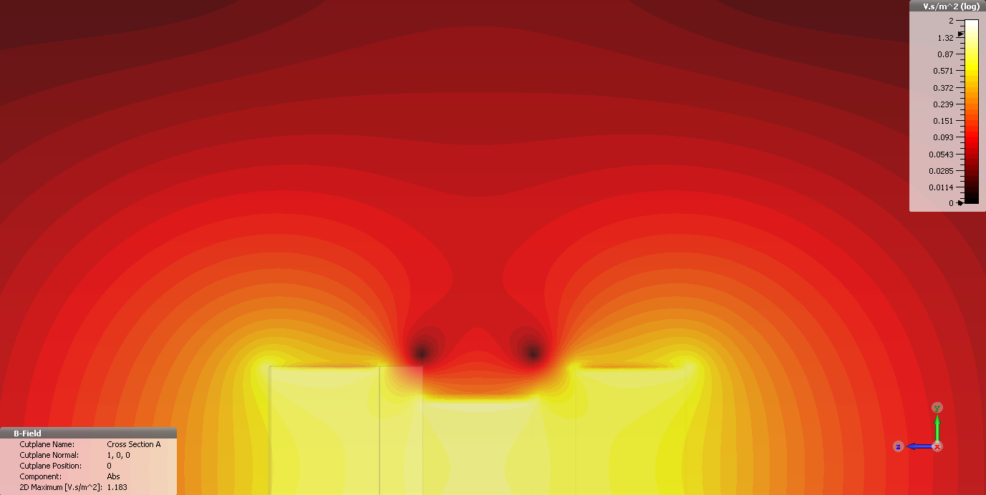

Figure 8: Contour plot of the magnitude of magnetic field from CST Studio.

Another ability of CST is that material types of objects may be changed. We can change the material type of the case and spacers to aluminum to view the result:



Figure 4: CST simulation of 3-magnet array with case and spacers set to a material of aluminum. Magnet block materials are left as a material of air.

As we would expect, the magnetic field has barely changed. This is due to the low relative permeability of aluminum (using 1.000 022 for this material).

**Conclusion**

With CST Studio and the optimization tool, we’ve been able to create a homogeneous spot unilateral magnet. This report is guided by the work done by Andrew Marble. The magnet designed in this report is very similar to the magnet found in Marble’s paper. The emphasis of this report is the exploration within CST, to optimize for a homogeneous spot by setting parameters as scalable variables in the optimization tool. The homogeneous spot of 800 gauss (3.41MHz) exists between 1.5-2.5 cm above the surface of the magnet. There are some obvious problems with this method if you were trying to find the most optimal results. For example, it’s a bit arbitrary when setting an upper or lower bound to the parameters, if you’re only searching for the largest homogeneous spot. Perhaps no limit on the width of a spacer may increase the length over which our magnet is homogeneous. However, this is not practical if we aim to have the magnet be small. For now, the bounds and goals are set such that the device is relatively small, and the magnetic field is not too weak. Some next steps could involve exploring more magnet combinations to find a larger homogeneous spot while keeping the magnets dimensions as small as possible.

**References**

[1] Marble, A. E., Balcom, B. J., Mastikhin, I. V., & Colpitts, B. G. “A compact permanent magnet array with a remote homogeneous field. Journal of Magnetic Resonance”, *Journal of Magnetic Resonance*, 100-104, (2007)

[2] Wang, C. (2007, 04 20). MagnetArray.m, Version 1.0

[3] CST Studio 2020 – Educational License, <https://www.3ds.com/>