**Coil Design to Minimize Surface Currents**

Devin Morin

7/3/2020

V.2.2

**Introduction**

This report aims to describe the steps taken to construct an RF probe, designed by Daniel. M Gruber *et al.*, in Computer Simulation Technology (CST) [1]. This probe design hopes to decrease probe offset from the surface of the magnet (therefore increasing available standoff distance) by reducing the effects of eddy currents induced in the conductive copper surface. In the past, this had been minimized by employing large coil offsets to avoid interferences with the oscillating magnetic field B1. A large offset is unwanted, as it will result in a reduced working distance. In this report, we explore the design and simulation of one of the recommended coil designs proposed by Gruber [2].

**Surface Coil Effects**

There are many coil designs proposed, however, this report will focus on the coil design that provides the best immunity from surface-induced RF attenuation. Before exploring this design, it is helpful to start by observing the effects of surface currents in a conducting sheet of copper due to a simple loop coil. To begin, we use CST to create a copper sheet, with 1 mm thickness, spanning 10x10 cm. We can then create a circular curve, with a radius of 2 cm. Then, we may set the curve to be a current path with a current of 1 amp and set the distance between the copper sheet and current path to 6 mm.

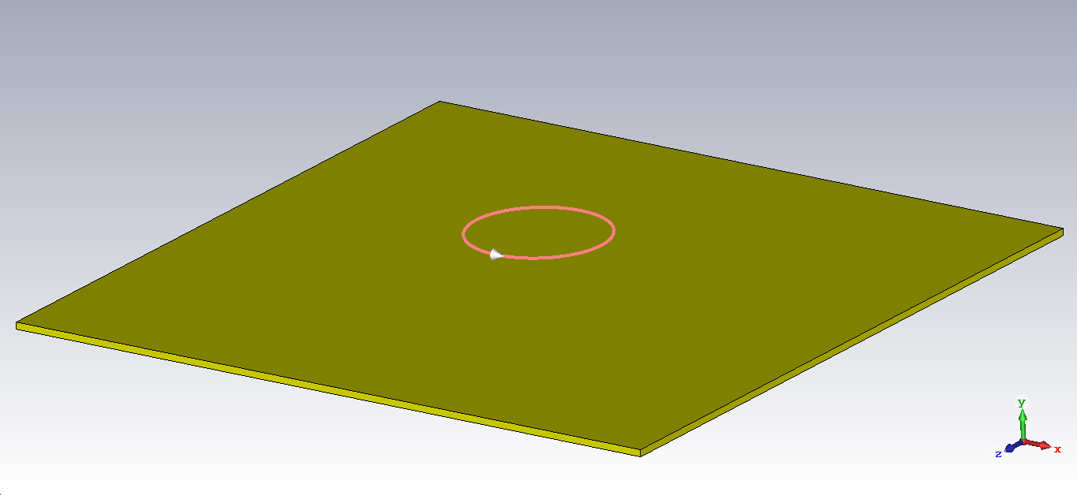

Figure 1: A simple visualization of the setup with a copper sheet and current path.

The following plot describes the magnitude of magnetic field as a function of y, with and without a conductive copper sheet.

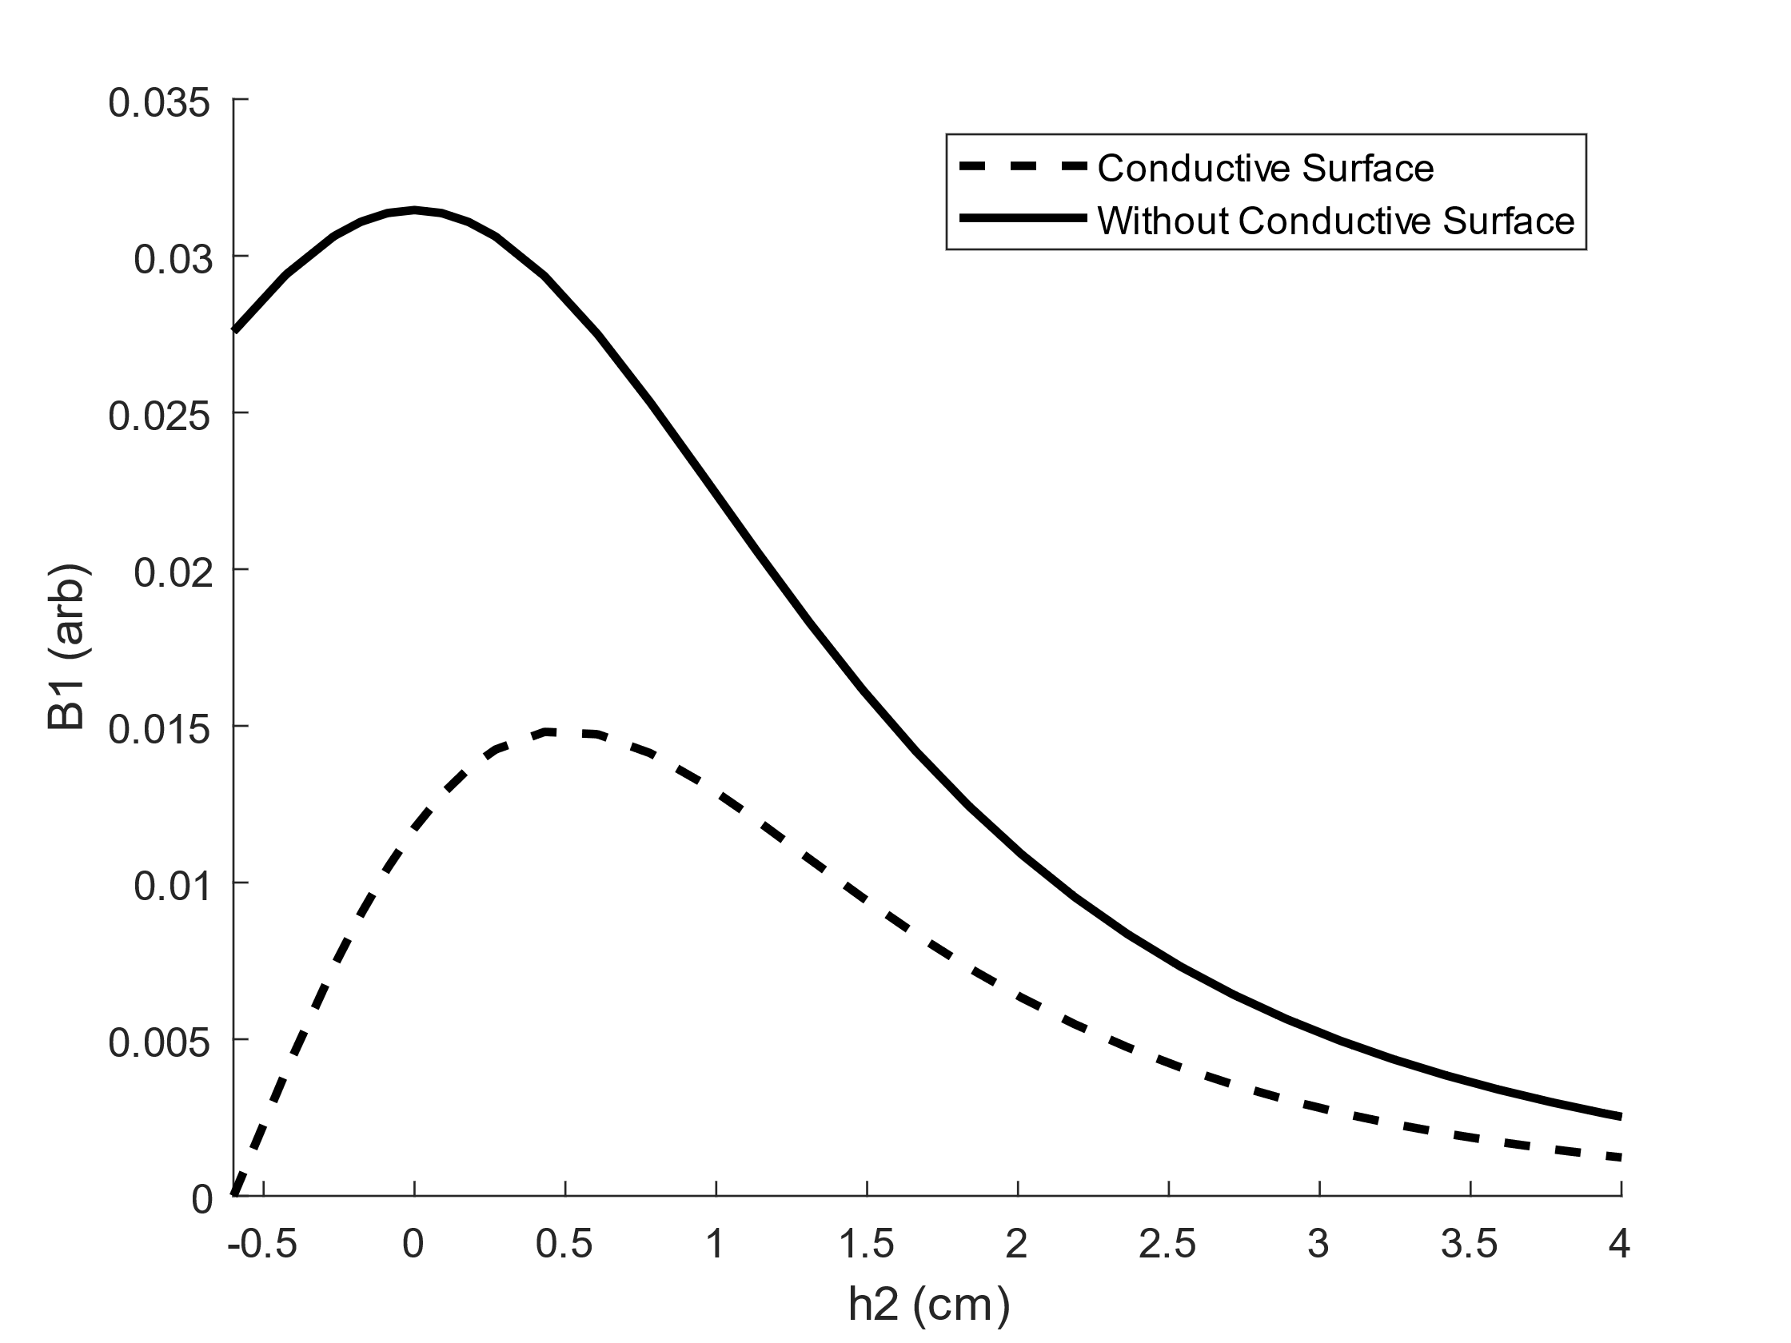

Figure 2: Plot of the magnitude of B1 field along the y direction at z=0, x=0 (exact center of the loop of current). In this case, the B1 field is dominated by the y-component. The plot starts at -0.6 cm as that is where the copper sheet begins (0.6 cm away from the coil at y=0). The magnetic field is represented with a dashed line for the conductive sheet simulation, and with a solid line for the simulation that omits the conductive sheet.

We can see that with a conductive surface the oscillating field B1 is significantly attenuated due to surface currents. At a h2 of 1 cm, the B1 field is attenuated by 42.5%.

**Design and Setup**

The design recommended by Gruber for providing the best immunity against B1 field attenuation can be described as two 1.8 cm long, 3.5 cm wide, 0.63 cm thick coils separated by 1.5 cm. One coil is wound clockwise, and the other is wound counterclockwise.

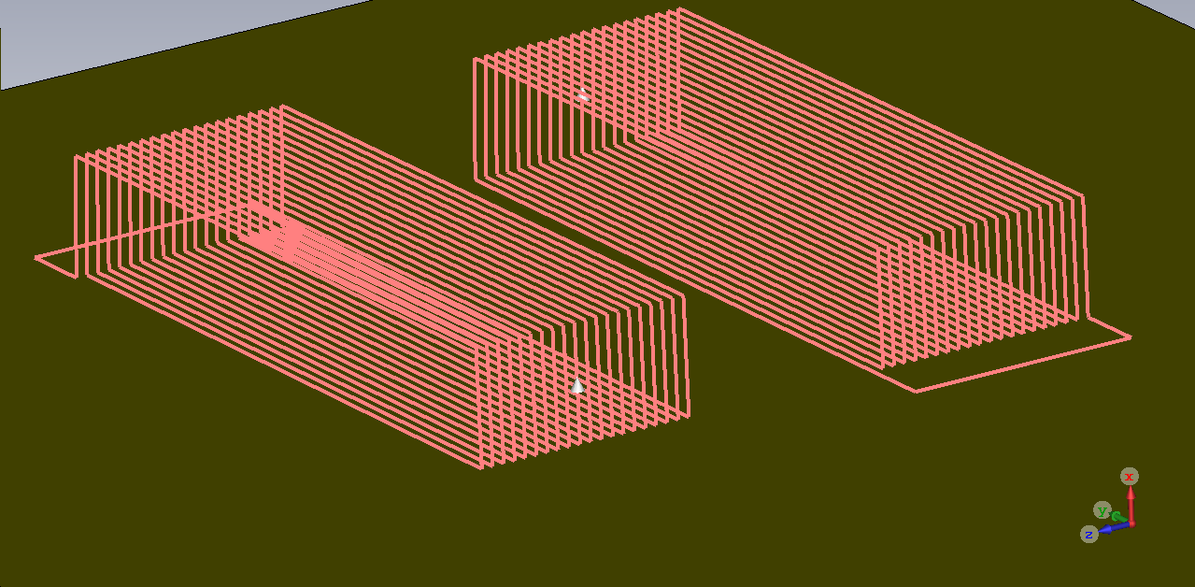

Figure 3: Two counter wound coils each separated by 1.5 cm. The coils have identical dimensions: 1.8 cm length, 3.5 cm width, and 0.63 cm thickness. Each coil has 20 turns.

The current paths can be seen in figure 3. It’s important to note that this simulation will be different than the simulation done by Gruber, as it is unknown how many turns each coil has. Furthermore, our example will include wire leads which will inevitably affect the B1 field. It is also unknown what Gruber had for the dimensions of the conductive sheet, but for the sake of comparing to fig. 2, the copper sheet will have a thickness of 1 mm, length of 10 cm, and width of 10 cm.

The simulation can be constructed using the ‘Low Frequency’ problem type developed for CST. If one was looking to tune and match this probe, the ‘High Frequency’ problem type should be selected. This would allow the user to add wire ports that connect both ends of the wire leads. Then, through the schematic window, one could add capacitors accordingly. For simplicity, we use the low frequency option which will allow us to observe field shape.

To construct this coil in CST, one may click under the macros button in the home tab. Through here, one may create a coil type of ‘Helical Spiral’, with an angle increment of 90 degrees. Parameters such as coil radius or height could be set depending on what the experimenter is looking to do, but in our case, we set both the major and minor radius to 10 cm. From here, we may draw the curves one by one by utilizing the ‘Picks’ and ‘Curves’ tool in the modeling tab. Once the wire leads are in place, we can scale the coil to our desired length, width, and height by selecting our model in the components tab, and then selecting transform in the modeling tab. The transform feature allows the user to scale the coil to the desired dimensions. In this case we use the dimensions provided by Gruber. Upon completion of our coil, we may duplicate by clicking ‘Copy’ (also found in the transform option), ‘Apply’, and separating each coil by the desired length. After setting each coil to their own separate current paths, we may begin by selecting ‘Start Simulation’.

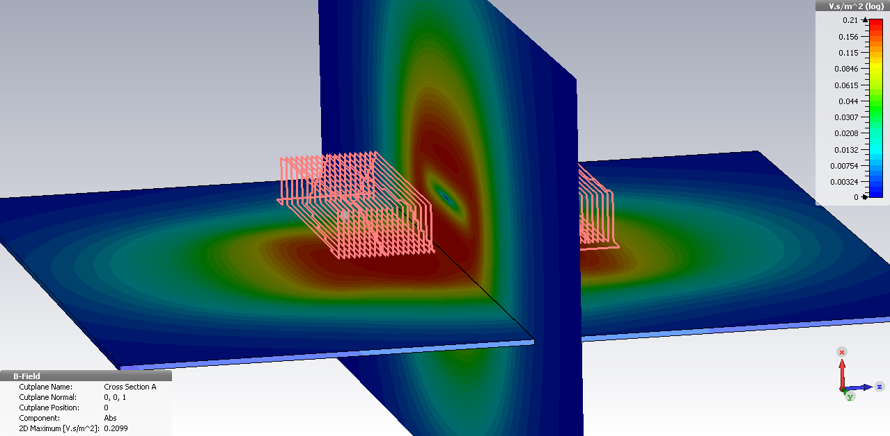

Figure 4: This shows a side view of two contour plots, for both the ZY and XY planes. Each contour plot shows the magnitude of B1 magnetic field.

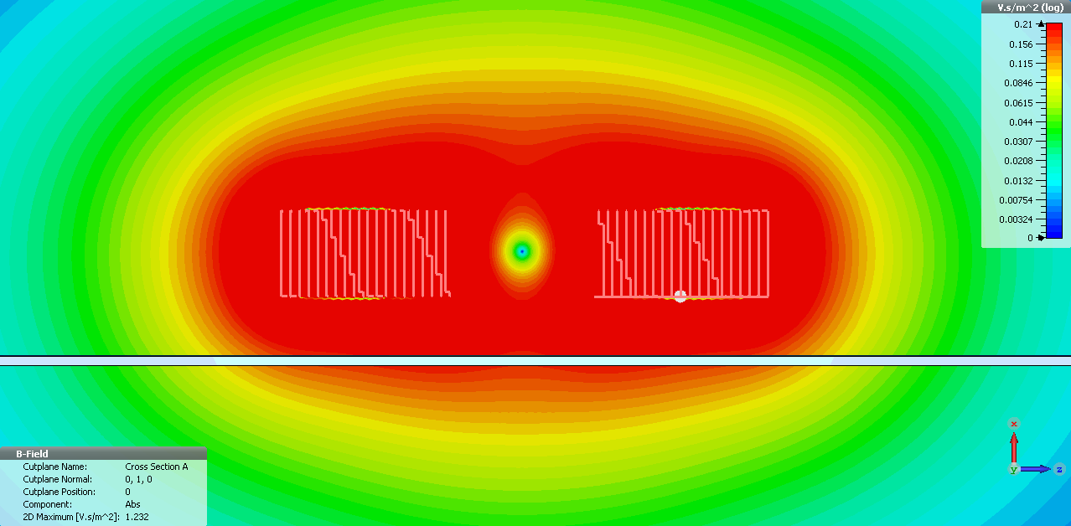

Figure 5: Contour plot of the field in the XZ plane. This shows the magnitude of B1 field.

Figures 4 and 5 provide a reference to the contour plots provided in Gruber’s paper (listed as fig. 6 in the paper).

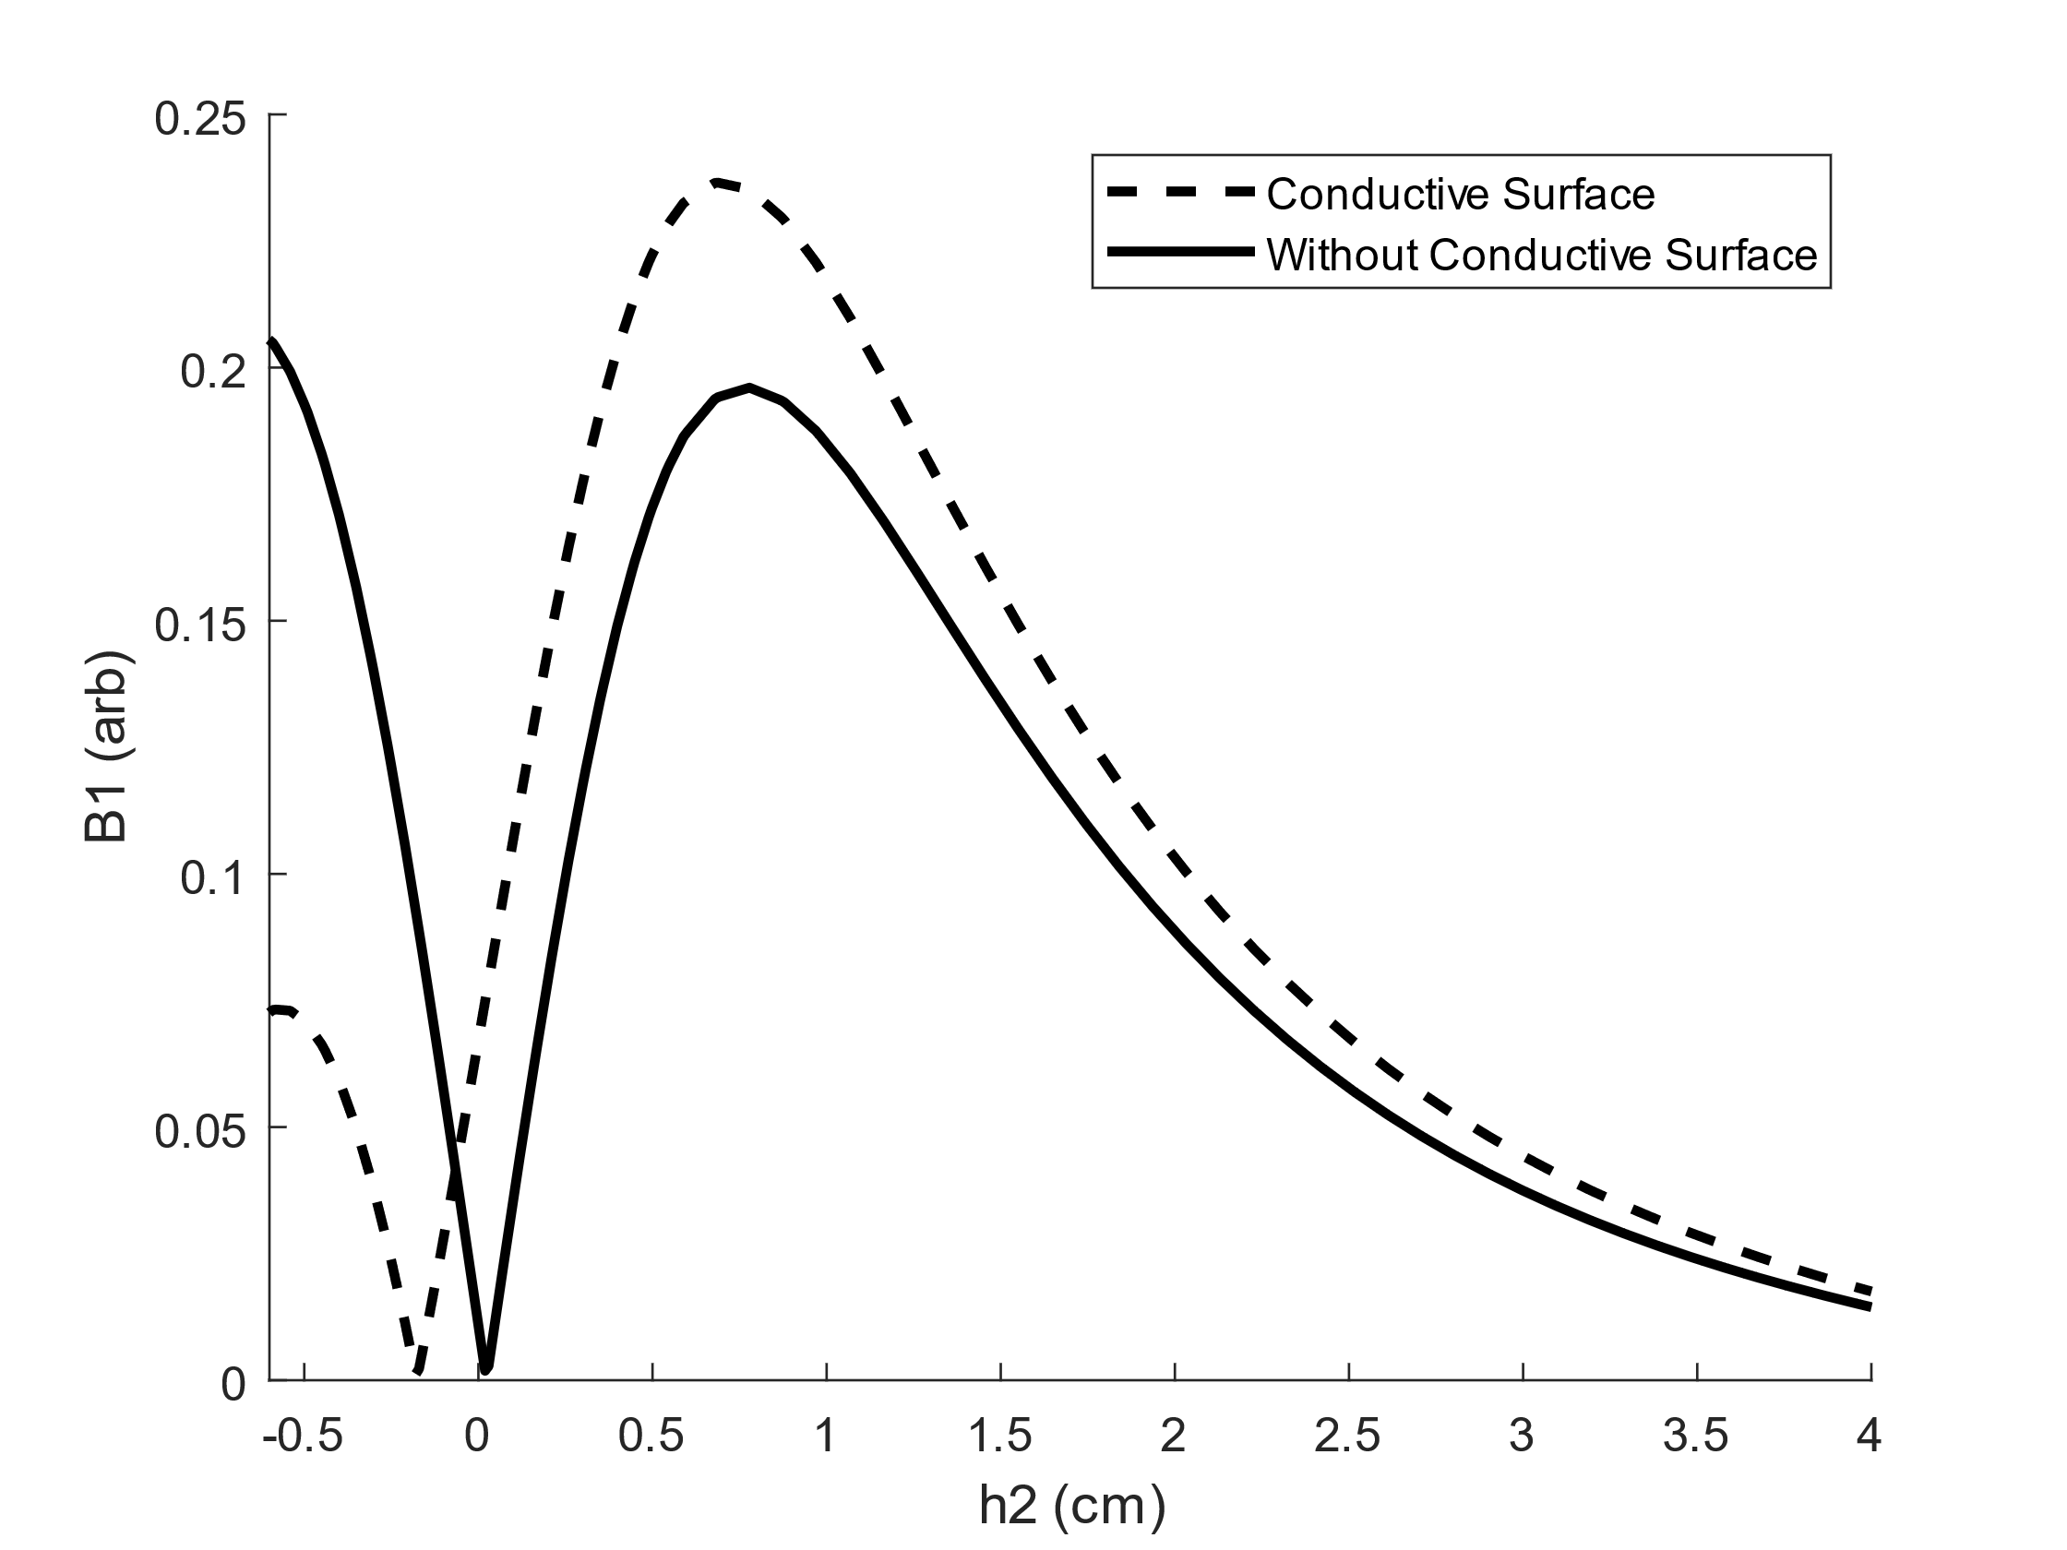

Figure 6: The plot shows the magnitude of magnetic field as a function of h2 (distance from the copper sheet). The dashed line represents the field with the conductive sheet, and the solid line represents the field without.

In fig.6 at a h2 of 1 cm, the B1 field is improved by 17.5%. In contrast, this is a large difference between fig.2, which has a B1 field attenuation of 42.5%. In both simulations, the copper sheet is placed 6 mm from the bottom of the RF coil.

**Conclusion**

The designs presented by Daniel. M Gruber *et al.*, have been simulated and show that with a new RF coil geometry, the effects of surface currents can be minimized. With respect to a conventional surface mounted coil, B1 field attenuation can be greatly minimized with the use of two counter-wound rectangular coils. This is a very useful design, as it allows the experimenter to fully exploit magnet standoff distance without offsetting the RF probe from the surface to reduce surface currents. The surface coil design is also advantageous for complicated sample shapes, that may not allow for a solenoid RF coil. For example, the idea of using UMR for below-skin measurements on blood would greatly benefit from this design.

**References**

[1] CST Studio 2020 – Educational License, https://www.3ds.com/

[2] Daniel M. Gruber, Sophia N. Fricke, Vanessa Lee, Bruce J. Balcom, and Matthew P. Augustine, “Coils for Large Standoff Relaxometry with Unilateral Magnets”, 69 Chemistry Building, University of California, Davis, CA 95616 USA