**UC Davis Counter-Wound Coil Design**

Devin Morin

7/14/2020

V.3.3

**Introduction**

The purpose of this report is to describe some of the subtleties of the UC Davis counter-wound coil design. Throughout the progress made to reproduce the results by Gruber *et al.,* it was clear that one could learn a lot from the simulations in CST. This report aims to further explore the counter wound coil design beyond what was shown in the original paper by Gruber.

The design consists of two coils, separated by 1.5 cm. Each coil has dimensions of 1.8 cm in length, 3.5 cm in width, and 0.63 cm in thickness. One coil is wound clockwise, and the other is wound counter-clockwise. The coil design aims to reduce surface currents due to the oscillating B1 field on the surface of the conducting copper sheet. As nature abhors a change in flux, one can view the magnetic field due to surface currents, as a secondary field, which will oppose the magnetic field lines due to B1, which intersects with the conducing surface.

A regular surface coil that is wound clockwise will have a magnetic field that points upwards in the center of the coil. If the coil is mounted on the surface of the conducting sheet, the magnetic field lines due to the coil will point upwards on the surface of the sheet. With an oscillating current, the flux on the surface of the conducting sheet is always changing. This change in flux, causes surface currents in the conducting sheet that create an opposing, secondary magnetic field that superimposes itself on the ideal B1 field, to attenuate the experienced B1 field. This attenuated field is unwanted, as a reduction in B1 field intensity will cause a reduction in signal intensity.

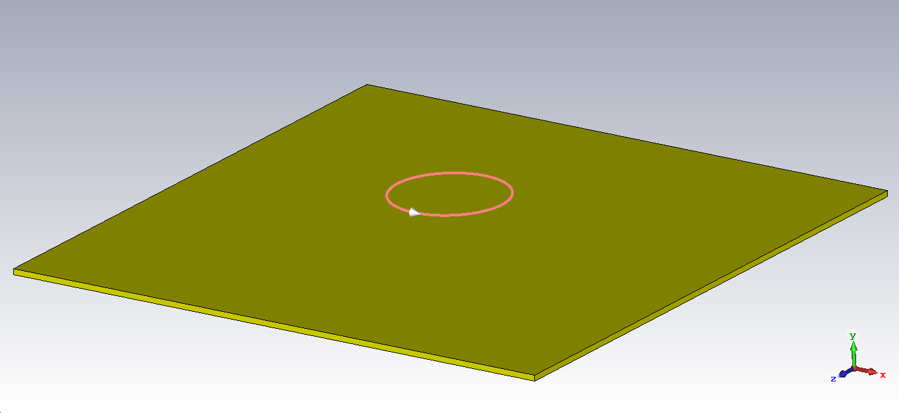

Figure 1: Simple single loop coil wound clockwise.

**Counter-Wound Design**

Below, is an image showing an overview of the coil. Paired with this, is a very useful image of the direction of the magnetic field lines due to the coil.

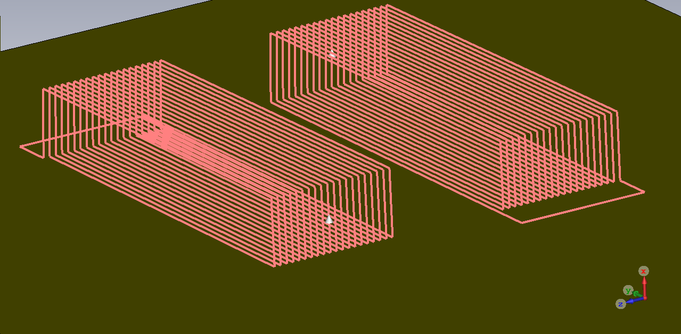

Figure 2: Overview of the coil design.

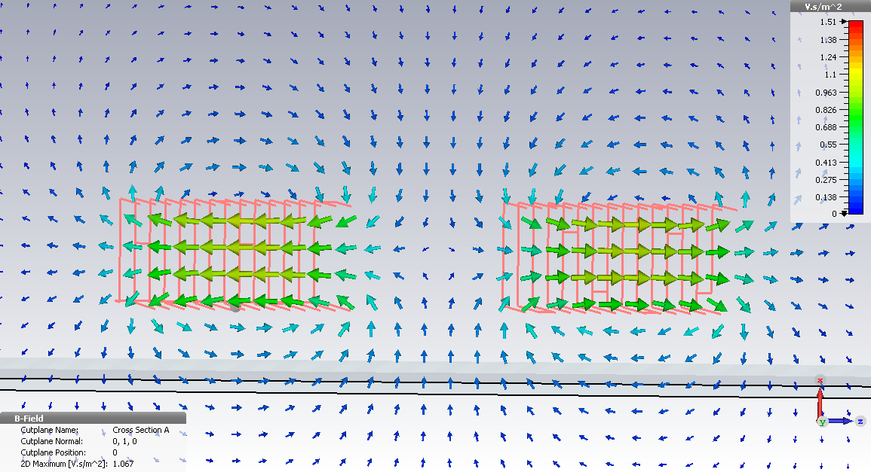

Figure 3: Arrow plot of the magnitude of magnetic field in the XZ plane. This figure is useful for determining the direction of surface currents and how they superimpose themselves on the sensitive spot region.

Figure 3 is a very useful plot which can be used to help one understand the direction of the magnetic field B1 about the coil. This is helpful when trying to understand why this coil design is so useful. As mentioned before, with a B1 field that points upwards on the conducting surface, surface currents in the conducting sheet will create a secondary magnetic field that points downwards. We can see that in the middle of the two coils, at the conducting surface there is a magnetic field that points upwards. This causes surface currents that generate a secondary magnetic field that points downwards. The wonderful part of this design is that we are utilizing the B1 field above the coil, which points downwards. The B1 field above the coil superimposes with the “secondary” field due to surface currents, causing an overall increase in the magnitude of magnetic field B1. Likewise, when the current passes in the other direction, we use the same reasoning to deduce that the magnetic field B1 at the surface of the conductor will be moving downwards, and the B1 field above the coil moves upwards. Since the B1 field is downwards on the conducting surface, this causes surface currents that oppose that field and points upwards. This secondary upwards field superimposes itself on the B1 field above which adds to the magnitude of magnetic field B1. We can now see that with an oscillating field B1, this coil design adds to the magnitude of B1 field, rather than opposing it.

A benefit of this design is the increase in signal due to an increase in B1 field. The signal is proportional to B1 squared, so we may observe the B1 field within the sensitive region to get a perspective on the signal gain due to this design. Below is a plot of the magnitude of magnetic field as a function of h2 (the line that is perpendicular to the surface of the conducting sheet, in the middle of the two coils). The h2 axis represents the axis along the line that runs from the center of the coil at an h2=0 cm, upwards (or perpendicular to the magnet surface). In the following examples, the position of the coils remains the same, but the position of the conducting surface is moved downwards, in the negative h2 direction.

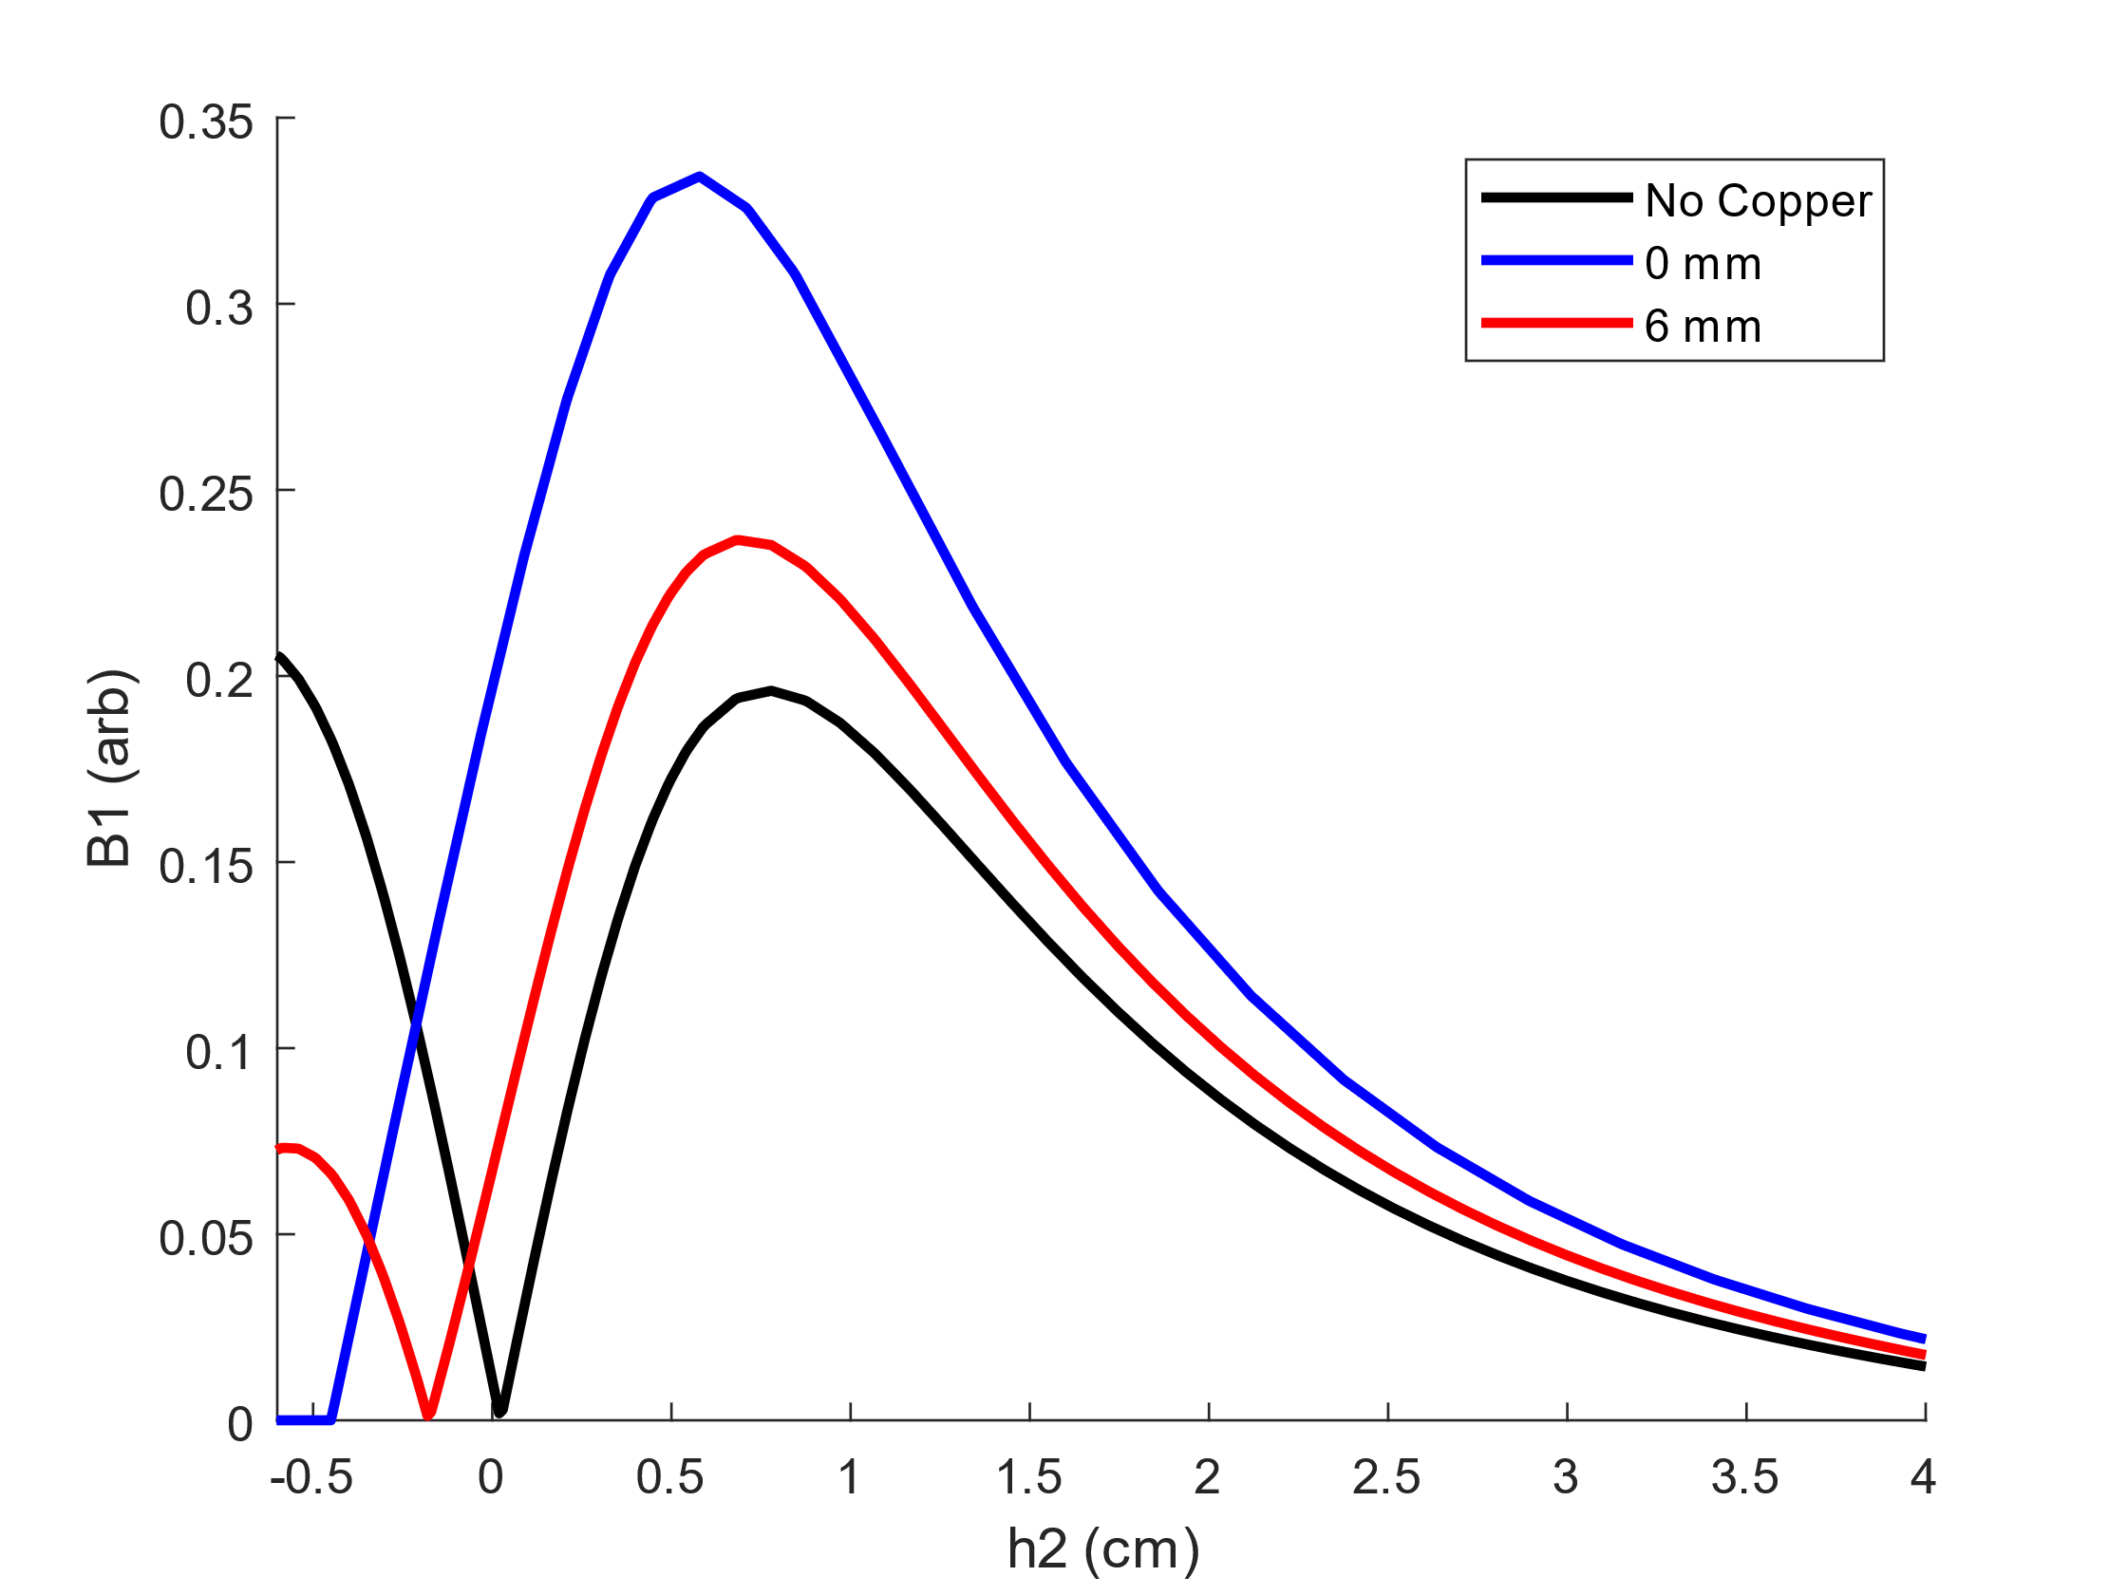

Figure : Magnitude of magnetic field as a function of h2 (the line that is perpendicular to the surface of the conducting sheet, in the middle of the two coils). The bottom curve (in black) represents the magnitude of magnetic field with no copper sheet. The distances in the legend represent the displacement between the conductive sheet and the bottom of the counter-wound coil.

The plot in figure 4 was gathered using CST. The magnitude of magnetic field can be seen to be larger with the conducting surface than without. The top to bottom curves represent the 0 mm, 6 mm, and no copper curves respectively. The h2 axis represents the distance from the center of the coil geometry, along the axis that runs perpendicular to the conductive copper sheet. This means that the exact center of the coil geometry will always be h2=0 cm. To generate an idea for how much of an improvement the conducting surface makes, we can look at the percent change at a particular height (h2). As an example, we use the 3-magnet array containing 3, 50x25x18 mm block magnets, with a sensitive spot from 0.52 – 1.45 cm above the surface. At an h2 = 1 cm, the percent difference is 17.6% for the 6 mm curve, and 51.6% for the 0 mm curve. As signal scales with B1 squared, we would expect an approximate increase to signal by a factor of 1.38, and 2.30 for the 6 mm and 0 mm curves, respectively.

**Comparisons Between B1 Field Improvement**

The issue with the counter-wound coil design, is that the experimenter will be utilizing the fringe field, which is much weaker than the field within the squashed solenoid. Because of this, it’s important to compare the field improved from the counter-wound design, to the field that is attenuated from surface currents. Even with field attenuation due to surface currents, a simple surface coil may generate a large enough B1 field within the coil region to outweigh any gain in field due to the counter-wound design.

Making comparisons between the two designs is difficult as geometries are different, so changing a single parameter does not give the best justification to conclude that one design is better than the other. In the effort of minimizing differences, the coil used in this example will have the same current, and number of turns as the counter-wound example. The surface coil has dimension of 1x1 cm in length and width (in the yz plane), and is infinitely thin in the vertical, or x direction. The origin is in the exact center of the coil. Below is an overview of the coil:

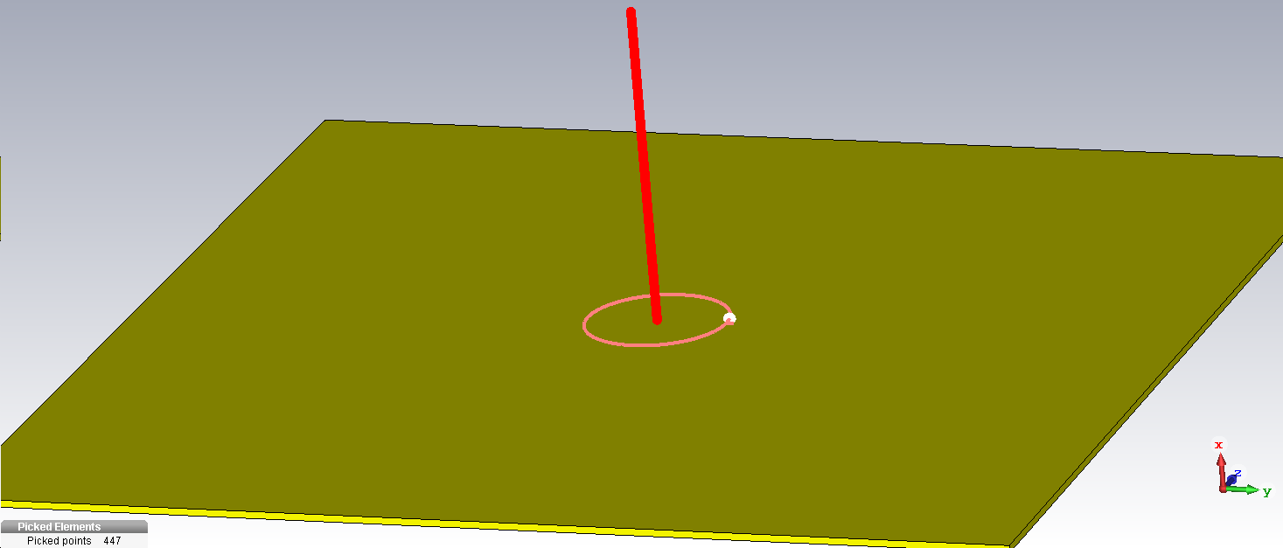

Figure : Overview of the simple surface coil. In red, we can see the line that is used to represent the measurement of the magnitude of magnetic field. We can also see that the line starts in the center of the coil, where x=0,z=0,z=0.

Below, is a plot describing what has similarly been described in figure 4. The plot shows the magnitude of magnetic field plotted as a function of h2 (x).

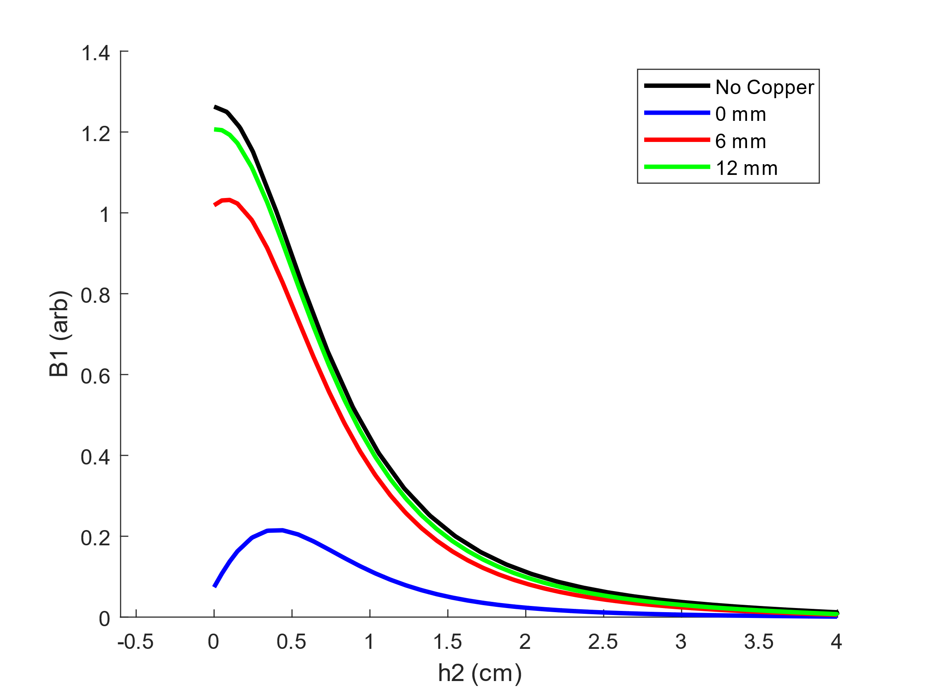

Figure 6: Magnitude of magnetic field as a function of h2 (x), along the line that is perpendicular to the conductive sheet at the exact center of the coil. The coil is positioned at h2=0 cm. The percent change between the ‘No Copper’ curve, and 6 mm curve at a h2=1 cm is -25.7%

In figure 6, we see that without a conductive copper sheet, the magnitude of magnetic field at the center of the coil is slightly above 1.2 in our arbitrary B1 field units. We can also see from top to bottom, the curves that represent the magnitude of magnetic field with different positions of the copper sheet. From top to bottom, we see the ‘No Copper’ curve, 12 mm, 6 mm, and 0 mm curves respectively. The distance in millimeters, represents the distance between the top of the conducting sheet, and the coil. As expected, when the surface coil is resting directly on the conductive surface, the magnetic field is greatly attenuated (this can be seen in the bottom curve, where the maximum reaches a bit above 0.2 in arbitrary units).

Although the counter-wound and surface coil designs do not have the same geometry, one can still draw a meaningful conclusion from this data. With a surface coil that has the same number of turns, and the same current, the 0 mm curve shows that the magnitude of magnetic field is almost equivalent to the counter-wound design (seen in figure 4) at a coil to conductive surface separation of 0 mm. Comparing figures 4 and 6, one could see how the surface coil design would be preferable in almost every situation, other than the case where the surface coil must be placed directly on the surface of the conducting surface, with a 0 mm separation.

**Conclusion**

According to CST simulations, it would be much more beneficial to use a surface coil design, rather than a counter-wound design, in almost every circumstance. This is due to the weak magnetic field of the counter-wound fringe coil not being able to compete with the much larger magnetic field found directly above the surface coil. For the surface coil at an h2=1 cm, the magnitude of magnetic field is only attenuated by 25.7% when the copper sheet is displaced by 6 mm. Although this is a much greater attenuation compared to the counter-wound design, the magnetic field directly above the surface coil is large enough for the surface coil to still be preferable.

In a circumstance where the experimenter can lift the surface coil just slightly above the conductive sheet, surface currents will be reduced, and the magnitude of B1 field will increase. Because of this, the surface coil design will be the preferable choice in almost every instance except for when the coil must be placed directly on the surface of the conductive sheet.