Devin Morin

7/8/2020

Handheld 3-Magnet Array for 50x25x18 cm Block Magnets w/ Homogeneous Spot

All magnets within the 3-magnet array have dimensions of 50x25x18 mm. They are separated by spacers with a 0.356 cm thickness. The center magnet is displaced downwards by 0.364 cm. For this simulation, the magnet material is set to air, and the case/spacer material is set to aluminum.

The magnet design contains a sensitive spot region of 0.92 cm in length, from 0.52-1.45 cm above the surface. The sensitive spot has an approximate field strength of 651 gauss (2.77MHz).

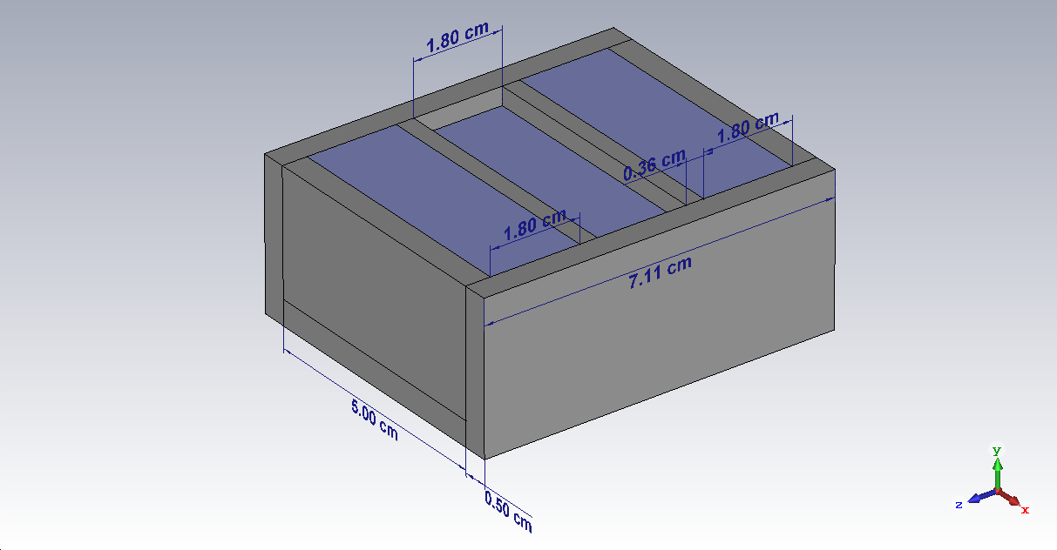

Figure : Overview of magnet design.

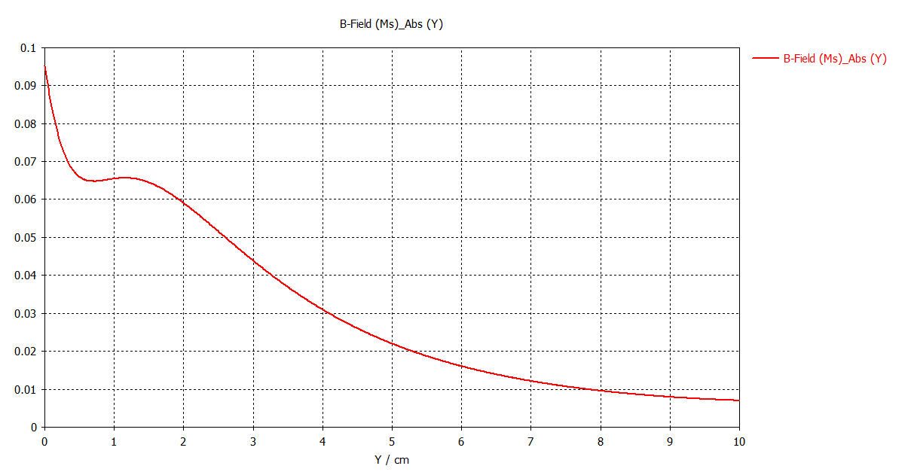

Figure : Magnitude of magnetic field along the y-axis. The field is displayed along the line that is perpendicular to the surface at z=0, x=0.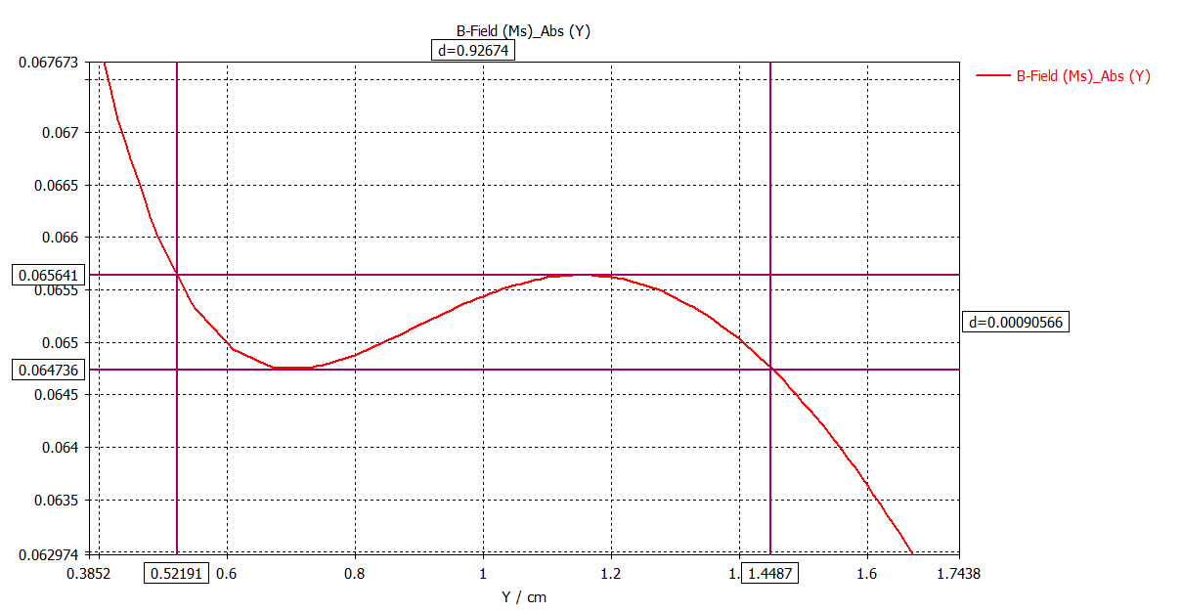

Figure : Close up of fig.2. This shows an acceptable region from 0.52 - 1.45 cm above the surface, where the magnitude of magnetic field varies by less than 10 gauss.

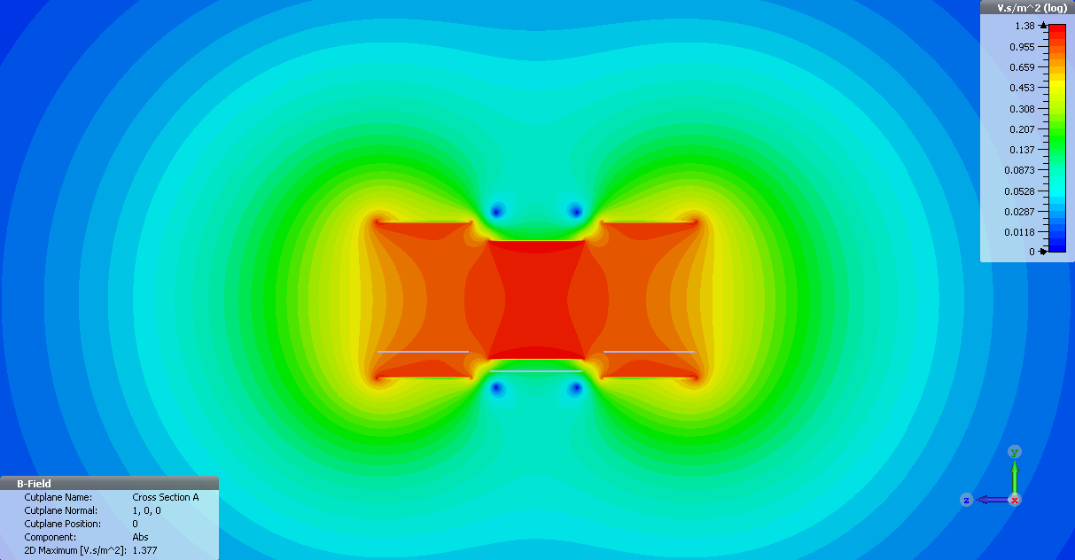

Figure : Contour plot of the magnitude of magnetic field in the YZ plane.