

MAGNET Array

USER’S
MANUAL

University of New Brunswick, MRI department

Created by: Chen Wang

Date: April, 2007
Revision Sheet

Release No. | Date | Revision Description
Rev. 0 | 4/02/2007 | User’s Manual

TABLE OF CONTENTS

Page #

1.0 GENERAL INFORMATION -1
1.1 System Overview 1-1
1.2 Project References 1-1

2.0 GETTING STARTED 2-1
2.1 Start the Program 2-1
2.2 Exit System 2-2
3.0 USING THE SYSTEM 3-1
3.1 Place and Size Magnets 3-1
3.2 Run 3-3
3.3 Set Ymin,Ymax,Zmin and Zmax Limits 3-5
3.4 View Z and Y Cross Section Plots 3-6
3.5 Export Data 3-8
3.6 About the Program 3-9
3.7 Help of the Program 3-9
3.8 Special Instructions 3-9

1.0 GENERAL INFORMATION

GENERAL INFORMATION

1.1 System Overview

The Magnet Array is a MATLAB based stand-alone GUI (graphic user interface) program created based on paper “A compact permanent magnet array with a remote homogeneous field” [1]. Typical uses of the program include:
- Users defined the sizes and locations of the three magnets.
- Generate magnetic field plots based on the sizes and locations of the magenets.
- View Z and Y cross sections of the magnetic field plots.
- Adjusting the views of the Z and Y cross section views using sliders.
- Change the magnetic field plot limits by redefine Ymin, Ymax, Zmin and Zmax limits.
- Export magnetic field contour plot, Z and Y cross section data to text files.

1.2 Project References
[1] “A compact permanent magnet array with a remote homogeneous field”
Andrew E. Marble, Igor V. Mastikhin, Bruce G. Colpitts and Bruce J. Balcom

2.0 GETTING STARTED

GETTING STARTED

2.1 Start the Program

Open the folder ‘MagnetArray’ and double clicked the ‘MagnetArray’ icon to run the program.

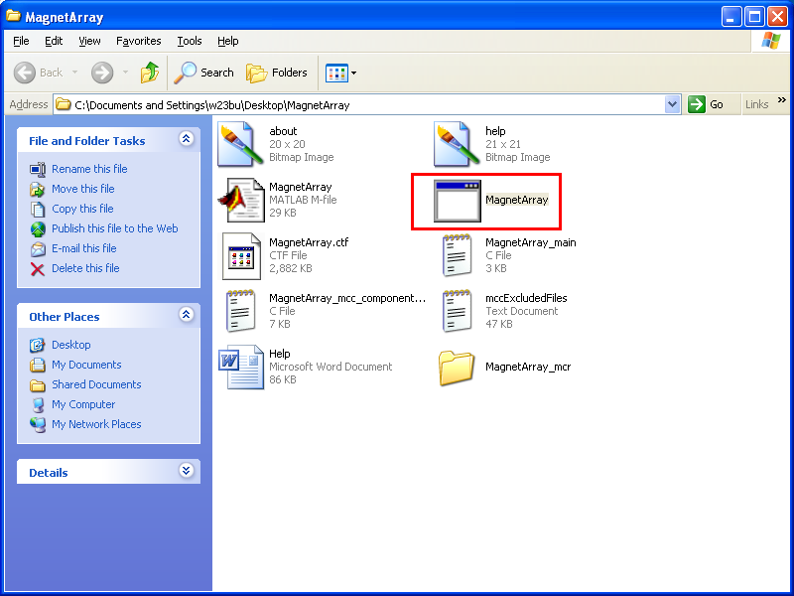

Example: Click the ‘MagnetArray’ to run the program

The three magnets are represented by three rectangles (black, red and blue) as shown in the “Magnet Position” axes. Magnets are centered at the midpoint of the upper edge of the rectangles. The center of the magnets is shown as a yellow dot.

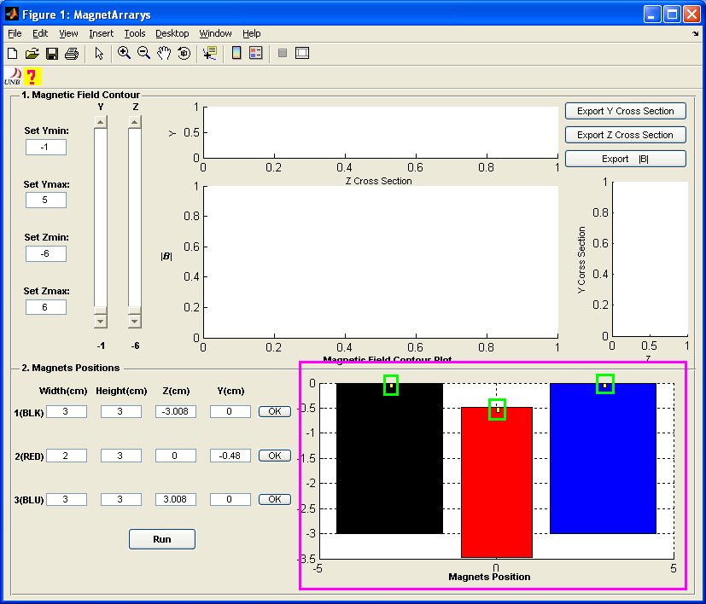

Example: Magnet Array User Interface

2.2 Exit System
Close the program.

3.0 USING THE SYSTEM

USING the program

  - Specifying the width, height, Z and Y values for all three magnets in the corresponding text boxes. Click ‘OK’ to confirm the size and location of each magnet. Click ‘Run’ to run the program.

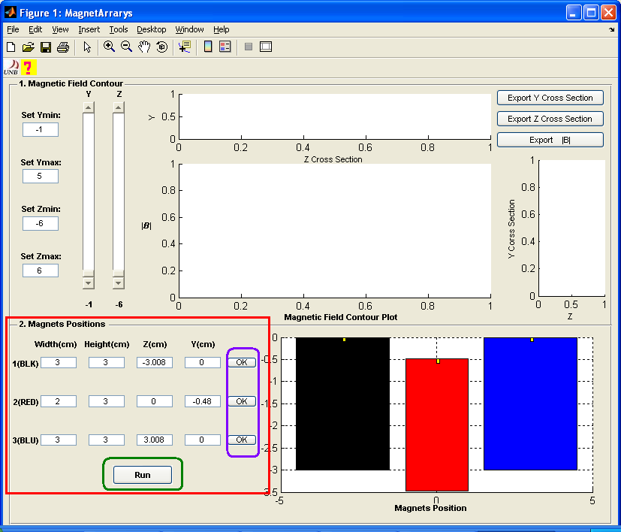
Example: Enter width, height, Z and Y values for magnets. Click ‘OK’ to confirm and click ‘Run’ to run the program.

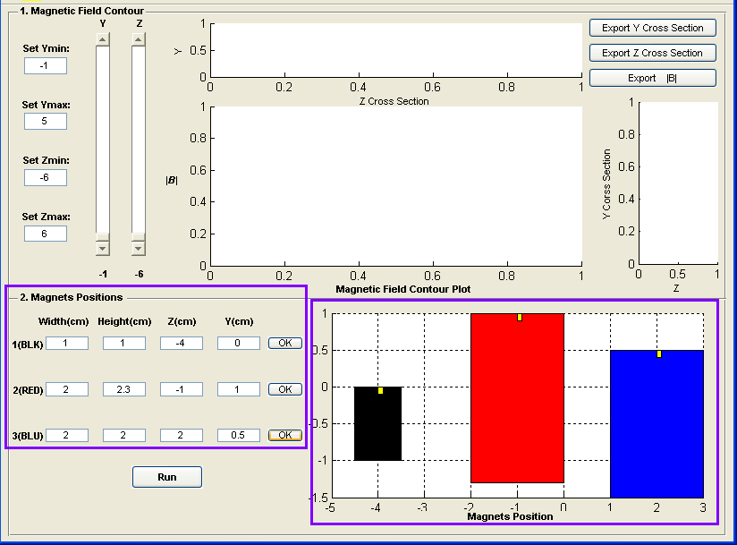

Example: Using user defined width, height, Z and Y values, magnets changed sizes and positions correspondingly

  - After click ‘Run’ and program finishes running, the magnetic field contour plot will be generated.

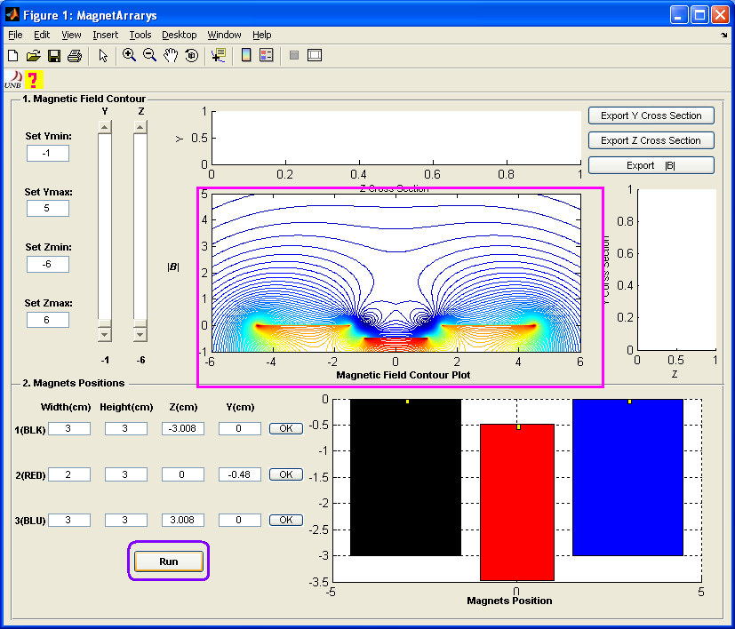

Example: Run using the default magnets size and position information

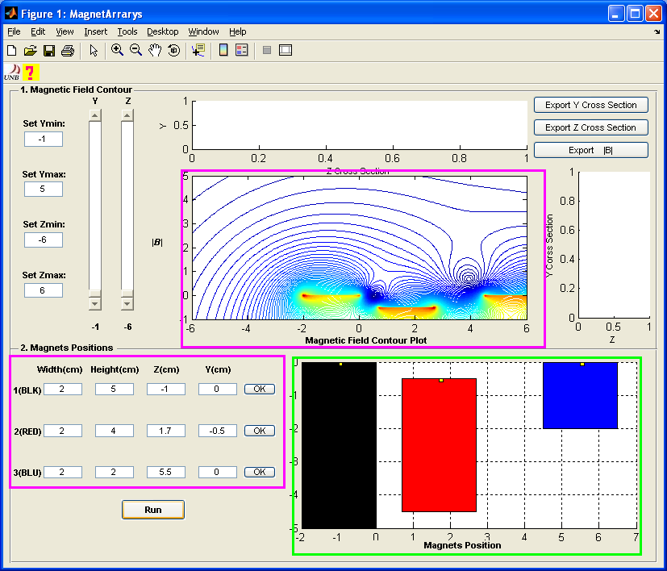

Example: Run with user defined width, height, Z and Y values

  - Enter values of “Set Ymin”, “Set Ymax”, “Set Zmin” and “Set Zmax” to set the “Magnetic Field Contour Plot” Y and Z limits or use the default values. Click ‘Run’ to generate plots with new limits.

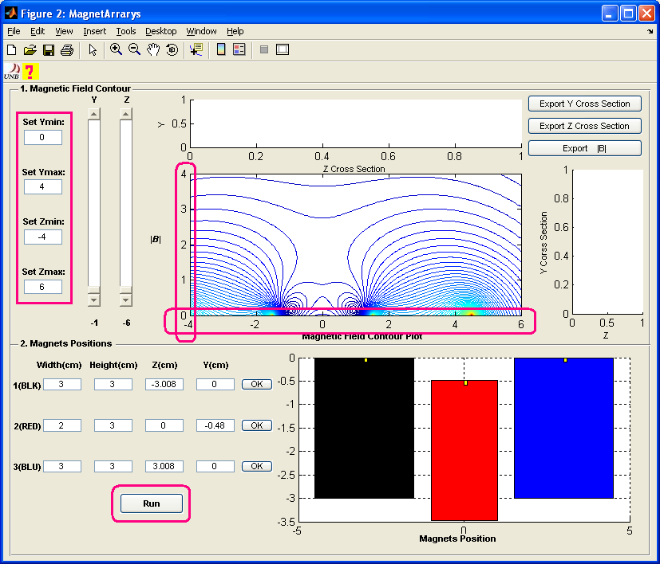

Example: Changing the contour plot limits

  - Adjust sliders “Y” and “Z” to view the Z and Y cross section views of the magnetic field contour plot. On the ‘Magnetic field contour plot’, the value of the Y slider is indicated by a blue line and the value of the Z slider is indicated by a red line. The upper and lower limits of the Y slider are set by Ymin and Ymax; the upper and lower limits of the Z slider are set by Zmin and Zmax. For example, if Ymin = 0 and Ymax = 4, the minimum value of the Y slider is 0 and the maximum value is 4.

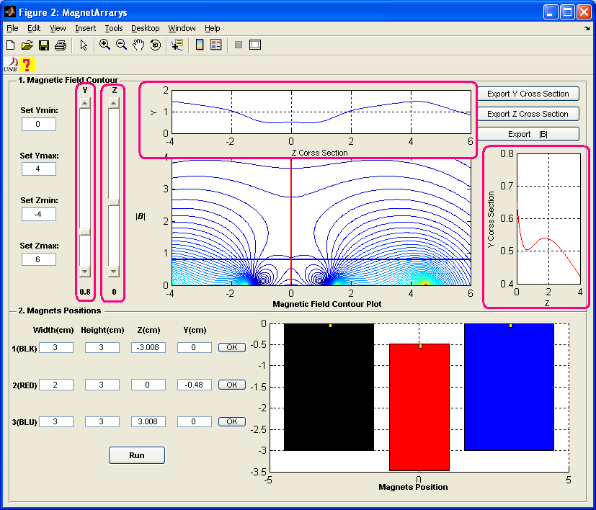

Example: View the Y and Z cross section plots by adjusting the Y and Z sliders

  - Click “Export Y Cross Section”, “Export Z Cross Section” and “Export |B|” to export data. All data will be saved as text format. If there are more than one variables, variables will be separated by one row of ‘NaN’.

- Export Y Cross Section: saves data from the ‘Y Cross Section Plot’ of the magnetic field. The order of the saved variables is: Z and B. Z define the limits of the plot. B is the Y cross section of the magnetic field contour. Variables are separated by one row NaN.

- Export Z Cross Section: saves data from the ‘Z Cross Section Plot’ of the magnetic field. The order of the saved variables is: Y and B. Z define the limits of the plot. B is the Z cross section of the magnetic field contour. Variables are separated by one row NaN.

- Export |B|: saves data from the ‘Magnetic Field Contour Plot’. The order of the saved variables is: Z, Y and B. Z and Y are used to define the limits of the plot and create a mesh grid. B is the magnetic field contour. Variables are separated by one row of NaN.

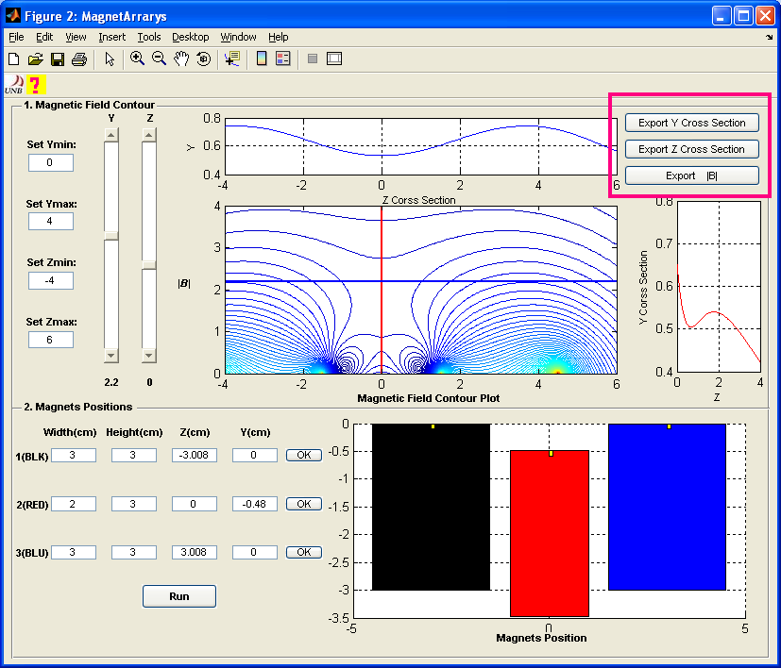

Example: Click the buttons to export data

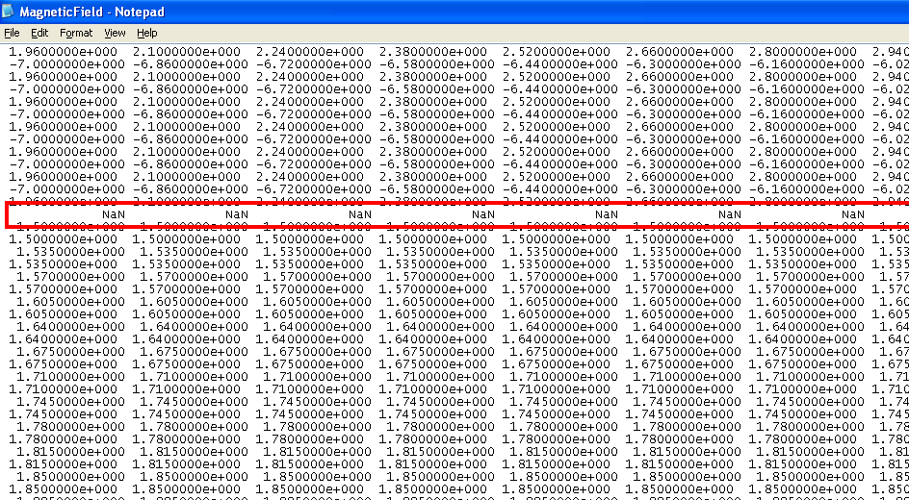

Example: Variables are separated by ‘NaN’

  - Click the UNB logo just below the ‘File’ icon to learn more about the program.

  - Click to open the help file. This only works with Windows machine.

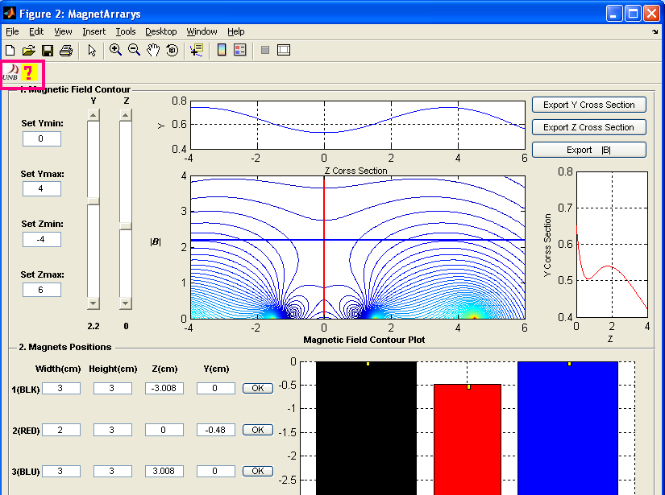

Example: About and Help

  - Special Instructions for Error Correction
If the program crushes, close the program and run it again. Some simulations will take a long time to run.

