

MAGNET DESIGN

USER’S
MANUAL

University of New Brunswick, MRI department

Created by: Chen Wang

Date: April, 2007
Revision Sheet

Release No. | Date | Revision Description
Rev. 0 | Apr 22, 2007 | User’s Manual

TABLE OF CONTENTS

Page #

1.0 GENERAL INFORMATION
1.1 System Overview
1.2 Project References

2.0 GETTING STARTED
2.1 Start the Program 2-1
2.2 Exit System 2-2
3.0 USING THE SYSTEM 3-1
3.1 Choose a Method 3-1
3.2 Input Variables 3-2
3.3 Run the Program 3-3
3.4 Input Variables 3-2
3.5 Other Functions 3-6
3.6 About 3-14
3.7 Help 3-14
3.8 Special Instructions for Error Correction 3-14

1.0 GENERAL INFORMATION

GENERAL INFORMATION

1.1 System Overview

The Magnet Design is a MATLAB based stand-alone GUI (graphic user interface) program created based on Andrew Marble’s PHD thesis. Typical uses of the program include:

- Stand-alone application. Can be distributed to users who do not have MATLAB on their systems.
- Calculate magnetic field plots and scalar potential plots using user specified method, coordinate and variables (a, gradient, x, y width, height, N, M and many others).
- View X and Y cross section plots of the magnetic field plots.
- Adjust the cross section view using sliders.
- Calculate using user defined boundary limits (Set Ymin, Set Ymax, Set Xmin and set Xmax).
- Calculate the shape of pole pieces using user defined upper and lower limits.
- Adjust the upper and lower limits of the pole pieces using sliders.
- View and/or re-define output coefficients.
- Export magnetic field plots, cross section plots, scalar potential plots and pole pieces data into text files.

Project References

[1] Designing static fields for unilateral magnetic resonance with the scalar potential approach
Andrew E. Marble, Igor V. Mastikhin, Bruce G. Colpitts, and Bruce J. Balcom

[2] An analytical methodology for magnetic field control in unilateral NMR
Andrew E. Marble, Igor V. Mastikhin, Bruce G. Colpitts, and Bruce J. Balcom

2.0 GETTING STARTED

GETTING STARTED

Start the Program

Open the folder ‘MagnetDesign’ and double clicked the ‘MagnetDesign’ icon to run the program.

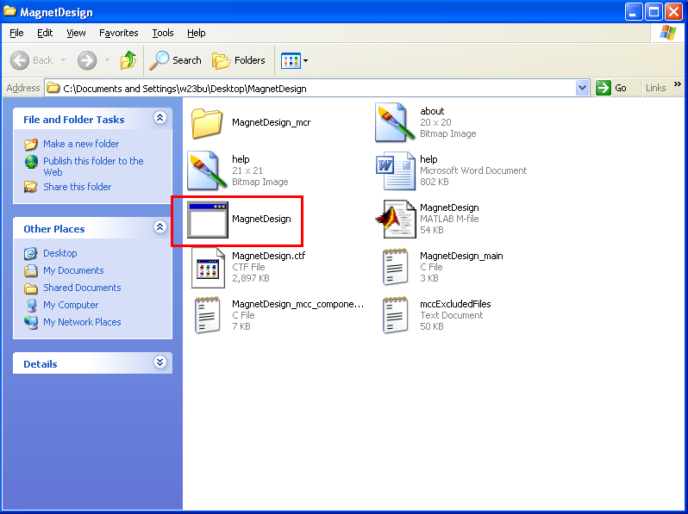

Example: Click the ‘MagnetDesign’ to run the program
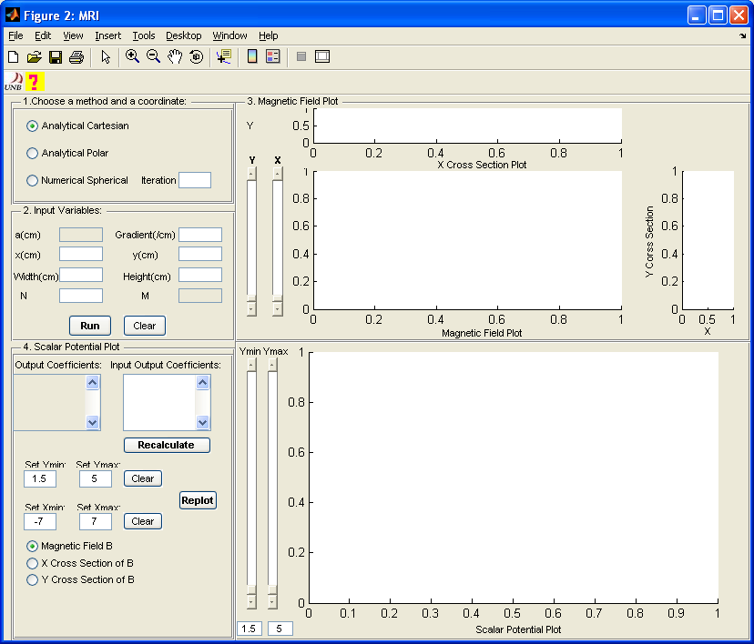

Example: Magnet Design User Interface

2.2 Exit System
Close the program.

3.0 USING THE SYSTEM

USING the program

  - Click to select an appropriate method and coordinate to use. There are 3 choices:
- Analytical Cartesian
- Analytical Polar
- Numerical Spherical
  - Iteration (optional): It is optional and it is only used with the ‘Numerical Spherical’ method. Leave this iteration box blank most of the time unless you get an error indicating that ‘the number of iterations exceeds this maximum number of iterations’. If you get this error, try to put iteration = 1000, 2000, 3000, etc. until you get a desired result.

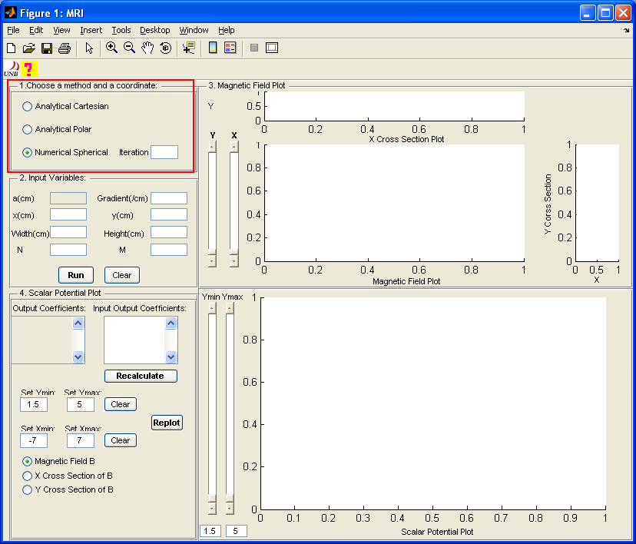

Example: ‘Numerical Spherical’ is selected

  - Input variables for the following:
- a (cm): array width (Cartesian coordinates only).
- Gradient (cm⁻¹): Gradient/B_{o}, B_{o} is always assumed to be 1T at the center of the sensitive spot.
- x (cm) and y (cm): center of volume to be optimized.
- width (cm) and height (cm): size of volume to be optimized.
- N: number of analytically calculated free parameters.
- M: number of numerically calculated free parameters.

Depends on which method is selected in 3.1, irrelevant variables (e.g. variable ‘a’ in the example below) will be disabled.

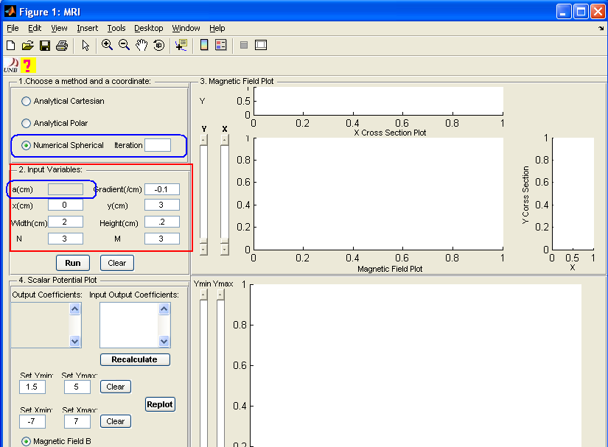

Example: ‘Numerical Spherical’ is selected, ‘a’ is disabled.
User inputs values for all the variables.

  - Click ‘Run’ button to run the program. Use ‘Clear’ button to clear all variables.

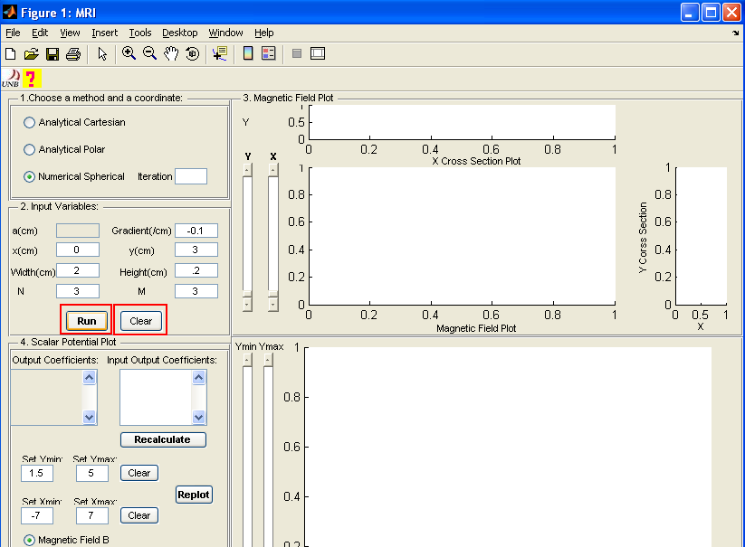

Example: Click ‘Run’ to run the program; click ‘Clear’ to clear variables

  - After click ‘Run’, a wait bar will appear. The wait bar will disappear when the program finishes running. The following things will happen after clicking ‘Run’ button.

- ‘Magnetic Field Plot’ and ‘Scalar Potential Plot’ will be generated.
- The color bar will appear beside the ‘Scalar Potential Plot’. The color bar indicates the values of the contour.
- Output coefficients will be displayed in the ‘Output Coefficient’ box. Browse the output coefficients using the scroll bar.
- The default pole piece will be highlighted on the ‘Scalar Potential Plot’.

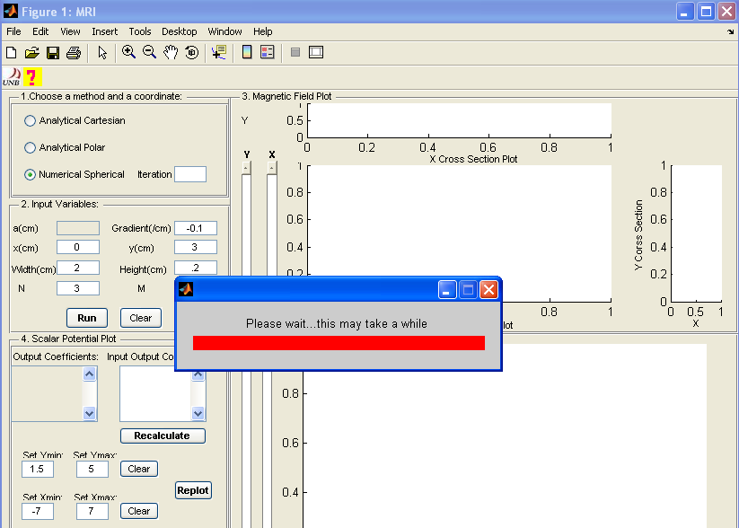

Example: After click ‘Run’, a wait bar will appear until the program finishes running.
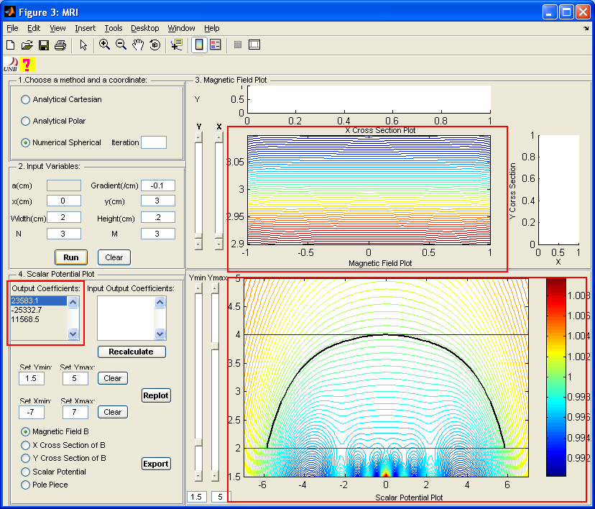

Example: After click ‘Run’ and program finishes running

  - Then if you want to:
- View the X and Y cross sections of the magnetic field B in the ‘Magnetic Field Plot’:

Adjust the ‘X’ and ‘Y’ slider bars beside the ‘Magnetic Field Plot’.

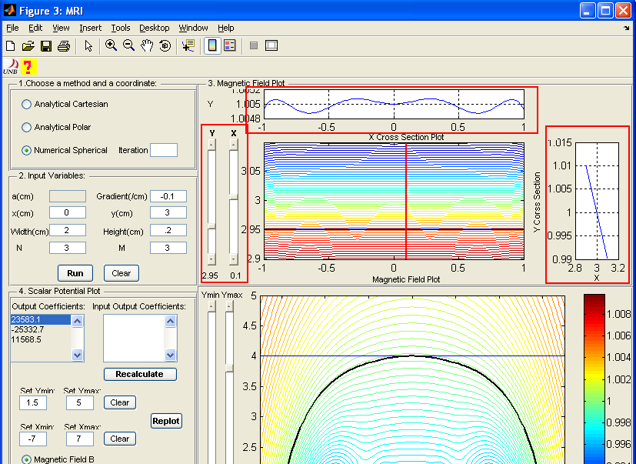

Example: View the X and Y cross section plots by adjusting the Y and X sliders

- Enter user defined output coefficient values:

Enter values in the output coefficients box in the form of example shown below. Then click ‘Recalculate’ button to run.

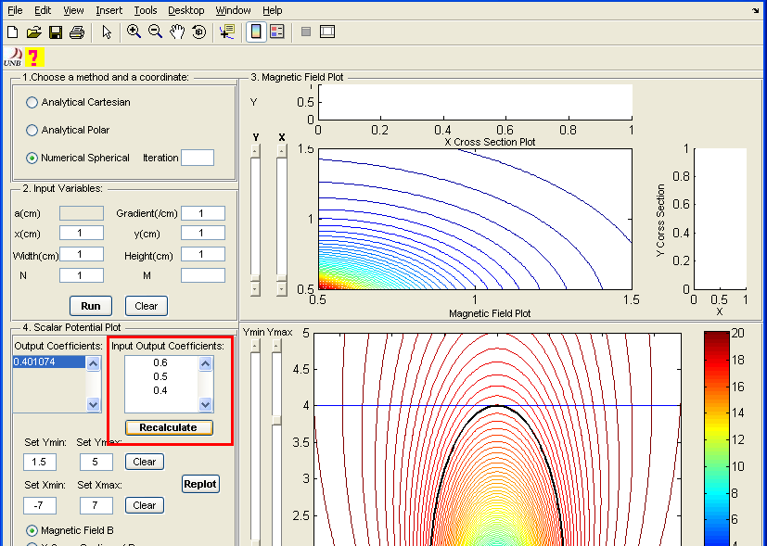

Example: Enter output coefficients manually

- Plot ‘Scalar Potential Plot’ using user defined limits:

Enter new ‘Ymin’, ‘Ymax’, ‘Xmin’ and ‘Xmax’ limits at the corresponding textboxes. Click ‘Replot’ button to replot. ‘Ymin’, ‘Ymax’, ‘Xmin’ and ‘Xmax’ are the limits of ‘Scalar Potential Plot’.

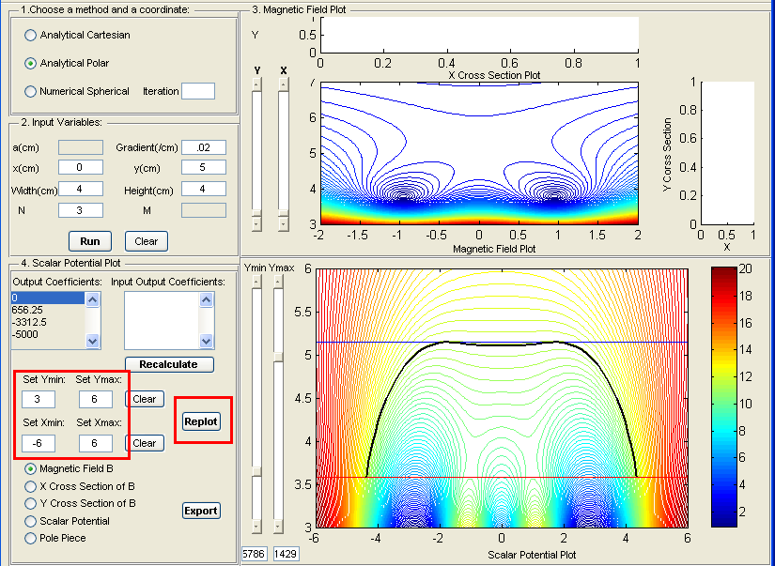

Example: Change the Ymin, Ymax, Xmin and Xmax limits

- Change the upper and/or lower limit(s) of the pole piece:

There are two ways to this.
- One way is to adjust the Ymin and/or Ymax slider(s) to move the Ymin and/or Ymax line(s) on the ‘Scalar Potential Plot’. The Ymin line (red) represents the lower limit of the pole piece and Ymax line (blue) represents the upper limit of the pole piece. The upper and lower limits of the sliders are set by ‘Ymin’ and ‘Ymax’. For example, if Ymin = 3 and Ymax = 6, then the lower limit of the Ymin slider is 3 and the upper limit is 6. Same with the Ymax slider.
- The other way is to input values inside the text boxes just below the Ymin and/or Ymax slider(s) for changing lower and/or upper limit(s). Make sure the values entered are within the ‘Set Ymin’ and ‘Set Ymax’ limits. The value entered for the Ymin slider should be smaller than the value entered for the Ymax slider.

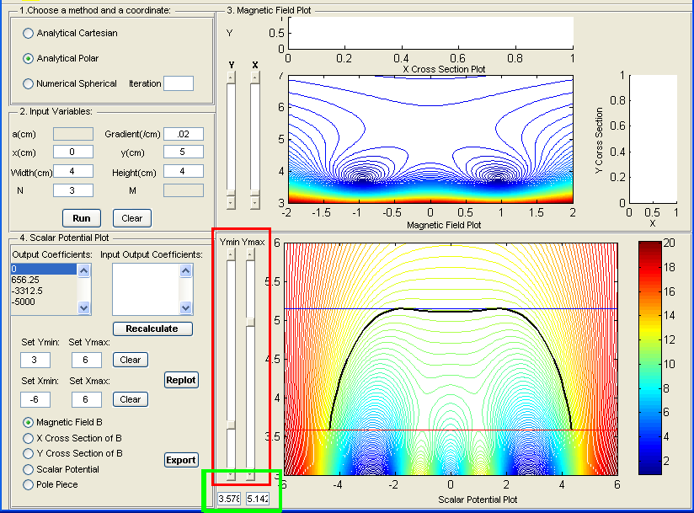

Example: Adjust the lower and upper limits of the pole piece using Ymin and Ymax sliders or enter desired values in the text boxes (highlighted by the green rectangle).

- To export:

There are 5 export options: magnetic field, X cross section of the magnetic field, Y cross section of the magnetic field, scalar potential and pole piece. Select the appropriate option and click ‘Export’ to export the data. The exported data are in ASCII and the file will save as text format. If there are more than one variables saved, the variables are separated by a row of ‘NaN’ (not a number).

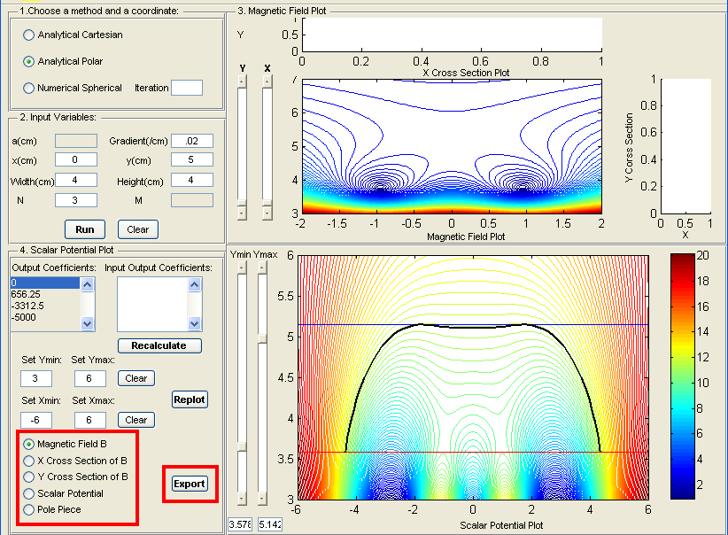

Example: Export choices

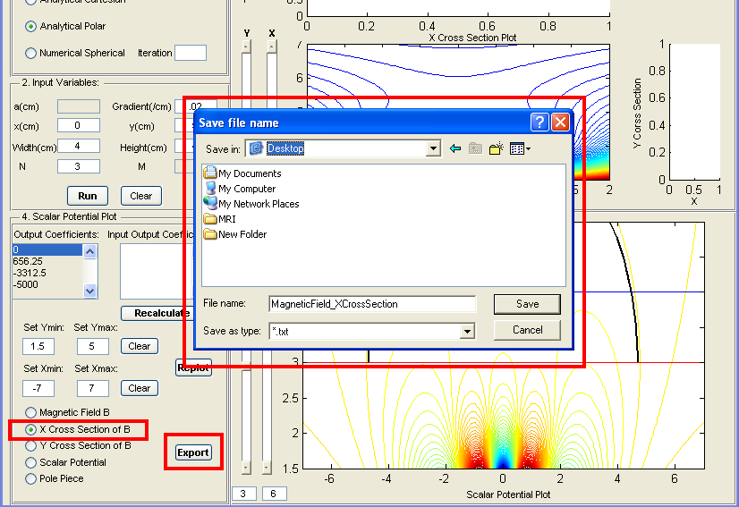

Example: Select the desired data to export

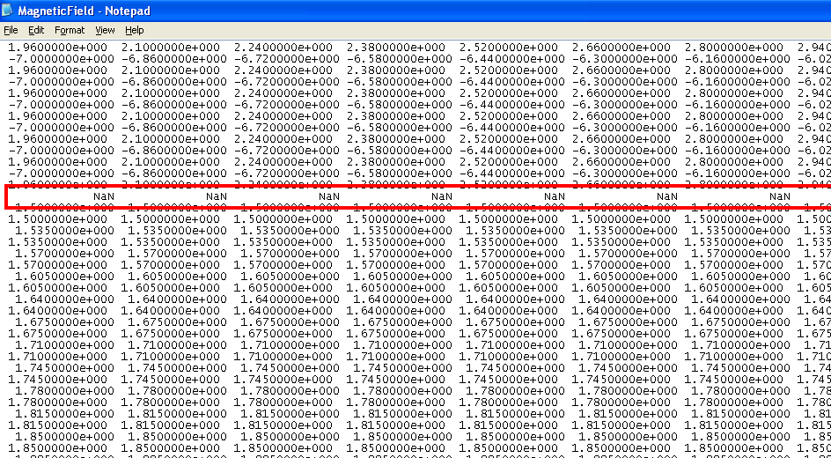

Example: Variables are separated by ‘NaN’

- Magnetic Field B: saves data from the ‘Magnetic Field Plot’. The order of the saved variables is: X, Y and B. X and Y are used to define the limits of the plot and to create a mesh grid. B is the magnetic field. Variables are separated by one row of NaN.
- X Cross Section of B: saves data from the ‘X Cross Section Plot’ of the magnetic field. The order of the saved variables is: X and B. X define the limits of the plot. B is the X cross section of the magnetic field. Variables are separated by one row NaN.

- Y Cross Section of B: saves data from the ‘Y Cross Section Plot’. The order of the saved variables is: Y and B. Y define the limits of the plot. B is the Y cross section of the magnetic field. Variables are separated by one row NaN.

- Scalar Potential: saves data from the ‘Scalar Potential Plot’. The order of the saved variables is: X, Y and scalar potential. X and Y define the limits of the plot. Variables are separated by one row NaN.

- Pole Piece: saves data from the ‘Scalar Potential Plot’. The order of the saved variables is: X and Y. X and Y define the shape of the pole piece. Variables are separated by one row NaN.

Note: Both ‘Analytical Cartesian’ and ‘Analytical Polar’ are 2D design as shown in Picture 1 and ‘Numerical Spherical’ is a 3D design (axially symmetrical) as shown in Picture 2.

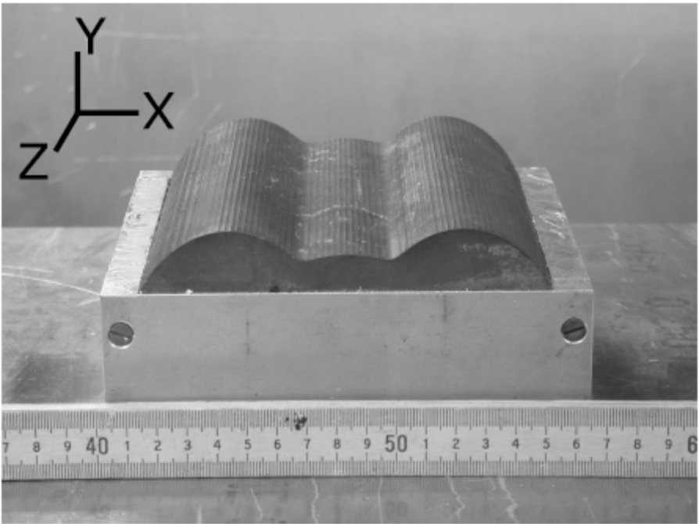

Picture 1: ‘Analytical Cartesian’ with a = 0.314, x = 0, y = 3, N = 3, G = 0.013

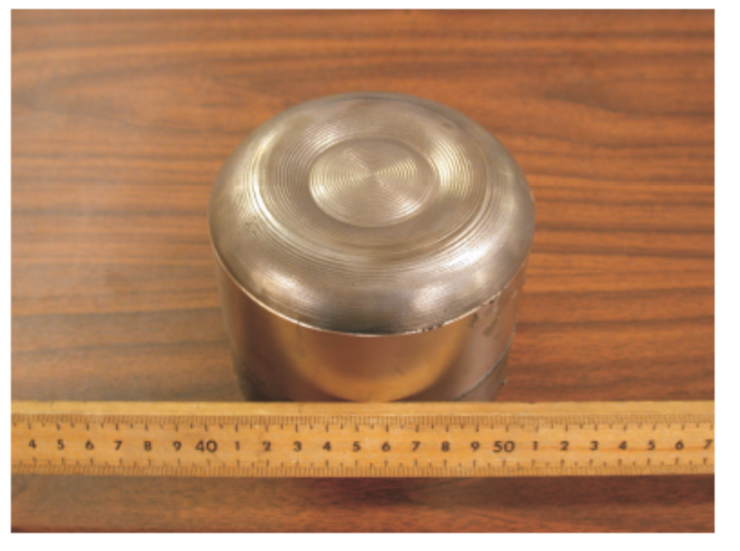
Picture 2: ‘Numerical Spherical’ with x = 0, y = 3, width = 2, height = 0.2, N = 3, M = 3, G = 0.1

  - Click the UNB logo just below the ‘File’ icon to learn more about the program.

  - Click to open the help file. This only works with Windows machine.

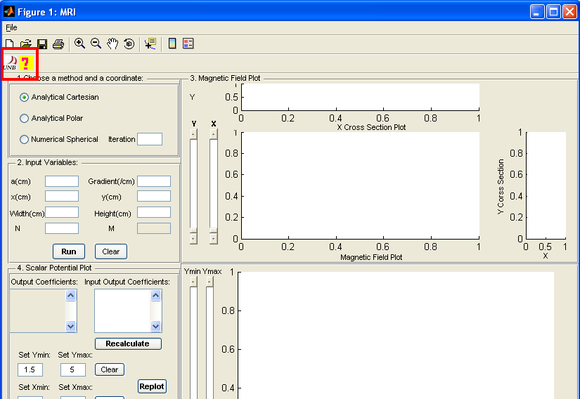

Example: About and Help of the program

  - Special Instructions for Error Correction
If program crushes, close the program and run it again. Some simulations will take a longer time to run than others.

