Devin Morin
BA11-3 Magnet Characterization
July 9th 2019

Background

The purpose of this document is to keep track of information regarding the BA11-3 magnet. The original use of this document is to characterize the BA11-3 magnet for the use of measuring fluid flow through a tube with a large constant gradient. To do this, the evolution of the gradient at far points from the magnets center must be shown. With information regarding how far this constant gradient exists, the magnet can be offset by an angle to create a gradient over some length of tube.

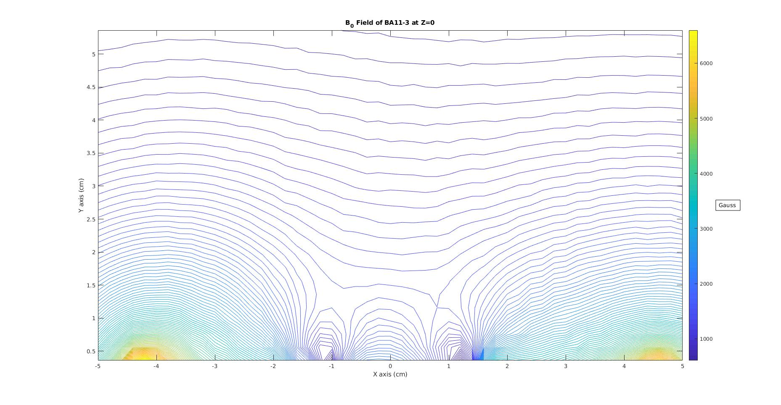
Y

x

z

BA11-3

Comparison Plot

Essentially, the purpose of plotting the magnet in 2D is to compare the magnet field at far reaching points on the magnets surface, to the magnet field generated by the center. Plotting the magnetic field at the center, with respect to distance from the surface, shows that the BA11-3 has a constant gradient at roughly 1.5cm to 4.5cm from the surface.

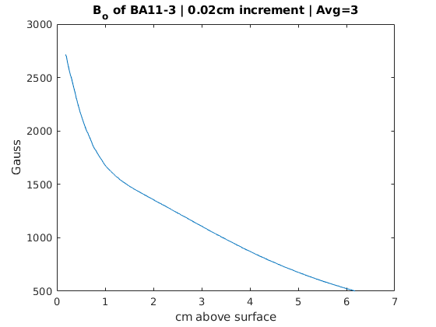

Fig.1
Magnitude of magnet field of BA11-3 magnet as the probe from the Velmex field plotter moves away from the surface of the magnet. 0.02cm increments, and 3 measurements to average per data point.

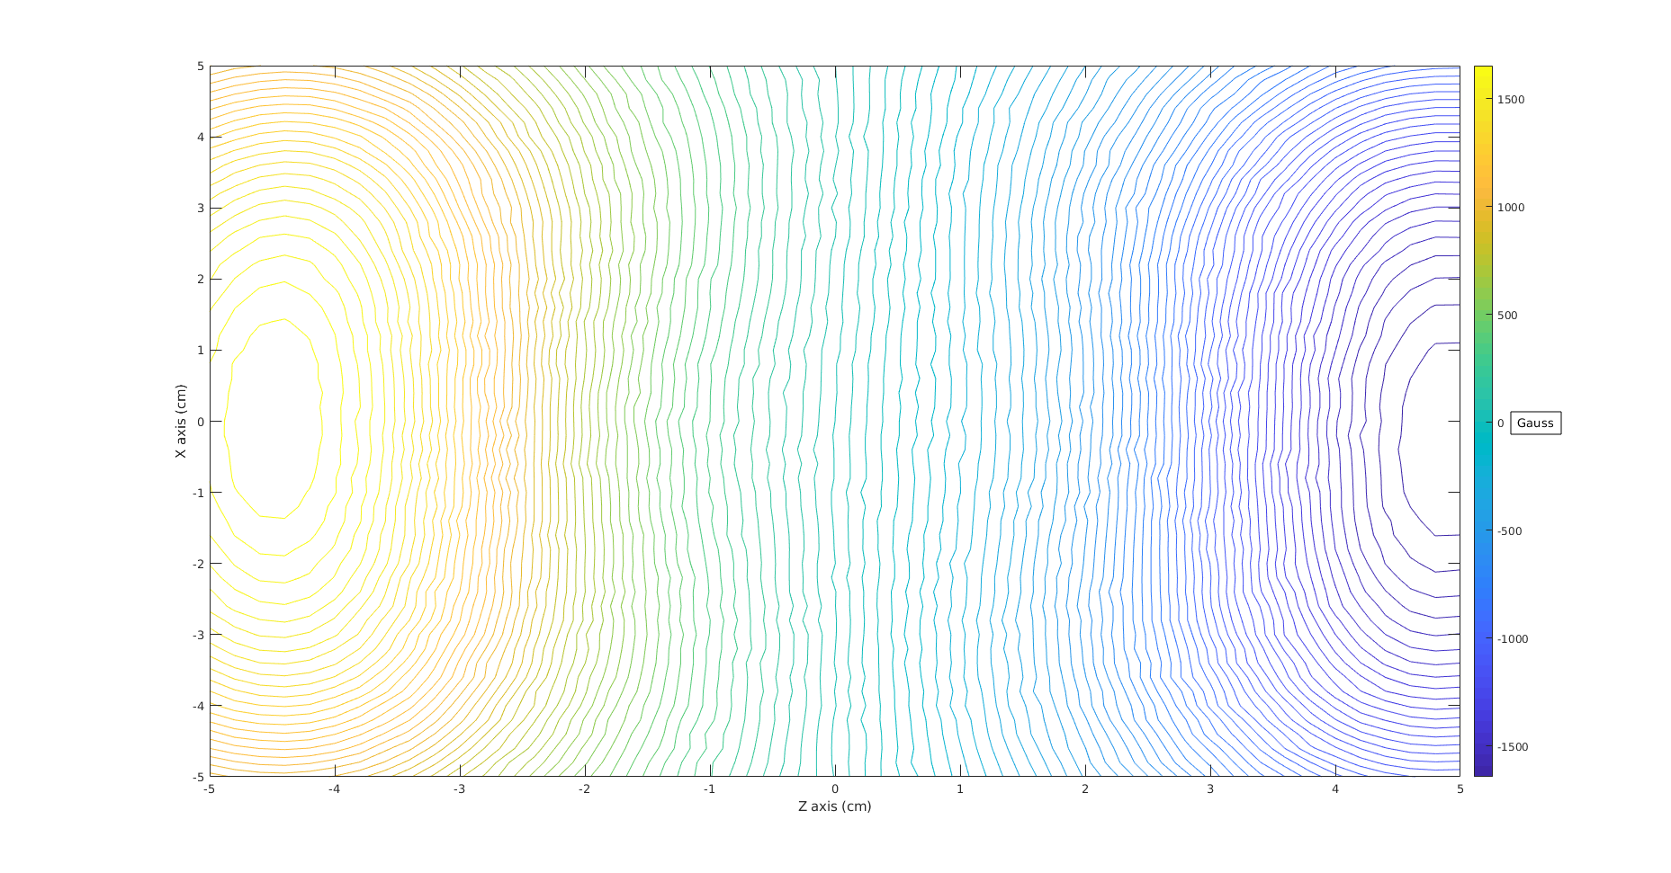
Fig.2
This is a plot of the magnetic field in the Z direction of the plotter, in the ZX plane of the BA11-3 magnet. The field lines move from left to right.
Plot was made from the Velmex field plotter system, with 0.2cm increment size, 3 measurements to average per point, at a height of 2.0cm above the magnet.

In characterizing the structure of the magnetic field, plots where taken in the ZX direction of the magnet. The above figure shows the strength of the magnetic field in the Z direction of the plotter (out of the page). As can be seen, the field strength is very strong on the left side of the plot. This is to be expected, as the field lines emerge out of the page on the left, and move towards the right. The field lines should be exactly horizontal on the page at Z=0, and move into the page on the right. This is also consitent with the plot, as the magnetic field is negative on the right side of the plot.

From this, it can be concluded that the gradient will most likely remain similar to figure 1, at Z=0. From this plot, the next step would be to plot the XY plane of the magnet. This way, the Y=0 would be the baseline measurement (the exact center of the magnet, with the best part of the gradient), and comparisons could be made within a range of X to see the spread. Essentially, Fig.1 is the baseline plot, and the following plots should be as consistent as possible with it. If the plot differs too much, then the range on X is too large. Doing this will give an idea for how long the tube could be, but not how wide.

XY Plane

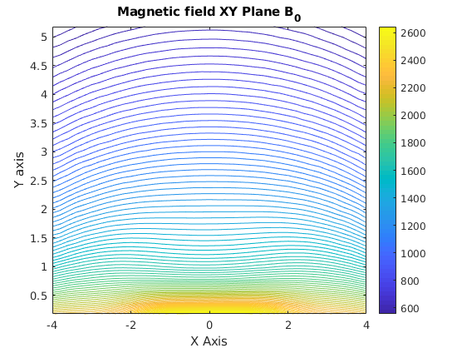
Fig.3
This figure shows the magnitude of magnetic field in the YZ plane of the BA11-3 magnet.

If the values of magnetic field at Z=0 where plotted to the Y axis, then we would get fig.1 back. With
this data, we can compare values along X to see how far they differ from fig.1
Plotting data from Z=-4 to Z=4 gives:

Fig.4
The above figure shows the magnitude of magnetic field as a function of Y. The various stacked plots show the variability in Z. Increment size of 0.2cm, and 3 measurements taken to average per data point. It’s expected that this would decrease is variability if the Z has a higher constraint.
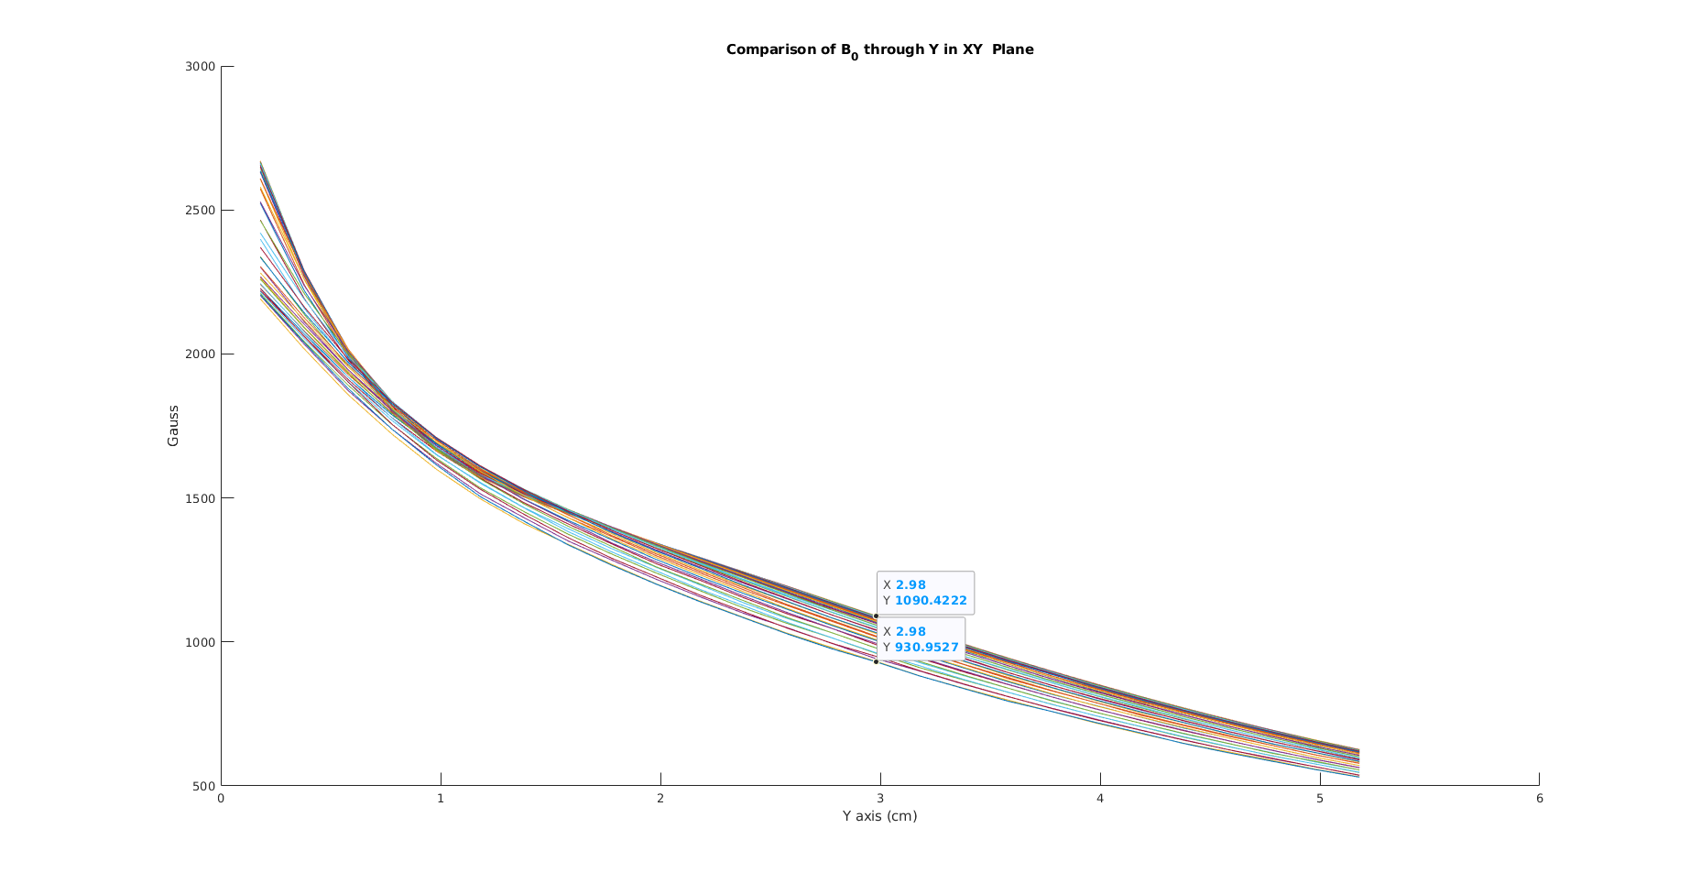

So, the spread is pretty large. At most, there’s roughly a 160 Gauss difference between the gradient in fig.1 at some point and the worst case senario. The next step in refining with would be to observe the variability as the range on Z got smaller.

Z Range (cm) | Max Spread (Gauss)
-4 : 4 | 160
-3.6:3.6 | 123
-3.2:3.2 | 94
-2.8:2.8 | 66
-2.4:2.4 | 46
-2.0:2.0 | 30
-1.6:1.6 | 19

This ‘Max Spread’ really is worst case senario. In a large part of a given plot for Z ranges, the values were almost identical to that of Fig.1. If it’s accepted that 46 Gauss is a reasonable max spread, then the total length of the gradient is 4.8cm.

Using a length of 4.8cm gives the following plot:

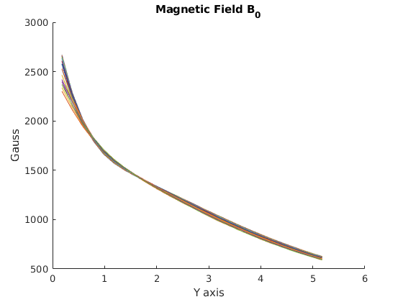
Fig.5
This plot shows the magnitude of magnetic field as a function of Y. The spread has decrease as these plots only includes values from -2.6cm to 2.6cm on the Z axis. For reference, Z=0 is the center of the magnet. This was taken with increments of 0.2cm, and 3 measurements to average per data point. Some viable ranges for the fluid flow experiment could be from 1.5cm high to 4.5cm.

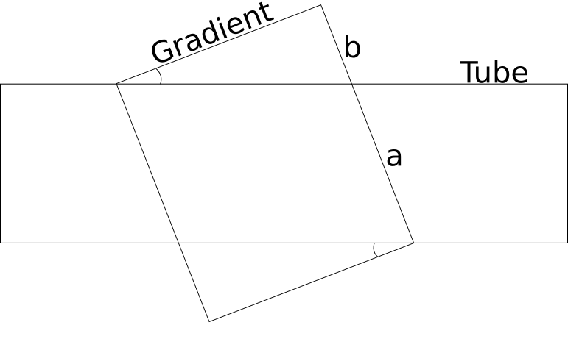

If the tube diameter was 1cm (along the vertical), and we know that the gradient length (along horizontal) is 4.8cm. Some geometry can be done to calculate the angle at which the magnet must be placed.

3 = a +b
3 = 4.8tan(x) +1/cos(x)

x = 21.8 degrees

Understanding Width of the Tube

All of the previous characterization was for the Z axis of the magnet. This is the most important axis, as the tube would be parallel to this direction. However, understanding how wide the gradient remains similar to the center gradient is important as well. As the tube will have some thickness. If the tube is thin enough, it’s likely that this section will be insignificant in the end.

Regardless, I’ll proceed with plotting and understanding how the gradient moves along the X axis of the magnet.
Fig.6
This plot will show the XY plane of the magnet (YZ plane of the plotter), and how the magnet field intensity varies through X. If the magnetic field intensity at X=0 was plotted against Y, we should get Fig.1 back.

After getting this data, the next step would involve plotting the magnetic field strength at various X positions, as a function of Y. As an initial range based on intuition, values from -1cm to 1cm on the X axis are plotted in relation to Y. This should give an idea for how wide a tube.

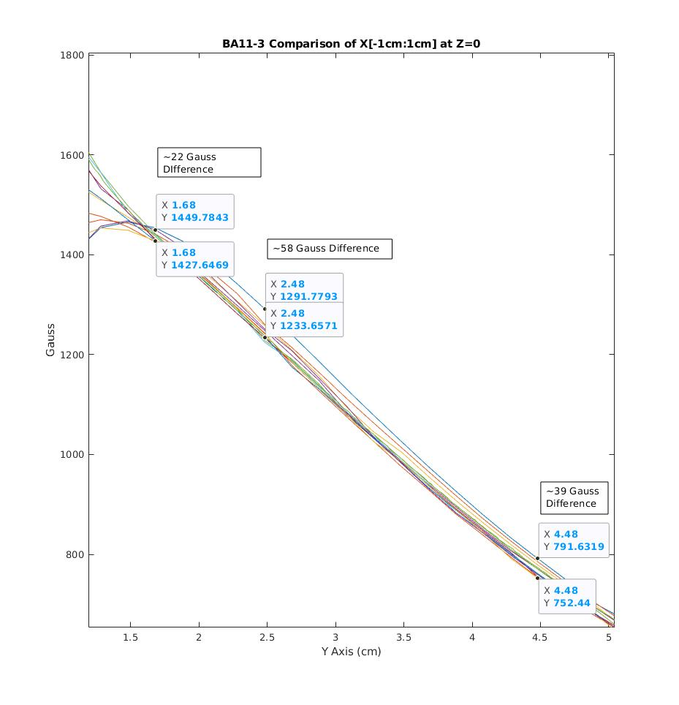
Fig.7
The plot shows the magnitude of the magnetic field of the BA11-3 magnet plotted against the Y axis of the magnet. Multiple plots are stacked on top of eachother, which represents the spread of magnetic field with variation in the X axis. If X=0, then Fig.1 will be exactly similar to this. However, in the above figure, plots are taken from -1cm to 1cm on the X axis, with a resolution of 0.2cm.

With a 2cm diameter tube, the magnetic field would vary by roughly 58 Gauss along the width. Of course, the variation in the magnitude of the magnetic field could be decreased is the tube has a smaller diameter.

