Devin Morin
Problems Encountered with Magnetic Field Plotter
Supervisor – Ben Newling
Department of Physics, University of New Brunswick
July – Summer 2019

Purpose of Document

The purpose of this document is to maintain references to problems experienced while rebuilding the code for the Velmex/Lakeshore Magnetic field plotter. During the testing of the magnetic field plotter system, issues come up when reaching some of the limits of the system, so adjustesments are made in order to improve accuracy. This document aims to clarify and give the justifcation for why certain steps are taking in a given measurement. The notes taken here can give a foundation for future works in improving the system, and increasing the level of accuracy and precision achievable.

Importance of the SideToSide Motion

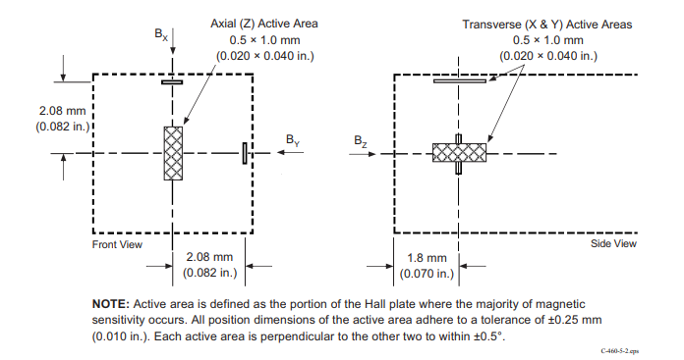
Without the side to side motion of the probe tip during measurements, some coherent data will be gathered, however only one axis will truly be a correct measurement. Since XY axis measurements are located on the sides of the probe, a side to side motion is needed to make sure that all axes are being measured in the exact same position. The Z axis sensitive area is in the center of the probe tip, located 0.18cm above the bottom probe tip, which means that the Z axis will be the only axis that is true to the measurement you expect. In the example of a 2D scan, if the ‘SideToSide’ motion is not active, then only one axis will be accurate, another will be correct but shifted by 0.208cm, and another will be completely incorrect.

Figure 1: Shows the probe tip dimensions as well as the location of each axis sensitive area. This is the justification for shifting Z measurements by 0.18cm since the sensitive area of the Z axis will never be touching the surface of the magnet.

Image Source : Lake Shore Model 460 Gaussmeter User’s Manual, Page 5-5, “Figure 5-2. 3-Axis Probe Tip Details”

Some benefits of removing the side to side motion are that the measurements are done very quickly, and a rough idea for the magnetic field can be obtained without waiting too long. This is especially helpful in testing the code to make sure all the parts are functioning properly; the side to side motion just adds a layer of accuracy to the measurements.

SidetoSide Motion Fixing “Uneven Table”

A problem that came up in the plots of some of the smaller disk magnets, was that every plot had a very strong magnetic field on one side. For example:

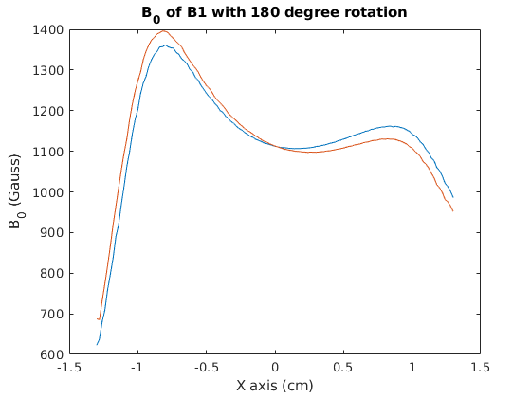

Figure 2: The plot shows the magnitude of magnetic field as the probe moves across the surface of the disk magnet. The red and blue plots represent the difference in 180 degree rotation of the magnet.

This stronger region of the magnet has nothing to do a physical property associated with that particular magnet since a rotation of 180 degrees doesn’t change the high field region of the plot. If this was a specific property of the magnet, then rotating the magnet by 180 degrees should change the plots high region to flip over to the right side. To test this even further, the magnets are moved across the surface of the plateform for the magnet to rest on. This was to make sure the displacement of the magnet on the surface didn’t change this effect. Doing this did not change the effect, so it was most likely a problem with the table being uneven.

However, after looking at the Bx, By, and Bz region it was noted that Bz would give exactly what would be expected for a rotation of 180 degrees.
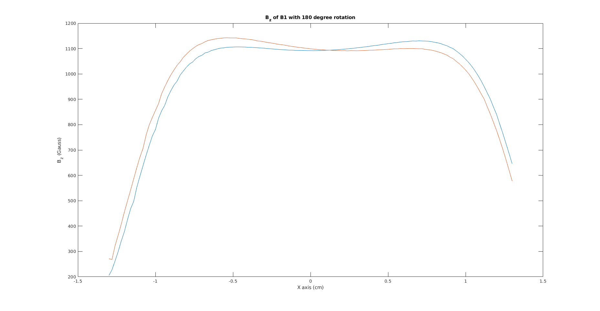
Figure 3: Shows the Bz (Bz of the probe system is pointing directly upwards) of magnetic field as the probe tip moves across the surface of the smaller disk magnet. The two plots represent one magnet in a given postion, and the same magnet rotated 180 degrees.

This hinted at the problem having nothing to do with the table being uneven. Because all measurements previous to this were done on much larger magnets, this effect was unnoticable, but what was actually happening was that the ‘SidetoSide’ motion was not active. This resulted in an incorrect Bx, and By value. These incorrect values with give an incorrect magnitude plot that would always have a high region on one side.

Before this incident, the side to side motion was used for high accuracy measurements, but when the magnets become very small the side to side motion is really important for getting proper plots of magnet fields. In most cases, high accuracy would be wanted but in the case of a 3D measurement, the plotting time can be reduced considerably if the only goal was to see a general structure.

Delay

If there appears to be a problem with noise appearing in the measurements, it could have something to do with the delay time between measurements. The problem has nothing to do with the fluctuations in values that the Lakeshore gaussmeter displays, but instead the delay time between measurements. The number of points each data point averages is 6 in the first image, and 3 in the second. This shows that the problem has nothing to do with averages but the delay time between when the probes movement has ended and the measurement begins.

With 0.1 second delay:
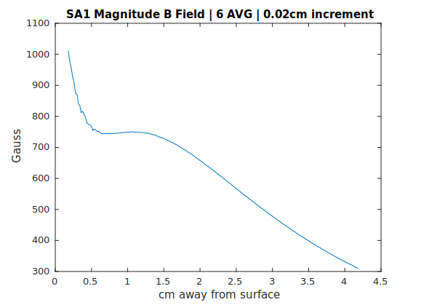

Figure 4: Shows the magnitude of B Field of the SA1 magnet. This plot contains 6 measurements of average per data point. Notice that the beginning first few points contain a fair amount of noise compared to the rest of the plot.

With 0.5 second delay:

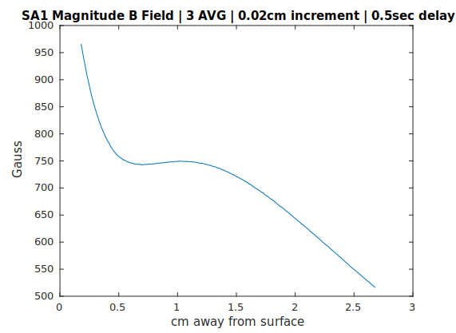

Figure 5: Shows the magnitude of B Field of the SA1 magnet. This plot contains 3 measurements of average per data point. Notice that the beginning of the plot is very smooth, even with less measurement of average per data point.

Describing the backlash problem

Initially the design of the plotter was flawed, and added quite a lot of extra time to an acquisition due to pointless probe tip movements. In the case of a 2D ZY measurement, the plotter was designed to start by taking a Z axis measurement, then move 0.208cm on the X axis to take it’s center Bx measurement, then move back to it’s original position, 0.208cm back on the X axis. The next part is to gather a By measurement, so the probe move 0.208cm on the Y axis and takes it’s measurement, then moves back to it’s original position 0.208cm back on the Y axis. This is a key movement that ends up being pointless is most cases, and a waste of time. Instead, the probe tip could move on the Y axis by 0.208cm, then do a quick calculation of how much it should move next (moveAfter = increment-0.208).

In most cases, this works perfectly. However, if the increment size if 0.2cm, then the probe must move backwards 0.008cm. With a movement so small, going backwards on the Y axis, the gears of the Velmex stepper motor do not lock. This leads to a backlash problem, so to overcome this a simple ‘if’ statement is added to the code to make sure that the ‘moveAfter’ parameter is never less or equal to the backlash amount. The backlash compensation setting on the Velmex stepper motor controller manual is set at 20 steps by the guide. Assuming that this is a correct amount of steps to correct the backlash, then converting this to centimeters and adding that into the if statement should correct any backlash issues in the future.

