An ulam spiral is when you list numbers in a spiral fashion, maintaining the square shape characteristic. What's interesting is that when you focus on all the prime numbers in these spirals, they seem to line up in perfect diagonal lines. This is significant and cool because it is patterns in a concept that seems relatively random, because prime numbers are completely unpredictable.

The program I wrote demonstrates this principle and points out where all the prime numbers are in a spiral, so you can see the patterns.

**an ulam spiral to 2500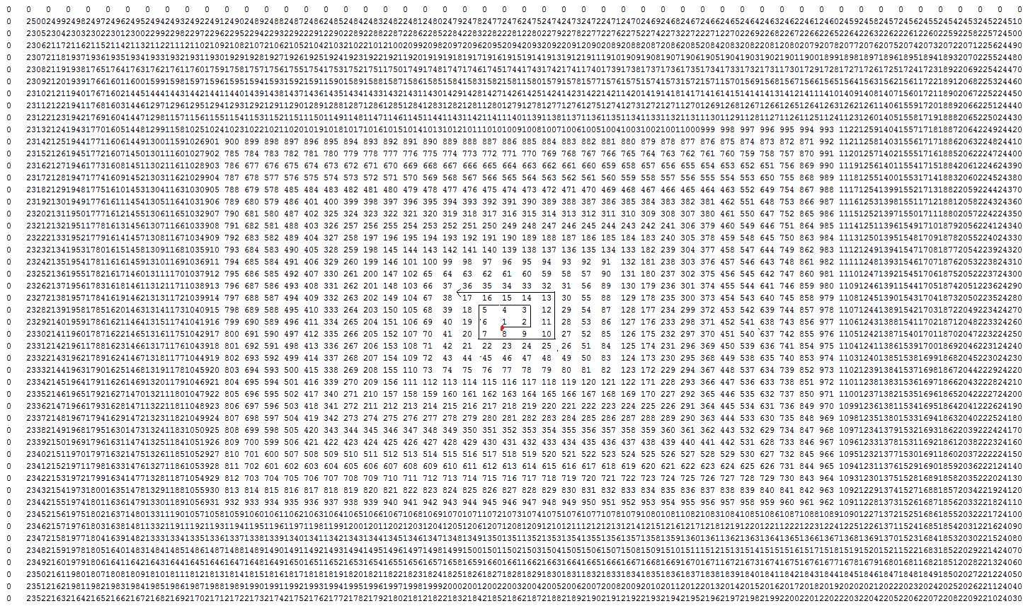

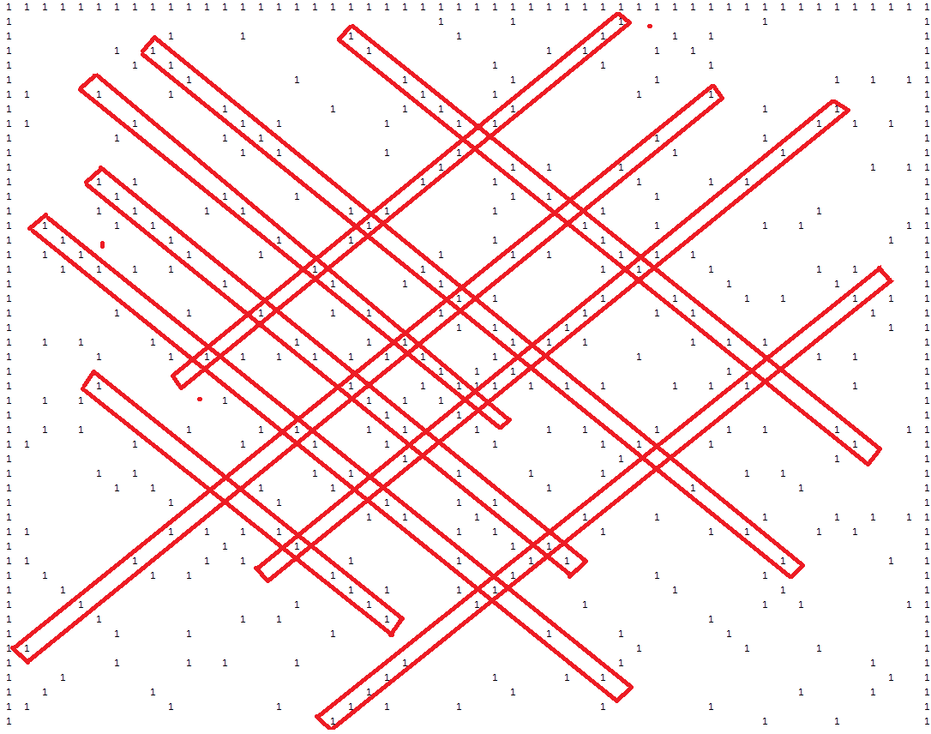

all prime numbers in that ulam spiral represented by a 1, and non primes are empty space.

Source code in folder.

For more info on Ulam Spirals:

[Ulam Spirals explained by Numberphile](https://www.youtube.com/watch?v=iFuR97YcSLM)