Appendix E: DMCodeGen
The Broadband Forum now publishes the XML schema definition for each data model. These schema file and data model definitions are available at http://broadband-forum.org/cwmp.zip. Gatespace has replaced the treegen program that was used to generate the raw object/parameter tables and the getter/setter stub files with the DMCodeGen program. A simple GUI is provided to allow the user to select the Data model definitions, the profiles and to individually select objects and parameters if needed. This is a Java program that processes the data model definition files and creates the following:
- A single normalized data model definition file of the data definitions selected by the user. The include and component directives are fully resolved in order to create a single definition file. The created file is named dm-instance.xml. This file can be imported to the ACS to provide data model definition support for a specific data model( ACS feature in development ).
- A single data model definition file that includes on the object and parameters selected by the user from the profile list and optionally filtered by individual selections of objects and parameters. This file is the input to the code generator and is named code-gen-dm-instance.xml. This file can be imported to the ACS to provide data model definition support for a specific CPE type.
- The tables.c file that defines all of the objects and associated parameters as defined by the code-gen-dm-instance.xml file.
- For each top-level object the getter/setter stubs file for the object and it’s descendants is generated. Such as SofwareManagement.c, Bridging.c, etc.
- Optionally for each object a typedef that defines a C structure containing the object’s parameters is defined and added to the associated top-level object header file. Each getter/setter function in the stubs files get or set the associated parameter’s data item in the object’s structure. This is may be used as a starting point for CPE/CWMPc integration and can be easily removed if not required.
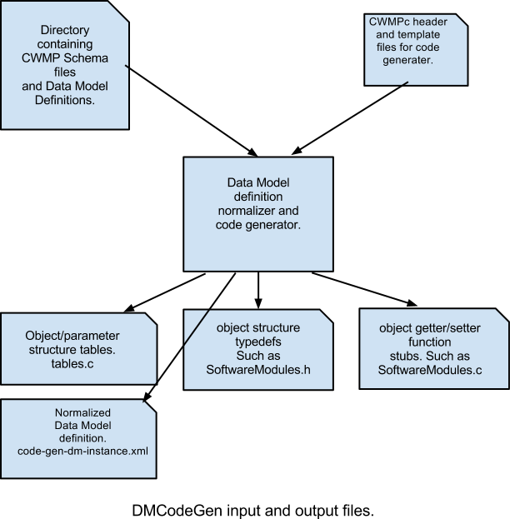Appendix E: DMCodeGen
The Broadband Forum now publishes the XML schema definition for each data model. These schema file and data model definitions are available at http://broadband-forum.org/cwmp.zip. Gatespace has replaced the treegen program that was used to generate the raw object/parameter tables and the getter/setter stub files with the DMCodeGen program. A simple GUI is provided to allow the user to select the Data model definitions, the profiles and to individually select objects and parameters if needed. This is a Java program that processes the data model definition files and creates the following:
- A single normalized data model definition file of the data definitions selected by the user. The include and component directives are fully resolved in order to create a single definition file. The created file is named dm-instance.xml. This file can be imported to the ACS to provide data model definition support for a specific data model( ACS feature in development ).
- A single data model definition file that includes on the object and parameters selected by the user from the profile list and optionally filtered by individual selections of objects and parameters. This file is the input to the code generator and is named code-gen-dm-instance.xml. This file can be imported to the ACS to provide data model definition support for a specific CPE type.
- The tables.c file that defines all of the objects and associated parameters as defined by the code-gen-dm-instance.xml file.
- For each top-level object the getter/setter stubs file for the object and it’s descendants is generated. Such as SofwareManagement.c, Bridging.c, etc.
- Optionally for each object a typedef that defines a C structure containing the object’s parameters is defined and added to the associated top-level object header file. Each getter/setter function in the stubs files get or set the associated parameter’s data item in the object’s structure. This is may be used as a starting point for CPE/CWMPc integration and can be easily removed if not required.

This version of the code generator provides support for current and future data models that are defined using the Data Model Definition Schema (DM Schema) v1.4(cwmp-datamodel-1-4.xsd) as defined by TR-106 Issue: 1 Amendment 6 (July 2011).

Using DMCodeGen:
The jar file containing the DMCodeGen program and its required libraries is in the top-level cwmp directory checked out from the CVS. A JVM version 1.6 or later is required. The DMCodeGen may be used to generate your required data model code by the following steps:
- Download the Broadband Forums XML Schemas and Data Model Definitions from the following: http://broadband-forum.org/cwmp.zip and unzip the file in to a convenient directory.
- Under the cwmp checkout directory create a working directory for your new data model code. For example:
$ cd cwmpc
$ mkdir tr181-mymodel

This is the target directory for the code generated by the DMCodeGen program.
Run the DMCodeGen program
$ java -jar DMCodeGen.jar

A new GUI window will open prompting for input.
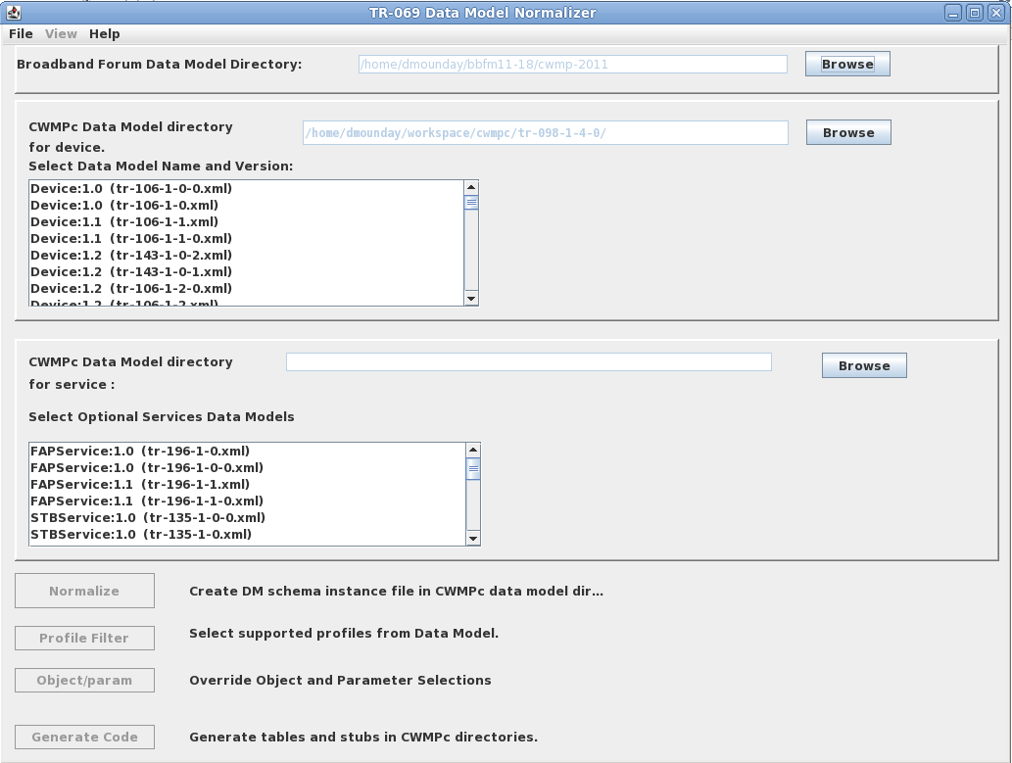
  - In the Broadband Forum Data Model Directory input field enter the directory where you unzipped the schema and DM definitions.
  - In the CWMPc Data Model Directory input field enter the cwmpc directory you created to hold your data model code.
  - From the displayed list of Data Models select the name and version of your data model.
  - Click the Normalize button to create the normalized data model. This action creates a single data model definition instance file (xml) for the selected data model.
  - Click the Profile Filter button to open the list of profiles defined for the selected data model. Refer to the Broadband Forum’s web site for a definition of the data models list of profiles. Such as http://www.broadband-forum.org/cwmp/tr-181-2-4-0.html. Select the required profiles from the list and click the Apply button.

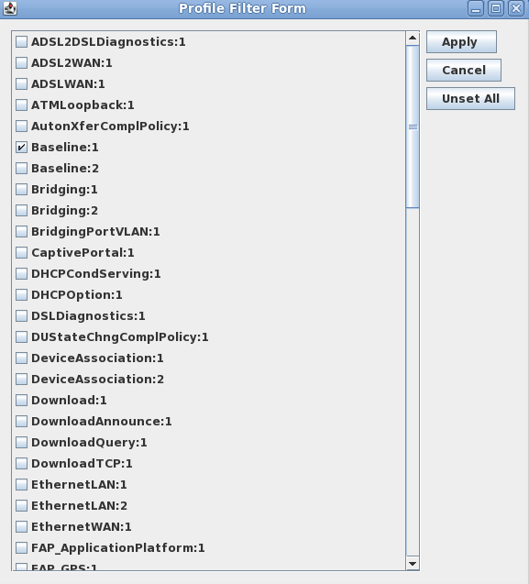

  - If specific objects and parameters are required or omitted open the Object/param selection dialog by clicking the Object/param button. After selecting or de-selecting the object and/or parameters click the Apply button to close the dialog. This dialog also allows the user to optionally select generation of the object commit and object initialization callbacks by checking the Commit Call and/or Init Obj/Param columns.
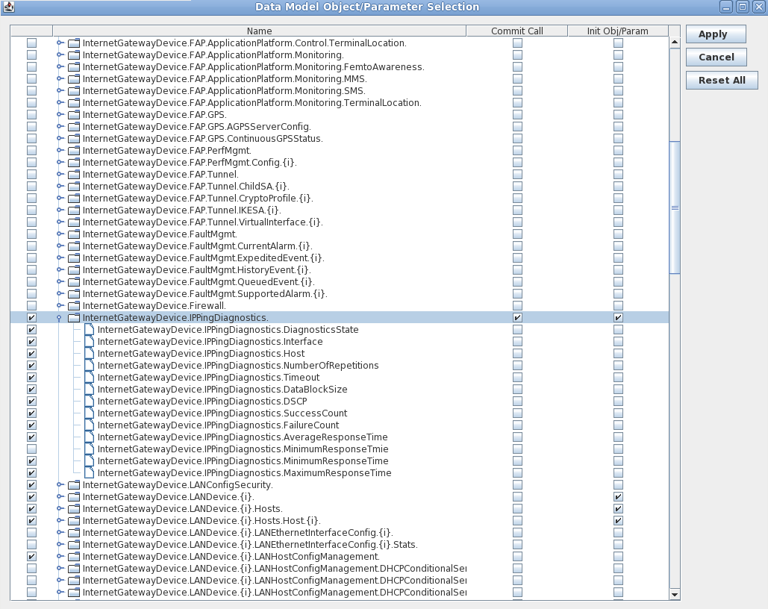

  - Click the Generate Code button. The generated code will be output to the CWMPc Data Model Directory specified above.

The first time the DMCodeGen program generate code is run the ‘.c’ files in the cwmpc/code-gen-templates directory are merged with the generated file. For example the ManagementServer.c file in the code-gen-templates directory contains the implemented getter and setter stubs that are used by the quick-start CWMPc framework to connect to and maintain state with the ACS. Any code delimited by the “/**@obj”, “/**@param” and “/**@endobj”, “/**@endparam” in the newly generated code files are replaced with the corresponding code from the template file. If the DMCodeGen is ran subsequently the current files in the data model directory are moved to the sub-directory ‘old’ (i.e. ./cwmpc/tr181-2-3/old). These old files are then merged with the newer files. The freshly generated code is copied to the 'generated' sub-directory.
This allows the data model to be regenerated without the necessity of cutting and pasting from older code to update the newly generated code when an object or parameter is added or removed from the data model instance. The code merging algorithm avoids deleting older objects and parameters. When adding and deleting objects or parameters if may be necessary to run a diff between the merged source code and the generated source code.

The DMCodeGen’s File/Options menu provides some control over the above actions. The following options are available:

Generate object typedef and parameter access code:
De-select to inhibit generation of the object structure typedef and getter/setter code. When enabled a typedef is generated for each object containing the variable definitions for each of the objects parameters. Code is generated in each of the parameter getter and setter stubs to access the variable storage.
Generate Alias instance set and get label code(CWMP v1.3):
CWMP versions of v1.3 and higher define an non-functional Alias parameter for multi-instance objects. This may be used by the ACS as an alternate way to address an object instance. The CWMPc implementation stores the Alias data as a component of the Instance structure. If this option is enabled the code to get and set the alias string data is generated for the Alias parameters. This should be disabled for CWMP protocol version 1.2 or earlier.
Ignore DEPRECATED parameters:
Any parameter with a status of “DEPRECATED” or “OBSOLETE” are ignored and not included in any data model definitions or generated code.
Generate a single stubs file for all objects:
The default is to generate a separate ‘C’ source file for each top-level object of the data model. Enabling this option generates all getter and setter stubs in the same file.
Add preamble files to stubs and header files:
The code-gen-templates directory contains the files stubgenPre which is added to the beginning of each of the generated stubs files and file tablegenPre which is added to the generated tables.c file.
Merge *.c files from previous implementation:
If a previous version of the generated file is present merge it with the newly generated file.
Merge *.c files from templates directory:
The first time the DMCodeGen is run on a target data model directory the ‘C’ files in the code-gen-templates directory are merged with the generated files.

Other Merge Files:
On the first code generation by DMCodeGen the following files are also copied from the code-gen-templates directory:
targetsys-h: This is the default targetsys.h header file. It is renamed to targetsys.h when copied to the data model directory. This file should be modified to meet the requirements of the CPE intergration.

cpe.c: This is a generic initialization file that is copied to the data model directory as a basis for adding any additional initialization functions required by the CPE. Any file beginning with “cpe” is copied to the data model directory without modification and is never moved or merged following the first code generation run.

Makefile: This is a generic Makefile that is invoked by the top-level Makefile when the CWMPc is built.

This version of the code generator provides support for current and future data models that are defined using the Data Model Definition Schema (DM Schema) v1.4(cwmp-datamodel-1-4.xsd) as defined by TR-106 Issue: 1 Amendment 6 (July 2011).

Using DMCodeGen:
The jar file containing the DMCodeGen program and its required libraries is in the top-level cwmp directory checked out from the CVS. A JVM version 1.6 or later is required. The DMCodeGen may be used to generate your required data model code by the following steps:
- Download the Broadband Forums XML Schemas and Data Model Definitions from the following: http://broadband-forum.org/cwmp.zip and unzip the file in to a convenient directory.
- Under the cwmp checkout directory create a working directory for your new data model code. For example:
$ cd cwmpc
$ mkdir tr181-mymodel

This is the target directory for the code generated by the DMCodeGen program.
Run the DMCodeGen program
$ java -jar DMCodeGen.jar

A new GUI window will open prompting for input.
  - In the Broadband Forum Data Model Directory input field enter the directory where you unzipped the schema and DM definitions.
  - In the CWMPc Data Model Directory input field enter the cwmpc directory you created to hold your data model code.
  - From the displayed list of Data Models select the name and version of your data model.
  - Click the Normalize button to create the normalized data model. This action creates a single data model definition instance file (xml) for the selected data model.
  - Click the Profile Filter button to open the list of profiles defined for the selected data model. Refer to the Broadband Forum’s web site for a definition of the data models list of profiles. Such as http://www.broadband-forum.org/cwmp/tr-181-2-4-0.html. Select the required profiles from the list and click the Apply button.

  - If specific objects and parameters are required or omitted open the Object/param selection dialog by clicking the Object/param button. After selecting or de-selecting the object and/or parameters click the Apply button to close the dialog. This dialog also allows the user to optionally select generation of the object commit and object initialization callbacks by checking the Commit Call and/or Init Obj/Param columns.

  - Click the Generate Code button. The generated code will be output to the CWMPc Data Model Directory specified above.

The first time the DMCodeGen program generate code is run the ‘.c’ files in the cwmpc/code-gen-templates directory are merged with the generated file. For example the ManagementServer.c file in the code-gen-templates directory contains the implemented getter and setter stubs that are used by the quick-start CWMPc framework to connect to and maintain state with the ACS. Any code delimited by the “/**@obj”, “/**@param” and “/**@endobj”, “/**@endparam” in the newly generated code files are replaced with the corresponding code from the template file. If the DMCodeGen is ran subsequently the current files in the data model directory are moved to the sub-directory ‘old’ (i.e. ./cwmpc/tr181-2-3/old). These old files are then merged with the newer files. The freshly generated code is copied to the 'generated' sub-directory.
This allows the data model to be regenerated without the necessity of cutting and pasting from older code to update the newly generated code when an object or parameter is added or removed from the data model instance. The code merging algorithm avoids deleting older objects and parameters. When adding and deleting objects or parameters if may be necessary to run a diff between the merged source code and the generated source code.

The DMCodeGen’s File/Options menu provides some control over the above actions. The following options are available:

Generate object typedef and parameter access code:
De-select to inhibit generation of the object structure typedef and getter/setter code. When enabled a typedef is generated for each object containing the variable definitions for each of the objects parameters. Code is generated in each of the parameter getter and setter stubs to access the variable storage.
Generate Alias instance set and get label code(CWMP v1.3):
CWMP versions of v1.3 and higher define an non-functional Alias parameter for multi-instance objects. This may be used by the ACS as an alternate way to address an object instance. The CWMPc implementation stores the Alias data as a component of the Instance structure. If this option is enabled the code to get and set the alias string data is generated for the Alias parameters. This should be disabled for CWMP protocol version 1.2 or earlier.
Ignore DEPRECATED parameters:
Any parameter with a status of “DEPRECATED” or “OBSOLETE” are ignored and not included in any data model definitions or generated code.
Generate a single stubs file for all objects:
The default is to generate a separate ‘C’ source file for each top-level object of the data model. Enabling this option generates all getter and setter stubs in the same file.
Add preamble files to stubs and header files:
The code-gen-templates directory contains the files stubgenPre which is added to the beginning of each of the generated stubs files and file tablegenPre which is added to the generated tables.c file.
Merge *.c files from previous implementation:
If a previous version of the generated file is present merge it with the newly generated file.
Merge *.c files from templates directory:
The first time the DMCodeGen is run on a target data model directory the ‘C’ files in the code-gen-templates directory are merged with the generated files.

Other Merge Files:
On the first code generation by DMCodeGen the following files are also copied from the code-gen-templates directory:
targetsys-h: This is the default targetsys.h header file. It is renamed to targetsys.h when copied to the data model directory. This file should be modified to meet the requirements of the CPE intergration.

cpe.c: This is a generic initialization file that is copied to the data model directory as a basis for adding any additional initialization functions required by the CPE. Any file beginning with “cpe” is copied to the data model directory without modification and is never moved or merged following the first code generation run.

Makefile: This is a generic Makefile that is invoked by the top-level Makefile when the CWMPc is built.

