WEB700 Week10-2 Lab Report
Lab: Week10-2 – Connecting Neon PostgreSQL to Express and Returning JSON Data

Objective
This lab demonstrates how to create a Neon PostgreSQL database, connect it to pgAdmin, import product data, configure Sequelize in an Express application, and expose database records through REST API endpoints.
Screenshot 1 – Neon Project
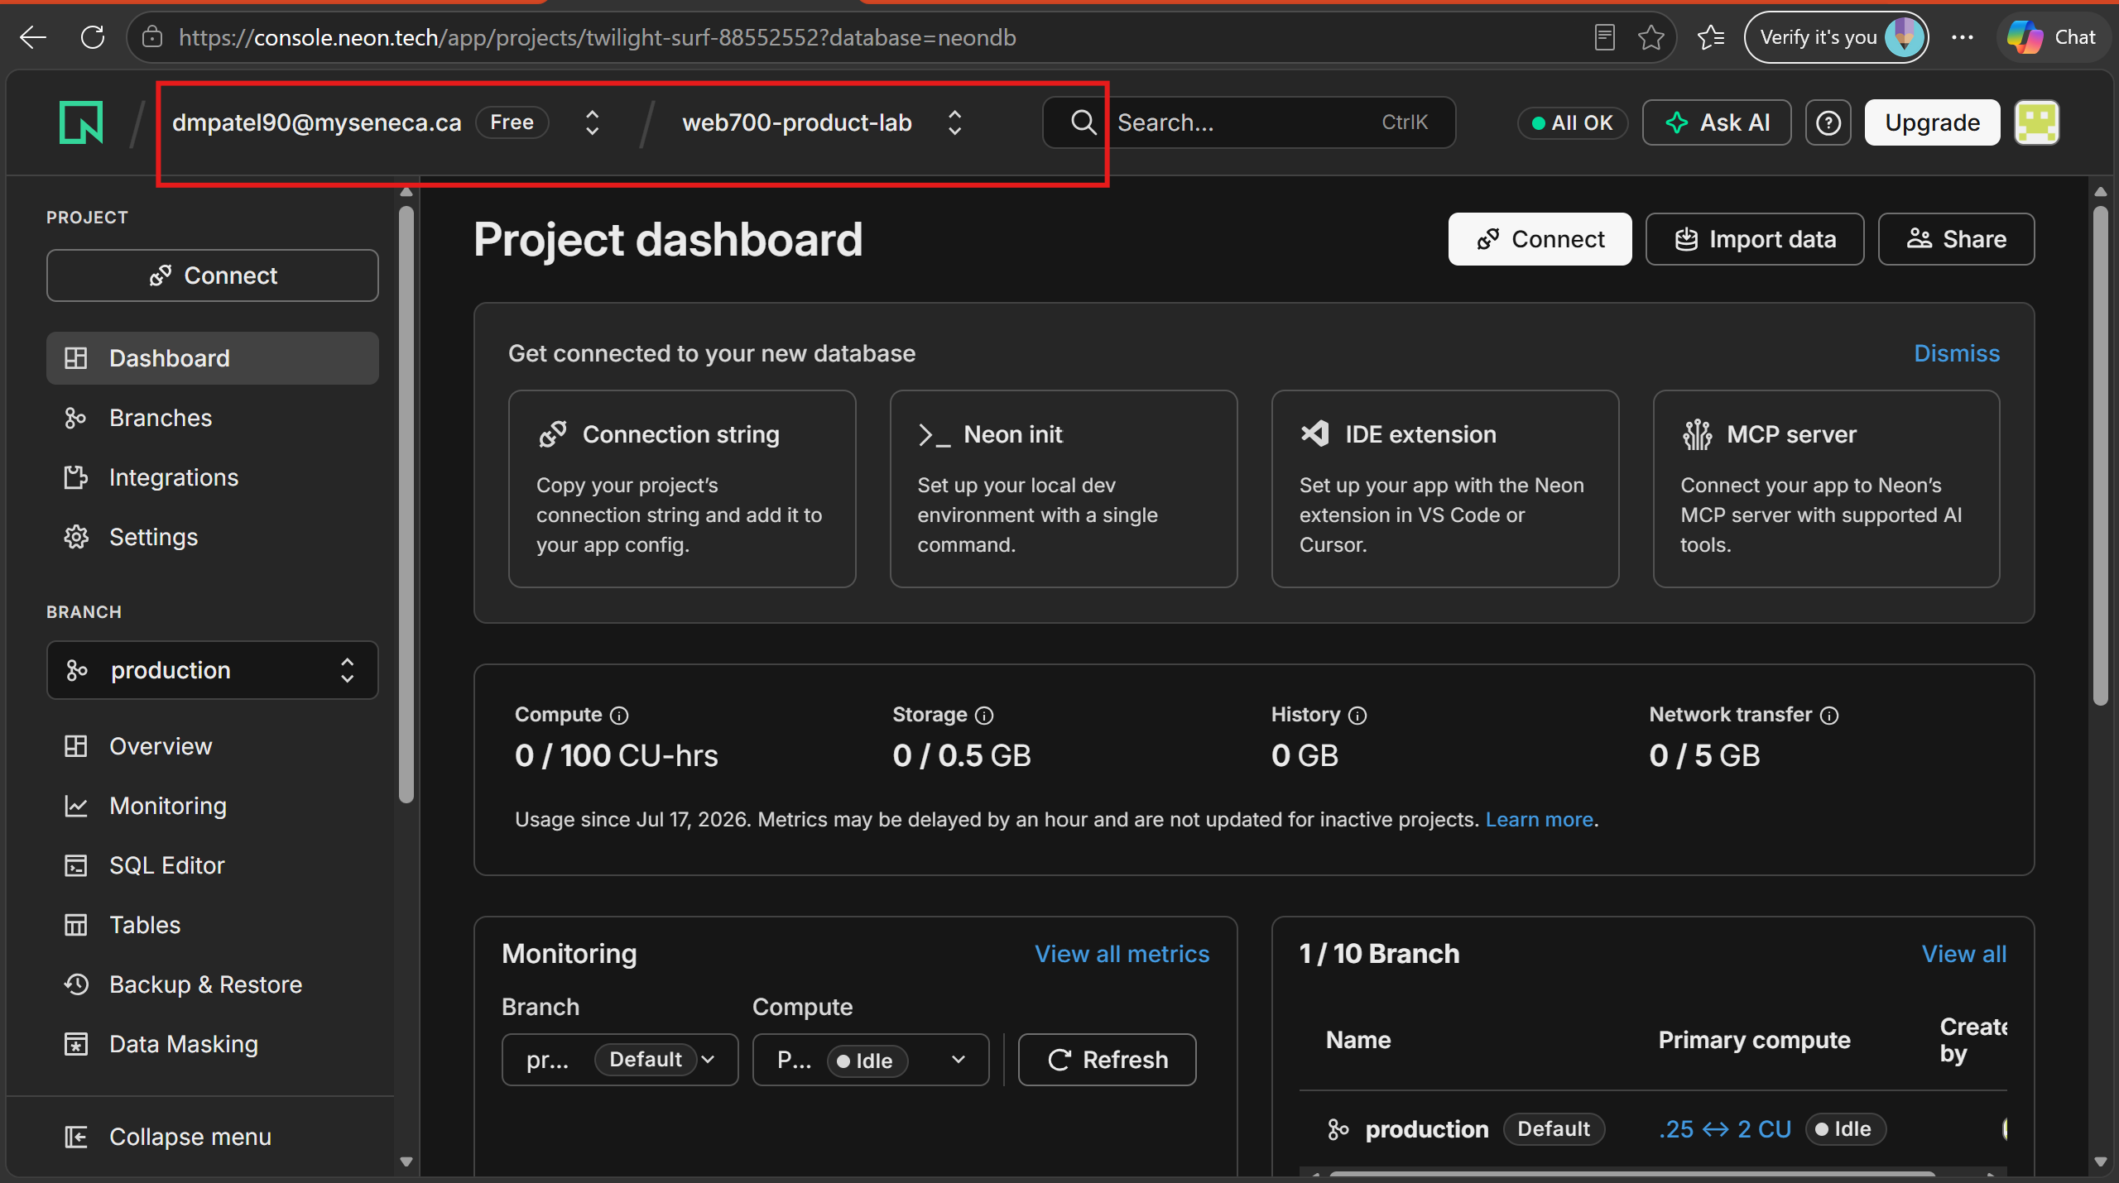

Screenshot 2 – pgAdmin Connection
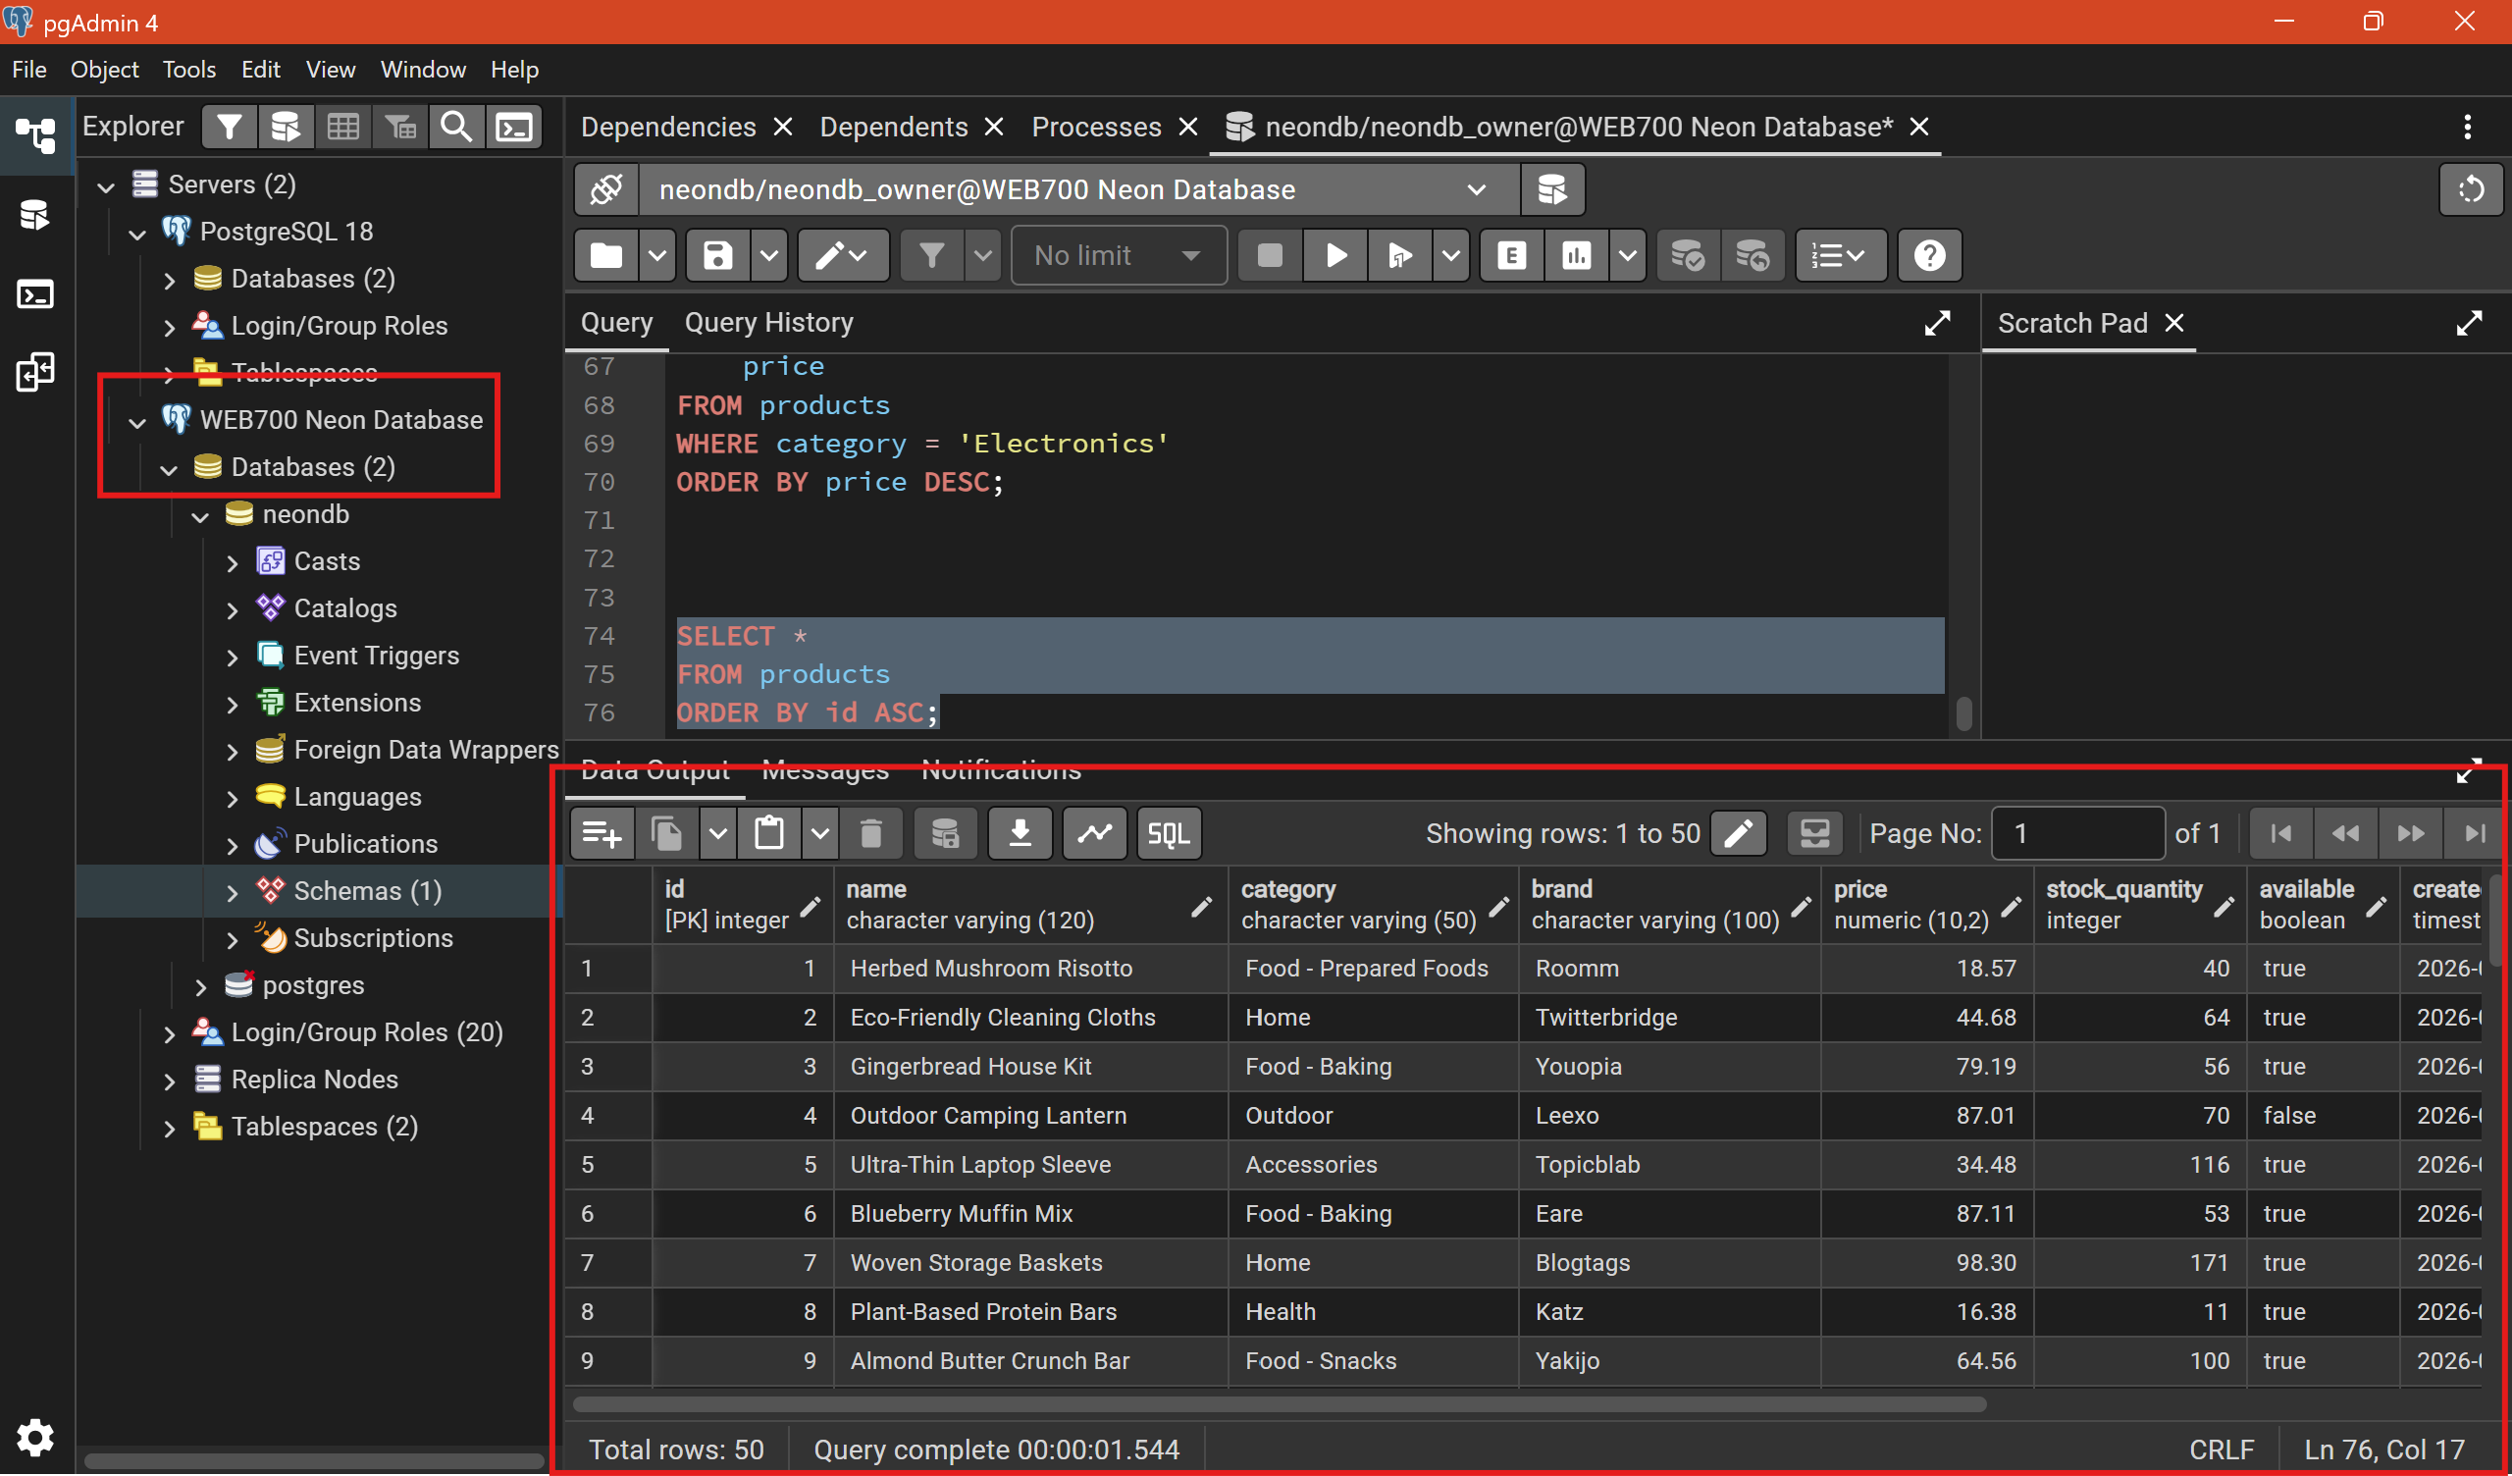
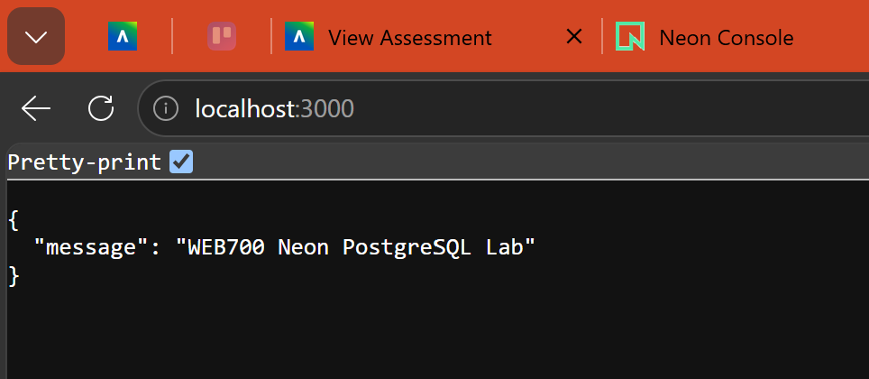
Screenshot 7 – /health Endpoint
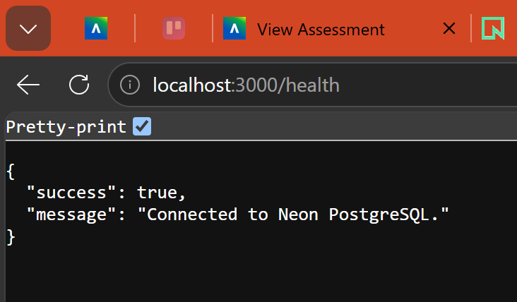
Screenshot 8 – /api/products Endpoint
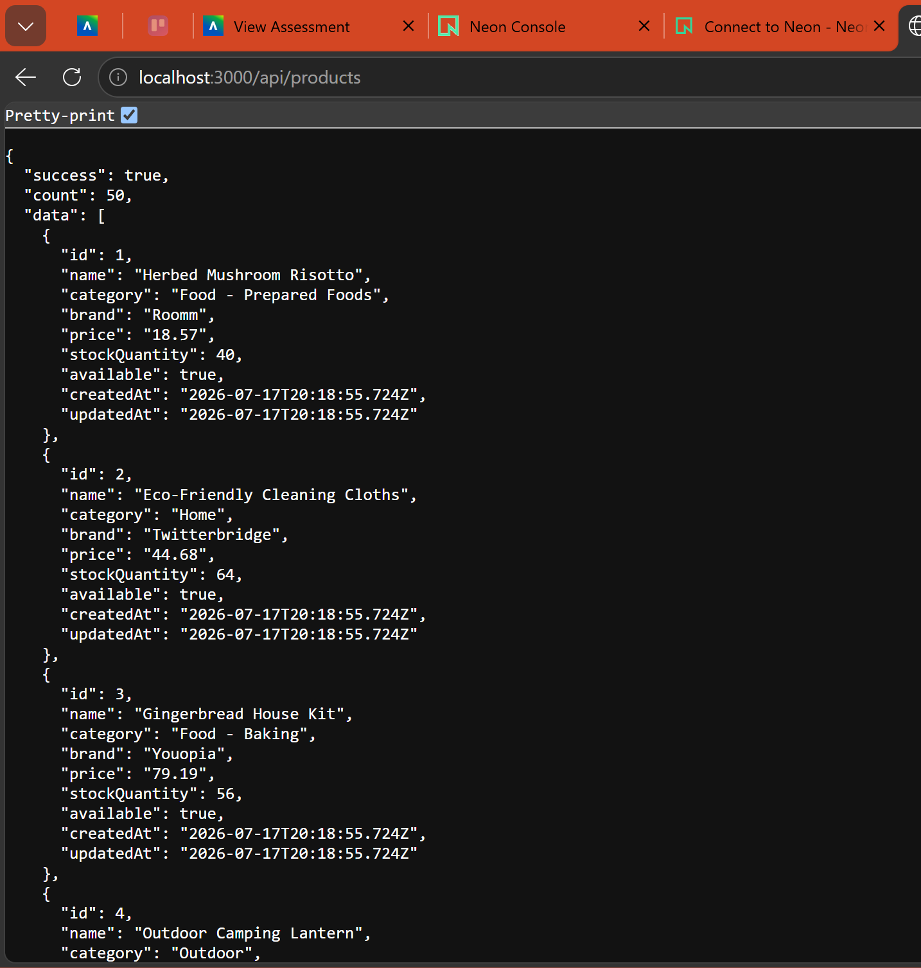Exit Questions
Where is the PostgreSQL database hosted?
The PostgreSQL database is hosted on Neon Cloud.
What is the role of pgAdmin?
pgAdmin is used to connect to, manage, and execute SQL queries on the PostgreSQL database.
Does Express connect through pgAdmin?
No. Express connects directly to the Neon PostgreSQL database using Sequelize.
What information is stored in DATABASE_URL?
The PostgreSQL connection string, including host, database, username, password, and SSL settings.
What is the purpose of the Sequelize model?
It maps the PostgreSQL table to JavaScript objects so the application can interact with the database.
What SQL operation is represented by Product.findAll()?
SELECT * FROM products.
Why should .env not be committed?
It contains sensitive credentials such as the database connection string.
What is the purpose of the /health endpoint?
It verifies that the application can successfully connect to the database.

