Juvenile Dungeness Pop Compare 2020 survival

Table of Contents

Load Libraries 1

Read and clean data 1

plot survival curves 1

# Load Libraries

# Read and clean data

sadfdsgfadsga

# plot survival curves

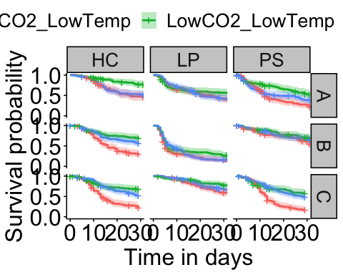

|  |  |
| --- | --- |
| mom | date |
| Hood Canal Parent 1 | 2020-02-19 |
| Hood Canal Parent 2 | 2020-02-21 |
| Hood Canal Parent 3 | 2020-02-20 |
| Outer Coast Parent 1 | 2020-02-15 |
| Outer Coast Parent 2 | 2020-02-15 |
| Outer Coast Parent 3 | 2020-02-15 |
| Puget Sound Parent 1 | 2020-02-18 |
| Puget Sound Parent 2 | 2020-02-18 |
| Puget Sound Parent 3 | 2020-02-20 |