Developing an avian collision risk model to incorporate variability and uncertainty

# Elizabeth A. Masden

Environmental Research Institute

North Highland College – UHI

University of the Highlands and Islands

Thurso, KW14 7EE

# http://portal.northhighland.ac.uk/ERI/Admin-Comms/Image%20Library/Image%20Library/Branding%20and%20logos/UHI%20Logo_CMYK.jpg http://portal.northhighland.ac.uk/ERI/Admin-Comms/Image%20Library/Image%20Library/Branding%20and%20logos/New_NHC_UHI_logo_30-08-11.jpghttp://portal.northhighland.ac.uk/ERI/Admin-Comms/Image%20Library/Image%20Library/Branding%20and%20logos/eri%20logo_flag.jpg

# Acknowledgements

This project was funded through a NERC knowledge exchange grant (grant number NE/L002728/1). The work was overseen by a project group comprising Aonghais Cook and Lucy Wright (BTO), Ian Davies (Marine Scotland Science), Aly McCluskie (RSPB), Marcus Cross (ScottishPower Renewables), and Kit Hawkins (HiDef Aerial Surveying Limited). However, this document is not officially endorsed by any of these organisations and does not constitute guidance from statutory bodies.

The original R model code from which this model update was developed was written by Aonghais Cook. Seabird data were provided by the RSPB from the FAME project, with particular thanks to Ellie Owen. Many thanks also to those who participated in the stakeholder interviews.

# Background

As wind energy developments increase globally the potential associated environmental impacts are receiving considerable attention, particularly avian impacts. These potential impacts on bird populations can be grouped into three main types: direct mortality due to collision with turbines/infrastructure; physical habitat modification and/or loss; and behavioural responses of birds to turbines (Fox *et al.* 2006; Langston 2013). Focussing on avian collision, a variety of methods have been developed to aid the assessment of the risk of collision, including collision risk models.

After extensively reviewing both the peer-reviewed scientific literature and grey literature, 10 distinct collision risk models referring to birds and wind turbines were identified, the earliest dating back to 1996 (Tucker 1996). At their core, most avian collision risk models include a calculation of the probability of a collision occurring (assuming no evasive action or avoidance behaviour) and often also a measure of the number of birds at risk, if an estimate of likely collision events is to be calculated. The probability of collision is generally based on the probability of a turbine blade occupying the same space as the bird during the time that the bird takes to pass through the rotor swept area. This therefore relies upon information on both bird and wind turbine characteristics such as bird morphometrics and flight speed, turbine rotor speed and size, etc.

In the UK, the most frequently used avian collision risk model is commonly known as ‘the Band model’ (Band, Madders & Whitfield 2007) and was originally conceived in 1995. Since then it has undergone several iterations with the most recent associated with the Strategic Ornithological Support Services (SOSS) (Band 2012a; b). The Band model (Band 2012b) provides four different options for calculating collision risk.

* Option 1 - Basic model, i.e. assuming that a uniform distribution of flight heights between the lowest and the highest levels of the rotors and using the proportion of birds at risk height as derived from site survey.
* Option 2 - Basic model, but using the proportion of birds at risk height as derived from a generic flight height distribution provided.
* Option 3 - Extended model and using a generic flight height distribution.
* Option 4 - Extended model and using a flight height distribution generated from site survey.

The most recent update of the Band model guidance also provides an approach under which uncertainty can be expressed. However, this approach is relatively simplistic and can only be applied when the sources of variability are independent of one another. Furthermore, although provided, it is not routinely followed and so could be improved upon. From undertaking interviews with stakeholders (for summary see Appendix 1), it was established that a new collision risk model that was fundamentally different was not required by the industry and the Band model was considered generally fit for purpose. However, although the majority of the stakeholders questioned did not consider major changes necessary, the general opinion was that if it were possible to incorporate uncertainty into the modelling process, it would be beneficial. The main reasoning for this was that expressing collisions as a single number does not sufficiently represent the complexity of the situation. In addition, it is known that the Band model is sensitive to the choice of input parameters (Chamberlain *et al.* 2006). Variability in input parameters such as bird density, flight speed and turbine rotor speed are likely to contribute uncertainty to the final collision estimates. Sensitivity analyses of both the basic and extended options of the Band model are provided in Appendix 2.

# General purpose of model update

The general purpose of this collision risk model update is to further develop the application of the Band model using a simulation approach to incorporate variability and uncertainty. In this report we refer to variability as the inherent heterogeneity of the environment and uncertainty as a lack of data or incomplete knowledge. The simulation model randomly samples from distributions for each of the model parameters and the simulations can then be used to derive average collision estimates, with associated confidence intervals. The model update will therefore allow for a better understanding of the uncertainty associated with the predicted collision impact of a wind farm development and provide confidence limits, something which has previously been absent. In addition, the incorporation of uncertainty would reduce the possibility that a collision estimate was driven by the choice of a single input parameter value. Ultimately, the update should aid streamlining of the planning/consenting stages of a development by providing information not only on the magnitude of collisions i.e. the number of collision events, but also the likelihood of that number of collisions occurring.

In this model update, variability and uncertainty are considered together in combination, rather than separately. Some model input parameters will have associated variability, for example bird body length, others may be expected to be point estimates with associated uncertainty, such as turbine rotor radius, and some parameters may have both variability and uncertainty. Ideally it would be possible to differentiate between variability and uncertainty but at present this is not possible due to a lack of data. However, including variability and uncertainty in combination in the model still provides a significant step forward.

The report describes the data required, and the methods used, to estimate collision risk. It is accompanied by a worked example and R code, which enables the collision risk calculations to be performed in a standardised and reproducible way.

# Model format

Whereas previous iterations of the Band model have used Microsoft Excel, the collision risk model updated presented uses R <http://www.r-project.org>. Opinions given during stakeholder interviews (for summary see Appendix 1) were that the Excel spreadsheet was difficult to use at times and there was the potential for errors to be easily introduced into calculations, particularly if the spreadsheet did not update correctly when new input parameters were entered. In addition, the Excel spreadsheet does not allow results to be reproduced easily making auditing onerous, as values have to be entered manually for each occasion or scenario. Using R enables reproducible methods and results as code and data are provided along with the computational environment used. This improves understanding and allows verification of results, therefore increasing transparency.

# Relationship to previous guidance on collision risk modelling

The model described and presented in this document is an update to the Band collision risk model (Band 2012b) which was most recently updated as part of SOSS. The mechanistic details of the Band model have not been altered and form the core of the model update described below.

The guidance (Band 2012b) states clearly that the collision estimate should be a best-estimate rather than a worst-case scenario.

“This guidance does not recommend use of ‘worst case’ assumptions at every stage. These can lead to an overly pessimistic result, and one in which the source of the difficulty is often concealed. Rather, it is recommended that ‘best estimates’ are deployed, and with them an analysis of the uncertainty or variability surrounding each estimate and the range within which the collision risk can be assessed with confidence. In stating such a range, the aspiration should be to pitch that at a 95% confidence level, that is, so that there is 95% likelihood that the collision risk falls within the specified range. However, given the uncertainties and variability in source data, and the limited firm information on bird avoidance behaviour, it seems likely that for many aspects the range of uncertainty may have to be the product of expert judgement, rather than derived from statistical analysis.”

The model update presented in this document follows this principle by using ranges of values rather than a single, ‘worst-case’ scenario.

The previous guidance (Band 2012b) presented a method to express overall uncertainty in collision estimates (stage F), as there are a large number of sources of variability or uncertainty. Cook *et al.* (2012) and Johnston *et al.* (2014) are key resources to include in this process as they provide data with confidence limits. However, the uptake of stage F in the collision estimation process appears to have been minimal. There have also been cases of its misapplication with estimates presented with implausible confidence limits such as 40±100 collisions, suggesting that negative numbers of collisions are possible. In addition, the method for expressing uncertainty suggested in stage F does so *post hoc*, rather than being integrated in to the model itself. Also, combining sources of uncertainty as suggested is only applicable when parameters are independent. The model update described in this document further develops the concepts presented in stage F of the previous guidance.

Before the most recent iteration of the Band model (Band 2012b) was conceived, McAdam (2005) produced a model which incorporated species specific flight height distributions. Variation in flight height has now been incorporated in to the most recent update (Band 2012b), however, the model produced by McAdam (2005) used Monte Carlo simulation to obtain 500 samples. Using Monte Carlo methods allowed for the production of summary statistics rather than single collision estimates, as well as probability distributions of events (numbers of collisions) occurring. It was also executed using R rather than Excel. In the model update presented below, the method of Monte Carlo simulation used by McAdam (2005) has been applied to the most recent version of the Band model to allow the incorporation of uncertain parameter values.

# General data requirements

The model update is based on the Band model (Band 2012b) therefore the types of data required are the same:

* Bird survey – data on the number of birds flying through or around the site, and their flight height
* Bird specification – details on bird morphology and flight speed
* Turbine specification – details on the number, size and rotation speed of turbine blades
* Bird behaviour – prediction of likely change due to wind farm, e.g. avoidance

The crucial difference from previous iterations of the Band model is that rather than using a single value for a given input parameter, for example bird flight speed, this update of the model randomly samples from a distribution of values. Using the randomly sampled parameter values, a collision risk estimate is calculated. This process is then repeated numerous times to produce a distribution of collision estimate for which summary statistics i.e. average and spread, can be calculated. Whereas the previous guidance and methods provided a measure of uncertainty post hoc, uncertainty is now incorporated in the modelling procedure itself with this update. Therefore, information regarding uncertainty in the data is required to be entered into the model.

Where possible, and when suitable, a mean and standard deviation should be provided for input parameters. These should capture the uncertainty within the data. For example, if the maximum turbine blade width has not been decided upon but is likely to be 5 metres then a mean = 5 should be provided with a standard deviation which describes the uncertainty and possible values. For this example, a mean of 5 and standard deviation of 0.3 would give a minimum of approximately 4 metres, and a maximum of approximately 6 metres. If there is no uncertainty and it is definite that the maximum blade width is to be 5 metres then a value of 5 should be entered as the mean and either 0 entered as the standard deviation or it left blank.

To incorporate uncertainty into the collision risk estimate, a mean and standard deviation will be required for the following parameters. Attention should be paid to the units of measure.

Table 1: Bird-related parameters

|  |  |  |
| --- | --- | --- |
| **Parameter** | **Units** | **Description/Notes** |
| Length | m (metres) |  |
| Wingspan | m (metres) |  |
| Flight speed | m/sec | Available from telemetry data or wind tunnel experiments |
| Flight type |  | Flapping or gliding |
| Nocturnal activity | Proportion e.g. 0.5 for 50% | Available from telemetry data or visual observations |
| Proportion at collision risk height | Proportion e.g. 0.5 for 50% |  |
| Flight height distribution | Proportion e.g. 0.5 for 50% | Distribution curves from which the proportion of birds flying within 1 metre height bands are calculated. Data provided by BTO (Johnston *et al.* 2014). (See below) |
| Avoidance rate | Proportion e.g. 0.5 for 50% | Suggested values available from MSS avoidance report |
| Bird density | Birds/km2 | Birds in flight in daytime, taken from survey data |

Table 2: Turbine-related parameters

|  |  |  |
| --- | --- | --- |
| **Parameter** | **Units** | **Description/Notes** |
| Rotor radius | m (metres) | Measured from the axis of rotation to blade tip. |
| Hub height | m (metres) | Sum of rotor radius and minimum blade clearance above HAT. (See below) |
| Max. blade chord width | m (metres) |  |
| Rotation speed | rpm | See below |
| Blade pitch | Degrees relative to rotor plane | See below |
| Turbine operation time | Proportion e.g. 0.5 for 50% | Requires both information on wind availability and maintenance down time. |

This model requires information on flight height distributions, if options 2, 3 or 4 are to be used. A generic flight height distribution is presented with the SOSS guidance (Band 2012a; b; Cook *et al.* 2012), however this does not provide information on the uncertainty associated with the distribution. Johnston *et al.* (2014) used a bootstrapping technique to provide confidence limits associated with the generic flight distribution and these bootstraps can be used within this model update to provide uncertainty associated with the flight height distribution curve. For each iteration of the model, a curve produced from a bootstrap sample is re-sampled and used. It is possible to use this update to calculate a collision risk estimate using option 4, should site-specific data on flight height distributions be available.

The model also requires information on wind speed (m.s-1) at the proposed site as well as the relationship between rotor speed and wind speed and turbine pitch and wind speed. This allows rotor speed and pitch to be linked both to the wind speed and also to each other. This is achieved through the provision of data similar to that in table 3 (below), describing the relationship between wind speed and rotor speed and pitch, as well as information on wind speed at the site.

Table 3: Example data describing relationship between wind speed, rotor speed and blade pitch.

|  |  |  |
| --- | --- | --- |
| **Wind speed (m/s)** | **Rotor Speed (rpm)** | **Pitch (degrees)** |
| 0 | 0 | 90 |
| 1 | 0 | 90 |
| 2 | 0 | 90 |
| 3 | 6 | 0 |
| 4 | 6 | 0 |
| 5 | 6 | 2 |
| 6 | 8 | 4 |
| … | … | … |

The turbine operation time is wind availability minus maintenance down time. Wind availability should be provided as a constant i.e. proportion of time the wind conditions allow for turbine operation and should be available from meteorological data. Maintenance time should be provided as a monthly mean and standard variation as it is expected that there will be uncertainty and variability surrounding maintenance.

Hub height is the distance from highest astronomical tide (HAT) to the axis of rotation of the turbine. This distance comprises the rotor radius and the distance between the minimum rotor tip height and HAT. Therefore, as rotor radius is already entered into the model, it is importantly only the distance component from HAT to the minimum rotor height that is required here and not the total hub height.

# Calculating collision risk

As stated previously, this model is an update of the Band model. For more information on the Band model refer to (Band 2012a; b) and associated information on the SOSS website <http://www.bto.org/science/wetland-and-marine/soss/projects>.

## Monte Carlo simulation

The model update presented herein uses Monte Carlo simulation. Monte Carlo simulation is a computational technique that uses random sampling to produce numerical results, and in this model update, is used to obtain values for uncertain input parameters, for example flight speed or bird length. These values are then used in the Band model. For each set of random samples, a collision estimate is calculated. Therefore if the simulation is run for 100 iterations, 100 sets of random input parameters will be sampled and 100 collision risk estimates calculated, instead of a single value. Monte Carlo simulation therefore allows for the presentation of a range of possible outcomes, when there is uncertainty surrounding the input data, and produces distributions of possible collision estimates. The distribution data can then be further re-sampled and used in stochastic population models, should this be required.

## Sampling distributions

With the exception of rotor speed, pitch and flight height distributions, input values for the Band model are sampled from probability distributions. These distributions are parameterised using data provided by the user and have been constrained to the Normal distribution, or in cases where negative values are not plausible, the truncated Normal distribution. The user defines the mean or expected value and a standard deviation to describe the variation about the mean. Values in the middle near the mean are most likely to occur. The decision to use the Normal distribution was made on the basis of ease of parameterisation for the user as well as suitability. The Normal distribution was considered more suitable that a uniform distribution because in most cases it is expected that there will be a more likely value, and the uniform distribution, where all values are equally likely, would therefore enter more uncertainty than realistic into the model. It is however accepted that in all cases, the Normal distribution may not be the most suitable distribution, but there is a balance to be achieved between suitability and ease of use.

## Collision risk options

The Band model provides four different options for calculating collision risk (Band 2012b). Options 1, 2 and 3 are the most frequently used. The model update calculates estimates for both the basic (options 1 and 2) and extended (option 3) versions of the Band model. It is possible to use this update to calculate a collision risk estimate using option 4, should site-specific data on flight height distributions be available. However, this would require a large amount of data collection, to provide information on variation in flight height distribution therefore the default option does not include option 4.

## Running the model

As well as being designed to run numerous simulations of the Band model, this update is designed to loop through multiple species and multiple turbine designs automatically. Therefore once the initial user information is entered and the model begins, the user is not required to enter any further information and the results will be saved automatically to the location specified by the user. The number of results obtained will depend on the number of different turbine designs and species entered.

# Model Output

The model outputs information on the expected numbers of collisions. The information is provided both as tables and figures. Descriptions of the outputs are listed below and illustrated examples are provided in the worked example.

**TABLES**

1. Overall summary table of collisions by species, turbine and model option. Results are presented as mean, standard deviation (SD) and coefficient of variation (CV), and median and inter quartile range (IQR).
2. Monthly summaries of collisions. Separate tables are produced according to species, turbine and model option for example 6_Black_legged_Kittiwake_monthlySummaryOpt3.csv. Results are presented as mean, standard deviation (SD) and coefficient of variation (CV), and median and inter quartile range (IQR).
3. Summary of sampled bird parameters by species, turbine and model option presented as mean and standard deviation (SD), and median and inter quartile range (IQR).
4. Summary of sampled turbine parameters by species, turbine and model option presented as mean and standard deviation (SD), and median and inter quartile range (IQR).

**FIGURES**

1. 3-panel boxplots of monthly collisions for model options 1, 2 and 3 by species, and turbine type.
2. Density plots of numbers of collisions by species, and turbine type. A density curve is plotted for each of the 3 model options.
3. If 2 or more turbine models are included, then a 3-panel figure will be produced for each species, with the panels representing model options 1, 2 and 3 and each panel containing density plots for the different turbines included.

In addition to the collision estimates, the model also saves a copy of the input files which were entered into the model, as well as a summary of the randomly sampled input parameter values. This would therefore allow for the model to be re-run and results verified (if required). It also outputs a text file stating the time elapsed between the start and the end of the model, the number of iterations, the species for which the model was run and also the different turbines i.e. 6MW, 8MW, etc. if more than one turbine type was specified.

# Future work

During this project, an update to the Band collision risk model (Band 2012b) has been developed, however it is accepted that there are still aspects which could be improved further in the future with additional updates, particularly with improved data collection methods and understanding of the interactions between birds and wind farms. These are listed below.

1. Wind speed data: This model update has taken a step forward from previous iterations of the Band model by including the relationship between wind speed data and both rotor speed and rotor pitch, however there are still improvements which could be made. Due to a lack of clarity in the availability and format of site-specific wind speed data which is available to developers it was decided that in this model update, wind speed would be sampled from a truncated Normal distribution, parameterised by a mean and standard deviation set by the user. In the future, if consensus could be reached on wind data availability and format, a summary of the raw wind speed data could be used, rather than using it to parameterise a sampling distribution. If this were the case, then it would also be possible to programme the model to automatically calculate wind availability from the wind speed data, rather than this being entered manually.

2. Monthly vs. annual input parameters: The current model uses annual estimates for the majority of input parameters such as bird flight speed and percentage of nocturnal activity. It is possible that these may differ between the breeding and non-breeding season, and vary monthly, and in response to wind speed. However, at present it was considered that data of sufficient quality were not available for enough parameters on a monthly basis to warrant including this in the model for all. Should this be the case, including monthly values for all parameters could introduce unrealistic precision into the model; therefore only monthly values were included for bird density and turbine operation time. In the future it might be more appropriate to consider all input parameters on a monthly basis.

3. Linking wind speed and flight speed: Within this model update bird flight speed was not linked to wind speed. This alteration could improve the model, however little data is available regarding bird flight speeds, especially in relation to wind speed, though more flight speed data are becoming available as the number of projects using telemetry e.g. GPS tags, increases . The link between flight speed and wind speed was however included in the model produced by McAdam (2005), therefore it would be possible to include this relationship in future updates, should sufficient data become available.

4. Validate the model: Due to the difficulties associated with collecting collision data offshore, as yet, it has not been possible to validate this model update. This is the case for previous versions of the Band model and also collision risk models in general. In the guidance supplied alongside the 2012 update to the Band model, Band (2012b) highlights that there is likely to be uncertainty as a result of simplifications in the model itself. As an estimate, it is suggested that this may be in the region of 20%. By using the results of projects, such as the bird collision avoidance component of the Offshore Renewables Joint Industry Programme (ORJIP) in the UK, to validate the model, it may be possible to quantify this uncertainty more accurately and reduce it through further refinements to the model.

5. Sensitivity analysis: Whilst it is possible to perform a manual sensitivity analysis on the model update (results available in Appendix 2), it would be useful in the future to have the utility to perform a sensitivity analysis as a matter of course during the assessment of collision risk. This would offer users the ability to highlight which parameters had the strongest influence on the final collision estimates and consider how best to target data collection in order to reduce uncertainty. It may also enable developers to plan mitigation strategies, for example by demonstrating how using fewer, larger turbines may reduce collision risk.

# References

Band, B. (2012a) *Using a Collsion Risk Model to Assess Bird Collision Risks for Offshore Windfarms - with Extended Method: Worked Example*.

Band, W. (2012b) Using a collision risk model to assess bird collision risks for offshore windfarms. *SOSS report, The Crown Estate*.

Band, W., Madders, M. & Whitfield, D.P. (2007) Developing field and analytical methods to assess avian collision risk at wind farms. (eds M. De Lucas, G.F.E. Janss & M. Ferrer), Quercus, Madrid.

Chamberlain, D.E., Rehfisch, M.R., Fox, A.D., Desholm, M. & Anthony, S.J. (2006) The effect of avoidance rates on bird mortality predictions made by wind turbine collision risk models. *Ibis*, **148**, 198–202.

Cook, A.S.C.P., Johnston, A., Wright, L.J. & Burton, N.H.K. (2012) A Review of Flight Heights and Avoidance Rates of Birds in Relation to Offshore Wind Farms. *BTO Research Report 618*, 1–61.

Fox, A.D., Desholm, M., Kahlert, J., Christensen, T.K. & Petersen, I.K. (2006) Information needs to support environmental impact assessment of the effects of European offshore wind farms on birds. *Ibis*, **148**, 129–144.

Johnston, A., Cook, A.S.C.P., Wright, L.J., Humphreys, E.M. & Burton, N.H.K. (2014) Modelling flight heights of marine birds to more accurately assess collision risk with offshore wind turbines. *Journal of Applied Ecology*, **51**, 31–41.

Langston, R.H.W. (2013) Birds and wind projects across the pond: A UK perspective. *Wildlife Society Bulletin*.

McAdam, B.J. (2005) *A Monte-Carlo Model for Bird / Wind Turbine Collisions. MSc Ecology.* University of Aberdeen.

Tucker, V.A. (1996) A mathematical model of bird collisions with wind turbine rotors. *Journal of Solar Energy Engineering*, 253–262.

Appendix 1: Stakeholder Interviews

# Purpose of interviews

To obtain views and opinions of a wide range of stakeholders involved in offshore wind, on collision risk models and modelling, particularly in relation to uncertainty and variability.

# Interview questions

Conducted telephone interviews based around the following questions:

1. How much experience do you have, relating to collision risk models/modelling?
2. What collision risk models do you most regularly use or have experience of?
3. What uncertainties exist in the collision risk models that you have used?
4. What are the key uncertainties in input parameters?
5. What parameters do you think have the greatest influence on the outputs of collision risk modelling?
6. If you could, how would you improve collision risk models/modelling?
7. Would the explicit reporting of variability and uncertainty in outputs from collision risk models benefit the consenting process and discussions with regulators?

Interviews were approximately 20-30 minutes each.

# Interviewees

I contacted 30 people from a range of stakeholder groups and from those I conducted 20 interviews with people from the following organisations:

BTO

DONG Energy

EDPR

MacArthur Green

Natural England

NIRAS

PMSS

Scottish Natural Heritage

Sue King Consulting

CEH

ECON

Joint Nature Conservation Committee

Marine Scotland Science

Natural Power

Pelagica

Royal Society for the Protection of Birds

Statkraft/Forewind

The Crown Estate

…and Bill Band

# Results

## Experience of interviewees

**Question 1: How much experience do you have, relating to collision risk models/modelling?**

The experience of interviewees varied from ‘intelligent client’ to model creator. All interviewees had a good understanding of the general modelling process and the use of model output though not all had conducted the modelling and run the models themselves. One person declined the offer of being interviewed because they thought they didn’t have enough experience to contribute constructively.

**Question 2: What collision risk models do you most regularly use or have experience of?**

All people interviewed (20) used the Band model and the associated updates. Of these, most people mentioned options 1 and 3 rather than 2 and 4. Additionally, 5 people used the Folkerts model, though less regularly, and one had an understanding of the Tucker model. These were the only models mentioned.

## Uncertainties in collision risk modelling

**Question 3: What uncertainties exist in the collision risk models that you have used?**

This question was targeted at the broader uncertainties surrounding collision risk modelling. The following opinions were given more than once:

* Data collection methods including number and timing of surveys and the fact that surveys only occur in good weather least to a density estimate which may not capture the variability in the environment.
* The use of the Rochdale Envelope and therefore wide ranges for turbine parameters.
* How much precaution should be included?
* Bird behaviour and avoidance
* Which option of the model (or in most cases, which option of Band) is acceptable?
* Little empirical data and also no validation or comparison with post-construction data.
* The appropriate use of the model and output. The collision estimate is considered as definitive and black and white when it is supposed to be a collision risk tool.
* In the case of the Band model, what is the latest version of the model and flight height data sets to use?

**Question 4: What are the key uncertainties in input parameters?**

All of the input parameters were discussed and raised by the interviewees as a whole but those that occurred more than once and in descending order (most frequently highlighted first):

* Flight height data
* Avoidance
* Density
* Nocturnal activity
* Flight speed
* Rotor speed

**Question 5: What parameters do you think have the greatest influence on the outputs of collision risk modelling?**

Most of the input parameters were discussed and raised by the interviewees as a whole but those that occurred more than once and in descending order (most frequently highlighted first):

* Avoidance rate
* Flight height data
* Rotor Speed
* Density
* Number of turbines
* Which Band option used
* Operation time

## Changes or updates to model

**Question 6: If you could, how would you improve collision risk models/modelling?**

There were many different opinions on how to improve collision risk modelling but generally they did not involve making large changes to the mechanics of the model itself but rather to the input data or presentation of data and outputs. Comments that were raised more than once and in descending order (most frequently highlighted first) included:

* Present a covering/summary sheet with input data values to ensure parameters are clearly set out and defined.
* Stop presenting single numbers as black and white and also provide context.
* Take data from existing sites to validate the model and also use post-construction monitoring.
* Have a standard approach to derive turbine parameters and bird parameters including consistently defining breeding season periods.
* More studies/data on bird behaviour around turbines and avoidance behaviour.
* More and clearer guidance on the model and model use and intended use, especially on the tidal offset.
* Collect flight height data objectively, not just human observation/estimation but using rangefinders.
* Factor uncertainty into estimates.
* Use R code rather than excel to make modelling process more reproducible.
* Better interpretation of model outputs.
* Single location to have the most up to date version of model and email updates.

These can then be split into comments that were more input data-related:

* Present a covering/summary sheet with input data values to ensure parameters are clearly set out and defined.
* Have a standard approach to derive turbine parameters and bird parameters including consistently defining breeding season periods.
* More studies/data on bird behaviour around turbines and avoidance behaviour.
* Collect flight height data objectively, not just human observation/estimation but using rangefinders.

Or those which were model or output data-related:

* Stop presenting single numbers as black and white and also provide context.
* Take data from existing sites to validate the model and also use post-construction monitoring.
* More and clearer guidance on the model and model use and intended use, especially on the tidal offset.
* Factor uncertainty into estimates.
* Use R code rather than excel to make modelling process more reproducible.
* Better interpretation of model outputs.
* Single location to have the most up to date version of model and email updates.

**Question 7: Would the explicit reporting of variability and uncertainty in outputs from collision risk models benefit the consenting process and discussions with regulators?**

When asked more specifically about including variability and uncertainty in CRMs interviewees gave a wide range of responses but these were not consistent within different stakeholder groups. Of the 20 people interviewed, 13 agreed that including variability and uncertainty in outputs from collision risk models would benefit the consenting process and discussions with regulators, however 7 people disagreed. Of those 7, all said that they disagreed because of the consenting and assessment process and that in principle it would be better to include variability and uncertainty, but they though that the system did not allow for it. A recurrent comment was that interviewees were unsure of how variability and uncertainty could be included in outputs and still fit in with the Habitats Regulations.

Some comments and themes that were raised in the interviews are listed below:

* Scientifically there is a benefit to making clear what the uncertainties are.
* Accounting for uncertainty in data collection methods and survey data would be useful.
* I am uncomfortable with presenting a value that is apparently so precise.
* There is an absolute fixation on single numbers which is dangerous.
* We need greater acceptance that we live and work in an uncertain world and things are grey, not black and white.
* We need a way of showing that some scenarios are more likely than others.
* Decision makers have to be confident that they are making the right decisions so they need to an understanding of uncertainty around the single numbers.
* We need to weigh up risk (or use a risk assessment process) and we can’t do that currently with CRM, though it happens more regularly with PVA.
* The current approach is too precautionary and always uses the most precautionary values.
* If the system were to change, including variability and uncertainty is a more useful approach.
* Any outputs need to be suitable to be taken forward through the assessment process.
* The risk is that it complicates the process even more than already because the more the risks are explicit the more difficult it is to explain to the planning inspectorate.
* There is probably too much uncertainty in the system to make it useful to include it.

There was a wide range of views on some topics, for example opinions on using probability distributions:

* Presenting probability distributions would help a lot because regulators often have a background of understanding risk probabilities.
* Using probability distributions might help with presentation but it might not help with interpretation of outputs, especially if people don’t understand how to interpret probability distributions.
* Distributions are probably more helpful but people need to understand them.
* Scientists are used to dealing with probabilities but legislation is binary.

This probably stems from uncertainty and/or inconsistency in (the understanding of) how decisions are made and the lack of a strategic decision on a standard method for presenting data which is most informative for the decision makers.

Appendix 2: Sensitivity analyses

Chamberlain *et al.* (2006) previously documented that the Band model was sensitive to input parameters. Following on from this, the sensitivity of the Band model update produced during the SOSS project (Band 2012) was assessed, both for the basic and extended versions. Similar to Chamberlain *et al.* (2006), the effect of a 10% change in the input parameters was assessed but in addition, a more realistic parameter range was also assessed.

When assessing the effect of a 10% change in the flight height distribution for the extended model, we increased the proportions of birds at heights between the minimum and maximum rotor tip heights by 10%.

The following data sources were used for the input parameters. For turbine-related parameters, expert opinion within the project group was used to assess reasonable parameters ranges and those likely to be built out in the near future.

|  |  |
| --- | --- |
| **Bird-related Parameter** | **Data description** |
| Length | Taken from Concise Birds of the Western Palearctic (Cramp and Perrins, 1993) and other sources |
| Wingspan | Taken from Concise Birds of the Western Palearctic (Cramp and Perrins, 1993) and other sources |
| Flight speed | RSPB telemetry data (breeding season only) |
| Nocturnal activity | RSPB telemetry data (breeding season only) |
| Proportion at collision risk height | Generic flight height curve provided with the Band model and data provided by BTO (Johnston *et al.* 2014). |
| Flight height distributions | Data provided by BTO (Johnston *et al.* 2014). |
| Avoidance | ‘All gulls’ rate available from Marine Scotland Science avoidance report (Cook et al. 2014) |
| Bird density | Taken from Creyke Beck A Environmental Statement |

|  |  |
| --- | --- |
| **Turbine-related Parameter** | **Description/Notes** |
| Rotor radius | Expert opinion |
| Hub height | Expert opinion |
| Max. blade chord width | Expert opinion |
| Rotation speed | Expert opinion (example relationship between wind speed and rotation speed) |
| Blade pitch | Expert opinion (example relationship between wind speed and pitch) |
| Turbine operation time | Taken from Inch Cape Environmental Statement |

# 10% change

## BASIC MODEL (Option 1)

|  |  |  |  |  |  |
| --- | --- | --- | --- | --- | --- |
| **Input variable** | **Baseline** | **Baseline ± 10% (whichever increases mortality)** | **Collision risk (in absence of avoidance)** | **Revised number of collisions** | **% increase in number of collisions** |
| **Avoidance rate** | 0.9893 | 0.8904 | 0.065 | 439 | 921 |
| **Non-avoidance rate** | 0.0107 | 0.0118 | 0.065 | 47 | 9 |
| **% at collision risk height** | 6 | 6.6 | 0.065 | 47 | 9 |
| **Bird density (birds/km2)** | 9.89 | 10.879 | 0.065 | 47 | 9 |
| **Flight speed (m.s-1)** | 7.26 | 7.986 | 0.063 | 46 | 7 |
| **% nocturnal flight** | 3.3 | 3.63 | 0.065 | 43 | 0 |
| **Bird length (cm)** | 39 | 42.9 | 0.067 | 44 | 2 |
| **Wing span (cm)** | 108 | 118.8 | 0.065 | 43 | 0 |
| **Number of turbines** | 100 | 110 | 0.056 | 47 | 9 |
| **Rotor radius (m)** | 80 | 88 | 0.061 | 44 | 2 |
| **Hub height (m)** | 125 | 112.5 | 0.065 | 43 | 0 |
| **Rotation speed (rpm)** | 7.74 | 8.514 | 0.067 | 44 | 2 |
| **Blade width (m)** | 5.5 | 6.05 | 0.069 | 46 | 7 |
| **Blade pitch (degrees)** | 0 | - | - | - | - |
| **% time operational** | 87.61 | 96.371 | 0.065 | 47 | 9 |

Effects of 10% variation in input parameters on predicted mortality rates of black-legged kittiwakes using hypothetical wind farm parameters (100 turbines). The original collision risk was 0.065 and the original number of predicted collisions per year was 43. Collisions are presented as integers.

## EXTENDED MODEL (Option3)

|  |  |  |  |  |  |
| --- | --- | --- | --- | --- | --- |
| **Input variable** | **Baseline** | **Baseline ± 10% (whichever increases mortality)** | **Collision risk (in absence of avoidance)** | **Revised number of collisions** | **% increase in number of collisions** |
| **Avoidance rate** | 0.9672 | 0.8705 | 0.065 | 9 | 350 |
| **Non-avoidance rate** | 0.0328 | 0.0361 | 0.065 | 3 | 50 |
| **% at collision risk height** | 6 | 6.6 | 0.065 | 3 | 50 |
| **Bird density (birds/km2)** | 9.89 | 10.879 | 0.065 | 3 | 50 |
| **Flight speed (m.s-1)** | 7.26 | 7.986 | 0.063 | 2 | 0 |
| **% nocturnal flight** | 3.3 | 3.63 | 0.065 | 2 | 0 |
| **Bird length (cm)** | 39 | 42.9 | 0.067 | 2 | 0 |
| **Wing span (cm)** | 108 | 118.8 | 0.065 | 2 | 0 |
| **Number of turbines** | 100 | 110 | 0.065 | 3 | 50 |
| **Rotor radius (m)** | 80 | 88 | 0.061 | 5 | 150 |
| **Hub height (m)** | 125 | 112.5 | 0.065 | 8 | 300 |
| **Rotation speed (rpm)** | 7.74 | 8.514 | 0.067 | 2 | 0 |
| **Blade width (m)** | 5.5 | 6.05 | 0.069 | 2 | 0 |
| **Blade pitch (degrees)** | 0 | - | - | - | - |
| **% time operational** | 87.61 | 96.371 | 0.065 | 3 | 50 |

Effects of 10% variation in input parameters on predicted mortality rates of black-legged kittiwakes using the hypothetical wind farm parameters (100 turbines). The original collision risk was 0.065 and the original number of predicted collisions per year was 2.Collisions are presented as integers, therefore the % increase in the number of collisions is greatly influenced by rounding.

# Real data range

## BASIC MODEL (Option 1)

|  |  |  |  |
| --- | --- | --- | --- |
| **Input variable** | **Input variability** | **Mean collisions (SD)** | **Median collisions (IQR)** |
| **Avoidance rate** | N(0.9893,0.0007) | 39.76 (2.55) | 39.72 (3.61) |
| **% at collision risk height** | N(6, 0.9) | 39.77 (6.06) | 39.77 (7.86) |
| **Bird density (birds/km2)** | tN(monthly mean, monthly SD) | 41.86 (6.40) | 41.99 (8.39) |
| **Flight speed (m.s-1)** | N(7.26, 1.50) | 40.25 (5.73) | 40.30 (8.09) |
| **% nocturnal flight** | N(3.3, 0.45) | 39.90 (0.19) | 39.91 (0.26) |
| **Bird length (cm)** | N(39, 0.5) | 39.89 (0.15) | 39.89 (0.21) |
| **Wing span (cm)** | N(108, 4) | 39.89 (0.09) | 39.89 (0.12) |
| **Rotor radius (m)** | N(80, 5) | 39.89 (0.67) | 39.84 (0.88) |
| **Hub height (m)** | Rotor radius + N(26.5, 2) | 39.89 (0) | 39.89 (0) |
| **Rotation speed (rpm** | Relationship to wind speed | 40.15 (1.81) | 38.51 (3.76) |
| **Blade width (m)** | N(5.5,0.3) | 39.91 (1.39) | 39.90 (1.97) |
| **Blade pitch (degrees)** | Relationship to wind speed | 40.50 (1.66) | 39.89 (0.32) |
| **% time operational** | Wind availability-tN(6.3, 2) | 39.91 (1.39) | 39.90 (1.97) |

Effects of variation in input parameters on predicted mortality rates of black-legged kittiwakes using the hypothetical wind farm parameters (100 turbines). 500 iterations. The original collision risk was 0.065 and the original number of predicted collisions per year was 40. N is normal distribution. N(mean, SD). tN is truncated normal distribution. Hub height does not affect calculations in option 1, therefore the values were constant across all iterations.

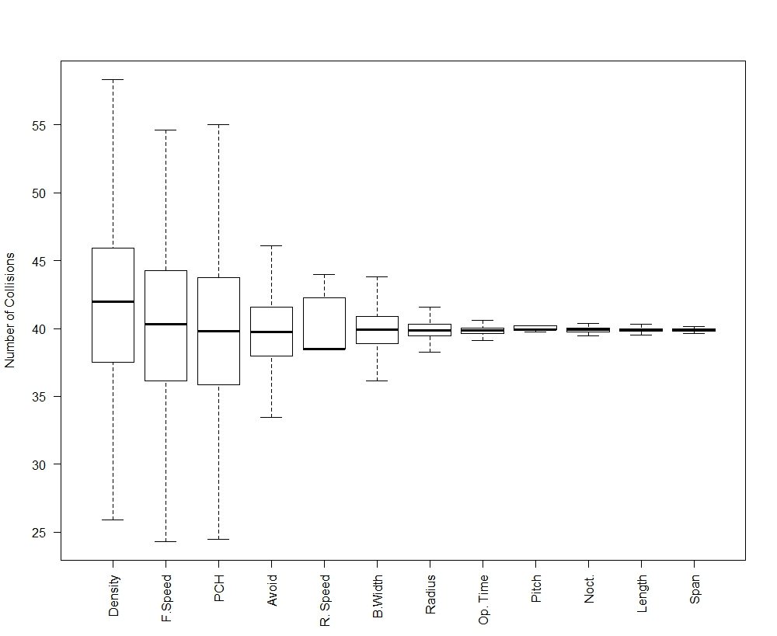

Effects of variation in input parameters on predicted collision mortality of black-legged kittiwakes using the basic Band model. Density values are slightly skewed due to need for use of truncated normal distribution as negative density values are not possible.

## EXTENDED MODEL (Option3)

|  |  |  |  |
| --- | --- | --- | --- |
| **Input variable** | **Input variability** | **Mean collisions (SD)** | **Median collisions (IQR)** |
| **Avoidance rate** | N(0.9672, 0.0018) | 18.34(1.03) | 18.33 (1.35) |
| **% at collision risk height** | Data from BTO | 29.60 (5.92) | 29.94 (7.70) |
| **Bird density (birds/km2)** | tN(monthly mean, monthly SD) | 19.06 (3.03) | 18.97 (4.04) |
| **Flight speed (m.s-1)** | N(7.26, 1.50) | 18.31 (1.38) | 18.32 (1.75) |
| **% nocturnal flight** | N(3.3, 0.45) | 18.32 (0.09) | 18.32 (0.12) |
| **Bird length (cm)** | N(39, 0.5) | 18.32 (0.16) | 18.32 (0.22) |
| **Wing span (cm)** | N(108, 4) | 18.32 (0.16) | 18.32 (0.22) |
| **Rotor radius (m)** | N(80, 5) | 18.35 (0.10) | 18.13 (0.14) |
| **Hub height (m)** | Rotor radius + N(26.5, 2) | 18.72 (5.33) | 18.11 (7.08) |
| **Rotation speed (rpm)** | Relationship to wind speed | 18.57 (1.87) | 16.86 (3.89) |
| **Blade width (m)** | N(5.5,0.3) | 18.31 (0.32) | 18.32 (0.44) |
| **Blade pitch (degrees)** | Relationship to wind speed | 18.32 (0.00074) | 18.32 (0.00014) |
| **% time operational** | Wind availability-tN(6.3, 2) | 18.32 (0.14) | 18.32 (0.18) |

Effects of variation in input parameters on predicted mortality rates of black-legged kittiwakes using the hypothetical wind farm parameters (100 turbines). 500 iterations. The original collision risk was 0.065 and the original number of predicted collisions per year was 18. N is normal distribution. N(mean, SD). tN is truncated normal distribution.

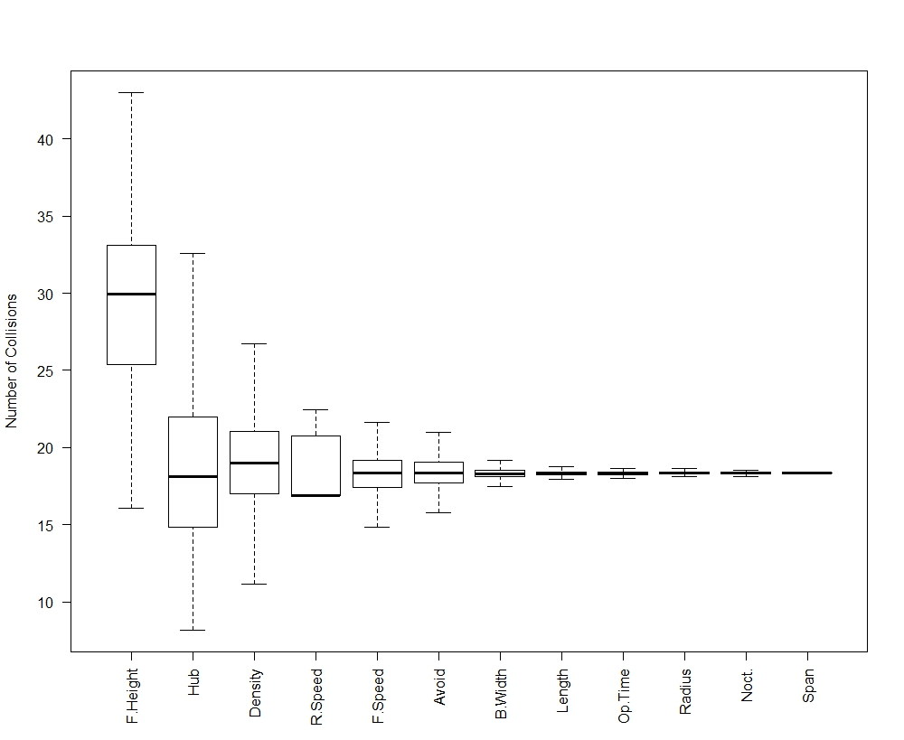

Effects of variation in input parameters on predicted collision mortality of black-legged kittiwakes using the extended Band model. Density values are slightly skewed due to need for use of truncated normal distribution as negative density values are not possible.

A note on variation in flight height: It is noticeable that when variation in the flight height distribution used for the extended model (option 3) is considered, it results in a very different average value to that obtained using the best fit distribution. This should be expected. Flight height distributions are estimated following the methodology set out in Johnston et al. (2014). The best fit distribution is estimated from the complete flight height dataset, and is that which best fits the available data. Confidence intervals were calculated around this distribution using a bootstrapping approach, randomly sampling from the original dataset each time. As a result, each individual bootstrap reflects the shape of the distribution would be if some of the data were excluded. It is not meaningful to compare the mean values obtained from the bootstraps to the best-fit distribution because they are a series of sub-samples. On closer examination, it is clear that the best fit distribution predicts a lower proportion of birds at collision risk height than is obtained from the mean across all bootstraps, and that crucially, this difference is greatest towards the centre of the rotor-swept area, where collision risk is greatest. As a result, the mean collision rate predicted from the bootstraps is greater than collision rate predicted from the best fit distribution. 

Comparison of the best fit (red) and bootstrapped (grey) flight height distributions for kittiwake. The best fit distribution does not pass through the centre of the bootstrapped distributions as would be expected if it were directly comparable to the mean. Instead, as height above sea level increases, the proportion of birds predicted by the best-fit distribution moves towards the lower end of the proportion predicted by the bootstraps. The difference is most apparent at heights of around 100 m, which roughly corresponds to the centre of the rotor sweep, the point at which collision risk is greatest. This can be seen more clearly by examining the ratio of the best fit distribution to the mean of the bootstrap distribution at 1 m intervals.



References:

Band, W. (2012) Using a collision risk model to assess bird collision risks for offshore windfarms. SOSS report, The Crown Estate.

Chamberlain, D.E., Rehfisch, M.R., Fox, A.D., Desholm, M. & Anthony, S.J. (2006) The effect of avoidance rates on bird mortality predictions made by wind turbine collision risk models. Ibis, 148, 198–202.

Cook, A. S. C. P., Humphreys, E. M., Masden, E. A., and Burton, N. H. K. (2014) The avoidance rates of collision between birds and offshore turbines. BTO Research Report No. 656. <http://www.scotland.gov.uk/Publications/2014/12/1666/0>

Cramp, S., & Perrins, C. (1993) The birds of the Western Palearctic. Oxford University Press.

Johnston, A., Cook, A.S.C.P., Wright, L.J., Humphreys, E.M. & Burton, N.H.K. (2014) Modelling flight heights of marine birds to more accurately assess collision risk with offshore wind turbines. Journal of Applied Ecology, 51, 31–41.