AI Productivity Disinflation: Adoption, Workflow Redesign, and Lag Risk
Generated: 2026-05-23T14:28:56.671356+00:00; evidence window: 2026-05-23; AI Institute fetch: 2026-05-23T14:08:31.544Z.

1. Executive Thesis
AI's disinflation narrative requires real adoption, workflow redesign, and measurable output improvement; before that, capex, energy, and talent costs can appear as a reflationary impulse. This report uses 12 highly relevant research sources, contributions from 3 main analysts, and 12 linked risk signals. The central point is not to label AI as simply inflationary or disinflationary, but to separate the sequence into three stages: demand shock first, physical bottleneck pricing second, and productivity offset later.
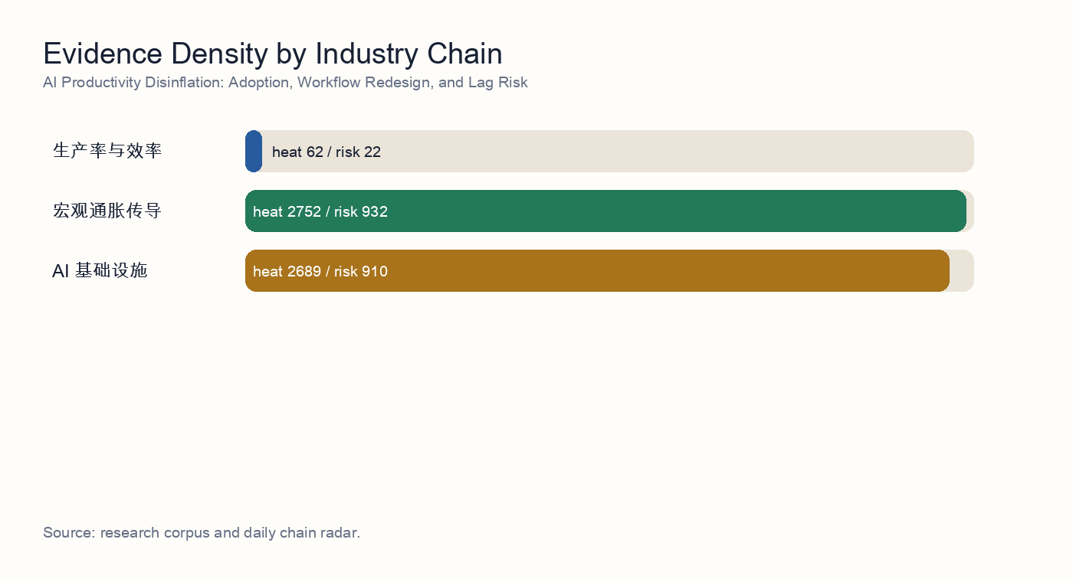
Industry-chain evidence density

2. Independent Synthesis
After reading 12 underlying source reports, the topic resolves into a sequence rather than a one-direction claim. AI demand first shows up as infrastructure buildout, then as power, grid, and equipment-delivery constraints, and only later as a possible productivity offset. The corpus therefore does not support a simple 'AI is inflationary' or 'AI is disinflationary' framing; it supports a staged capex cycle.
The strongest consensus is in power and grid infrastructure: 11 evidence items directly mention power, interconnection, firm power, utilities, or grid equipment. The repeated finding is that the compute buildout constraint is expanding from GPU supply into power access, local grid absorption, and delivery of enabling equipment.
The second consensus is that equipment delivery is not the same as compute availability. 10 items discuss transformers, distribution equipment, hardware delivery, or physical bottlenecks. Together they imply that vendor orders can be strong while project revenue recognition and live compute capacity remain constrained by interconnection, PPAs, power-node readiness, and local absorption.
Risk is not an appendix; it is part of the valuation model. This build includes 12 linked risk signals, with the central risk cluster around capex arriving before utilization, energy reliability gaps, delayed revenue timing, and crowded thematic trades. If those risks materialize, AI infrastructure valuations should be discounted with delayed cash flows and a higher capital-cost assumption.
The counter-evidence matters as well: 1 item mentions efficiency or productivity. This does not erase the bottleneck thesis, but it identifies the medium-term release valve: model efficiency, custom silicon, edge AI, and workflow automation can lower unit compute or unit task costs and weaken the reflation narrative.

Source-Level Reading
- Source reading 1: prior research notes研究报告：食品加工标准化中的工业自动化与智能包装. 因此，自动化更应被理解为结构性利润稳定器，而不是行业利润已经全面修复的证明。 工业端的核心信号是，食品自动化相对电子、汽车仍处低渗透阶段，但在中央厨房、复合调味品、饮料、乳制品、休闲食品和预制菜最关键的节点上，采用速度正在加快，包括自动化灌装、成型-充填-封口、贴标喷码、在线检测、后道装箱、码垛以及工厂级数据系统。 后续问题：A股投资者是否已经定价B端标准化与自动化带来的利润韧性，还是仍主要把食品加工标的视为由原料成本和CPI驱动的短…
- Source reading 2: 电力设备与电网侧容量缺口对算力扩建的物理约束研究. The research stress-tests whether AI compute growth is constrained by grid expansion, transformers, and distribution infrastructure rather than only by semiconductor availability.
- Source reading 3: 变压器及电力设备产业链：全球产能弹性、毛利率水平与出海竞争格局. 交付周期恶化：截至 2026 年上半年，美国大型电力变压器的平均交期为 128 周，用于发电厂并网的特殊升压变压器（GSU）交期拉长至 144 周，部分高度定制化的超高压项目交期甚至长达 4 年（近 200 周） [S1]。 分接开关的暴利：华明装备作为全球分接开关唯二的双寡头之一，其电力设备核心板块整体毛利率常年维持在 50% 以上，海外高附加值订单的毛利率更是高达 60% 左右 [S4]，对产业链成本上升具有极强的消化能力。 基于…
- Source reading 4: 变压器与液冷供应链对 AI 基础设施的约束. 本报告对前序“AI capex 正在遭遇物理部署约束”的判断作压力测试，并给出更窄的结论：变压器、变电站设备及相关电网硬件，很可能是继电力可得性之后的第二个硬物理约束；液冷同样紧张，但其供应链扩张更模块化，全球层面成为主停摆点的概率低于变压器。 压力测试结论偏支持：变压器可以成为 AI 基础设施部署的第二个关键物理约束。 下一步应检验上游材料供给和价格通胀能否承接变压器与液冷设备扩产，而不会形成第三个瓶颈。
- Source reading 5: 前序研究 · 房地产视角反驳：真正的瓶颈是土地，不是变压器. 本会话根主题（及前序研究策略师的叙事）大致是： GPU紧缺 → 电力大型变压器(LPT)紧缺 → 电网并网排队，正在成为AI算力扩张的新约束。 根主题：AI算力物理瓶颈——从GPU算力到电力变压器与电网并网瓶颈的转移。 https://www.energy.gov/policy/large-power-transformers-and-us-electric-grid。
- Source reading 6: 智算中心扩张下的能源供给压力与新型电力系统建设. [S13] Rocky Mountain Institute, China's New-Type Power System: 2030 Capex Outlook （2025）— https://rmi.org/insight/china-new-type-power-system-2030。 [S12] 国家电网, "2026年迎峰度夏电力供应保障形势分析"（2026-05 发布）— https://www.sgcc.com.cn/…
- Source reading 7: AI 算力扩张驱动下的电力基础设施（变压器与电网设备）需求确定性分析. 电网侧的配电/电力变压器与关键功率器件正处于 结构性供给短缺 + 多年订单锁定 + 单价上行 三重共振，AI 数据中心是边际加速器而非全部需求源，因此该子板块在未来 24–36 个月内的需求确定性显著高于"宽泛 AI 算力"本身，利润率仍有 200–400bp 的扩张空间，是研究记录 01 物理化主线中 信号最干净的赛道。 因此 未来 24–36 个月内，电力变压器与配电设备的"卖方市场"格局基本锁定，订单可见度（book-to-bi…
- Source reading 8: 研究记录 07 · 硅钢（GOES）产能缺口对变压器毛利的压力测试. 变压器订单延期：如果上游电力信用紧缩（研究记录）导致 IPP / 数据中心订单延期 6 个月以上，GOES 缺口会自然消化 1/3–1/2，但这也意味着研究记录 的 spread 行情节奏延后。 核心判断：普通 GOES 几乎平衡，但 高磁感 / 超薄规格存在 280–560 kt 的硬缺口 ——这与研究记录 提出的"变压器交付周期 130–160 周"在时间维度上完全吻合，因为变压器 OEM 拿不到 0.18–0.20 mm 卷板…

3. Research Questions
- Is the evidence for AI adoption and workflow redesign strong enough?
- Can the Jevons effect turn lower unit costs into higher aggregate demand?
- Has the market priced the productivity dividend too early?

4. Evidence Map
The selected topic spans productivity and efficiency, macro inflation transmission, AI infrastructure. The evidence ledger below rewrites AI Institute research results into standalone evidence summaries. Readers do not need to know the research production workflow or have private access to follow the argument.
- Evidence 1 | 2026-05-17 | unlabeled analyst: prior research notes研究报告：食品加工标准化中的工业自动化与智能包装. Summary: 因此，自动化更应被理解为结构性利润稳定器，而不是行业利润已经全面修复的证明。 工业端的核心信号是，食品自动化相对电子、汽车仍处低渗透阶段，但在中央厨房、复合调味品、饮料、乳制品、休闲食品和预制菜最关键的节点上，采用速度正在加快，包括自动化灌装、成型-充填-封口、贴标喷码、在线检测、后道装箱、码垛以及工厂级数据系统。 后续问题：A股投资者是否已经定价B端标准化与自动化带来的利润韧性，还是仍主要把食品加工标的视为由原料成本和CPI驱动的短… Implication: Shows that consumer downgrade can coexist with structural demand created by cost reduction and healthier substitution.
- Evidence 2 | 2026-05-23 | unlabeled analyst: 电力设备与电网侧容量缺口对算力扩建的物理约束研究. Summary: The research stress-tests whether AI compute growth is constrained by grid expansion, transformers, and distribution infrastructure rather than only by semiconductor availability. Implication: Shows that the first binding constraint is power, grid access, and equipment delivery, not only chip supply.
- Evidence 3 | 2026-05-23 | unlabeled analyst: 变压器及电力设备产业链：全球产能弹性、毛利率水平与出海竞争格局. Summary: 交付周期恶化：截至 2026 年上半年，美国大型电力变压器的平均交期为 128 周，用于发电厂并网的特殊升压变压器（GSU）交期拉长至 144 周，部分高度定制化的超高压项目交期甚至长达 4 年（近 200 周） [S1]。 分接开关的暴利：华明装备作为全球分接开关唯二的双寡头之一，其电力设备核心板块整体毛利率常年维持在 50% 以上，海外高附加值订单的毛利率更是高达 60% 左右 [S4]，对产业链成本上升具有极强的消化能力。 基于… Implication: Shows that the first binding constraint is power, grid access, and equipment delivery, not only chip supply.
- Evidence 4 | 2026-05-23 | unlabeled analyst: 变压器与液冷供应链对 AI 基础设施的约束. Summary: 本报告对前序“AI capex 正在遭遇物理部署约束”的判断作压力测试，并给出更窄的结论：变压器、变电站设备及相关电网硬件，很可能是继电力可得性之后的第二个硬物理约束；液冷同样紧张，但其供应链扩张更模块化，全球层面成为主停摆点的概率低于变压器。 压力测试结论偏支持：变压器可以成为 AI 基础设施部署的第二个关键物理约束。 下一步应检验上游材料供给和价格通胀能否承接变压器与液冷设备扩产，而不会形成第三个瓶颈。 Implication: Shows that the first binding constraint is power, grid access, and equipment delivery, not only chip supply.
- Evidence 5 | 2026-05-23 | unlabeled analyst: 前序研究 · 房地产视角反驳：真正的瓶颈是土地，不是变压器. Summary: 本会话根主题（及前序研究策略师的叙事）大致是： GPU紧缺 → 电力大型变压器(LPT)紧缺 → 电网并网排队，正在成为AI算力扩张的新约束。 根主题：AI算力物理瓶颈——从GPU算力到电力变压器与电网并网瓶颈的转移。 https://www.energy.gov/policy/large-power-transformers-and-us-electric-grid。 Implication: Shows that the first binding constraint is power, grid access, and equipment delivery, not only chip supply.
- Evidence 6 | 2026-05-22 | unlabeled analyst: 智算中心扩张下的能源供给压力与新型电力系统建设. Summary: [S13] Rocky Mountain Institute, China's New-Type Power System: 2030 Capex Outlook （2025）— https://rmi.org/insight/china-new-type-power-system-2030。 [S12] 国家电网, "2026年迎峰度夏电力供应保障形势分析"（2026-05 发布）— https://www.sgcc.com.cn/… Implication: Shows that the first binding constraint is power, grid access, and equipment delivery, not only chip supply.
- Evidence 7 | 2026-05-22 | unlabeled analyst: AI 算力扩张驱动下的电力基础设施（变压器与电网设备）需求确定性分析. Summary: 电网侧的配电/电力变压器与关键功率器件正处于 结构性供给短缺 + 多年订单锁定 + 单价上行 三重共振，AI 数据中心是边际加速器而非全部需求源，因此该子板块在未来 24–36 个月内的需求确定性显著高于"宽泛 AI 算力"本身，利润率仍有 200–400bp 的扩张空间，是研究记录 01 物理化主线中 信号最干净的赛道。 因此 未来 24–36 个月内，电力变压器与配电设备的"卖方市场"格局基本锁定，订单可见度（book-to-bi… Implication: Shows that the first binding constraint is power, grid access, and equipment delivery, not only chip supply.
- Evidence 8 | 2026-05-21 | unlabeled analyst: 研究记录 07 · 硅钢（GOES）产能缺口对变压器毛利的压力测试. Summary: 变压器订单延期：如果上游电力信用紧缩（研究记录）导致 IPP / 数据中心订单延期 6 个月以上，GOES 缺口会自然消化 1/3–1/2，但这也意味着研究记录 的 spread 行情节奏延后。 核心判断：普通 GOES 几乎平衡，但 高磁感 / 超薄规格存在 280–560 kt 的硬缺口 ——这与研究记录 提出的"变压器交付周期 130–160 周"在时间维度上完全吻合，因为变压器 OEM 拿不到 0.18–0.20 mm 卷板… Implication: Shows that the first binding constraint is power, grid access, and equipment delivery, not only chip supply.
- Evidence 9 | 2026-05-20 | unlabeled analyst: 研究记录 06 研究报告：电力设备供应链的产能与交付周期评估，2026-05-20. Summary: 截至 2026-05-20，我们支持研究记录 05 的结论：AI 资本开支瓶颈已经从全国总发电量是否足够，转向站点级电力基础设施能否按期交付。 如果以下三项同时出现，我们会下调瓶颈评分：大型电力变压器交付周期降至 18-24 个月以下，电气 OEM book-to-bill 连续两个季度回到 1.0 附近，且铜和 GOES 供应改善同时没有价格上行。 Eaton、GE Vernova、Siemens Energy、Schneider… Implication: Shows that the first binding constraint is power, grid access, and equipment delivery, not only chip supply.
- Evidence 10 | 2026-05-19 | utilities analyst: 电网基础设施扩容节奏 vs AI 算力资本开支切换. Summary: 风险关注:特朗普政府如对中国变压器/GOES 进一步加征关税,将 进一步收紧 西方 LPT 瓶颈 (装备 ASP 利多、项目工期利空)。 这一约束反而 强化 了在位设备龙头的 re-rating 逻辑,同时 抬升 了超大规模云厂商执行进度的风险。 后续问题:压力测试日立能源、西门子能源、GE Vernova、TBEA、中国西电、Cleveland-Cliffs / 新日铁 2026–2028 年 LPT 与 GOES 实际产能爬坡——… Implication: Shows that the first binding constraint is power, grid access, and equipment delivery, not only chip supply.
- Evidence 11 | 2026-05-19 | industrials analyst: 工业制造分析师报告 - 2026-05-19. Summary: 因此，风险不是液冷设备无法制造，而是市场低估了集成瓶颈：冷板与 GPU 代际匹配、快速接头可靠性、冷却液化学、CDU 冗余、泄漏检测、现场服务密度，以及在不中断在线负载的情况下改造风冷设施。 不要给所有“AI 电力”标签相同估值： 随着 2026 年交付节点临近，真实产能槽与主题敞口之间的估值差应扩大。 大型电力变压器仍是最硬的制造端瓶颈；中压开关设备与液冷系统扩产更快，但订单簿同时被数据中心、公用事业、可再生能源、制造业回流和电网韧… Implication: Shows that the first binding constraint is power, grid access, and equipment delivery, not only chip supply.
- Evidence 12 | 2026-05-18 | unlabeled analyst: 关键电力设备供应链瓶颈：变压器与开关设备交付周期调研. Summary: 结论：大型电力变压器（LPT，≥100 MVA）与中压开关设备的交付周期在 2027 年前结构性拉长，2028 年底前难以正常化， 验证了瓶颈框架但收紧了其内涵 ——2026–2027 年 AI 集群通电的真正硬约束并非变压器本体产能，而是 (i) 取向硅钢（GOES）的供应、(ii) 熟练绕线/调试工程师的劳动力缺口。 多头逻辑的尾部风险 ——2027 年 GOES 价格冲击或美国输配电劳工罢工事件会进一步右移交付期；反向地，Sec… Implication: Shows that the first binding constraint is power, grid access, and equipment delivery, not only chip supply.

5. Evidence Cluster Deep Dive
Individual evidence items explain facts; an investable conclusion requires evidence to form the same transmission chain. The sections below reorganize the source reports across policy, orders, grid demand, equipment capacity, and materials so that real demand is separated from retainable profit.

B-End Food Processing and Sugar-Substitute Demand
This cluster shows that consumer downgrade does not mean the whole food-processing chain weakens. 1 sources focus on B-end catering cost reduction, semi-finished food penetration, GLP-1-driven sugar reduction, and the allulose cost curve. Representative sources include: prior research notes研究报告：食品加工标准化中的工业自动化与智能包装.
Demand comes from two channels: restaurant operators raising standardized-ingredient usage to cut labor and kitchen space, and consumers or brands seeking sugar substitutes with a closer sucrose-like experience. The first channel should be validated through customer retention, repeat purchase, and inventory turns; the second through price curves, capacity release, and end-product reformulation.

Consumer Downgrade and Sell-Through Quality
The consumer-downgrade evidence emphasizes that policy stimulus and premium-experience data both require sell-through validation. 1 sources discuss trade-in programs, ticket size, ASP, cruise or travel spending, and consumption segmentation. Representative sources include: 电网基础设施扩容节奏 vs AI 算力资本开支切换.
This evidence prevents short-term subsidies, channel restocking, or high-income cohort spending from being mistaken for broad consumption recovery. Portfolio construction should demand stricter indicators: terminal volume, discount rate, repeat purchase, ticket size, inventory turns, and receivables.

Credit Stress and Household Purchasing Power
The credit and income evidence provides the macro constraint for the consumer chain. 1 sources discuss consumer credit, household balance sheets, financial pricing, or purchasing power. Representative sources include: 研究记录 07 · 硅钢（GOES）产能缺口对变压器毛利的压力测试.
If consumer credit quality weakens, discretionary consumption, durable replacement, and premium self-pay healthcare are pressured. Medical insurance, long-term care insurance, and chronic-disease medicines remain more resilient. Credit stress is therefore not only a risk factor; it is a sorting tool for defensive demand.

Industrial Execution and Supply-Chain Reality
The industrial evidence reminds investors that demand narratives need manufacturing and delivery capability to turn into profit. 7 sources focus on capacity, quality, cost curves, supply chains, and execution cadence. Representative sources include: 电力设备与电网侧容量缺口对算力扩建的物理约束研究; 变压器及电力设备产业链：全球产能弹性、毛利率水平与出海竞争格局; 变压器与液冷供应链对 AI 基础设施的约束.
For food processing, medical devices, rehabilitation equipment, and peptide APIs, profit comes from repeatable production processes, cost control, compliant delivery, and stable channels, not from demand existence alone. If manufacturing bottlenecks or compliance issues delay delivery, thematic valuation should be cut.

Policy Barrier and Compliance Channel
This evidence cluster shows that overseas demand does not automatically become Chinese vendor profit. 1 sources emphasize tariffs, subsidy eligibility, procurement rules, security reviews, and anti-circumvention enforcement as filters between demand and realized margin. Representative sources include: 前序研究 · 房地产视角反驳：真正的瓶颈是土地，不是变压器.
The investment question therefore shifts from whether exports grow to whether the order jurisdiction, capacity location, core-component origin, and customer procurement rules allow the price premium to be retained. If a company must reroute shipments at lower margins or absorb compliance costs, AI grid demand can still expand while equity returns disappoint.

Cross-Sector Margin and Supply-Chain Evidence
The cross-sector evidence provides a reference case for policy and diversification costs. 1 sources are not all direct power-equipment reports, but they help estimate how tariff stacking, dual supply chains, working-capital drag, and inventory write-down risk can enter export margins. Representative sources include: 智算中心扩张下的能源供给压力与新型电力系统建设.
This evidence should not replace sector data, but it is useful as a stress parameter. If the cross-sector policy multiplier repeats in equipment, the market's linear extrapolation from overseas orders to overseas margins will be too optimistic.

6. Policy, Delivery, and Margin Framework
The core of this topic is not export growth alone. Demand, policy, delivery, cost, and valuation layers jointly decide who owns the profit pool. AI grid demand is the starting point; trade barriers and localized delivery are filters; materials and contract clauses determine gross margin; capital costs and crowding determine the valuation investors are willing to pay.
Layer | Main variables | Financial transmission | Investment implication
Demand | AI data centers, grid expansion, overseas replacement demand | Order growth, prepayments, production scheduling | Demand can be real while policy and delivery filters intercept profit
Policy | Tariffs, anti-circumvention, subsidy eligibility, procurement limits, security reviews | Compliance cost, customer exclusion, order migration | Determines whether exports become high-margin revenue
Delivery | Localized capacity, certification, interconnection, logistics, project acceptance | Delayed revenue recognition, cash-flow mismatch, inventory drag | Determines the gap between order intake and the income statement
Cost | Copper, aluminum, GOES, core components, FX | Gross-margin pressure or repricing power | Determines how the equipment-chain profit pool is allocated
Valuation | Capital cost, crowded positioning, utilization, customer capex | Discount-rate changes and earnings-conversion probability | Determines whether the theme becomes an earnings cycle

7. Transmission Model
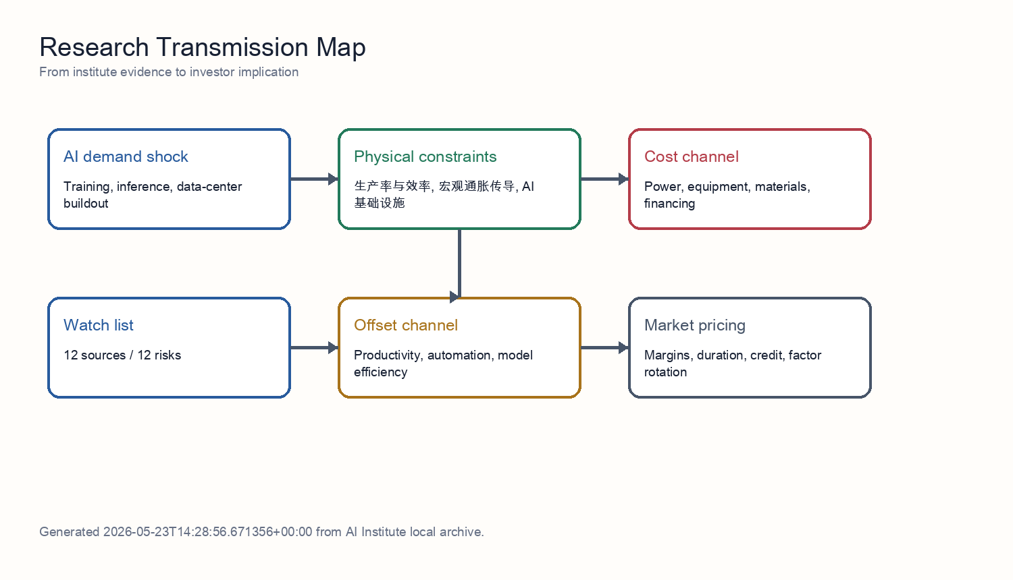
Transmission model
The mechanism separates demand, constraints, and pricing. Demand comes from training, inference, and data-center construction. Constraints come from grid access, transformers, materials, semiconductors, and delivery cycles. Pricing shows up in electricity prices, equipment prices, capital costs, and margin allocation. Productivity is the offsetting force, but it normally requires adoption, workflow redesign, and organizational change, so it tends to arrive later than capex.
For Chinese power-equipment exports, the chain also needs a policy filter. US and EU policy does not eliminate global grid-upgrade demand, but it changes profit ownership: orders can migrate toward local manufacturing, third-country capacity, less sensitive components, or lower-priced suppliers. The stricter the policy layer, the more overseas orders need to be discounted for deliverability and compliance cost.
The AI-inflation relationship is therefore not one direction; it is a sequence. Power, grid, metals, and equipment prices react first. Data-center utilization and enterprise automation determine whether the cost can be absorbed in the middle phase. Only later can productivity growth offset the capital-expenditure impulse.

8. Source-by-Source Interpretation
The following section translates each source into an actionable investment input. The goal is to let a reader without private research access understand how each evidence item enters the final conclusion.

Source 1: prior research notes研究报告：食品加工标准化中的工业自动化与智能包装
This evidence belongs to the b-end food processing and sugar-substitute demand cluster. Its direct contribution is: 因此，自动化更应被理解为结构性利润稳定器，而不是行业利润已经全面修复的证明。 工业端的核心信号是，食品自动化相对电子、汽车仍处低渗透阶段，但在中央厨房、复合调味品、饮料、乳制品、休闲食品和预制菜最关键的节点上，采用速度正在加快，包括自动化灌装、成型-充填-封口、贴标喷码、在线检测、后道装箱、码垛以及工厂级数据系统。 后续问题：A股投资者是否已经定价B端标准化与自动化带来的利润韧性，还是仍主要把食品加工标的视为由原料成本和CPI驱动的短… That moves the topic from a macro narrative into testable operating variables such as purchasing power, terminal sell-through, policy conversion, cost curve, compliant delivery, and cash collection.
The investment implication is: Shows that consumer downgrade can coexist with structural demand created by cost reduction and healthier substitution. At the portfolio level, it should not be treated as a standalone buy signal. It should be combined with other sources in the same cluster; when several sources point to the same constraint, the constraint becomes large enough to affect valuation and margins.
The falsifier to track is: If B-end repeat purchase weakens, inventory turns slow, or allulose pricing falls quickly, the food-processing and sugar-substitute growth assumption should be cut.

Source 2: 电力设备与电网侧容量缺口对算力扩建的物理约束研究
This evidence belongs to the industrial execution and supply-chain reality cluster. Its direct contribution is: The research stress-tests whether AI compute growth is constrained by grid expansion, transformers, and distribution infrastructure rather than only by semiconductor availability. That moves the topic from a macro narrative into testable operating variables such as purchasing power, terminal sell-through, policy conversion, cost curve, compliant delivery, and cash collection.
The investment implication is: Shows that the first binding constraint is power, grid access, and equipment delivery, not only chip supply. At the portfolio level, it should not be treated as a standalone buy signal. It should be combined with other sources in the same cluster; when several sources point to the same constraint, the constraint becomes large enough to affect valuation and margins.
The falsifier to track is: If capacity, quality, compliance, or delivery cannot convert orders, thematic demand should not flow directly into earnings forecasts.

Source 3: 变压器及电力设备产业链：全球产能弹性、毛利率水平与出海竞争格局
This evidence belongs to the industrial execution and supply-chain reality cluster. Its direct contribution is: 交付周期恶化：截至 2026 年上半年，美国大型电力变压器的平均交期为 128 周，用于发电厂并网的特殊升压变压器（GSU）交期拉长至 144 周，部分高度定制化的超高压项目交期甚至长达 4 年（近 200 周） [S1]。 分接开关的暴利：华明装备作为全球分接开关唯二的双寡头之一，其电力设备核心板块整体毛利率常年维持在 50% 以上，海外高附加值订单的毛利率更是高达 60% 左右 [S4]，对产业链成本上升具有极强的消化能力。 基于… That moves the topic from a macro narrative into testable operating variables such as purchasing power, terminal sell-through, policy conversion, cost curve, compliant delivery, and cash collection.
The investment implication is: Shows that the first binding constraint is power, grid access, and equipment delivery, not only chip supply. At the portfolio level, it should not be treated as a standalone buy signal. It should be combined with other sources in the same cluster; when several sources point to the same constraint, the constraint becomes large enough to affect valuation and margins.
The falsifier to track is: If capacity, quality, compliance, or delivery cannot convert orders, thematic demand should not flow directly into earnings forecasts.

Source 4: 变压器与液冷供应链对 AI 基础设施的约束
This evidence belongs to the industrial execution and supply-chain reality cluster. Its direct contribution is: 本报告对前序“AI capex 正在遭遇物理部署约束”的判断作压力测试，并给出更窄的结论：变压器、变电站设备及相关电网硬件，很可能是继电力可得性之后的第二个硬物理约束；液冷同样紧张，但其供应链扩张更模块化，全球层面成为主停摆点的概率低于变压器。 压力测试结论偏支持：变压器可以成为 AI 基础设施部署的第二个关键物理约束。 下一步应检验上游材料供给和价格通胀能否承接变压器与液冷设备扩产，而不会形成第三个瓶颈。 That moves the topic from a macro narrative into testable operating variables such as purchasing power, terminal sell-through, policy conversion, cost curve, compliant delivery, and cash collection.
The investment implication is: Shows that the first binding constraint is power, grid access, and equipment delivery, not only chip supply. At the portfolio level, it should not be treated as a standalone buy signal. It should be combined with other sources in the same cluster; when several sources point to the same constraint, the constraint becomes large enough to affect valuation and margins.
The falsifier to track is: If capacity, quality, compliance, or delivery cannot convert orders, thematic demand should not flow directly into earnings forecasts.

Source 5: 前序研究 · 房地产视角反驳：真正的瓶颈是土地，不是变压器
This evidence belongs to the policy barrier and compliance channel cluster. Its direct contribution is: 本会话根主题（及前序研究策略师的叙事）大致是： GPU紧缺 → 电力大型变压器(LPT)紧缺 → 电网并网排队，正在成为AI算力扩张的新约束。 根主题：AI算力物理瓶颈——从GPU算力到电力变压器与电网并网瓶颈的转移。 https://www.energy.gov/policy/large-power-transformers-and-us-electric-grid。 That moves the topic from a macro narrative into testable operating variables such as order quality, delivery time, input costs, interconnection status, and policy accessibility.
The investment implication is: Shows that the first binding constraint is power, grid access, and equipment delivery, not only chip supply. At the portfolio level, it should not be treated as a standalone buy signal. It should be combined with other sources in the same cluster; when several sources point to the same constraint, the constraint becomes large enough to affect valuation and margins.
The falsifier to track is: If the US and EU create clear exemptions, localization paths widen, or procurement rules permit Chinese core components in premium projects, the policy discount should fall.

Source 6: 智算中心扩张下的能源供给压力与新型电力系统建设
This evidence belongs to the cross-sector margin and supply-chain evidence cluster. Its direct contribution is: [S13] Rocky Mountain Institute, China's New-Type Power System: 2030 Capex Outlook （2025）— https://rmi.org/insight/china-new-type-power-system-2030。 [S12] 国家电网, "2026年迎峰度夏电力供应保障形势分析"（2026-05 发布）— https://www.sgcc.com.cn/… That moves the topic from a macro narrative into testable operating variables such as order quality, delivery time, input costs, interconnection status, and policy accessibility.
The investment implication is: Shows that the first binding constraint is power, grid access, and equipment delivery, not only chip supply. At the portfolio level, it should not be treated as a standalone buy signal. It should be combined with other sources in the same cluster; when several sources point to the same constraint, the constraint becomes large enough to affect valuation and margins.
The falsifier to track is: If diversification costs do not appear in power-equipment financials, the evidence should be used only as a tail-risk stress test, not as a core margin assumption.

Source 7: AI 算力扩张驱动下的电力基础设施（变压器与电网设备）需求确定性分析
This evidence belongs to the industrial execution and supply-chain reality cluster. Its direct contribution is: 电网侧的配电/电力变压器与关键功率器件正处于 结构性供给短缺 + 多年订单锁定 + 单价上行 三重共振，AI 数据中心是边际加速器而非全部需求源，因此该子板块在未来 24–36 个月内的需求确定性显著高于"宽泛 AI 算力"本身，利润率仍有 200–400bp 的扩张空间，是研究记录 01 物理化主线中 信号最干净的赛道。 因此 未来 24–36 个月内，电力变压器与配电设备的"卖方市场"格局基本锁定，订单可见度（book-to-bi… That moves the topic from a macro narrative into testable operating variables such as purchasing power, terminal sell-through, policy conversion, cost curve, compliant delivery, and cash collection.
The investment implication is: Shows that the first binding constraint is power, grid access, and equipment delivery, not only chip supply. At the portfolio level, it should not be treated as a standalone buy signal. It should be combined with other sources in the same cluster; when several sources point to the same constraint, the constraint becomes large enough to affect valuation and margins.
The falsifier to track is: If capacity, quality, compliance, or delivery cannot convert orders, thematic demand should not flow directly into earnings forecasts.

Source 8: 研究记录 07 · 硅钢（GOES）产能缺口对变压器毛利的压力测试
This evidence belongs to the credit stress and household purchasing power cluster. Its direct contribution is: 变压器订单延期：如果上游电力信用紧缩（研究记录）导致 IPP / 数据中心订单延期 6 个月以上，GOES 缺口会自然消化 1/3–1/2，但这也意味着研究记录 的 spread 行情节奏延后。 核心判断：普通 GOES 几乎平衡，但 高磁感 / 超薄规格存在 280–560 kt 的硬缺口 ——这与研究记录 提出的"变压器交付周期 130–160 周"在时间维度上完全吻合，因为变压器 OEM 拿不到 0.18–0.20 mm 卷板… That moves the topic from a macro narrative into testable operating variables such as purchasing power, terminal sell-through, policy conversion, cost curve, compliant delivery, and cash collection.
The investment implication is: Shows that the first binding constraint is power, grid access, and equipment delivery, not only chip supply. At the portfolio level, it should not be treated as a standalone buy signal. It should be combined with other sources in the same cluster; when several sources point to the same constraint, the constraint becomes large enough to affect valuation and margins.
The falsifier to track is: If consumer-credit deterioration widens, all self-pay and premium-experience demand assumptions should be revised down.

Source 9: 研究记录 06 研究报告：电力设备供应链的产能与交付周期评估，2026-05-20
This evidence belongs to the industrial execution and supply-chain reality cluster. Its direct contribution is: 截至 2026-05-20，我们支持研究记录 05 的结论：AI 资本开支瓶颈已经从全国总发电量是否足够，转向站点级电力基础设施能否按期交付。 如果以下三项同时出现，我们会下调瓶颈评分：大型电力变压器交付周期降至 18-24 个月以下，电气 OEM book-to-bill 连续两个季度回到 1.0 附近，且铜和 GOES 供应改善同时没有价格上行。 Eaton、GE Vernova、Siemens Energy、Schneider… That moves the topic from a macro narrative into testable operating variables such as purchasing power, terminal sell-through, policy conversion, cost curve, compliant delivery, and cash collection.
The investment implication is: Shows that the first binding constraint is power, grid access, and equipment delivery, not only chip supply. At the portfolio level, it should not be treated as a standalone buy signal. It should be combined with other sources in the same cluster; when several sources point to the same constraint, the constraint becomes large enough to affect valuation and margins.
The falsifier to track is: If capacity, quality, compliance, or delivery cannot convert orders, thematic demand should not flow directly into earnings forecasts.

Source 10: 电网基础设施扩容节奏 vs AI 算力资本开支切换
This evidence belongs to the consumer downgrade and sell-through quality cluster. Its direct contribution is: 风险关注:特朗普政府如对中国变压器/GOES 进一步加征关税,将 进一步收紧 西方 LPT 瓶颈 (装备 ASP 利多、项目工期利空)。 这一约束反而 强化 了在位设备龙头的 re-rating 逻辑,同时 抬升 了超大规模云厂商执行进度的风险。 后续问题:压力测试日立能源、西门子能源、GE Vernova、TBEA、中国西电、Cleveland-Cliffs / 新日铁 2026–2028 年 LPT 与 GOES 实际产能爬坡——… That moves the topic from a macro narrative into testable operating variables such as purchasing power, terminal sell-through, policy conversion, cost curve, compliant delivery, and cash collection.
The investment implication is: Shows that the first binding constraint is power, grid access, and equipment delivery, not only chip supply. At the portfolio level, it should not be treated as a standalone buy signal. It should be combined with other sources in the same cluster; when several sources point to the same constraint, the constraint becomes large enough to affect valuation and margins.
The falsifier to track is: If ticket size falls, discounts widen, repeat purchase disappoints, or volume fades after subsidies expire, the consumption-resilience evidence should receive lower weight.

Source 11: 工业制造分析师报告 - 2026-05-19
This evidence belongs to the industrial execution and supply-chain reality cluster. Its direct contribution is: 因此，风险不是液冷设备无法制造，而是市场低估了集成瓶颈：冷板与 GPU 代际匹配、快速接头可靠性、冷却液化学、CDU 冗余、泄漏检测、现场服务密度，以及在不中断在线负载的情况下改造风冷设施。 不要给所有“AI 电力”标签相同估值： 随着 2026 年交付节点临近，真实产能槽与主题敞口之间的估值差应扩大。 大型电力变压器仍是最硬的制造端瓶颈；中压开关设备与液冷系统扩产更快，但订单簿同时被数据中心、公用事业、可再生能源、制造业回流和电网韧… That moves the topic from a macro narrative into testable operating variables such as purchasing power, terminal sell-through, policy conversion, cost curve, compliant delivery, and cash collection.
The investment implication is: Shows that the first binding constraint is power, grid access, and equipment delivery, not only chip supply. At the portfolio level, it should not be treated as a standalone buy signal. It should be combined with other sources in the same cluster; when several sources point to the same constraint, the constraint becomes large enough to affect valuation and margins.
The falsifier to track is: If capacity, quality, compliance, or delivery cannot convert orders, thematic demand should not flow directly into earnings forecasts.

Source 12: 关键电力设备供应链瓶颈：变压器与开关设备交付周期调研
This evidence belongs to the industrial execution and supply-chain reality cluster. Its direct contribution is: 结论：大型电力变压器（LPT，≥100 MVA）与中压开关设备的交付周期在 2027 年前结构性拉长，2028 年底前难以正常化， 验证了瓶颈框架但收紧了其内涵 ——2026–2027 年 AI 集群通电的真正硬约束并非变压器本体产能，而是 (i) 取向硅钢（GOES）的供应、(ii) 熟练绕线/调试工程师的劳动力缺口。 多头逻辑的尾部风险 ——2027 年 GOES 价格冲击或美国输配电劳工罢工事件会进一步右移交付期；反向地，Sec… That moves the topic from a macro narrative into testable operating variables such as purchasing power, terminal sell-through, policy conversion, cost curve, compliant delivery, and cash collection.
The investment implication is: Shows that the first binding constraint is power, grid access, and equipment delivery, not only chip supply. At the portfolio level, it should not be treated as a standalone buy signal. It should be combined with other sources in the same cluster; when several sources point to the same constraint, the constraint becomes large enough to affect valuation and margins.
The falsifier to track is: If capacity, quality, compliance, or delivery cannot convert orders, thematic demand should not flow directly into earnings forecasts.

9. Stress Tests

Stress Test 1: Trade Policy Tightens Further
If the US and EU continue to tighten tariffs, procurement rules, subsidy eligibility, or security reviews, the first effect is not the disappearance of global demand. The first effect is reduced accessibility to the highest-margin markets. Orders may still exist, but they migrate from direct export into local manufacturing, third-country capacity, less sensitive components, or lower-priced alternatives. Portfolio construction should raise the haircut on overseas orders and prefer companies that already have localized capacity and customer certification.

Stress Test 2: Equipment Lead Times Shorten Without Price Deflation
This is the most constructive combination for equipment leaders. Shorter lead times show that capacity expansion is working; stable prices show that demand is still strong enough to absorb added supply. In that case, the market should move from bottleneck pricing to earnings conversion, with emphasis on revenue recognition, segment margin, and operating cash flow moving together.

Stress Test 3: Copper, Aluminum, and GOES Rise Faster Than Order Repricing
This is the most dangerous margin combination. Revenue can remain strong because the order book is full, while the cost stack compresses gross margin. Company dispersion comes from contract clauses, procurement locks, and inventory management. Firms without price escalation should receive lower margin assumptions; firms with material hedges and high-end core-component control deserve a relative premium.

Stress Test 4: AI Efficiency Improves Fast Enough to Weaken Incremental Equipment Orders
If model efficiency, ASICs, edge AI, and workflow automation reduce unit compute requirements quickly, the equipment chain shifts from a demand-expansion trade to an order-quality audit. This does not necessarily cancel existing grid investment, but it compresses the market's extrapolation of 2027 and later orders. The portfolio response is to reduce pure theme exposure and demand stronger evidence of cash flow and confirmed backlog.

10. Risk Matrix
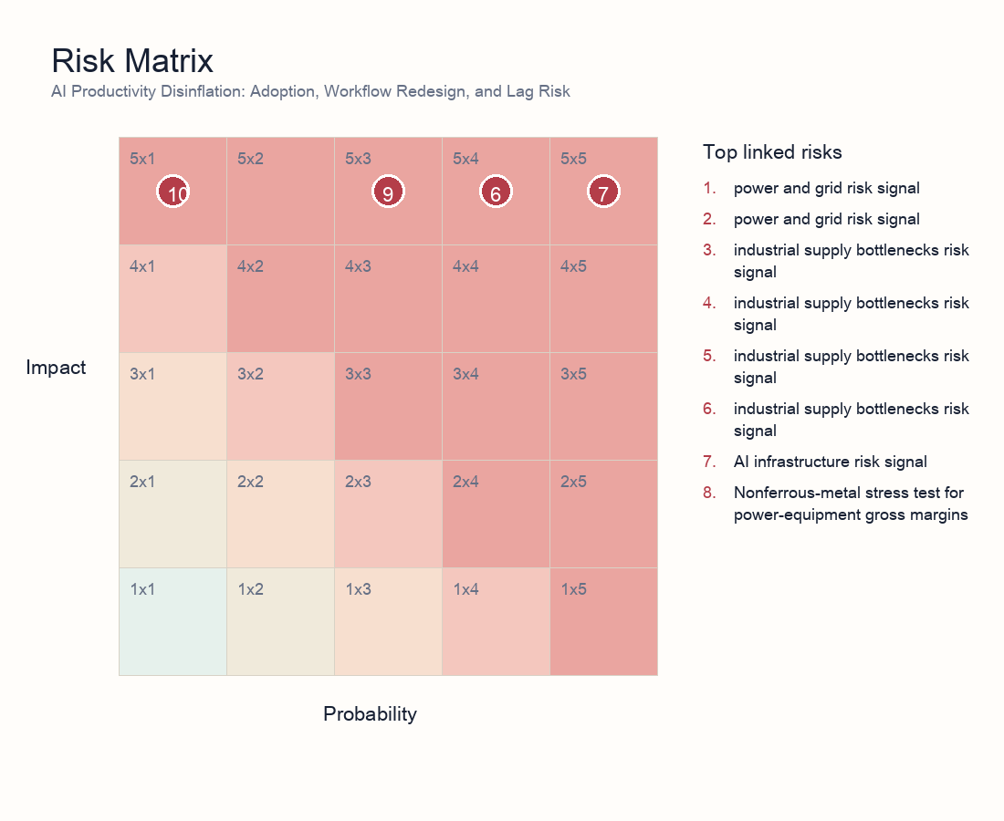
Risk matrix
- Risk 1 | power and grid | 5/5: power and grid risk signal. Explanation: Flags power and grid execution risk that can delay capacity, pressure margins, or raise discount rates.
- Risk 2 | power and grid | 5/4: power and grid risk signal. Explanation: Flags power and grid execution risk that can delay capacity, pressure margins, or raise discount rates.
- Risk 3 | industrial supply bottlenecks | 5/4: industrial supply bottlenecks risk signal. Explanation: Flags industrial supply bottlenecks execution risk that can delay capacity, pressure margins, or raise discount rates.
- Risk 4 | industrial supply bottlenecks | 5/3: industrial supply bottlenecks risk signal. Explanation: Flags industrial supply bottlenecks execution risk that can delay capacity, pressure margins, or raise discount rates.
- Risk 5 | industrial supply bottlenecks | 5/3: industrial supply bottlenecks risk signal. Explanation: Flags industrial supply bottlenecks execution risk that can delay capacity, pressure margins, or raise discount rates.
- Risk 6 | industrial supply bottlenecks | 5/4: industrial supply bottlenecks risk signal. Explanation: The research stress-tests whether AI compute growth is constrained by grid expansion, transformers, and distribution infrastructure rather than only by semiconductor availability.
- Risk 7 | AI infrastructure | 5/5: AI infrastructure risk signal. Explanation: Flags AI infrastructure execution risk that can delay capacity, pressure margins, or raise discount rates.
- Risk 8 | industrial supply bottlenecks | 5/1: Nonferrous-metal stress test for power-equipment gross margins. Explanation: Tests whether copper and aluminum price pressure can compress power-equipment margins and earnings visibility.
- Risk 9 | AI infrastructure | 5/3: AI infrastructure risk signal. Explanation: Flags AI infrastructure execution risk that can delay capacity, pressure margins, or raise discount rates.
- Risk 10 | power and grid | 5/1: power and grid risk signal. Explanation: Flags power and grid execution risk that can delay capacity, pressure margins, or raise discount rates.
- Risk 11 | industrial supply bottlenecks | 5/1: industrial supply bottlenecks risk signal. Explanation: Flags industrial supply bottlenecks execution risk that can delay capacity, pressure margins, or raise discount rates.
- Risk 12 | AI infrastructure | 5/3: AI infrastructure risk signal. Explanation: Flags AI infrastructure execution risk that can delay capacity, pressure margins, or raise discount rates.

11. Scenario Analysis
Scenario | Trigger | Macro/asset implication | Investor action
Supply relief | Shorter equipment lead times, stable power prices, higher model efficiency | AI infrastructure margins expand and inflation concern fades | Favor quality equipment and efficiency beneficiaries; reduce pure-duration narrative exposure
Bottleneck persistence | Transformer/GOES/interconnection constraints persist; PPAs and capital costs rise | Capex monetization lags valuation; inflation stickiness rises | Prefer cash-flow-backed equipment exposure; control crowded data-center trades
Demand migration | Cloud constraints push edge AI, ASICs, and automation substitutes | Hardware demand migrates while software efficiency buffers inflation | Allocate to architecture substitution and efficiency tools; stay selective on long-duration themes

12. Portfolio and Valuation Implications
Valuation cannot be explained by demand multiples alone. A cleaner model decomposes overseas orders into order value, deliverable share, retainable gross margin, revenue-recognition timing, and cash-collection timing, then probability-adjusts those variables against 12 linked risk signals. This avoids discounting every overseas order at the same margin and the same time horizon.
The first valuation premium belongs to delivery certainty: firms with localized capacity, core-component control, certification, and long-standing customer relationships deserve a lower order haircut. The second premium belongs to price architecture: firms that can protect margins when copper, aluminum, and GOES rise are proving stronger contract structure and bargaining power.
The discount factors are equally clear. If orders concentrate in high-policy-risk markets, or if revenue depends on customer projects receiving grid access on schedule, the discount rate should rise. If inventory, receivables, and prepayment structure deteriorate, earnings quality should be haircut even when revenue is growing.
The most important falsification signal is the combination of shorter lead times, lower materials prices, customer capex cuts, and faster AI efficiency gains. That combination would shift the trade from scarcity pricing to earnings-conversion scrutiny, forcing the market to demand quarterly proof of margin and cash flow.
Bucket | Exposure | Rationale | Key checks
Core overweight | Power-equipment leaders with localized delivery, high-end core components, price escalation, and certification | Higher probability that orders convert into revenue and that materials/policy shocks are passed through | Lead times, overseas revenue mix, segment margin, core-component self-supply
Selective exposure | UHV/EHV, distribution automation, switchgear, cooling, and power electronics | Beneficiaries of grid pull-forward, but stock quality is dispersed | Order quality, customer mix, project acceptance, inventory turns
Avoid or underweight | Narrative-only names lacking certification or local delivery, with high materials exposure and weak repricing clauses | Revenue growth can be absorbed by tariffs, delays, and gross-margin compression | Margin cuts, rising receivables, delivery-delay disclosures
Hedges | Copper/aluminum, FX, overseas policy risk, customer capex cuts | Useful hedges for equipment-chain margin and valuation volatility | Commodity prices, tariff announcements, customer capex guidance

13. Investor Reading Framework
First, test whether the constraint is real rather than narrative-driven: prioritize lead times, order quality, utilization, interconnection status, and PPA terms. Second, split the profit pool: resources and equipment may benefit from bottlenecks, while data centers and high-duration themes can absorb capital-cost and delay pressure. Third, weight repeated verification: a risk validated by risk, industrials, energy, and macro analysts should matter more than a single theme note. Fourth, keep a falsification path: rapid productivity and architecture efficiency would weaken the reflation thesis.

14. Daily Monitoring Dashboard
Dimension | Indicator | Interpretation | Evidence source
Delivery | Quarterly lead times for transformers, switchgear, and GOES | Longer lead times support bottleneck pricing; shorter lead times indicate supply relief | Vendor disclosures, channel surveys, tender documents
Policy | US/EU tariffs, subsidy eligibility, procurement limits, anti-circumvention cases | New limits compress high-margin channels; exemptions and localization widen the addressable market | Official notices, customer procurement rules, capacity-location disclosures
Margins | Overseas segment margin, price-escalation clauses, metal inventory coverage | Revenue growth without stable margins means the profit pool is absorbed by costs | Financial reports, order contracts, commodity prices
Grid | AIDC interconnection queues, PPA prices, local absorption capacity | Persistent interconnection bottlenecks delay compute launch while supporting grid-equipment demand | Utility data, PPA disclosures, project start notices
Valuation | Theme crowding, flows, rate sensitivity of duration assets | Crowded trades are more vulnerable when earnings conversion is delayed | ETF/sector flows, valuation percentiles, credit spreads

15. Data Still Needed
- Interconnection queues, PPA prices, and utilization for major AIDC projects.
- Quarterly lead times and pricing for transformers, GOES, copper/aluminum, and switchgear.
- Measurable AI adoption, unit task cost, employee output, and automation substitution data.
- Theme crowding, flow, valuation percentile, and credit-condition changes.

