Transformers, GOES, and Copper: Price Pass-Through in AI Power Hardware
Generated: 2026-05-23T14:28:34.927417+00:00; evidence window: 2026-05-23; AI Institute fetch: 2026-05-23T14:08:31.544Z.

1. Executive Thesis
The AI power trade is not only about generation; it is constrained by high-voltage transformers, grain-oriented electrical steel, copper, aluminum, and switchgear, which determine equipment margins, customer delivery timing, and compute release. This report uses 12 highly relevant research sources, contributions from 4 main analysts, and 16 linked risk signals. The central point is not to label AI as simply inflationary or disinflationary, but to separate the sequence into three stages: demand shock first, physical bottleneck pricing second, and productivity offset later.
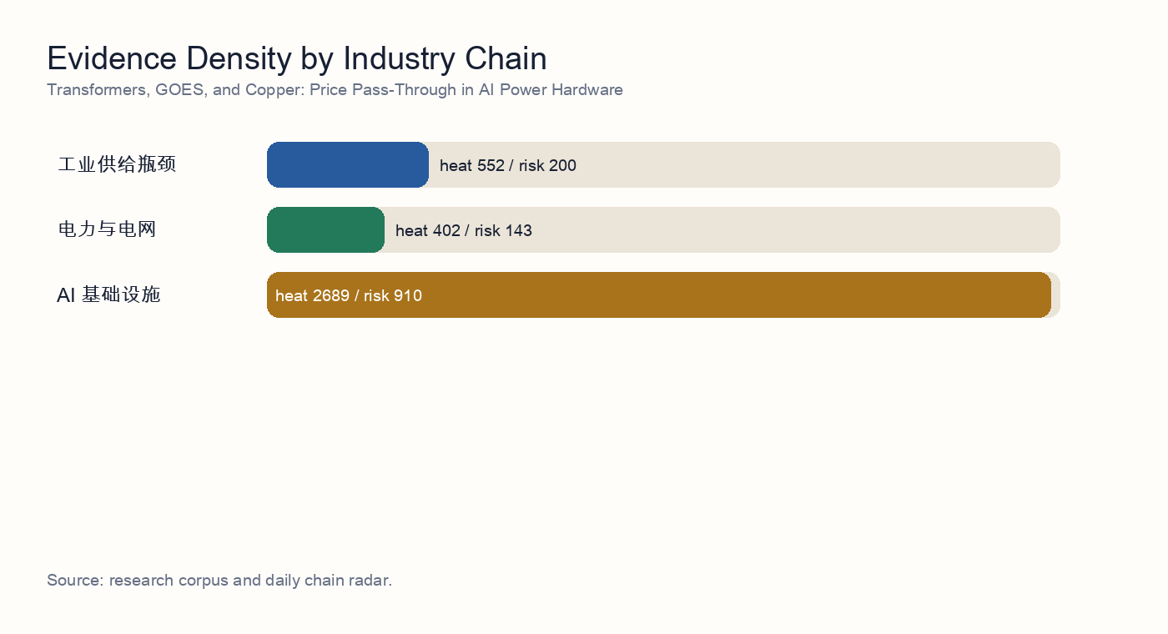
Industry-chain evidence density

2. Independent Synthesis
After reading 12 underlying source reports, the topic resolves into a sequence rather than a one-direction claim. AI demand first shows up as infrastructure buildout, then as power, grid, and equipment-delivery constraints, and only later as a possible productivity offset. The corpus therefore does not support a simple 'AI is inflationary' or 'AI is disinflationary' framing; it supports a staged capex cycle.
The strongest consensus is in power and grid infrastructure: 11 evidence items directly mention power, interconnection, firm power, utilities, or grid equipment. The repeated finding is that the compute buildout constraint is expanding from GPU supply into power access, local grid absorption, and delivery of enabling equipment.
The second consensus is that equipment delivery is not the same as compute availability. 12 items discuss transformers, distribution equipment, hardware delivery, or physical bottlenecks. Together they imply that vendor orders can be strong while project revenue recognition and live compute capacity remain constrained by interconnection, PPAs, power-node readiness, and local absorption.
Risk is not an appendix; it is part of the valuation model. This build includes 16 linked risk signals, with the central risk cluster around capex arriving before utilization, energy reliability gaps, delayed revenue timing, and crowded thematic trades. If those risks materialize, AI infrastructure valuations should be discounted with delayed cash flows and a higher capital-cost assumption.
The counter-evidence matters as well: 0 items mention efficiency or productivity. This does not erase the bottleneck thesis, but it identifies the medium-term release valve: model efficiency, custom silicon, edge AI, and workflow automation can lower unit compute or unit task costs and weaken the reflation narrative.

Source-Level Reading
- Source reading 1: 关键电力设备供应链瓶颈：变压器与开关设备交付周期调研. 结论：大型电力变压器（LPT，≥100 MVA）与中压开关设备的交付周期在 2027 年前结构性拉长，2028 年底前难以正常化， 验证了瓶颈框架但收紧了其内涵 ——2026–2027 年 AI 集群通电的真正硬约束并非变压器本体产能，而是 (i) 取向硅钢（GOES）的供应、(ii) 熟练绕线/调试工程师的劳动力缺口。 多头逻辑的尾部风险 ——2027 年 GOES 价格冲击或美国输配电劳工罢工事件会进一步右移交付期；反向地，Sec…
- Source reading 2: Transformer and distribution-grid component capacity and lead-time survey. The supply-chain survey identifies transformer capacity and high-grade electrical steel as the core delivery constraints for the 2026-2027 distribution-grid investment cycle.
- Source reading 3: 研究记录 07 研究报告：铜、铝、GOES及变压器油等关键原材料的供应缺口与价格传导风险，2026-05-20. 研究记录 07 研究报告：铜、铝、GOES及变压器油等关键原材料的供应缺口与价格传导风险，2026-05-20。 “原材料指数联动”条款： 一线电力设备巨头在积压的多年期在手订单中，普遍写入了铜、钢、铝价格指数联动协议（Price Escalation Clauses）。 价格替代平衡点： 2026 年初以来，铜铝价格比（Copper-to-Aluminum Price Ratio）已冲破 4.2，远超传统工业大规模铜铝替代的 3.5…
- Source reading 4: 研究报告：2026-05-17 - 变压器供应瓶颈与GOES利润捕获. 因此更优交易表达应是有选择地超配高压变压器、变电站、开关设备、Grid Integration产能以及合格GOES/铁芯钢供应商；不应把受监管公用事业简单当作最纯AI电力beta，因为其准许收益率、融资久期和资产负债表约束仍会稀释主题收益。 变压器OEM在近端足以用定价权抵消GOES、铜、物流和关税等成本上行。 pv magazine，美国变压器市场约束，2026年5月12日：https://www.pv-magazine.com/2…
- Source reading 5: 变压器及电力设备产业链：全球产能弹性、毛利率水平与出海竞争格局. [S1] Silicon Analysts, US Power Transformer Supply Chain: Lead Times, GOES Scarcity, and Domestic Capex Ramps in 2025-2026 — https://siliconanalysts.com/tsmc-cowos-capacity-lead-time。 虽然中国变压器和电力设备企业在全球“缺电”周期中具备极强的盈利弹性和交…
- Source reading 6: 研究记录 07 · 硅钢（GOES）产能缺口对变压器毛利的压力测试. 变压器订单延期：如果上游电力信用紧缩（研究记录）导致 IPP / 数据中心订单延期 6 个月以上，GOES 缺口会自然消化 1/3–1/2，但这也意味着研究记录 的 spread 行情节奏延后。 核心判断：普通 GOES 几乎平衡，但 高磁感 / 超薄规格存在 280–560 kt 的硬缺口 ——这与研究记录 提出的"变压器交付周期 130–160 周"在时间维度上完全吻合，因为变压器 OEM 拿不到 0.18–0.20 mm 卷板…
- Source reading 7: AI电力硬件瓶颈：变压器与GOES交付风险. 配电变压器交期已从2019年的3-6个月拉长到2023年的12-30个月，DOE把GOES、铝、铜等材料短缺列为原因之一。 工业证据很强：变压器交期仍远高于正常采购周期，核心OEM的在手订单增长快于收入兑现，高等级取向硅钢（GOES）的认证与保供比表观钢材吨数更紧。 认证风险： 电网公司和电力设备OEM对变压器、铁芯、有载分接开关、套管、绝缘系统的认证周期很长。
- Source reading 8: 研究报告：变压器瓶颈的压力测试 —— 上游取向硅钢（GOES）与铜的物理约束. 研究报告：变压器瓶颈的压力测试 —— 上游取向硅钢（GOES）与铜的物理约束。 尽管扩大变压器组装产能是 AI 基础设施竞赛的关键环节，但在 2026-2028 年窗口期内，部署的终极物理咽喉在于高等级取向硅钢（GOES）的极度缺乏弹性，以及全球铜供应链的结构性短缺。 向上游轮动： 投资者应将其 AI 基础设施组合的一部分从“组装导向型”工业股轮动至“提取与加工导向型”材料股（即 HGO 生产商和具备 2026-2027 年交付能力的…

3. Research Questions
- Do equipment lead times explain AI compute delays better than generation capacity?
- Can equipment vendors pass raw-material inflation through to data-center customers?
- Will trade barriers dilute the overseas opportunity for Chinese power-equipment suppliers?

4. Evidence Map
The selected topic spans industrial supply bottlenecks, power and grid, AI infrastructure. The evidence ledger below rewrites AI Institute research results into standalone evidence summaries. Readers do not need to know the research production workflow or have private access to follow the argument.
- Evidence 1 | 2026-05-18 | unlabeled analyst: 关键电力设备供应链瓶颈：变压器与开关设备交付周期调研. Summary: 结论：大型电力变压器（LPT，≥100 MVA）与中压开关设备的交付周期在 2027 年前结构性拉长，2028 年底前难以正常化， 验证了瓶颈框架但收紧了其内涵 ——2026–2027 年 AI 集群通电的真正硬约束并非变压器本体产能，而是 (i) 取向硅钢（GOES）的供应、(ii) 熟练绕线/调试工程师的劳动力缺口。 多头逻辑的尾部风险 ——2027 年 GOES 价格冲击或美国输配电劳工罢工事件会进一步右移交付期；反向地，Sec… Implication: Shows that the first binding constraint is power, grid access, and equipment delivery, not only chip supply.
- Evidence 2 | 2026-05-17 | unlabeled analyst: Transformer and distribution-grid component capacity and lead-time survey. Summary: The supply-chain survey identifies transformer capacity and high-grade electrical steel as the core delivery constraints for the 2026-2027 distribution-grid investment cycle. Implication: Shows that the first binding constraint is power, grid access, and equipment delivery, not only chip supply.
- Evidence 3 | 2026-05-20 | unlabeled analyst: 研究记录 07 研究报告：铜、铝、GOES及变压器油等关键原材料的供应缺口与价格传导风险，2026-05-20. Summary: 研究记录 07 研究报告：铜、铝、GOES及变压器油等关键原材料的供应缺口与价格传导风险，2026-05-20。 “原材料指数联动”条款： 一线电力设备巨头在积压的多年期在手订单中，普遍写入了铜、钢、铝价格指数联动协议（Price Escalation Clauses）。 价格替代平衡点： 2026 年初以来，铜铝价格比（Copper-to-Aluminum Price Ratio）已冲破 4.2，远超传统工业大规模铜铝替代的 3.5… Implication: Shows that the first binding constraint is power, grid access, and equipment delivery, not only chip supply.
- Evidence 4 | 2026-05-17 | unlabeled analyst: 研究报告：2026-05-17 - 变压器供应瓶颈与GOES利润捕获. Summary: 因此更优交易表达应是有选择地超配高压变压器、变电站、开关设备、Grid Integration产能以及合格GOES/铁芯钢供应商；不应把受监管公用事业简单当作最纯AI电力beta，因为其准许收益率、融资久期和资产负债表约束仍会稀释主题收益。 变压器OEM在近端足以用定价权抵消GOES、铜、物流和关税等成本上行。 pv magazine，美国变压器市场约束，2026年5月12日：https://www.pv-magazine.com/2… Implication: Shows that the first binding constraint is power, grid access, and equipment delivery, not only chip supply.
- Evidence 5 | 2026-05-23 | unlabeled analyst: 变压器及电力设备产业链：全球产能弹性、毛利率水平与出海竞争格局. Summary: [S1] Silicon Analysts, US Power Transformer Supply Chain: Lead Times, GOES Scarcity, and Domestic Capex Ramps in 2025-2026 — https://siliconanalysts.com/tsmc-cowos-capacity-lead-time。 虽然中国变压器和电力设备企业在全球“缺电”周期中具备极强的盈利弹性和交… Implication: Shows that the first binding constraint is power, grid access, and equipment delivery, not only chip supply.
- Evidence 6 | 2026-05-21 | unlabeled analyst: 研究记录 07 · 硅钢（GOES）产能缺口对变压器毛利的压力测试. Summary: 变压器订单延期：如果上游电力信用紧缩（研究记录）导致 IPP / 数据中心订单延期 6 个月以上，GOES 缺口会自然消化 1/3–1/2，但这也意味着研究记录 的 spread 行情节奏延后。 核心判断：普通 GOES 几乎平衡，但 高磁感 / 超薄规格存在 280–560 kt 的硬缺口 ——这与研究记录 提出的"变压器交付周期 130–160 周"在时间维度上完全吻合，因为变压器 OEM 拿不到 0.18–0.20 mm 卷板… Implication: Shows that the first binding constraint is power, grid access, and equipment delivery, not only chip supply.
- Evidence 7 | 2026-05-18 | industrials analyst: AI电力硬件瓶颈：变压器与GOES交付风险. Summary: 配电变压器交期已从2019年的3-6个月拉长到2023年的12-30个月，DOE把GOES、铝、铜等材料短缺列为原因之一。 工业证据很强：变压器交期仍远高于正常采购周期，核心OEM的在手订单增长快于收入兑现，高等级取向硅钢（GOES）的认证与保供比表观钢材吨数更紧。 认证风险： 电网公司和电力设备OEM对变压器、铁芯、有载分接开关、套管、绝缘系统的认证周期很长。 Implication: Shows that the first binding constraint is power, grid access, and equipment delivery, not only chip supply.
- Evidence 8 | 2026-05-19 | materials analyst: 研究报告：变压器瓶颈的压力测试 —— 上游取向硅钢（GOES）与铜的物理约束. Summary: 研究报告：变压器瓶颈的压力测试 —— 上游取向硅钢（GOES）与铜的物理约束。 尽管扩大变压器组装产能是 AI 基础设施竞赛的关键环节，但在 2026-2028 年窗口期内，部署的终极物理咽喉在于高等级取向硅钢（GOES）的极度缺乏弹性，以及全球铜供应链的结构性短缺。 向上游轮动： 投资者应将其 AI 基础设施组合的一部分从“组装导向型”工业股轮动至“提取与加工导向型”材料股（即 HGO 生产商和具备 2026-2027 年交付能力的… Implication: Shows that the first binding constraint is power, grid access, and equipment delivery, not only chip supply.
- Evidence 9 | 2026-05-18 | 政策分析师: 电力设备价格联动机制与监管政策：铜铝冲击究竟有多少传导到利润？. Summary: 研究记录 05（materials-analyst）的结论是：铜同比 +42.1%、铝 +46.5% 是真实的成本冲击，但 不足以 击穿 2026 Q3 之前电力设备的业绩可见度，因为 (i) 国家电网订单与特高压在手 + 12–24 个月交付时滞已锁定收入；(ii) 部分细分有价格调整传导；(iii) 主设备厂（东方/上海/哈电 + 特高压主力）通过产品结构升级稳定毛利率。 电力设备价格联动机制与监管政策：铜铝冲击究竟有多少传导到利… Implication: Shows that the first binding constraint is power, grid access, and equipment delivery, not only chip supply.
- Evidence 10 | 2026-05-17 | unlabeled analyst: prior research notes— Section 232 与 CRMA 下的 GOES 与精炼铜贸易政策路径如何重塑电力设备 OE.... Summary: 政策风险关注：中国 GOES/铜出口商面临 OECD 电网采购的缓慢行政性挤出——非价格崩塌而是出口流向重排。 prior research notes— Section 232 与 CRMA 下的 GOES 与精炼铜贸易政策路径如何重塑电力设备 OEM 的 2027–2029 护城河。 prior research notes— Section 232 与 CRMA 下的 GOES 与精炼铜贸易政策路径如何重塑电力设备 OE...。 Implication: Shows that the first binding constraint is power, grid access, and equipment delivery, not only chip supply.
- Evidence 11 | 2026-05-14 | unlabeled analyst: 前序研究 — 电力设备扩产的材料瓶颈：GOES、铜与大型铸锻件. Summary: 即便 GE Vernova、Siemens Energy、Mitsubishi Power、Hitachi Energy、Hyundai Electric、HD Hyundai、Prolec-GE 以及国内变压器三强（TBEA、CHINT、山东电工）在 2026-2028 年兑现 30-50% 的扩产承诺， 材料底座 ——取向硅钢（GOES）、高导铜、大型铸锻件（转子、GSU 油箱、汽轮发电机轴）以及关税/进口管制——会在 2027-… Implication: Shows that the first binding constraint is power, grid access, and equipment delivery, not only chip supply.
- Evidence 12 | | unlabeled analyst: 电工钢 (GOES) 与铜：电力设备瓶颈的上游压力测试. Summary: 电工钢 (GOES) 与铜：电力设备瓶颈的上游压力测试。 本报告从材料侧做压力测试，结论是： GOES 与精炼铜的供需缺口在 2026–2028 年仍足以为 OEM 提供定价支撑，但 2028–2030 年的「定价权可持续性」并非一边倒 ——GOES 端的真实瓶颈是高磁感薄规格 (HiB / domain-refined) 与硅钢片冲剪产能，而不是粗钢；铜端的真实瓶颈在精炼与电网级线材，而非矿端。 需求侧：变压器用 GOES 在 AI… Implication: Shows that the first binding constraint is power, grid access, and equipment delivery, not only chip supply.

5. Evidence Cluster Deep Dive
Individual evidence items explain facts; an investable conclusion requires evidence to form the same transmission chain. The sections below reorganize the source reports across policy, orders, grid demand, equipment capacity, and materials so that real demand is separated from retainable profit.

Credit Stress and Household Purchasing Power
The credit and income evidence provides the macro constraint for the consumer chain. 1 sources discuss consumer credit, household balance sheets, financial pricing, or purchasing power. Representative sources include: 研究记录 07 · 硅钢（GOES）产能缺口对变压器毛利的压力测试.
If consumer credit quality weakens, discretionary consumption, durable replacement, and premium self-pay healthcare are pressured. Medical insurance, long-term care insurance, and chronic-disease medicines remain more resilient. Credit stress is therefore not only a risk factor; it is a sorting tool for defensive demand.

Industrial Execution and Supply-Chain Reality
The industrial evidence reminds investors that demand narratives need manufacturing and delivery capability to turn into profit. 9 sources focus on capacity, quality, cost curves, supply chains, and execution cadence. Representative sources include: 关键电力设备供应链瓶颈：变压器与开关设备交付周期调研; Transformer and distribution-grid component capacity and lead-time survey; 研究报告：2026-05-17 - 变压器供应瓶颈与GOES利润捕获.
For food processing, medical devices, rehabilitation equipment, and peptide APIs, profit comes from repeatable production processes, cost control, compliant delivery, and stable channels, not from demand existence alone. If manufacturing bottlenecks or compliance issues delay delivery, thematic valuation should be cut.

Transformer, UHV, and Distribution Equipment Capacity
The equipment evidence emphasizes physical delivery constraints. 2 sources concentrate on transformers, UHV/EHV gear, distribution-grid components, switchgear, and high-grade electrical steel. Representative sources include: 研究记录 07 研究报告：铜、铝、GOES及变压器油等关键原材料的供应缺口与价格传导风险，2026-05-20; prior research notes— Section 232 与 CRMA 下的 GOES 与精炼铜贸易政策路径如何重塑电力设备 OE....
Scarcity is both the source of investment value and the source of risk. Tight capacity improves pricing power, but it also magnifies quality issues, delivery slippage, inventory mismatch, and customer cancellation risk. The highest-quality firms are not merely the largest capacity owners; they combine high-end components, certification, local delivery, and pricing clauses.

6. Policy, Delivery, and Margin Framework
The core of this topic is not export growth alone. Demand, policy, delivery, cost, and valuation layers jointly decide who owns the profit pool. AI grid demand is the starting point; trade barriers and localized delivery are filters; materials and contract clauses determine gross margin; capital costs and crowding determine the valuation investors are willing to pay.
Layer | Main variables | Financial transmission | Investment implication
Demand | AI data centers, grid expansion, overseas replacement demand | Order growth, prepayments, production scheduling | Demand can be real while policy and delivery filters intercept profit
Policy | Tariffs, anti-circumvention, subsidy eligibility, procurement limits, security reviews | Compliance cost, customer exclusion, order migration | Determines whether exports become high-margin revenue
Delivery | Localized capacity, certification, interconnection, logistics, project acceptance | Delayed revenue recognition, cash-flow mismatch, inventory drag | Determines the gap between order intake and the income statement
Cost | Copper, aluminum, GOES, core components, FX | Gross-margin pressure or repricing power | Determines how the equipment-chain profit pool is allocated
Valuation | Capital cost, crowded positioning, utilization, customer capex | Discount-rate changes and earnings-conversion probability | Determines whether the theme becomes an earnings cycle

7. Transmission Model
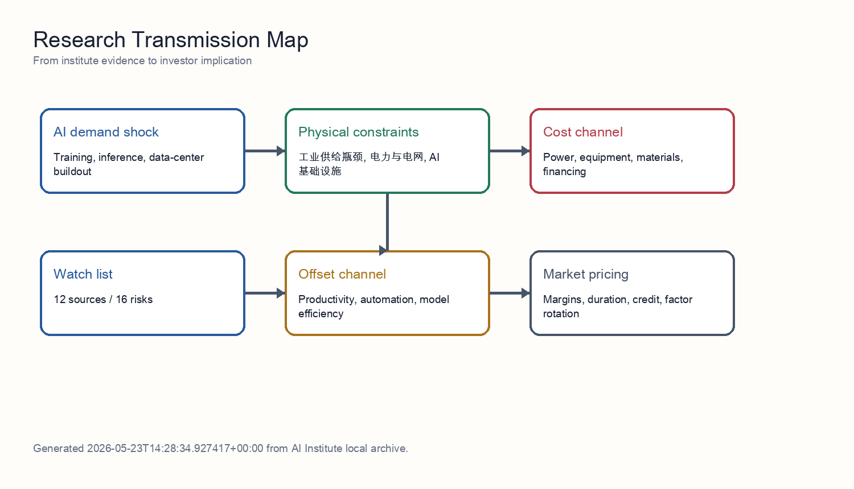
Transmission model
The mechanism separates demand, constraints, and pricing. Demand comes from training, inference, and data-center construction. Constraints come from grid access, transformers, materials, semiconductors, and delivery cycles. Pricing shows up in electricity prices, equipment prices, capital costs, and margin allocation. Productivity is the offsetting force, but it normally requires adoption, workflow redesign, and organizational change, so it tends to arrive later than capex.
For Chinese power-equipment exports, the chain also needs a policy filter. US and EU policy does not eliminate global grid-upgrade demand, but it changes profit ownership: orders can migrate toward local manufacturing, third-country capacity, less sensitive components, or lower-priced suppliers. The stricter the policy layer, the more overseas orders need to be discounted for deliverability and compliance cost.
The AI-inflation relationship is therefore not one direction; it is a sequence. Power, grid, metals, and equipment prices react first. Data-center utilization and enterprise automation determine whether the cost can be absorbed in the middle phase. Only later can productivity growth offset the capital-expenditure impulse.

8. Source-by-Source Interpretation
The following section translates each source into an actionable investment input. The goal is to let a reader without private research access understand how each evidence item enters the final conclusion.

Source 1: 关键电力设备供应链瓶颈：变压器与开关设备交付周期调研
This evidence belongs to the industrial execution and supply-chain reality cluster. Its direct contribution is: 结论：大型电力变压器（LPT，≥100 MVA）与中压开关设备的交付周期在 2027 年前结构性拉长，2028 年底前难以正常化， 验证了瓶颈框架但收紧了其内涵 ——2026–2027 年 AI 集群通电的真正硬约束并非变压器本体产能，而是 (i) 取向硅钢（GOES）的供应、(ii) 熟练绕线/调试工程师的劳动力缺口。 多头逻辑的尾部风险 ——2027 年 GOES 价格冲击或美国输配电劳工罢工事件会进一步右移交付期；反向地，Sec… That moves the topic from a macro narrative into testable operating variables such as purchasing power, terminal sell-through, policy conversion, cost curve, compliant delivery, and cash collection.
The investment implication is: Shows that the first binding constraint is power, grid access, and equipment delivery, not only chip supply. At the portfolio level, it should not be treated as a standalone buy signal. It should be combined with other sources in the same cluster; when several sources point to the same constraint, the constraint becomes large enough to affect valuation and margins.
The falsifier to track is: If capacity, quality, compliance, or delivery cannot convert orders, thematic demand should not flow directly into earnings forecasts.

Source 2: Transformer and distribution-grid component capacity and lead-time survey
This evidence belongs to the industrial execution and supply-chain reality cluster. Its direct contribution is: The supply-chain survey identifies transformer capacity and high-grade electrical steel as the core delivery constraints for the 2026-2027 distribution-grid investment cycle. That moves the topic from a macro narrative into testable operating variables such as purchasing power, terminal sell-through, policy conversion, cost curve, compliant delivery, and cash collection.
The investment implication is: Shows that the first binding constraint is power, grid access, and equipment delivery, not only chip supply. At the portfolio level, it should not be treated as a standalone buy signal. It should be combined with other sources in the same cluster; when several sources point to the same constraint, the constraint becomes large enough to affect valuation and margins.
The falsifier to track is: If capacity, quality, compliance, or delivery cannot convert orders, thematic demand should not flow directly into earnings forecasts.

Source 3: 研究记录 07 研究报告：铜、铝、GOES及变压器油等关键原材料的供应缺口与价格传导风险，2026-05-20
This evidence belongs to the transformer, uhv, and distribution equipment capacity cluster. Its direct contribution is: 研究记录 07 研究报告：铜、铝、GOES及变压器油等关键原材料的供应缺口与价格传导风险，2026-05-20。 “原材料指数联动”条款： 一线电力设备巨头在积压的多年期在手订单中，普遍写入了铜、钢、铝价格指数联动协议（Price Escalation Clauses）。 价格替代平衡点： 2026 年初以来，铜铝价格比（Copper-to-Aluminum Price Ratio）已冲破 4.2，远超传统工业大规模铜铝替代的 3.5… That moves the topic from a macro narrative into testable operating variables such as order quality, delivery time, input costs, interconnection status, and policy accessibility.
The investment implication is: Shows that the first binding constraint is power, grid access, and equipment delivery, not only chip supply. At the portfolio level, it should not be treated as a standalone buy signal. It should be combined with other sources in the same cluster; when several sources point to the same constraint, the constraint becomes large enough to affect valuation and margins.
The falsifier to track is: If transformer, switchgear, and distribution-component lead times shorten quickly, scarcity pricing shifts from supply shortage to competitive normalization.

Source 4: 研究报告：2026-05-17 - 变压器供应瓶颈与GOES利润捕获
This evidence belongs to the industrial execution and supply-chain reality cluster. Its direct contribution is: 因此更优交易表达应是有选择地超配高压变压器、变电站、开关设备、Grid Integration产能以及合格GOES/铁芯钢供应商；不应把受监管公用事业简单当作最纯AI电力beta，因为其准许收益率、融资久期和资产负债表约束仍会稀释主题收益。 变压器OEM在近端足以用定价权抵消GOES、铜、物流和关税等成本上行。 pv magazine，美国变压器市场约束，2026年5月12日：https://www.pv-magazine.com/2… That moves the topic from a macro narrative into testable operating variables such as purchasing power, terminal sell-through, policy conversion, cost curve, compliant delivery, and cash collection.
The investment implication is: Shows that the first binding constraint is power, grid access, and equipment delivery, not only chip supply. At the portfolio level, it should not be treated as a standalone buy signal. It should be combined with other sources in the same cluster; when several sources point to the same constraint, the constraint becomes large enough to affect valuation and margins.
The falsifier to track is: If capacity, quality, compliance, or delivery cannot convert orders, thematic demand should not flow directly into earnings forecasts.

Source 5: 变压器及电力设备产业链：全球产能弹性、毛利率水平与出海竞争格局
This evidence belongs to the industrial execution and supply-chain reality cluster. Its direct contribution is: [S1] Silicon Analysts, US Power Transformer Supply Chain: Lead Times, GOES Scarcity, and Domestic Capex Ramps in 2025-2026 — https://siliconanalysts.com/tsmc-cowos-capacity-lead-time。 虽然中国变压器和电力设备企业在全球“缺电”周期中具备极强的盈利弹性和交… That moves the topic from a macro narrative into testable operating variables such as purchasing power, terminal sell-through, policy conversion, cost curve, compliant delivery, and cash collection.
The investment implication is: Shows that the first binding constraint is power, grid access, and equipment delivery, not only chip supply. At the portfolio level, it should not be treated as a standalone buy signal. It should be combined with other sources in the same cluster; when several sources point to the same constraint, the constraint becomes large enough to affect valuation and margins.
The falsifier to track is: If capacity, quality, compliance, or delivery cannot convert orders, thematic demand should not flow directly into earnings forecasts.

Source 6: 研究记录 07 · 硅钢（GOES）产能缺口对变压器毛利的压力测试
This evidence belongs to the credit stress and household purchasing power cluster. Its direct contribution is: 变压器订单延期：如果上游电力信用紧缩（研究记录）导致 IPP / 数据中心订单延期 6 个月以上，GOES 缺口会自然消化 1/3–1/2，但这也意味着研究记录 的 spread 行情节奏延后。 核心判断：普通 GOES 几乎平衡，但 高磁感 / 超薄规格存在 280–560 kt 的硬缺口 ——这与研究记录 提出的"变压器交付周期 130–160 周"在时间维度上完全吻合，因为变压器 OEM 拿不到 0.18–0.20 mm 卷板… That moves the topic from a macro narrative into testable operating variables such as purchasing power, terminal sell-through, policy conversion, cost curve, compliant delivery, and cash collection.
The investment implication is: Shows that the first binding constraint is power, grid access, and equipment delivery, not only chip supply. At the portfolio level, it should not be treated as a standalone buy signal. It should be combined with other sources in the same cluster; when several sources point to the same constraint, the constraint becomes large enough to affect valuation and margins.
The falsifier to track is: If consumer-credit deterioration widens, all self-pay and premium-experience demand assumptions should be revised down.

Source 7: AI电力硬件瓶颈：变压器与GOES交付风险
This evidence belongs to the industrial execution and supply-chain reality cluster. Its direct contribution is: 配电变压器交期已从2019年的3-6个月拉长到2023年的12-30个月，DOE把GOES、铝、铜等材料短缺列为原因之一。 工业证据很强：变压器交期仍远高于正常采购周期，核心OEM的在手订单增长快于收入兑现，高等级取向硅钢（GOES）的认证与保供比表观钢材吨数更紧。 认证风险： 电网公司和电力设备OEM对变压器、铁芯、有载分接开关、套管、绝缘系统的认证周期很长。 That moves the topic from a macro narrative into testable operating variables such as purchasing power, terminal sell-through, policy conversion, cost curve, compliant delivery, and cash collection.
The investment implication is: Shows that the first binding constraint is power, grid access, and equipment delivery, not only chip supply. At the portfolio level, it should not be treated as a standalone buy signal. It should be combined with other sources in the same cluster; when several sources point to the same constraint, the constraint becomes large enough to affect valuation and margins.
The falsifier to track is: If capacity, quality, compliance, or delivery cannot convert orders, thematic demand should not flow directly into earnings forecasts.

Source 8: 研究报告：变压器瓶颈的压力测试 —— 上游取向硅钢（GOES）与铜的物理约束
This evidence belongs to the industrial execution and supply-chain reality cluster. Its direct contribution is: 研究报告：变压器瓶颈的压力测试 —— 上游取向硅钢（GOES）与铜的物理约束。 尽管扩大变压器组装产能是 AI 基础设施竞赛的关键环节，但在 2026-2028 年窗口期内，部署的终极物理咽喉在于高等级取向硅钢（GOES）的极度缺乏弹性，以及全球铜供应链的结构性短缺。 向上游轮动： 投资者应将其 AI 基础设施组合的一部分从“组装导向型”工业股轮动至“提取与加工导向型”材料股（即 HGO 生产商和具备 2026-2027 年交付能力的… That moves the topic from a macro narrative into testable operating variables such as purchasing power, terminal sell-through, policy conversion, cost curve, compliant delivery, and cash collection.
The investment implication is: Shows that the first binding constraint is power, grid access, and equipment delivery, not only chip supply. At the portfolio level, it should not be treated as a standalone buy signal. It should be combined with other sources in the same cluster; when several sources point to the same constraint, the constraint becomes large enough to affect valuation and margins.
The falsifier to track is: If capacity, quality, compliance, or delivery cannot convert orders, thematic demand should not flow directly into earnings forecasts.

Source 9: 电力设备价格联动机制与监管政策：铜铝冲击究竟有多少传导到利润？
This evidence belongs to the industrial execution and supply-chain reality cluster. Its direct contribution is: 研究记录 05（materials-analyst）的结论是：铜同比 +42.1%、铝 +46.5% 是真实的成本冲击，但 不足以 击穿 2026 Q3 之前电力设备的业绩可见度，因为 (i) 国家电网订单与特高压在手 + 12–24 个月交付时滞已锁定收入；(ii) 部分细分有价格调整传导；(iii) 主设备厂（东方/上海/哈电 + 特高压主力）通过产品结构升级稳定毛利率。 电力设备价格联动机制与监管政策：铜铝冲击究竟有多少传导到利… That moves the topic from a macro narrative into testable operating variables such as purchasing power, terminal sell-through, policy conversion, cost curve, compliant delivery, and cash collection.
The investment implication is: Shows that the first binding constraint is power, grid access, and equipment delivery, not only chip supply. At the portfolio level, it should not be treated as a standalone buy signal. It should be combined with other sources in the same cluster; when several sources point to the same constraint, the constraint becomes large enough to affect valuation and margins.
The falsifier to track is: If capacity, quality, compliance, or delivery cannot convert orders, thematic demand should not flow directly into earnings forecasts.

Source 10: prior research notes— Section 232 与 CRMA 下的 GOES 与精炼铜贸易政策路径如何重塑电力设备 OE...
This evidence belongs to the transformer, uhv, and distribution equipment capacity cluster. Its direct contribution is: 政策风险关注：中国 GOES/铜出口商面临 OECD 电网采购的缓慢行政性挤出——非价格崩塌而是出口流向重排。 prior research notes— Section 232 与 CRMA 下的 GOES 与精炼铜贸易政策路径如何重塑电力设备 OEM 的 2027–2029 护城河。 prior research notes— Section 232 与 CRMA 下的 GOES 与精炼铜贸易政策路径如何重塑电力设备 OE...。 That moves the topic from a macro narrative into testable operating variables such as order quality, delivery time, input costs, interconnection status, and policy accessibility.
The investment implication is: Shows that the first binding constraint is power, grid access, and equipment delivery, not only chip supply. At the portfolio level, it should not be treated as a standalone buy signal. It should be combined with other sources in the same cluster; when several sources point to the same constraint, the constraint becomes large enough to affect valuation and margins.
The falsifier to track is: If transformer, switchgear, and distribution-component lead times shorten quickly, scarcity pricing shifts from supply shortage to competitive normalization.

Source 11: 前序研究 — 电力设备扩产的材料瓶颈：GOES、铜与大型铸锻件
This evidence belongs to the industrial execution and supply-chain reality cluster. Its direct contribution is: 即便 GE Vernova、Siemens Energy、Mitsubishi Power、Hitachi Energy、Hyundai Electric、HD Hyundai、Prolec-GE 以及国内变压器三强（TBEA、CHINT、山东电工）在 2026-2028 年兑现 30-50% 的扩产承诺， 材料底座 ——取向硅钢（GOES）、高导铜、大型铸锻件（转子、GSU 油箱、汽轮发电机轴）以及关税/进口管制——会在 2027-… That moves the topic from a macro narrative into testable operating variables such as purchasing power, terminal sell-through, policy conversion, cost curve, compliant delivery, and cash collection.
The investment implication is: Shows that the first binding constraint is power, grid access, and equipment delivery, not only chip supply. At the portfolio level, it should not be treated as a standalone buy signal. It should be combined with other sources in the same cluster; when several sources point to the same constraint, the constraint becomes large enough to affect valuation and margins.
The falsifier to track is: If capacity, quality, compliance, or delivery cannot convert orders, thematic demand should not flow directly into earnings forecasts.

Source 12: 电工钢 (GOES) 与铜：电力设备瓶颈的上游压力测试
This evidence belongs to the industrial execution and supply-chain reality cluster. Its direct contribution is: 电工钢 (GOES) 与铜：电力设备瓶颈的上游压力测试。 本报告从材料侧做压力测试，结论是： GOES 与精炼铜的供需缺口在 2026–2028 年仍足以为 OEM 提供定价支撑，但 2028–2030 年的「定价权可持续性」并非一边倒 ——GOES 端的真实瓶颈是高磁感薄规格 (HiB / domain-refined) 与硅钢片冲剪产能，而不是粗钢；铜端的真实瓶颈在精炼与电网级线材，而非矿端。 需求侧：变压器用 GOES 在 AI… That moves the topic from a macro narrative into testable operating variables such as purchasing power, terminal sell-through, policy conversion, cost curve, compliant delivery, and cash collection.
The investment implication is: Shows that the first binding constraint is power, grid access, and equipment delivery, not only chip supply. At the portfolio level, it should not be treated as a standalone buy signal. It should be combined with other sources in the same cluster; when several sources point to the same constraint, the constraint becomes large enough to affect valuation and margins.
The falsifier to track is: If capacity, quality, compliance, or delivery cannot convert orders, thematic demand should not flow directly into earnings forecasts.

9. Stress Tests

Stress Test 1: Trade Policy Tightens Further
If the US and EU continue to tighten tariffs, procurement rules, subsidy eligibility, or security reviews, the first effect is not the disappearance of global demand. The first effect is reduced accessibility to the highest-margin markets. Orders may still exist, but they migrate from direct export into local manufacturing, third-country capacity, less sensitive components, or lower-priced alternatives. Portfolio construction should raise the haircut on overseas orders and prefer companies that already have localized capacity and customer certification.

Stress Test 2: Equipment Lead Times Shorten Without Price Deflation
This is the most constructive combination for equipment leaders. Shorter lead times show that capacity expansion is working; stable prices show that demand is still strong enough to absorb added supply. In that case, the market should move from bottleneck pricing to earnings conversion, with emphasis on revenue recognition, segment margin, and operating cash flow moving together.

Stress Test 3: Copper, Aluminum, and GOES Rise Faster Than Order Repricing
This is the most dangerous margin combination. Revenue can remain strong because the order book is full, while the cost stack compresses gross margin. Company dispersion comes from contract clauses, procurement locks, and inventory management. Firms without price escalation should receive lower margin assumptions; firms with material hedges and high-end core-component control deserve a relative premium.

Stress Test 4: AI Efficiency Improves Fast Enough to Weaken Incremental Equipment Orders
If model efficiency, ASICs, edge AI, and workflow automation reduce unit compute requirements quickly, the equipment chain shifts from a demand-expansion trade to an order-quality audit. This does not necessarily cancel existing grid investment, but it compresses the market's extrapolation of 2027 and later orders. The portfolio response is to reduce pure theme exposure and demand stronger evidence of cash flow and confirmed backlog.

10. Risk Matrix
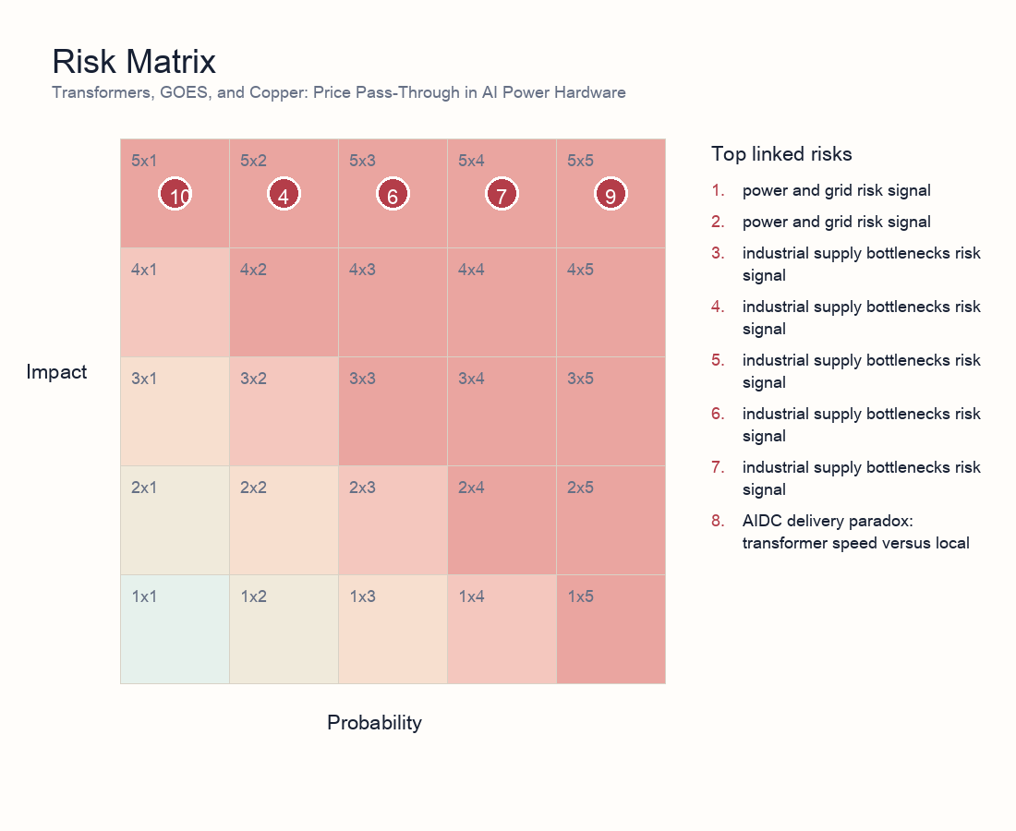
Risk matrix
- Risk 1 | power and grid | 5/5: power and grid risk signal. Explanation: Flags power and grid execution risk that can delay capacity, pressure margins, or raise discount rates.
- Risk 2 | power and grid | 5/4: power and grid risk signal. Explanation: Flags power and grid execution risk that can delay capacity, pressure margins, or raise discount rates.
- Risk 3 | industrial supply bottlenecks | 5/4: industrial supply bottlenecks risk signal. Explanation: Flags industrial supply bottlenecks execution risk that can delay capacity, pressure margins, or raise discount rates.
- Risk 4 | industrial supply bottlenecks | 5/2: industrial supply bottlenecks risk signal. Explanation: Flags industrial supply bottlenecks execution risk that can delay capacity, pressure margins, or raise discount rates.
- Risk 5 | industrial supply bottlenecks | 5/3: industrial supply bottlenecks risk signal. Explanation: Flags industrial supply bottlenecks execution risk that can delay capacity, pressure margins, or raise discount rates.
- Risk 6 | industrial supply bottlenecks | 5/3: industrial supply bottlenecks risk signal. Explanation: Flags industrial supply bottlenecks execution risk that can delay capacity, pressure margins, or raise discount rates.
- Risk 7 | industrial supply bottlenecks | 5/4: industrial supply bottlenecks risk signal. Explanation: The research stress-tests whether AI compute growth is constrained by grid expansion, transformers, and distribution infrastructure rather than only by semiconductor availability.
- Risk 8 | power and grid | 5/5: AIDC delivery paradox: transformer speed versus local grid absorption. Explanation: Shows that faster transformer delivery does not automatically become usable compute; interconnection, power quality, dispatch rules, and local grid absorption remain binding constraints.
- Risk 9 | AI infrastructure | 5/5: AI infrastructure risk signal. Explanation: Flags AI infrastructure execution risk that can delay capacity, pressure margins, or raise discount rates.
- Risk 10 | industrial supply bottlenecks | 5/1: Nonferrous-metal stress test for power-equipment gross margins. Explanation: Tests whether copper and aluminum price pressure can compress power-equipment margins and earnings visibility.
- Risk 11 | AI infrastructure | 5/3: AI infrastructure risk signal. Explanation: Flags AI infrastructure execution risk that can delay capacity, pressure margins, or raise discount rates.
- Risk 12 | industrial supply bottlenecks | 5/3: Transformer and distribution-grid component capacity and lead-time survey. Explanation: Checks transformer and distribution-grid component capacity, lead times, and order convertibility.
- Risk 13 | power and grid | 5/1: power and grid risk signal. Explanation: Flags power and grid execution risk that can delay capacity, pressure margins, or raise discount rates.
- Risk 14 | industrial supply bottlenecks | 5/1: industrial supply bottlenecks risk signal. Explanation: Flags industrial supply bottlenecks execution risk that can delay capacity, pressure margins, or raise discount rates.
- Risk 15 | industrial supply bottlenecks | 5/4: AI power-hardware bottlenecks: transformer and GOES delivery risk. Explanation: Tracks transformer and GOES delivery risk as a key constraint on AI power-hardware deployment.
- Risk 16 | AI infrastructure | 5/3: AI infrastructure risk signal. Explanation: Flags AI infrastructure execution risk that can delay capacity, pressure margins, or raise discount rates.

11. Scenario Analysis
Scenario | Trigger | Macro/asset implication | Investor action
Supply relief | Shorter equipment lead times, stable power prices, higher model efficiency | AI infrastructure margins expand and inflation concern fades | Favor quality equipment and efficiency beneficiaries; reduce pure-duration narrative exposure
Bottleneck persistence | Transformer/GOES/interconnection constraints persist; PPAs and capital costs rise | Capex monetization lags valuation; inflation stickiness rises | Prefer cash-flow-backed equipment exposure; control crowded data-center trades
Demand migration | Cloud constraints push edge AI, ASICs, and automation substitutes | Hardware demand migrates while software efficiency buffers inflation | Allocate to architecture substitution and efficiency tools; stay selective on long-duration themes

12. Portfolio and Valuation Implications
Valuation cannot be explained by demand multiples alone. A cleaner model decomposes overseas orders into order value, deliverable share, retainable gross margin, revenue-recognition timing, and cash-collection timing, then probability-adjusts those variables against 16 linked risk signals. This avoids discounting every overseas order at the same margin and the same time horizon.
The first valuation premium belongs to delivery certainty: firms with localized capacity, core-component control, certification, and long-standing customer relationships deserve a lower order haircut. The second premium belongs to price architecture: firms that can protect margins when copper, aluminum, and GOES rise are proving stronger contract structure and bargaining power.
The discount factors are equally clear. If orders concentrate in high-policy-risk markets, or if revenue depends on customer projects receiving grid access on schedule, the discount rate should rise. If inventory, receivables, and prepayment structure deteriorate, earnings quality should be haircut even when revenue is growing.
The most important falsification signal is the combination of shorter lead times, lower materials prices, customer capex cuts, and faster AI efficiency gains. That combination would shift the trade from scarcity pricing to earnings-conversion scrutiny, forcing the market to demand quarterly proof of margin and cash flow.
Bucket | Exposure | Rationale | Key checks
Core overweight | Power-equipment leaders with localized delivery, high-end core components, price escalation, and certification | Higher probability that orders convert into revenue and that materials/policy shocks are passed through | Lead times, overseas revenue mix, segment margin, core-component self-supply
Selective exposure | UHV/EHV, distribution automation, switchgear, cooling, and power electronics | Beneficiaries of grid pull-forward, but stock quality is dispersed | Order quality, customer mix, project acceptance, inventory turns
Avoid or underweight | Narrative-only names lacking certification or local delivery, with high materials exposure and weak repricing clauses | Revenue growth can be absorbed by tariffs, delays, and gross-margin compression | Margin cuts, rising receivables, delivery-delay disclosures
Hedges | Copper/aluminum, FX, overseas policy risk, customer capex cuts | Useful hedges for equipment-chain margin and valuation volatility | Commodity prices, tariff announcements, customer capex guidance

13. Investor Reading Framework
First, test whether the constraint is real rather than narrative-driven: prioritize lead times, order quality, utilization, interconnection status, and PPA terms. Second, split the profit pool: resources and equipment may benefit from bottlenecks, while data centers and high-duration themes can absorb capital-cost and delay pressure. Third, weight repeated verification: a risk validated by risk, industrials, energy, and macro analysts should matter more than a single theme note. Fourth, keep a falsification path: rapid productivity and architecture efficiency would weaken the reflation thesis.

14. Daily Monitoring Dashboard
Dimension | Indicator | Interpretation | Evidence source
Delivery | Quarterly lead times for transformers, switchgear, and GOES | Longer lead times support bottleneck pricing; shorter lead times indicate supply relief | Vendor disclosures, channel surveys, tender documents
Policy | US/EU tariffs, subsidy eligibility, procurement limits, anti-circumvention cases | New limits compress high-margin channels; exemptions and localization widen the addressable market | Official notices, customer procurement rules, capacity-location disclosures
Margins | Overseas segment margin, price-escalation clauses, metal inventory coverage | Revenue growth without stable margins means the profit pool is absorbed by costs | Financial reports, order contracts, commodity prices
Grid | AIDC interconnection queues, PPA prices, local absorption capacity | Persistent interconnection bottlenecks delay compute launch while supporting grid-equipment demand | Utility data, PPA disclosures, project start notices
Valuation | Theme crowding, flows, rate sensitivity of duration assets | Crowded trades are more vulnerable when earnings conversion is delayed | ETF/sector flows, valuation percentiles, credit spreads

15. Data Still Needed
- Interconnection queues, PPA prices, and utilization for major AIDC projects.
- Quarterly lead times and pricing for transformers, GOES, copper/aluminum, and switchgear.
- Measurable AI adoption, unit task cost, employee output, and automation substitution data.
- Theme crowding, flow, valuation percentile, and credit-condition changes.

