AI Compute Capex, Power Bottlenecks, and Inflation Repricing
Generated: 2026-05-18T00:52:54.563618+00:00; evidence window: 2026-05-18; AI Institute fetch: 2026-05-17T23:33:10.284Z.

1. Executive Thesis
AI infrastructure demand first creates a cost impulse through power, grid, transformer, and materials constraints, while productivity and architecture efficiency arrive later as a possible offset; the investable conclusion depends on which channel clears first. This report uses 12 highly relevant research sources, contributions from 5 main analysts, and 16 linked risk signals. The central point is not to label AI as simply inflationary or disinflationary, but to separate the sequence into three stages: demand shock first, physical bottleneck pricing second, and productivity offset later.
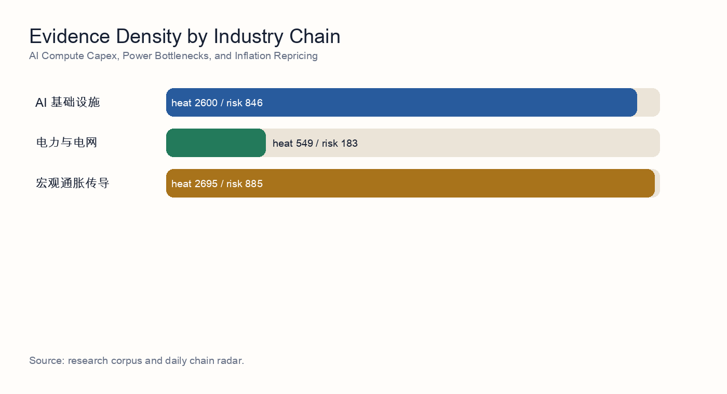
Industry-chain evidence density

2. Independent Synthesis
After reading 12 underlying source reports, the topic resolves into a sequence rather than a one-direction claim. AI demand first shows up as infrastructure buildout, then as power, grid, and equipment-delivery constraints, and only later as a possible productivity offset. The corpus therefore does not support a simple 'AI is inflationary' or 'AI is disinflationary' framing; it supports a staged capex cycle.
The strongest consensus is in power and grid infrastructure: 12 evidence items directly mention power, interconnection, firm power, utilities, or grid equipment. The repeated finding is that the compute buildout constraint is expanding from GPU supply into power access, local grid absorption, and delivery of enabling equipment.
The second consensus is that equipment delivery is not the same as compute availability. 8 items discuss transformers, distribution equipment, hardware delivery, or physical bottlenecks. Together they imply that vendor orders can be strong while project revenue recognition and live compute capacity remain constrained by interconnection, PPAs, power-node readiness, and local absorption.
Risk is not an appendix; it is part of the valuation model. This build includes 16 linked risk signals, with the central risk cluster around capex arriving before utilization, energy reliability gaps, delayed revenue timing, and crowded thematic trades. If those risks materialize, AI infrastructure valuations should be discounted with delayed cash flows and a higher capital-cost assumption.
The counter-evidence matters as well: 1 item mentions efficiency or productivity. This does not erase the bottleneck thesis, but it identifies the medium-term release valve: model efficiency, custom silicon, edge AI, and workflow automation can lower unit compute or unit task costs and weaken the reflation narrative.

Source-Level Reading
- Source reading 1: Power-equipment and grid bottleneck stress test for AI compute expansion. The research stress-tests whether AI compute growth is constrained by grid expansion, transformers, and distribution infrastructure rather than only by semiconductor availability.
- Source reading 2: AI data-center power bottlenecks across utilities, grid equipment, and firm power. The evidence frames firm power, utility capacity, and grid equipment as direct constraints and beneficiaries of AI data-center growth.
- Source reading 3: AIDC delivery paradox: transformer speed versus local grid absorption. The analysis argues that faster transformer delivery does not automatically translate into compute output because interconnection and local grid absorption can remain bottlenecks.
- Source reading 4: AIDC hardware delivery lag and compute capex timing anchored by power nodes. The note links hardware delivery delays to power-node readiness, implying that capex recognition and compute monetization can diverge.
- Source reading 5: AIDC energy fragility and valuation stress test. The risk analysis treats AIDC energy reliability as a valuation variable because delayed power availability can weaken utilization and revenue timing.
- Source reading 6: AI compute efficiency, hyperscaler capex, and 2027 power-OEM order risk. The evidence raises a 2027 downside case in which compute-efficiency gains reduce hyperscaler power-equipment orders.
- Source reading 7: Utilities and AI power infrastructure as a post-theme-rotation allocation candidate. The research asks whether utilities and AI power infrastructure have become a durable allocation theme after a broader market rotation.
- Source reading 8: AI compute power demand versus delayed grid upgrades. The stress test compares AI compute power demand with the slower pace of grid upgrades, highlighting a timing mismatch.

3. Research Questions
- Is AI power demand large enough to change local electricity prices, PPAs, and grid investment timing?
- Does the inflation impulse come from energy prices, equipment lead times, or repriced capital costs?
- When can productivity gains offset the front-loaded cost impulse?

4. Evidence Map
The selected topic spans AI infrastructure, power and grid, macro inflation transmission. The evidence ledger below rewrites AI Institute research results into standalone evidence summaries. Readers do not need to know the research production workflow or have private access to follow the argument.
- Evidence 1 | 2026-05-16 | unlabeled analyst: Power-equipment and grid bottleneck stress test for AI compute expansion. Summary: The research stress-tests whether AI compute growth is constrained by grid expansion, transformers, and distribution infrastructure rather than only by semiconductor availability. Implication: Shows that the first binding constraint is power, grid access, and equipment delivery, not only chip supply.
- Evidence 2 | 2026-05-02 | unlabeled analyst: AI data-center power bottlenecks across utilities, grid equipment, and firm power. Summary: The evidence frames firm power, utility capacity, and grid equipment as direct constraints and beneficiaries of AI data-center growth. Implication: Shows that the first binding constraint is power, grid access, and equipment delivery, not only chip supply.
- Evidence 3 | 2026-05-18 | industrials analyst: AIDC delivery paradox: transformer speed versus local grid absorption. Summary: The analysis argues that faster transformer delivery does not automatically translate into compute output because interconnection and local grid absorption can remain bottlenecks. Implication: Shows that the first binding constraint is power, grid access, and equipment delivery, not only chip supply.
- Evidence 4 | 2026-05-18 | unlabeled analyst: AIDC delivery paradox: transformer speed versus local grid absorption. Summary: The analysis argues that faster transformer delivery does not automatically translate into compute output because interconnection and local grid absorption can remain bottlenecks. Implication: Shows that the first binding constraint is power, grid access, and equipment delivery, not only chip supply.
- Evidence 5 | 2026-05-18 | TMT analyst: AIDC hardware delivery lag and compute capex timing anchored by power nodes. Summary: The note links hardware delivery delays to power-node readiness, implying that capex recognition and compute monetization can diverge. Implication: Shows that the first binding constraint is power, grid access, and equipment delivery, not only chip supply.
- Evidence 6 | 2026-05-18 | unlabeled analyst: AIDC hardware delivery lag and compute capex timing anchored by power nodes. Summary: The note links hardware delivery delays to power-node readiness, implying that capex recognition and compute monetization can diverge. Implication: Shows that the first binding constraint is power, grid access, and equipment delivery, not only chip supply.
- Evidence 7 | 2026-05-18 | chief risk officer: AIDC energy fragility and valuation stress test. Summary: The risk analysis treats AIDC energy reliability as a valuation variable because delayed power availability can weaken utilization and revenue timing. Implication: Shows that the first binding constraint is power, grid access, and equipment delivery, not only chip supply.
- Evidence 8 | 2026-05-18 | unlabeled analyst: AIDC energy fragility and valuation stress test. Summary: The risk analysis treats AIDC energy reliability as a valuation variable because delayed power availability can weaken utilization and revenue timing. Implication: Shows that the first binding constraint is power, grid access, and equipment delivery, not only chip supply.
- Evidence 9 | 2026-05-17 | unlabeled analyst: AI compute efficiency, hyperscaler capex, and 2027 power-OEM order risk. Summary: The evidence raises a 2027 downside case in which compute-efficiency gains reduce hyperscaler power-equipment orders. Implication: Shows that the first binding constraint is power, grid access, and equipment delivery, not only chip supply.
- Evidence 10 | 2026-05-17 | unlabeled analyst: Utilities and AI power infrastructure as a post-theme-rotation allocation candidate. Summary: The research asks whether utilities and AI power infrastructure have become a durable allocation theme after a broader market rotation. Implication: Shows that the first binding constraint is power, grid access, and equipment delivery, not only chip supply.
- Evidence 11 | 2026-05-17 | unlabeled analyst: AI compute power demand versus delayed grid upgrades. Summary: The stress test compares AI compute power demand with the slower pace of grid upgrades, highlighting a timing mismatch. Implication: Shows that the first binding constraint is power, grid access, and equipment delivery, not only chip supply.
- Evidence 12 | 2026-05-16 | utilities analyst: AI data-center power demand and grid-capacity bottlenecks. Summary: The stress test compares AI compute power demand with the slower pace of grid upgrades, highlighting a timing mismatch. Implication: Shows that the first binding constraint is power, grid access, and equipment delivery, not only chip supply.

5. Transmission Model
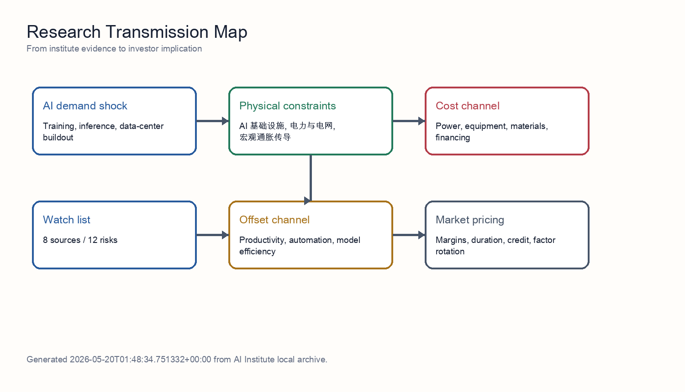
Transmission model
The mechanism separates demand, constraints, and pricing. Demand comes from training, inference, and data-center construction. Constraints come from grid access, transformers, materials, semiconductors, and delivery cycles. Pricing shows up in electricity prices, equipment prices, capital costs, and margin allocation. Productivity is the offsetting force, but it normally requires adoption, workflow redesign, and organizational change, so it tends to arrive later than capex.

6. Risk Matrix
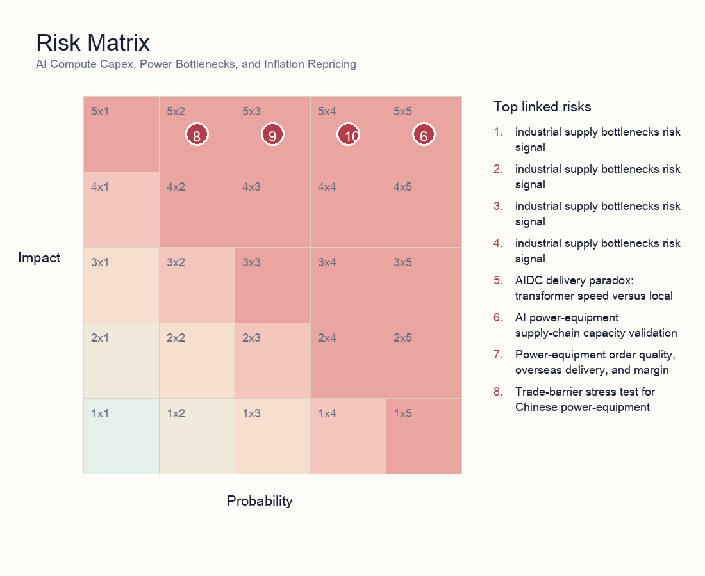
Risk matrix
- Risk 1 | power and grid | 5/5: AIDC delivery paradox: transformer speed versus local grid absorption. Explanation: Shows that faster transformer delivery does not automatically become usable compute; interconnection, power quality, dispatch rules, and local grid absorption remain binding constraints.
- Risk 2 | industrial supply bottlenecks | 5/5: AI power-equipment supply-chain capacity validation. Explanation: Tests whether transformer, switchgear, and grid-equipment capacity can absorb AI infrastructure demand without delivery slippage or margin pressure.
- Risk 3 | industrial supply bottlenecks | 5/3: Power-equipment order quality, overseas delivery, and margin dispersion. Explanation: Separates high-quality overseas and grid orders from weaker concept exposure; order quality and margin dispersion are the core risks.
- Risk 4 | power and grid | 5/2: Trade-barrier stress test for Chinese power-equipment exports. Explanation: Tests whether US and EU trade barriers can weaken the overseas growth thesis for Chinese power-equipment exporters.
- Risk 5 | power and grid | 5/5: AIDC delivery paradox: transformer speed versus local grid absorption. Explanation: Shows that faster transformer delivery does not automatically become usable compute; interconnection, power quality, dispatch rules, and local grid absorption remain binding constraints.
- Risk 6 | power and grid | 5/3: Power-equipment and grid bottleneck stress test for AI compute expansion. Explanation: Tests whether AI compute growth is constrained by grid expansion, transformer supply, and distribution infrastructure rather than only semiconductor availability.
- Risk 7 | AI infrastructure | 5/4: Edge AI and custom silicon under power-infrastructure constraints. Explanation: Frames power bottlenecks as a catalyst for edge AI, ASICs, and architecture substitution rather than a collapse in AI capex.
- Risk 8 | AI infrastructure | 5/4: Edge AI and custom silicon under power-infrastructure constraints. Explanation: Frames power bottlenecks as a catalyst for edge AI, ASICs, and architecture substitution rather than a collapse in AI capex.
- Risk 9 | industrial supply bottlenecks | 5/5: Material bottlenecks for power-equipment expansion. Explanation: Flags GOES, copper, and large casting/forging availability as upstream constraints on equipment output and margins.
- Risk 10 | industrial supply bottlenecks | 5/3: Transformer and distribution-grid component capacity and lead-time survey. Explanation: Checks transformer and distribution-grid component capacity, lead times, and order convertibility.
- Risk 11 | industrial supply bottlenecks | 5/3: Power-equipment supply chain and grid-expansion capacity validation. Explanation: Validates whether power-equipment supply and grid-expansion capacity can support the AI compute buildout pace.
- Risk 12 | industrial supply bottlenecks | 5/5: AI power-equipment supply-chain capacity validation. Explanation: Tests whether transformer, switchgear, and grid-equipment capacity can absorb AI infrastructure demand without delivery slippage or margin pressure.
- Risk 13 | industrial supply bottlenecks | 5/4: AI power-hardware bottlenecks: transformer and GOES delivery risk. Explanation: Tracks transformer and GOES delivery risk as a key constraint on AI power-hardware deployment.
- Risk 14 | industrial supply bottlenecks | 5/4: AI power-hardware bottlenecks: transformer and GOES delivery risk. Explanation: Tracks transformer and GOES delivery risk as a key constraint on AI power-hardware deployment.
- Risk 15 | macro inflation transmission | 5/2: Nonferrous-metal stress test for power-equipment gross margins. Explanation: Tests whether copper and aluminum price pressure can compress power-equipment margins and earnings visibility.
- Risk 16 | macro inflation transmission | 5/2: Nonferrous-metal stress test for power-equipment gross margins. Explanation: Tests whether copper and aluminum price pressure can compress power-equipment margins and earnings visibility.

7. Scenario Analysis
Scenario | Trigger | Macro/asset implication | Investor action
Supply relief | Shorter equipment lead times, stable power prices, higher model efficiency | AI infrastructure margins expand and inflation concern fades | Favor quality equipment and efficiency beneficiaries; reduce pure-duration narrative exposure
Bottleneck persistence | Transformer/GOES/interconnection constraints persist; PPAs and capital costs rise | Capex monetization lags valuation; inflation stickiness rises | Prefer cash-flow-backed equipment exposure; control crowded data-center trades
Demand migration | Cloud constraints push edge AI, ASICs, and automation substitutes | Hardware demand migrates while software efficiency buffers inflation | Allocate to architecture substitution and efficiency tools; stay selective on long-duration themes

8. Investor Reading Framework
First, test whether the constraint is real rather than narrative-driven: prioritize lead times, order quality, utilization, interconnection status, and PPA terms. Second, split the profit pool: resources and equipment may benefit from bottlenecks, while data centers and high-duration themes can absorb capital-cost and delay pressure. Third, weight repeated verification: a risk validated by risk, industrials, energy, and macro analysts should matter more than a single theme note. Fourth, keep a falsification path: rapid productivity and architecture efficiency would weaken the reflation thesis.

9. Data Still Needed
- Interconnection queues, PPA prices, and utilization for major AIDC projects.
- Quarterly lead times and pricing for transformers, GOES, copper/aluminum, and switchgear.
- Measurable AI adoption, unit task cost, employee output, and automation substitution data.
- Theme crowding, flow, valuation percentile, and credit-condition changes.

