Chinese Power Equipment Exports: AI Grid Demand, Trade Barriers, and Margin Dispersion
Generated: 2026-05-18T02:07:59.841010+00:00; evidence window: 2026-05-18; AI Institute fetch: 2026-05-17T23:33:10.284Z.

1. Executive Thesis
Global AI grid investment creates a demand window for Chinese power equipment, but tariffs, certification, delivery capability, and raw-material costs determine which firms convert orders into profit. This report uses 10 highly relevant research sources, contributions from 5 main analysts, and 11 linked risk signals. The central point is not to label AI as simply inflationary or disinflationary, but to separate the sequence into three stages: demand shock first, physical bottleneck pricing second, and productivity offset later.
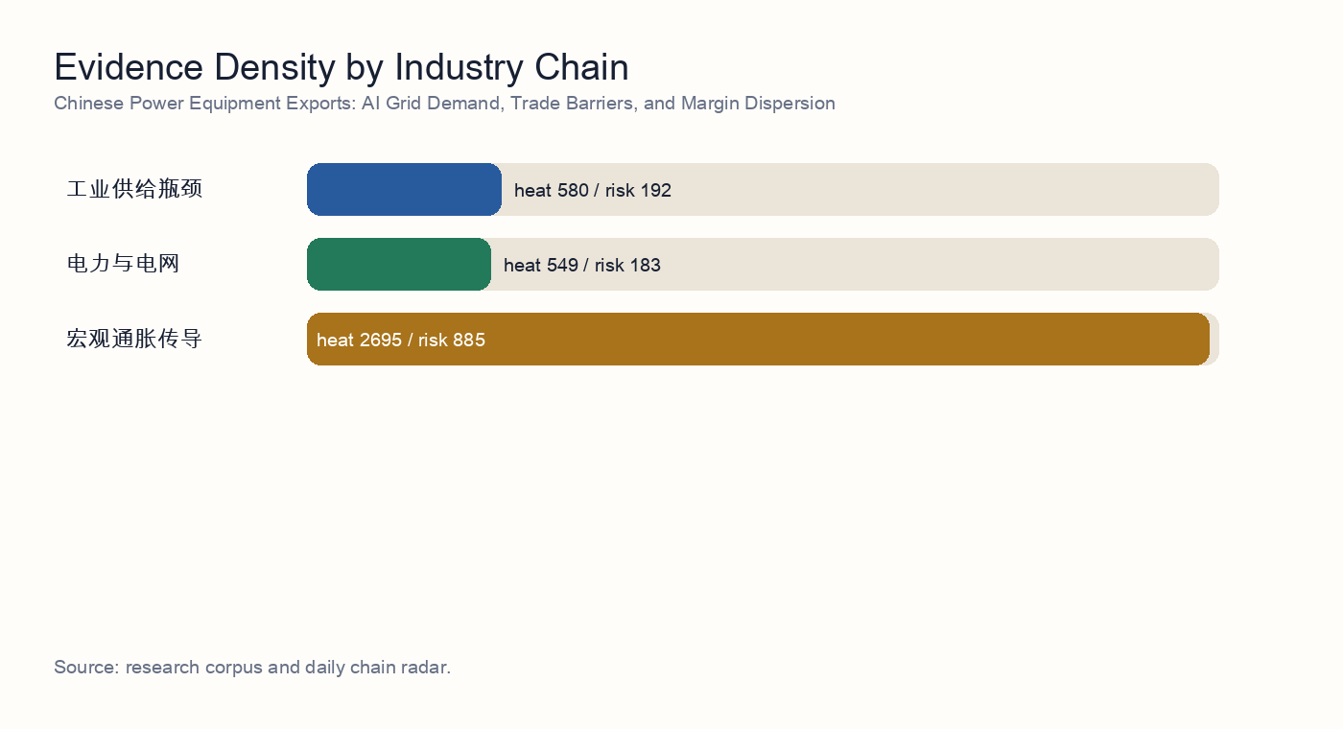
Industry-chain evidence density

2. Independent Synthesis
After reading 10 underlying source reports, the topic resolves into a sequence rather than a one-direction claim. AI demand first shows up as infrastructure buildout, then as power, grid, and equipment-delivery constraints, and only later as a possible productivity offset. The corpus therefore does not support a simple 'AI is inflationary' or 'AI is disinflationary' framing; it supports a staged capex cycle.
The strongest consensus is in power and grid infrastructure: 9 evidence items directly mention power, interconnection, firm power, utilities, or grid equipment. The repeated finding is that the compute buildout constraint is expanding from GPU supply into power access, local grid absorption, and delivery of enabling equipment.
The second consensus is that equipment delivery is not the same as compute availability. 9 items discuss transformers, distribution equipment, hardware delivery, or physical bottlenecks. Together they imply that vendor orders can be strong while project revenue recognition and live compute capacity remain constrained by interconnection, PPAs, power-node readiness, and local absorption.
Risk is not an appendix; it is part of the valuation model. This build includes 11 linked risk signals, with the central risk cluster around capex arriving before utilization, energy reliability gaps, delayed revenue timing, and crowded thematic trades. If those risks materialize, AI infrastructure valuations should be discounted with delayed cash flows and a higher capital-cost assumption.
The counter-evidence matters as well: 0 items mention efficiency or productivity. This does not erase the bottleneck thesis, but it identifies the medium-term release valve: model efficiency, custom silicon, edge AI, and workflow automation can lower unit compute or unit task costs and weaken the reflation narrative.

Source-Level Reading
- Source reading 1: Trade-barrier stress test for Chinese power-equipment exports. The source tests whether US and EU tariff, procurement, subsidy, and security-review pressure can intercept the highest-margin overseas channels even while transformer, switchgear, tap-changer, and data-center power-infrastructure demand remains real.
- Source reading 2: Power-equipment order quality, overseas delivery capability, and margin dispersion. The analysis separates broad order momentum from profit conversion: vendors with local delivery capacity and high-end core components should benefit most, while concept exposure without overseas execution can see weaker margin realization.
- Source reading 3: Tariff stacking and supply-chain diversification as a policy multiplier for export margins. Although cross-sector, the report is useful because it quantifies the policy multiplier: tariff stacking and diversification costs can amplify a demand-led gross-margin shock and raise working-capital pressure.
- Source reading 4: AI power demand, global grid upgrades, and the Chinese power-equipment export cycle. The evidence argues that AI power demand is pulling forward global grid investment, expanding the order, price, and margin window for Chinese power-equipment exporters.
- Source reading 5: Offshore capacity, trade barriers, and pass-through to power-equipment margins. The report reframes the trade from simple export volume growth to scarce transformer and high-voltage capacity located in jurisdictions that can preserve price premia.
- Source reading 6: Export-tax rebate calibration and third-country capacity strategy for Chinese grid-equipment exports. The policy note evaluates whether export-tax rebates, third-country capacity, and compliance positioning can protect the competitiveness of Chinese grid-equipment firms under tighter US and EU scrutiny.
- Source reading 7: Nonferrous-metals stress test for power-equipment gross margins. The materials stress test finds that copper and aluminum inflation can compress 2026 margins, but procurement locks, price-escalation clauses, and order-level metal coverage determine how much pressure reaches earnings.
- Source reading 8: Transformer and distribution-grid component capacity and lead-time survey. The supply-chain survey identifies transformer capacity and high-grade electrical steel as the core delivery constraints for the 2026-2027 distribution-grid investment cycle.

3. Research Questions
- Will overseas AI grid demand be intercepted by trade policy?
- Are order quality, delivery timing, and margins diverging?
- Which cost items most easily erode equipment vendors' excess returns?

4. Evidence Map
The selected topic spans industrial supply bottlenecks, power and grid, macro inflation transmission. The evidence ledger below rewrites AI Institute research results into standalone evidence summaries. Readers do not need to know the research production workflow or have private access to follow the argument.
- Evidence 1 | 2026-05-14 | unlabeled analyst: Trade-barrier stress test for Chinese power-equipment exports. Summary: The source tests whether US and EU tariff, procurement, subsidy, and security-review pressure can intercept the highest-margin overseas channels even while transformer, switchgear, tap-changer, and data-center power-infrastructure demand remains real. Implication: Shows that the first binding constraint is power, grid access, and equipment delivery, not only chip supply.
- Evidence 2 | 2026-05-13 | unlabeled analyst: Power-equipment order quality, overseas delivery capability, and margin dispersion. Summary: The analysis separates broad order momentum from profit conversion: vendors with local delivery capacity and high-end core components should benefit most, while concept exposure without overseas execution can see weaker margin realization. Implication: Shows that the first binding constraint is power, grid access, and equipment delivery, not only chip supply.
- Evidence 3 | 2026-05-17 | unlabeled analyst: Tariff stacking and supply-chain diversification as a policy multiplier for export margins. Summary: Although cross-sector, the report is useful because it quantifies the policy multiplier: tariff stacking and diversification costs can amplify a demand-led gross-margin shock and raise working-capital pressure. Implication: Requires valuation and capex timing to include delay, concentration, and delivery-failure stress tests.
- Evidence 4 | 2026-05-14 | unlabeled analyst: AI power demand, global grid upgrades, and the Chinese power-equipment export cycle. Summary: The evidence argues that AI power demand is pulling forward global grid investment, expanding the order, price, and margin window for Chinese power-equipment exporters. Implication: Shows that the first binding constraint is power, grid access, and equipment delivery, not only chip supply.
- Evidence 5 | 2026-05-13 | unlabeled analyst: Offshore capacity, trade barriers, and pass-through to power-equipment margins. Summary: The report reframes the trade from simple export volume growth to scarce transformer and high-voltage capacity located in jurisdictions that can preserve price premia. Implication: Shows that the first binding constraint is power, grid access, and equipment delivery, not only chip supply.
- Evidence 6 | 2026-05-06 | 中国宏观分析师: Export-tax rebate calibration and third-country capacity strategy for Chinese grid-equipment exports. Summary: The policy note evaluates whether export-tax rebates, third-country capacity, and compliance positioning can protect the competitiveness of Chinese grid-equipment firms under tighter US and EU scrutiny. Implication: Shows that the first binding constraint is power, grid access, and equipment delivery, not only chip supply.
- Evidence 7 | 2026-05-18 | materials analyst: Nonferrous-metals stress test for power-equipment gross margins. Summary: The materials stress test finds that copper and aluminum inflation can compress 2026 margins, but procurement locks, price-escalation clauses, and order-level metal coverage determine how much pressure reaches earnings. Implication: Shows that the first binding constraint is power, grid access, and equipment delivery, not only chip supply.
- Evidence 8 | 2026-05-17 | unlabeled analyst: Transformer and distribution-grid component capacity and lead-time survey. Summary: The supply-chain survey identifies transformer capacity and high-grade electrical steel as the core delivery constraints for the 2026-2027 distribution-grid investment cycle. Implication: Shows that the first binding constraint is power, grid access, and equipment delivery, not only chip supply.
- Evidence 9 | 2026-05-16 | energy analyst: Power-equipment supply chain and grid-expansion capacity validation. Summary: The research stress-tests whether AI compute growth is constrained by grid expansion, transformers, and distribution infrastructure rather than only by semiconductor availability. Implication: Shows that the first binding constraint is power, grid access, and equipment delivery, not only chip supply.
- Evidence 10 | 2026-05-16 | industrials analyst: AI power-equipment bottlenecks and capacity verification. Summary: The industrials research argues that China's integrated ultra-high-voltage supply chain can deliver faster than Western peers, making transformer and grid equipment a central beneficiary and constraint. Implication: Shows that the first binding constraint is power, grid access, and equipment delivery, not only chip supply.

5. Evidence Cluster Deep Dive
Individual evidence items explain facts; an investable conclusion requires evidence to form the same transmission chain. The sections below reorganize the source reports across policy, orders, grid demand, equipment capacity, and materials so that real demand is separated from retainable profit.

Policy Barrier and Compliance Channel
This evidence cluster shows that overseas demand does not automatically become Chinese vendor profit. 5 sources emphasize tariffs, subsidy eligibility, procurement rules, security reviews, and anti-circumvention enforcement as filters between demand and realized margin. Representative sources include: Trade-barrier stress test for Chinese power-equipment exports; Tariff stacking and supply-chain diversification as a policy multiplier for export margins; Offshore capacity, trade barriers, and pass-through to power-equipment margins.
The investment question therefore shifts from whether exports grow to whether the order jurisdiction, capacity location, core-component origin, and customer procurement rules allow the price premium to be retained. If a company must reroute shipments at lower margins or absorb compliance costs, AI grid demand can still expand while equity returns disappoint.

Order Quality and Margin Conversion
The order-level issue is not whether vendors have orders, but whether orders convert into profit. 1 sources highlight localized delivery capacity, high-end core components, certification, delivery scheduling, and project acceptance as the variables that separate high-quality orders from narrative exposure. Representative sources include: Power-equipment order quality, overseas delivery capability, and margin dispersion.
The clean framework splits orders into three layers: signed but undelivered, delivered but not accepted, and recognized revenue with price-escalation protection. Only the third layer moves reliably into earnings; the first two layers remain exposed to interconnection delays, logistics, certification, tariffs, and customer project slippage.

AI Power Demand and Global Grid Pull-Forward
AI power demand is pulling forward a traditional grid-investment cycle. 2 sources point to the same mechanism: data-center construction turns firm power, PPAs, interconnection queues, and local grid absorption into prerequisites for usable compute. Representative sources include: AI power demand, global grid upgrades, and the Chinese power-equipment export cycle; Transformer and distribution-grid component capacity and lead-time survey.
That makes Chinese power-equipment exports not only an external-demand trade, but also an inflation-transmission trade. If grid investment arrives before productivity gains, equipment prices, engineering costs, and capital costs rise first. The offset arrives only when utilization and automation efficiency begin to show up in unit-output data.

Transformer, UHV, and Distribution Equipment Capacity
The equipment evidence emphasizes physical delivery constraints. 2 sources concentrate on transformers, UHV/EHV gear, distribution-grid components, switchgear, and high-grade electrical steel. Representative sources include: Nonferrous-metals stress test for power-equipment gross margins; AI power-equipment bottlenecks and capacity verification.
Scarcity is both the source of investment value and the source of risk. Tight capacity improves pricing power, but it also magnifies quality issues, delivery slippage, inventory mismatch, and customer cancellation risk. The highest-quality firms are not merely the largest capacity owners; they combine high-end components, certification, local delivery, and pricing clauses.

6. Policy, Delivery, and Margin Framework
The core of this topic is not export growth alone. Demand, policy, delivery, cost, and valuation layers jointly decide who owns the profit pool. AI grid demand is the starting point; trade barriers and localized delivery are filters; materials and contract clauses determine gross margin; capital costs and crowding determine the valuation investors are willing to pay.
Layer | Main variables | Financial transmission | Investment implication
Demand | AI data centers, grid expansion, overseas replacement demand | Order growth, prepayments, production scheduling | Demand can be real while policy and delivery filters intercept profit
Policy | Tariffs, anti-circumvention, subsidy eligibility, procurement limits, security reviews | Compliance cost, customer exclusion, order migration | Determines whether exports become high-margin revenue
Delivery | Localized capacity, certification, interconnection, logistics, project acceptance | Delayed revenue recognition, cash-flow mismatch, inventory drag | Determines the gap between order intake and the income statement
Cost | Copper, aluminum, GOES, core components, FX | Gross-margin pressure or repricing power | Determines how the equipment-chain profit pool is allocated
Valuation | Capital cost, crowded positioning, utilization, customer capex | Discount-rate changes and earnings-conversion probability | Determines whether the theme becomes an earnings cycle

7. Transmission Model
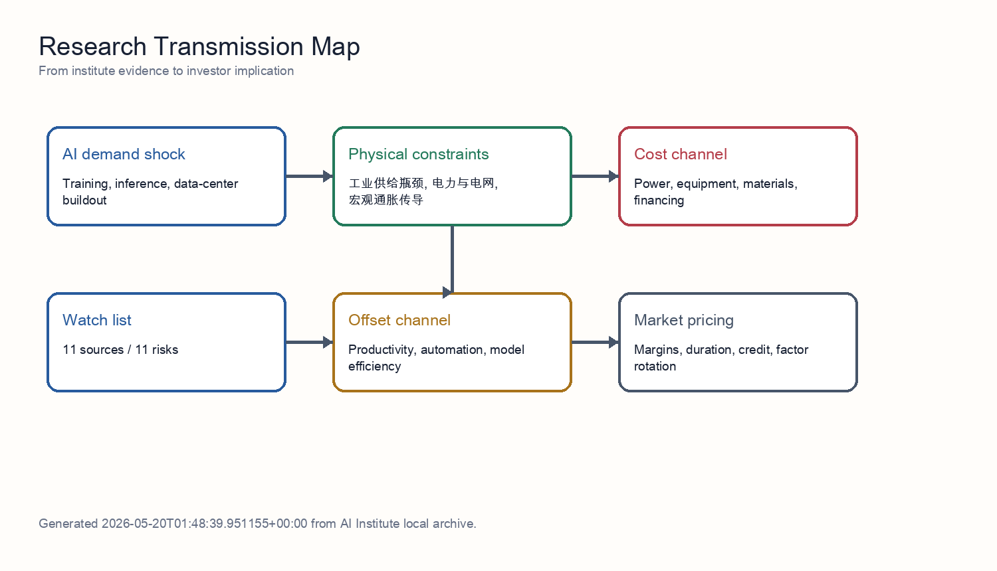
Transmission model
The mechanism separates demand, constraints, and pricing. Demand comes from training, inference, and data-center construction. Constraints come from grid access, transformers, materials, semiconductors, and delivery cycles. Pricing shows up in electricity prices, equipment prices, capital costs, and margin allocation. Productivity is the offsetting force, but it normally requires adoption, workflow redesign, and organizational change, so it tends to arrive later than capex.
For Chinese power-equipment exports, the chain also needs a policy filter. US and EU policy does not eliminate global grid-upgrade demand, but it changes profit ownership: orders can migrate toward local manufacturing, third-country capacity, less sensitive components, or lower-priced suppliers. The stricter the policy layer, the more overseas orders need to be discounted for deliverability and compliance cost.
The AI-inflation relationship is therefore not one direction; it is a sequence. Power, grid, metals, and equipment prices react first. Data-center utilization and enterprise automation determine whether the cost can be absorbed in the middle phase. Only later can productivity growth offset the capital-expenditure impulse.

8. Source-by-Source Interpretation
The following section translates each source into an actionable investment input. The goal is to let a reader without private research access understand how each evidence item enters the final conclusion.

Source 1: Trade-barrier stress test for Chinese power-equipment exports
This evidence belongs to the policy barrier and compliance channel cluster. Its direct contribution is: The source tests whether US and EU tariff, procurement, subsidy, and security-review pressure can intercept the highest-margin overseas channels even while transformer, switchgear, tap-changer, and data-center power-infrastructure demand remains real. That moves the topic from a macro narrative into testable operating variables such as order quality, delivery time, input costs, interconnection status, and policy accessibility.
The investment implication is: Shows that the first binding constraint is power, grid access, and equipment delivery, not only chip supply. At the portfolio level, it should not be treated as a standalone buy signal. It should be combined with other sources in the same cluster; when several sources point to the same constraint, the constraint becomes large enough to affect valuation and margins.
The falsifier to track is: If the US and EU create clear exemptions, localization paths widen, or procurement rules permit Chinese core components in premium projects, the policy discount should fall.

Source 2: Power-equipment order quality, overseas delivery capability, and margin dispersion
This evidence belongs to the order quality and margin conversion cluster. Its direct contribution is: The analysis separates broad order momentum from profit conversion: vendors with local delivery capacity and high-end core components should benefit most, while concept exposure without overseas execution can see weaker margin realization. That moves the topic from a macro narrative into testable operating variables such as order quality, delivery time, input costs, interconnection status, and policy accessibility.
The investment implication is: Shows that the first binding constraint is power, grid access, and equipment delivery, not only chip supply. At the portfolio level, it should not be treated as a standalone buy signal. It should be combined with other sources in the same cluster; when several sources point to the same constraint, the constraint becomes large enough to affect valuation and margins.
The falsifier to track is: If overseas orders keep growing but advances, acceptance progress, and segment margins do not improve, order quality is weaker than the headline order number.

Source 3: Tariff stacking and supply-chain diversification as a policy multiplier for export margins
This evidence belongs to the policy barrier and compliance channel cluster. Its direct contribution is: Although cross-sector, the report is useful because it quantifies the policy multiplier: tariff stacking and diversification costs can amplify a demand-led gross-margin shock and raise working-capital pressure. That moves the topic from a macro narrative into testable operating variables such as order quality, delivery time, input costs, interconnection status, and policy accessibility.
The investment implication is: Requires valuation and capex timing to include delay, concentration, and delivery-failure stress tests. At the portfolio level, it should not be treated as a standalone buy signal. It should be combined with other sources in the same cluster; when several sources point to the same constraint, the constraint becomes large enough to affect valuation and margins.
The falsifier to track is: If the US and EU create clear exemptions, localization paths widen, or procurement rules permit Chinese core components in premium projects, the policy discount should fall.

Source 4: AI power demand, global grid upgrades, and the Chinese power-equipment export cycle
This evidence belongs to the ai power demand and global grid pull-forward cluster. Its direct contribution is: The evidence argues that AI power demand is pulling forward global grid investment, expanding the order, price, and margin window for Chinese power-equipment exporters. That moves the topic from a macro narrative into testable operating variables such as order quality, delivery time, input costs, interconnection status, and policy accessibility.
The investment implication is: Shows that the first binding constraint is power, grid access, and equipment delivery, not only chip supply. At the portfolio level, it should not be treated as a standalone buy signal. It should be combined with other sources in the same cluster; when several sources point to the same constraint, the constraint becomes large enough to affect valuation and margins.
The falsifier to track is: If AIDC interconnection queues shorten, PPA prices fall, and grid investment is delayed, the strength of the AI grid pull-forward thesis should be revised down.

Source 5: Offshore capacity, trade barriers, and pass-through to power-equipment margins
This evidence belongs to the policy barrier and compliance channel cluster. Its direct contribution is: The report reframes the trade from simple export volume growth to scarce transformer and high-voltage capacity located in jurisdictions that can preserve price premia. That moves the topic from a macro narrative into testable operating variables such as order quality, delivery time, input costs, interconnection status, and policy accessibility.
The investment implication is: Shows that the first binding constraint is power, grid access, and equipment delivery, not only chip supply. At the portfolio level, it should not be treated as a standalone buy signal. It should be combined with other sources in the same cluster; when several sources point to the same constraint, the constraint becomes large enough to affect valuation and margins.
The falsifier to track is: If the US and EU create clear exemptions, localization paths widen, or procurement rules permit Chinese core components in premium projects, the policy discount should fall.

Source 6: Export-tax rebate calibration and third-country capacity strategy for Chinese grid-equipment exports
This evidence belongs to the policy barrier and compliance channel cluster. Its direct contribution is: The policy note evaluates whether export-tax rebates, third-country capacity, and compliance positioning can protect the competitiveness of Chinese grid-equipment firms under tighter US and EU scrutiny. That moves the topic from a macro narrative into testable operating variables such as order quality, delivery time, input costs, interconnection status, and policy accessibility.
The investment implication is: Shows that the first binding constraint is power, grid access, and equipment delivery, not only chip supply. At the portfolio level, it should not be treated as a standalone buy signal. It should be combined with other sources in the same cluster; when several sources point to the same constraint, the constraint becomes large enough to affect valuation and margins.
The falsifier to track is: If the US and EU create clear exemptions, localization paths widen, or procurement rules permit Chinese core components in premium projects, the policy discount should fall.

Source 7: Nonferrous-metals stress test for power-equipment gross margins
This evidence belongs to the transformer, uhv, and distribution equipment capacity cluster. Its direct contribution is: The materials stress test finds that copper and aluminum inflation can compress 2026 margins, but procurement locks, price-escalation clauses, and order-level metal coverage determine how much pressure reaches earnings. That moves the topic from a macro narrative into testable operating variables such as order quality, delivery time, input costs, interconnection status, and policy accessibility.
The investment implication is: Shows that the first binding constraint is power, grid access, and equipment delivery, not only chip supply. At the portfolio level, it should not be treated as a standalone buy signal. It should be combined with other sources in the same cluster; when several sources point to the same constraint, the constraint becomes large enough to affect valuation and margins.
The falsifier to track is: If transformer, switchgear, and distribution-component lead times shorten quickly, scarcity pricing shifts from supply shortage to competitive normalization.

Source 8: Transformer and distribution-grid component capacity and lead-time survey
This evidence belongs to the ai power demand and global grid pull-forward cluster. Its direct contribution is: The supply-chain survey identifies transformer capacity and high-grade electrical steel as the core delivery constraints for the 2026-2027 distribution-grid investment cycle. That moves the topic from a macro narrative into testable operating variables such as order quality, delivery time, input costs, interconnection status, and policy accessibility.
The investment implication is: Shows that the first binding constraint is power, grid access, and equipment delivery, not only chip supply. At the portfolio level, it should not be treated as a standalone buy signal. It should be combined with other sources in the same cluster; when several sources point to the same constraint, the constraint becomes large enough to affect valuation and margins.
The falsifier to track is: If AIDC interconnection queues shorten, PPA prices fall, and grid investment is delayed, the strength of the AI grid pull-forward thesis should be revised down.

Source 9: Power-equipment supply chain and grid-expansion capacity validation
This evidence belongs to the policy barrier and compliance channel cluster. Its direct contribution is: The research stress-tests whether AI compute growth is constrained by grid expansion, transformers, and distribution infrastructure rather than only by semiconductor availability. That moves the topic from a macro narrative into testable operating variables such as order quality, delivery time, input costs, interconnection status, and policy accessibility.
The investment implication is: Shows that the first binding constraint is power, grid access, and equipment delivery, not only chip supply. At the portfolio level, it should not be treated as a standalone buy signal. It should be combined with other sources in the same cluster; when several sources point to the same constraint, the constraint becomes large enough to affect valuation and margins.
The falsifier to track is: If the US and EU create clear exemptions, localization paths widen, or procurement rules permit Chinese core components in premium projects, the policy discount should fall.

Source 10: AI power-equipment bottlenecks and capacity verification
This evidence belongs to the transformer, uhv, and distribution equipment capacity cluster. Its direct contribution is: The industrials research argues that China's integrated ultra-high-voltage supply chain can deliver faster than Western peers, making transformer and grid equipment a central beneficiary and constraint. That moves the topic from a macro narrative into testable operating variables such as order quality, delivery time, input costs, interconnection status, and policy accessibility.
The investment implication is: Shows that the first binding constraint is power, grid access, and equipment delivery, not only chip supply. At the portfolio level, it should not be treated as a standalone buy signal. It should be combined with other sources in the same cluster; when several sources point to the same constraint, the constraint becomes large enough to affect valuation and margins.
The falsifier to track is: If transformer, switchgear, and distribution-component lead times shorten quickly, scarcity pricing shifts from supply shortage to competitive normalization.

9. Stress Tests

Stress Test 1: Trade Policy Tightens Further
If the US and EU continue to tighten tariffs, procurement rules, subsidy eligibility, or security reviews, the first effect is not the disappearance of global demand. The first effect is reduced accessibility to the highest-margin markets. Orders may still exist, but they migrate from direct export into local manufacturing, third-country capacity, less sensitive components, or lower-priced alternatives. Portfolio construction should raise the haircut on overseas orders and prefer companies that already have localized capacity and customer certification.

Stress Test 2: Equipment Lead Times Shorten Without Price Deflation
This is the most constructive combination for equipment leaders. Shorter lead times show that capacity expansion is working; stable prices show that demand is still strong enough to absorb added supply. In that case, the market should move from bottleneck pricing to earnings conversion, with emphasis on revenue recognition, segment margin, and operating cash flow moving together.

Stress Test 3: Copper, Aluminum, and GOES Rise Faster Than Order Repricing
This is the most dangerous margin combination. Revenue can remain strong because the order book is full, while the cost stack compresses gross margin. Company dispersion comes from contract clauses, procurement locks, and inventory management. Firms without price escalation should receive lower margin assumptions; firms with material hedges and high-end core-component control deserve a relative premium.

Stress Test 4: AI Efficiency Improves Fast Enough to Weaken Incremental Equipment Orders
If model efficiency, ASICs, edge AI, and workflow automation reduce unit compute requirements quickly, the equipment chain shifts from a demand-expansion trade to an order-quality audit. This does not necessarily cancel existing grid investment, but it compresses the market's extrapolation of 2027 and later orders. The portfolio response is to reduce pure theme exposure and demand stronger evidence of cash flow and confirmed backlog.

10. Risk Matrix
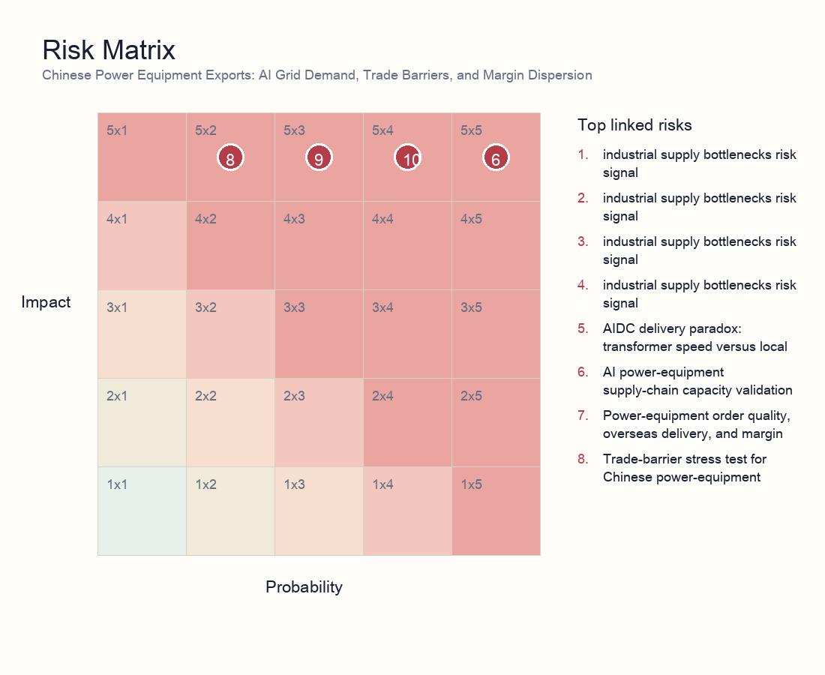
Risk matrix
- Risk 1 | power and grid | 5/5: AIDC delivery paradox: transformer speed versus local grid absorption. Explanation: Shows that faster transformer delivery does not automatically become usable compute; interconnection, power quality, dispatch rules, and local grid absorption remain binding constraints.
- Risk 2 | industrial supply bottlenecks | 5/5: AI power-equipment supply-chain capacity validation. Explanation: Tests whether transformer, switchgear, and grid-equipment capacity can absorb AI infrastructure demand without delivery slippage or margin pressure.
- Risk 3 | industrial supply bottlenecks | 5/3: Power-equipment order quality, overseas delivery, and margin dispersion. Explanation: Separates high-quality overseas and grid orders from weaker concept exposure; order quality and margin dispersion are the core risks.
- Risk 4 | power and grid | 5/2: Trade-barrier stress test for Chinese power-equipment exports. Explanation: Tests whether US and EU trade barriers can weaken the overseas growth thesis for Chinese power-equipment exporters.
- Risk 5 | power and grid | 5/3: Power-equipment and grid bottleneck stress test for AI compute expansion. Explanation: Tests whether AI compute growth is constrained by grid expansion, transformer supply, and distribution infrastructure rather than only semiconductor availability.
- Risk 6 | AI infrastructure | 5/4: Edge AI and custom silicon under power-infrastructure constraints. Explanation: Frames power bottlenecks as a catalyst for edge AI, ASICs, and architecture substitution rather than a collapse in AI capex.
- Risk 7 | industrial supply bottlenecks | 5/5: Material bottlenecks for power-equipment expansion. Explanation: Flags GOES, copper, and large casting/forging availability as upstream constraints on equipment output and margins.
- Risk 8 | industrial supply bottlenecks | 5/3: Transformer and distribution-grid component capacity and lead-time survey. Explanation: Checks transformer and distribution-grid component capacity, lead times, and order convertibility.
- Risk 9 | industrial supply bottlenecks | 5/3: Power-equipment supply chain and grid-expansion capacity validation. Explanation: Validates whether power-equipment supply and grid-expansion capacity can support the AI compute buildout pace.
- Risk 10 | industrial supply bottlenecks | 5/4: AI power-hardware bottlenecks: transformer and GOES delivery risk. Explanation: Tracks transformer and GOES delivery risk as a key constraint on AI power-hardware deployment.
- Risk 11 | macro inflation transmission | 5/2: Nonferrous-metal stress test for power-equipment gross margins. Explanation: Tests whether copper and aluminum price pressure can compress power-equipment margins and earnings visibility.

11. Scenario Analysis
Scenario | Trigger | Macro/asset implication | Investor action
Supply relief | Shorter equipment lead times, stable power prices, higher model efficiency | AI infrastructure margins expand and inflation concern fades | Favor quality equipment and efficiency beneficiaries; reduce pure-duration narrative exposure
Bottleneck persistence | Transformer/GOES/interconnection constraints persist; PPAs and capital costs rise | Capex monetization lags valuation; inflation stickiness rises | Prefer cash-flow-backed equipment exposure; control crowded data-center trades
Demand migration | Cloud constraints push edge AI, ASICs, and automation substitutes | Hardware demand migrates while software efficiency buffers inflation | Allocate to architecture substitution and efficiency tools; stay selective on long-duration themes

12. Portfolio and Valuation Implications
Valuation cannot be explained by demand multiples alone. A cleaner model decomposes overseas orders into order value, deliverable share, retainable gross margin, revenue-recognition timing, and cash-collection timing, then probability-adjusts those variables against 11 linked risk signals. This avoids discounting every overseas order at the same margin and the same time horizon.
The first valuation premium belongs to delivery certainty: firms with localized capacity, core-component control, certification, and long-standing customer relationships deserve a lower order haircut. The second premium belongs to price architecture: firms that can protect margins when copper, aluminum, and GOES rise are proving stronger contract structure and bargaining power.
The discount factors are equally clear. If orders concentrate in high-policy-risk markets, or if revenue depends on customer projects receiving grid access on schedule, the discount rate should rise. If inventory, receivables, and prepayment structure deteriorate, earnings quality should be haircut even when revenue is growing.
The most important falsification signal is the combination of shorter lead times, lower materials prices, customer capex cuts, and faster AI efficiency gains. That combination would shift the trade from scarcity pricing to earnings-conversion scrutiny, forcing the market to demand quarterly proof of margin and cash flow.
Bucket | Exposure | Rationale | Key checks
Core overweight | Power-equipment leaders with localized delivery, high-end core components, price escalation, and certification | Higher probability that orders convert into revenue and that materials/policy shocks are passed through | Lead times, overseas revenue mix, segment margin, core-component self-supply
Selective exposure | UHV/EHV, distribution automation, switchgear, cooling, and power electronics | Beneficiaries of grid pull-forward, but stock quality is dispersed | Order quality, customer mix, project acceptance, inventory turns
Avoid or underweight | Narrative-only names lacking certification or local delivery, with high materials exposure and weak repricing clauses | Revenue growth can be absorbed by tariffs, delays, and gross-margin compression | Margin cuts, rising receivables, delivery-delay disclosures
Hedges | Copper/aluminum, FX, overseas policy risk, customer capex cuts | Useful hedges for equipment-chain margin and valuation volatility | Commodity prices, tariff announcements, customer capex guidance

13. Investor Reading Framework
First, test whether the constraint is real rather than narrative-driven: prioritize lead times, order quality, utilization, interconnection status, and PPA terms. Second, split the profit pool: resources and equipment may benefit from bottlenecks, while data centers and high-duration themes can absorb capital-cost and delay pressure. Third, weight repeated verification: a risk validated by risk, industrials, energy, and macro analysts should matter more than a single theme note. Fourth, keep a falsification path: rapid productivity and architecture efficiency would weaken the reflation thesis.

14. Daily Monitoring Dashboard
Dimension | Indicator | Interpretation | Evidence source
Delivery | Quarterly lead times for transformers, switchgear, and GOES | Longer lead times support bottleneck pricing; shorter lead times indicate supply relief | Vendor disclosures, channel surveys, tender documents
Policy | US/EU tariffs, subsidy eligibility, procurement limits, anti-circumvention cases | New limits compress high-margin channels; exemptions and localization widen the addressable market | Official notices, customer procurement rules, capacity-location disclosures
Margins | Overseas segment margin, price-escalation clauses, metal inventory coverage | Revenue growth without stable margins means the profit pool is absorbed by costs | Financial reports, order contracts, commodity prices
Grid | AIDC interconnection queues, PPA prices, local absorption capacity | Persistent interconnection bottlenecks delay compute launch while supporting grid-equipment demand | Utility data, PPA disclosures, project start notices
Valuation | Theme crowding, flows, rate sensitivity of duration assets | Crowded trades are more vulnerable when earnings conversion is delayed | ETF/sector flows, valuation percentiles, credit spreads

15. Data Still Needed
- Interconnection queues, PPA prices, and utilization for major AIDC projects.
- Quarterly lead times and pricing for transformers, GOES, copper/aluminum, and switchgear.
- Measurable AI adoption, unit task cost, employee output, and automation substitution data.
- Theme crowding, flow, valuation percentile, and credit-condition changes.

