Consumer Downgrade, Silver Economy, and Structural Healthcare Opportunities
Generated: 2026-05-19T14:04:25.020350+00:00; evidence window: 2026-05-19; research archive fetch: 2026-05-19T12:49:36.748Z.

1. Executive Thesis
Consumption is shifting from aggregate beta to structural divergence: silver-economy demand, healthcare, sugar substitutes, and B-end catering penetration may create defensive demand, but purchasing power and channel sell-through must be validated. This report uses 12 relevant source reports, contributions from 2 main analysts, and 6 risk signals. The central conclusion is that consumer downgrade has not eliminated demand; it has moved demand from aggregate elasticity toward payment certainty, cost-reduction efficiency, and healthcare necessity. Investment value depends on whether those demand pockets can be verified through sell-through, gross margin, and cash collection.
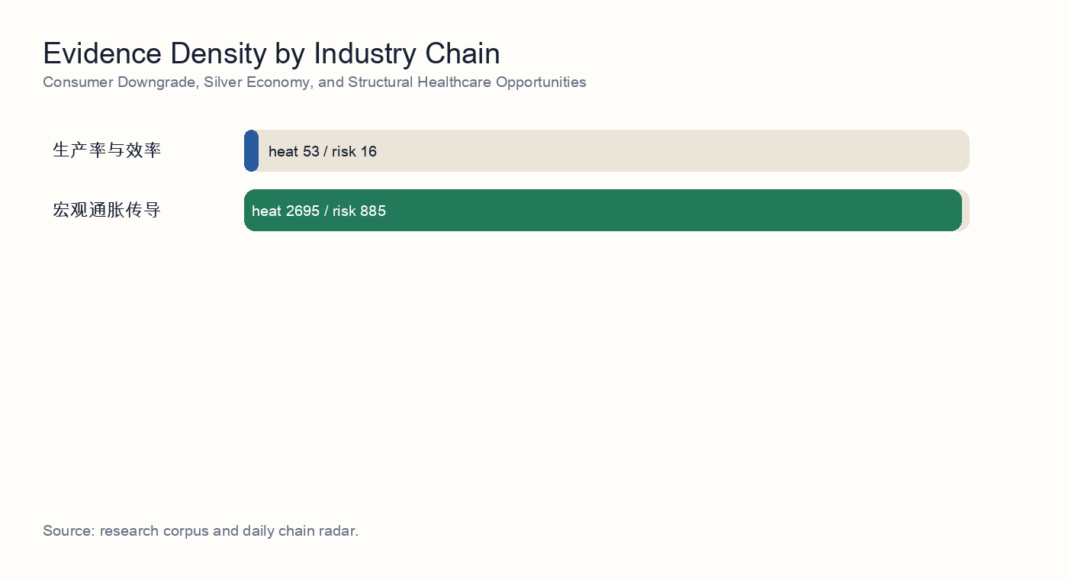
Industry-chain evidence density

2. Independent Synthesis
After reading 12 source reports, this topic is not a binary call between broad consumption recovery and broad consumer downgrade. It is a structural divergence problem: aggregate purchasing power is under pressure, while healthcare necessity, long-term care, rehabilitation devices, B-end catering cost reduction, and sugar-substitute ingredients still form distinct demand curves.
The consumer evidence includes 6 items on ticket size, sell-through, B-end catering, trade-in demand, or premium experience consumption. The shared conclusion is that channel restocking and policy stimulus cannot be treated as final demand; they need validation through repeat purchase, inventory turns, average selling price, discount rate, and customer retention.
Silver-economy purchasing power is the constraint layer. 3 items discuss pensions, medical insurance, long-term care insurance, rehabilitation, or assistive devices. These sources support a rigid healthcare base, but they also challenge linear extrapolation from headline silver-economy size into high-end self-pay medical consumption.
Healthcare is the structural opportunity layer. 9 items discuss innovative drugs, medical devices, GLP-1, allulose, CXO, or outbound pharma BD. The portfolio implication is to price certainty anchors, policy events, and high-beta assets separately rather than assigning one healthcare multiple to the entire basket.
The risk layer includes 6 signals. The central risk is not whether demand exists, but whether demand becomes margin and cash flow. The required stress tests are purchasing power, reimbursement timing, overseas compliance, channel inventory, and the concentration of premium consumption among high-income cohorts.

Source-Level Reading
- Source reading 1: Downstream food-processing demand: B-end catering penetration and GLP-1 sugar-substitute pull. The source validates two defensive growth lines in food processing: restaurant operators using B-end semi-finished products to lower labor and kitchen costs, and GLP-1-driven sugar reduction supporting allulose and other next-generation sweeteners.
- Source reading 2: Pension-system transition and the silver-economy consumption base. The pension stress test argues that silver-economy healthcare demand is real but cash-flow constrained: basic medical insurance and long-term care insurance support rigid demand, while high-end self-pay medical services need lower expectations.
- Source reading 3: Consumer-downgrade risk and the quality of trade-in replacement demand. The trade-in demand note warns that policy stimulus and replacement demand must be separated from true discretionary recovery; sell-through, subsidy intensity, and household balance-sheet pressure determine earnings quality.
- Source reading 4: Healthcare cost anchor under the Biosecure Act and CXO decoupling. The healthcare macro stress test treats Biosecure Act risk, CXO decoupling, and compliance cost as a cost anchor that can change the margin profile of healthcare globalization.
- Source reading 5: Policy-driven repricing of innovative drugs and medical-device R&D. The policy repricing note supports innovative drugs and medical devices, but the upside depends on reimbursement, procurement, product approval, and commercialization cadence rather than broad sector beta.
- Source reading 6: Healthcare structural opportunities and A/H-share portfolio path. The strategy report proposes a barbell healthcare portfolio: high-certainty Hong Kong-listed anchors and tactical A-share high-beta positions, with different holding periods and risk discounts.
- Source reading 7: Consumer-credit stress transmission and financial-sector pricing. The credit-stress report is a household purchasing-power cross-check: weaker consumer credit quality can cap discretionary healthcare, premium experience consumption, and replacement demand.
- Source reading 8: A-share healthcare allocation under rigid domestic demand and offshore-dollar constraints. The allocation note frames domestic healthcare as a rigid-demand A-share exposure, but warns that offshore-dollar constraints and global risk appetite affect valuation and capital-flow timing.

3. Research Questions
- Which subsectors retain real demand resilience under consumer downgrade?
- Are silver-economy and healthcare themes a durable base or a defensive trade?
- How should sugar substitutes, B-end catering, and healthcare chains validate sell-through quality?

4. Evidence Map
The selected topic spans productivity and efficiency, macro inflation transmission. The evidence ledger below rewrites the research archive into standalone evidence summaries. Readers do not need to know any internal workflow to follow the argument.
- Evidence 1 | 2026-05-18 | unlabeled analyst: Downstream food-processing demand: B-end catering penetration and GLP-1 sugar-substitute pull. Summary: The source validates two defensive growth lines in food processing: restaurant operators using B-end semi-finished products to lower labor and kitchen costs, and GLP-1-driven sugar reduction supporting allulose and other next-generation sweeteners. Implication: Shows that consumer downgrade can coexist with structural demand created by cost reduction and healthier substitution.
- Evidence 2 | 2026-05-18 | unlabeled analyst: Pension-system transition and the silver-economy consumption base. Summary: The pension stress test argues that silver-economy healthcare demand is real but cash-flow constrained: basic medical insurance and long-term care insurance support rigid demand, while high-end self-pay medical services need lower expectations. Implication: Separates the silver-economy headline from actual cash-flow support, policy reimbursement, and self-pay elasticity.
- Evidence 3 | 2026-05-18 | unlabeled analyst: Consumer-downgrade risk and the quality of trade-in replacement demand. Summary: The trade-in demand note warns that policy stimulus and replacement demand must be separated from true discretionary recovery; sell-through, subsidy intensity, and household balance-sheet pressure determine earnings quality. Implication: Requires validation through ticket size, discount rate, credit stress, and real sell-through rather than headline demand.
- Evidence 4 | 2026-05-16 | unlabeled analyst: Healthcare cost anchor under the Biosecure Act and CXO decoupling. Summary: The healthcare macro stress test treats Biosecure Act risk, CXO decoupling, and compliance cost as a cost anchor that can change the margin profile of healthcare globalization. Implication: Places healthcare upside inside a margin stress test for policy, compliance, outbound orders, and cash collection.
- Evidence 5 | 2026-05-14 | unlabeled analyst: Policy-driven repricing of innovative drugs and medical-device R&D. Summary: The policy repricing note supports innovative drugs and medical devices, but the upside depends on reimbursement, procurement, product approval, and commercialization cadence rather than broad sector beta. Implication: Places healthcare upside inside a margin stress test for policy, compliance, outbound orders, and cash collection.
- Evidence 6 | 2026-05-19 | 首席策略师: Healthcare structural opportunities and A/H-share portfolio path. Summary: The strategy report proposes a barbell healthcare portfolio: high-certainty Hong Kong-listed anchors and tactical A-share high-beta positions, with different holding periods and risk discounts. Implication: Places healthcare upside inside a margin stress test for policy, compliance, outbound orders, and cash collection.
- Evidence 7 | 2026-05-18 | unlabeled analyst: Consumer-credit stress transmission and financial-sector pricing. Summary: The credit-stress report is a household purchasing-power cross-check: weaker consumer credit quality can cap discretionary healthcare, premium experience consumption, and replacement demand. Implication: Requires validation through ticket size, discount rate, credit stress, and real sell-through rather than headline demand.
- Evidence 8 | 2026-05-18 | unlabeled analyst: A-share healthcare allocation under rigid domestic demand and offshore-dollar constraints. Summary: The allocation note frames domestic healthcare as a rigid-demand A-share exposure, but warns that offshore-dollar constraints and global risk appetite affect valuation and capital-flow timing. Implication: Provides cross-checking evidence for structural opportunities under consumer downgrade, with focus on purchasing power, sell-through quality, and cash-flow conversion.
- Evidence 9 | 2026-05-18 | unlabeled analyst: Bailong Chuangyuan and the allulose cost-curve compression thesis. Summary: The allulose thesis focuses on cost-curve compression, continuous production, by-product recycling, and Thai capacity as evidence that sweetener demand can become margin advantage for a cost leader. Implication: Shows that consumer downgrade can coexist with structural demand created by cost reduction and healthier substitution.
- Evidence 10 | 2026-05-18 | unlabeled analyst: Industrial challenge to healthcare-chain execution assumptions. Summary: The industrial challenge asks whether healthcare demand can be fulfilled through capacity, delivery, manufacturing quality, and supply-chain execution rather than only through thematic demand. Implication: Provides cross-checking evidence for structural opportunities under consumer downgrade, with focus on purchasing power, sell-through quality, and cash-flow conversion.
- Evidence 11 | 2026-05-18 | unlabeled analyst: Outbound pharma BD and offshore-dollar retention. Summary: The outbound BD note links pharma globalization to offshore-dollar retention, deal timing, and cash repatriation, which can affect domestic valuation despite operating progress. Implication: Places healthcare upside inside a margin stress test for policy, compliance, outbound orders, and cash collection.
- Evidence 12 | 2026-05-17 | unlabeled analyst: Premium experience consumption: ASP and margin validation. Summary: The premium-experience note stress-tests whether strong cruise and travel spending represent durable pricing power or a narrow high-income cohort that cannot offset broad consumer downgrade. Implication: Requires validation through ticket size, discount rate, credit stress, and real sell-through rather than headline demand.

5. Evidence Cluster Deep Dive
A single source can explain a fact; an investable conclusion requires several sources to form the same transmission chain. The sections below reorganize the evidence across food processing, silver-economy payment, sell-through, healthcare policy, credit income, and industrial execution.

B-End Food Processing and Sugar-Substitute Demand
This cluster shows that consumer downgrade does not mean the whole food-processing chain weakens. 2 sources focus on B-end catering cost reduction, semi-finished food penetration, GLP-1-driven sugar reduction, and the allulose cost curve. Representative sources include: Downstream food-processing demand: B-end catering penetration and GLP-1 sugar-substitute pull; Bailong Chuangyuan and the allulose cost-curve compression thesis.
Demand comes from two channels: restaurant operators raising standardized-ingredient usage to cut labor and kitchen space, and consumers or brands seeking sugar substitutes with a closer sucrose-like experience. The first channel should be validated through customer retention, repeat purchase, and inventory turns; the second through price curves, capacity release, and end-product reformulation.

Silver-Economy Payment Capacity
The silver-economy evidence pulls the theme back from population size to payment capacity. 1 sources discuss pensions, medical insurance, long-term care insurance, rehabilitation, assistive devices, and self-pay medical elasticity. Representative sources include: Pension-system transition and the silver-economy consumption base.
The core conclusion is that basic medical insurance and long-term care insurance can support rigid demand in chronic disease, rehabilitation, care services, and home devices. However, the first-pillar replacement rate, weaker housing wealth effect, and locked third-pillar pension assets constrain premium checkups, anti-aging, aesthetic medicine, and other self-pay upgrades.

Consumer Downgrade and Sell-Through Quality
The consumer-downgrade evidence emphasizes that policy stimulus and premium-experience data both require sell-through validation. 2 sources discuss trade-in programs, ticket size, ASP, cruise or travel spending, and consumption segmentation. Representative sources include: Consumer-downgrade risk and the quality of trade-in replacement demand; Premium experience consumption: ASP and margin validation.
This evidence prevents short-term subsidies, channel restocking, or high-income cohort spending from being mistaken for broad consumption recovery. Portfolio construction should demand stricter indicators: terminal volume, discount rate, repeat purchase, ticket size, inventory turns, and receivables.

Healthcare Policy, Innovation, and Globalization
The healthcare evidence shows that structural opportunities exist, but policy and execution must be separated. 6 sources cover innovative drugs, medical devices, GLP-1, peptides, CXO, Biosecure Act risk, outbound BD, and A/H-share allocation. Representative sources include: Healthcare cost anchor under the Biosecure Act and CXO decoupling; Policy-driven repricing of innovative drugs and medical-device R&D; Healthcare structural opportunities and A/H-share portfolio path.
Healthcare assets should not receive a single thematic multiple. Reimbursement-backed and rigid-payment names fit the core bucket; peptides, GLP-1 APIs, and outbound BD fit event-driven or right-side trading; CXO and overseas revenue need compliance, regulatory, and cash-collection discounts.

Credit Stress and Household Purchasing Power
The credit and income evidence provides the macro constraint for the consumer chain. 1 sources discuss consumer credit, household balance sheets, financial pricing, or purchasing power. Representative sources include: Consumer-credit stress transmission and financial-sector pricing.
If consumer credit quality weakens, discretionary consumption, durable replacement, and premium self-pay healthcare are pressured. Medical insurance, long-term care insurance, and chronic-disease medicines remain more resilient. Credit stress is therefore not only a risk factor; it is a sorting tool for defensive demand.

6. Payment, Channel, and Margin Framework
The core task is not to decide whether consumption recovers in one direction. It is to identify who has purchasing power, which channels show real sell-through, and which companies can turn demand into gross margin and cash flow.
Layer | Main variables | Financial transmission | Investment implication
Payment | Pensions, wage income, housing wealth effect, consumer credit | Sets the ceiling for self-pay healthcare, premium experience, and durable replacement | Start with cash flow, not population size
Policy | Medical insurance, long-term care insurance, equipment renewal, procurement, local fiscal budget | Determines whether rigid healthcare demand becomes orders and collections | Policy certainty must be adjusted for payment timing
Channel | B-end catering clients, terminal repeat purchase, inventory turns, discount rate | Tests whether restocking is real sell-through | Avoid treating channel inventory as consumption recovery
Supply | Capacity, cost curve, compliance, quality, delivery | Determines whether revenue growth protects gross margin | Cost leadership and compliant delivery deserve premium valuation
Valuation | A/H liquidity, overseas compliance discount, theme crowding | Sets weights for certainty assets versus high-beta assets | Price core holdings and tactical positions separately

7. Transmission Model
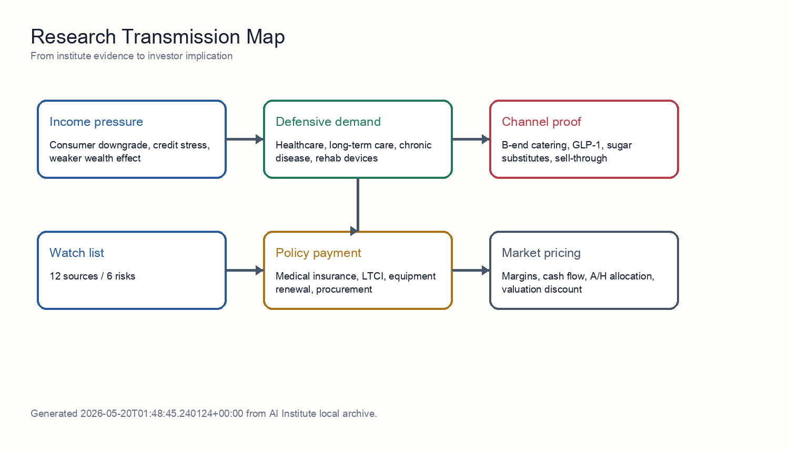
Transmission model
Consumer downgrade first compresses valuation extrapolation for discretionary consumption and premium self-pay healthcare, but it also strengthens restaurant cost reduction, healthcare necessity, and healthier-substitution demand. The sequence is: income and wealth effect determine purchasing power; policy payment sets the rigid-demand base; channel sell-through validates revenue quality; supply capability determines margin; collections and valuation crowding determine portfolio weight.
The correct reading of the silver economy is not population multiplied by ticket size. Payment sources must be separated. Medical insurance and long-term care insurance are the certainty base, pensions and household wealth determine self-pay elasticity, and commercial insurance plus subsidies set the marginal upside. Combining them overstates premium self-pay sectors and understates chronic disease, rehabilitation, care services, and home assistive devices.
The food-processing and sugar-substitute chain is driven by two forces: efficiency and health. B-end catering penetration comes from store-level cost reduction; GLP-1 and sugar reduction come from changing consumption preferences. Both must be validated through repeat purchase, price, and inventory turns rather than order headlines or concept intensity.

8. Source-by-Source Interpretation
The following section translates each source report into an actionable investment input, focusing on payment capacity, sell-through quality, policy conversion, supply-chain execution, and valuation discount.

Source 1: Downstream food-processing demand: B-end catering penetration and GLP-1 sugar-substitute pull
This evidence belongs to the b-end food processing and sugar-substitute demand cluster. Its direct contribution is: The source validates two defensive growth lines in food processing: restaurant operators using B-end semi-finished products to lower labor and kitchen costs, and GLP-1-driven sugar reduction supporting allulose and other next-generation sweeteners. That moves the topic from a macro narrative into testable operating variables such as purchasing power, terminal sell-through, policy conversion, cost curve, compliant delivery, and cash collection.
The investment implication is: Shows that consumer downgrade can coexist with structural demand created by cost reduction and healthier substitution. At the portfolio level, it should not be treated as a standalone buy signal. It should be combined with other sources in the same cluster; when several sources point to the same constraint, the constraint becomes large enough to affect valuation and margins.
The falsifier to track is: If B-end repeat purchase weakens, inventory turns slow, or allulose pricing falls quickly, the food-processing and sugar-substitute growth assumption should be cut.

Source 2: Pension-system transition and the silver-economy consumption base
This evidence belongs to the silver-economy payment capacity cluster. Its direct contribution is: The pension stress test argues that silver-economy healthcare demand is real but cash-flow constrained: basic medical insurance and long-term care insurance support rigid demand, while high-end self-pay medical services need lower expectations. That moves the topic from a macro narrative into testable operating variables such as purchasing power, terminal sell-through, policy conversion, cost curve, compliant delivery, and cash collection.
The investment implication is: Separates the silver-economy headline from actual cash-flow support, policy reimbursement, and self-pay elasticity. At the portfolio level, it should not be treated as a standalone buy signal. It should be combined with other sources in the same cluster; when several sources point to the same constraint, the constraint becomes large enough to affect valuation and margins.
The falsifier to track is: If medical and long-term care insurance payments lag, or pension cash flow fails to support self-pay healthcare, the silver economy should be priced as rigid demand rather than premium consumption upgrade.

Source 3: Consumer-downgrade risk and the quality of trade-in replacement demand
This evidence belongs to the consumer downgrade and sell-through quality cluster. Its direct contribution is: The trade-in demand note warns that policy stimulus and replacement demand must be separated from true discretionary recovery; sell-through, subsidy intensity, and household balance-sheet pressure determine earnings quality. That moves the topic from a macro narrative into testable operating variables such as purchasing power, terminal sell-through, policy conversion, cost curve, compliant delivery, and cash collection.
The investment implication is: Requires validation through ticket size, discount rate, credit stress, and real sell-through rather than headline demand. At the portfolio level, it should not be treated as a standalone buy signal. It should be combined with other sources in the same cluster; when several sources point to the same constraint, the constraint becomes large enough to affect valuation and margins.
The falsifier to track is: If ticket size falls, discounts widen, repeat purchase disappoints, or volume fades after subsidies expire, the consumption-resilience evidence should receive lower weight.

Source 4: Healthcare cost anchor under the Biosecure Act and CXO decoupling
This evidence belongs to the healthcare policy, innovation, and globalization cluster. Its direct contribution is: The healthcare macro stress test treats Biosecure Act risk, CXO decoupling, and compliance cost as a cost anchor that can change the margin profile of healthcare globalization. That moves the topic from a macro narrative into testable operating variables such as purchasing power, terminal sell-through, policy conversion, cost curve, compliant delivery, and cash collection.
The investment implication is: Places healthcare upside inside a margin stress test for policy, compliance, outbound orders, and cash collection. At the portfolio level, it should not be treated as a standalone buy signal. It should be combined with other sources in the same cluster; when several sources point to the same constraint, the constraint becomes large enough to affect valuation and margins.
The falsifier to track is: If hospital uptake, reimbursement, FDA inspection, BD collection, or overseas orders weaken, healthcare assets should receive a higher execution discount.

Source 5: Policy-driven repricing of innovative drugs and medical-device R&D
This evidence belongs to the healthcare policy, innovation, and globalization cluster. Its direct contribution is: The policy repricing note supports innovative drugs and medical devices, but the upside depends on reimbursement, procurement, product approval, and commercialization cadence rather than broad sector beta. That moves the topic from a macro narrative into testable operating variables such as purchasing power, terminal sell-through, policy conversion, cost curve, compliant delivery, and cash collection.
The investment implication is: Places healthcare upside inside a margin stress test for policy, compliance, outbound orders, and cash collection. At the portfolio level, it should not be treated as a standalone buy signal. It should be combined with other sources in the same cluster; when several sources point to the same constraint, the constraint becomes large enough to affect valuation and margins.
The falsifier to track is: If hospital uptake, reimbursement, FDA inspection, BD collection, or overseas orders weaken, healthcare assets should receive a higher execution discount.

Source 6: Healthcare structural opportunities and A/H-share portfolio path
This evidence belongs to the healthcare policy, innovation, and globalization cluster. Its direct contribution is: The strategy report proposes a barbell healthcare portfolio: high-certainty Hong Kong-listed anchors and tactical A-share high-beta positions, with different holding periods and risk discounts. That moves the topic from a macro narrative into testable operating variables such as purchasing power, terminal sell-through, policy conversion, cost curve, compliant delivery, and cash collection.
The investment implication is: Places healthcare upside inside a margin stress test for policy, compliance, outbound orders, and cash collection. At the portfolio level, it should not be treated as a standalone buy signal. It should be combined with other sources in the same cluster; when several sources point to the same constraint, the constraint becomes large enough to affect valuation and margins.
The falsifier to track is: If hospital uptake, reimbursement, FDA inspection, BD collection, or overseas orders weaken, healthcare assets should receive a higher execution discount.

Source 7: Consumer-credit stress transmission and financial-sector pricing
This evidence belongs to the credit stress and household purchasing power cluster. Its direct contribution is: The credit-stress report is a household purchasing-power cross-check: weaker consumer credit quality can cap discretionary healthcare, premium experience consumption, and replacement demand. That moves the topic from a macro narrative into testable operating variables such as purchasing power, terminal sell-through, policy conversion, cost curve, compliant delivery, and cash collection.
The investment implication is: Requires validation through ticket size, discount rate, credit stress, and real sell-through rather than headline demand. At the portfolio level, it should not be treated as a standalone buy signal. It should be combined with other sources in the same cluster; when several sources point to the same constraint, the constraint becomes large enough to affect valuation and margins.
The falsifier to track is: If consumer-credit deterioration widens, all self-pay and premium-experience demand assumptions should be revised down.

Source 8: A-share healthcare allocation under rigid domestic demand and offshore-dollar constraints
This evidence belongs to the healthcare policy, innovation, and globalization cluster. Its direct contribution is: The allocation note frames domestic healthcare as a rigid-demand A-share exposure, but warns that offshore-dollar constraints and global risk appetite affect valuation and capital-flow timing. That moves the topic from a macro narrative into testable operating variables such as purchasing power, terminal sell-through, policy conversion, cost curve, compliant delivery, and cash collection.
The investment implication is: Provides cross-checking evidence for structural opportunities under consumer downgrade, with focus on purchasing power, sell-through quality, and cash-flow conversion. At the portfolio level, it should not be treated as a standalone buy signal. It should be combined with other sources in the same cluster; when several sources point to the same constraint, the constraint becomes large enough to affect valuation and margins.
The falsifier to track is: If hospital uptake, reimbursement, FDA inspection, BD collection, or overseas orders weaken, healthcare assets should receive a higher execution discount.

Source 9: Bailong Chuangyuan and the allulose cost-curve compression thesis
This evidence belongs to the b-end food processing and sugar-substitute demand cluster. Its direct contribution is: The allulose thesis focuses on cost-curve compression, continuous production, by-product recycling, and Thai capacity as evidence that sweetener demand can become margin advantage for a cost leader. That moves the topic from a macro narrative into testable operating variables such as purchasing power, terminal sell-through, policy conversion, cost curve, compliant delivery, and cash collection.
The investment implication is: Shows that consumer downgrade can coexist with structural demand created by cost reduction and healthier substitution. At the portfolio level, it should not be treated as a standalone buy signal. It should be combined with other sources in the same cluster; when several sources point to the same constraint, the constraint becomes large enough to affect valuation and margins.
The falsifier to track is: If B-end repeat purchase weakens, inventory turns slow, or allulose pricing falls quickly, the food-processing and sugar-substitute growth assumption should be cut.

Source 10: Industrial challenge to healthcare-chain execution assumptions
This evidence belongs to the healthcare policy, innovation, and globalization cluster. Its direct contribution is: The industrial challenge asks whether healthcare demand can be fulfilled through capacity, delivery, manufacturing quality, and supply-chain execution rather than only through thematic demand. That moves the topic from a macro narrative into testable operating variables such as purchasing power, terminal sell-through, policy conversion, cost curve, compliant delivery, and cash collection.
The investment implication is: Provides cross-checking evidence for structural opportunities under consumer downgrade, with focus on purchasing power, sell-through quality, and cash-flow conversion. At the portfolio level, it should not be treated as a standalone buy signal. It should be combined with other sources in the same cluster; when several sources point to the same constraint, the constraint becomes large enough to affect valuation and margins.
The falsifier to track is: If hospital uptake, reimbursement, FDA inspection, BD collection, or overseas orders weaken, healthcare assets should receive a higher execution discount.

Source 11: Outbound pharma BD and offshore-dollar retention
This evidence belongs to the healthcare policy, innovation, and globalization cluster. Its direct contribution is: The outbound BD note links pharma globalization to offshore-dollar retention, deal timing, and cash repatriation, which can affect domestic valuation despite operating progress. That moves the topic from a macro narrative into testable operating variables such as purchasing power, terminal sell-through, policy conversion, cost curve, compliant delivery, and cash collection.
The investment implication is: Places healthcare upside inside a margin stress test for policy, compliance, outbound orders, and cash collection. At the portfolio level, it should not be treated as a standalone buy signal. It should be combined with other sources in the same cluster; when several sources point to the same constraint, the constraint becomes large enough to affect valuation and margins.
The falsifier to track is: If hospital uptake, reimbursement, FDA inspection, BD collection, or overseas orders weaken, healthcare assets should receive a higher execution discount.

Source 12: Premium experience consumption: ASP and margin validation
This evidence belongs to the consumer downgrade and sell-through quality cluster. Its direct contribution is: The premium-experience note stress-tests whether strong cruise and travel spending represent durable pricing power or a narrow high-income cohort that cannot offset broad consumer downgrade. That moves the topic from a macro narrative into testable operating variables such as purchasing power, terminal sell-through, policy conversion, cost curve, compliant delivery, and cash collection.
The investment implication is: Requires validation through ticket size, discount rate, credit stress, and real sell-through rather than headline demand. At the portfolio level, it should not be treated as a standalone buy signal. It should be combined with other sources in the same cluster; when several sources point to the same constraint, the constraint becomes large enough to affect valuation and margins.
The falsifier to track is: If ticket size falls, discounts widen, repeat purchase disappoints, or volume fades after subsidies expire, the consumption-resilience evidence should receive lower weight.

9. Stress Tests

Stress Test 1: The Silver Economy Has Scale but Not Enough Cash Flow
If pension replacement rates keep falling, personal-pension contributions undershoot, and the housing wealth effect does not recover, the silver economy still exists but mainly appears in reimbursement-backed medical demand, long-term care, rehabilitation, and chronic disease rather than broad premium self-pay healthcare. Portfolio construction should raise rigid-payment exposure and cut valuation assigned to generic silver-economy concepts.

Stress Test 2: B-End Catering Restocking Does Not Become Repeat Purchase
If restaurant clients restock temporarily but repeat orders disappoint, terminal discounts widen, and inventory turns slow, demand elasticity in food processing is overstated. Revenue growth should be decomposed into new clients, repeat purchase, price, and inventory. Penetration is real only when repeat purchase and price stability appear together.

Stress Test 3: Sugar Reduction Is Real but the Price Curve Falls Too Fast
GLP-1 and healthier diets can support allulose and other sweetener demand. But if capacity arrives in clusters, customers push down prices, or raw-material costs move against producers, growth-stock valuation shifts from demand multiples to cost-curve competition. Cost leadership, continuous production, by-product recycling, and stable offshore capacity become the valuation core.

Stress Test 4: Healthcare Globalization Is Discounted by Compliance and Cash Collection
Innovative drugs, CXO, peptide APIs, and outbound IVD all have structural opportunities, but Biosecure Act risk, FDA inspections, tariffs, and offshore-dollar repatriation affect profit retention. If order growth does not bring cash collection and stable margins, overseas revenue should receive a discount.

10. Risk Matrix
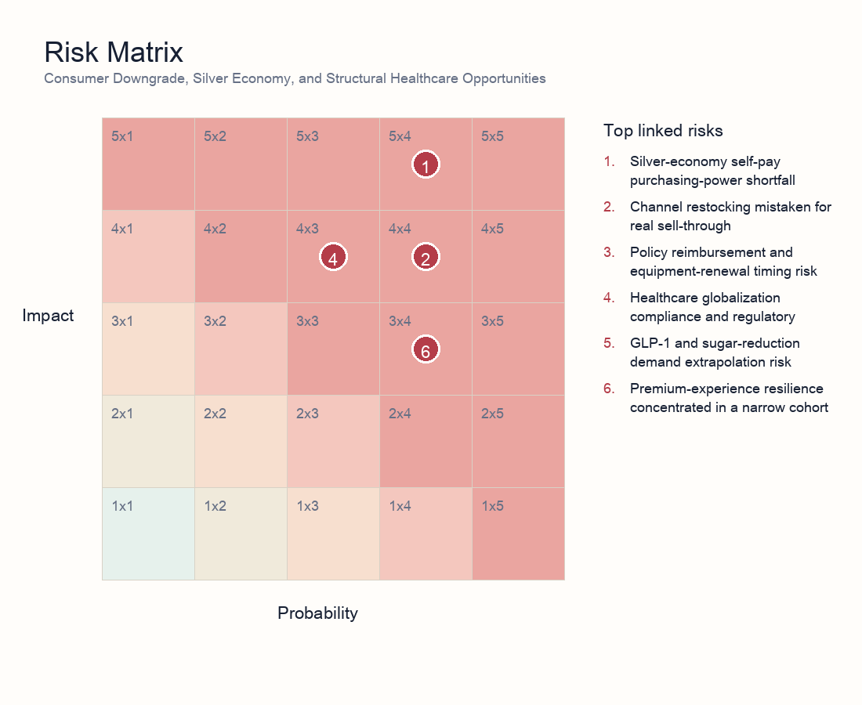
Risk matrix
- Risk 1 | consumer and healthcare | 5/4: Silver-economy self-pay purchasing-power shortfall. Explanation: Pension, housing wealth, and intergenerational-transfer constraints can weaken premium self-pay healthcare, leaving reimbursement, long-term care, and rehabilitation devices as the rigid base.
- Risk 2 | consumer and healthcare | 4/4: Channel restocking mistaken for real sell-through. Explanation: Food processing, B-end catering, sweeteners, and premium experience consumption need validation through repeat purchase, inventory turns, ticket size, and customer retention, not order headlines alone.
- Risk 3 | healthcare | 4/3: Policy reimbursement and equipment-renewal timing risk. Explanation: Medical insurance, long-term care insurance, and equipment renewal have policy support, but slow tenders, designation, or collections can trap orders in receivables.
- Risk 4 | outbound healthcare | 4/3: Healthcare globalization compliance and regulatory discount. Explanation: CXO decoupling, FDA inspections, tariffs, and compliance costs can reduce profit retention for peptide APIs, innovative-drug BD, and outbound IVD revenue.
- Risk 5 | consumer and healthcare | 3/4: GLP-1 and sugar-reduction demand extrapolation risk. Explanation: Sugar reduction is structural, but price decline, capacity release, and reformulation speed determine allulose margins.
- Risk 6 | discretionary consumption | 3/4: Premium-experience resilience concentrated in a narrow cohort. Explanation: Premium experience consumption may reflect high-income resilience rather than broad consumption or self-pay healthcare recovery.

11. Scenario Analysis
Scenario | Trigger | Macro/asset implication | Investor action
Rigid base clears | Medical/long-term care spending, rehab-device tenders, and chronic-drug uptake improve together | Defensive growth forms inside consumer downgrade | Raise reimbursement-chain, rehab, and cash-flow-certain exposure
Structural growth spreads | B-end catering repeat orders, stable allulose pricing, persistent GLP-1 sugar-reduction demand | Food-processing and healthy-ingredient margins improve | Own cost leaders with strong channel validation
Purchasing power weakens | Consumer credit worsens, housing wealth effect does not recover, self-pay healthcare slows | Premium experience and self-pay healthcare valuations fall | Cut generic concepts and premium self-pay exposure
Outbound discount widens | Biosecure/FDA/tariff pressure rises; BD collections lag expectations | Outbound healthcare revenue gets discounted; A/H valuations diverge | Prefer domestic rigid demand and verified overseas cash flow

12. Portfolio and Valuation Implications
Valuation should not be explained by one broad consumption-recovery multiple. A cleaner model decomposes each subsector into payment source, demand frequency, channel sell-through, gross-margin protection, collection cycle, and policy or compliance discount, then probability-adjusts those variables against 6 risk signals.
Core holdings deserve a certainty premium when reimbursement or long-term care payment is clear, hospital uptake is visible, and cash flow can be verified. Chronic disease, autoimmune medicine, rehabilitation, IVD, and assistive-device assets can act as defensive growth in a consumer-downgrade environment.
High-beta assets need execution discounts. GLP-1, peptides, innovative-drug BD, equipment renewal, and allulose can offer high payoff, but they become medium-term holdings only after orders, price, capacity, regulation, and collections are all validated.
The main valuation trap is treating aging demographics, health upgrades, or premium-experience resilience as unconditional growth. If purchasing power, sell-through, or cash flow is missing, the thematic premium should fall.
Bucket | Exposure | Rationale | Key checks
Core holdings | Reimbursement-backed drugs, chronic and autoimmune medicines, outbound IVD, rehabilitation equipment, home assistive devices | Rigid payment and policy certainty offer better resistance to consumer downgrade | Reimbursement execution, hospital uptake, overseas cash flow, tender collections
Structural growth | B-end food processing, frozen bakery, prepared ingredients, allulose and sugar-reduction inputs | Restaurant cost reduction and healthier substitution create two demand curves | Customer retention, repeat purchase, inventory turns, cost curve, price decline pace
Tactical beta | GLP-1 peptide APIs, innovative-drug BD, A-share medical-equipment renewal events | High upside but exposed to regulation, order conversion, and fiscal payment timing | FDA inspections, overseas orders, BD payments, fiscal releases, capacity approvals
Cautious/underweight | Premium checkups, anti-aging, aesthetic medicine, premium experience consumption, generic silver-economy concepts | Highly dependent on self-pay elasticity and high-income cohorts; easy to over-extrapolate | Ticket size, discount rate, repeat purchase, housing wealth effect, consumer-credit delinquencies
Hedges | Consumer-credit deterioration, policy payment delay, overseas compliance, FX | Corrects self-pay demand, outbound margin, and valuation duration | Credit-card/loan data, policy documents, FDA/tariff events, offshore-dollar flows

13. Investor Reading Framework
First, identify the payment source: medical insurance, long-term care insurance, personal self-pay, and commercial insurance deserve different valuations. Second, test sell-through: orders without terminal repeat purchase and inventory turns should not receive growth multiples. Third, check margin protection: food processing and healthcare globalization both require cost curves, compliance, and pricing power. Fourth, demand cash flow: policy payments, BD proceeds, and overseas revenue should raise position size only after collections are visible.

14. Daily Monitoring Dashboard
Dimension | Indicator | Interpretation | Evidence source
Purchasing power | Pension contributions/payouts, medical and long-term care insurance spending, consumer-credit delinquencies | Improvement supports self-pay elasticity; deterioration favors rigid reimbursement chains | Human resources, medical-insurance data, financial disclosures, local budgets
Sell-through quality | B-end repeat purchase, inventory turns, terminal discounting, ticket size | Better repeat purchase and turns prove demand; restocking alone does not | Channel checks, company monthly operations, restaurant client orders
Healthcare conversion | Reimbursement access, hospital uptake, equipment-renewal tenders, collection cycle | Policy certainty must become hospital usage and cash collection | Medical-insurance catalogues, tender platforms, company announcements
Outbound risk | FDA inspections, Biosecure Act, tariffs, BD payments, offshore-dollar retention | Determines profit retention and valuation discount for overseas revenue | Regulatory notices, customs/orders, contract disclosures
Valuation crowding | A/H turnover, flows, valuation percentile, theme concentration | Crowded trades require stronger execution evidence | Exchange data, ETF and Stock Connect flows, sector valuation

15. Data Still Needed
- Monthly payment and tender progress for medical insurance, long-term care insurance, and medical-equipment renewal.
- B-end food-processing repeat purchase, inventory turns, discount rate, and terminal ticket size.
- Price, capacity, orders, and collections for allulose, GLP-1 peptide APIs, and medical devices.
- Consumer-credit delinquency, housing wealth effect, personal-pension contribution rate, and commercial-health renewal rate.
- A/H healthcare flows, valuation percentiles, overseas compliance events, and offshore-dollar repatriation.

