Problem 1

Part a

For general n, the possible values of 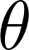:

Part b

This problem got me thinking about how I could generate a set of normalized vectors that are separated by the same angle and how familiar this was to the Gram-Schmidt procedure for finding orthonormal vectors. GS applies for the general n but with angle 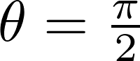.

The way GS works is that when you subtract out the projection of x1 onto x2 from x1, you are left with the remaining component of x1 that is perpendicular.
Problem 2
Part a

We are trying to determine which input will force all of the cars to converge to a given configuration. Based on the information given we are interested in what happens as t approaches some far along time in the future (let’s say infinity), then the equations of motion suggest:

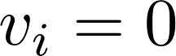 therefore: 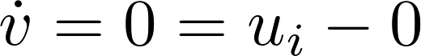 leads to the obvious result: 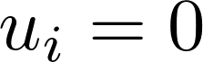. This also leads to: 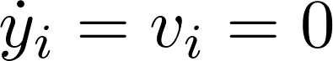 and therefore after integrating: 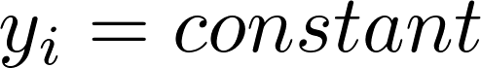. This makes sense in context, the constant value is simply the position i. This is interesting, as this suggests that ultimately the control schemes that we are evaluating in this problem have to approach zero as t approaches infinity.

Since 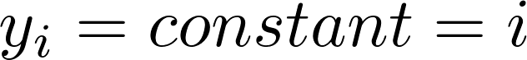 when the system converges and the desired position then, 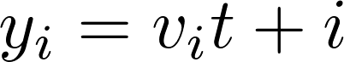 after integration.

Looking at the first control scheme (right looking control), we have:

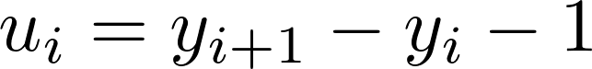 and for n = 1-4 and for n =5 we have 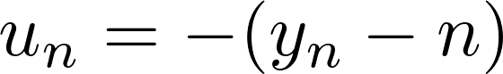:

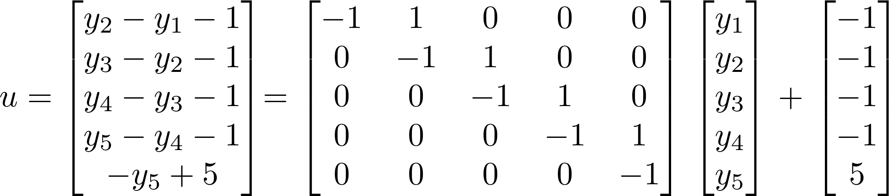

Looking at the second control scheme (left and right looking control), we have:
and for n = 2-4 and then n=1 and n=5 are similar to the previous one:

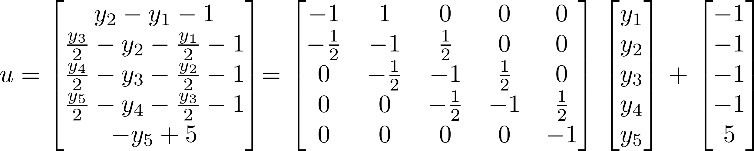
For the third control scheme ( independent alignment we have:
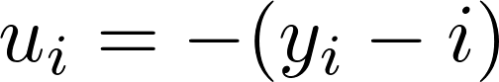.

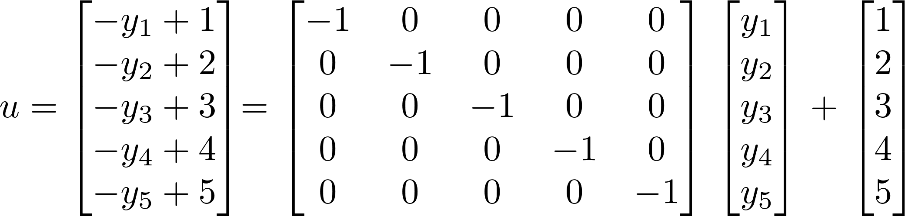
To determine which scheme converges, I decided to look at the 5x5 matrix of each u. In all cases, we have real components of their eigenvalues that are -1. The first and third scheme’s matrices have real eigenvalues while the second scheme (left and right looking control) has complex eigenvalues.

I am working on the assumption that this is a continuous LDS. Under this assumption, the fact that the real components of the eigenvalues are all -1 means that all three schemes will cause the vehicles to converge to the desired configuration.

If I apply the matrix exponential to the three 5x5 matrices and look at what happens as t gets very large, I can see that indeed all three are decaying to zero. I used t=100 and ran expm(u1*100) for scheme 1, expm(u2*100) for scheme 2 and expm(u3*100) for scheme 3 where u1, u2, u3 are the 5x5 matrices derived on the previous page. Scheme 2 and scheme 3 (left and right looking control and independent alignment) decay much faster than scheme 1 (right looking control). At t=100, both scheme 2 and 3 are at e-43 whereas scheme 1 is at e-36.

Part b

I am having trouble setting up this problem so that I can solve it analytically so I will describe what I think a valid approach might be and hope that it lines up with a possible way of determining the collisions.

We want to know when 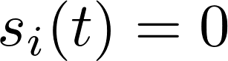 when 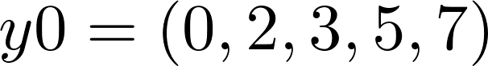 and 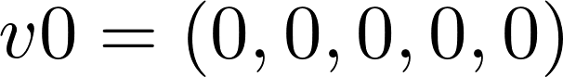. So, I could try to find an equation for the position of the vehicles by integrating the dv/dt equation twice. This would give me the following:

.

Since v0 is zero we can ignore that term. This equation seems to make sense in the long term since when we want it to converge, vi = 0. It’s possible that it would converge so that the y positions align in the ith order. The only problem with this equation is that I don’t see how over time t, the inputs will cause the system to converge. My purpose for trying to find a position equation is to determine when a collision might occur between two vehicles. As I said before, this happens when :

Then this happens when: 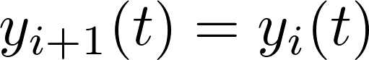.

If I could figure the correct equation, I would solve for time t for the above equality for each combination of vehicles. This would tell me at what time they collide and I would also know which two vehicles are part of the collision.
Problem 3

In this problem we are combining the matrix exponential solution to an autonomous linear dynamical system, eigenvalue of the system, and singular value decomposition to come up with the worst-case scenario.

My approach was to first to find out what the LDS looks like when there is no input fault.

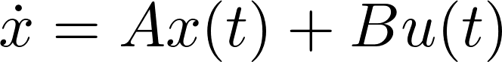
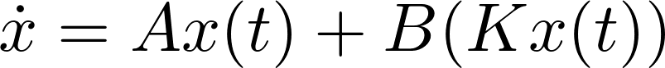
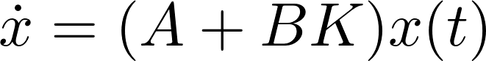
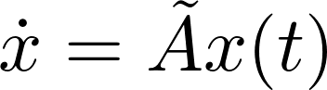
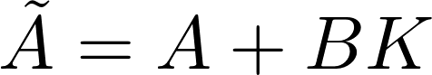

When the system is not in fault, it is still an autonomous linear dynamical system. The equation when it does fault is simply: 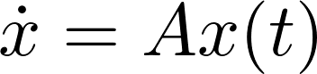.

My next step was to look at the sigma values and eigenvalues of both 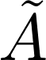 and A. What I was first looking for was confirmation that was a decaying system and then I was curious to see what was happening when the fault occurred.

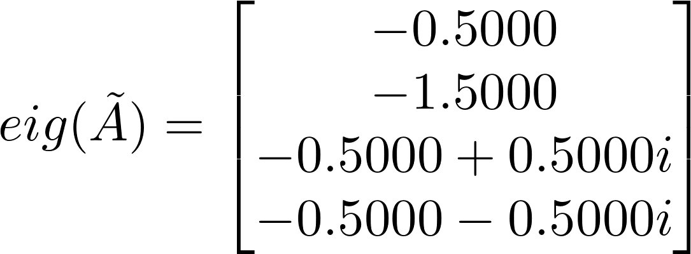 and 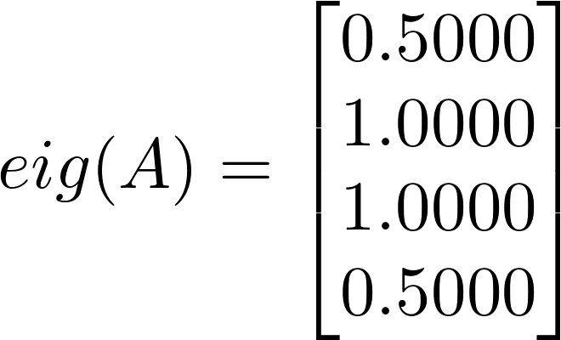

We can see that is acting as described in the problem. The system is being driven to zero because the the real component of the eigenvalues are all less than zero for the continuous system. There is some oscillation but that’s not as important. When the system faults, however, the eigenvalues are all real and all greater than zero. There is no decay in the system and it will eventually “blow up” as t approaches infinity.

I then looked at the sigma values of the A matrix. What I want to do is drive the system along a right sigma vector that will have the most gain. I want the maximum gain out of the fault in the system.

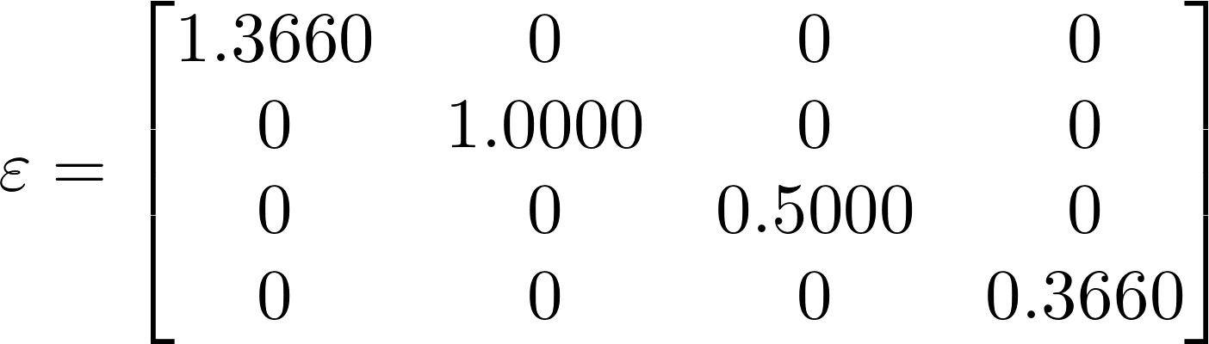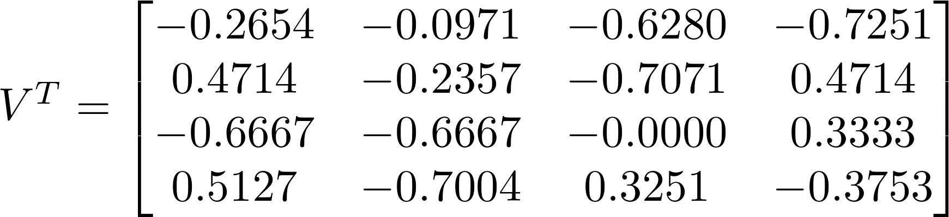

We see that: 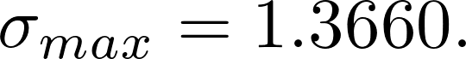 This sigma is associated with the right singular vector:

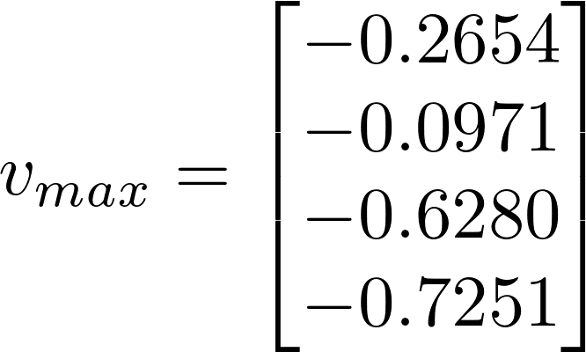.

I claim that if I set the initial condition as: 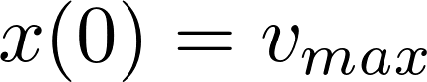 that we will have the maximum gain when the system faults. I believe this is true because the right singular vectors are sensitive to input direction. Furthermore, 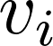 that is associated with the biggest 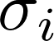 should be the most sensitive according to the theory. However, I first had to make sure that it met the constraint that 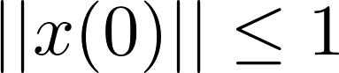. As it turns out, 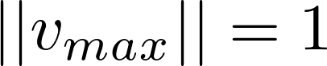. Of course, this makes sense since the U and V matrices of the singular value decomposition of a matrix are orthogonal so this guarantees that the vectors have unit norms. Now, my next step was to determine when the fault should occur.

To decide this, I looked to the matrix exponential. Realizing that this is a composite system, we have two A’s that we are switching between between the time interval [0,9] seconds. Since is decaying over time exponentially (ignoring the oscillations for simplicity), this system can be modeled using this plot:

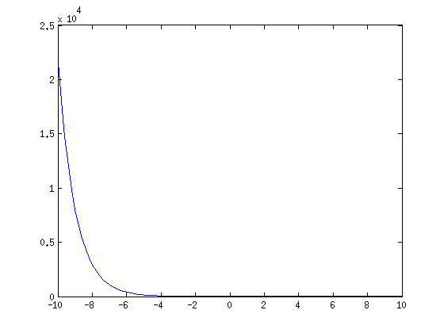

You can see from the above plot of 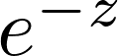 (z is an arbitrary variable not related to the system itself) that if we run the system too long it will hit a very rapid decay that will overpower the effects of the fault. So, if we want to maximize the fault’s effects, then we must prevent the system from entering that rapid decay. Thus, I believe that the fault should occur somewhere in the middle of [0,9] seconds so that we maximize 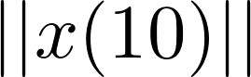.

Here is what the solution for x looks like so far: . Based on my above hypothesis, I used MATLAB to run the system with fault times around 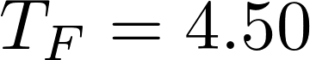 where I believed the fault would have the greatest effect on . I also tested extreme cases to make sure my reasoning made sense. I found that 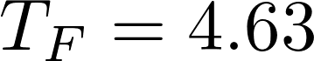 maximizes .

My final solution is: 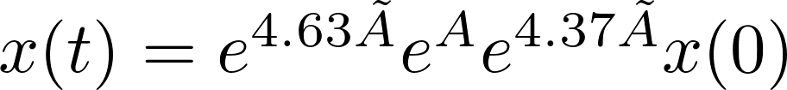 which gives me the following: 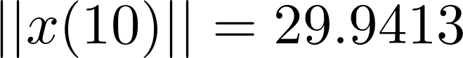 where , the right singular vector associated with 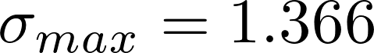.
Problem 4

This is a non-linear least-squares problem with the added addition of trying to estimate the position and the time that the transmission was made. We can solve this using the Gauss-Newton method (GNM).

Using GNM, I want to linearize the residual such that I have an approximate linear LS problem:

Where, in this case x actually contains three entries:
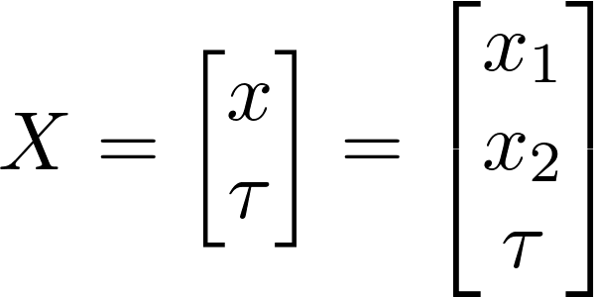
The r(x) that will be minimized is as follows:
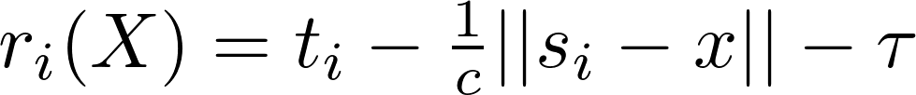

The next part is finding the linear approximation of each 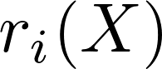. This comes from the following method:

From here we can find the least-squares approximation:

Where:
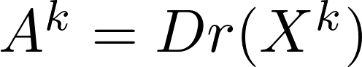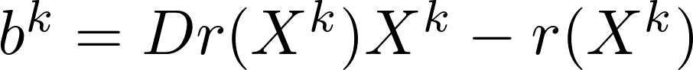

I worked out the Jacobian derivatives on scratch paper and found:

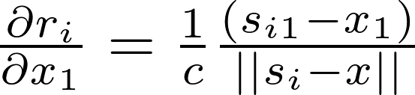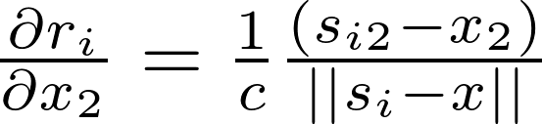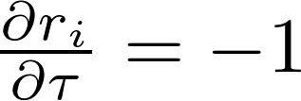

Putting this all together gives the following matrices that get run through the iterative GNM in MATLAB.

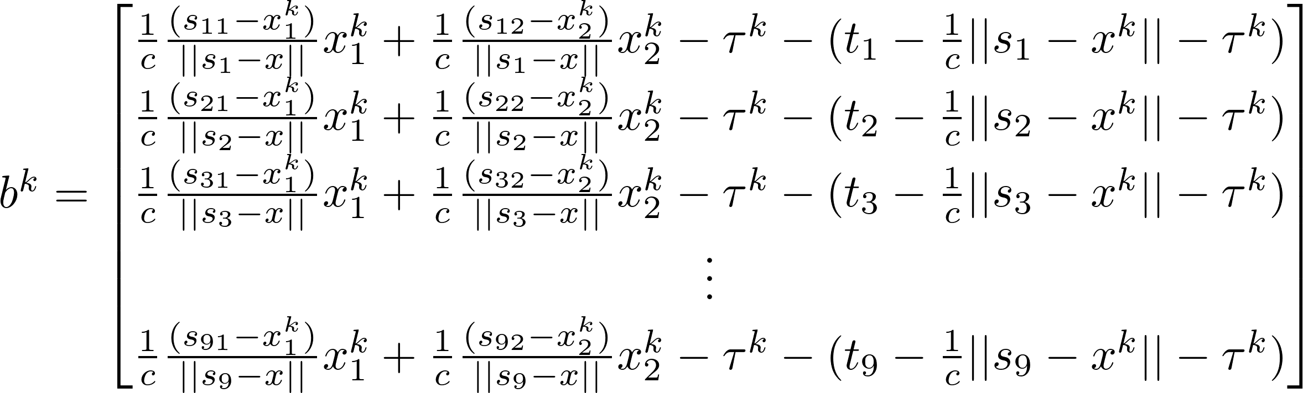
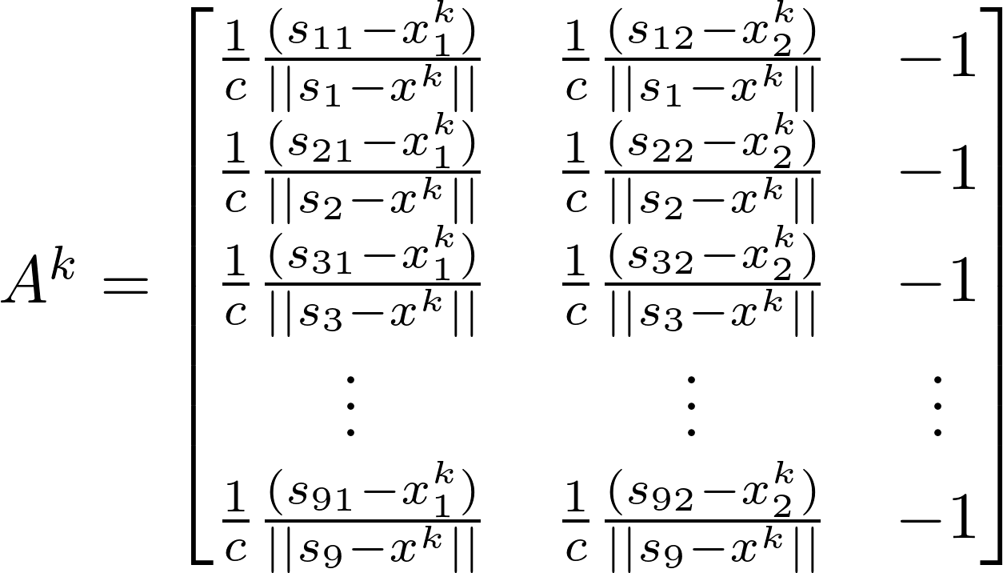

Lastly, in order to find the next 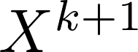 we must actually solve the approximate least-squares problem:
.

The problem says that we can assume the position x is somewhere in the box 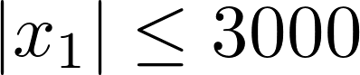 and , and that 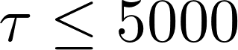. This information informs my educated guess for X.

In order to make sure that I have arrived at the actual solution to the problem I check the following:
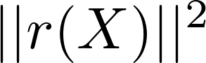 and plot the results over all iterations. If the results converge, then I’ve found an estimate for the position of the caller and the time that the call/transmission was made. Way cool. If not, my solution either did not converge of I’ve done this wrong.

As of now, the GNM is converging but there is huge error when I calculate 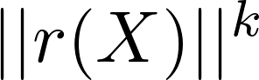 that I don’t really believe it. I’ve tried a variety of different initial guesses within the parameters given in the problem and they all return the same solution. 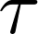 Is not less than or equal to 5000 in my solution so I know it must be wrong. The position values are within the box, but with being off, this solution is not believable. I followed the steps outline in the course notes. Code is attached.
Problem 5

Part a

After some thought, it occurred to me that the fundamental equation for eigenvalues is in the form: 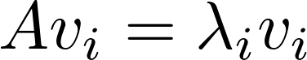.

Then it occurred to me that I could make this into a least-squares problem if I looked at the equation the right way. I thought about what known information we had in the problem: the measured matrix 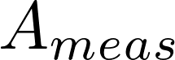 which contains errors and the eigenvectors that are associated with the true matrix A. What if we assume the following:

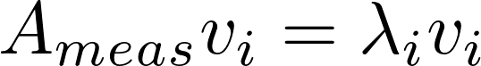 where 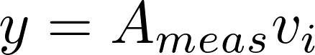 and 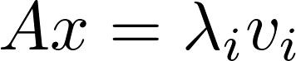, giving us: 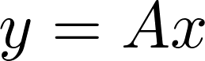.

In this case, we are solving for the least-squares approximate solution for each individual eigenvalue of the original matrix using the “y-measurements” that contain the errors from .

The eigenvalues are estimated then with the following equation:

There is only minimal iteration here: we must calculate the least-squares approximate solution for each eigenvalue. So we’d run the above line n-times for n-unknown eigenvalues.

Then from here we can construct our A_ls matrix using the eigenvalue decomposition relationship:

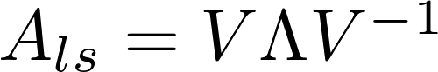 Where the V matrix’s columns are made of the known independent eigenvectors given in the problem. V-inverse is simply the matrix whose rows are the independent left eigenvectors of A. 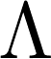 is a matrix whose diagonals are the least-squares approximate eigenvalues of A, all other entries are zero. Using the least-squares approximate solutions for the eigenvalues, and this equation, A_ls can be constructed.

From here, the final step is to check that J is minimized. Of course, since this is being solved as a least-squares problem, the mean-square should in fact be minimized. That’s the whole point of least-squares.

Part b

I carried out my method using the data given in the problem and found J = 0.0264. This number gives me great confidence that this is in fact the estimated A matrix. The eigenvectors are the ones given in the problem. Here are the corresponding approximate eigenvalues I found and the estimated A matrix:

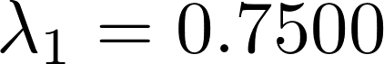 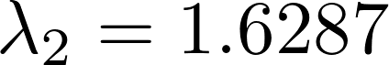 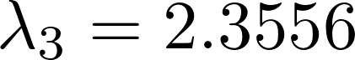 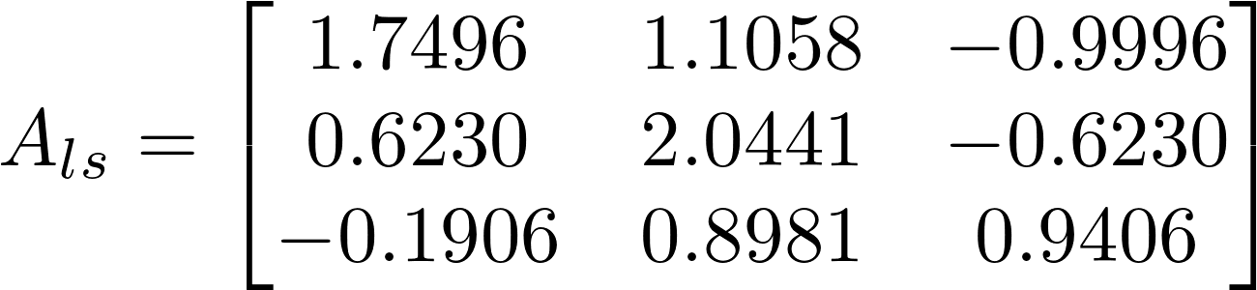.
Code is attached.

