ER
All attributes are required to be valid data unless marked with “(optional)”.
The image below shows the ER model:
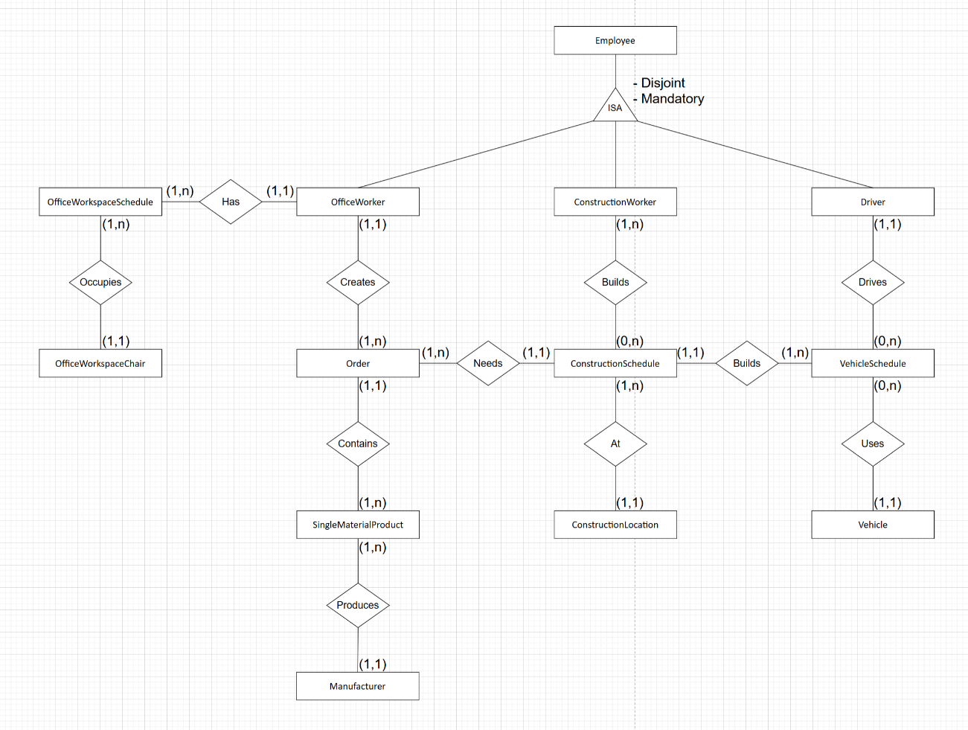

The attributes are mentioned in the text below.
Entity Order:
- Order ID (primary key)
- Single material product ID (foreign key references entity SingleMaterialProduct)
- Date - text
- Price - integer
- Delivered - integer
Entity SingleMaterialProduct:
- Single material product ID (primary key)
- Manufacturer ID (foreign key references entity Manufacturer)
- Brand name - text
- Material type - text
Entity Manufacturer:
- Manufacturer ID (primary key)
- Company name - text
Entity VehicleSchedule:
- Vehicle schedule ID (primary key)
- Vehicle ID (foreign key references entity Vehicle)
- Driver ID (foreign key references entity Driver)
- ConstructionSchedule ID (foreign key references entity ConstructionSchedule)
- Date of start - text
- Date of end - text
Entity OfficeWorkspaceSchedule:
- Office workspace schedule ID (primary key)
- Office worker ID (foreign key references entity OfficeWorker)
- Office workspace chair ID (foreign key references entity OfficeWorkspaceChair)
- Duration - integer
Entity ConstructionSchedule:
- Construction schedule ID (primary key)
- Construction worker ID (foreign key references entity ConstructionWorker)
- Construction location ID (foreign key references entity ConstructionLocation)
- Order ID (foreign key references entity Order)
- Duration - integer
- Description - text
Entity Employee:
- Employee ID (primary key)
- Name - text
- Age - integer
- Date of starting job - text
Entity Driver:
- Inherits Employee attributes
Entity OfficeWorker:
- Inherits Employee attributes
Entity ConstructionWorker:
- Inherits Employee attributes
- Job - text

Entity Vehicle:
- Vehicle ID (primary key)
- Vehicle type - text
Entity OfficeWorkspaceChair:
- Office workspace chair ID (primary key)
- Floor height - integer
Entity ConstructionLocation:
- Construction location ID (primary key)
- Building type - text
- Land location - text

