CS 1632 - DELIVERABLE 2: Unit Testing Ruby Rus

David Stropkey

Github username: dms80790

Github url: <https://github.com/dms80790/D2>

*Summary*

There weren’t any major issues in terms of implementing the program or the tests. The major hurdle for me was getting used to Ruby styling and dealing with every annoyance of RuboCop. While that may be the case, I can certainly understand the benefit of using a linter like RuboCop as it encourages us to write more readable and standardized code.

All of my tests passed, but I feel like I could’ve organized my code a little bit better while writing the program. This is apparent because quite a few of my methods don’t really lend themselves to equivalence class partitioning as there are several without parameters and some which do more than one defined operation. Hopefully in the future I will be able to take this experience to write code that is more testable and methods which have more clear-cut purposes that can be easily tested.

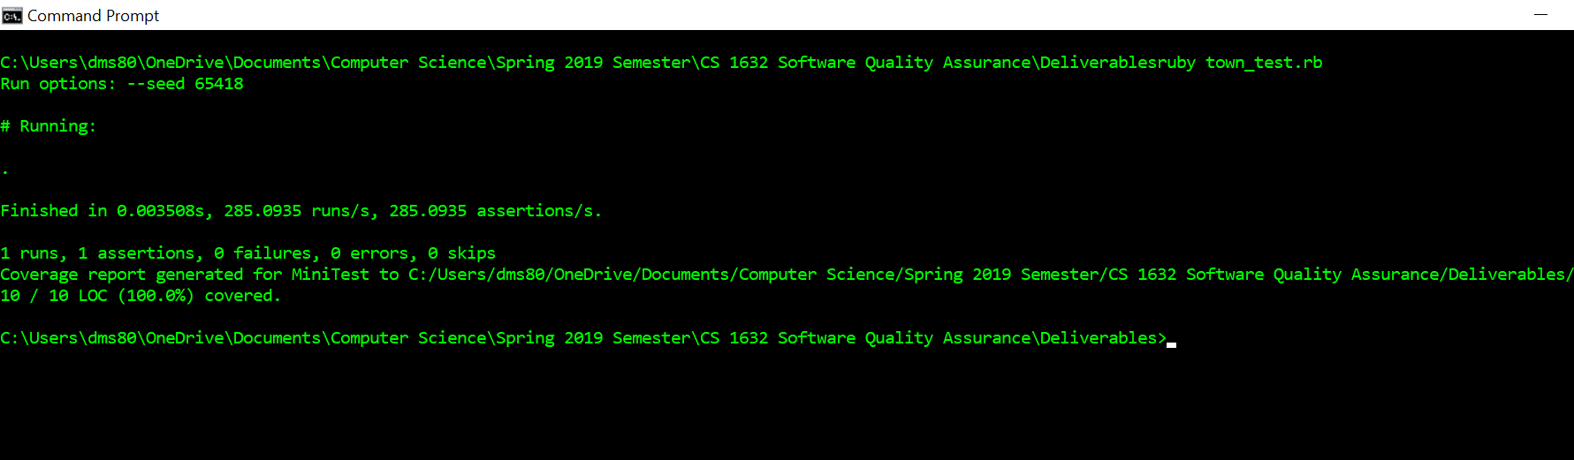

town_test.rb

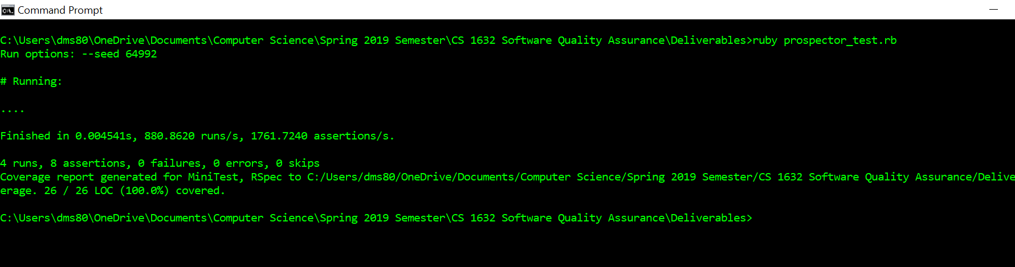

prospector_test.rb

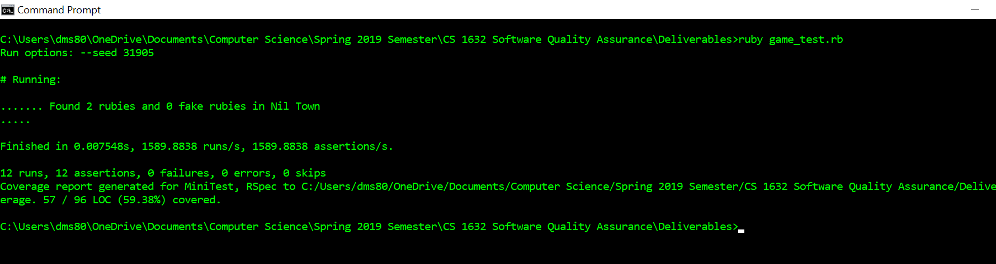

game_test.rb