CS 1632 - DELIVERABLE 3:

Automated System Testing of a Web Application

David Stropkey

Github username: dms80790

Github url: <https://github.com/dms80790/D3>

**Summary**

I had a few minor issues while doing this project. While writing the program, I was having some issues with creating a 2D array for the truth table. Unlike in Java, you can’t use the array[][] notation when declaring the array. So, I ended up just making a single-dimensional array, and then looped through it based on the user-entered size and at each index placed another single-dimensional array. I’m not sure if there is an easier way to go about this, but really it was just a minor annoyance. Another issue I had to figure out was that the values of text-box variables are nil upon the page first loading, and are no longer nil but an empty string (‘’) if the user clicks the submit button while leaving the text-box blank. This wasn’t really apparent at first as I figured that empty boxes were always just nil. Once I figured that out, writing the program was relatively simple.

While using Katalon, I also experienced a few issues that seem to be inherent to Katalon itself. For example, when running some of my test cases, you have to hit the reload button in the web browser for the suite to continue or Katalon will just freeze up. Also, it was difficult to assert what the individual rows of truth tables were, as well as the table as a whole. What I ended up doing was just using the regular expression * operator between all table elements because that is what worked. I’m guessing that Katalon does have a better way to evaluate entire rows and entire tables for specific text, but I couldn’t quite figure it out. Finally, I couldn’t determine how to test for the presence of the 404 error code when the user puts an invalid address.

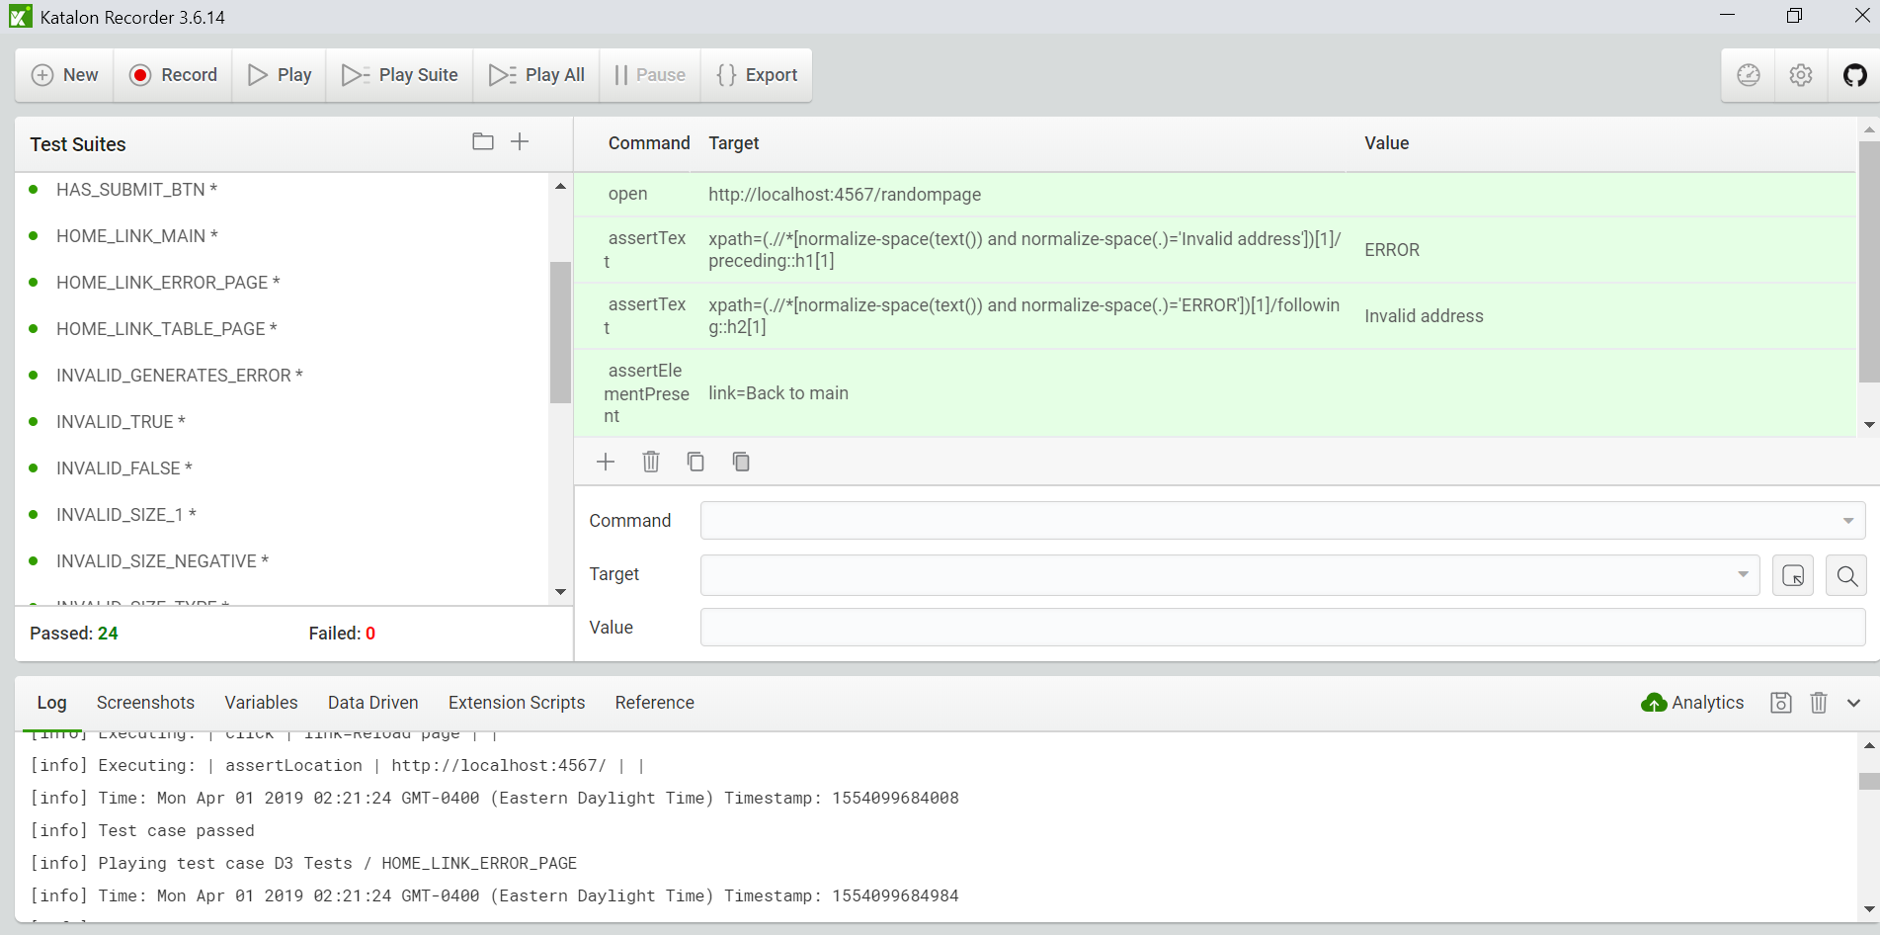

Katalon Test Suite Run Screenshot. 24 tests passed, 0 failed

**TRACEABILITY MATRIX**

**1**: HAS_TRUE_BOX, HAS_FALSE_BOX, HAS_SIZE_BOX, HAS_SUBMIT_BTN

**2**: HOME_LINK_MAIN, HOME_LINK_ERROR_PAGE, HOME_LINK_TABLE_PAGE

**3**:INVALID_GENERATES_ERROR

**4**: INVALID_TRUE, INVALID_FALSE, INVALID_SIZE_1, INVALID_SIZE_NEGATIVE, INVALID_SIZE_TYPE, INVALID_SAME_SYMBOL

**5**: TRUTH_TABLE_PROPER_LAYOUT, VALID_ALL_LARGE

**6**: TRUTH_TABLE_AND_TEST, TRUTH_TABLE_OR_TEST, TRUTH_TABLE_NAND_TEST, TRUTH_TABLE_NOR_TEST

**7**: DEFAULT_TRUE, DEFAULT_FALSE, DEFAULT_SIZE

**8**: INVALID_ADDRESS